Statement of Insurance for Pavement Cafe Licence purposes | 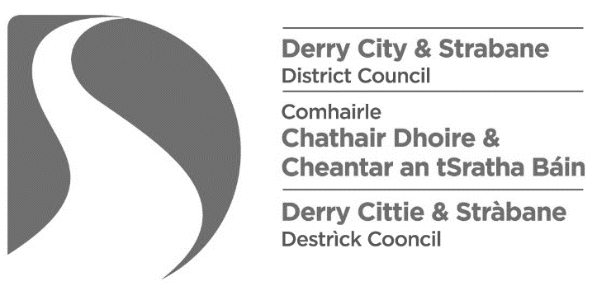

This statement must be completed by the insurer and either accompanied by a covering letter, on the insurer’s headed notepaper, or otherwise verified, e.g. by means of an official stamp or seal, or e-mailed directly from the insurer to licensing@derrystrabane.com

I, the undersigned, confirm that the details of the insurance policy, that is in force in respect of the pavement café licence for the premises named herein, are as follows:
Premises:

Policy number:

Date renewal is due:

Limits of indemnity: | Public liability cover:  (minimum £5M required) | £
Please provide details of any restrictive endorsements applicable to the pavement café located outside these premises:

Signed: |  | Date:
on behalf of: |  |  | Company stamp
 | [insert name of company]

