Licensing of Pavement Cafés Act (Northern Ireland) 2014
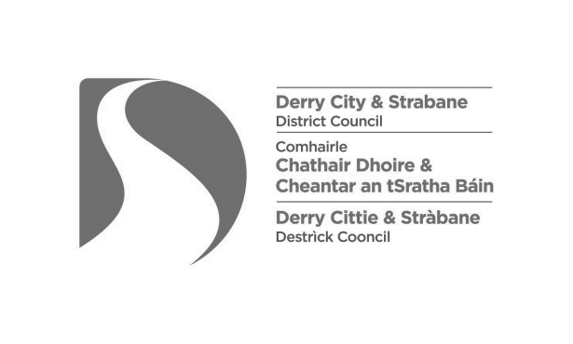

PUBLIC NOTICE
APPLICATION FOR A PAVEMENT CAFÉ LICENCE

Notice is hereby given that I have made an application to Derry City and Strabane District Council for a licence in relation to a pavement café for:
Name of premises:
Address of premises:

The pavement café will be located at:

You can view details of this application on the Council website at:
www.derrystrabane.com/Licensing/Pavement-cafe-licences
You can also arrange to view this application, free of charge, by contacting the Council by telephone on 028 71253253 or by email at licensing@derrystrabane.com
Any objections to this application must be made, in writing, within 28 days of the date of application and sent to the following address, outlining the grounds of the objection:

Derry City & Strabane District Council, Licensing & Safety Advisory
Group, 98 Strand Road, Derry, BT48 7NN
e-mail: licensing@derrystrabane.com

Date of application:

Signed: |  | Date:

