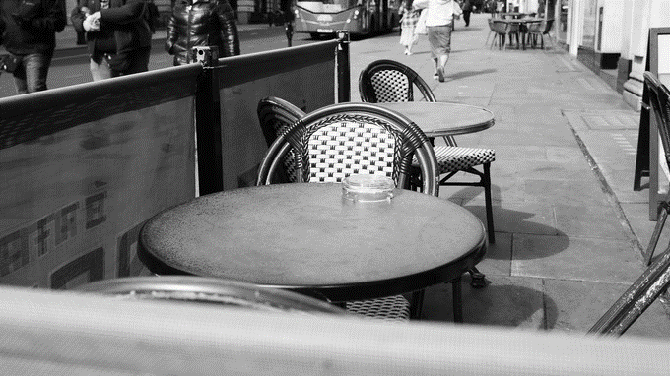

|  |
| --- |
| C:\Users\paul.rafferty.DERRYSTRABANE\Desktop\work desktop 260320\Desktop 280120\Desktop 221119\Desktop 250919\dcsd logo.jpg Pavement Café Licences:A Guide for Applicants |
| Derry City and Strabane District Council  Licensing and Safety Advisory Group  98 Strand Road  Derry  BT48 7NN  t. 028 71253253  e. [licensing@derrystrabane.com](mailto:licensing@derrystrabane.com) |

# Summary

1. A pavement café licence permits furniture to be placed on a specified public area for customers to consume food or drink supplied from the licence holder’s premises.
2. “Furniture” includes tables, chairs, umbrellas, screens, heaters, menu boards, etc., which must be of a temporary nature and be capable of being removed from the public area within 20 minutes.
3. A “public area” is a place in the open air, to which the public has access, as of right and which is not a market area.
4. The types of business which may apply for a “pavement café licence” are those supplying food or drink (in or from premises), including cafés, restaurants, pubs, retail outlets providing refreshments, takeaways and supermarkets with a deli counter.
5. An application must be made in the prescribed format and be accompanied by the information specified on the application form.
6. The application must be accompanied by the appropriate application fee:

|  |  |
| --- | --- |
| Application type | Fee |
| Grant (3 year licence) | £255 |
| Renewal (3 year licence) | £210 |
| Variation | £150 |

1. A Public Notice, in the approved format, must be displayed on/at the premises for 28 days from the date of application.
2. Council will consult DfI Roads in all cases, PSNI where the premises is licensed under The Licensing (Northern Ireland) Order 1996, and any other persons as it considers appropriate.
3. In exercising its functions, Council must take into account any representations made in connection with an application.
4. Council will aim to make a determination within 8 weeks of receipt of a complete application.
5. Licences will last for a period of 3 years and will be granted subject to conditions.
6. If a condition of the licence has been breached, Council may revoke the licence or may require steps to be taken to remedy the breach.
7. Further grounds for revocation of the licence include where the furniture is giving rise to risks to public health and safety or risks causing a public nuisance.

# Pavement Café licences

## Introduction

Pavement cafés have become a familiar sight across the UK and Ireland. They can help develop a local café culture, which in turn can have a positive effect on urban environments, promote town and city centres, contribute to the general well-being of communities and appeal to tourists.

Tourism is a key driver for economic growth within the Derry City and Strabane District Council area, offering business opportunities to create jobs and generate wealth. Visitor attitude surveys undertaken by the Northern Ireland Tourist Board have highlighted the attractiveness of a vibrant café culture, especially for short breaks where shopping, good food and evening entertainment are high on the agenda. Well regulated pavement cafés can contribute to an excellent visitor experience, enhancing the attractiveness of a local area and encouraging visitors to stay longer and spend more.

## Purpose of this guide

Not every public area will be suitable for use as a pavement café, as in order to be considered suitable for a pavement café licence, an area will need to satisfy particular safety, public health and accessibility criteria.

This guide details the application process and the criteria that must be satisfied.

It is not intended to be an authoritative interpretation of the law; however, reading the guide will assist those wishing to apply for a licence.

Before submitting their applications, applicants should read this guide thoroughly to check whether their proposal meets all of the required criteria. This will help to minimise time wasted on applications which may later be refused.

## Scope

Pavement café licensing applies to public areas only. Land clearly in private ownership is excluded from the licensing requirements.

## Legislation

The Licensing of Pavement Cafés Act (Northern Ireland) 2014 prohibits the operation of a pavement café, except under licence granted by a district council. Applications for a licence will be considered from owners of cafés, restaurants, pubs or other premises selling food or drink to the public.

The Act also permits Council to impose a range of licence conditions, charge a reasonable fee and to vary, suspend or revoke the licence in certain circumstances.

## What is a Pavement Café Licence?

A pavement café licence (“a licence”) authorises a person who carries on a business, involving the supply of food or drink (in or from premises), to place furniture (tables, chairs, etc.) on a public area for use by customers. This includes cafés, restaurants, pubs, retail outlets providing refreshments, takeaways, supermarkets with a deli counter, etc.

A licensed pavement café area will remain a public place and is, therefore, subject to all other legislation applicable to such areas, except alcohol bye-laws in certain circumstances.

## Who may apply?

Any person or persons carrying on a business (in or from a premises), involving the supply of food or drink to the public, may apply for a Pavement Café Licence.

## What businesses are eligible?

Businesses that are eligible include: public houses, cafes, restaurants, snack bars, coffee shops, retail outlets providing refreshments, takeaways, supermarkets with a deli counter and ice cream parlours.

## Will the pavement café area you hope to use be suitable for use as a pavement café?

Appendix 1 “Suitability Criteria for a Pavement Café Licence” outlines the criteria that will be considered when applications are being assessed. These cover a range of issues, including: Size and layout; Pedestrian and vehicular access; Furniture design; Screening; Safety issues; and Potential disturbance to other businesses or residents.

In general, the pavement café area will need to be set-up immediately adjacent to the premises. However, a licence for a remote café may be granted where:

* The proposed café does not interfere with both vehicular and pedestrian traffic flow; and
* The licence holder is able to demonstrate that they will be able to exercise proper control and supervision of the pavement café area.

It is important to be aware that a pavement café licence simply authorises a person carrying on a business, involving the supply of food or drink (in or from premises), to place furniture temporarily on a public area. If you wish to place furniture on private land, you do not require authorisation to do so under a pavement café licence, unless the private land in question has been adopted and forms part of a public footpath or public realm area.

## Hours of operation

Council will set the hours and days of use for the pavement café area having regard to the location, likely disturbance to local residents or other businesses and representations from interested parties.

Licences will normally be granted for a set period between 8.00 am and 11.00 pm and will be reflective of the normal operating hours of the business. If the premises are licensed under The Licensing (Northern Ireland) Order 1996, a licence will not be issued beyond 11.30 pm, regardless of any additional operating hours that may apply to the premises.

## How much does a licence cost?

Applications for a pavement café licence require payment of the appropriate fee that has been determined by Council for the particular type of licence:

* applications for the **grant** of a licence cost **£255**;
* applications for the **renewal** of a licence cost **£210**; and
* applications for the **variation** of a licence cost **£150**.

## Pre-application consultation with neighbouring premises

The applicant is encouraged to talk to neighbouring businesses and occupiers prior to applying to Council and to take any concerns around noise and nuisance into consideration as part of the proposal. This will be particularly important where it is intended to establish a pavement café abutting neighbouring premises. Early engagement will help to reduce the likelihood of objections.

## Consideration of planning issues

Depending on the circumstances, planning permission may be required if development is to be undertaken. Anyone considering the establishment of a pavement café is advised to contact Council’s Planning Department for advice and guidance on whether an application for planning permission is required or not and for design advice when appropriate.

## Rates liability on grant of licence

The Department of Finance has advised that for the vast majority of cases a marginal, seasonal increase in seating of a temporary nature under the terms of the licence would be regarded as de-minimus in rating terms and would not warrant a change in Net Annual Value (NAV). Where the type of arrangement goes beyond the marginal, seasonal or temporary arrangement and it is assessed or evidenced that it adds to the rental value of the premises, an adjustment to the NAV may be warranted. Each case will be judged on its merits and will be the decision of the District Valuer.

**Applicants, who have concerns in this respect, should contact the District Valuer, Land and Property Services.**

# Making an Application

## What information does an applicant need to provide?

Applicants must submit a fully completed application form together with appropriate fee and the requested supporting documentation. Failure to do so will result in applications being returned, which will delay processing of the application.

##### Application form

The application form must be completed in full and the declaration signed and dated.

The application may be returned:

* by post, to Derry City and Strabane District Council, Licensing and Safety Advisory Group, 98 Strand Road, Derry, BT48 7NN, or
* by e-mail, to [licensing@derrystrabane.com](mailto:licensing@derrystrabane.com)

Completed application forms must be accompanied by the following supporting information and material:

##### Site location map

Applicants must provide a map (preferably an ordnance survey map), showing the location of the premises marked by a red line, so that the application site and adjoining streets and properties can be clearly identified, as in the following example.

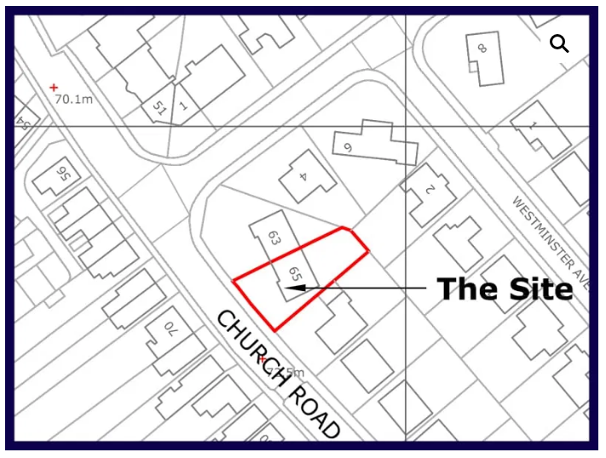

##### Site layout plan

A site layout plan that clearly shows the dimensions of the proposed pavement café area and its relationship with the existing streetscape is an important element of the application process.

The plan must include the following details:

* dimensions of the proposed pavement café area and the dimensions and location of the tables, chairs or other items of furniture to be located within the area; and
* all utilities / services and any items of existing street furniture, such as lampposts, bollards, fire hydrants, manholes, cycle stands, litter bins, etc. located within the immediate vicinity.

The site plan will be used by Council and the partner agencies with whom we are required to consult, when determining whether or not a proposed pavement café is suitable, e.g. in terms of pedestrian safety and accessibility requirements. Therefore, it is essential that it is sufficiently detailed and accurate, clearly showing the details of the pavement café and the relationship between the pavement café area and its surroundings.

### Plans that are inaccurate or insufficiently detailed may result in the application being deemed invalid and will lead to delays in the application process.

### Do I need to have the plans professionally drawn?

### Premises licensed under The Licensing (Northern Ireland) Order 1996:

### Applications relating to premises licensed under The Licensing (Northern Ireland) Order 1996 must be accompanied by plans that are of a professional standard and drawn to an appropriate scale.

### Other, non-licensed premises:

### While it is recommended that all plans are professionally drawn and to scale, there is no requirement to employ the services of an architect; a simple layout plan is all that may be required. However, plans must be drawn to a satisfactory standard and be sufficiently accurate and detailed. If the plan is not drawn to scale, measurements must be clearly shown, as illustrated in Appendix 2 “Examples of Pavement Café Plans”.

### Details of the furniture

In addition to a site plan, we require details of the existing or proposed furniture so that associated safety and other matters can be considered properly. Photographs or manufacturers' brochures showing the furniture can be very helpful in this regard.

"Furniture" includes tables, chairs, umbrellas, screens, space heaters, menu boards, etc.

Furniture must be capable of being removed within 20 minutes at the end of the licensed period, or when access to the area is required by any statutory body, e.g. for street cleaning purposes and utilities work, or in the event of an emergency. Obviously, this excludes any furniture or structures of a permanent or semi-permanent nature.

Risk assessment / Management Plan

If the application is for a location remote from the business, the application must be accompanied by a management plan and/or risk assessment, outlining how you intend to maintain control over the pavement café, in order to ensure safety and to prevent nuisance.

Risks to public health and safety to consider will include:

* the footpath being obstructed (other than by anything permitted by the licence); and
* anti-social behaviour and public nuisance, such as noise or litter not being cleaned up.

## What other information is required?

The following information must be submitted, following the application, prior to a licence being issued:

##### Public liability indemnity cover

Evidence of public liability insurance cover for the pavement café area, with minimum indemnity of £5m, will be required prior to any licence being issued.

Applicants will be required to have their insurer complete the “Statement of Insurance for Pavement Cafe Licence Purposes” (Appendix 5) prior to receiving the licence.

## The Public notice

The applicant is required to affix a public notice to the premises, in the format prescribed by Council (Appendix 6).

This notice must be displayed on the day the application is made to Council and positioned so that it is easily visible and legible to the public.

Applicants are encouraged to keep evidence of this by taking a photograph of the notice in place.

Applicants must ensure that the notice remains in place for the public consultation period, which is the period of 28 days from the date of application.

During this period, interested parties can make representations to Council in respect of an application.

# Determining the application

## What happens once an application is submitted to Council?

Once an application is received, Council will consult with key stakeholders and make a determination as to whether to grant or refuse the licence.

Who will Council consult with?

When assessing an application, Council will consult with the following agencies:

* Department for Infrastructure (Roads); and
* Police Service for Northern Ireland, where the premises are licensed to sell alcohol; and
* Such other Council Departments, organisations or individuals, as may be considered appropriate, e.g. planning department, environmental health (regarding health and safety, noise nuisance, etc.).

Council will also make the application details available to be viewed by the public on its website <https://www.derrystrabane.com/Licensing/Pavement-cafe-licences> until the end of the 28 day consultation period allowed for representations.

Council will have regard to any representations made, including those made by members of the public within the statutory 28 day consultation period.

How long does it take to process an application?

Council will aim to provide a determination within 8 weeks from the date of receipt of a full and proper (valid) application. Failure to provide sufficient detail may, however, result in delays.

If there are objections to the granting of the licence, or other input from consultees, this period will be extended to allow consideration of the objections or considerations. This may necessitate providing the applicant and the persons making representations an opportunity to be heard by Committee.

Can my licence application be refused?

Yes. Each application will be considered on its own merits; however, it will not always be possible to accommodate pavement cafés in all locations due to factors such as width restrictions, obstructions or heavy pedestrian flow.

As an alternative to refusing an application Council may suggest changes to your proposal to make the proposal acceptable, for example, by amending the size and shape of the licensed area.

If there are objections to an application, which cannot be resolved through mediation, the application will be referred to Committee for determination. If this happens, both the applicant and anyone who objects to the application, will have the opportunity to present a case to the committee.

If the application is refused by the Council you will be informed of that decision and the reasons why.

While the operation of pavement cafés can provide commercial opportunities for local businesses, when determining applications, Council must ensure that the needs of pedestrians and other street users are not detrimentally affected and that licensed areas will be safe, well managed and sensitive to the needs of street users and the surrounding area.

Can decisions be appealed?

Should an application be refused, the applicant may appeal the decision to the Magistrates’ Court within 21 days of being notified of the Council’s decision.

## Are licences issued with conditions?

## Every licence will include a condition requiring temporary furniture not to be placed on any public area other than that covered by the licence.

## A condition requiring the licence holder not to allow consumption of alcohol when using the furniture on the area in the licence will be included where the premises are licensed as an off licence. This condition may also be included in any other pavement café licence (whether or not the premises are licensed), if the council is of the opinion that it would be likely to lead to disorder.

## In addition, Council has discretion to impose such “further conditions” as it considers reasonable, including: limiting the days and times when the furniture can be placed in the area; limiting the kind, amount, size, nature of the furniture; etc. (Appendix 4)

## We will advise licence holders of any right of appeal against particular conditions at the time of granting the licence.

## Consumption of Alcohol

Alcohol may be consumed (but not sold) in a pavement café area where the premises are licensed under the Licensing Order unless:

* The business is an ‘off sales’ as defined under Article 5(1) (b) of the Licensing Order; or
* The council has prohibited the consumption of alcohol where it is likely that there would be disorder caused by permitting consumption of alcohol.

What enforcement powers do the Council have?

Failure to obtain an appropriate licence or failure to comply with the conditions attached to a licence may result in Council taking enforcement action.

### Unlicensed pavement cafés

It is an offence to place furniture (for use for the consumption of food and drink) on a public area without a Pavement Café Licence. This offence may be liable to a fine of up to £1,000 on summary conviction.

Council may also remove any furniture placed on the pavement without a licence and may recover the costs reasonably incurred in removing and storing this furniture.

### Suspension/Compulsory variation of a licence

Council may suspend a licence when maintenance of street utilities is required or road works are scheduled.

The licence can also be suspended for a breach of licence conditions, making false statements or failure to pay any fee to the Council without good reason

During any period of suspension, the pavement café licence is invalid and Council may remove any furniture placed in the public area during the period of suspension.

The Council may also compulsorily vary a licence where part of an area has become unsuitable or its continued use is likely to result in interference or inconvenience to persons or vehicles in the vicinity or public order concerns.

The Council will consult with PSNI before varying a licence on public order grounds.

# Appendix 1: Suitability Criteria for a Pavement Café Licence

In determining an application for a pavement café licence, consideration will be given to a range of factors.

While the legislation enables Council to take into account any factor it considers reasonable, the key factors that we consider are detailed below and these should be considered during the planning and design stage.

Each application will be evaluated on its own merits, having regard to possible implications for vehicular traffic or pedestrians, public safety issues, and environmental impacts.

## Size, layout and design

The suitability of any location will depend on a range of factors, including the type of premises, the space available, the existing streetscape, traffic volume / level of footfall in the immediate area and proximity to crossings and bus stops.

The needs of other users of the public area will be of paramount importance and the pavement café will need to be designed in such a way as not to compromise safe access for pedestrians or vehicles.

The pavement café must not result in undue interference or inconvenience to pedestrians or vehicles in the vicinity, particularly in relation to disabled people, older people and others with mobility needs including all pram and wheelchair users.

Issues to consider include:

* other, permanent / existing street furniture or structures in place on the footway that already restrict space for access; and
* other users of the space, for example if there are high levels of pedestrian footfall.

Decisions will, therefore, be made on a case by case basis, taking account of the characteristics of the site and its surroundings, the space available and the proposed layout of the café area.

In general, the licensed area should:

* Avoid conflict with the principal lines of pedestrian movement, particularly for disabled people, older people and those with mobility needs
* Avoid conflict between customers going in and out of the pavement café, passing pedestrians and neighbouring premises.
* Ideally be confined to the frontage of its own premises, with close integration of internal and external activities; however, this does not preclude a remote location.

In pedestrianized and public realm areas, a 4.0 metre corridor of unobstructed road width must be maintained in the street at all times, to facilitate emergency vehicle access.

## Accessibility

A clear pedestrian route must be maintained at all times, taking into account the needs of disabled people and the recommended minimum footway widths and distances required for access by mobility impaired and visually impaired people as set out in Section 3.1 of “Inclusive Mobility”.

In order to safeguard the interests of pedestrians, particularly disabled people, older people, the blind and visually impaired and those with mobility needs, including pram and wheelchair users, a clear width of 2.0m clearance should be maintained on the pavement, between the edge of the licensed area and the kerbside.

This will be considered as the minimum under normal circumstances; however, exceptionally, where this is not possible, due to physical constraints, a lesser clearance width may be acceptable, down to an absolute minimum of 1.5m.

Additional width may be required at bus stops and by shops.

In addition to consideration of persons using the footpath, pavement cafes must be designed to comply with relevant disability discrimination legislation, which requires all businesses to make “reasonable adjustments” in relation to access to premises and services by the disabled.

The Equality Commission for Northern Ireland has published guidance, “The impact of Covid-19 on disabled customers – some recommendations for the hospitality sector” that includes advice on Outside Seating Areas, which is still relevant. (Appendix 3)

## Boundary screening

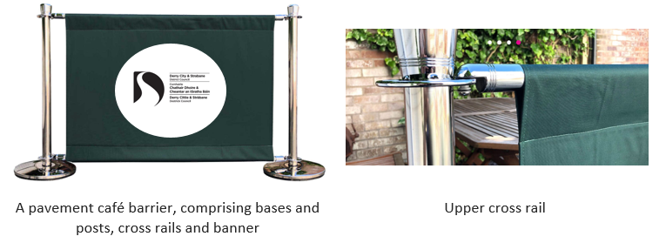

Requirement for screening

Where practicable, a pavement café area must always be enclosed and the edges defined by way of adequate screening.

The extent of enclosure required will depend on the size and location of the pavement café area. For smaller café areas, with limited pavement width, screens may only be required at each end of the seating area.

Purpose of screening

The main purpose of any pavement café screening is:

* to clearly define the limits of the licensed area, within which all furniture must be placed;
* to provide a clear demarcation between the licensed area and the footpath and to make it distinguishable to other pavement users;
* to reduce risks associated with obstructions and tripping hazards; and
* to assist blind and visually impaired pedestrians in identifying the boundary of the premises

Design requirements

* Portable, sturdy screens with a low level tapping rail are recommended.
* The materials should be lightweight in construction, but stable enough to prevent collapse if accidentally walked into or being overturned by a sudden gust of wind. Where necessary, screens should be weighted or otherwise secured to improve stability.
* Bases should not cause an obstruction or tripping hazard to pedestrians.
* Rope barriers and those of the “post and chain” type are potentially hazardous to pedestrians and are, therefore, unsuitable and should not be used.
* In certain circumstances, it may be possible to utilise existing street railings, planters and bins as a suitable means of enclosure.
* The design of the screen should ideally complement the character of the surrounding area.
* Screens should be colour contrasted from their surroundings to assist partially sighted persons.
* Screens should not be placed in areas where they are likely to block visibility splays (sight lines), such as at junctions.
* Screens must be maintained in a safe condition to ensure that there are no hazards associated with its use, such as sharp edges

## Furniture

* Furniture must be of a high-quality design and suitable for outdoor, commercial use.
* All items of furniture, including menu boards and portable gas heaters, must be approved as part of the licensed area and details must be included within the application.
* All furniture must be of a temporary nature that is capable of being removed within 20 minutes. The materials used should, therefore, be lightweight in construction and portable, but stable enough to prevent collapse if accidentally walked into or overturned by a gust of wind.
* If the business trades later than the licensed period, consideration must be given as to where the furniture will be stored and this should be made clear within the application.
* The use of parasols, along with their locations, materials and colours, must be specified as part of the design and must be positioned so that their full extent is contained within the boundary, to ensure they do not present a danger to any user of the pavement café or any other pedestrians.
* Parasols should be of the heavy-duty commercial type and suitably secured by purpose designed pavement weights to avoid being blown over.
* Where heating is to be provided, this must be of a type suitable for outdoor use and shall be placed within the licensed area. If patio style liquid petroleum gas (LPG) heaters are to be used, they must to be adequately secured upright, be fitted with a flame failure device and be maintained on a regular basis.

## General safety and environmental management issues

* It is the responsibility of the applicant to ensure that the pavement café and equipment used complies with all relevant legislation.
* Applicants are reminded of their duty to carry out a risk assessment, under the Management of Health and Safety at Work Regulations, in relation to the pavement cafe area and the activities carried on in connection with its use.
* Cables must be not trailed over footpaths or roadways, where they could create a tripping hazard and/or be exposed to risk of physical damage.
* Applicants proposing to licence a pavement café, which is remote from their main premises, or where they need to cross a public pavement to reach the café area, must be able to demonstrate that they will be able to exercise proper control and supervision of the remote pavement café area.
* Pavement cafes must not obstruct emergency egress from neighbouring properties.
* Use of pavement café areas must not result in nuisance or undue noise disturbance to neighbours.
* The licence will not permit the use of amplified music or loudspeaker equipment.
* It will be the responsibility of the licence holder to keep the licensed area clean and free of litter, during the licensed hours and at the conclusion of business each day. This will include the cleaning of liquid spillages onto the pavement.
* The conduct of customers using the licensed café area will also be the responsibility of the licence holder.
* It is important to note that a pavement café licence simply authorises a person carrying on a business involving the supply of food or drink (in or from premises) to place furniture temporarily on a public area. The licence does not create or imply an exclusive right to use the licensed area.
* Access must be facilitated for Council and utilities to carry out inspections, repairs, cleaning and other works, as required.
* Licence holders must promote a safe, clean and generally welcoming environment in the pavement café area.
* Licence holders are reminded that they must comply with smoke free legislation. Licence holders may wish to consider, for the convenience of their patrons, dividing their licensed café area into smoking and non-smoking sections, with each section clearly marked as such.

# Appendix 2: Examples of Pavement Café Plans

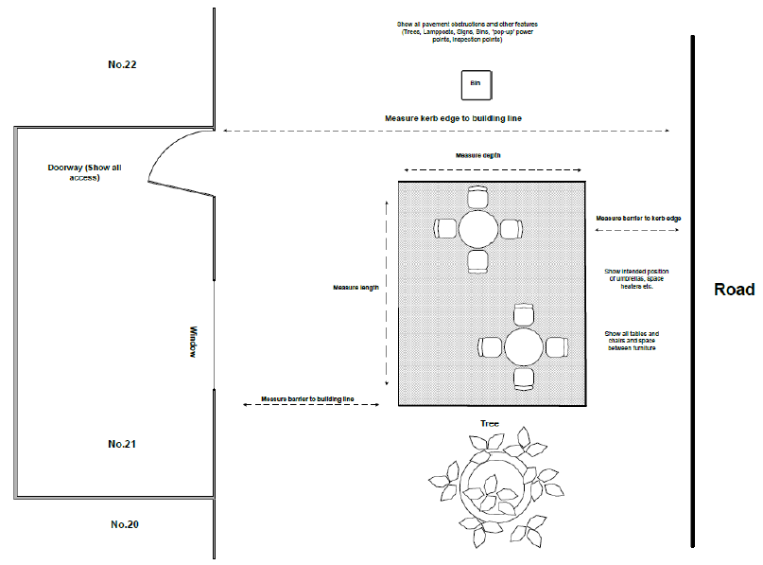

No.21

No.10

No.3

Road

Tree



Show intended position of umbrellas, space heaters, etc.

Show all tables and chairs and space between furniture

Measure screen to kerb edge

Show all pavement obstructions and other features (trees, lampposts, signs, bins, pop-up power points, inspection points)

Bin

Measure kerb edge to building line

Measure depth

Measure length

Measure screen to building line

Window

Doorway: show all access

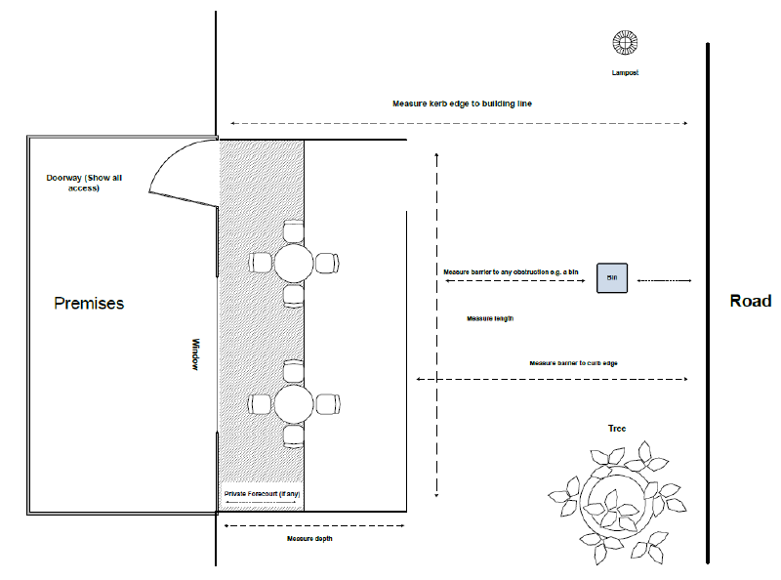

Measure from screen to any obstruction e.g. bin

Measure from screen to kerb edge

Road



Measure length

Private forecourt

Measure depth

Tree

Bin

Window

Premises

Lamppost

Measure kerb edge to building line

Doorway: show all access

# Appendix 3: Outdoor Seating Areas

 

The following information is extracted from the Equality Commission for Northern Ireland’s publication, “The impact of Covid-19 on disabled customers – some recommendations for the hospitality sector”.

### Outside Seating Areas

* Ensure that a clear route is maintained outside your seating area to allow pedestrians, wheelchair users, and people with mobility aids or pushchairs to pass by easily. This should be at least 2 metres between the edge of the seating area and the edge of the pavement, where practicable.
* Tables should be of a design to allow ease of use for wheelchair users and those accompanied by assistance dogs and adequate space should be provided between tables for wheelchair access.
* The seating area should be enclosed and edges should be defined with screens, not ropes, so that customers with visual impairments can identify the boundary of your premises.
* Remove A-boards, pavement sited menu boards and other street clutter to allow pavement access for people with restricted mobility and visual impairments.

# Appendix 4: Conditions of licence

**Conditions of licence**

Section 6 of the Licensing of Pavement Cafés Act (Northern Ireland) 2014 empowers Council to impose conditions on a pavement café licence.

**Standard condition**

All licences **must** contain a condition requiring the holder not to place furniture in an area other than the area covered by the licence [Section 6(1)].

**Alcohol condition**

An alcohol condition, prohibiting the consumption of alcohol within the pavement café area:

**MUST** be included where the associated premise is an **off-licence** (i.e. it is licensed for off-sales only [Section 6(2)(a)]. This is to prevent alcohol, purchased in the off-sales, from being consumed in the pavement café area.

**MAY** be included where Council is satisfied that consumption of alcohol in the area covered by the licence would be **likely to result in disorder** [Section 6(2)(b)].

**Other conditions**

Council has discretion to specify such further conditions as it considers reasonable.

[Section 6(3)]

The following “further conditions” will be applied to all licences granted by Council. However, we may also place additional conditions on a licence, as and when necessary or appropriate.

1. The licensed area must only be used for the purpose of consuming food and/or drink supplied from the licence holder’s premises, during the hours permitted by the licence.
2. Only furniture detailed within the licence application shall be used in the licensed area and such furniture shall be placed in accordance with the layout plan agreed with the Council.
3. Furniture must be sufficiently portable so that it is capable of being removed within 20 minutes.
4. The licence holder will ensure that pavement café furniture is removed after each day’s permitted hours and/or as may be required for street cleaning or utilities’ purposes, including for inspection and repair of equipment, services and surfaces, and/or following any reasonable request by an authorised officer of the Council or any statutory body and/or, where necessary, in the event of an emergency.
5. Suitable and adequate arrangements must be maintained for the safe and secure storage of furniture that has been removed from the licensed area.
6. The licence holder shall ensure that furniture provided in the licensed area does not mark or damage the surface of the pavement.
7. The licence holder shall ensure that the licensed pavement café area is maintained in a clean condition and free from litter and spillages.
8. The licence holder shall ensure that the pavement café area does not give rise to any safety risks, nuisance, public health issue or detriment to amenity to other users of the highway or nearby premises.

[Without prejudice to the generality of this condition, the licence holder must not use any portable generator within the pavement café area; must not run electrical leads across the public footway or roadway; and must ensure that furniture does not obstruct emergency egress from neighbouring properties.]

1. This licence does not in any way permit the playing of live or recorded music for the entertainment of customers and no amplified music or loudspeaker equipment shall be used in the pavement café area.
2. The licence holder shall ensure that sufficient and adequate Public Liability insurance cover (not being less than £5M) is maintained in force to cover the licensed area throughout the duration of the licence.
3. The licence holder shall notify the Council of any proposed change to the licenced pavement café area and/or any material changes to the associated premises.
4. An authorised officer of the Council shall be permitted to inspect the licensed area, associated premises and any documentation relevant to the issuing of this licence, at any reasonable time.

# Appendix 5: Statement of Insurance

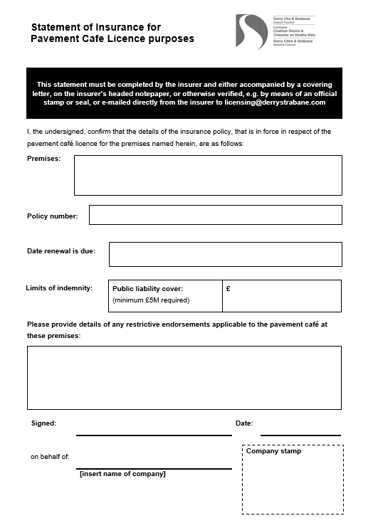

Example

# Appendix 6: Form of Public Notice

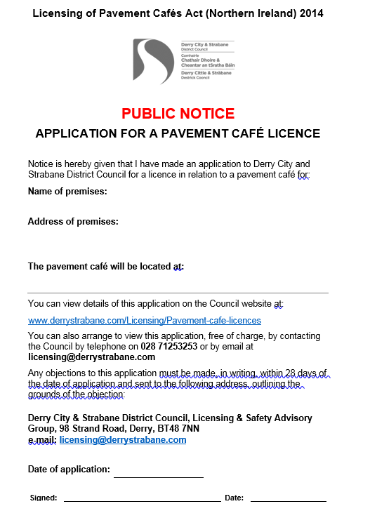

Example