**AGE FRIENDLY NEWS & UPDATES**

**Edition 31 – 22/09/2023**

* **Cultural Heritage**

 Derry City and Strabane District Council, in partnership with The Honourable Irish Society and funding from The National Lottery Heritage Fund, will present a comprehensive programme of heritage and arts activities that will complete the overall Culture Night Programme. The 18th edition of Culture Night will take place on Friday 22nd September 2023, with events happening all over Ireland. As part of the overall programme, a diverse range of heritage related events will take place in Derry and Strabane including the majestic Lucia McGinnis Harp Ensemble in St Augustine’s Church, The World from Your Window in The Verbal Arts Centre and Together in Music with the Strabane Brass Band and Britannia Band in the Guildhall. To find out more about Derry and Strabane’s programme of events on Culture Night, please visit [www.derrystrabane.com/culturenight](http://www.derrystrabane.com/culturenight)

* **Information Events for Positive Ageing Month**

Please see below poster for upcoming events. Please circulate and raise awareness as places are limited.

* **BBC Spotlight Request**

BBC Spotlight are making a programme about NI’s hospital waiting times and the fact they are getting worse and worse.  I’m aware that older people are disproportionately affected by long waiting lists and that the impact of waiting for prolonged periods of time for treatment can be very detrimental to their overall health and quality of life. As part of the documentary, we want to include real-life voices – people who are or have been on a waiting list, and whose health and wellbeing has been affected as a result. I wondered if through the work of the organisation, you might be able to help put me in touch with someone willing to share their experience? So for example, that could be someone who was on a list for a long time and had a delayed diagnosis, or someone who has been battling for an appointment to receive treatment and whose quality of life has been hampered as a result. It would involve going on camera and telling their story. We’re keen to highlight the serious impact these worsening waiting lists are having on people - particularly our ageing population.

If you are interested in getting involved please contact Vicki Caddy, Head of Communications & Marketing, Age NI by contacting 07814 380487 or email [vicki.caddy@ageni.org](mailto:vicki.caddy@ageni.org)

* **Praxis Foyle Floating Support**

This service provides housing related support to older people with complex needs, such as addictions, dementia, sensory support needs, acquired brain injury and disabilities, to enable them to remain independent/retain skills and access their local community. The Floating Support Service is available to individuals in the Derry/Londonderry and the surrounding areas. Staff are available to provide floating support from Monday-Friday, during the hours of 9.00am to 5.30pm. Please visit the following link for details of the latest brochure and services offered. [Foyle-Floating-Support-Trifold-297mm-x-210mm.pdf (praxiscare.org)](https://www.praxiscare.org/wp-content/uploads/2023/05/Foyle-Floating-Support-Trifold-297mm-x-210mm.pdf)

* **One World Festival 23rd September 2023**

Please see below poster for the One World Festival



* **NWCN E-bulletin**

For the latest NWCN e-bulletin please visit <http://www.nwcn.org/content/nwcn-ebulletin-20-september-2023>

* **Indoor Bowling Club**

Please see below poster for Indoor Bowling Club



* **Macmillian Cancer Support Coffee Mornings**

Please see below posters for upcoming coffee mornings for Macmillan

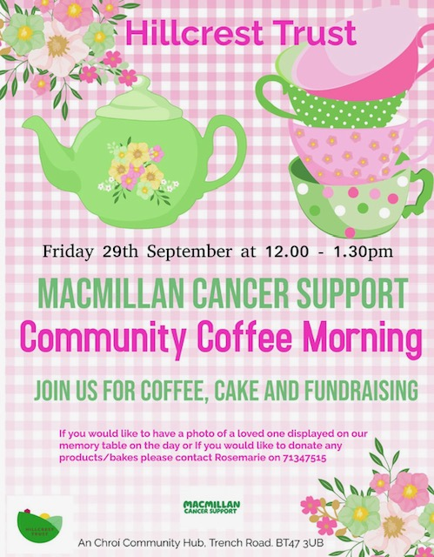

* **FWINS Upcoming Events**

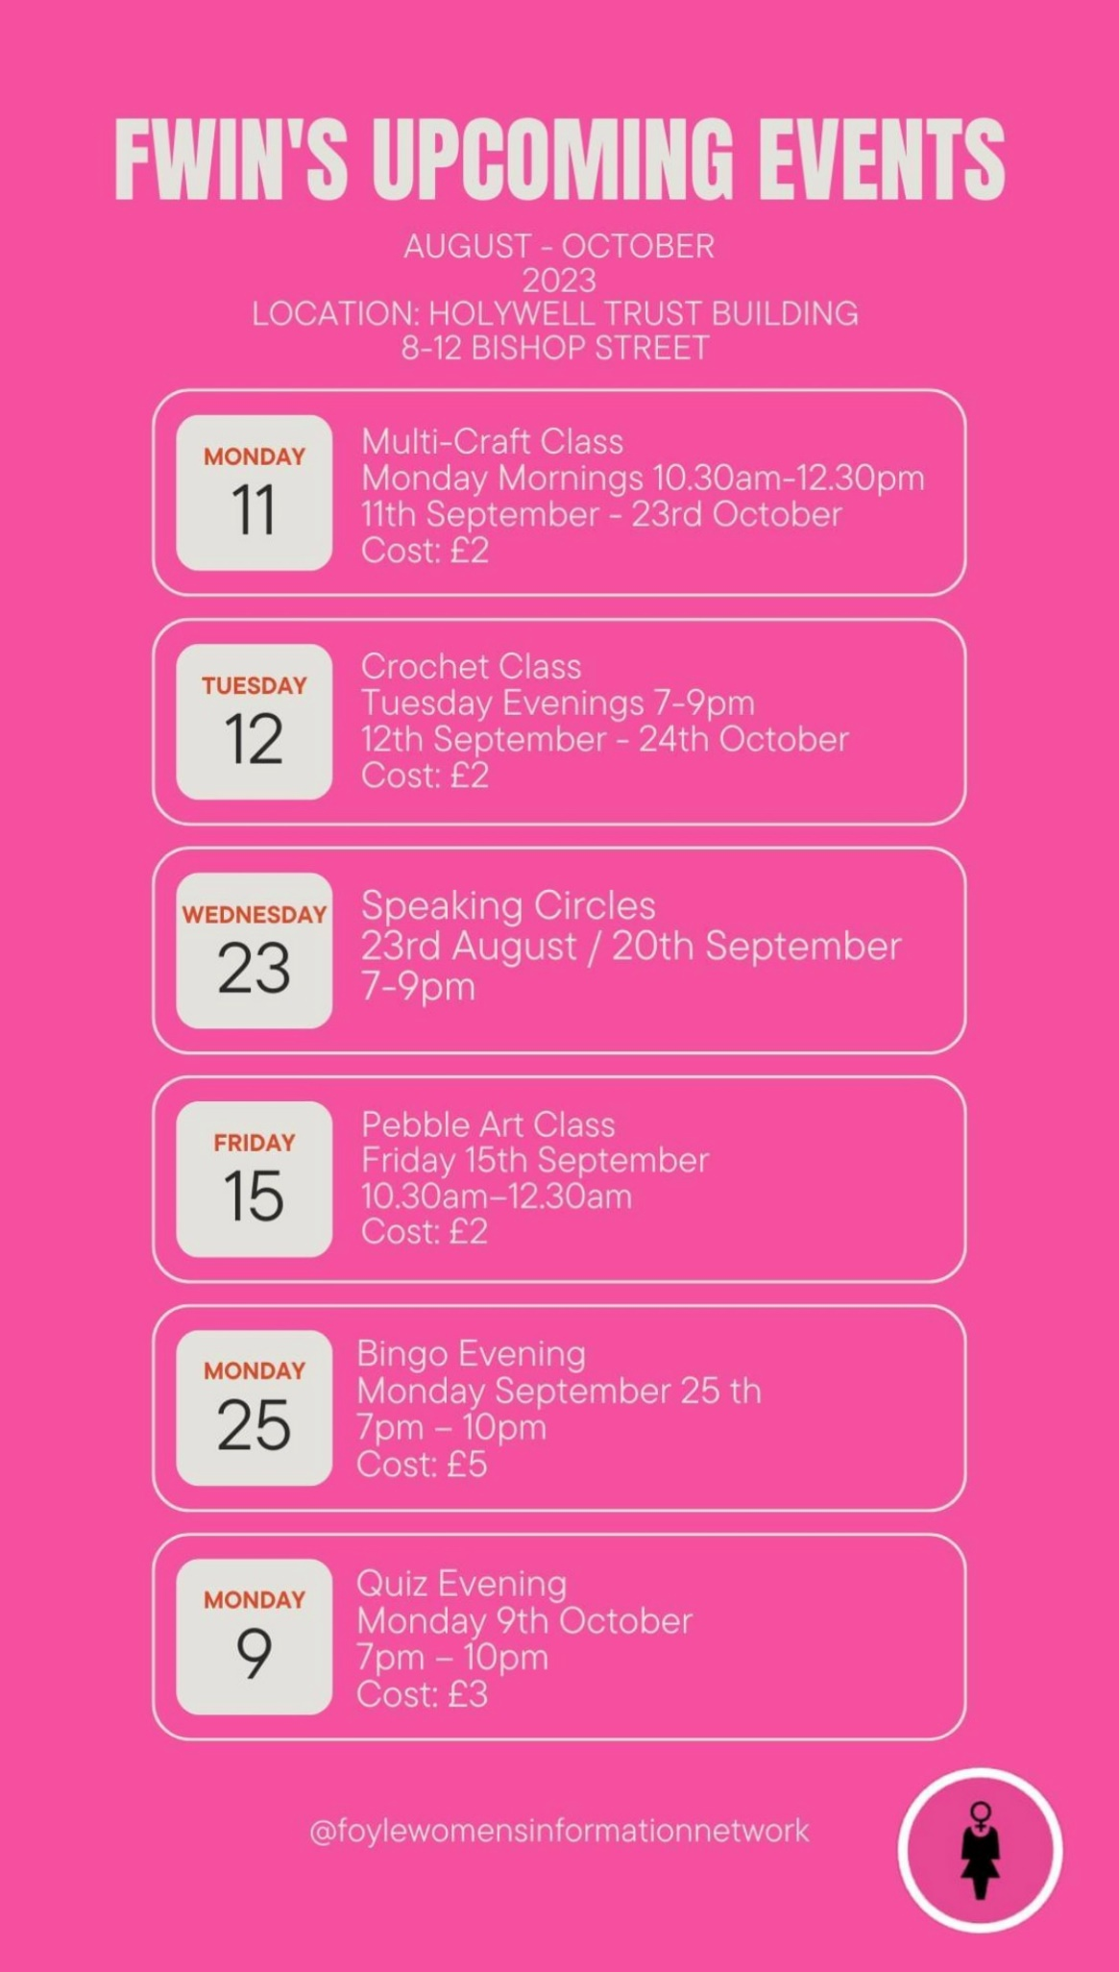

* **NI Frailty Network/BGS Conference – Friday 13th October**

The NI Frailty Network/BGS Conference is fast approaching and everyone is welcome to register! This year’s NI Frailty Network Conference will be a joint event with the British Geriatric Society NI Division on Friday 13th October 2023,with options to attend both in person and online**.** Please note that places for this year’s conference can only be booked through the BGS website- [2023 Joint BGS and Northern Ireland Frailty Network Meeting | British Geriatrics Society](https://protect-eu.mimecast.com/s/IT-rCN9LJh0A4AWim31i5?domain=bgs.org.uk)

* **Launch of the Fuel Poverty Coalition’s Report**

Launch of the Fuel Poverty Coalition’s Report, 'A New Fuel Poverty Strategy for Northern Ireland' will be held on Monday 2nd October 2023 in Stormont Hotel, Belfast from 2:00pm — 4:00pm.Refreshments will be provided on arrival. **We ask that you please RSVP to** [stephanie.ward@nea.org.uk](mailto:stephanie.ward@nea.org.uk)  **no later than 12pm on Tuesday 26th September** and advise of any accessibility, parking or dietary requirements.  Spaces are limited and will be on a first come first serve basis.

* **Mindfulness Based Stress Reduction**

The Western Trust Recovery College is offering an 8-week course in Mindfulness Based Stress Reduction. The aim of the course is to increase our awareness and to learn to live more fully, responding to situations with choice rather than reacting automatically. This is done by paying attention to our bodily sensation, thoughts, moods and emotions and to the small changes within.

The course will be facilitated face to face by a Mindfulness Practitioner who has undertaken Mindfulness Teacher Training at Bangor University centre of Mindfulness, Research and Practice from Friday 13th October - Friday 1st December: 10.30am - 1pm for 8 weeks in Holywell Trust. An information workshop for anyone who is interested will be held in the Holywell Trust on Monday 2nd October 10.30am - 1pm. An information workshop for anyone who is interested will be held in the Holywell Trust on Monday 2nd October 10.30am - 1pm.  You can book a place by downloading the [Recovery College Autumn Prospectus](https://protect-eu.mimecast.com/s/aAibCL87EHRAOWyiBAzGR?domain=westerntrust.hscni.net/)  and following the instructions on page 7.

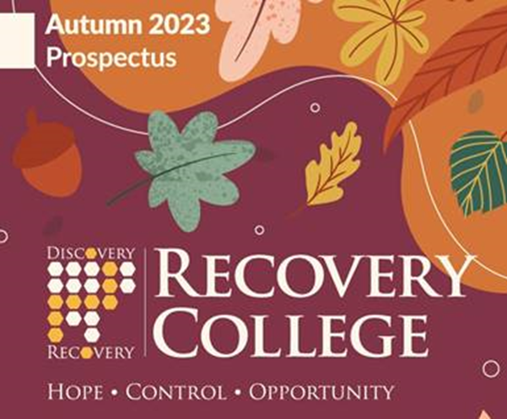

|  |  |  |  |  |  |  |
| --- | --- | --- | --- | --- | --- | --- |
| |  |  |  |  |  |  | | --- | --- | --- | --- | --- | --- | | |  |  |  |  |  | | --- | --- | --- | --- | --- | | |  | | --- | |  | | |  | | --- | |  | | |  | | | |

* **Recruitment Campaign - Volunteers to the Independent Monitoring Board**

The Department of Justice is seeking to appoint volunteers to the Independent Monitoring Board (IMB) for Northern Ireland. The role of an IMB member is to monitor the treatment of prisoners and the conditions of their imprisonment. For further information on the role and how to apply go to this link - [Do you have an interest in prisons and improving prison life? | Department of Justice (justice-ni.gov.uk)](https://protect-eu.mimecast.com/s/WdLACN9LJh0AqnMc4-PdB?domain=justice-ni.gov.uk)

* **International Day of Older People Campaign & Support Materials**

October 1st is International Day of Older Persons (IDOP). A day recognised across the world to raise awareness of opportunities and challenges faced by ageing populations, and to mobilize the wider community to address difficulties faced by older people. This year, Age-friendly Communities across the UK are taking this opportunity to spotlight the integral role older people play in their place, as well as the importance of place to ageing well. We hope this year’s focus on knowing your place will provide an opportunity to discover stories of your place’s past, celebrate how you’re becoming more age-friendly here and now, and inspire action for the future - so that even more people are able to enjoy later life where you are.

For the first time, we are delighted to share with you an International Day of Older Persons logo, that we welcome you to use in your campaign materials should you wish. You can find different versions of the logo, as well as other supplementary materials including posters, infographics, zoom backgrounds and images, on the webpage: <https://ageing-better.org.uk/international-day-older-persons-2023>. The attached PowerPoint provides a preview of the materials available, with guidance. At the Centre for Ageing Better, it is our pleasure to spotlight the fantastic work happening across the UK to make ageing better a reality for more people. Please use the hashtag #IDOP2023 on social media and send through your posters, photos, poems, postcards, videos, artwork and more to [afc.network@ageing-better.org.uk](mailto:afc.network@ageing-better.org.uk) – so we can celebrate International Day of Older Persons with you.



* **Come along and join the Chat Tea Train**

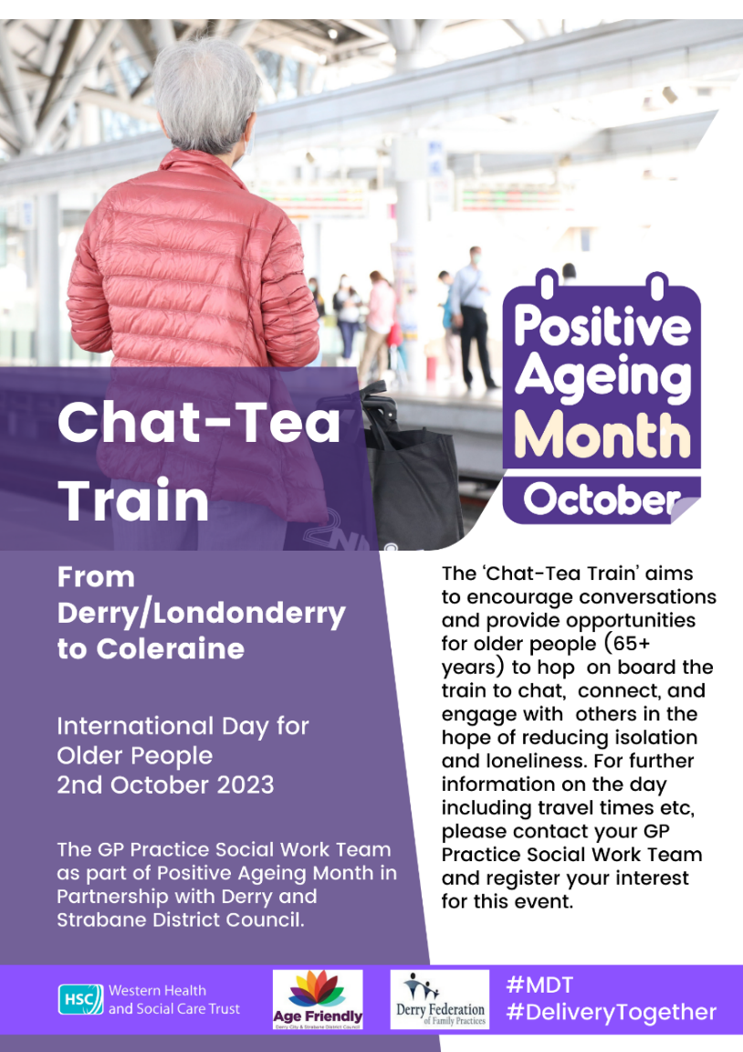

* **Community Transport Review**

The Department for Infrastructure is seeking your views on the community transport service you use, either,

* the Dial-a-Lift service with your local rural community transport operator or
* the Disability Action Transport Scheme within your urban area.

The results will allow us to assess user views on how the transport services are provided and any associated benefits to its users. Please complete the answers based on your usual travel experiences. This short survey should take around 5-10 minutes.  The closing date for the return of the survey is 13 October 2023. If you require a copy of the survey by e-mail or post or in an alternative format such as a large print version of the survey, please contact your transport provider or e-mail [dficommunitytransportreview@infrastructure-ni.gov.uk](mailto:dficommunitytransportreview@infrastructure-ni.gov.uk) or phone 028 9034 6284. If complete in hard copy format, return the form to your local Community Transport operator.  An envelope has been provided for this purpose. For further information please visit <https://consultations2.nidirect.gov.uk/dfi-1/community-transport-review/consult_view/>