**AGE FRIENDLY NEWS & UPDATES**

**Edition 33 – 06/10/2023**

* **Positive Ageing Month Information Events**

To register for the upcoming event in Foyle Arena on Wednesday 11th October, please advise if any special assistance is required or if you have any dietary requirements. To book your place at the Positive Ageing Month information events please contact Alexandra Wallace on 028 7125 3253 or email [agefriendly@derrystrabane.com](mailto:agefriendly@derrystrabane.com).

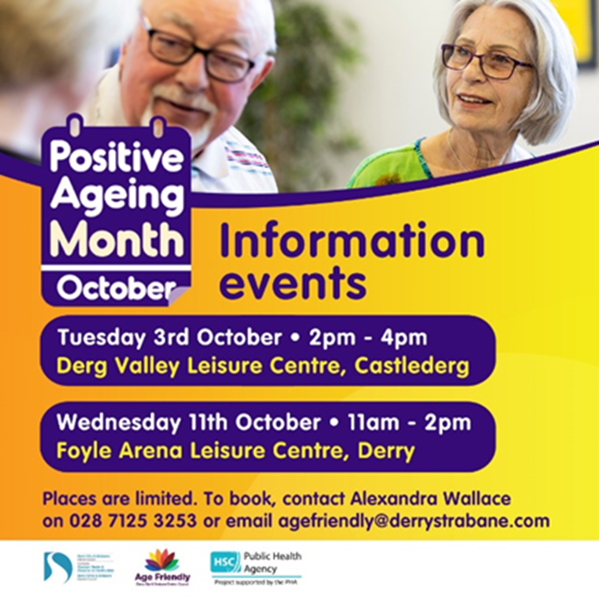

* **Active Ageing Week**

As you get older, it's important to keep active so you can age well and help lower your risk of future health conditions including type 2 diabetes, stroke and some cancers. Do something you enjoy or why not try something new? Visit [www.pha.site/ActiveAgeing](http://www.pha.site/ActiveAgeing) for more info and advice.

* **Age NI’s Signpost Express**

See enclosed Age NI’s recent edition of Signpost Express



* **Hospice Care Week**

Final Chapters – Palliative and End of Life Care awareness and education training is being delivered on Monday 9th October from 10am-12noon at the Day Hospice as part of Hospice Care Week – “ We are Hospice Care”. If you would like to attend please contact Susanne Bergin at Compassionate Communities NI on 028 71 351010 or email [www.compassionatecommunitiesni.com](https://protect-eu.mimecast.com/s/UAHnCl5x1T2BlzDI91upB?domain=compassionatecommunitiesnw.com)

* **Compassionate Conversations Workshop**

* **Self Management Course**

* **Positive Ageing Month Brochures**

This year’s brochure for Positive Ageing Month has been launched by the Mayor of Derry City & Strabane District Council Patricia Logue. Information on the campaign and also Positive Ageing Month brochures can be accessed online by visiting [www.derrystrabane.com/agefriendly](http://www.derrystrabane.com/agefriendly) Copies of the brochures will be distributed across the area and are available from the Western Trust Health Improvement, Equality and Involvement Department by emailing [Health.Improvement@westerntrust.hscni.net](mailto:Health.Improvement@westerntrust.hscni.net)  or phone 028 7186 5127, or from Derry City & Strabane District Council by telephoning  028 7125 3253



If you are organising an event during October for Positive Ageing Month, please visit [Derry City & Strabane - What's On (derrystrabane.com)](https://www.derrystrabane.com/what-s-on) to submit your event information

* **Launch Event – Loving Life Living Longer**

To celebrate the launch of the new Older People’s Wellbeing Project, funded by the National Lottery Community Fund a Tea Dance will be held on Monday 9th October from 12-4pm. This event is free and to book please contact Sarah on [sarah@bbhealthforum.org](mailto:sarah@bbhealthforum.org) or phone 028 7136 5330

* **Moves and Melodies Goes on Tour to Eglington Community Hall**

The Millennium Forum’s “Moves and Melodies” age-friendly project on

tour to Eglington on Wednesday 11th October from 11am-12.30pm. There will be an opportunity to learn new dance skills and sing a range of song styles. Admission is free. Everyone is welcome – complimentary tea! To book visit www.millenniumforum.co.uk or telephone box office 028 7126 4455 (Select Option 1). For further information email Lisa on [lisah@millenniumforum.co.uk](mailto:lisah@millenniumforum.co.uk)

* **Shepherd’s Crook Making workshops**

Shepherd’s Crook Making workshops in Glenelly House, Plumbridge. The CARE project are running a 4 week Shepherd’s Crook making workshop. Places limited and starts on Wednesday 11th October from 7-9pm for further information and to book contact Bronagh Kearney on 028 8164 8000.

* **Cancer Through Our Eyes**

The Macmillan Health & Wellbeing Campus at Altnagelvin Hospital is inviting anyone impacted by cancer to participate in a creative arts project funded by Macmillan Cancer Support using wool. Whether you are an expert knitter, enjoy crochet, like to work creatively with wool or are a complete beginner, our facilitator will support you to work as a group to create a collaborative piece using wool to represent the theme of ‘Cancer: Through Our Eyes.’ Sessions are open to anyone who has experienced a cancer diagnosis, supported a family member, friend or work colleague who has experienced cancer, is bereaved due to cancer or works or volunteers with anyone impacted by cancer. Sessions will take place Mondays 7-9pm at Macmillan Health & Wellbeing Campus, Altnagelvin Hospital starting on 2nd October until mid December. See flyer for further information



* **Positive Ageing Month Evaluation**

This year the brochure includes an evaluation form, which people are being encouraged to complete at various events and return. An online version of the evaluation form can also be accessed using by Scanning the QR code or go to <https://forms.office.com/e/cCKs050Pg6>



* **Menopause After Cancer Workshops**

WHSCT and Macmillan Health & Wellbeing Campus at Altnagelvin are delighted to be working in partnership with Action Cancer and SWELL (Supported We Life Live) to offer two workshops to support anyone experiencing menopause following treatment for any type of cancer. A workshop will be held on Monday 23rd October in the Waterfoot Hotel from 10.00am – 1.30pm. Contact Leigh on [lwhite@actioncancer.org](mailto:lwhite@actioncancer.org) or 07580133757 to register. See below poster



* **Macmillan Engagement Sessions**

The Western Trust, in partnership with Macmillan Cancer Support is inviting anyone impacted by cancer or other long-term conditions to one of our service-users engagement sessions. We want to hear what you think of our environment at the Macmillan Health & Wellbeing Campus, Altnagelvin and the Macmillan Information & Support Service available Trustwide. If you have experience of a cancer diagnosis or live with a long-term condition, or if you care for someone who does, please come along and tell us what’s good, what we could do better and what we’re missing. These will take place on Wednesday 11th October in Riversdale Leisure Centre, Strabane (from 11.30am-1.30pm) or Thursday 26th October in Macmillan Centre, Altnagelvin from 11.00am – 1.00pm. See poster for further information.



* **Review of Community Transport – Dial-a-Lift (DAL) and Disability Action Transport Scheme (DATS)**

The Department for Infrastructure is conducting a review of the community transport Dial-a-Lift services in rural areas and the Disability Action Transport Scheme in urban areas which it provides funding for. The Department is interested in obtaining views from both current users and non-users of community transport services. Your feedback is important.

Please complete online via [Community Transport Review - NI Direct - Citizen Space](https://consultations2.nidirect.gov.uk/dfi-1/community-transport-review/) or alternatively using the version enclosed below and return to

Community Transport Review Team, Room G-23, Department for Infrastructure, Clarence Court, 10-18 Adelaide Street, Belfast, BT2 8GB or Email: [dficommunitytransportreview@infrastructure-ni.gov.uk](mailto:dficommunitytransportreview@infrastructure-ni.gov.uk)



* **Sustaining Tenancies Grant Funding**

Tranche 1 of the Housing Executive Sustaining Tenancies Grant Funding Programme 2023-2025 has opened to expressions of interest. The fund will support our tenants in creating more resilient, sustainable tenancies in the short, medium and long term. They are particularly keen to help vulnerable customers at greater risk of tenancy breakdown. They aim to invest over £3 million in the voluntary, community and charitable sector through grants between £5k and £100k for this purpose - to be delivered over three tranches for projects lasting up to 36 months. Expressions of interest should be for funding for projects lasting up to 36 months. Closes at 5pm on Friday 20 October 2023. Please visit for further information <https://www.nihe.gov.uk/community/community-involvement/sustaining-tenancies-funding>

* **Is your Driving Licence due for Renewal?**

Check the date of expiry of your licence at section 4b of your plastic photocard licence. Please visit <https://www.nidirect.gov.uk/articles/renew-your-driving-licence> for further information relating to the renewal process.

* **TrACE to Transform - Exciting New Programme**

A new way to understand family and community life! TrACE to Transform is looking for women to join our exciting new programme, consisting of 1 session per week over 10 weeks commencing October 2023. This will include Lunch, day trips, workshops. For further information contact Laura on 077 8980 9487 or email [laurabrown@thechurchestrust.org.uk](mailto:laurabrown@thechurchestrust.org.uk). See below poster

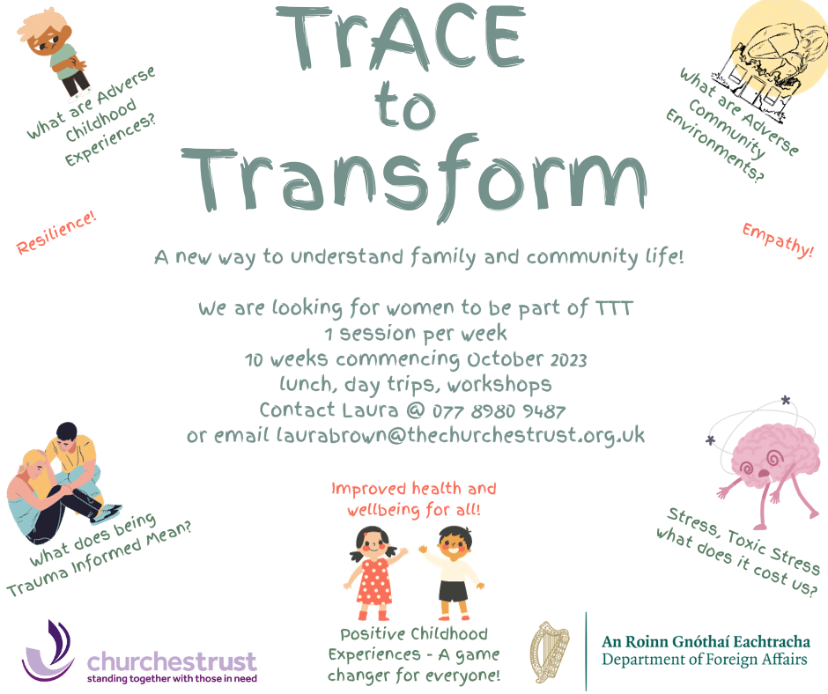

* **North West Job Fairs**

The Cross Border Partnership for Employment Services (CBPES) will host a virtual cross border job fair – North West Border Region on Wednesday 8th November from 10am– 3pm for all sectors. Please visit <https://www.crossborderjobfair.com/events/events-inner/north-west-border-region-virtual-jobfair-november-2023?id=29> for further information and to register. There will also be Mini Job Fair events taking place in the local Jobs & Benefits Offices organised in collaboration with the local Labour Market Partnership. These will take place on Wednesday 11th October from 1pm-3:30pm in Foyle Jobs & Benefits Office and Thursday 12th October 1pm-3:30pm in Lisnagelvin Jobs & Benefits Office.

* **Community Relation Council’s Core Funding Scheme Opens**

Community Relation Council’s Core Funding Scheme is now open for applications. The Core Funding Scheme provides support for organisations which are considered of strategic importance in promoting community relations work across Northern Ireland. The scheme contributes towards salary and organisational running costs. Applications open at 1 PM Monday 2 October 2023 and will close at 4 PM Friday 17 November 2023.  You can find the full details here: [https://www.community-relations.org.uk/funding-scheme/core-funding-scheme](https://protect-eu.mimecast.com/s/Dr8fC32QNfp552WUgEN0h?domain=community-relations.org.uk)

* **All Party Group on Loneliness**

The All Party Group on Loneliness will meet on Tuesday 17th October at 1.30 – 2.30pm in Room 21, Parliament Buildings and online.  Tea and coffee will be available from 1.15pm. We are grateful to be joined by Matthew McFarland from The Executive Office, who will present their latest figures on Loneliness in Northern Ireland including its prevalence and contributing factors.  This will be helpful in understanding the current local impact of loneliness and how it can be addressed. We also look forward to hearing from Stephanie Rock and Tracey Powell on the valuable work of Age Friendly Networks and Loneliness Networks in tackling loneliness.  This will be followed by an open discussion for any questions and reflections. To RSVP please email [stephenbrowne@redcross.org.uk](mailto:stephenbrowne@redcross.org.uk) by Thursday 12th October and confirm if you will be attending in person or online.

* **NWCN E-bulletin**

For the latest NWCN e-bulletin please visit <http://www.nwcn.org/content/nwcn-ebulletin-04-october-2023>

* **Millennium Forum’s Access Newsletter – October 2023**

Please see below the latest Access Newsletter from Millennium Forum

