Betting, Gaming Lotteries and Amusements (NI) Order 1985

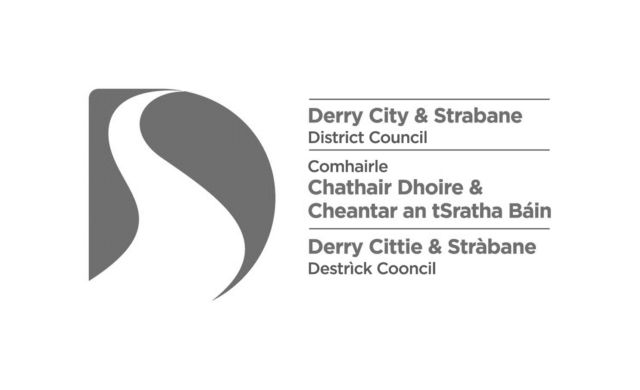

Application for an Amusement Permit

AP1 (01/24)

Please complete ALL sections in CAPITAL LETTERS.

|  |  |  |  |  |  |  |  |  |  |
| --- | --- | --- | --- | --- | --- | --- | --- | --- | --- |
|  |  |  |  |  |  |  |  |  |  |
| **1. Type of application:** | **Grant:** |  |  | **Provisional grant:** |  |  | **Renewal:** |  |  |
|  | | | | | | | | | |

**About the premises**

|  |  |  |  |  |
| --- | --- | --- | --- | --- |
| **2. Premises to which application relates:** | |  | |  |
| Name of premises |  | | |  |
|  |  | | |  |
| Address |  | | |  |
|  |  |
|  |  | | |  |
| Post code: |  |  |  |  |
|  |  |  |  |  |
| Telephone |  | | |  |
|  |  |  | |  |
| Email |  | | |  |
|  | | | | |

|  |  |  |  |  |
| --- | --- | --- | --- | --- |
| **3. Who owns these premises?** | |  | |  |
| Name |  | | |  |
|  |  | | |  |
| Address |  | | |  |
|  |  |
|  |  | | |  |
| Post code: |  |  |  |  |
|  |  |  |  |  |
| Telephone |  | | |  |
|  |  |  | |  |
| Email |  | | |  |
|  | | | | |

|  |  |  |  |  |  |  |
| --- | --- | --- | --- | --- | --- | --- |
| **4. Use to which premises are being/will be put:** [Tick either (i) or (ii) and provide the requested numbers] | | | | | |  |
|  | | | | | |  |
| (i) **Amusement arcade:** i.e. premises used wholly or mainly for the provision of amusements by means of gaming machines |  | Number of gaming machines applied for: | |  |  |  |
|  |  |  |  |  |  |
|  | Number of non-gaming machines on premises: | |  |  |  |
|  | |  |  |  |  |  |
| (ii) **Pleasure fair:** i.e. premises used wholly or mainly for the purpose of a pleasure fair consisting wholly or mainly of amusements |  | Number of gaming machines applied for: | |  |  |  |
|  |  |  |  |  |  |
|  | Number of non-gaming machines on premises: | |  |  |  |
|  |  |  |  |  |  |

|  |  |  |
| --- | --- | --- |
|  | | |
| **5. On which floor(s) will gaming machines be located?** (e.g. ground floor, 1st floor, etc.) |  |  |
|  | | |

|  |  |  |
| --- | --- | --- |
|  | | |
| **6.** Is there **planning permission** for all parts of the premises, in which gaming machines will be located, to be used as an amusement arcade? |  |  |
|  | | |

**About the applicant**

|  |  |  |  |  |  |  |  |  |  |
| --- | --- | --- | --- | --- | --- | --- | --- | --- | --- |
|  |  |  |  |  |  |  |  |  |  |
| **7. Nature of applicant:** | **Individual:** |  |  | **Limited company:** |  |  | **Partnership:** |  |  |
|  | Complete 7.1 | |  | Complete 7.2 | |  | Complete 7.3 | |  |

**7.1 Application made by an individual:**

|  |  |  |  |  |
| --- | --- | --- | --- | --- |
|  | |  | |  |
| Name |  | | |  |
|  |  | | |  |
| Home address |  | | |  |
|  |  |
|  |  | | |  |
| Post code: |  |  |  |  |
|  |  |  |  |  |
| Telephone |  | | |  |
|  |  |  | |  |
| Email |  | | |  |
|  |  |  | |  |
| Date of birth |  |  | |  |
|  |  |  | |  |

**7.2 Application made by a Limited Company:**

|  |  |  |  |  |
| --- | --- | --- | --- | --- |
|  | |  | |  |
| Name of company |  | | |  |
|  |  | | |  |
| Name of Secretary |  | | |  |
|  |  | | |  |
| Date of birth |  |  | |  |
|  |  |  | |  |
| Address of Registered Office |  | | |  |
|  |  |
|  |  | | |  |
| Post code: |  |  |  |  |
|  |  |  |  |  |
| Telephone |  | | |  |
|  |  |  | |  |
| Email |  | | |  |
|  | | | | |

**7.3 Application made by a partnership:** (Partner 1)

|  |  |  |  |  |
| --- | --- | --- | --- | --- |
|  | |  | |  |
| Name |  | | |  |
|  |  | | |  |
| Home address |  | | |  |
|  |  |
|  |  | | |  |
| Post code: |  |  |  |  |
|  |  |  |  |  |
| Telephone |  | | |  |
|  |  |  | |  |
| Email |  | | |  |
|  |  |  | |  |
| Date of birth |  |  | | |
|  | | | | |

**Application made by a partnership:** (Partner 2)

|  |  |  |  |  |
| --- | --- | --- | --- | --- |
|  | |  | |  |
| Name |  | | |  |
|  |  | | |  |
| Home address |  | | |  |
|  |  |
|  |  | | |  |
| Post code: |  |  |  |  |
|  |  |  |  |  |
| Telephone |  | | |  |
|  |  |  | |  |
| Email |  | | |  |
|  |  |  | |  |
| Date of birth |  |  | |  |
|  |  |  | |  |

**Application made by a partnership:** (Partner 3)

|  |  |  |  |  |
| --- | --- | --- | --- | --- |
|  | |  | |  |
| Name |  | | |  |
|  |  | | |  |
| Home address |  | | |  |
|  |  |
|  |  | | |  |
| Post code: |  |  |  |  |
|  |  |  |  |  |
| Telephone |  | | |  |
|  |  |  | |  |
| Email |  | | |  |
|  |  |  | |  |
| Date of birth |  |  | |  |
|  |  |  | |  |

(Where necessary, attach details of other partners on additional pages)

**Management of the premises**

If the business is/will be managed by a person other than the applicant, please provide the following details:

**8. Manager’s details:**

|  |  |  |  |  |
| --- | --- | --- | --- | --- |
|  | |  | |  |
| Name |  | | |  |
|  |  | | |  |
| Home address |  | | |  |
|  |  |
|  |  | | |  |
| Post code: |  |  |  |  |
|  |  |  |  |  |
| Telephone |  | | |  |
|  |  |  | |  |
| Email |  | | |  |
|  |  |  | |  |
| Date of birth |  |  | |  |
|  | | | |  |

|  |  |  |  |  |
| --- | --- | --- | --- | --- |
| **9. Type of amusement permit:** | | | | |
|  | | | | |
| The type of amusement permit applied for is for the purposes of: | | | | |
|  | | |  |  |
| Article 108(1)(c) (machines with maximum prize value of £8) | | |  |  |
|  |  |  |  |  |
| Article 108(1)(ca) (machines with maximum cash prize value of £25) | | |  |  |
|  | | |  |  |

|  |  |  |  |  |  |  |
| --- | --- | --- | --- | --- | --- | --- |
|  | | | | | | |
| **10. Declaration and Signature of applicant:** | | | | | | |
| I hereby make application for an Amusement Permit to be issued under The Betting Gaming, Lotteries and Amusements (Northern Ireland) Order 1985, for the authorisation of gaming by means of gaming machines, in accordance with the conditions of Article 108 of the Order and subject to such conditions as the Council may impose. | | | | | | |
|  |  | |  |  |  | |
| I do hereby declare that: | | | | | | |
| * All the information provided in this application form, is correct to the best of my knowledge and belief | | | | | | |
| * I have enclosed the relevant fee: | | | | **Please tick** | | |
|  | **Permit type** | | **Fee** |
|  | 108(1)(c) | | £32 |  |  | |
|  |  | |  |  |
|  | 108(1)(ca) | | £250 |  |
|  |
| * I undertake to ensure that the premises will not be used for any unlawful purpose or as a resort of persons of known bad character | | | | | | |
| * I will serve a copy of this application on the PSNI Commander for Derry City and Strabane District | | | | | | |
| * I give authority to the Council to make enquiries from PSNI, and any other relevant body, as to the fitness of myself, and any other person by whom the business that is, or is proposed to be, carried on under the permit would be managed, or for whose benefit that business would be carried on, to hold the permit. | | | | | | |
| Note: In the case of an application made on behalf of a Limited Company, the signature must be that of Secretary; for an application made on behalf of a Partnership, the signature must be that of one of the partners | | | | | | |
|  | | | | | | |
| **Signature of applicant:** | |  | | | |  |
|  | |  | | | |  |
| **Print name in capital letters:** | |  | | | |  |
|  | |  | | | |  |
| **Position:** | |  | | | |  |
|  | |  | | | |  |
| **Date:** | |  | | | |  |
|  | |  | | | |  |

|  |  |
| --- | --- |
| The completed application form may be returned by post or by email: | |
| **Post:** | **Derry City and Strabane District Council, Licensing & Safety Advisory Group, 98 Strand Road, Derry, BT48 7NN** |
| **e-mail:** | [**licensing@derrystrabane.com**](mailto:licensing@derrystrabane.com) |

# Checklist for Applicants

|  |  |  |  |
| --- | --- | --- | --- |
| **New application (Grant / Provisional grant)** | | **Renewal** | |
| **PLEASE ENSURE YOU HAVE TAKEN THE FOLLOWING ACTION:** | | | |
| Copy served on sub-divisional commander PSNI |  | Copy served on sub-divisional commander PSNI |  |
| Arranged for advertisement in 2 local newspapers |  | Advertisements are **NOT** required for renewals |  |
| **PLEASE ENSURE THAT YOU HAVE ENCLOSED THE FOLLOWING WITH THIS APPLICATION:** | | | |
| **Application Fee:** |  | **Application Fee:** |  |
| Article 108 1(a) permit £32 |  | Article 108 1(a) permit £32 |  |
| Article 108 1(ca) permit £250 |  | Article 108 1(ca) permit £250 |  |
| **Two recent references:** |  | **Two recent references:** |  |
| Character/Reputation |  | Character/Reputation |  |
| Financial Standing |  | Financial Standing |  |
| Copy of planning approval for use of the premises as an amusement arcade |  | Copy of planning approval for any recent change of use of the premises as an amusement arcade |  |
| Public liability insurance |  | Public liability insurance |  |
| Copy of plan for premises (Scale 1/100) |  | Copy of plan for premises **where structural change has been made** (Scale 1/100) |  |
| Completion certificate for any changes and/or works requiring building control approval |  | Completion certificate for any changes and/or works requiring building control approval, **carried out since the date of the previous application** |  |

**Note:**

Part 3 of the Fire and Rescue Services (Northern Ireland) Order 2006 introduced the following duties:

* a general duty to ensure, so far as is reasonably practicable, the safety of employees;
* a general duty in relation to non-employees to take such fire safety measures as it is reasonable to take to ensure the safety of persons lawfully on the premises and in the vicinity in respect of harm caused by fire; and
* a duty to carry out an assessment to identify risks to safety in respect of harm caused by fire.

Therefore, you must ensure that a competent person carries out a suitable and sufficient fire risk assessment for the premises and that it is regularly reviewed and kept up to date, to ensure that all the fire precautions in your premises remain current and adequate.

You must ensure that electrical installations, fire alarm systems, emergency lighting and fire-fighting equipment are maintained in effective working order and subject to regular inspection and testing.

Fire safety legislation is enforced by NIFRS, whose officers have the authority to inspect the premises to ensure that adequate provisions are in place for fire safety.

In addition, Council enforces general health and safety requirements in amusement arcades and

**Privacy Notice**

**Data Controller**

Name: Health & Community Well Being Department/Licensing Derry City & Strabane District Council

Address: 98 Strand Road, Derry, BT48 7NN

Telephone: 02871 253253 Email: [licensing@derrystrabane.com](mailto:licensing@derrystrabane.com)

**Data Protection Officer**

Name: Damian McCay

Telephone: 02871 253253 Email: [Damian.McCay@derrystrabane.com](mailto:Damian.McCay@derrystrabane.com)

**Why are you processing my personal information?**

For the logging, processing and determination of licensing/permit applications.

**What categories of personal data are you processing?**

Personal contact details

**Where do you get my personal data from?**

Application Forms and accompanying documents

**Do you share my personal data with anyone else?**

Yes, where required by legislation we may share personal date with other agencies as outlined on Council website at the following link <http://www.derrystrabane.com/Footer/Privacy-Policy>

**Do you transfer my personal data to other countries?**

No

**How long do you keep my personal data?**

We will only retain your data for as long as necessary to process your application or investigate an Enforcement case, and in line with Council’s Retention and Disposal Schedule.

**What rights do I have?**

You have the right to obtain confirmation that your data is being processed, and access to your personal data

You are entitled to have personal data rectified if it is inaccurate or incomplete

You have a right to have personal data erased and to prevent processing, in specific circumstances

You have the right to ‘block’ or suppress processing of personal data, in specific circumstances

You have the right to data portability, in specific circumstances

You have the right to object to the processing of your data, **in specific circumstances**

You have rights in relation to automated decision making and profiling

**You should refer to the Council’s website for further information on your rights:** <http://www.derrystrabane.com/Footer/Privacy-Policy>

**How do I complain if I am not happy?**

If you are unhappy with how any aspect of this privacy notice, or how your personal information is being processed, please contact our Data Protection Officer*.*

If you are still not happy, you have the right to lodge a complaint with the Information Commissioner’s Office (ICO):

**Information Commissioner’s Office:**

Information Commissioner’s Office, Wycliffe House, Water Lane, Wilmslow, Cheshire, SK9 5AF

Tel: 0303 123 1113 Email: [casework@ico.org.uk](mailto:casework@ico.org.uk) <https://ico.org.uk/global/contact-us/>