**AGE FRIENDLY NEWS & UPDATES**

**Edition 32 – 29/09/2023**

* **Positive Ageing Month Brochures**

This year’s brochure for Positive Ageing Month has been launched by the Mayor of Derry City & Strabane District Council Patricia Logue. Information on the campaign and also Positive Ageing Month brochures can be accessed online by visiting [www.derrystrabane.com/agefriendly](http://www.derrystrabane.com/agefriendly) Copies of the brochures will be distributed across the area and are available from the Western Trust Health Improvement, Equality and Involvement Department by emailing [Health.Improvement@westerntrust.hscni.net](mailto:Health.Improvement@westerntrust.hscni.net)  or phone 028 7186 5127, or from Derry City & Strabane District Council by telephoning  028 7125 3253



If you are organising an event during October for Positive Ageing Month, please visit [Derry City & Strabane - What's On (derrystrabane.com)](https://www.derrystrabane.com/what-s-on) to submit your event information

* **Positive Ageing Month Evaluation**

This year the brochure includes an evaluation form, which people are being encouraged to complete at various events and return. An online version of the evaluation form can also be accessed using by Scanning the QR code or go to <https://forms.office.com/e/cCKs050Pg6>



* **Positive Ageing Month Events**

To register for either of the events, please advise if any special assistance is required or if you have any dietary requirements. To book your place at the Positive Ageing Month information events please contact Alexandra Wallace on 028 7125 3253 or email [agefriendly@derrystrabane.com](mailto:agefriendly@derrystrabane.com).

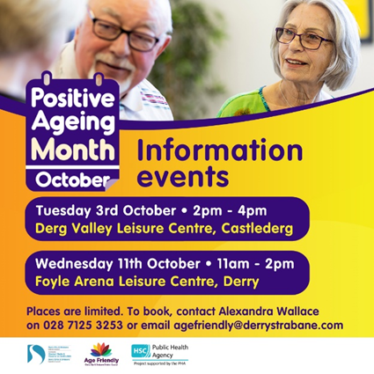

* **National Trust Free Passes**

The National Trust are giving away free passes this Autumn. Between now and 20th October, the National Trust are giving out free National Trust family passes. The pass provides a fantastic opportunity to visit some of the Trusts local historic sites and venues regionally (some locations are excluded). The passes allow free entry for either, 2 adults and up to 3 children , 1 adult and up to 4 children or 2 adults on their own. For further information or to apply please visit   
[https://www.nationaltrust.org.uk/visit/escape-into-autumn](https://protect-eu.mimecast.com/s/x5uqCyrojirlzQguMfhAw?domain=nationaltrust.org.uk)

* **Carers Monthly Drop In – looking after someone with Dementia**

This is a monthly support group - which alternates between day and evening runs to enable those who work to attend the evening sessions. Just simply turn up at the session. We will cover a range of topics during these sessions.  All Sessions are held in the Old Library Trust, 2 Central Drive in Creggan on following dates 28th  September at  6pm/26th October at 11am/23rd November at 6pm and 14th  December at 11am

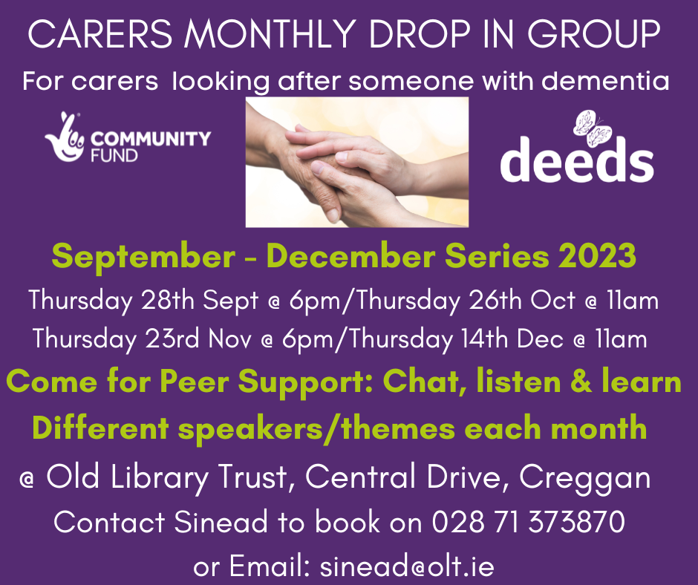

* **FREE 4  week Carers Education Course.– See two runs of this:**

This is run quarterly and alternates between a daytime run and an evening run to capture carers who may still be working or cannot attend daytime programmes due to other commitments. It is a FREE 4-week Course for those looking after someone with dementia at home.  We encourage families to come and learn together on the course. This course will be delivered in Shantallow in the evenings and in Hillcrest Trust during the day.

This course teaches what is dementia and helps carers to gain an understanding about different types of dementia, their signs, and symptoms, about communication, different behaviours, and coping strategies etc. It is taught weekly with time for carers to talk and make connections as well as learning together. We do encourage family members to come on together and share the learning, so places are open for several members of the same family to come onto the programme at the same time and share the learning. For more information contact Sinead on 028 71 37 38 70 or email [sinead@olt.ie](mailto:sinead@olt.ie)

* **Menopause after cancer workshops**

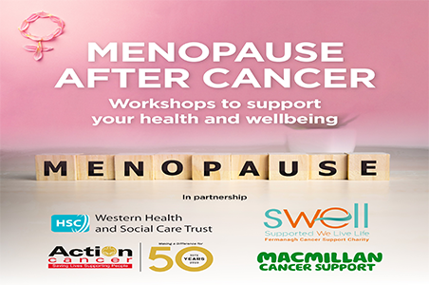

WHSCT and Macmillan Health & Wellbeing Campus at Altnagelvin are delighted to be working in partnership with Action Cancer and SWELL (Supported We Life Live) to offer two workshops to support anyone experiencing menopause following treatment for any type of cancer. The workshops will be led by Dr Gwyneth Hinds and include input from a WHSCT Women’s Health physiotherapist. Content includes how to manage menopausal symptoms, reduce side effects of treatment and improve long term survival. These workshops have been jointly funded by Action Cancer and WHSCT Endowments & Gifts Fund for patients with cancer. Workshops will be held in

* Fermanagh House, Enniskillen on Friday 20th October (10am–1.30pm)
* Waterfoot Hotel, Derry on Monday 23rd October (10.00am – 1.30pm)

To register contact Action Cancer on (028) 9080 3344 or visit <https://actioncancer.org/services-info/support/support-events/>

* **Online Access Guides for disability groups and organisations**

AccessAble is here to take the chance out of going out. To give you the accessibility information you need to work out if a place is going to be accessible for you. We've surveyed 10,000s of venues across the UK and Ireland, including shops, pubs, restaurants, cinemas, theatres, railway stations, hotels, colleges, universities, hospitals and more. Use AccessAble to find wheelchair friendly venues or check out disabled access and facilities. AccessAble is Your Accessibility Guide. Download our free App to use AccessAble on the go or visit [www.AccessAble.co.uk](http://www.AccessAble.co.uk)

* **British Heart Foundation’s Free Digital CPR Training Tool**

British Heart Foundation have a free digital training tool to teach you to save a life in 15 minutes with just your phone and a cushion. RevivR is the 15-minute mobile training that shows you when and how to do CPR to save someone’s life. Try RevivR now. [https://revivr.bhf.org.uk](https://protect-eu.mimecast.com/s/qfC3COyMKhp6ZlqcvLbRK?domain=revivr.bhf.org.uk)

* **Your Views on Food Poverty**

Researchers in the Health Promotion Research Centre in the University of Galway are looking for members of the public from Northern Ireland to join a stakeholder panel to advise on a project about communicating food poverty on the island of Ireland. To find out more information, please email Dr Claire Kerins at [ckerins@universityofgalway.ie](mailto:ckerins@universityofgalway.ie)

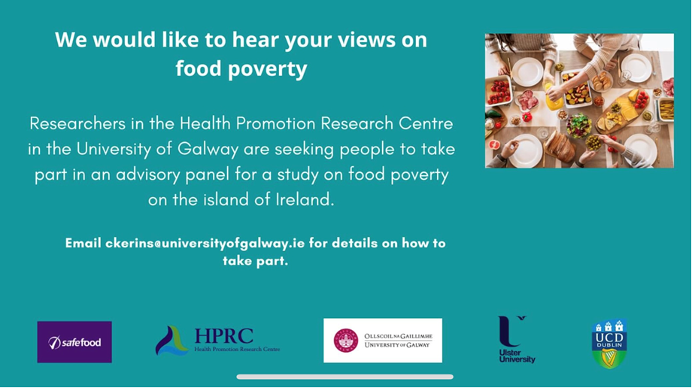

* **All Party Group on Loneliness**

The All Party Group on Loneliness will meet on Tuesday 17th October at 1.30 – 2.30pm in Room 21, Parliament Buildings and online.  Tea and coffee will be available from 1.15pm. We are grateful to be joined by Matthew McFarland from The Executive Office, who will present their latest figures on Loneliness in Northern Ireland including its prevalence and contributing factors.  This will be helpful in understanding the current local impact of loneliness and how it can be addressed. We also look forward to hearing from Stephanie Rock and Tracey Powell on the valuable work of Age Friendly Networks and Loneliness Networks in tackling loneliness.  This will be followed by an open discussion for any questions and reflections. To RSVP please email [stephenbrowne@redcross.org.uk](mailto:stephenbrowne@redcross.org.uk) by Thursday 12th October and confirm if you will be attending in person or online.

* **Movement for all: Getting and staying active with a disability**

The Institute of Public Health (IPH) is hosting a webinar on “Getting and Staying Active with a Disability – Insights from Research, Policy and Practice” on Thursday, 26 October between 10am – 12 noon. Opening remarks will be provided by Minister of State with Responsibility for Disability, Anne Rabbitte TD and confirmed speakers include Catherine Carty, Munster Technological University, Brett Smith, Durham University and Kwok Ng, University of Limerick.

Topics covered will include the importance of physical activity for people with disabilities, guidelines and recommendations for disabled adults and older adults, language and messaging, findings from the all-island report card on physical activity in children and adolescents with disabilities. IPH Director of Ageing Research & Development, Professor Roger O'Sullivan will also chair a Q&A discussion with a panel of academics, advocates, coaches on the theme on of “Getting and Staying Active with a Disability”. Register online by visiting <https://us06web.zoom.us/webinar/register/WN_x0au3ZDTdmo3zW8w9l8Mg#/>

* **Free Online Interactive Dementia Training 7pm 11th Oct 2023**

Dementia Friendly East Belfast is bringing back it’s Free Online Interactive Dementia Training. Which will be held at 7pm Wednesday 11th October 2023 via Zoom To book click this link:  [https://InteractiveDementiaTraining11Oct2023.eventbrite.co.uk](https://protect-eu.mimecast.com/s/XLHRCW7LVu5APwlhK1aY-?domain=interactivedementiatraining11oct2023.eventbrite.co.uk) To view the promotional video to get a flavour of it, click this link:  [https://www.youtube.com/watch?v=AyxSDrJfV-I](https://protect-eu.mimecast.com/s/4qiDCXoLWCXxq7pckYNHi?domain=youtube.com) See specially made films on making homes, managing money, shopping and getting out and about more dementia friendly. Ideal for carers, friends and family, and anyone who provides a service like running a shop or café or a community group. Book now and click here:  [https://InteractiveDementiaTraining11Oct2023.eventbrite.co.uk](https://protect-eu.mimecast.com/s/XLHRCW7LVu5APwlhK1aY-?domain=interactivedementiatraining11oct2023.eventbrite.co.uk)

* **Workshop for Frontline Personnel supporting Families Bereaved in Traumatic Circumstances**

Anam Cara Northern Ireland are an all-island organisation that provides information, resources, and support to bereaved parents. Currently we have groups in Belfast and Armagh. Although our organisation supports bereaved parents, we are acutely aware of the many frontline personnel who interact with families bereaved in traumatic circumstances and the impact that has on them.  For that reason, Anam Cara Northern Ireland is organising a one-day Training workshop in the Balmoral Hotel, Belfast on Wednesday 18th October 2023, this is open to any professional or person who supports bereaved families in theirrole at work**.** Please find attached an information flyer with more details about this workshop.



* **NWCN E-bulletin**

For the latest NWCN e-bulletin please visit <http://www.nwcn.org/content/nwcn-ebulletin-27-september-2023>

* **Shared Lives Northern Ireland for Older People – New Service Launched**



A new service that was launched recently for older people aged 65 and over, Shared Lives Northern Ireland for Older People. This service is funded by the Department of Health and will be delivered by Age NI. Speaking at the launch of **‘Shared Lives Northern Ireland for Older People’** Brendan Whittle, Director of Community Care, Department of Health said: “Imagine if, instead of relying on limited outside care services for help, an older person could be supported by a caring family, couple, or individual living locally. This is Shared Lives.”

If you would like to find out more information about Shared Lives NI for Older People please contact [Alison.Milford@ageni.org](mailto:Alison.Milford@ageni.org) or telephone 028 9024 5729 or 078 9098 6442, or visit [www.ageni.org/sharedlives](https://protect-eu.mimecast.com/s/21fXCVPARfxDLmJFJLJ6d?domain=ageni.org)

Feel free to promote widely on your channels and you are welcome to attach/link the resources (these are also available at AgeNI website linked below). Shared Lives NI animation - [https://www.youtube.com/watch?v=Bo7wV4Nnhtk](https://protect-eu.mimecast.com/s/crGLCQ0nMfk5EgQuPRYLU?domain=youtube.com) or visit [Shared Lives for Older People in Northern Ireland](https://protect-eu.mimecast.com/s/lqr4CPZ7LtK7r9whznlxB?domain=insight.hscni.net/)

 

* **Hopewalk**

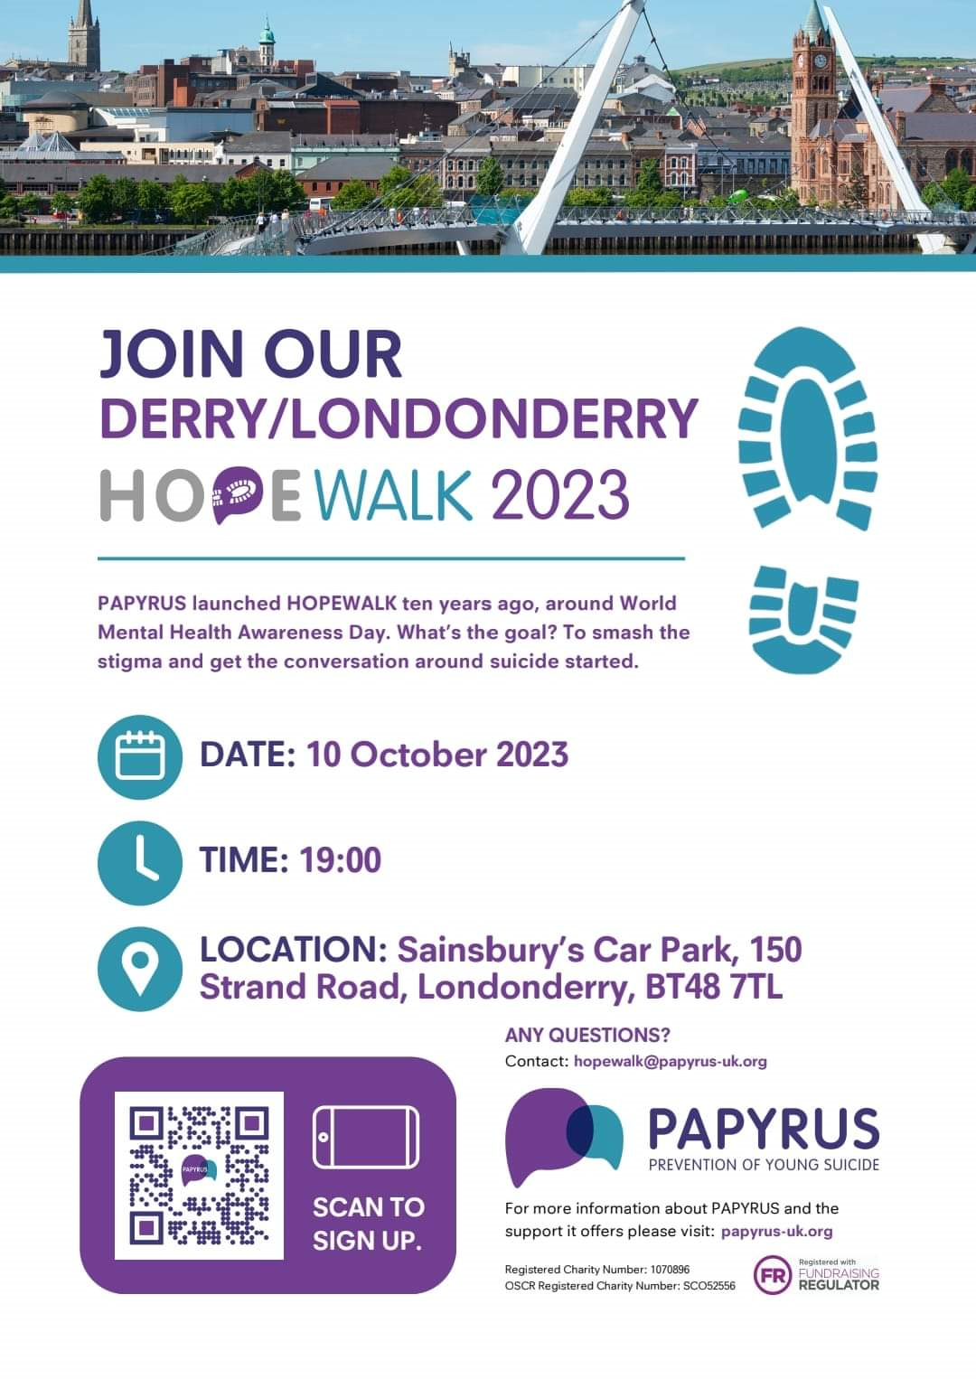

PAPYRUS is celebrating the 10th year of HOPEWALKS and this year is our very first one in Foyle after opening our office there last year. The aim of HOPEWALK every year is to smash the stigma around suicide and open the conversation to talk safely about suicide prevention. This year on Tuesday 10th October at 7pm we are asking everyone in the Foyle area to come out and walk with us to do just that – smash the stigma! The walk will start from the Sainsbury’s Car Park, Strand Road, and finish at the Guildhall where the Mayor of Derry will be there to welcome everyone in and give a message of HOPE. Everyone is welcome, bring all the family and friends even the four legged fury ones!! You can register for the walk [https://www.papyrus-uk.org/hopewalk/](https://protect-eu.mimecast.com/s/Q7FQCvol1C7Dq24fQTvdd?domain=papyrus-uk.org/) or just turn up on the night. If you have any questions please do not hesitate to contact Caroline on [caroline.king@papyrus-uk.org](mailto:caroline.king@papyrus-uk.org) or phone 028 2044 1807

* **Linking Generations NI – Intergenerational Connections this October**

LGNI is calling on our supporters to develop new and celebrate existing intergenerational connections during Positive Ageing Month and have developed a page on our website and also an ideas guide as inspiration.  So far we have shared this on social media, with our networks and via the schools C2kni network. Please see attached the guide as a document and also an LGNI graphic for PAM which can be used for social media along with the link to our webpage where you can also download the resource and get more info.  The webpage link is [Positive Ageing Month 2023 Intergenerational Inspiration! – Linking Generations NI](https://protect-eu.mimecast.com/s/1IKoCoQV1Cr75ngF1lRNb?domain=linkinggenerationsni.com/)

If you have any further queries please don’t hesitate to contact Vicki Titterington LGNI Director by email [Vicki.titterington@bjf.org.uk](mailto:Vicki.titterington@bjf.org.uk) or telephone 07732875409



* **Breast Cancer Awareness Month - October**

Breast Screening aims to find cancers early, it uses an x-ray called a mammogram which can find very small cancers before they have caused any symptoms or can be felt. If you are aged 50 – 70 and are registered with a GP, you will be called every three years for a mammogram with the NHS Breast Screening Programme. This service is organised via your GP. For more information contact your GP or local breast screening unit within the Western Health and Social Care Trust by contacting 028 7161 1443.

Action Cancer is the only charity in the UK and Ireland to offer breast screening to women aged 40 – 49 and 70 plus who fall outside the NHS age range. To make an appointment for a mammogram with Action Cancer please contact 028 9080 3344.

For further information on

* the changes to look out for visit  [www.pha.site/breastchanges](http://www.pha.site/breastchanges)
* breast cancer visit [www.becancerawareni.info/breast-cancer](http://www.becancerawareni.info/breast-cancer)
* breast screening is available at [www.nidirect.gov.uk/articles/breast-screening-overview](http://www.nidirect.gov.uk/articles/breast-screening-overview)
* **Royal Mail Price Increases**

Royal Mail will increase the price of 1st class stamps from Monday 2 October, with 1st class stamps £1.10 up to £1.25 and 2nd class stamps staying at 75p. Large letters will also increase with 1st class large letter £1.60 increasing up to £1.95 and 2nd class large letter £1.15 increasing up to £1.55. For more information visit <https://www.royalmail.com/prices2023>

* **Get Moving with Libraries NI**

Between now and the end of March, Libraries NI will be hosting a series of online sessions designed to boost your wellbeing.  To take part in these Zoom sessions, register on the library website [www.librariesni.org.uk](https://protect-eu.mimecast.com/s/4fZdCpQ81CnjpWzFDaSTd?domain=urldefense.proofpoint.com)  or ask library staff for more information.

**Yoga** - This is gentle yoga designed to soothe the nervous system, with an emphasis on the breath and relaxation. It will help improve strength, flexibility, balance and focus. With facilitator Fiona Jones. These sessions will take place every second Tuesday (except during February, when they will take place **every** Tuesday)

Tuesday 10 October      2:00pm-3:00pm

Tuesday 24 October      2:00pm-3:00pm

Tuesday 7 November    2:00pm-3:00pm

Tuesday 21 November   2:00pm-3:00pm

Tuesday 5 December    2:00pm-3:00pm

Tuesday 19 December   2:00pm-3:00pm

Tuesday 9 January        2:00pm-3:00pm

Tuesday 23 January      2:00pm-3:00pm

Tuesday 6 February      2:00pm-3:00pm

Tuesday 13 February     2:00pm-3:00pm

Tuesday 20 February     2:00pm-3:00pm

Tuesday 27 February     2:00pm-3:00pm

Tuesday 5 March           2:00pm-3:00pm

**Chi Me** - Chi Me is a simplified and accessible form of Tai Chi.  It gently helps to improve overall health and reduce stress. It improves posture and balance and helps to strengthen vital internal energy. With facilitator Gareth Klein. These sessions will take place every second Tuesday (Thursdays in February).

Tuesday 17 October      11:00am-12 noon

Tuesday 31 October      11:00am-12 noon

Tuesday 14 November   11:00am-12 noon

Tuesday 28 November   11:00am-12 noon

Tuesday 12 December   11:00am-12 noon

Tuesday 16 January      11:00am-12 noon

Tuesday 30 January      11:00am-12 noon

Thursday 8 February     11:00am-12 noon

Thursday 15 February    11:00am-12 noon

Thursday 22 February    11:00am-12 noon

Thursday 29 February    11:00am-12 noon

Tuesday 12 March         11:00am-12 noon

* **Consumer Councils Average Price of Home Heating Oil**

 As winter approaches, many people are considering heating their homes more. The consumer Council have a weekly round up of the average prices of home heating oil. This week the average price of 500L of home heating oil is £401.06, up over £17 on last week. View this week’s average prices for 300, 500 and 900 litres in your area using our price checker tool

[Home Heating Oil Price Checker- Tool | Consumer Council](https://www.consumercouncil.org.uk/homeheatingoilpricechecker/tool?utm_source=facebook&amp;utm_medium=animation&amp;utm_campaign=oiltool&amp;utm_content=report)

* **Planning on Going Foraging**

Foraging can be a great way to spend time in nature, especially at this time of year. However, you must make sure that the food you gather is safe to eat. Here are some top tips:

* Always be certain of the identity of the plants you are foraging, as some are poisonous. Don’t allow children to pick or eat wild food unsupervised.
* Don’t collect any plant or fruit that looks damaged (e.g. if it appears bruised or mouldy)
* Avoid collecting from plants which are low to the ground which may have been contaminated by animals or near developed land or busy roadsides where pesticides may have been applied.
* If it’s your first time trying a foraged food, only consume a small amount initially to ensure you don’t have an adverse reaction.
* Join a group! There are many guided foraging walks and foraging groups available to join across the UK, who can help give you tips on how to identify and safely consume wild foods you have gathered.

Read the following guide to safe foraging: [https://www.food.gov.uk/safety-hygiene/guidance-for-safe-foraging](https://protect-eu.mimecast.com/s/xXIoC32QNfp5VXjsvC8hz?domain=food.gov.uk)