**AGE FRIENDLY NEWS & UPDATES**

**Edition 22 – 22/06/2023**

* **Compassionate Conversations Skills**



Compassionate Communities are running their first delivery of Compassionate Conversations Skills based training on Monday 26th June at 10.00am until 12.00noon at Foyle Hospice. This training is a way of empowering all of us to listen and support someone in a Compassionate Conversation to process grief, bereavement, and loss. To register (or express an interest in future dates planned for July and August) please contact Susanne Bergin, Community Engagement Facilitator, Compassionate Communities NI on 028 7135 1010 or email Susanne Bergin [susanne@compassionatecommunitiesni.com](mailto:susanne@compassionatecommunitiesni.com)

* **Meals on Wheels**

* **Involve Fest West**

This July, as part of Co-Production week, the Western Trust’s Involvement team along with HSC partners, service users and carers, as well as the community and voluntary sector are hosting Involve Fest West, a week-long celebration of involvement.   The festival will celebrate and create awareness about the importance of involvement and hopes to encourage more staff, service users and carers to become engaged in involvement, particularly through core methods like co-production, whereby they can work as equal partners with HSC staff in creating resources that will change and improve the services they are using. For more information please see below poster and booklet

 

* **Dementia Awareness Training**

Are you or your group/organisation interested in accessing training in relation to Dementia. Please contact DEED’s project for further information or to discuss your training needs.028 7137 3870 or email[leann@olt.ie](mailto:leann@olt.ie)



* **Did you know that you can do a benefits check online with Age NI**

Find out exactly what you are owed, quickly and easily, using the online benefit calculator: [https://www.ageuk.org.uk/northern-ireland/information-advice/money-matters/benefits-entitlements/](https://protect-eu.mimecast.com/s/xaXICMQwGCqEZMrcWKqh2?domain=ageuk.org.uk) Learn more about this service and all the ways Age NI can support you in our More Money In Your Pocket guide, download or read online here: [www.ageni.org/moremoney](https://protect-eu.mimecast.com/s/bcj7CN9LJh0vBDWCrcteI?domain=ageni.org)

* **It’s never too late to start thinking about stopping smoking**

Hundreds of free stop smoking services are available regionally. Most of these services provide licensed NRT and are run by specially trained staff who can advise you on the best way to stop smoking. For information on services near you, visit [www.stopsmokingni.info](https://protect-eu.mimecast.com/s/9ymGCQ0nMfkzWMyuA1hMT?domain=stopsmokingni.info)

* **NWCN E-bulletin 21st June 2023**

Please see below link for the latest e-bulletin newsletter from NWCN

<http://www.nwcn.org/content/nwcn-ebulletin-21-june-2023>

* **Healthy Eating Week 2023**

We all know that food prices have increased recently, which makes eating healthier more challenging. Here are some tips on you can save money on your weekly food shopping.



* **Lived Experience Survey 2023**

The Lived Experience 2023 survey will help Age NI to highlight the issues that matter most to older people and raise these with our elected representatives, policy makers and decision takers. Please help us to promote this survey with older people. The survey should be returned to Age NI by 14 July 2023.   If you would like some hard copies with pre-paid envelopes contact [michele.young@ageni.org](mailto:michele.young@ageni.org) Here’s how you can help:

•         Invite older people to complete the survey.  Here’s the link for those who can access the survey online:

[https://www.surveymonkey.co.uk/r/LivedExperience23External-other](https://protect-eu.mimecast.com/s/Duy2Cnrx1i7MW5Zu9dUsO?domain=surveymonkey.co.uk)

•         Distribute hard copies of the survey with pre-paid envelopes (contact [michele.young@ageni.org](mailto:michele.young@ageni.org))

•         Offer to support them to complete the survey if that’s appropriate

•         Promote our survey on your own social media – I’ve attached some images and copies for posts and social media content.

Thank you in advance for helping us to reach and hear the views of older people. If you have any questions, please contact: [paschal.mckeown@ageni.org](mailto:paschal.mckeown@ageni.org)



* **Alcohol Awareness Week 2023**

Taking that first step to seek help with alcohol and drug issues is difficult but it is made all the easier by services being local to you and readily available. This Alcohol Awareness Week (19-25 June) we're highlighting the support services that are available for individuals who misuse alcohol.  
Find out more at [www.pha.site/NIAAW23](https://protect-eu.mimecast.com/s/bG8ICRoONCv7LjzHQ1bp-?domain=pha.site)

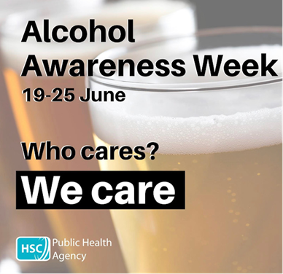

* **MOT Health Event**

Please see below poster of the annual MOT Health Event being organised in Castlederg.



* **Health Inclusion Hub for people experiencing homelessness**

A new Health Inclusion hub in Derry City Centre, has opened to meet the needs of people experiencing homelessness. The new hub, which opened on 20 June 2023 has been named ‘Labre’ after the Patron Saint of the homeless and was chosen following input from Service Users. The new health hub provides the foundation to bring services out of the clinic setting, into the community, to wrap care around the people who need it most, where they need it. This will include nursing and podiatry services, alongside physical and mental health care and addictions services for those sleeping rough, or in hostel accommodation or non-standard accommodation. Read more on our website: [https://westerntrust.hscni.net/health-inclusion-hub-for-homeless-opens-in-derry-city-centre/](https://protect-eu.mimecast.com/s/jUllCVPARfxOANRsEQFW1?domain=westerntrust.hscni.net)

* **CDHN Launch research**

CDHN recently launched their new participatory research ‘Our Lives, Our Meds, Our Health: Exploring Medication Safety through a Social Lens’. This research shows how the social determinants of health and health literacy impact on a person's ability to take their medication safely.  
 Thank you to the Department of Health SPPG for funding this research. It was a collaborative effort that we could not have completed without the input of everyone involved. Download a copy of the report please visit <https://www.cdhn.org/our-lives-our-meds-our-health-exploring-medication-safety-through-social-lens>.

* **Library of Things Foyle**

Currently your feedback is being sought from the community in advance of their next project - Library of Things Foyle, where you can borrow, loan, share, rent, hire everything but the kitchen sink!. Please help by taking 2 minutes to complete this survey!

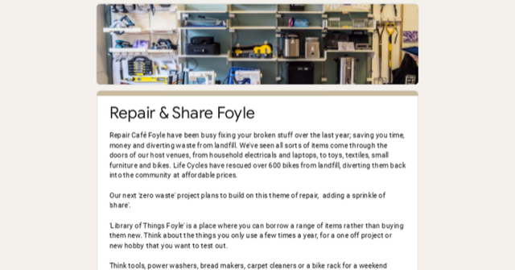

|  |  |
| --- | --- |
| |  | | --- | | [Repair & Share Foyle](https://protect-eu.mimecast.com/s/8eGZCYvW8iLGxMkT01CAe?domain=docs.google.com)  [docs.google.com](https://protect-eu.mimecast.com/s/8eGZCYvW8iLGxMkT01CAe?domain=docs.google.com) | |

* **Interested in Hosting a Language Student**

Why not try something new this summer, provide a home away from home. Experience a new culture from the comfort of your own home. Make new friendships across the world. We are looking for Derry locals to host our Junior English Language students this summer (aged 13-17 years old). For more details or get in touch at 02871 371 535 / [accommodation@foyle.eu](mailto:accommodation@foyle.eu)

* **Age Concern, Castlederg Summer Outing**

Please see below poster of an upcoming Summer Outing, which Age Concern are organising.

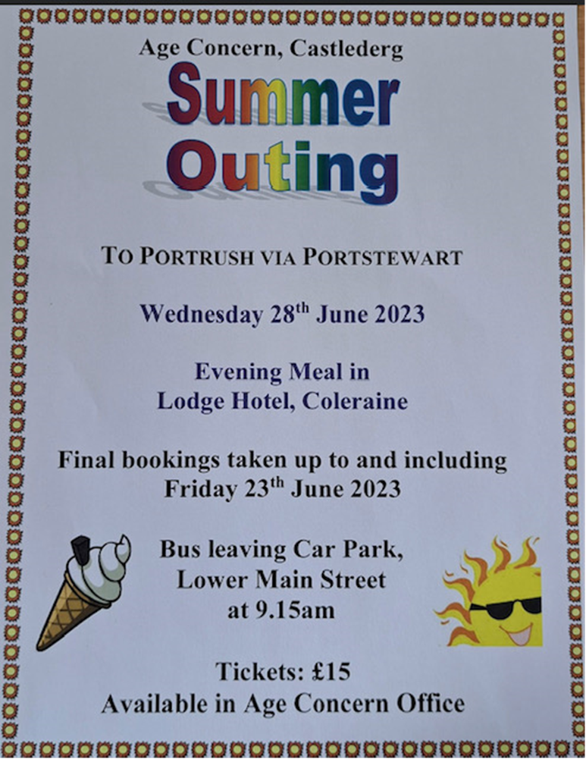

* **Paws for Thought Doggie Event**

Please see below poster for the upcoming event for dog lovers



* **Be TICK aware**

Ticks are found throughout the region. They're common in woodland and moorland areas, but can also be found in gardens or parks. Lyme disease is a bacterial infection spread to humans by infected ticks. There's currently no vaccine available to prevent Lyme disease. The best way to prevent it is to adopt easy habits when you're in the countryside or near wildlife. Find out more at: [www.nidirect.gov.uk/conditions/lyme-disease](https://protect-eu.mimecast.com/s/xMlcCPZ7LtKyx8kT6obQm?domain=nidirect.gov.uk)

|  |
| --- |
|  |

* **Interested in joining the Older Persons Reference Panel?**

As part of developing the Age Friendly structures locally, DCSDC are inviting persons aged 50+ years from across the council area to get involved with the Older Persons Reference Panel. Demographically and geographically representative of older people across all council areas, the group members will also be reflective of the World Health Organisations eight domains for creating age friendly cities and communities.

This group will be co-designed by older people, including its function, name, frequency of how often it meets. The group should also design regular events to share and review progress and make sure that older voices continue to be heard throughout the Age Friendly programme journey.

Please see attached Expression of Interest Form and these should be returned by 1st September 2023, as it is envisaged the first meeting will be held in October, during Positive Ageing Month. Further hard copies are available by contacting Alexandra Wallace at DCSDC on 028 7125 3253 or by emailing [Alexandra.wallace@derrystrabane.com](mailto:Alexandra.wallace@derrystrabane.com)



* **Positive Ageing Month Planning Group – 3rd July 2-3.30pm**

DCSDC in partnership with the WHSCT are organising a second planning meeting to develop this Octobers Positive Ageing Month campaign and to mark International Day of Older People on 1st October. This is open to stakeholders and organisation’s interested in getting involved with developing Positive Ageing Month. This will be held on Monday 3rd July from 2-3.30pm online. If you are interested in attending, please register by contacting 028 7125 3253 or email [agefriendly@derrystrabane.com](mailto:agefriendly@derrystrabane.com)