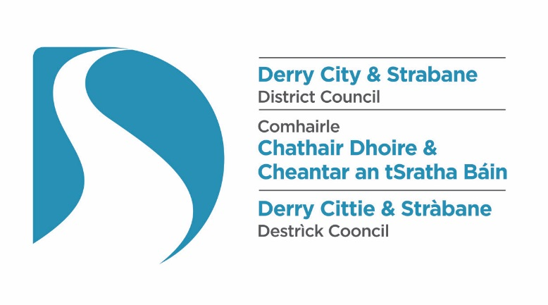

APPLICATION FOR A LICENCE TO KEEP PETROLEUM SPIRIT
PETROLEUM (CONSOLIDATION) ACT (NORTHERN IRELAND) 1929

Premises for which License is required

Name:

Address:

Telephone Number: Post Code:

Applicant Details

Name:

Address:

Telephone Number: Post Code:

Signature of Applicant …………………………………….. Date: ………………………………………

STORAGE DETAILS

Type of Fuel | Quantity in Litres | Mode of Storage  (Underground etc)
Petroleum Spirit

FEE and LICENCE TYPE

FEE PAYABLE FROM 1 April 2010 | PLEASE  TICK |  | TYPE OF LICENCE | PLEASE  TICK
£42.00  Quantity not exceeding 2,500 litres  not exceeding 2,500 Litres |  |  | RENEWAL
£58.00  Exceeding 2,500 but not exceeding  50,000 Litres |  |  | GRANT
£120.00  Exceeding 50,000 litres |  |  | TRANSFER
£8.00
Petroleum (Transfer of License)

WE WILL ENDEAVOUR TO RESPOND WITHIN 20 WORKING DAYS FROM RECEIPT OF THIS APPLICATON. IF YOU
HAVE NOT HEARD FROM THIS OFFICE WITHIN THIS TIME, PLEASE CONTACT US AT THE ADDRESSS BELOW.

Derry City and Strabane District Council

GRANT/RENEWAL OF PETROLEUM LICENCE

IMPORTANT

An application for a Petroleum License consists of:
- Completed application form (see Council website for electronic version)
- Completed up to date certificates as required
- Appropriate fee, effective from May 2012

For details of fees The Health and Safety (Fees) Regulations (NI) 2012 see the schedule overleaf. This legislation can be accessed from the following website: http://www.hseni.gov.uk
The application must be signed by:
- In the case of a sole trader, the licensee
- In the case of a registered company, the company secretary
- In the case of a partnership, one of the partners.

Please note that when an application is received for the grant or renewal of a petrol license the application must be accompanied by the following documents:

(a) An Electrical Periodic Inspection certificate/report for a Filling Station supplied by an approved contractor that has been assessed under UKAS Accreditation standard EN45011 and competent to carry out work in Filling Stations. You must satisfy yourself that the engineer has been assessed for the hazardous area extension, the qualifications for such work are known as Compex Certificates.

(b) A current Certificate of Inspection for Fire Extinguishers. Confirming that all firefighting equipment on site is in good working order and suitable for the purpose for which it is intended to British Standard BS 5306 (2009).

Council would bring to your attention the Fire and Rescue Services (N.I.) Order 2006, Part 3, which requires the owners of buildings other than private dwellings to carry out and maintain a Fire Risk Assessment for those premises together with The Dangerous Substances and Explosive Atmospheres Regulations (NI) 2003, which require employers and the self-employed in the workplace to carry out a risk assessment for any work activities involving dangerous substances.
Failure to submit these documents along with a properly completed application form and fee will result in your license being delayed or withheld.

The keeping of petroleum spirit, without a current Petroleum License, is an offence. Council will consider taking legal action which may lead to prosecution.

