**AGE FRIENDLY NEWS & UPDATES**

**Edition 30 – 16/09/2023**

* **Falls Health Events – 18th & 20th September 2023**

The WHSCT are organising a number of events to raise awareness of falls, and encourage falls prevention messages as part of Falls Awareness Week 2023. Please see below posters of event taking place



* **World Alzheimer’s Day marked in Foyleside Shopping Centre**

To mark World Alzheimer’s Day on Thursday 21st September, DEEDS in partnership with the WHSCT Community Dementia Service Improvement Group are working in partnership to host a One Stop Shop in Foyleside Shopping Centre between 11am -1pm. This is an opportunity for all members of the public to come along and ask about services and support available in their community.

* **Positive Ageing Month Small Grants – up to £500**

As part of Positive Ageing Month, community and voluntary organisations supporting older people (aged 60+) can apply for a small grant of up to £500 to improve physical activity, reduce loneliness and social isolation and encourage older people to stay socially connected. The programme is funded by the PHA and administered by the WHSCT. Applications forms are available by emailing [info@bbhealthforum.org](mailto:info@bbhealthforum.org) for the DCSDC area. Closing date for applications is Friday 22nd September 2023.

* **Age NI’s Signpost Express – September Edition**

Please find enclosed September’s edition of Signpost Express  


* **International Day of Older People Campaign & Support Materials**

October 1st is International Day of Older Persons (IDOP). A day recognised across the world to raise awareness of opportunities and challenges faced by ageing populations, and to mobilize the wider community to address difficulties faced by older people. This year, Age-friendly Communities across the UK are taking this opportunity to spotlight the integral role older people play in their place, as well as the importance of place to ageing well. We hope this year’s focus on knowing your place will provide an opportunity to discover stories of your place’s past, celebrate how you’re becoming more age-friendly here and now, and inspire action for the future - so that even more people are able to enjoy later life where you are.

For the first time, we are delighted to share with you an International Day of Older Persons logo, that we welcome you to use in your campaign materials should you wish. You can find different versions of the logo, as well as other supplementary materials including posters, infographics, zoom backgrounds and images, on the webpage: <https://ageing-better.org.uk/international-day-older-persons-2023>. The attached PowerPoint provides a preview of the materials available, with guidance. At the Centre for Ageing Better, it is our pleasure to spotlight the fantastic work happening across the UK to make ageing better a reality for more people. Please use the hashtag #IDOP2023 on social media and send through your posters, photos, poems, postcards, videos, artwork and more to [afc.network@ageing-better.org.uk](mailto:afc.network@ageing-better.org.uk) – so we can celebrate International Day of Older Persons with you.



* **National Playlist Day – 20th September 2023**

National Playlist Dayis a UK-wide campaign celebrating the power of

personally meaningful playlists for people living with dementia. Everyone has a soundtrack to their life, and National Playlist Day seeks to uncover these special and unique playlists, all while raising awareness of a simple but effective intervention already benefitting thousands of people living with dementia throughout the UK. Please find enclosed their useful guide.



* **Dementia: Caring for Today, Planning for Tomorrow Conference at Queen's University Belfast (The Great Hall).**

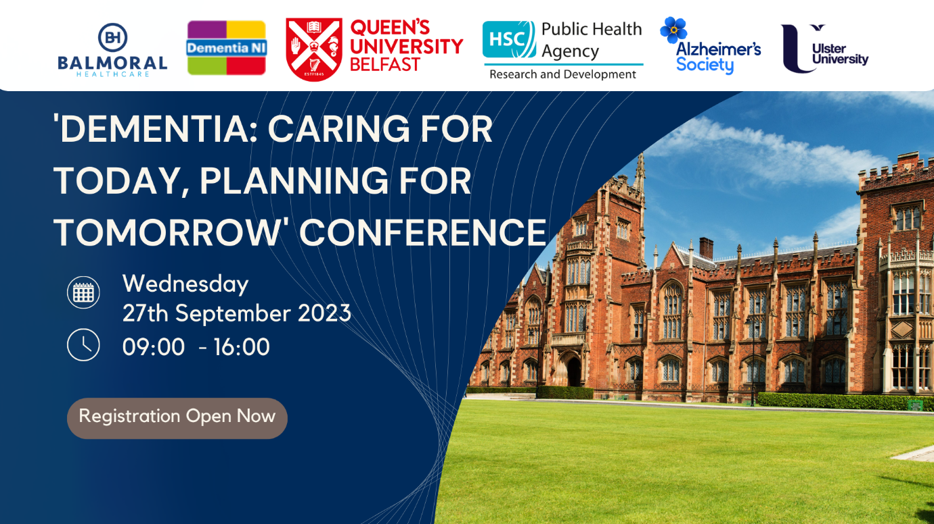

This co-designed conference will mark the end of World Alzheimer's Month on **Wednesday 27th September 2023,** it will provide delegates with an overview of the latest local research to optimise both the quality of care and the quality of life for people living with dementia.

Presentations will include Dr Julie Christie, Professor Christine Brown Wilson, Dr Frances Duffy, The InspireD Reminiscence App Team, Dementia NI, Alzheimer's Society and many more! Places are available at no cost on a first come first served basis. Early booking is essential. Register using this link [Dementia: Caring for Today, Planning for Tomorrow Conference. Tickets, Wed 27 Sep 2023 at 09:30 | Eventbrite](https://protect-eu.mimecast.com/s/r1kbCL87EHRvpJgHBkMHU?domain=eventbrite.co.uk) and any further queries contact [scraig22@qub.ac.uk](mailto:scraig22@qub.ac.uk)

* **Good Recruitment of Older Workers (GROW Project)**

The latest phase of our Good Recruitment for Older Workers (GROW) project, delivered by the Behavioural Insights Team, engaged employers, recruiters and older people to design and test new approaches to reducing age bias in recruitment. The Centre for Ageing Better has launched three practical new tools that the working group agreed would have the best feasibility and impact for reducing age bias in the recruitment process. To access this information please visit [Good Recruitment for Older Workers: A new toolkit | Centre for Ageing Better (ageing-better.org.uk)](https://ageing-better.org.uk/grow-a-new-toolkit)

* **Later Years Physical Activity Survey**

The joint Public Health Agency and local Health & Social Care Trusts Physical Activity Forum would like to invite professionals and practitioners delivering later years services to those over 65 in Northern Ireland to complete a survey to determine the level of awareness and knowledge of the UK Chief Medical Officer (CMO) physical activity guidelines. We know, professionals and practitioners working in this field are key to promoting physical activity within this population and we are keen to hear your views in order to support our older adult population make physical activity part of their daily routine. The survey will help identify training needs and contribute to the development of further training materials and resources which can support you to promote physical activity within your professional practice and settings for older adults. This piece of research is being conducted by the Health Intelligence Unit, within the Public Health Agency. To access the survey please click on the following link: [Later Years Physical Activity Survey](https://protect-eu.mimecast.com/s/YYW9CQ0nMfk8RMosxbG1R?domain=forms.office.com)

* **Walking Football for Over 40’s at Glebe Muga Pitch**

Sion Swifts FC in conjunction with the Glebe Cross Community Association are starting Walking Football. See below poster for further details.

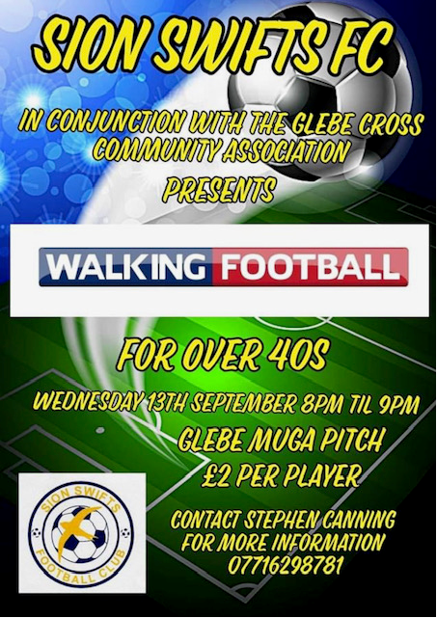

* **Good Relations Week 2023**

Good Relations Week 2023, is scheduled to run from Monday 18th September to Sunday 24th September 2023. It will deliver a positive message of togetherness as it celebrates peace-building and cultural diversity in an effort to eradicate sectarianism, racism and inequality across Northern Ireland.  The annual celebration will highlight the importance of local organisations working collaboratively and collectively to drive meaningful progress towards building a shared future for everyone. The theme for this year’s celebration is ‘Together’ which will shine a light on individuals and organisations working together and sharing ideas and experiences in tackling everything from sectarianism and racism to gender inequality, shared spaces, peace-building, and cultural diversity. #GRWEEK23**.** Please click link to download your brochure<https://www.derrystrabane.com/community/good-relations/good-relations-week-2023>



* **Come along and join the Chat Tea Train**

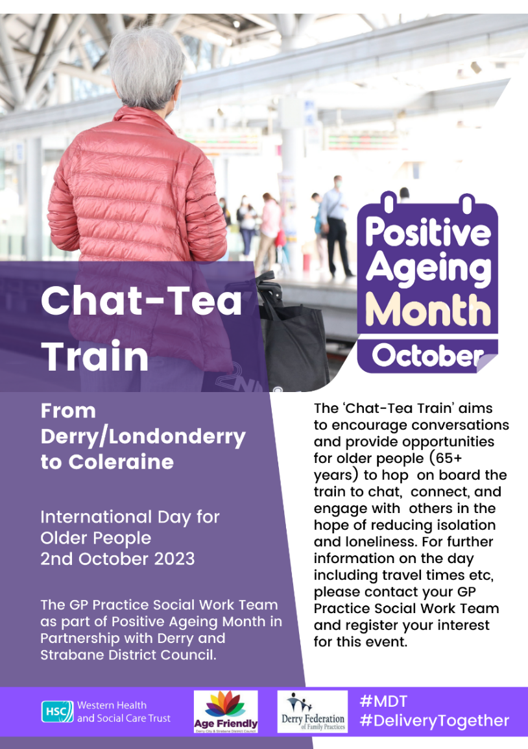

* **Healthy Ageing in a Changing Climate – Online Event**

Healthy Ageing in a Changing Climate is a project which aims to better understand how extreme weather is impacting older people across the UK, and how we can build climate resilient age-friendly cities and communities that support the health and wellbeing of older adults. A Results and Recommendations online event will be held on 26th September from 1-3pm on zoom. This will present findings and recommendations from our exciting programme of research that has engaged with older people and key stakeholders across the UK in priority mapping workshops, community engagement events, and co-design workshops. The aim of the event is to further shape the recommendations and to identify next steps to achieve climate resilient, age friendly cities and communities in the UK. To attend, please sign up here: [healthy-ageing-climate-results.eventbrite.com](https://protect-eu.mimecast.com/s/v8BiCN9LJh0A1EOu4HNZF?domain=urldefense.proofpoint.com)

* **Human Library Project at North West Community Network (NWCN)**

NWCN have received funding from the National Lottery Community Fund and the Halifax Foundation to continue our Human Library Project. What is the Human Library? A conversation at the Human Library is an interactive experience that engages people. The Human Library creates a safe space for a conversation where topics are discussed openly between our human books and their readers. You will hear lived experience from someone from a community you might not have met before, someone who is different from you. A place to ask questions about difficult issues. An opportunity to challenge stereotypes. For more information or to book a Human Library session contact Roisin McLaughlin by email [roisin@nwcn.org](mailto:roisin@nwcn.org) or 028 7126 1941

* **Research opportunity: Lifelong learning - what works?**

Submissions wanted for a new project to learn about what works to support successful continuous education and training across the life course. If you would like to get involved in the research and share good practice on existing schemes, practices and programmes that facilitate lifelong learning, please get in touch with [annavanrenen@ilcuk.org.uk](mailto:annavanrenen@ilcuk.org.uk)

* **Island Voices 2023**

Please see below poster with opportunities as part of Island Voices 2023, taking place on 28th September, 26th October and 23rd November.

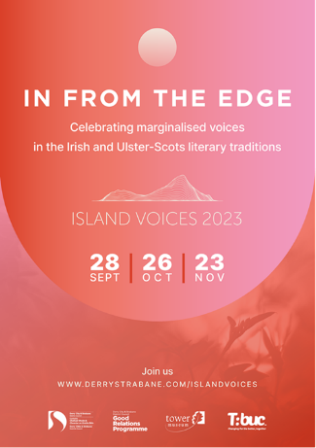

* **Free Chair Based Exercise Programme - Lisnafin Community Centre**

Free 10 week chair based exercise programme for seniors will commence on Monday 18th September from 4.00pm – 5.00pm, with more classes taking place in January. Registration is open to older residents living in the Derry City & Strabane District Council area. Benefits of Chair Based Exercise include increased flexibility and strength, increased coordination, increased circulation, reduced risk of falls because chair based exercises improve posture and balance and increased confidence and self-esteem. See below poster and if you would like to book a free place for yourself and a friend or a family member, please ring Lisnafin Community Centre on 028 71 88 06 58. This health improvement project is part of the Sports Development Healthy Towns Programme, funded by the Public Health Agency in partnership with Derry & Strabane District Council.

* **Autumn/Winter Vaccination Programme**

The life-saving vaccination programme which will protect the region against deadly viruses ahead of winter will commence on 18 September, it will see flu and COVID-19 vaccines offered to over 1 million people in within eligible groups over coming months, starting with carehomes which are some of the most vulnerable members of our community.  Please see below table outlining who is eligible for the vaccination programme.

* **Community Transport Review**

The Department for Infrastructure is seeking your views on the community transport service you use, either,

* the Dial-a-Lift service with your local rural community transport operator or
* the Disability Action Transport Scheme within your urban area.

The results will allow us to assess user views on how the transport services are provided and any associated benefits to its users. Please complete the answers based on your usual travel experiences. This short survey should take around 5-10 minutes.  The closing date for the return of the survey is 13 October 2023. If you require a copy of the survey by e-mail or post or in an alternative format such as a large print version of the survey, please contact your transport provider or e-mail [dficommunitytransportreview@infrastructure-ni.gov.uk](mailto:dficommunitytransportreview@infrastructure-ni.gov.uk) or phone 028 9034 6284. If complete in hard copy format, return the form to your local Community Transport operator.  An envelope has been provided for this purpose. For further information please visit <https://consultations2.nidirect.gov.uk/dfi-1/community-transport-review/consult_view/>

* **Census 2021: Outputs & Dissemination Webinar**

Census 2021 NISRA Webinar Email Header


You are invited to join us online to hear about the Census 2021 results. Topics covered include

* Census 2021 results: publications to date, key messages and plans for future releases
* New Census 2021 output geography: what they are and how they are used
* Our self-service products: how to access and use the Census Area Explorer and Flexible Table Builder

We are running 2 sessions which are openly available to anyone who wishes to attend. Each session will have the same content, so it isn’t necessary to register for both. Register now to join us at one of the sessions below:

* Wednesday 27 September 1pm – 3pm [https://census2021outputs27Sept.eventbrite.co.uk](https://protect-eu.mimecast.com/s/lUbFCL87EHRA45zTBxpg3?domain=census2021outputs27sept.eventbrite.co.uk)
* Thursday 28 September 1pm – 3pm [https://census2021outputs28Sept.eventbrite.co.uk](https://protect-eu.mimecast.com/s/UojgCMQwGCqgWGnHkvaSB?domain=census2021outputs28sept.eventbrite.co.uk)
* **Funding Opportunities**

For details of upcoming funding opportunities and those with a rolling deadline please visit the following link [Derry City & Strabane - Strategic Finance & Funding (derrystrabane.com)](https://www.derrystrabane.com/about-council/strategic-finance-funding)

* **Versus Arthritis Event**

Please see below poster of an event being held in Derry

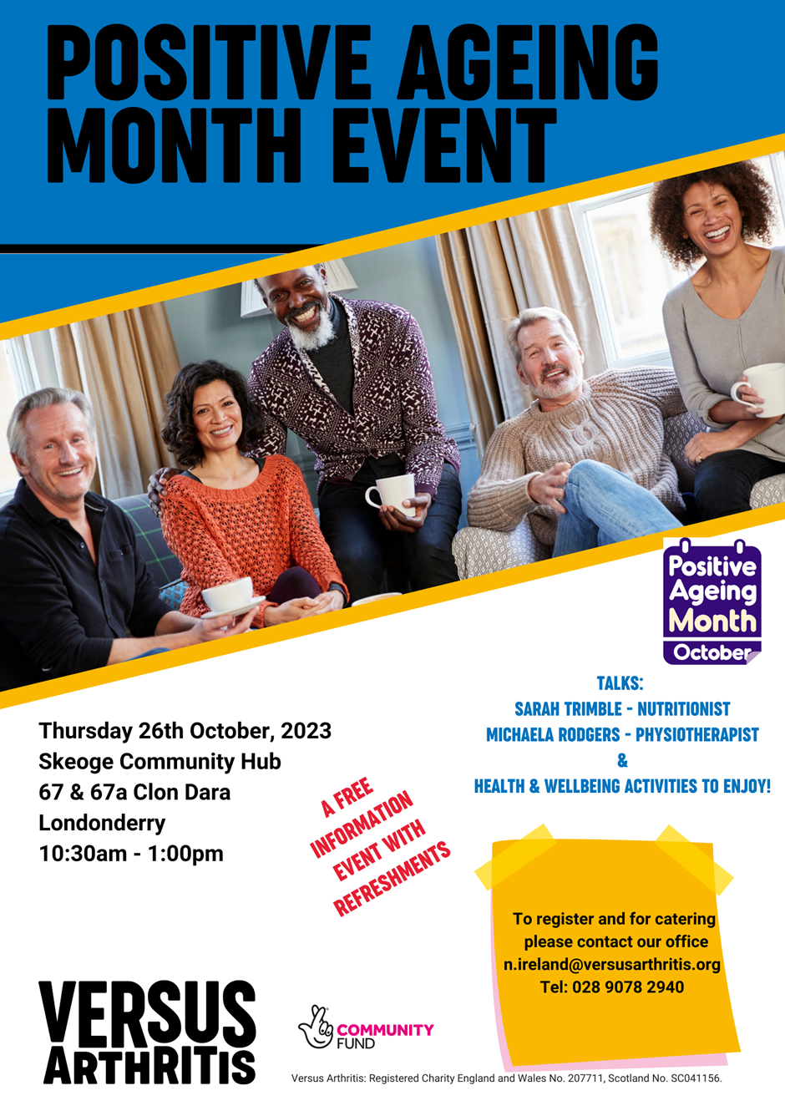

* **NWCN E-bulletin**

For the latest NWCN e-bulletin please visit <http://www.nwcn.org/content/nwcn-ebulletin-13-september-2023>