**AGE FRIENDLY NEWS & UPDATES**

**Edition 19 – 02/06/2023**

* **Be UV Aware**

Even on cool and cloudy days here the sun's UV rays can be strong enough to damage your skin. Use sunscreen when the UV index is 3 or more.  Find out what the UV index is where you are by visiting  [http://metoffice.gov.uk](https://protect-eu.mimecast.com/s/VRJWCAPNpfNmXrLhGSKak?domain=metoffice.gov.uk)

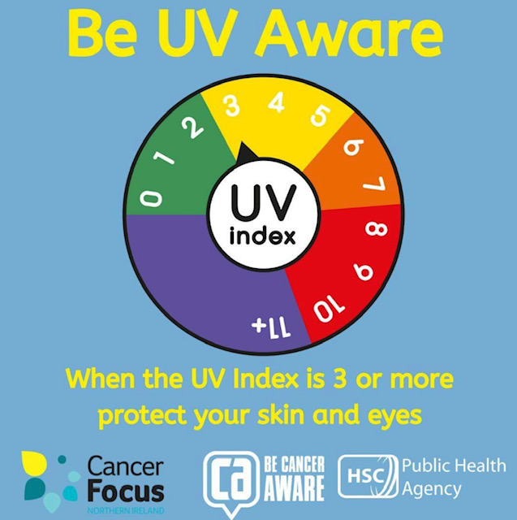

* **Volunteer Week 2023 takes place from 1-7 June**

Volunteers' Week is an annual celebration of the fantastic contribution many people make through volunteering in our communities and to say thank you. The North West Volunteer Centre offers a range of information, support and opportunities to encourage volunteering. Also if you are an organisation that would like to recognise your volunteers with 'Thank You' certificates, they are available to download please visit <https://www.nwvc.co.uk/> for details. If you would prefer printed copies, contact NWVC on 02871 271 017 or email: [info@nwvc.co.uk](mailto:info@nwvc.co.uk)

* **Daithi’s Law – Organ donation opt-out system**

Since 1 June 2023, to help save more lives, the law around organ donation changed from opt-in to an opt-out system. The law is known as Dáithí’s Law in recognition of young Dáithí Mac Gabhann who has been on the waiting list for a heart transplant since 2018. Dáithí’s Law means, if organ donation is a possibility after you die, it is considered that you agree to being an organ donor unless you have registered a decision not to donate, or are in an excluded group. Excluded groups include:

* those under the age of 18
* people who lack the mental capacity to understand the change in law
* visitors to Northern Ireland
* temporary residents

You will continue to have the right to choose whether or not to donate your organs. If you do not wish to be considered as an organ donor when you die, you should record your decision to opt-out, preferably on the NHS organ donor register(external link opens in a new window / tab) and tell your family so they are aware of your decision. Please visit <https://www.nidirect.gov.uk/articles/organ-donation>

* **Public’s feedback sought on Council’s Physical Activity and Sport strategy**

Derry City & Strabane District Council are seeking the publics feedback in relation to their Physical Activity and Sport Strategy. Please see below link for further information

<https://www.derrystrabane.com/Council/News/Public%E2%80%99s-feedback-sought-on-Council%E2%80%99s-Physical-Act>

* **Arts Council’s Arts and Older People Programme**

Please see attached links to funding opportunities available through the Arts council <https://artscouncil-ni.org/funding-for-organisations/arts-and-older-people-programme>

* **Over 55 and want to move to a new home but can’t afford to?**

If you are over 55 years of age and want to move to a new home but can’t afford to, Co-Ownership Housing can help you bridge the gap. Many people in later life find themselves living in a home that has become unsuitable due to a change in circumstances such as their family life, location, health or other issues. The trouble is that often their current house may not have the monetary value (equity) they need to buy their new home and getting a mortgage to cover the difference isn’t an option. Please visit their website <https://www.co-ownership.org/co-own-for-over-55s/about-co-own-for-over-55s/> Or alternatively telephone 028 9032 7276 or email [hello@co-ownership.org](mailto:hello@co-ownership.org)

* **Concessionary Fares Consultation**

The Department for Infrastructure (DfI) is considering making changes to the Concessionary Fares Scheme. This Scheme provides free and discounted public transport for some groups of people, including older people and people with disabilities. A consultation on changes to the Concessionary Fares Scheme has been launched by the Department for Infrastructure (DfI) on 1st June, which will run for 12 weeks. Please visit for further information please visit <https://www.infrastructure-ni.gov.uk/news/consultation-northern-ireland-concessionary-fares-scheme-launched>

IMTAC is supporting the consultation by coordinating a series of online focus groups on behalf of DfI. These focus groups will provide an opportunity for participants to hear from those leading the review process. Your views will contribute directly to the consultation exercise. These events are being organised to allow persons living with a disability the chance to have their say on the proposals. However, DfI are also engaging with older people as part of the consultation process. You can contact IMTAC to express an interest in attending an event for older people and they will pass your details on to the DfI team leading the consultation who will contact you directly. The events are taking place on the following dates:

* **Tuesday 13th June (2pm - 3.30pm) – Online using ZOOM**
* **Friday 30th June (10.30am - 12.30pm) – Online using ZOOM**

If you are interested in attending one of the above, please contact Michael Lorimer to register **by 12th June 2023**.  After that, they will send you the details on how to join the videocall on the day. Please include the following information when you register;

* Which event you are registering for
* If you are attending as an individual or on behalf of an organisation
* Whether you have any requirements for communication support.

You can contact IMTAC via email [info@imtac.org.uk](mailto:info@imtac.org.uk) or by telephone 028 9072 6020 Space is limited, so book early to secure a place.  If you are unable to attend one of the events, you can still have your say by completing DfI’s online survey. Please also visit this link on IMTAC website

<https://www.imtac.org.uk/news/concessionary-fares-consultation-online-consultation-meetings>

* **Women into Cycling**

This is a women-only, confidence-building session. You start slowly working parts of the bike and progress to confidently cycling the traffic free greenways. This will take place on 5th June from 1.30pm – 4.30pm at the Active Travel Centre, beside Waterside Railway Station. Please click on the following link to book [CLICK HERE TO BOOK](https://protect-eu.mimecast.com/s/wVFPC4RQOfBjZm8HOiDnk?domain=eventbrite.co.uk)

* **Dementia Café & Peer Support Group (Alzheimer’s Society)**

Dementia Cafés provides the opportunity to meet with others in a relaxed social environment. Run by a facilitator, these sessions offer an opportunity to access information on a range of related topics and activities for both carers and people with dementia. The peer support group is for family and carers of people with dementia provides the opportunity to meet with others who understand what you are going through. Run by a facilitator, these sessions provide an opportunity for people affected by dementia to ask questions, access information and share experiences in a safe and supportive environment. For details on any of these please contact Howard Clarke on 07902345229 or [howard.clarke@alzheimers.org.uk](mailto:howard.clarke@alzheimers.org.uk)

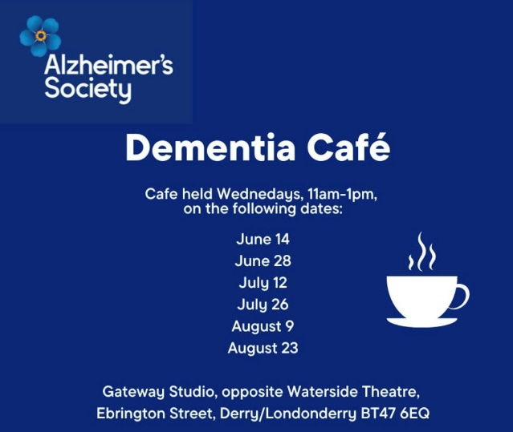 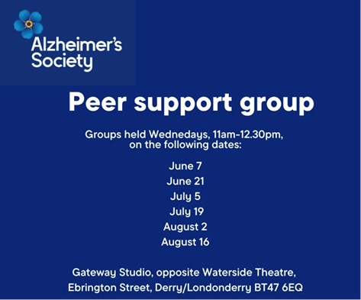

* **Alzheimer’s Society Carers Information Programme**

Please see below details of a Carers Information Programme available for unpaid carers and relations. See below details to register or for further information.

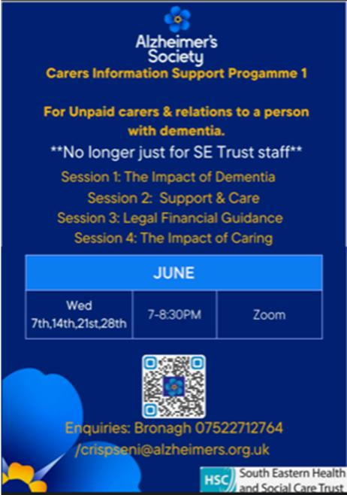

* **Aughabrack & District Community Association’s Information Event**

Donemana Medical Practice MDT is supporting Aughabrack and District community association to host a local information event on Tuesday 13th June from 2-4pm aimed at persons aged 50 plus, during Loneliness Awareness Week. The aim of the information event is to support older people in the local and surrounding areas to find out what is available for them locally to support their wellbeing, connect with local people and services. We are also hoping to have a consultation area with games/refreshments and get a chance to ask people what they would like/need in their local area. If you know anyone who may benefit from attending but struggles with transport etc please make contact with Michelle Allen on 02871397030.

* **Funding News – 30th May 2023**

Please visit the following weblink to view various funding opportunities available <https://www.grant-tracker.org/news/funding-news-30-may-2023>

* **Sustaining Health Relationships Workshops**

Looking to work on your relationships? Relate NI are delivering a workshop to develop the foundational relationships that improve wellbeing and bring us joy in life. This will be held on Tuesday 6th June from 6-8.30pm in Belfast. To register please visit <https://www.eventbrite.com/e/sustaining-healthy-relationships-tickets-635400689567>

* **Cost of Living Tracker – Summer 2023**

The cost of living crisis is far from over, and millions of households are still reporting going without essentials, and falling into debt. The Joseph Rowantree Foundation (JRF) has been tracking the impact that the pandemic and the cost of living crisis have had on the financial position of low-income households over the past 18 months, and in this webinar and report, we will provide an overview of both the financial and health and well-being impacts of the last six months for struggling households.

JRF will be focusing on levels of arrears, debt and the essential items that households are going without, as well as what needs to be done to ensure that those living at the sharp end of this crisis are not going without the basics, or living with deepening debt.

Join JRF on Wednesday 21st June at 10:00 on Zoom to learn from our findings and hear our recommendations. Additional speakers to be confirmed shortly. To register please visit <https://us02web.zoom.us/webinar/register/2716841596331/WN_QMYC5S45S8SIE02BkroDpw#/registration>

* **Preparing for International Day of Older Persons - Tuesday 6 June. 10:30-12:00**

Each Autumn, International Day of Older Persons (IDOP) provides the perfect opportunity to recognise and celebrate the positive contributions of older people in society. For members of the [UK Network of Age Friendly Communities](https://protect-eu.mimecast.com/s/zQgkCvol1C7Bn5RIzZsD_?domain=ageing-better.org.uk) it's also a chance to bring national attention to a shared topic or common issue and this year, Pride in Place has been chosen as a theme, to highlight older people's contributions to where they live.

The Centre for Ageing Better are hosting an online discussion group with some members of our experts by experience network to explore what Pride in Place might look like and would love to extend that invitation to you. Using Zoom, you will be joining us and colleagues from our Age-Friendly Communities Team to talk about the theme and share ideas. We’ll have some questions from the UK Network of Age Friendly Communities Steering Group and will take notes from the session back to that group to influence plans across the UK. This is an interactive session using Zoom and participants should be comfortable having their camera on and contributing to the discussion. If you are aged 50 and above, and are able to join in for the 90 minute session get in touch with Adele at [voice@ageing-better.org.uk](mailto:voice@ageing-better.org.uk) to reserve your place. In order for everyone to get a chance to have their say, places will be limited and will be offered on a first come first serve basis. Email [voice@ageing-better.org.uk](mailto:voice@ageing-better.org.uk) or ring 0203 150 4377, if you have any questions about the meeting.

* **All Party Group on Loneliness**

Just a reminder that the All Party Group on Loneliness will be meeting on Monday 5th June at 1.30 – 2.30pm in Room 21, Parliament Buildings and online.  Tea and coffee will be available from 1.15pm. This meeting will include the group’s annual AGM where its office bearers will be renominated.  This will be followed by a roundtable on health and social care.  After a short presentation on the loneliness context in Northern Ireland, this important discussion will explore the link between loneliness and health issues and how they can be jointly addressed through policy and practical initiatives.       Please confirm your attendance and if you will be attending in person or online by contacting Stephen Brown by email [StephenBrowne@redcross.org.uk](mailto:StephenBrowne@redcross.org.uk) or by telephone 07595411528

* **Positive Ageing Month Planning Group**

DCSDC in partnership with the WHSCT are organising a planning meeting to develop this Octobers Positive Ageing Month campaign. This is open to stakeholders and organisations interested in getting involved with developing Positive Ageing Month. This will be held on 6th June from 2-3.30pm online. If you are interested in attending, please register by contacting 028 7125 3253 or email [agefriendly@derrystrabane.com](mailto:agefriendly@derrystrabane.com)

* **Ageing and Climate Change**

This is an opportunity to share your thoughts about what climate change means to you and your community. Aged 60+? Please join this workshop, which will be held on Friday 16th June at 10am at the Europa Hotel in Belfast . Refreshments and lunch included. To attend, email Liam [age.friendly@causewaycoastandglens.gov.uk](mailto:age.friendly@causewaycoastandglens.gov.uk)



* **World Haemochromatosis Week 2023 (1-7th June 2023)**

Haemochromatosis is an inherited condition in which iron levels in the body slowly build up over many years, symptoms that range from chronic tiredness and joint pain to abdominal pain, discolouration or bronzing of skin and sexual dysfunction. Haemochromatosis is more common in Ireland than anywhere else in the world, as one in five people carry one copy of the gene and one in every 83 Irish people carry two copies of the gene, predisposing them to develop iron overload.

People with Haemochromatosis have a faulty gene which causes the normal system of iron absorption in the body to break down. Untreated, genetic haemochromatosis can lead to iron overload, where the body is unable to process excess iron. Excess iron is extremely toxic. Genetic haemochromatosis can cause liver disease, cancer, heart disease, chronic fatigue, diabetes, severe joint pain, sexual health issues and neurological issues. Early diagnosis is vital and if left untreated, can lead to organ damage or even premature death. If you are concerned please discuss with your GP or contact the Haemochromatosis UK helpline on 03030 401 102 (weekdays Noon-3pm) or visit their website <https://www.haemochromatosis.org.uk/world-haemochromatosis-week> for further information.

* **Self Compassion for Guys webinar (14/06/23) Mens Health Week**

To celebrate Men’s Health Week 2023, the Western and South Eastern Health and Social Care Trusts are delighted to invite you to a short webinar facilitated by Ed Sipler, Health Development Specialist.  Ed is widely regarded for his work in addictions and mental wellbeing and has created a range of resources exploring topics such as resilience, anxiety and managing stress. Also the seminar will introduce you to the concept of self-compassion - what it is, the evidence behind it, how to make the most of it for your personal wellbeing and self-care.  You will learn practical techniques to use in your daily life and take away top tips to keep up the good work afterwards! This webinar will be held on Wednesday 14 June 2023 from 2pm- 3.15pm online using Zoom. Book your place on Eventbrite by clicking on this link -   [Self Compassion for Guys: Why the Way We Talk to Ourselves Matters Tickets, Wed 14 Jun 2023 at 14:00 | Eventbrite](https://protect-eu.mimecast.com/s/SMuYCrR81f8NjOgc7V7hi?domain=eventbrite.co.uk)

* **Carer Poverty Commission**

The Carer Poverty Commission, run by Carers Northern Ireland, is running an online focus group on 16 June 2023 (11am - 12.30pm) with unpaid carers from rural areas in Northern Ireland to understand their experience of poverty and financial hardship. If you would like to get involved and offer your views then please register in advance at [https://www.eventbrite.co.uk/e/rural-unpaid-carer-focus-group-on-poverty-and-financial-hardship-tickets-635362314787](https://protect-eu.mimecast.com/s/9gWXC59QPhZnvgKFzWycI?domain=eventbrite.co.uk).  Every participant will receive a £20 Amazon voucher to thank them for their time.   For more information email [povertycommission@carersni.org](mailto:povertycommission@carersni.org).

* **DfC Consultation People and Place Review**

Age NI have asked to share this save this date and invite individual older people to this consultation meeting in relation to DfC’s People and Place Review. Further details and agenda to follow from Dfc. This will be held on 19th June online from 2.30pm-3.30pm meeting – for individual older people and between 4pm -5pm for ASN’s leaders . Please see below log in details for the meeting

________________________________________________________________________________

Microsoft Teams meeting

**Join on your computer, mobile app or room device**

[Click here to join the meeting](https://protect-eu.mimecast.com/s/TtxWCW7LVu5pZp8I6KLO_?domain=teams.microsoft.com)

Meeting ID: 384 416 291 469   
Passcode: twJ85w

[Download Teams](https://protect-eu.mimecast.com/s/4mMDCXoLWCX6j6ZHVgtD3?domain=microsoft.com) | [Join on the web](https://protect-eu.mimecast.com/s/OyWnCYvW8iL0m0XI99Bqk?domain=microsoft.com)

[Learn More](https://protect-eu.mimecast.com/s/ImWlCZVY1S5mAmYIynthE?domain=aka.ms) | [Meeting options](https://protect-eu.mimecast.com/s/-vxZC1rWLiMjxjXIYdqBK?domain=teams.microsoft.com)

________________________________________________________________________________

* **Try an E-Bike & Lead Ride**

Check out "Try an E-Bike & Lead Ride 2nd May to 27th June" on Eventbrite. <https://www.eventbrite.co.uk/e/try-an-e-bike-lead-ride-2nd-may-to-27th-june-tickets-626910465077>

* **Volunteer Recruitment Event**

The Red Cross are organising a Volunteer Recruitment Event alongside NW Volunteer centre, Derry GAA and Volunteer Now. This will be held on Friday 2nd June in Guildhall Green Room from 10am – 1.30pm.To find out more about volunteering opportunities in the area and the benefits of volunteering as it is Volunteer week 1st – 7th June. For further information please contact Toni-Lee Watson, Volunteer Management Transformation Officer with the British Red Cross by telephoning 028 90735350 or email [tonileewatson@redcross.org.uk](mailto:tonileewatson@redcross.org.uk)

* **Physical Activity Groups to support people with arthritis and musculoskeletal conditions**

Please see attached some leaflets for physical activity groups that have been set up to support people with arthritis and musculoskeletal conditions. Referrals can be made from clinical practitioners and self-referrals, please see referral link <https://forms.office.com/r/fq4CFZs6Vs> Information can also be found by visiting [www.versusarthritis.org](http://www.versusarthritis.org)

If there are any groups in North West that require support with chronic joint pain, please ask them to contact Susan Gilchrist, Regional Officer on 028 9692 3264 or mobile 07895 201210 or email [s.gilchrist@versusarthritis.org](mailto:s.gilchrist@versusarthritis.org)

* **Connecting Men with Mind Fitness**

To celebrate Men’s Health Week 2023, WHSCT Health Improvement Equality and Involvement, Men’s Health Forum In Ireland and Men’s Action Network are delighted to invite you to a half day event focusing on men’s mental wellbeing and showcasing a range of projects that support men and boys across the Western Trust area.   The event is aimed at practitioners who work with men of all ages. This will take place on Tuesday 13 June 2023 with registration from 9.30am and finishing with lunch at 1.30pm in the Great Hall at Magee Campus, Ulster University. To book your place via Eventbrite please visit <https://www.eventbrite.co.uk/e/manifest-connecting-men-with-mind-fitness-launch-event-tickets-629948391597> or follow the link on the flyer attached. Places are limited so early booking is recommended.



* **NWCN E-bulletin 31st May 2023**

Please see below link for the latest e-bulletin newsletter from NWCN

<http://www.nwcn.org/content/nwcn-ebulletin-31-may-2023>

* **Macmillan Health & Wellbeing Campus open day – 14th June 2023**

Western Health and Social Care Trust, in partnership with Macmillan Cancer Support, are delighted to invite you to our Macmillan Health & Wellbeing Campus open day.  The day is aimed at NW Cancer Centre staff, Trust staff and community and voluntary organisations and will take place on Wednesday 14th June 2023, 11.00am – 1.00pm. This is a celebration to showcase the beautiful campus and the services we provide.  Colleagues from North West Cancer Centre and some community and voluntary sector partners will also be in attendance to highlight the services they provide throughout the Western Trust area for people with cancer and their families.  A light lunch will be provided.We have limited space in our premises.  To help manage numbers please RSVP to confirm your attendance by emailing [HWB.Campus@westerntrust.hscni.net](mailto:HWB.Campus@westerntrust.hscni.net) or if you wish to bring information about your organisation or service to display on the day, please contact in advance.