Pavement Café Licence Application | 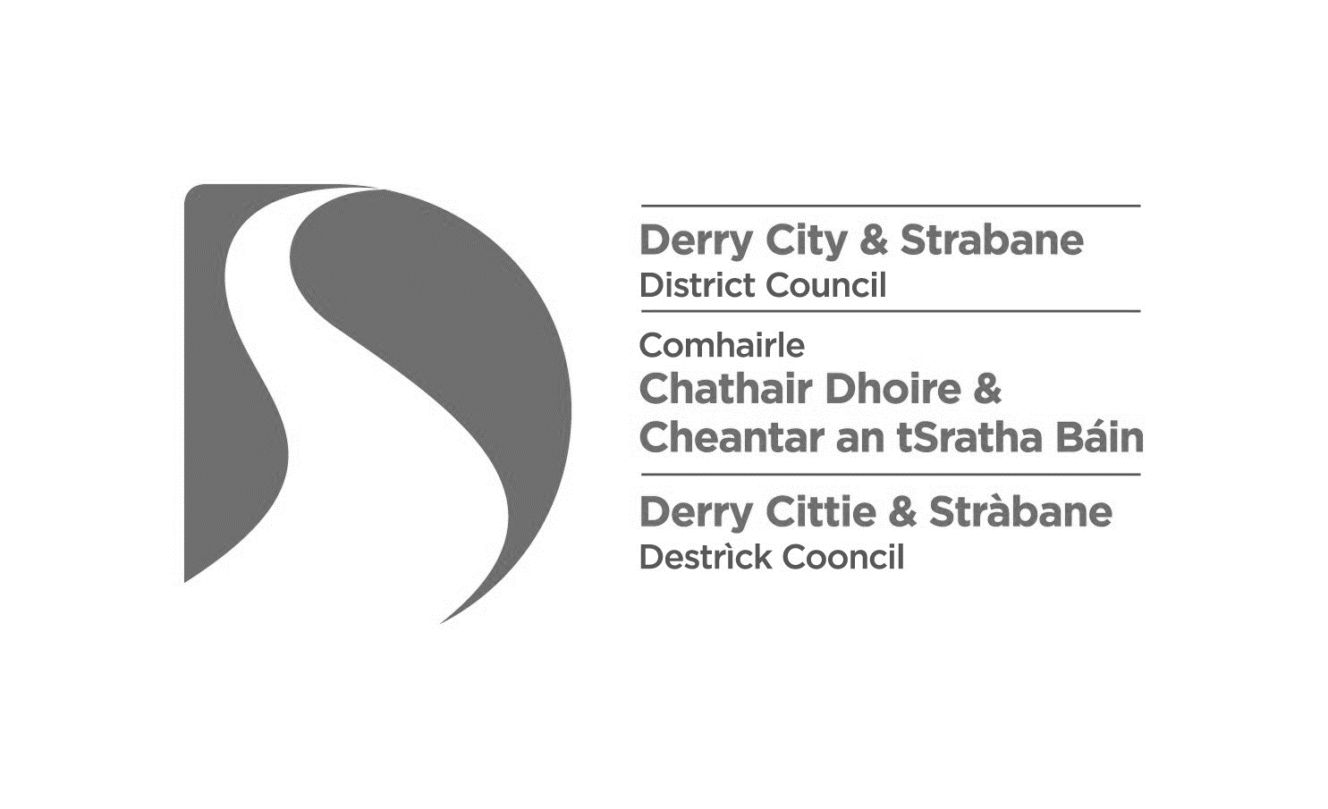
Please read our guide, “Pavement café licences – a guide for applicants” before completing your application. If you require any assistance when making your application we may be contacted by e-mail at licensing@derrystrabane.com or by telephone on 028 71253253
- Type of application
Grant (3-year licence)  Fee: £255 |  | Renewal (3-year licence)  Fee: £210 |  | Variation  Fee: £150

- Applicant Details
Name: | Telephone No:
Date of Birth: | Mobile No:
e-mail:

Home address:

Postcode:
Designation: Owner / Director / Manager / Other (please state):

- Premises Details
Business Type (e.g. café, public house):

Premises Name:

Address:

Postcode:

Telephone No:

e-mail:

4. Proposed Days and Hours of Operation of the Pavement Café
Note: The hours applied for should reflect the normal operating hours of the business. In general, the operating hours of a pavement café will be limited to 11:00pm latest, to reduce potential noise disturbance during nighttime hours.
Days:  (tick all that apply) |  | Hours:
 |  | From: |  | To:
Monday

Tuesday
Wednesday
Thursday
Friday
Saturday
Sunday

5. Alcohol consumption details
Will alcohol be consumed within the boundary of the Pavement Café? |  |  |  | YES |  |  | NO
Are the premises licensed under the Licensing (NI) Order 1996? |  |  |  | YES |  |  | NO
If the premises are licensed, what type of licence applies?

Public House | Off Sales | Restaurant | Hotel |  | Guest House with  Restaurant

6. Details of the proposed licensed café area:
Is the pavement café: | i) directly outside (adjacent to) the premises?
 | ii) remote from the premises?*
If remote, where is the location?

Note: If the pavement café is remote, you must provide a management plan or risk assessment outlining how you intend to maintain control over the pavement café.

Length of proposed café area in metres:
Depth of proposed café area in metres:
Width of existing footpath in metres:
Is the area within 10m of a road junction? |  | YES |  | NO
Distance to road junction in metres:

7. Enclosure and furniture details
Number of tables: | Number of chairs:
Number of umbrellas / parasols: | Number of space heaters:
Do you intend to install a fixed awning above the pavement café area? |  | YES |  |  |  | NO
Details of any additional furniture:

Where will the furniture be stored when the premises are closed?

What type of screen or enclosure will surround the pavement café area?

Height of screen or enclosure (m):

Does the screen have a tap rail? |  |  | YES |  |  |  | NO
8. Checklist of required items
Have you included the following with your application?
Appropriate fee: Grant (£255); Renewal (£210); Variation (£150) | YES |  | NO
Location Map: showing the location of the premises, marked by a red line | YES |  | NO
Site Layout Plan: detailing the dimensions and layout of the proposed pavement café area | YES |  | NO
Details of the furniture: including photographs, manufacturers’ brochures, etc. | YES |  | NO
Risk assessment / Management plan: (for remote pavement cafes only) | YES |  | NO
9. Declaration:
- I confirm that the prescribed Public Notice has been placed in a prominent place at or near the premises. I confirm that it can easily be read by the public, and that it will be displayed for 28 days from the date of this application.
- I confirm that public liability cover (minimum £5 Million) will be in place for the licensed area for the duration of the licensed period.
- I make this application to Derry City and Strabane District Council for a pavement café licence, under the provisions of the Licensing of Pavement Cafés Act (Northern Ireland) 2014 and I confirm that, to the best of my knowledge and belief, the information provided on this application form and submitted documents is correct.

Signature of Applicant:
Date of application:

The completed application form may be returned by post or by email:
Post: | Derry City and Strabane District Council, Licensing & Safety Advisory Group, 98 Strand Road, Derry, BT48 7NN
e-mail: | licensing@derrystrabane.com
Privacy Notice

Data Controller
Name: | Health & Community Well Being Department/Licensing, Derry City & Strabane District Council
Address: | 98 Strand Road, Derry, BT48 7NN
Telephone: | 02871 253253
Email: | licensing@derrystrabane.com

Data Protection Officer
Name: | Damian McCay
Address: | Derry City & Strabane District Council, 98 Strand Road, Derry, BT48 7NN
Telephone: | 02871 253253
Email: | Damian.McCay@derrystrabane.com

Why are you processing my personal information?
- For the logging, processing and determination of licensing/permit applications.
What categories of personal data are you processing?
- Personal contact details
Where do you get my personal data from?
- Application Forms and accompanying documents
Do you share my personal data with anyone else?
- Yes, where required by legislation we may share personal date with other agencies as outlined on Council website at the following link http://www.derrystrabane.com/Footer/Privacy-Policy
Do you transfer my personal data to other countries?
- No
How long do you keep my personal data?
- We will only retain your data for as long as necessary to process your application or investigate an Enforcement case, and in line with Council’s Retention and Disposal Schedule.
What rights do I have?
- You have the right to obtain confirmation that your data is being processed, and access to your personal data
- You are entitled to have personal data rectified if it is inaccurate or incomplete
- You have a right to have personal data erased and to prevent processing, in specific circumstances
- You have the right to ‘block’ or suppress processing of personal data, in specific circumstances
- You have the right to data portability, in specific circumstances
- You have the right to object to the processing of your data, in specific circumstances
- You have rights in relation to automated decision making and profiling

You should refer to the Council’s website for further information on your rights: http://www.derrystrabane.com/Footer/Privacy-Policy

How do I complain if I am not happy?
If you are unhappy with how any aspect of this privacy notice, or how your personal information is being processed, please contact our Data Protection Officer.

If you are still not happy, you have the right to lodge a complaint with the Information Commissioner’s Office (ICO):

Information Commissioner’s Office
Wycliffe House, Water Lane, Wilmslow, Cheshire, SK9 5AF

Tel: | 0303 123 1113 | Email: | casework@ico.org.uk | https://ico.org.uk/global/contact-us/

