**DCSDC PEACEPLUS Local Co-Designed Action Plan – E Newsletter November 2024**

The PEACEPLUS Programme is a funding partnership between the European Union, the Governments of the United Kingdom and Ireland, and the Northern Ireland Executive and will be administered by the Special EU Programmes Body (SEUPB).

**Communities lighting up winter with PEACE Project launches.**

It’s been fantastic over the past few months to see some of our community projects bringing light to their communities with project launches. From choirs to cricket, circus to community development, there’s beginning to be wide ranging opportunities out there for people wanting to participate in the cross-community programmes funded under PEACEPLUS.

As the winter weather closes in, the PEACE Team are glad to be closing in on the final phases of getting our 58 projects to contracting stage. By Christmas time over 80% of our contracts will have been awarded – that’s 47 out of a total of 58 projects. With a fair wind behind us we’d hope to have the full programme contracted before the end of this financial year so that 2024-25 sees our programme move completely into its delivery phase. Congratulations to all the community groups and organisations who have won contracts to date.

**Current live tenders under DCSDC PEACEPLUS Local Co-Designed Action Plan:**

|  |  |
| --- | --- |
| Tender | Deadline |
| T24-163BUS PEACEPLUS Journey To Peace (Reissue) | 29th November 2024 |
| T24-190BUS PEACEPLUS Distance Travelled (Reissue) | 6th December 2024 |
| T24-191BUS PEACPLUS Fit For Purpose – Soccer (Reissue) | 13th December 2024 |
| T24-201BUS PEACEPLUS Arts & Collaborative Resilience (Reissue) | 10th January 2024 |
| T24-202BUS PEACEPLUS Ballyarnett Early Years Project (Reissue) | 10th January 2024 |
| T24-203BUS PEACEPLUS Ballyarnett Women’s Programme (Reissue) | 10th January 2024 |

For exact deadlines for returns, please see e-tenders NI website.

Council Website announcement: <https://www.derrystrabane.com/business/tenders>

All tenders are on E-Tenders NI: <https://etendersni.gov.uk/epps/home.do>

All our tenders are public procurement processes. Any organisations wishing to tender should do so via E-Tenders NI.

**Celebrating recent project launches!**

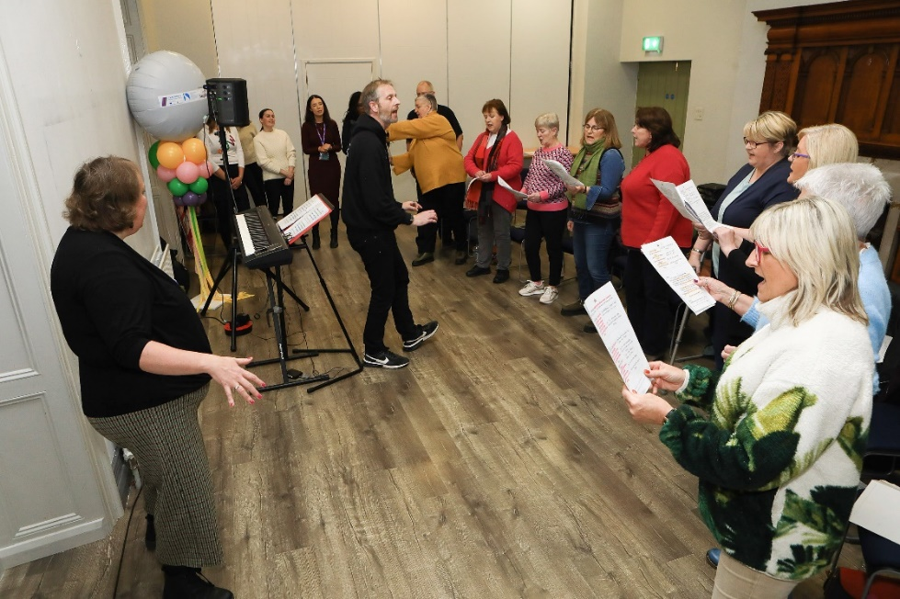

Creating Creatives – Delivered by MayWe, this cross-community and cross-border creative community development project is under the Thriving and Peaceful Communities Theme. With a focus on the Waterside area, it inclused skills, creative writing, visual arts and a choir.

Operation Desperation – Delivered by the Playhouse, this is an arts/theatre-based initiative giving voice to local women and exploring domestic violence in a historical and contemporary context. It’s under the Celebrating Cultural Diversity Theme.

**Coming soon! SEUPB €100,000 Small Grants Opportunity.**

SEUPB have indicated they will issue a Small Grants Programme under Theme 1.2. Groups will be able to apply for up to €100,000. This is anticipated in the near future. We’d encourage local groups to keep an eye out for this and to take the opportunity to apply once the funding opens. These grants are not run through the council. For details, watch out for announcements on: <https://www.seupb.eu/PEACEPLUS>

**Job Alert!**

Many of our projects are now advertising jobs. If you are interested in working in a community role, keep an eye out for opportunities. Currently open:

Green Clubs Project Officer - closes on 3rd December.  This is a 2-year post.

Details in the link below:

[https://nwrc.getgotjobs.co.uk/jobDetails/544d1cc2-8193-4e4e-9a64-7df7dd05a8f1](https://url.uk.m.mimecastprotect.com/s/_p5vC6RXQfoVgqDSpf2H5jJti?domain=nwrc.getgotjobs.co.uk)

**Download a user-friendly version of Counci’s Local Co-Designed Action Plan Here:**

[**https://www.derrystrabane.com/community/peace-plus/co-designed-action-plan**](https://www.derrystrabane.com/community/peace-plus/co-designed-action-plan)

**Download a more detailed project overview of the 58 included projects here:**

[**https://www.derrystrabane.com/community/peace-plus/co-designed-action-plan**](https://www.derrystrabane.com/community/peace-plus/co-designed-action-plan)

For email updates on tendering opportunities, see our website and make sure you’ve signed up to our email newsletter: <https://www.derrystrabane.com/community/peace-plus>

**Don’t miss out on wider PEACEPLUS funding opportunities!**

Remember, council doesn’t ‘run’ all of PEACEPLUS. Groups can apply directly to SEUPB.

Sign up to SEUPB’s emailing list here: <https://seupb.us7.list-manage.com/subscribe>

**Grantfinder.**

Check out other funding options on Grantfinder: <https://search.mygrantfinder.co.uk/>

**Contact us:**

The Peace Team in council can be reached via [peace@derrystrabane.com](mailto:peace@derrystrabane.com)

Our website is: <https://www.derrystrabane.com/community/peace-plus>

The PEACEPLUS Programme is a funding partnership between the European Union, the Governments of the United Kingdom and Ireland, and the Northern Ireland Executive and will be administered by the Special EU Programmes Body (SEUPB). Match-funding for this element of the PEACEPLUS Programme has been provided by the Executive Office in Northern Ireland and the Department of Housing, Planning, Community and Local Government in Ireland.