DCSDC PEACEPLUS Local Co-Designed Action Plan – E Newsletter February 2026

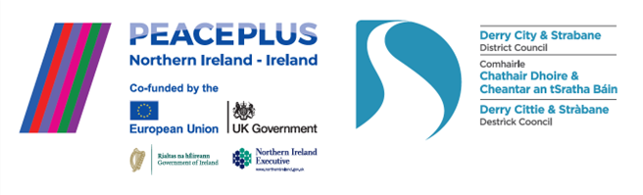

The PEACEPLUS Programme is a funding partnership between the European Union, the Governments of the United Kingdom and Ireland, and the Northern Ireland Executive and will be administered by the Special EU Programmes Body (SEUPB).
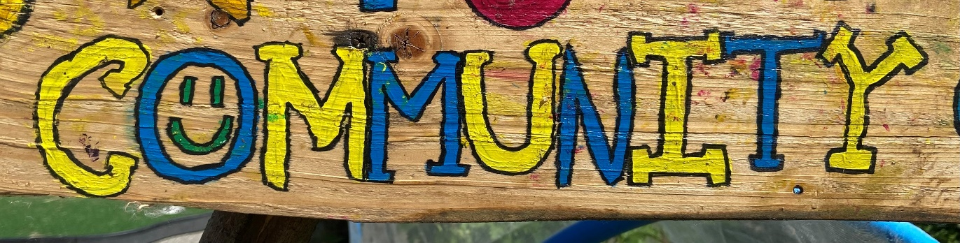
Working Together to Strengthen our Sector.

Our February focus is on what our local PEACEPLUS programme is doing to build capacity across our local community and voluntary sector. As well as working to deliver 58 individual funded projects across our council area, our PEACEPLUS programme also has a role to assist the sector with networking across identities, in different parts of our council area and cross-border. At a time when communities are under unprecedented pressure with funding, the relationships established through the PEACEPLUS programme can provide sustainability through opportunities to apply for wider funding requiring partnership working. Our programme also provides capacity building, awareness and training opportunities for free to local community workers and key volunteers. Read on to see a snapshot of what has been delivered and to find out about upcoming events.
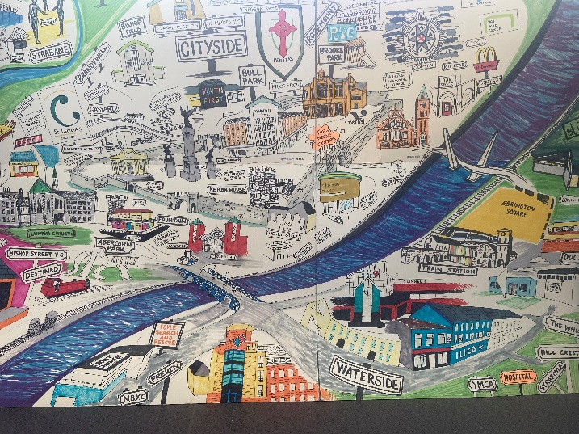
Conference Registration Open: Building Community Leadership in Peacebuilding.

All our funded PEACEPLUS Projects, local community workers and volunteers and anyone interested in peacebuilding are welcome to register for our next networking event. We also welcome registrations from PEACEPLUS funded projects in Donegal and other council areas – feel free to spread the invite.

Event: PEACEPLUS: Building Community Leadership in Peacebuilding.
Venue: Holywell Trust (Bishop Street, Derry~Londonderry)
Date: Thursday 19th March 2026
Time: 9:45am to 3:30pm
FREE (Includes refreshments on arrival and lunch)

Registration is now open through Eventbrite here:

https://www.eventbrite.co.uk/e/peaceplus-building-community-leadership-in-peacebuilding-tickets-1982874083762?

This is a capacity building and networking event for PEACEPLUS Projects in the DCSD Council area and cross-border. It is primarily aimed at community workers and key volunteers from PEACEPLUS funded projects in the Derry City and Strabane District Council area and cross-border into Donegal, but it is also open to the public and in particular any community workers in the north-west interested in networking and building capacity around cross-community, peace, good relations and diversity work. PEACE work goes beyond simply ‘cross-community’ work, and all our funded projects need to have focused peace-building content within their programming. Come along to find out about new ideas, skills, and share what works. The PEACEPLUS Team are delighted to be working with Holywell Trust on this event.
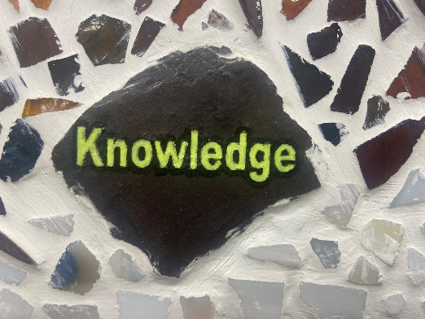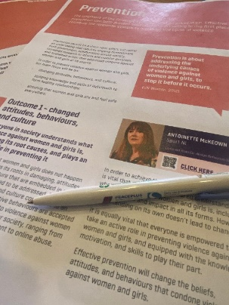
Level 2 Award in Community Development- Free Places

Are you interested in finding out more about being a community worker? One of our PEACEPLUS funded projects, Inspire Enthuse Equip, is delivering a free, OCN accredited, entry level course. No prior knowledge needed.

Course details
OCN NI Level 2 Award in Community Development
Start date- Friday 27th February
Time- 9.30am - 12.45pm
Location- Northwest Regional College- Strand Road Tower Building
Duration- 16 weeks with 1 class per week every Friday
The eligibility criteria for any applicants are they must have turned 16 yrs by July 2025.

This is a PEACEPLUS Project, and all places are fully funded. A great opportunity for anyone interested in a career in the community sector and upskilling themselves in 2026!
To register or for more info please contact Denise at- inspire.enthuse.equip@nwrc.ac.uk

Impactful ‘Ending Violence Against Women and Girls Training’ delivered.

On 16th February 2026, the DCSD Council PEACEPLUS Team worked with FWIN (Foyle Women’s Information Network) to deliver a free 1-day training course. Tailored to equip local communities to deliver work which will help to end violence against women and girls, the course proved to be really interactive and helped to generate practical ideas at a local level. It was also a practical demonstration of incorporating our ‘horizontal principle’ of equality into our programme in a meaningful way.

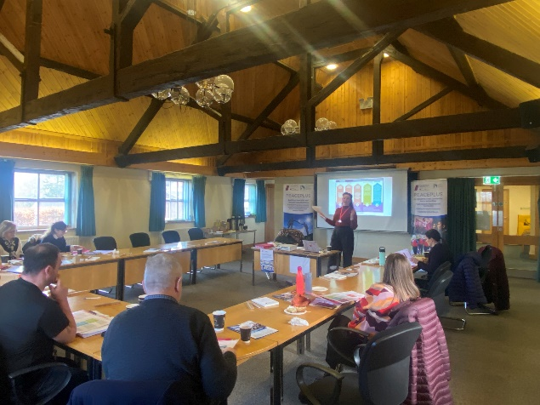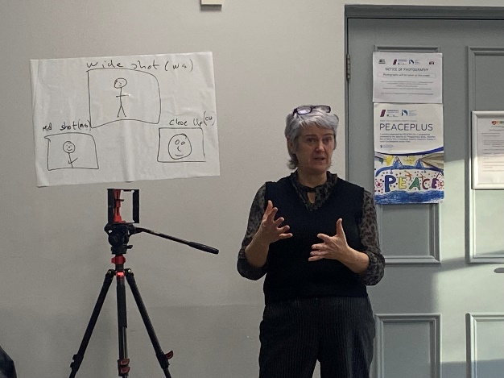

Smartphone communications training delivered.

In December 2025 a one-day course in using a smartphone to make videos was enjoyed by many of our PEACEPLUS projects. At our October networking event, we’d asked community workers present if they’d ever had any form of communications training. Staggeringly, most had had no training at all – yet community projects are expected by many funders to engage in a wide range of communications and publicity work. With video content on social media having a huge public reach, the PEACEPLUS team worked with Póca Productions from Letterkenny to delivery smartphone video training. This accessible and highly interactive training meant that by the end of the day, PEACEPLUS project facilitators had a basic grasp of the skills needed to produce an edited video with sound and captions about their project.

Sharing learning from the PEACEPLUS Programme –
with the President of Ireland.

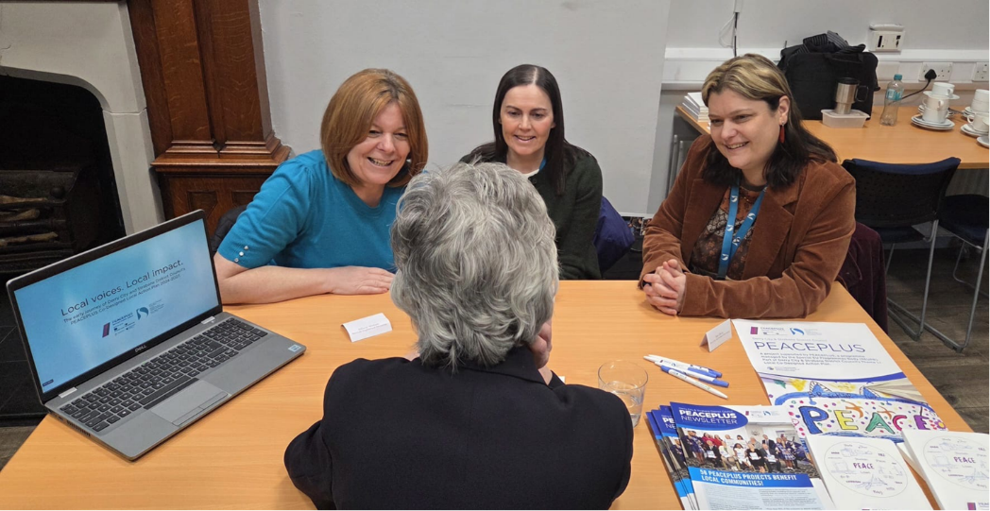

It was a real privilege for the PEACEPLUS Team in council to recently have the opportunity to share information about and learning from the PEACEPLUS programme with Uachtarán na hÉireann / President of Ireland, Catherine Connolly. The event, organised by Youth Action NI (who are also a Board member of our PEACEPLUS Partnership Board), and held in St.Columb’s Park House, focused on young people, cross-community and cross-border work.

OTHER THINGS OF INTEREST:

New PEACEPLUS funding call aimed at underrepresented groups

SEUPB is preparing a new PEACEPLUS funding opportunity under Building Peaceful and Thriving Communities. It will focus on increasing capacity and cooperation among organisations that work with groups which have so far not been successful in gaining funding across the Programme. These include ex-security service personnel, new community and minority ethnic groups, those involved in traditional cultural expression and ex-prisoners and former combatants. Ahead of the call opening, online/in person information sessions will take place from 19 to 27 February. Further details will be available shortly. If you would like to participate, or if you need more information, please contact js.peaceplus@seupb.eu Please note that this is an SEUPB initiative (not led by DCSD Council)

Watch our video!

This short video captures in a nutshell how the PEACEPLUS Local Action Plan came about, what is being delivered through it, and some of the impact it is having at this early stage of delivery.

Insert DCSDC PEACEPLUS video link here from Youtube/Website

Contact us:
The PEACE Team in council can be reached via peace@derrystrabane.com
Our website is: https://www.derrystrabane.com/community/peace-plus

The PEACEPLUS Programme is a funding partnership between the European Union, the Governments of the United Kingdom and Ireland, and the Northern Ireland Executive and will be administered by the Special EU Programmes Body (SEUPB). Match-funding for this element of the PEACEPLUS Programme has been provided by the Executive Office in Northern Ireland and the Department of Housing, Planning, Community and Local Government in Ireland.

