DCSDC PEACEPLUS Local Co-Designed Action Plan – E Newsletter May 2026

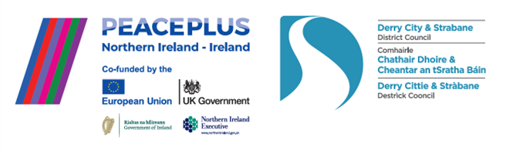

The PEACEPLUS Programme is a funding partnership between the European Union, the Governments of the United Kingdom and Ireland, and the Northern Ireland Executive and will be administered by the Special EU Programmes Body (SEUPB).

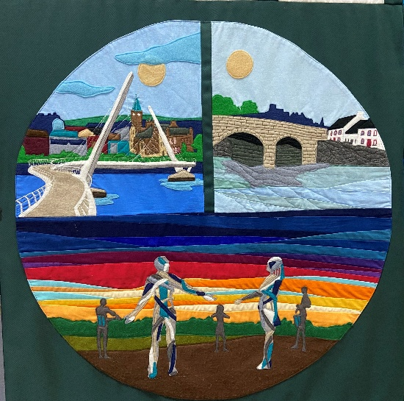

May signals ‘Mid-way’ for PEACEPLUS Local Delivery.

Remembering back almost 2 years to when the council’s local PEACEPLUS programme launched, it seemed a tall order to get 58 projects contracted and up and running. The target set by SEUPB was to have a cross-community peace programme reaching across the entire city and district, engaging 9255 people. The programme was about empowering local people to transform their communities, building wellbeing and connectedness, celebrating cultures and identities and providing support to the most marginalized in our communities and those with diverse views. Are we there yet? Almost! We’re well past half-way.

At the latest count we have 8488 (91%) of the participants on board. All projects are up and running – seven have even completed already. Funded projects have claimed over 60% of that £8 million, which is significant at a time when budgets are really difficult across the local community and voluntary sector. That’s why we’re also highlighting a couple of other PEACE related funding opportunities in this e-bulletin which are not run by the council. If you work with a community group, spread the word!

Rural Groups! Maximising Community Space Programme is for you!

Rural community organisations across Northern Ireland and the border counties are invited to apply for the new Maximising Community Space (MCS) programme.

The programme will support 40 organisations to make better use of existing community spaces, helping them expand activities, increase participation, and strengthen local connections.

Successful groups will receive:
- Accredited training and mentoring support
- Networking and study visit opportunities
- Up to £10,000/€10,000 activity support

Maximising Community Space is supported by PEACEPLUS, a programme managed by the Special EU Programmes Body (SEUPB). The programme is being delivered by Rural Action in partnership with Irish Rural Link and the Northern Ireland Rural Women’s Network (NIRWN).

📅 Closing date for Expressions of Interest: Friday 19th June 2026.

For more info and application details visit Maximising Community Space - Rural Action
📧 MCS@ruralaction.co 📞 +44 (0)28 8648 0900

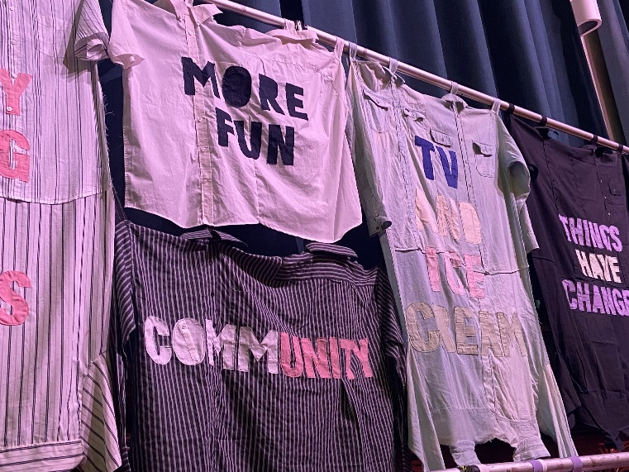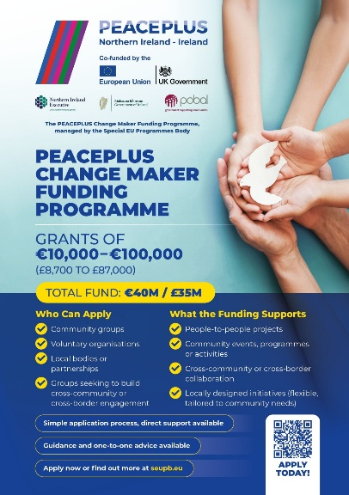

Active support available for PEACEPLUS Change Maker Funding.
Could your group use €100,000 (£87,000)? The Change Maker grants programme has a deadline on 30th June 26 for this year and word on the street is that there is now significant help available with filling in forms to groups who would like to apply and that 90% of applications are successful. The programme provides grants of up to €100,000 (approximately £87,000) for local projects that bring people together on a cross-community or cross-border basis. It is designed to be accessible to smaller organisations, with a simplified application process and practical support available throughout. If you haven’t looked at it, or if you previously did but thought it was too complicated, it might be worth another look. Apparently there are sections of the form that don’t need filled in by all projects and there is assistance to check your draft application and give advice.

Community groups, voluntary organisations and other local bodies can develop ideas at their own pace and seek one-to-one guidance from the programme’s delivery partners.
The Change Maker Funding Programme has been shaped to be clear and accessible, with a simplified application process and direct support available throughout from our support partners, led by Co-operation Ireland. Pobal is the implementing agent for the Change Maker Funding Programme, on behalf of SEUPB.

Further details and application guidance are available at: Change Maker Funding Programme | SEUPB

Shared Island Civic Society Fund – Deadline 2nd June 26.
Have you a project which can demonstrate a clear partnership between at least one organisation based in the South and at least one organisation based in the North?
The Shared Island Civic Society Fund closes for applications: 11:59pm 2 June.
The fund encourages and supports civic society and community organisations to develop new cross-border links, to further strengthen existing partnerships, or to create or broaden cross-border connectivity on issues of concern for the island of Ireland.

They look for applications that:

- foster sustained engagement between civic society at a regional, national or sectoral level as distinct from stand-alone events or engagements;
- are from business or trade union representative groups, civic society organisations, community/voluntary groups, NGOs or other regional or national representative bodies
- are representative of different groups of people on the island including persons with a disability, women, young people, older people, migrants, ethnic minorities, and the LGBTQI+ community;
- Address a sector that has cross border impact in areas such as the community/voluntary sector, environment, sport and youth engagement.

For more information, click this link: Shared Island Civic Society Fund

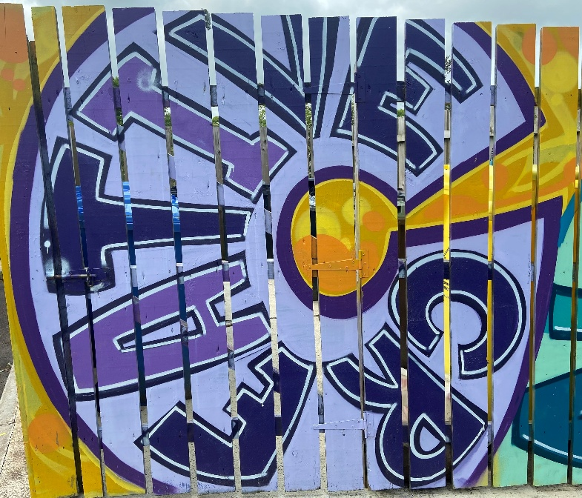

Public and Community invite to PEACEPLUS Film Showcase

An innovative collaboration between North West Regional College (NWRC) film students and PEACEPLUS community projects is to be celebrated in a showcase on 27th May in the college’s Foyle Theatre. Open to the public, the event runs from 11am – 12 noon and anyone interested can register in advance to attend. Email peace@derrystrabane.com to register.

Over recent months, students from North West Regional College (NWRC) have had the privilege of working alongside funded PEACEPLUS community projects to capture the stories, achievements, and real impact of the work. The films created reflect not only the creativity of the students, but also the dedication, collaboration, and positive change driven by communities. The event is an opportunity to come together, share these stories, and celebrate everything that has been achieved through partnership.

Event Details:
Date: 27th May 2026
Time: 11.00am-12noon followed by Light Lunch
Location: Foyle Theatre, North West Regional College, Strand Road

Contact us:
The PEACE Team in council can be reached via peace@derrystrabane.com
Our website is: https://www.derrystrabane.com/community/peace-plus

The PEACEPLUS Programme is a funding partnership between the European Union, the Governments of the United Kingdom and Ireland, and the Northern Ireland Executive and will be administered by the Special EU Programmes Body (SEUPB). Match-funding for this element of the PEACEPLUS Programme has been provided by the Executive Office in Northern Ireland and the Department of Housing, Planning, Community and Local Government in Ireland.

