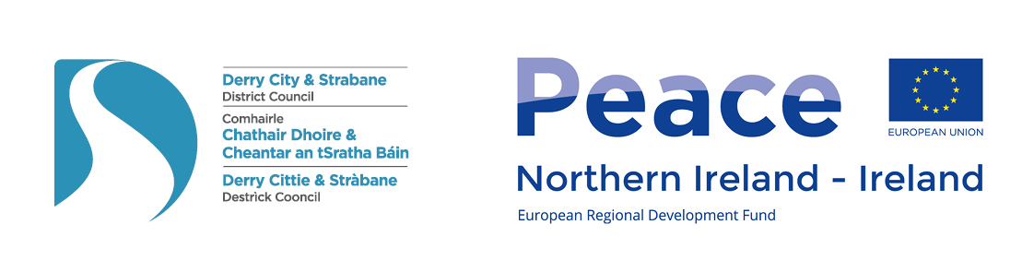
Derry City and Strabane District PEACEPLUS Partnership Board

Meeting Date: Tuesday 29th March 2022
Time: 10.00am – 1.00pm
Venue: Holywell Trust, Bishop Street, Derry~Londonderry

AGENDA ITEM
1. Meeting Opening (Sue Divin)
1.1 Welcome/Apologies
1.2 Introductions – Meet the PEACE Team and other Board members.
2. Familiarisation with PEACEPLUS & Consultation/Co-design Process (Myriam Fearon)
2.1 Presentation by Myriam Fearon – Focus on Theme 1.1
2.2 Presentation / Discussion & Input on Process & Timescale for Consultation and Co-design.
For decision: Board Sign Off of Approach / Model

3. Familiarisation with PEACEPLUS Board Policies and Procedures (Sue Divin)
3.1 Formal adoption of Partnership Agreement (with signatures) and Memo of Agreement
3.2 Code of Conduct and Conflict of Interest Training Powerpoint
3.3 Formal adoption Code of Conduct Policy
3.4 Completion of Conflict of Interest Forms
For decision: Official sign off of above policies and procedures

4. Board Diversity and Representation (Sue & Myriam)
4.1 Section 75 / Geographic / Thematic / Reconciliation representation (NB. DAERA, Foyleside)
4.2 Approach to youth engagement
For decision: List of Board members to be added to PEACEPLUS website

5. Processes to agree / defer to next meeting: (Sue & Myriam)
5.1 Paperless meetings – opinions sought.
5.2 Election of Chair / Co-Chair (representative of different ‘pillars’ and Section 75)
5.3 Briefing on optional expenses for Board members.
5.4 Schedule of meetings – proposed monthly. Tuesday mornings? Rotate venues?
5.5 Financial allocations models – initial thoughts only until SEUPB details/call issued.

6. Meeting Closing
7.1 Any Other Business
7.2 Review of Actions
7.3 Date of Next Meeting

Appendix A:

List of Board Members

Name | Organisation
Statutory Agencies (6)
Mary O'Neill | NI Housing Executive
William Calderwood | PSNI
Seamus Ward | Western Trust (HSCNI)
Deborah Cross | EA
Marie Gallaher | Dept of Communities
Decline to nominate | DAERA
Local Growth Partnerships (8)
Margaret McLaughlin | Sperrin
Alison Wallace | Waterside
Martin Duffy | Derg
Jacki Connolly | Ballyarnett
Gus Hastings | Faughan
Charles Lamberton | Moor
Aodhán Harkin | Strabane
TBC New NR Manager | Foyleside
Elected Representatives (12)
Conor Heaney | SF
Ruairi McHugh | SF
Christopher Jackson | SF
Rory Farrell | SDLP
Angela Dobbins | SDLP
Steven Edwards | SDLP
Hilary McClintock | DUP
Maurice Devenney | DUP
Keith Kerrigan | DUP
Darren Guy | UUP
Philip McKinney | Alliance
Maeve O'Neill | PBP
Social Partner Open Call Applicants (8)
Anne McTaggart | YouthActionNI
Catherine Cooke | Foyle Women's Information Network
Derek Moore | NW Cultural Partnership
Craig Barr | Holywell Trust
Kyra Reynolds | Bogside and Brandywell Initiative
Sharon Doherty | St.Columb's Park Reconciliation Trust
Noelle Donnell | Hummingbird (NI) CIC
Nikki Yau | Foyle Racial Equality Forum

NB. Noted that Elected Representatives change annually based on D’Hondt List.
Appendix B:

List of Deputy Board Members

Nominated Deputy | Organisation
Noel McNulty | NI Housing Executive
TBC | PSNI
Bronach McMonagle | Western Trust (HSCNI)
Declan Gallagher | EA
Sharon Mc Cullagh | Dept of Communities
Decline to nominate | DAERA
Patricia McNulty | Sperrin
Geraldine Doherty | Waterside
Andy McKane | Derg
Darren Kirby | Ballyarnett
Martin McCartney | Faughan
Seamus Breslin | Moor
Ursula Doherty | Strabane
TBC | Foyleside
Dominic Bonner | YouthActionNI
Amanda Leighton | Foyle Women's Information Network
Kyle Thompson | NW Cultural Partnership
Gerard Deane | Holywell Trust
Rachel Mullan-Carlin | Bogside and Brandywell Initiative
Michelle Simpson | St.Columb's Park Reconciliation Trust
Sinead Barr | Hummingbird (NI) CIC
Agnieszka Luczak | Foyle Racial Equality Forum

NB. A short briefing for Deputy Board members (and Board Members who sent apologies to the Board Meeting) will be held 10.30am Thursday 31st March, Room 5, Alley Theatre, Strabane.

Council Staff Contacts:

Generic contact peace@derrystrabane.com

Sue Divin sue.divin@derrystrabane.com Manager (PEACE)
Mary Claire Kerlin maryclaire.kerlin@derrystrabane.com Project Officer (PEACE)
Fiona Lafferty Fiona.lafferty@derrystrabane.com Project Officer (PEACE)

Kevin O’Connor kevin.oconnor@derrystrabane.com SRO/Head of Business

