DCSDC PEACEPLUS Local Co-Designed Action Plan – E Newsletter Summer 2026
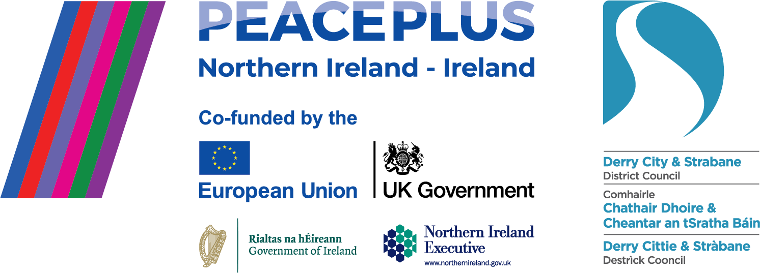

The PEACEPLUS Programme is a funding partnership between the European Union, the Governments of the United Kingdom and Ireland, and the Northern Ireland Executive and will be administered by the Special EU Programmes Body (SEUPB).

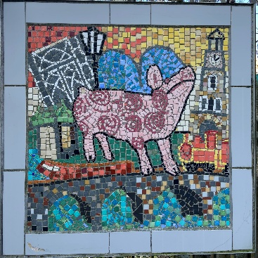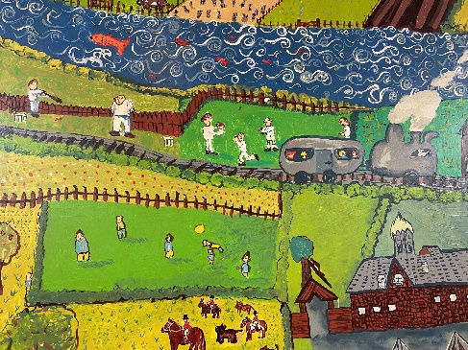

Over 9000 people taking part in PEACEPLUS Local Programme!
The PEACEPLUS Board are delighted that our local programme of 58 projects collectively has over 9000 people registered and taking part. That’s a huge milestone in the implementation of our action plan. Behind the statistic, each person is an individual benefitting directly from engagement in a cross-community programme on a theme or with an activity that personally interests them.
One example of that is the PEACEPLUS Stitch in Time project, delivered by Glen Development Initiative (based in the Foyleside area in the city). In glorious sunshine on the 25th June, the Stitch in Time project participants met for their ‘swansong summer’ closing event. Over 250 people, predominantly from the Glen/Rosemount area and the Waterside, linked up over 2025/2026 to complete a range of activities including history, heritage and social programming. It had a key focus on the history of the local Rosemount shirt factory, reconnecting communities to that history, and reconnecting former neighbours and factory workers – many of whom had moved out of the area during the conflict. ‘The real achievement has been the friendships formed,’ said Amanda, GDI project worker, speaking at the finale event. She spoke from the heart of people going places they’d never been before and of the cross-community links developed between the Waterside and the Glen area of the cityside. ‘The end of this project is not the end of the relationships we’ve built,’ she said, resonating with many PEACEPLUS projects that friendships and connection are one of the biggest legacies left after a project ends.
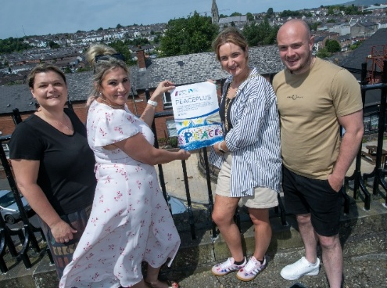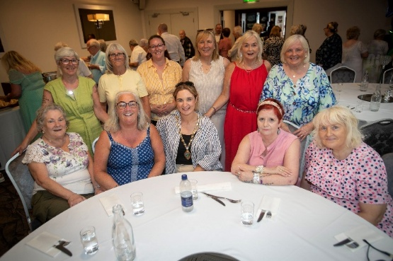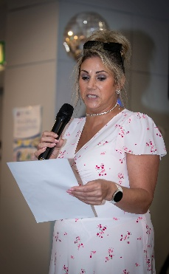

Celebrating the PEACEPLUS Film Showcase collaboration with NWRC.
A recent collaboration between Council’s PEACEPLUS programme, six funded community projects and the NW Regional College culminated in a successful film showcase in June. The initiative also enabled students to gain insight into community work.
‘The North West Regional College is deeply committed to meaningful, real-world experiences,’ said Dr Catherine O'Mullan, NWRC Director of Curriculum and Academic Standards. ‘This is a really good example of project-based learning and employability. These students amplified diverse voices which might otherwise go unnoticed. Their work encapsulates the values of empathy, professionalism and social responsibility.’
Offering her congratulations, the then Deputy Mayor, Niree McMorris stated, ‘The collaboration is a powerful message of how communities and students can work together. Ensuring that young adults have opportunities to showcase their talent and perspectives is a positive sign of active citizenship and engagement.’
Representing the PEACEPLUS Board, Dominic Bonner from YouthAction NI praised the film students, saying, ‘You’ve taken an idea and used your knowledge and skills into practice. You chose to shine a light on work in this city that deserves to be seen. You made the invisible, visible… Stories are what shape the world. That confidence, experience and voice you’ve found? Use it to put more stories on the screen.’
In introducing their short films, the students themselves reflected on the value of the experience. ‘We wanted to convey the importance of tackling racism and promoting equality and social inclusion,’ said Lucas and Josh who had worked on a video showing the relaunch of Foyle Racial Equality Forum under the Distance Travelled project. ‘The biggest takeaway for us,’ added Ryan and Ben who had filmed the Ballyarnett Early Years project, ‘was the importance of community and how it shapes our city and our future.’ Shay and Max who had filmed the Park Community Hall project reflected, ‘We got a good feel of the place and developed editing and videography skills.’ ‘We wanted to convey that positive relationships and dialogue can capture authentic moments to promote peace,’ said Jake who had worked with Josh filming the Waterside Together Project.
Two students who filmed the Operation Desperation project had a particularly unique and empathetic experience. ‘The project is creating a safe space for women who had suffered domestic violence,’ stated one of the videographers. ‘To protect identities, we couldn’t film faces, so we filmed the pottery work, kintsugi and cut to interviews with the project staff. Like the pottery, these women repair themselves and come out golden. We hope it helps empower women and heal hurt.’ Raymond and Chris filmed the Our Place, Our Planet project. ‘Our purpose was to connect creativity with environmental awareness. We developed skills with camera work, conversation and community workers. It was a good boost to the event and we’re glad we can support environmental awareness.’
Overall, the collaborative film showcase demonstrated that partnerships worked. Sinead Smyth, Churches Trust Project Officer pointed out that on their Celebrating Cecil Frances Alexander project, their paid film work was contracted with a former NWRC student. Genuine career paths exist at a local level for those with relevant skills.
The PEACEPLUS Team are delighted that the following six videos are now publicly available below for everyone to watch and gain an understanding of the important cross-community work being delivered.
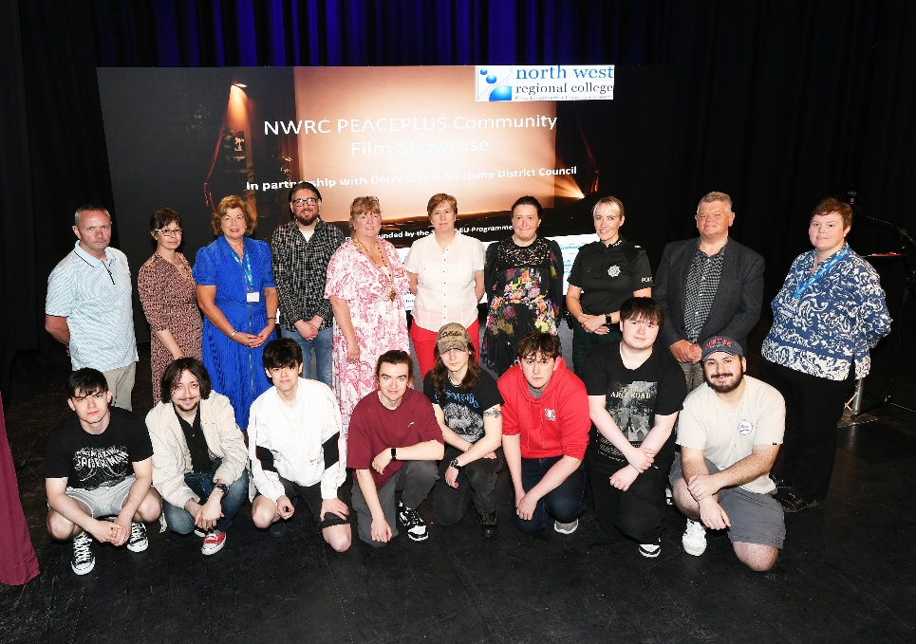

Ballyarnett Early Years PEACEPLUS Project
‘We’re seeing our [early years] parents going to different events in different parts of the city and making new friends. The project has allowed us to gain contacts with other communities.’ Charlie White – Parental Engagement Officer, Rainbow Child and Family Centre.
https://youtu.be/cVVdZgjjosk
Distance Travelled PEACEPLUS Project
‘We want to speak with one voice and to ensure that voice is heard in the city.’ Doreen Murugi, African Caribbean Community Network, Foyle Racial Equality Forum.
https://youtu.be/OzvQaDyHTKI

Park Community Hall PEACEPLUS Project
‘Park Community Hall got a new heating system, a new kitchen, disabled toilets. It’s a great shared space and a lifeline for the community.’ Carol O’Kane, Park Community Hall. ‘Attached to that was a programme of cross-community events,’ said Project Manager Minn McCann. The project was set up to address poverty, rural infrastructure. We’re here to sustain the life of this rural community.’
https://youtu.be/ajn_WW1Q36o
Waterside Together PEACEPLUS Project
‘The main goal is to transform the way people think about the area where they live and the people who live there.’ Tansy Cowley, Project Officer, Waterside Together. ‘I’ve seen people of all ages chatting and interacting. It’s about what unites us rather than what divides us.’ A young project participant said, ‘It was a really amazing opportunity to get to meet people from other communities we wouldn’t normally get to meet.’
https://youtu.be/u_j9nUuNRag
Operation Desperation PEACEPLUS Project
The Operation Desperation video shows the use of Kitsugi – the Japanese art of repairing broken pottery with gold. ‘The point is to collect stories about the history of Foyle Women’s Aid. It uses art as a vehicle for people to open up and share their stories,’ said Gary Crossan, Playhouse. ‘Without PEACEPLUS this work doesn’t happen. A lot more of these stories would never be heard,’ he added. ‘Kintsugi is a metaphor for life,’ explained the arts facilitator. ‘Those broken pieces, when fixed with gold, come out more beautiful.’ Ultimately the work will lead towards a piece of theatre.
https://youtu.be/flQudse9gLM
Our Place, Our Planet PEACEPLUS project.
Ciaran Flannagan, In Your Space project Co-ordinator said, ‘The project aimed to give young people access to ecological and arts education. The funding from PEACEPLUS has enabled us to reach 100’s of participants. Circus meets people where they are in life. This is about having a go and not being worried about failing. It’s an incredible artform for young and old people alike.’
https://youtu.be/_bFkedEIJnc

Contact us:
The PEACE Team in council can be reached via peace@derrystrabane.com
Our website is: https://www.derrystrabane.com/community/peace-plus

The PEACEPLUS Programme is a funding partnership between the European Union, the Governments of the United Kingdom and Ireland, and the Northern Ireland Executive and will be administered by the Special EU Programmes Body (SEUPB). Match-funding for this element of the PEACEPLUS Programme has been provided by the Executive Office in Northern Ireland and the Department of Housing, Planning, Community and Local Government in Ireland.

