**DCSDC PEACEPLUS Local Co-Designed Action Plan – E Newsletter May 2025**

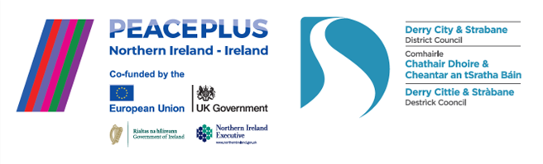

The PEACEPLUS Programme is a funding partnership between the European Union, the Governments of the United Kingdom and Ireland, and the Northern Ireland Executive and will be administered by the Special EU Programmes Body (SEUPB).

**All 58 projects now up and running!**

May has seen us achieve a huge milestone. All 58 projects in our Local PEACEPLUS Action Plan are now awarded. Huge thanks to all our communities who have worked so hard to reach this point. For individuals across our entire council area, that now means there are heaps of opportunities to take part. From Castlederg to Culmore and Creggan; Strabane to Strathfoyle to Sperrin; Cityside and Waterside there are brilliant projects. The diversity is not only in terms of geography – the projects involve anything and everything from arts, sports, community development, volunteering, training, culture, history, environment, festivals… and there is something for all age groups.

If your community group, or you as an individual, are interested in getting involved, contact us! Email us on peace@derrystrabane and we’ll try to connect you with a project that interests you. All our projects are free for participants.

**To get an idea of the projects we have on board, click here for our magazine:**

[**https://www.derrystrabane.com/community/peace-plus/co-designed-action-plan**](https://www.derrystrabane.com/community/peace-plus/co-designed-action-plan)

**Celebrating recent project launches!**

**Unlocking Silent Heritage**

May saw the launch in the Guildhall of our capital, genealogy and heritage project based around access to the hidden history in graveyards across the city and district. The capital heritage works are delivered by Council’s regeneration team and the accompanying cross-community programme is delivered by Creggan Enterprises Ltd.

**Our Shared History**

This project will engage with political ex-prisoners (loyalist and republican) and others, to explore history through talks, tours, visits, dialogue and tour guide training. Delivered by Tar Abhaile, it has a focus in the Moor area with connections across to the Waterside and wider.

**War and Peace**

This project involves the heritage restoration of four World War Memorials (Derry~Londonderry, Strabane, Castlederg and Sion Mills) by council’s regeneration team along with cross-community history and dialogue programming delivered by RAPID and the NW Cultural Partnership. It will explore the wartime history in its wider context with a range of perspectives.

**Art: Recovery to Discovery**

This Ballyarnett area project is an adult mental health community arts programme. Delivered by Greater Shantallow Community Arts, it will broaden experience of shared spaces and build friendships through a range of arts workshops on a cross-community basis.

**Cecil Frances Alexander Celebrated**

This is an inter-church cross-community project about the famous hymn-writer Cecil Frances Alexander who lived in various locations across our council area. She penned hymns such as All Things Bright and Beautiful, There is a Green Hill far away and the carol Once in Royal David’s City. Delivered by The Churches Trust, this project will connect people of diverse faiths and historical interests in workshops, study visits and lectures.

**Connecting with others and our past.**

Delivered by the Koram Centre in Strabane, this is a social engagement project for those most impacted by the Troubles and their legacy. It will include tours, trips a residential, dialogue and workshops.

**Grantfinder.**

Check out other funding options on Grantfinder: <https://search.mygrantfinder.co.uk/>

**Contact us:**

The PEACE Team in council can be reached via [peace@derrystrabane.com](mailto:peace@derrystrabane.com)

Our website is: <https://www.derrystrabane.com/community/peace-plus>

The PEACEPLUS Programme is a funding partnership between the European Union, the Governments of the United Kingdom and Ireland, and the Northern Ireland Executive and will be administered by the Special EU Programmes Body (SEUPB). Match-funding for this element of the PEACEPLUS Programme has been provided by the Executive Office in Northern Ireland and the Department of Housing, Planning, Community and Local Government in Ireland.