DCSDC PEACEPLUS Local Co-Designed Action Plan – E Newsletter September 2026
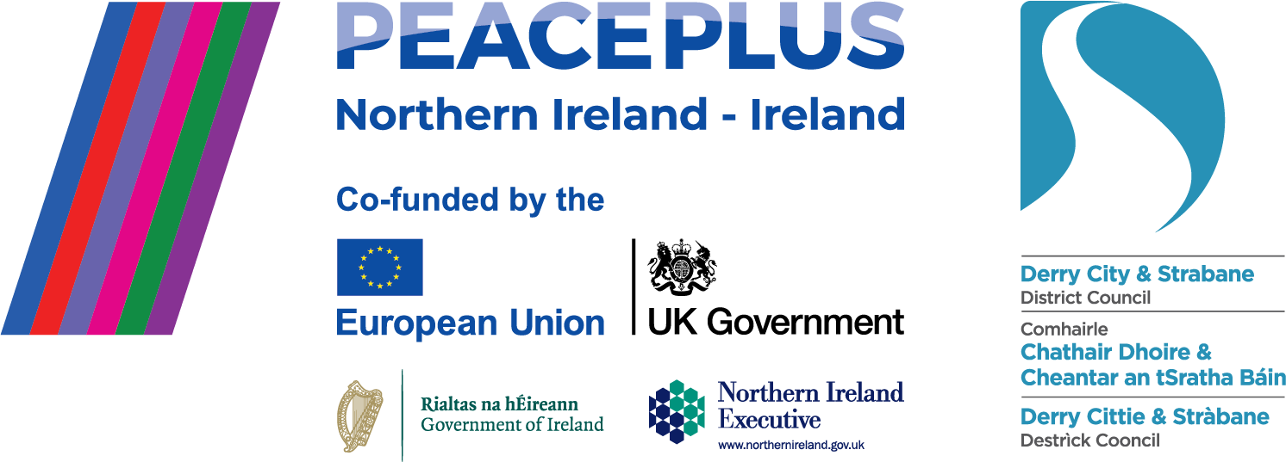

The PEACEPLUS Programme is a funding partnership between the European Union, the Governments of the United Kingdom and Ireland, and the Northern Ireland Executive and will be administered by the Special EU Programmes Body (SEUPB).
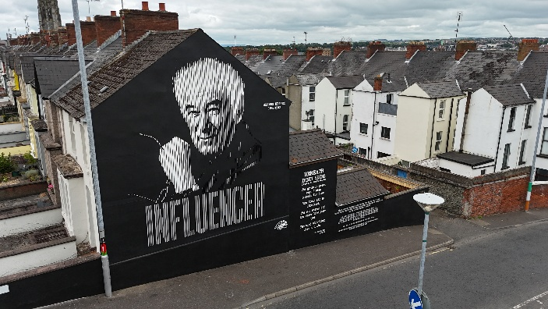
A new season with new opportunities.
September can be a little like a ‘new year.’ Why not start something new? There are still plenty of opportunities to take part in the PEACEPLUS programme or to catch up with what’s going on in our projects. Below in this e-zine is some information on events you may wish to register to attend. You can also read our 2026 Magazine here for stories and insight from our projects:
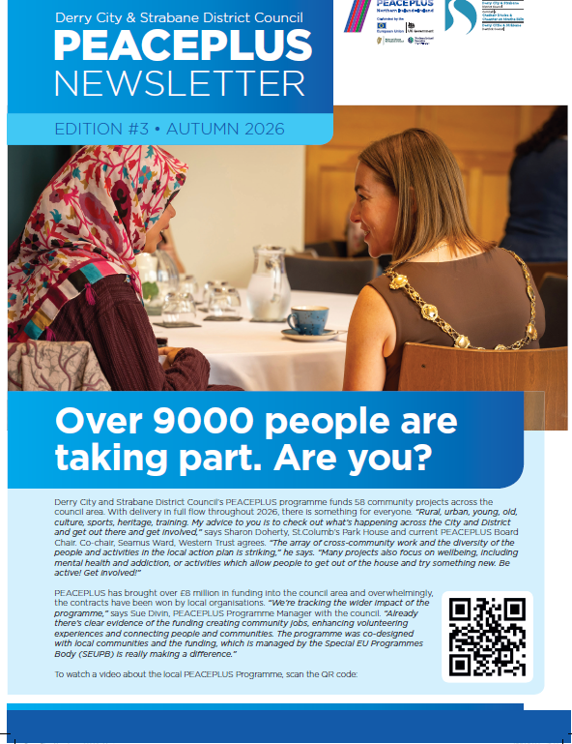 (Insert click link to magazine on our website)

Up the walls! PEACEPLUS Street Art Reimaging Project makes an impact.
‘When young people are given the opportunity to lead, art can transform spaces, spark conversations, and strengthen pride in the communities where they live,” says Ruairí O'Connell. He’s Project Coordinator at the Gasyard Wall Féile for the PEACEPLUS Street Art Project and is speaking about a series of vibrant murals popping up across the Moor area of the cityside and wider.
The murals are transformative not just as street art, but for the community processes behind them. As Ruairí explains, it’s not just a case of randomly picking a wall and paying an artist, instead local residents are engaged about concept and space before connecting young people through a series of cross-community workshops. ‘The groups learn about the history of street art and graffiti art techniques together,’ says Ruairí. ‘The idea for the Cultures in Bloom Waterside mural was to explore the growing diversity in the city. Young people from Clooney Youth Club, Our Space Youth Club, Hillcrest/Top of the Hill Youth Club and the NW Migrants Forum explored visual patterns from different cultures,’ he says. ‘A floral pattern emerged which sparked the idea of a vase of flowers. Each flower is differently coloured. The vase is green, representing Ireland and it’s a mosaic, representing all the different pieces which make up one whole.’
Often the art is replacing anti-social, political or hate-related graffiti. The stunning new Seamus Heaney Influencer mural process began after a local councillor and residents suggested the Bogside location. ‘It was a match made in heaven,’ says Ruairí. ‘Residents loved the concept and young people from Bishop Street and Newbuildings Youth Club worked together, bringing a huge amount of creativity and energy to the project… The hope is the wall won’t be defaced as the street art was generated by young people in the community.’ ‘I’m really honoured my poem is part of this mural,’ says Jude Shiels, a project participant. ‘I got to show my creative side and meet new friends from different identities.’
In Creggan, the new Trojans x Séan Dolan's art stands out proud. A collaboration between both sports clubs and the YMCA in Drumahoe, the driver for the theme was sport. ‘Sport unites,’ says Ruairí. ‘It builds emotional connection to community but also builds future citizens. We ran sports workshops, soccer and gaelic, together in Séan Dolan’s club. That inspired the images. The polaroids on the mural for example show girls making friends.’
In the pipeline are two more murals. Before wrapping up the project, expect to see an oakleaf themed mural in the Brandywell. ‘The oakleaf is synonymous with the city. A symbol everyone can get behind,’ says Ruairí. The design will be generated by cross-border participants from Oakleaf Boxing Club and Donegal Youth Service. From little acorns, mighty oaks grow. A final music themed mural exploring lyrics that unite is also being developed in collaboration between REACH Across and the Volunteer Investment Project for a central location.
‘The PEACEPLUS street art project proves creativity can bring communities together,’ says Ruairí.
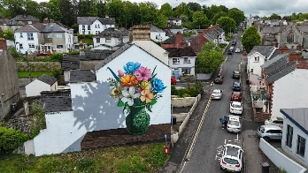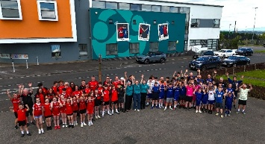

Open invite to cross-border PEACEPLUS Capacity Building and Networking Event
PEACEPLUS is a cross-border as well as cross-community programme, so we’re delighted to pass on an invite from our neighbouring Donegal County Council:
Event Details
📅 Date: Friday, 23 October 2026
📍 Venue: Mount Errigal Hotel, Ballyraine, Letterkenny, Co. Donegal
🕤 Registration and Refreshments: 9.30am
🕙 Event Start: 10.00am
🕐 Finish: 1.30pm (Lunch will be provided.)
Registration is through Eventbrite here:
https://www.eventbrite.com/e/1999389681359?aff=oddtdtcreator
This event will bring together PEACEPLUS-funded projects from across Donegal and the border region. While the primary audience is organisations and projects supported through PEACEPLUS, the event is also open to community groups, voluntary organisations, statutory agencies, and individuals from across the North-West who are committed to promoting peacebuilding, social inclusion, active participation, and positive community relations.
The event will provide an opportunity to share experiences, build new connections, learn from others, and strengthen the capacity of individuals and organisations to deliver meaningful community engagement. Through networking and collaboration, participants will explore ways to contribute to a more inclusive, connected, and peaceful society.
For further details email : peace@donegalcoco.ie

Mini Co-design process. Let’s hear your views!
If there was a limited chance for more PEACEPLUS funding in 2027, what should the priorities be? The PEACE Team would love to hear views from our local community and voluntary sector groups.
There is a possibility, but no guarantee, that in 2027 the SEUPB (Special EU Programmes Body) will have an underspend at programme level across the region. This may open an opportunity for councils to bid for 'underspend' monies through the Local Co-Designed Action Plan. There is zero guarantee of any funding at all, but it could be a good strategic step to think ahead.
If you have views or expertise you would like to input into the process, please register for a meeting and/or complete the questionnaire.
- Wednesday 9th September 2pm – 3.30pm The Hub, Sollus Centre, Bready.
Open invite / Community & Voluntary Sector / Existing DCSDC area PEACEPLUS Projects
Register for free here:
Local DCSDC PEACEPLUS 'Mini-codesign' community meeting Tickets, Wednesday 9 September • 2 PM - 3:30 PM | Eventbrite
- Tuesday 15th September 6.30pm – 7.30pm Online
Open invite / Community & Voluntary Sector / Existing DCSDC area PEACEPLUS Projects
Register for free here:
Online: Local DCSDC PEACEPLUS 'Mini-codesign' community meeting Tickets, Tuesday 15 September-Thursday 15 October • 6:30 PM-7:30 PM GMT+1 | Eventbrite
Questionnaire open for responses:
PEACEPLUS - Possible 2027 SEUPB Level Underspend - Co-design/Market Testing. – Fill out form
Contact us:
The PEACE Team in council can be reached via peace@derrystrabane.com
Our website is: https://www.derrystrabane.com/community/peace-plus
The PEACEPLUS Programme is a funding partnership between the European Union, the Governments of the United Kingdom and Ireland, and the Northern Ireland Executive and will be administered by the Special EU Programmes Body (SEUPB). Match-funding for this element of the PEACEPLUS Programme has been provided by the Executive Office in Northern Ireland and the Department of Housing, Planning, Community and Local Government in Ireland.

