DCSDC PEACEPLUS Local Co-Designed Action Plan – E Newsletter November 2025

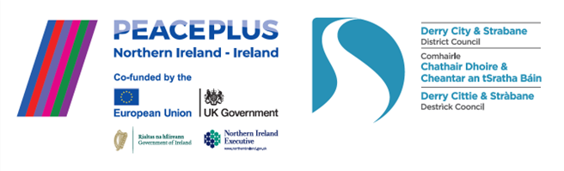

The PEACEPLUS Programme is a funding partnership between the European Union, the Governments of the United Kingdom and Ireland, and the Northern Ireland Executive and will be administered by the Special EU Programmes Body (SEUPB).

A snapshot of the action…

It’s November. The dark nights are in and there’s a quare drop in the temperature. For the PEACEPLUS Programme though, activity is heating up. All of our 58 projects are launched and delivering activities for local people and communities. In this e-newsletter, we give you a snapshot of just some of the activity being funded across our council area.

‘Community Regeneration and Transformation’

This theme is about community places and spaces. Re-imaging, refurbing, increasing usage from diverse identities. Pictured below is line dancing in the newly refurbished Park Community Hall, the launch of the Street Art Project, Waterside Together black and white photography workshops, a new community kitchen in our Food Poverty project and a new shed facility in Newtownstewart community garden.

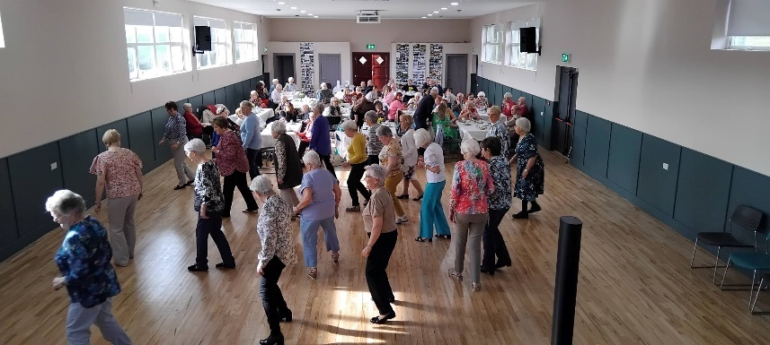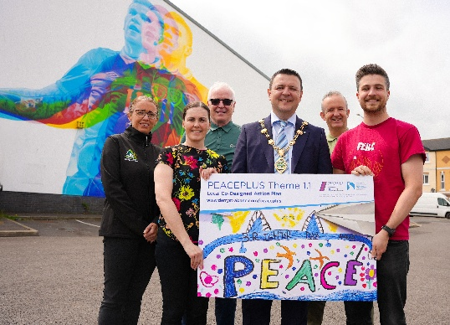
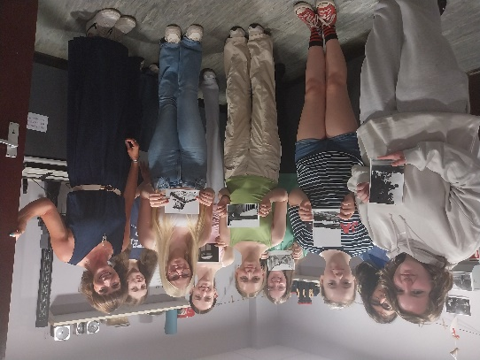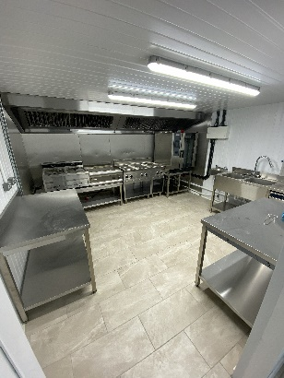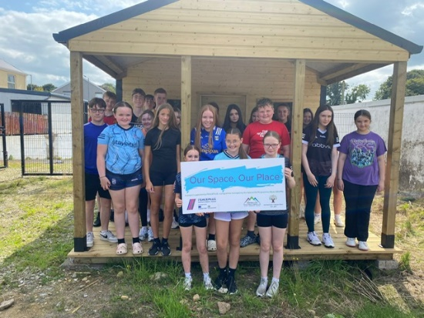

‘Thriving and Peaceful Communities’

This theme is about collaboration and partnership working between people and groups from different identities and brining people together on issues of common interest.

Pictured below are images of adults enjoying arts workshops from the Art: Recovery to Discovery project in Shantallow; youth performances in the Create: Youth Digital project; children engaging with environment in Our Place, Our Planet; Strabane Youth Project learning about farming; the IDEA (Intergenerational Dialogue Engaging Arts) project bringing together generations through arts; upcycling in the Reimage, recycle project; learning new sports in Cricket Connects and a day away fishing in the Farming and Environmental Champions project.

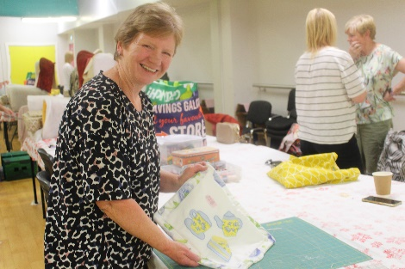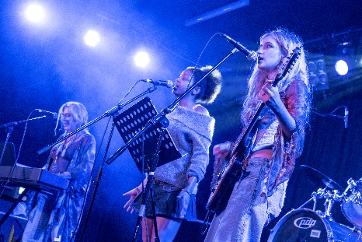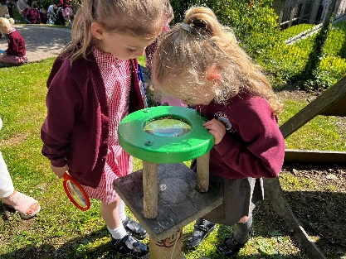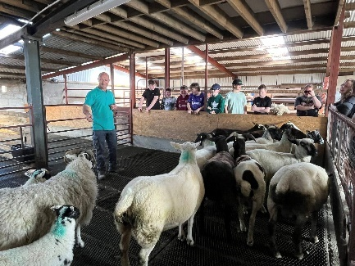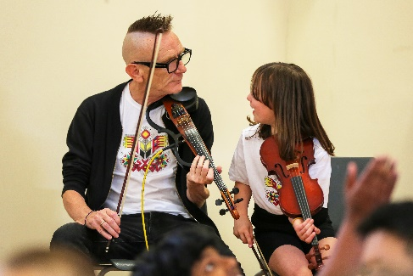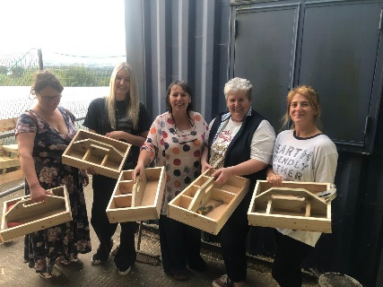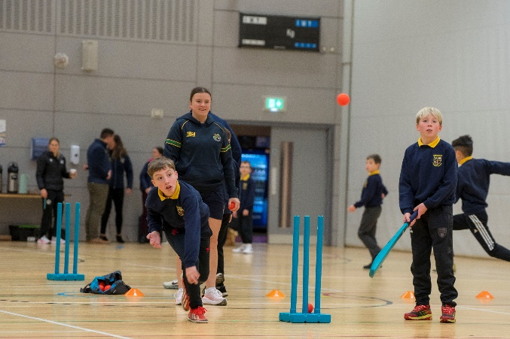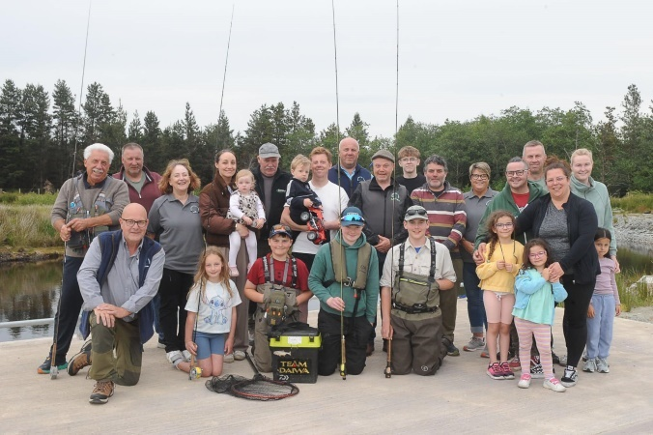

‘Celebrating Cultural Diversity’
This theme has a focus on reaching the most marginalised in our communities, tackling some of the bigger peace-building issues, exploring opinions on hot topics and promoting awareness and understanding of diverse cultures and identities. Below is a snapshot of projects including Our Journey to Peace, Culmore Connections, The Culture Club in Castlederg, Let’s Talk Youth, Muintearas, The Connect Project, Our Shared History, and Centre of Hope.
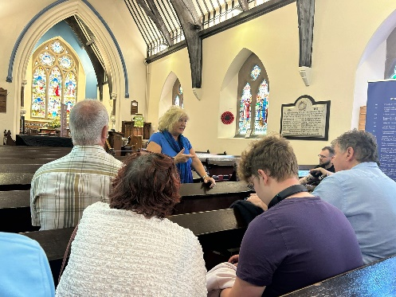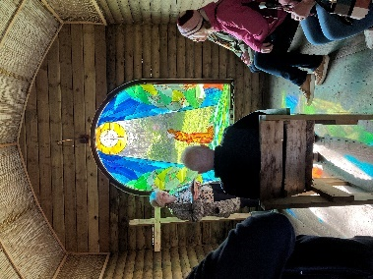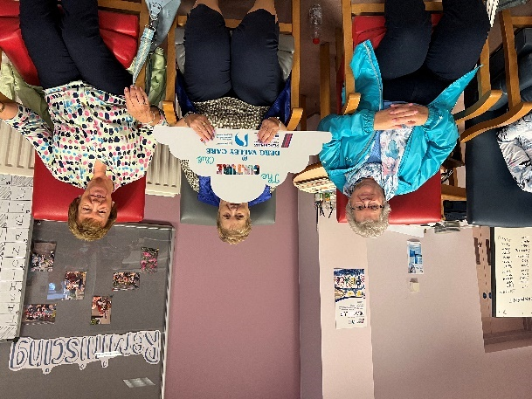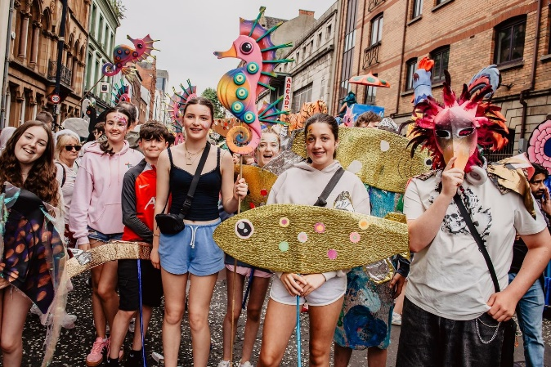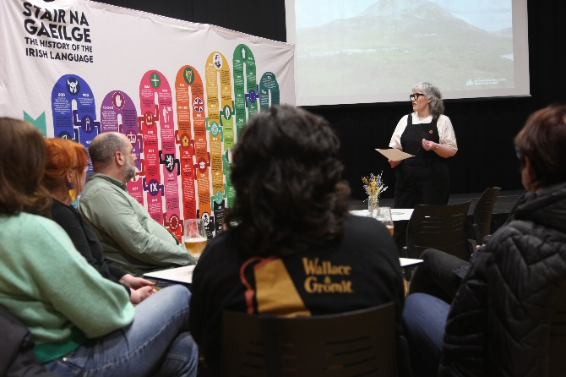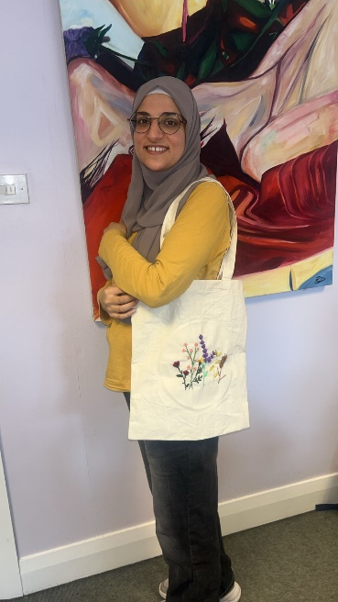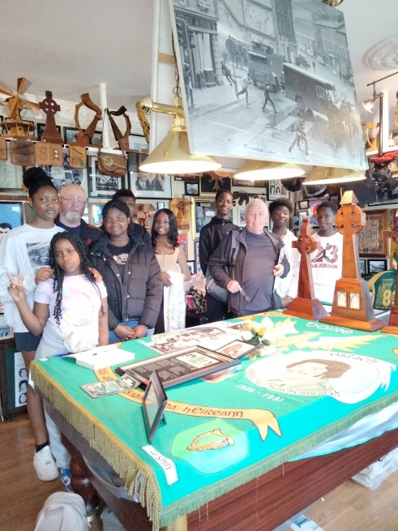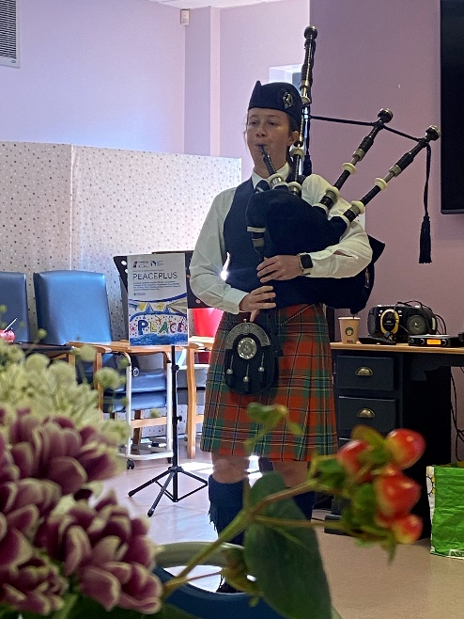

Read our Autumn Magazine (stories and funding) here:
(Insert Autumn 2025 magazine link)

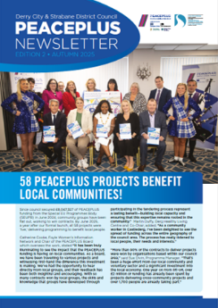
Want to take part?
Given the peace team a call on 028 71253253 or email us on peace@derrystrabane.com and we’ll try to link you with a project which suits your interests and needs. All our projects are free to take part in.

Contact us:
The PEACE Team in council can be reached via peace@derrystrabane.com
Our website is: https://www.derrystrabane.com/community/peace-plus

The PEACEPLUS Programme is a funding partnership between the European Union, the Governments of the United Kingdom and Ireland, and the Northern Ireland Executive and will be administered by the Special EU Programmes Body (SEUPB). Match-funding for this element of the PEACEPLUS Programme has been provided by the Executive Office in Northern Ireland and the Department of Housing, Planning, Community and Local Government in Ireland.

