DCSDC PEACEPLUS Local Co-Designed Action Plan – E Newsletter June 2026
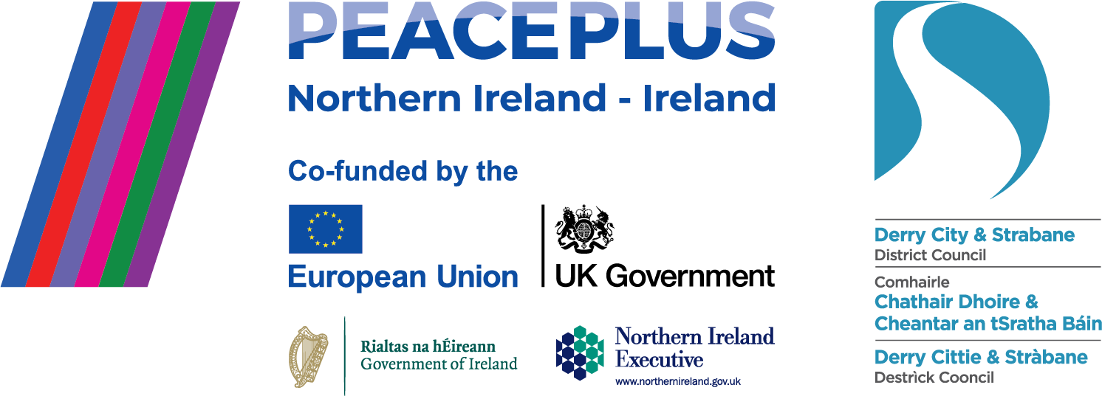

The PEACEPLUS Programme is a funding partnership between the European Union, the Governments of the United Kingdom and Ireland, and the Northern Ireland Executive and will be administered by the Special EU Programmes Body (SEUPB).
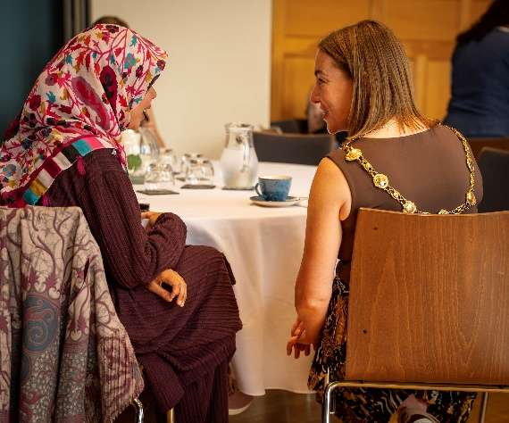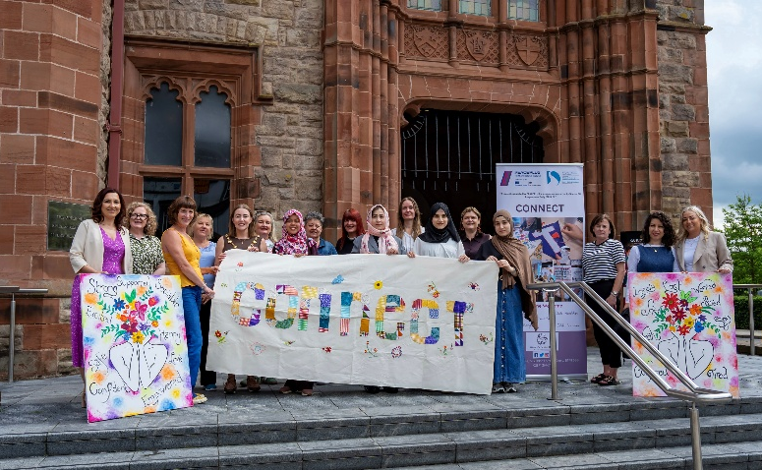
Sailing into Summer with PEACEPLUS Projects.
It’s June. The local Foyle Maritime Festival will soon be in full swing and our PEACEPLUS projects are sailing on with lots of activities for everyone across the City and District. This e-newsletter celebrates in images, some of that work. Our 58 funded projects have over 60 national identities taking part alongside participants defining as British, Irish and Northern Irish. This month we’re celebrating two positive projects delivered with, by and for local minoritised identities.
The ‘CONNECT’ project, delivered through The Women’s Centre, Derry, drew to a successful close in an event with the new Mayor, Grace Uí Niallais in the Guildhall. ‘When women are empowered, communities become stronger,’ stated the Mayor. The project connects women, newly arrived into the area, with women living here longer term. ‘It was very helpful for me to be connected with the community,’ said a young woman originally from Kurdistan/Iran who has been in the city a year. ‘I realised that when we are in these programmes we learn from different cultures. Even though we are from different places, we have many things in common. These kinds of programmes help people to feel welcome and useful in this society.’
The ‘People’s Café’ project, delivered through the NW Migrants Centre, officially opened the newly refurbished café space within their premises. The celebration, which included many high-profile speakers, also sent out a clear message for the council area that not just this specific space, but every place and service in our council area should feel inclusive and accessible. Racism should be given the red card. ‘Please talk to your racist Uncle,’ said one speaker. It was also articulated that the UN ‘Recognises racism and sectarianism as essentially two sides of the one coin,’ and how much of the challenge ‘is online, not on the streets.’ ‘Let’s work to change the conversation,’ said one panellist. ‘I don’t want to be having the same conversation in 5 years about safety and tolerance. Multi-culturalism is a phenomenal opportunity for a society. Let’s talk about that.’
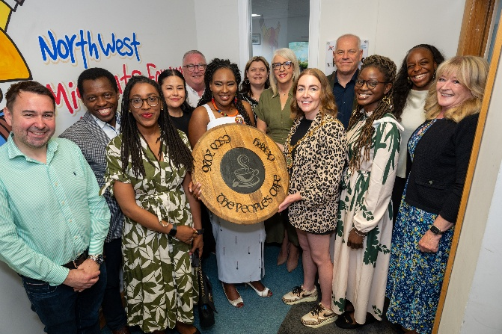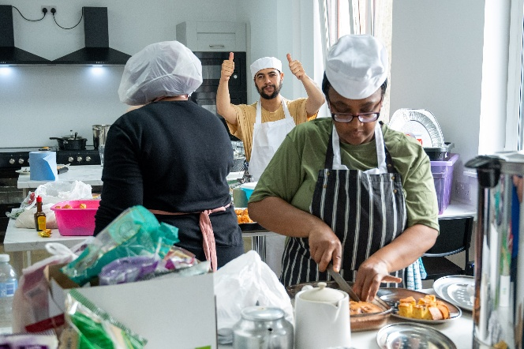

Community Regeneration and Transformation Theme.
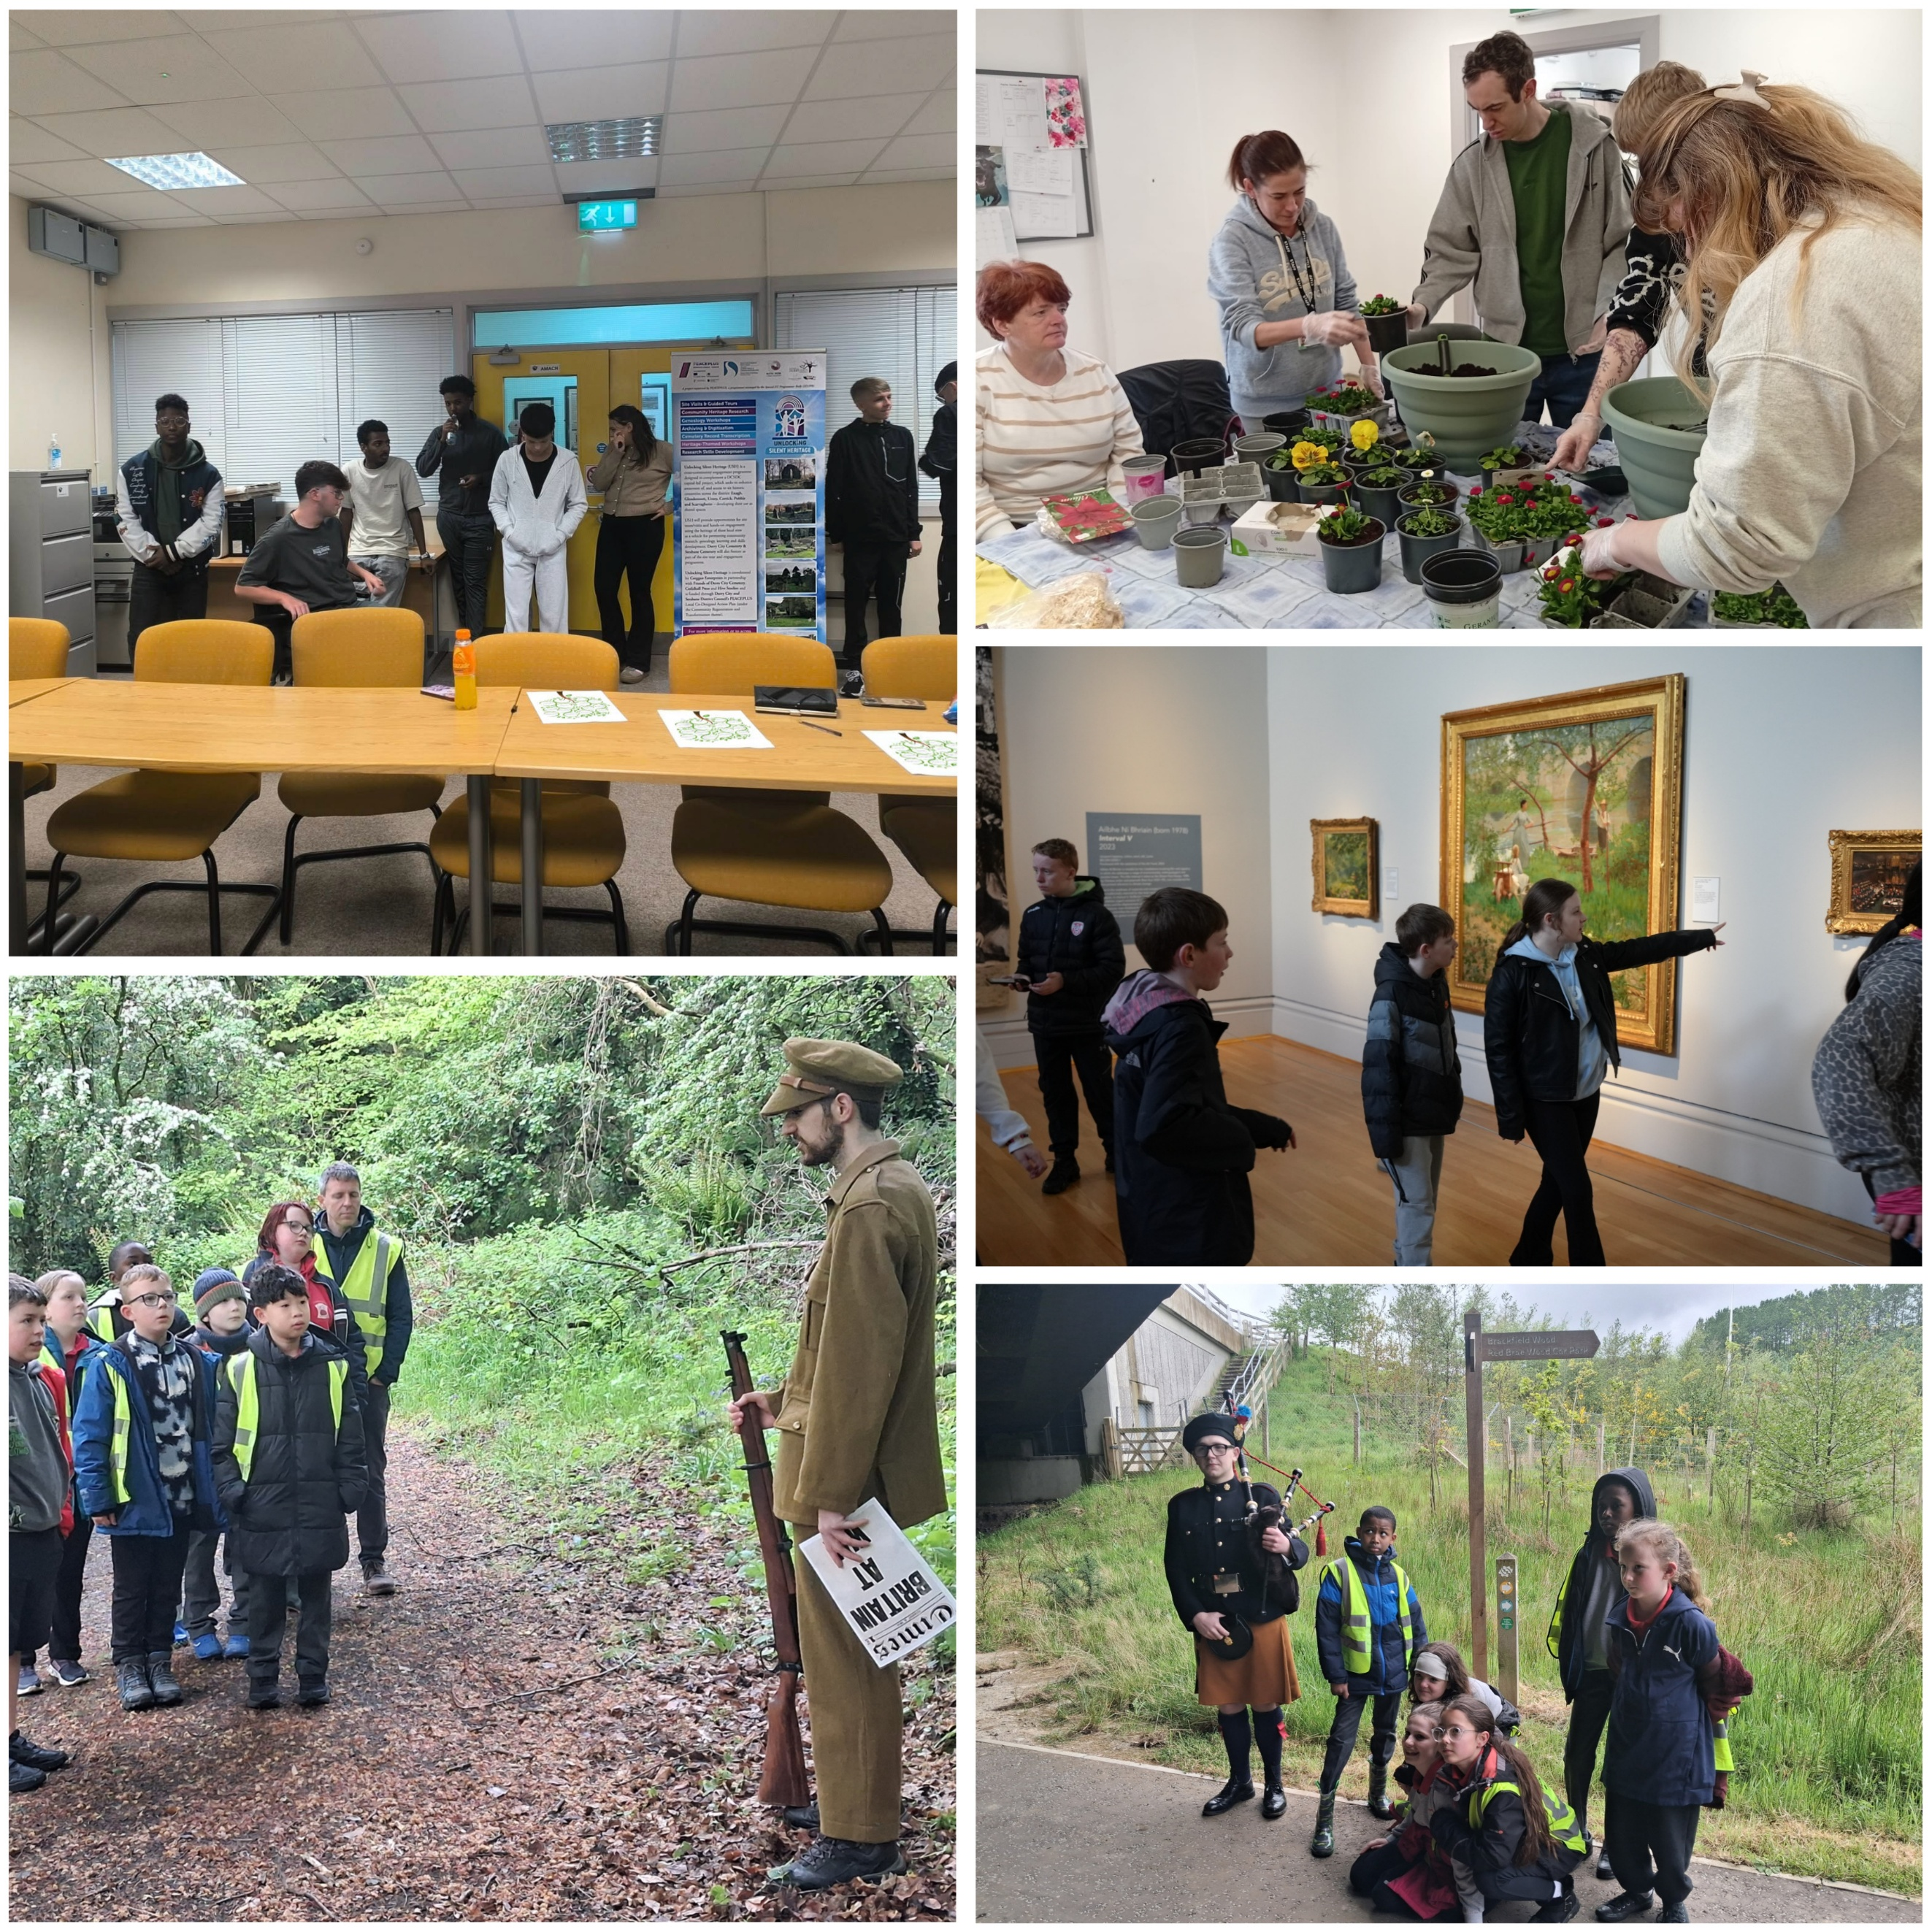

Within the Community Regeneration and Transformation theme, projects have encouraged young people to learn, connect and engage with their communities in meaningful ways. The Unlocking Silent Heritage project brought youth groups together to explore local history and discover stories from the past, while the War & Peace project took participants on educational field trips where actors recreated historical events, helping young people gain a deeper understanding of conflict and reconciliation. In the city, the Urban Social Farm project worked alongside the learning-disabled community, teaching practical skills such as plant potting and promoting inclusion through shared learning. The Street Art Reimagined project showcased Belfast’s rich artistic heritage, taking groups on tours of the city’s famous murals and museums to explore the history, culture and stories behind its public art.
Thriving and Peaceful Communities Theme.
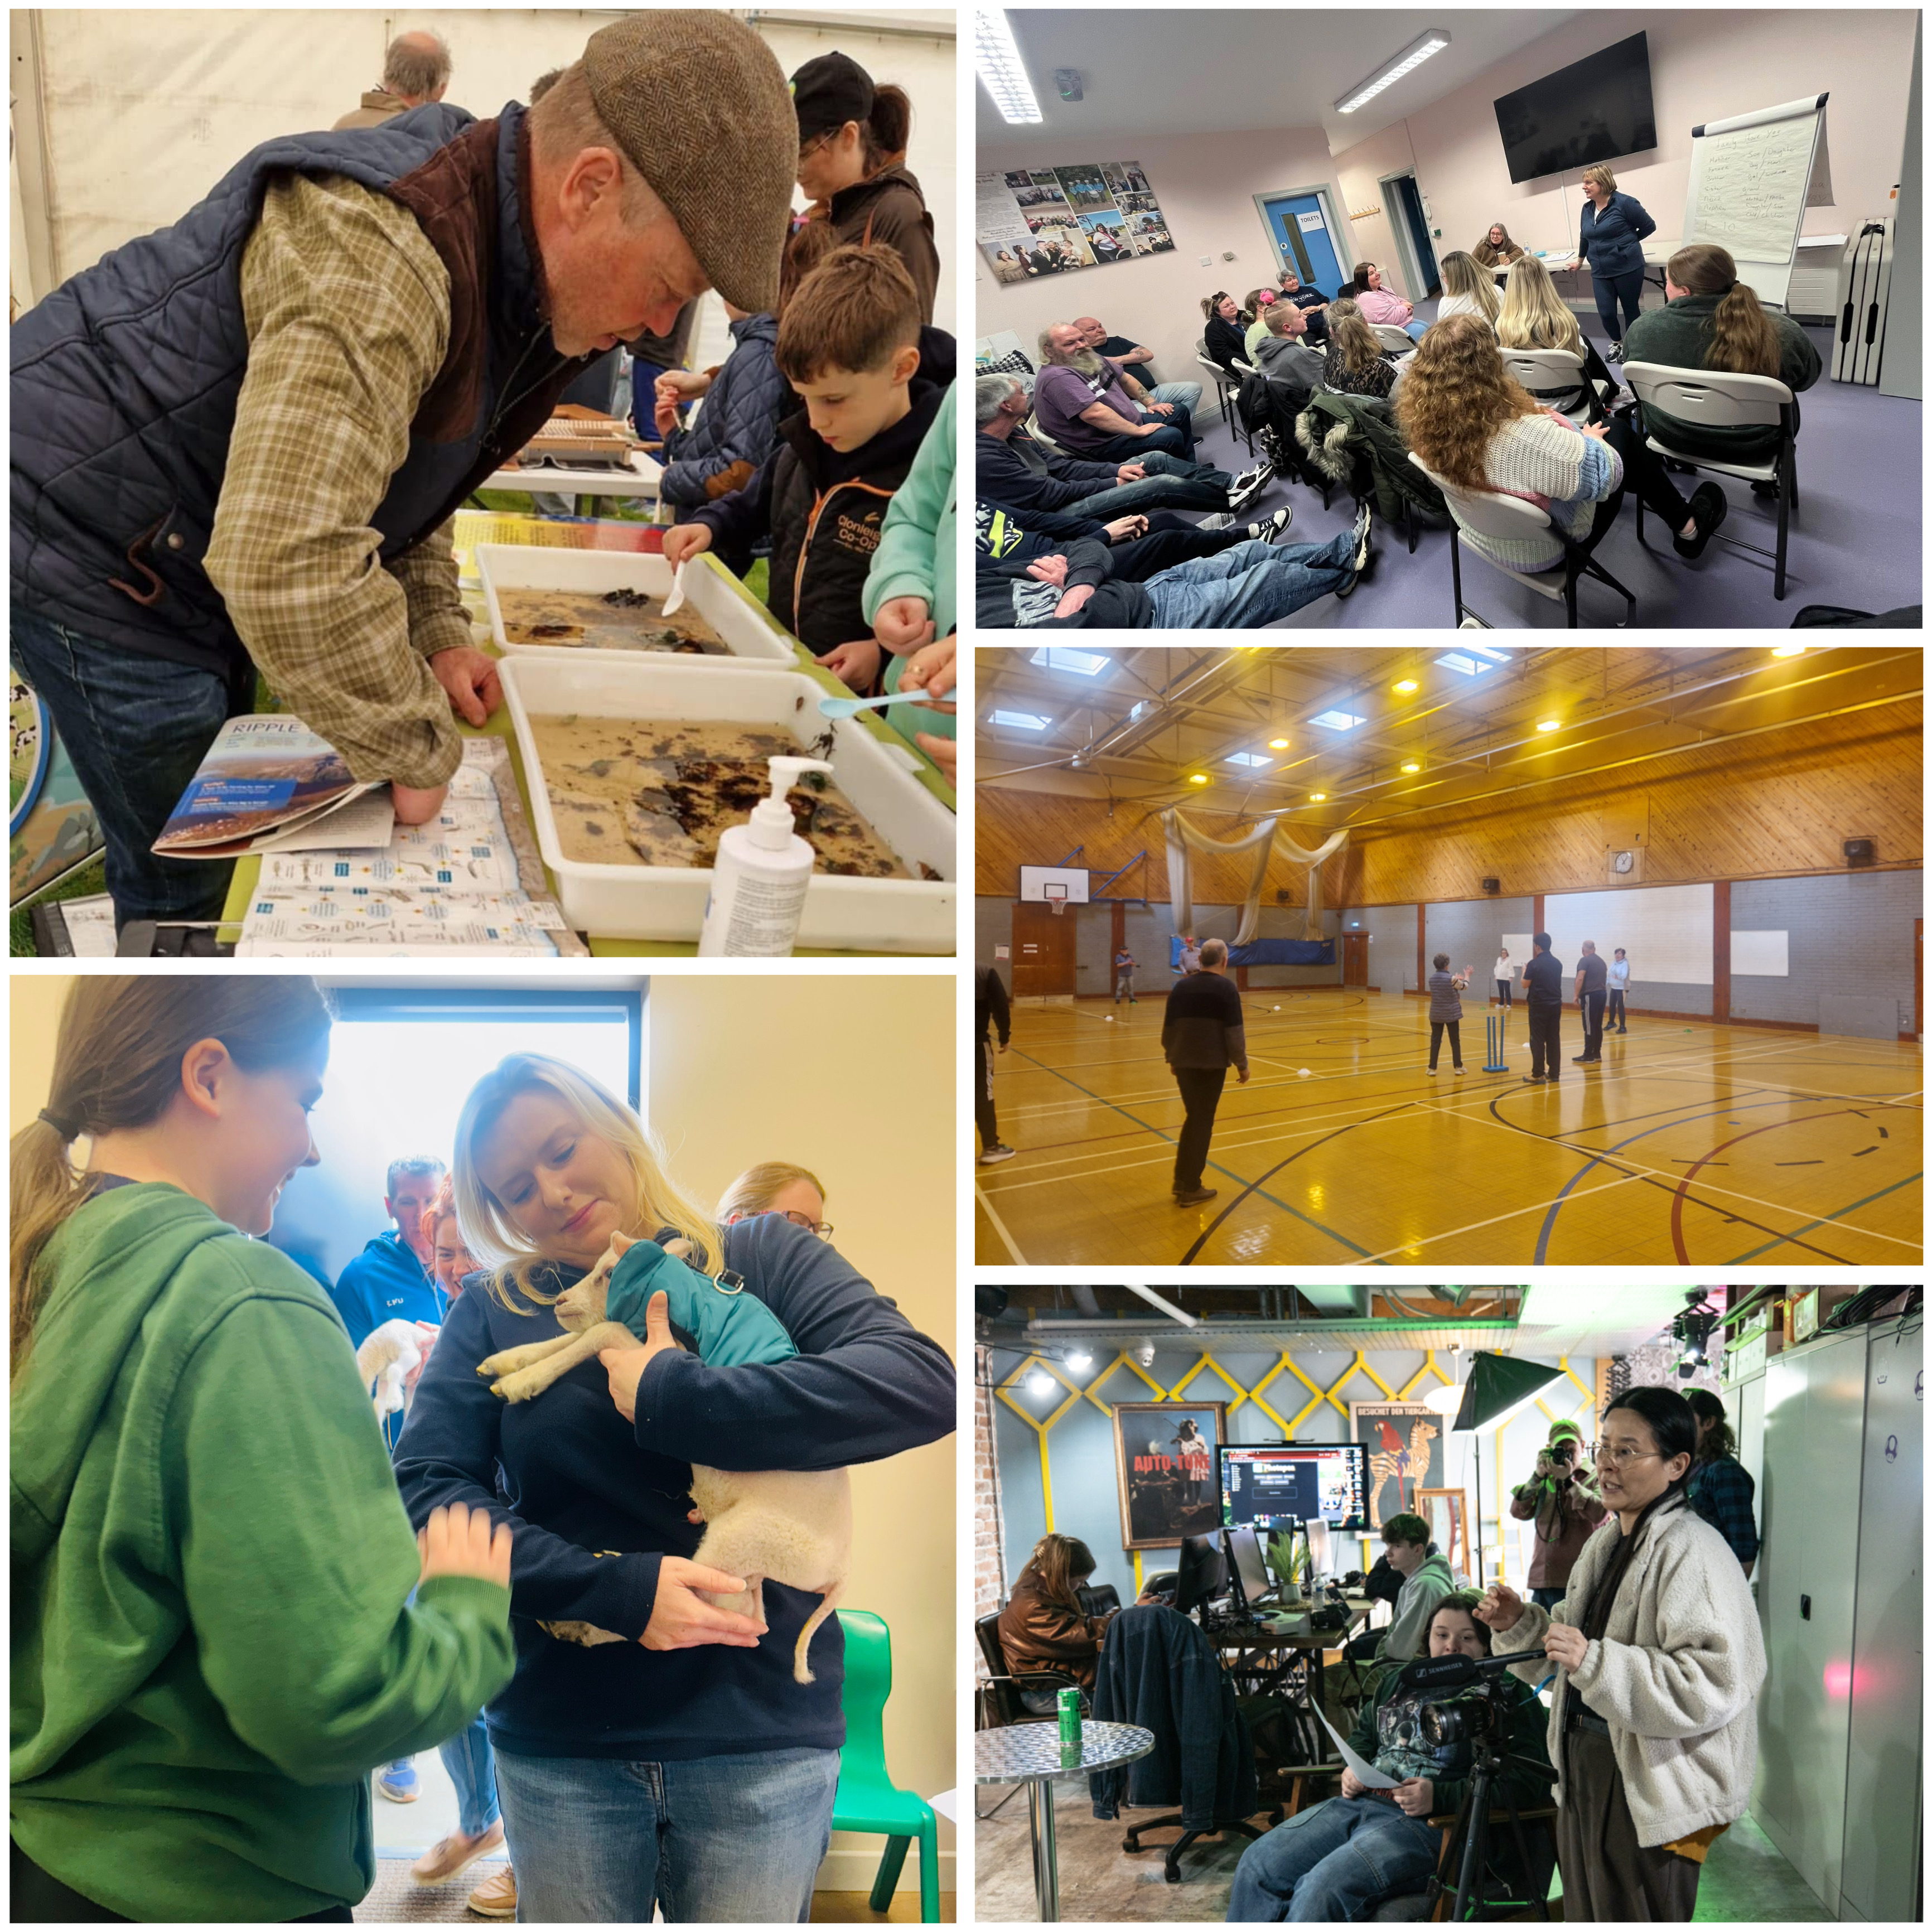

Within the Thriving and Peaceful Communities theme, projects have focused on improving wellbeing, promoting inclusion and creating opportunities for people of all ages to learn and thrive together. The Empowered Communities Strabane project encouraged older members of the community to stay active and social through fun activities such as walking cricket events. The Be Wild project gave participants the chance to interact with a variety of animals, including goats and horses, helping to build confidence and a greater appreciation for nature. Through the Farming and Environmental Champions project, participants learned from professionals working in the agricultural and environmental sectors, gaining hands-on experience and insight into their day-to-day roles. The Dare 2 Dream project delivered British Sign Language classes, raising awareness of accessibility and helping to create more inclusive communities. Meanwhile, the Create Youth and Music Digital project provided aspiring young creatives with opportunities to develop skills in camera work and digital media, learning from experienced professionals and gaining valuable industry experience.

Celebrating Cultural Diversity Theme.
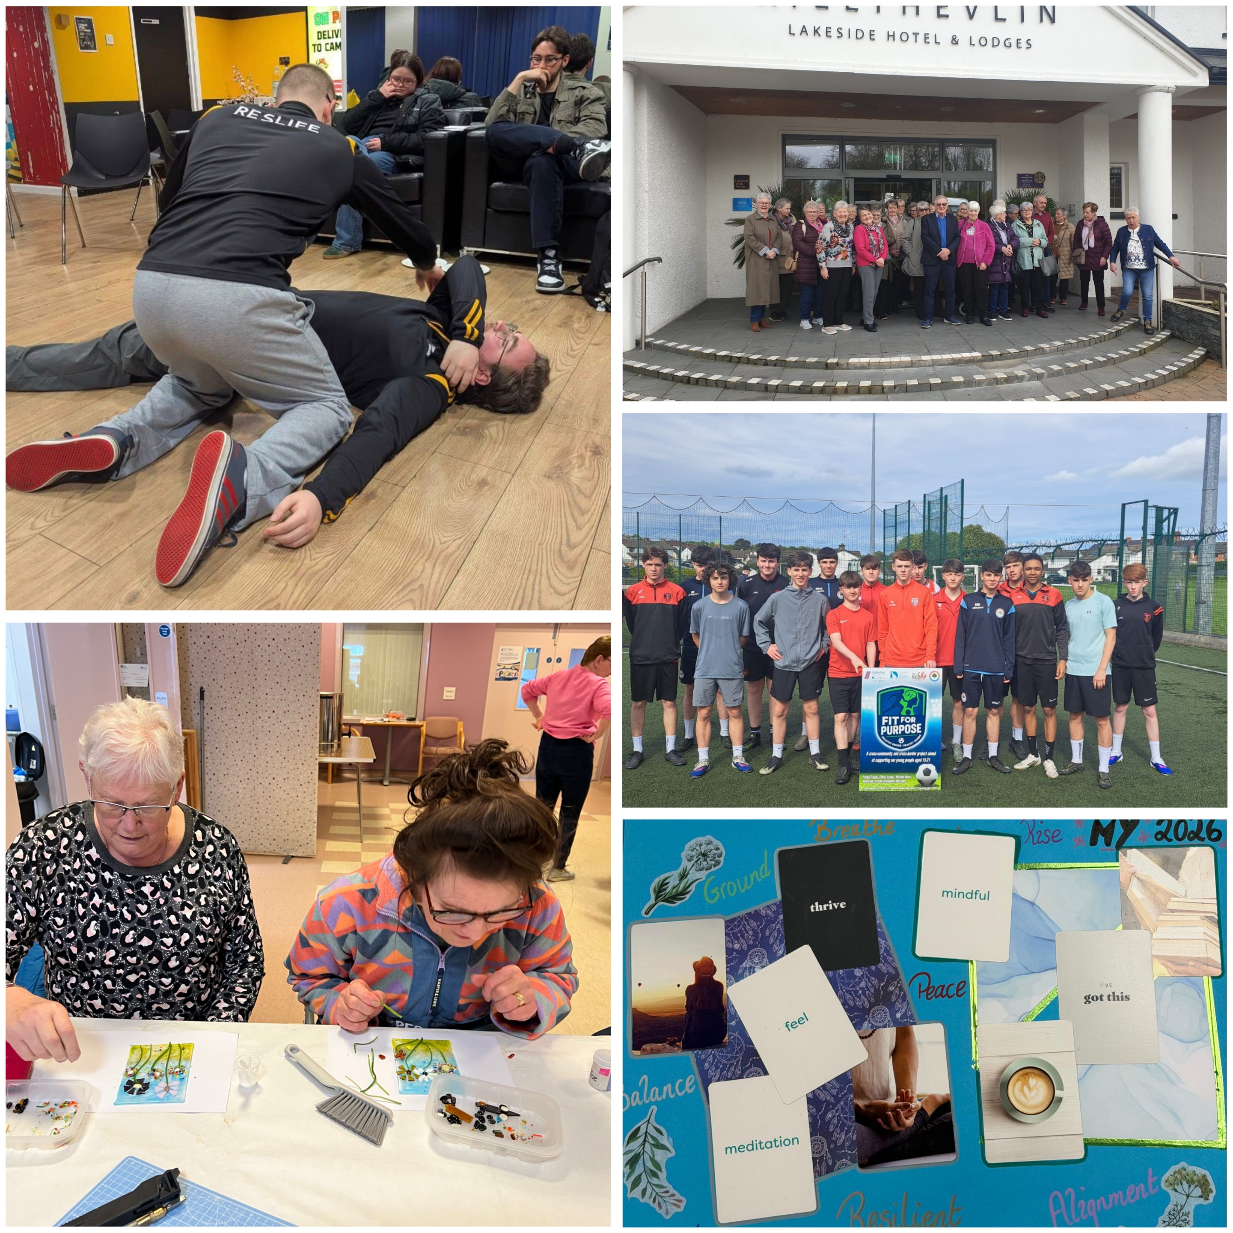

Within the Celebrating Cultural Diversity theme, projects have brought people together to learn from one another, celebrate different experiences and build stronger, more inclusive communities. The Humankind project saw Reslife working with participants at the Duncreggan Student Village, creating opportunities for social connection and shared experiences. Participants in the Our Present Past project took part in educational day trips to Enniskillen Castle, where they explored local history while building friendships and strengthening community bonds. The Culture Club project encouraged creativity and self-expression through the unique craft of glass making, allowing participants to develop new artistic skills. Meanwhile, Fit for Purpose continued to promote health and wellbeing among young people through activities such as football and workshops focused on healthy lifestyles. The Freedom Project provided a safe and engaging space for participants to reflect on the meaning of peace and discuss how it can be achieved within communities, using interactive card-based activities to encourage conversation, understanding and shared learning.

Contact us:
The PEACE Team in council can be reached via peace@derrystrabane.com
Our website is: https://www.derrystrabane.com/community/peace-plus

The PEACEPLUS Programme is a funding partnership between the European Union, the Governments of the United Kingdom and Ireland, and the Northern Ireland Executive and will be administered by the Special EU Programmes Body (SEUPB). Match-funding for this element of the PEACEPLUS Programme has been provided by the Executive Office in Northern Ireland and the Department of Housing, Planning, Community and Local Government in Ireland.

