DCSDC PEACEPLUS Local Co-Designed Action Plan – E Newsletter October 2025

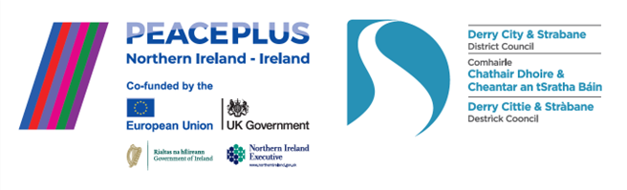

The PEACEPLUS Programme is a funding partnership between the European Union, the Governments of the United Kingdom and Ireland, and the Northern Ireland Executive and will be administered by the Special EU Programmes Body (SEUPB).

PEACEPLUS Projects Engage in Networking Conference.

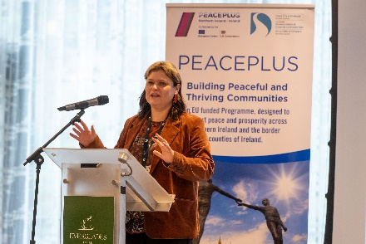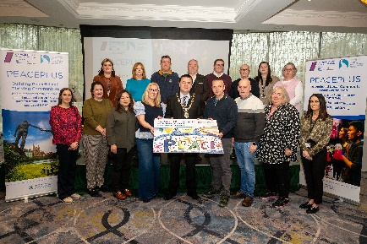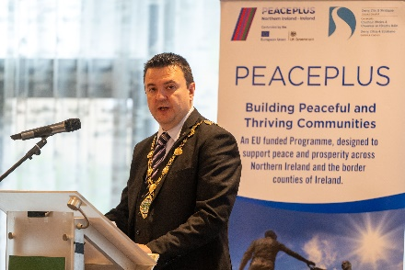
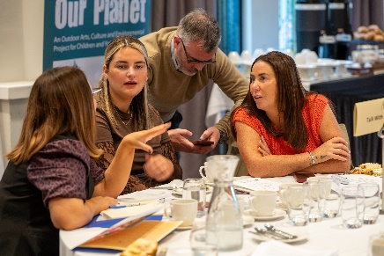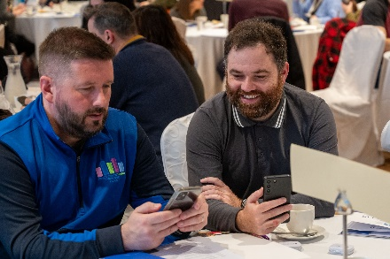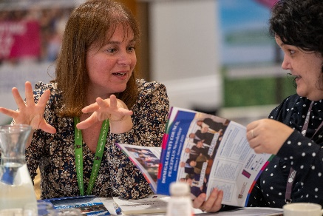

Around 65 community workers from across our 58 funded projects met together, with others, for a hugely successful PEACEPLUS Networking day on 21st October 2025.

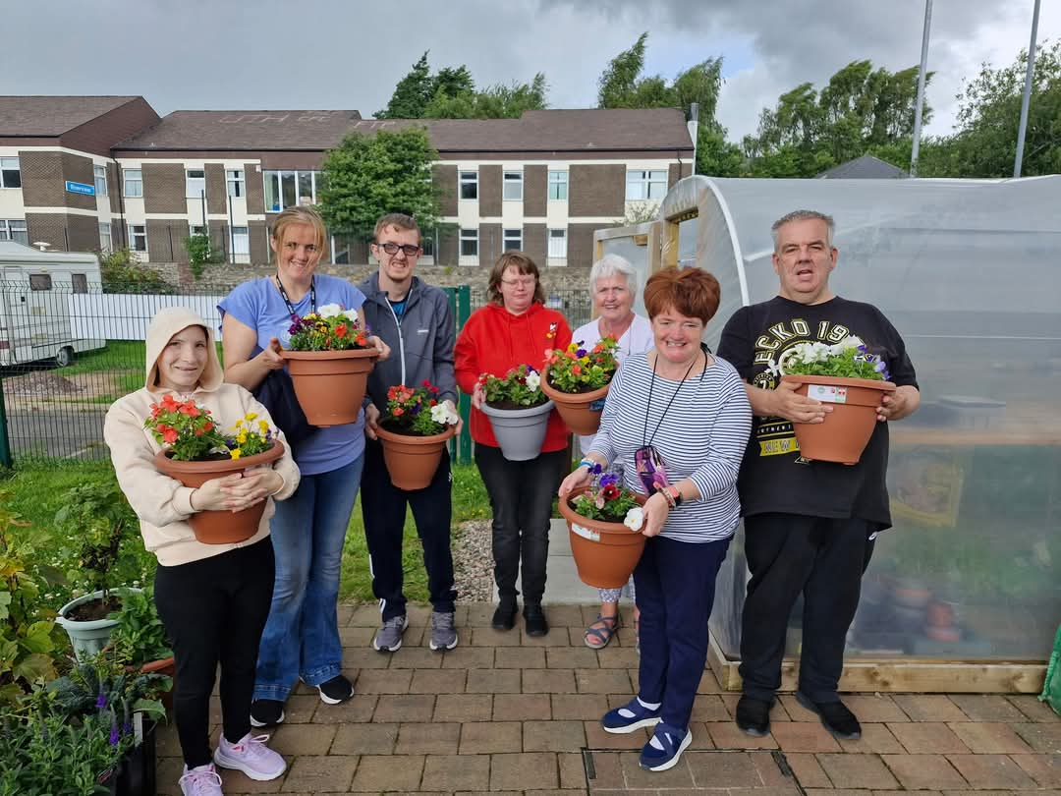
PEACEPLUS Urban Social Farm Project – Destined.
Get involved in PEACEPLUS!
Here’s a handful of free opportunities you might be interested in taking part in:

- Cecil Frances Alexander PEACEPLUS Project - 1st Nov Lantern Walk (Strabane).
'All Souls' Lantern Walk in Strabane on Saturday, November 1st 5pm to 9pm. Help us to create a river of light through Strabane town centre. Meeting place is the Canal Car Park (behind the Alley Theatre) at 4.45pm - 5pm.
An exploration of historical buildings of faith in Strabane. Join us as we delve into the history of the structures, windows and interiors of these magnificent spaces, while relaying the story of Cecil Frances Alexander in a seven-stop guided walking tour. All are welcome, please bring a torch or your own lantern (no candles please). Children must be accompanied. Refreshments will be served at St. Patrick's Hall near The Church of the Immaculate Conception from 8.30pm to 9pm. This is a gentle walking tour suitable for families with young children. A bus will be provided from/to Killeter for this event.
2. An evening with Cecil Frances Alexander, The Old Rectory, Fahan, Co. Donegal. Saturday, November 15th from 6pm to 9pm.
This promises to be an incredibly unique evening, which will be hosted by an actor from Living Breath Productions, directed by Ruth Garvey Williams. We will have inspirational, inflatable, garden light-sculptures from the Inishowen Carnival Group, A Discussion Panel on the life and influence of Cecil Frances Alexander (6pm - 7.30pm) with Eva Baxter from Enniskillen, Gordon Smyth of Christchurch, Strabane and Elizabeth Fielding of St. Columb's Cathedral in Derry. Contact to book a place: sineadsmyth@thechurchestrust.org.uk
- An evening with Sam McBride and Fintan O’Toole. 9th December 6pm @ Holywell Trust, Derry.
As part of Holywell Trust’s Forward Thinking Project, we are pleased to welcome Fintan O’Toole and Sam McBride to join us to discuss their new book, ‘For and Against a United Ireland.’ The publication was commissioned by the ARINS Project. Signed copies will be available to purchase on the night.
The event is at 6pm on Tuesday 9th December at Holywell Trust. It is free to attend, but you must register to attend as tickets will be limited:
https://www.eventbrite.co.uk/e/forward-thinking-event-with-fintan-otoole-sam-mcbride-tickets-1856964333309

A Journey to India (almost).
Travel to India isn’t exactly eligible under PEACEPLUS funding, but pupils at Sion Mills Integrated Primary School have had the next best thing. Sat cross-legged on the assembly hall floor, pupils from P1 to P7 wait in anticipation, their school mission statement painted onto the wall. We are here to help you smile, share experiences built on mutual respect, that inspire lifelong learning through opportunities to excel as individuals. It could be a motto for PEACEPLUS.
Hush descends as performer-facilitator Lauren, wordless, strides across the wooden boards and strikes an imposing stance in a red, gold and blue costume. Indian folk music sounds and, as she begins to dance there is rapt attention, followed by spontaneous applause.
Ms McGinley, P6 teacher, introduces the IDEA, Intergenerational Dialogue Engaging Arts, project. ‘P6 have been on an incredible journey. We’ve had workshops every Monday afternoon for eight weeks, learning about a culture from another country to create this performance – a whole synergy of Indian music and dance. Please put your hands together for P6!’
A class of 9 and 10-year-olds enter, dressed in colourful Indian costume. ‘Hari Pani is the term in Rajasthan for women who travel miles across the desert in search of water for their village,’ begins the narrator. ‘Heavy pots are balanced on their heads. As they return to their village, they teach strength and resilience to their community.’ Professional musician, Josie, and young violinists, viola players and percussionists, strike up Indian music. Facilitator, Marty, energises the singing of a Rajasthani folk song as the group dance in spins of turquoise, green, pink and orange, enacting a choreographed tale buzzing with energy.
‘I’m blown away by the work the facilitators and children have put into this,’ says Amy from organisation Arts Ekta who are delivering the project. ‘Learning about other cultures and having fun - we’re grateful to all the schools and communities engaging in this project.’
‘We were delighted to be selected for this PEACEPLUS project,’ says Ms McGinley after the event. ‘This wee corner of the earth is getting a taste of that lovely, lovely culture. One day, when we started, we had a Mandarin language teacher in the school on the same day as this Indian project. It struck me that, on that day, our pupils in our village were experiencing the cultures of 4.2 billion people. That’s cultural diversity at its very best. With experiences like these, we become better citizens.’
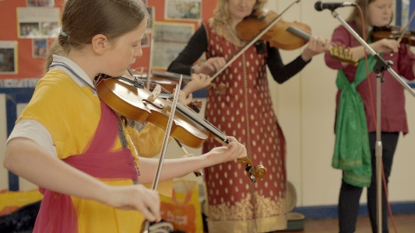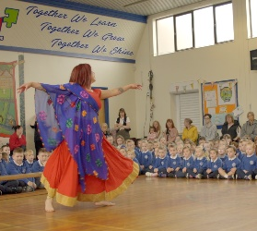

The Exodus Project
It’s an event that perhaps, should have happened long ago. A community project, exploring the The Exodus - a decline in the 18,000 strong Protestant population of Londonderry’s ‘cityside’ pre-Troubles to 3000 in 1993 to roughly 350 today. Why?
‘Elements of our past should be explored with clarity and honesty to assist our future,’ says Derek Moore, introducing the project delivered by the NW Cultural Partnership. He speaks of half a century of frustration and hurt. ‘This displacement story… the memory was allowed to fade and be undermined, impacting relationships and cohesion. Our research will be very balanced, open and include views from a range of perspectives.’
Jonathan Burgess, Blue Eagle Productions, introduces a dramatized scene from his play, The Exodus. ‘It’ll give you a sense of the trepidation and fear that was felt.’ Two actors grace the stage. The dialogue pulls no punches. ‘Fourteen Protestant families moved in one night.’ ‘This is still your town.’ ‘Well, it doesn’t feel like it.’
The impact on the Protestant community psyche is outlined by Brian Dougherty, CEO, MBE. ‘It influenced business, community and the economy. The whole demography and geography of the city changed. We’re hoping to produce a definitive piece of research, including going to estates directly impacted – Newbuildings, Irish Street, Clooney, Tullyally, Caw-Nelson Drive, The Fountain – but also people who lost neighbours, Creggan, the Bogside, Rosemount, Culmore, rural Donegal. Those areas were impacted too. We hope to reconnect people, to reflect on the findings and to look at how we as a city move forward.’
‘There are so many personal stories,’ says Lord William Hay, Apprentice Boys of Derry. ‘It had immense impact on cross-community work in the city. We all have a duty to tell the story authentically and see how we can heal.’
Jeanette Warke, Cathedral Youth Club, shares her personal experience. ‘My roots are where I was born, in Bellview Avenue on Bishop Street and, when I got married, in Mountjoy Street. That, to me, is still my home.’ She takes a deep breath, speaks of peering from skylights, terrified, hearing the crack of gunfire. Of verbal, sectarian threats to burn their home. Of shootings. Her husband caught in gunfire. ‘Our kids were 8, 5 and 2. The fear was instilled in us and my Catholic neighbours.’ She pauses, emotional. ‘We had to leave a community where I had grown up. Our school. Our church. Packing our stuff, I felt so vulnerable and degraded. We were Protestants and we were not welcome in our own city. We were too scared to voice opinions. Until now.’
Reflective, the Mayor, Ruairí McHugh speaks from the heart. ‘This is my first time in The Fountain, in Londonderry,’ he says. ‘I bet you never thought you’d hear me say that.’ His presence is welcomed. Acknowledging the Exodus as a raw wound in our local history, he notes the importance of this PEACEPLUS project, anticipating that it will be both inspiring and poignant. ‘I’m reminded,’ he says, ‘of a famous Irish proverb which, translated into English says It is in the shelter of each other, that people live. Perhaps that’s something to reflect on as we move forward together in reconciliation to make our city and district a place where everyone is welcomed and valued.’
It’s an event that sits with you even afterwards, as you walk, in the drizzle, to your car. One of those moments where you feel in your skin that something significant happened.
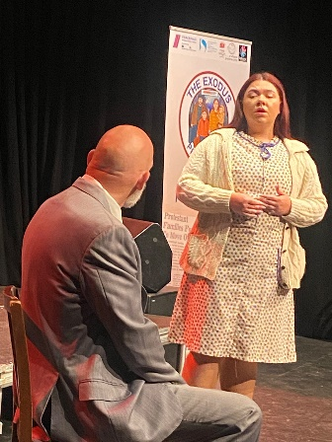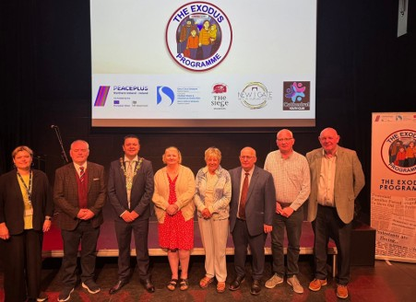
Free, accredited, community training.

One of the needs most strongly identified across our community and voluntary sector council wide, was the need for free community development training. This is to upskill and/or reskill current community volunteers and workers and to encourage new people into community work. Our ‘Inspire, Enthuse, Equip’ project is now providing that on a cross-community basis to help build capacity.

If you or your community group are interested in free training, please email inspire.enthuse.equip@nwrc.ac.uk to see what courses are coming up.

Read our Autumn Magazine (stories and funding) here:
(Insert Autumn 2025 magazine link)

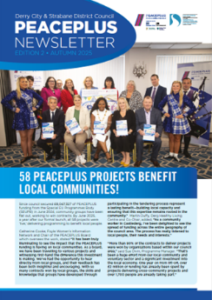

Funding.

- The NI Community Infrastructure Fund is open from 1st October 2025. See their website for further information.
https://www.nicva.org/article/new-fund-for-refurbishment-of-community-facilities-opens-1-october
- The Community Relations Council Core Funding Scheme The Core Funding Scheme is currently open for applications. Closing date: 12 November 2025 at 4 PM.
The Northern Ireland Community Relations Council's Core Funding Scheme provides support for organisations which are considered of strategic importance in promoting community relations work across the region. The scheme contributes towards salary and organisational running costs. See link for further details:
https://www.community-relations.org.uk/funding-scheme/core-funding-scheme

Contact us:
The PEACE Team in council can be reached via peace@derrystrabane.com
Our website is: https://www.derrystrabane.com/community/peace-plus

The PEACEPLUS Programme is a funding partnership between the European Union, the Governments of the United Kingdom and Ireland, and the Northern Ireland Executive and will be administered by the Special EU Programmes Body (SEUPB). Match-funding for this element of the PEACEPLUS Programme has been provided by the Executive Office in Northern Ireland and the Department of Housing, Planning, Community and Local Government in Ireland.

