DCSDC PEACEPLUS Local Co-Designed Action Plan – E Newsletter April 2026

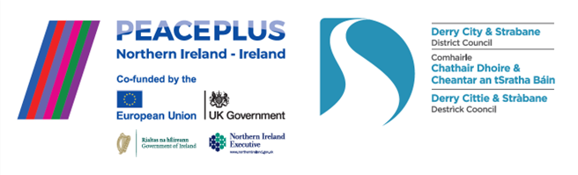

The PEACEPLUS Programme is a funding partnership between the European Union, the Governments of the United Kingdom and Ireland, and the Northern Ireland Executive and will be administered by the Special EU Programmes Body (SEUPB).

Springing Forward!

The PEACEPLUS programme has a spring in step moving into (hopefully) better weather and lighter nights. Many of the 58 funded projects have been looking outdoors for activities. The collages of images below show just a sample of the diversity in what the £8 million programme is delivering across our council area.

Community Regeneration and Transformation Theme.
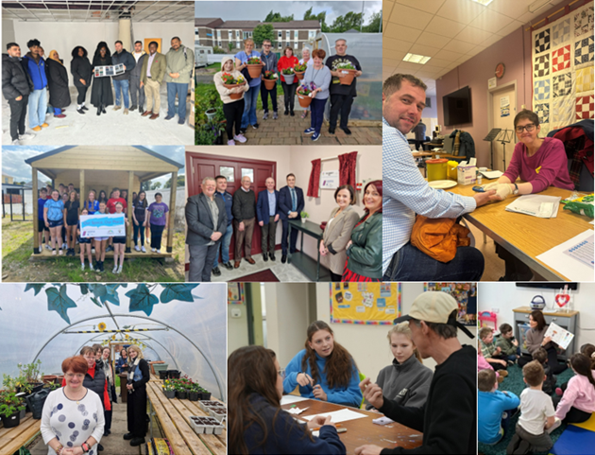
In our rural communities, the Community Regeneration and Transformation theme has included work like the refurbishment of Park Community Hall, the transformation of a community garden in Newtownstewart and a Health Fair in Castlederg. Projects in the city include the creation of an Urban Social Farm working with our learning disabled community, a graffiti mural project reimaging neighbourhoods, the development of an Intercultural Café space and projects connecting communities in the Skeoge area.

Thriving and Peaceful Communities Theme.

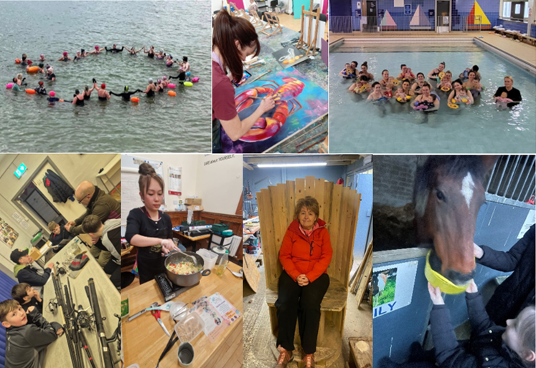

Thriving and Peaceful communities projects have been out and about with everything from fishing, sea-swimming, equestrian activities and upcycling/recycling materials into garden furniture. Also featured are arts, wellbeing, community development and early years work.
Celebrating Cultural Diversity Theme
Projects featured below include the ‘Let’s Talk’ Youth project who hosted a visit from the Irish President, visits by Culmore and Castlederg communities to the Guildhall, and our Fit for Purpose project with young men exploring peacebuilding through football. The Distance Travelled project is working with very diverse identities including Irish Travellers and Black and Minoritised Ethnic communities as well as the wider public. The Forward Thinking project continues to promote dialogue on issues of future relationships between these islands and the Out and About Project is shown below visiting the Siege Museum, learning about local history and culture.
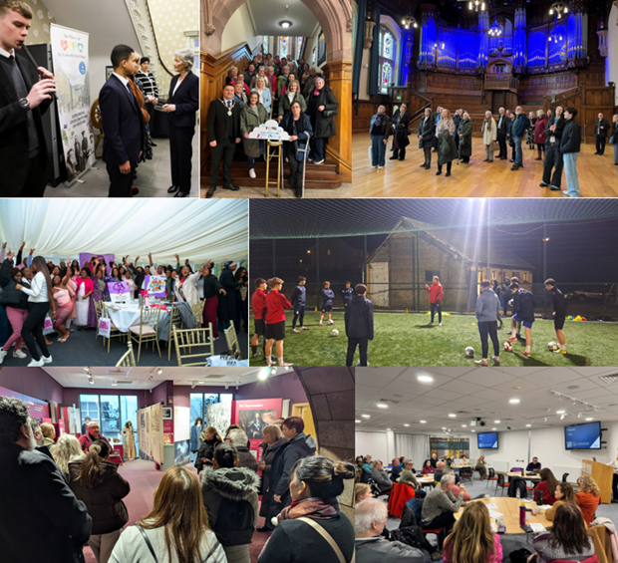
Strengthening Community Leadership in Peacebuilding.
In March 2026, the DCSD Council PEACEPLUS Programme delivered a capacity and networking event to build community leadership in the field of peacebuilding. PEACE work goes beyond simply cross-community work, and all our funded projects need to have focused peace-building content within their programming.

Held in Holywell, the booked-out event proved useful in connecting key community development workers and volunteers and taking a deeper look at what Good Relations and Peacebuilding work is about. Some key reflections from the day included that peacebuilding is more than a word. Core to the peace programme is people understanding people and galvanizing communities. The job of peacebuilding work is facilitative, not pushing a particular political agenda or political point-scoring. Equally important is including challenging voices and conversations in the work.

The day included exploring the groundwork done in advance of programming, the agreement of a contract at the start of the process, addressing unconscious bias and about building progression into the work. There was reflection on how to get to the conversation without debates around terminology getting in the way, and how trust building and bonding are important in a group to allow conversation to happen. The skills of facilitating dialogue, how to energize a conversation, how to be trauma-informed and ensure quiet or missing voices engaged as well as managing conflict constructively were considered.

There was a challenge that the conversation isn’t over – for some people, the conversation hasn’t really begun. Are we too ‘polite’ and adept at avoiding the more challenging legacies of the past when it comes to dialogue in cross-community projects? What does reconciliation look like in practice and is there a responsibility that comes with peace funding to deepen the conversation?

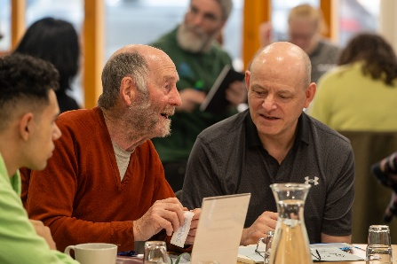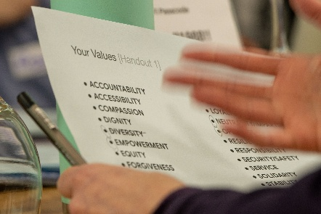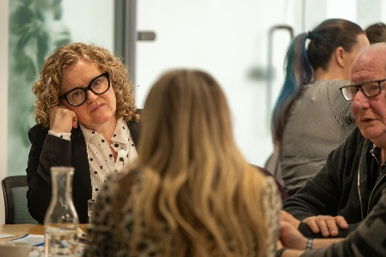

Watch our video!

This short video captures in a nutshell how the PEACEPLUS Local Action Plan came about, what is being delivered through it, and some of the impact it is having at this early stage of delivery.

Insert DCSDC PEACEPLUS video link here from Youtube/Website

Contact us:
The PEACE Team in council can be reached via peace@derrystrabane.com
Our website is: https://www.derrystrabane.com/community/peace-plus

The PEACEPLUS Programme is a funding partnership between the European Union, the Governments of the United Kingdom and Ireland, and the Northern Ireland Executive and will be administered by the Special EU Programmes Body (SEUPB). Match-funding for this element of the PEACEPLUS Programme has been provided by the Executive Office in Northern Ireland and the Department of Housing, Planning, Community and Local Government in Ireland.

