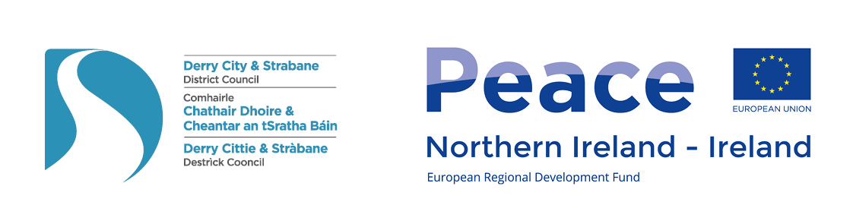
Derry City and Strabane District PEACEPLUS Partnership Board

Meeting Date: Tuesday 10th January 2023
Time: 10.00am – 12.00pm
Venue: St.Columb’s Park House, Derry~Londonderry.

AGENDA ITEM
1. Meeting Opening
1.1 Welcome and Apologies (Appendix A Board Attendance)

1.2 Conflict of Interest: Reminder Board Members to declare interests where relevant.

1.3 Minutes of previous meeting / Matters arising (p.3-11)

2. Communications Update (Sue)
2.1 Press, Social Media, Web & E-zine: Dec Ezine issued – indicated the Board decisions for District projects. Also issued to LGP’s & to concept form emails. Team will issue a January Ezine & communication to relevant remaining concept form emails based on any decisions made today.
3. Management Update (Myriam & Sue)
3.1 Update at Programme Level (SEUPB)
14th Dec SEUPB/Blu Zebra. ‘March’ prog launch. Implementation costs probably eligible from date bid submitted. Tendering ‘at risk’ before LOO probably eligible. Appendix C stats PIV comparison.

4. Key Business: Remaining Co-Design Decisions (Myriam & Sue)

4.1 Feedback from Questionnaire (Myriam)

4.2 Decision making. Memo of Agreement extract
‘Decisions will be taken by consensus, if possible, otherwise decisions may only be made by a majority of 75% of the Members present at the meeting. Voting shall be by show of hands unless otherwise decided by the meeting. At all meetings of the PEACEPLUS Partnership Members shall have one vote.’

4.3 Revisiting Sperrin DEA.
As requested by the Board, the team held a meeting on 12th December with the Chairs of the 3 rural DEA’s. The outcome of the conversation is that the Chairs of the 3 rural DEA’s are content with the original recommendation put forward for Sperrin in December, on the understanding that the Tender for £142K Pre-teen transition programme should be written to cover all 3 rural DEA’s.

For decision: Is the Board content to approve the revised Sperrin DEA calculations?

4.4 District Decision Making: TPC Theme. (Appendix F)

For discussion. Revisiting Arts & Collaborative Resilience. £26K project. 40 participants. Clarifications to be presented as requested at December Board. See also Traffic Lights.

For decision: Board will then need to either agree this project or agree a suitable alternative / way forward.

4.5 District Decision Making: CRT Theme. (Appendices D and E)

For discussion. Clarifications to be presented as requested at December Board. See also traffic lights. Revisiting the following two projects:

- Historic Cemeteries and 'Unlocking Our Silent Heritage' £250K. 275 participants.
- World War Memorials Heritage, Restoration and History. £415K. 450 participants.

For decision: Board will then need to either agree these projects or agree a suitable alternative(s) / way forward.

4.6 Next steps in Co-Design & update on draft application form. (Myriam & Sue)
Work on SEUPB application form ready for submission (powerpoint).
EQIA screening and process (Including Rural Needs and Climate Impact Assessment).
Feb – Item to Business & Culture Committee & Full Council ratification.
March – Probable submission of application (dependent on SEUPB).
DCSDC has ‘volunteered’ help to test JEMS system and give input into SEUPB eval & monitoring.

4.7 Review of project titles.
Some current project titles in traffic lights are just ‘working titles’. Is Board content that PEACE Team may adjust these in the writing of the bid? Open to any suggestions for titles.

4.8 Initial consideration of Evaluation and Monitoring.
Key issue for thought: SEUPB have indicated their intention to have some level of centralised monitoring and evaluation possibly based around TEO style Good Relations system. It is not yet clear whether this will have sufficient communication ‘back’ to DCSDC to be viable as a live project monitoring system for project management. Initial reflections welcomed from Board.

5. Meeting Closing
5.1 AOB

5.2 Date of Next Meeting: Tuesday 7th February 10am – 12 noon. (Fir Trees Hotel, Strabane)

Derry City and Strabane District PEACEPLUS Partnership Board
Minutes of Meeting

Meeting Date: Tuesday 6th December 2022
Time: 10.00am – 1.00 pm
Venue: Shantallow Community Centre (And online hybrid option)

Sue Divin | DCSDC | Christopher Jackson | SF
Mary Claire Kerlin | DCSDC | Philip McKinney(online) | Alliance
Fiona Lafferty | DCSDC | Martin Reilly | SDLP
Drew Thompson | DUP | Maurice Devenney (online) | DUP
Brian Tierney | SDLP | Keith Kerrigan | DUP
Gerard Deane | Holywell Trust | Nikki Yau | FREF
Martin Duffy | Derg | Myriam Fearon | Fearon Consulting
Sharon Doherty | St Columb’s Park Recon Trust | William Calderwood | PSNI
Declan Norris | SDLP | Conor Heaney | SF
Anne McTaggart | YouthAction NI | Charles Lamberton | Moor LGP
Derek Moore | NW Cultural Partnership | Jackie Connolly | Ballyarnett LGP
Lisa Moore-Maguire | Foyleside LGP | Paul Gallagher | IND
Alison Wallace | Waterside LGP | Gus Hastings (online) | Faughan LGP
Claire Russell | Sperrin LGP | Declan Gallagher | EA
Aodhán Harkin | Strabane LGP (Online) | Darren Guy (online) | UUP
Seamus Ward | HSCNI | Marie Gallagher | DFC
Bethany Moore | FWIN

  - Apologies received from: Catherine Cooke, FWIN; Ruairi Mc Hugh SF; Noelle Donnell, Hummingbird NI.

  - Conflict of Interest - The chairperson reminded members of Conflict of Interest and the responsibility of members to declare throughout the meeting where relevant.

  - Minutes of Previous meeting/Matters arising - Board meeting of 8th November 2022 were held to be an accurate record.

Approved: Martin Duffy Seconded: Nikki Yau

- Communications
  - Press, Social Media, Web & E-zine: Sue updated members on the communications provided by Peace Plus which is as follows: - Ezine issued for November – indicated the Board decisions for the 8 areas + update & signposting to wider funding. Stats: 278 people signed up. 44.8% open rate. 4.8% Click Through Rate. Ie. Higher than average 40% open & 4% click. Emails also issued to all Local Growth Partnership Chairs/Managers & to concept form emails.

- Management Update

  - Members were made aware that 30% of the Regional Concept notes to SEUPB were from the DSCSDC area for Theme 1.3 which is very positive for the area.
Also for clarification the board was updated that the Derg Festival and the Waterside Together project under the DEA’s are now moved to be in the CRT theme and SEUPB clarified this was acceptable as long as there was a small element of re-imaging or capital as they are broadly around shared space.

Clarifications had also been sought at the last board meeting on the eligibility of Faith based organisations to potentially apply for tenders. The PEACE Team sought advice on this and SEUPB clarified in writing that Faith Based organisations are eligible to tender for social programmes on the same basis as any other constituted organisation with appropriate insurances, experience etc. This has also been verified in writing from the DCSDC procurement service. Having been given this clarification the Board then re-looked at the Food Poverty Programme in the Waterside DEA.

Decision: It was agreed by the Board to proceed with the Food Poverty Programme in the Peace Plus Plan.

Proposed: Martin Duffy Seconded: Alison Wallace

  - Sue informed members that the traffic lights had been updated to factor in Management & Communication decisions from the November Board. SEUPB have confirmed that the planning rate is now €1.15. This reduced the overall DEA and Thematic allocations by £43,642.26 each. The agreed formula was used to breakdown the allocation across the 8 DEA areas as follows:-

Area | Difference
Ballyarnett | £7,620.05
Faughan | £4,380.57
Foyleside | £4,508.91
Moor | £6,786.28
Waterside | £6,947.29
Derg | £5,619.88
Sperrin | £3,658.11
Strabane | £4,121.17
Total | £43642.26

It was explained to members the scoping approach on these reductions recommended by the team was that firstly, any projects under the CRT theme should not be prioritized for reduction in monetary value as it was needed to make sure that within the plan this theme reached its overall target of 30% of the total budget. On the other hand, the TPC theme had over exceeded its % target threshold significantly so projects under this theme in the DEA’s were where the majority of the reductions were recommended.

The Peace Plus team took the members through each DEA area and approvals were sought

Decision: Ballyarnett Agreed.

Jackie Connolly declared an Interest

Proposed: Anne McTaggart Seconded: Jackie Connolly

Decision: Foyleside Agreed.

Proposed: Seamus Ward Seconded: Gerard Deane

Decision: Moor Agreed.

Proposed: Sharon Doherty Seconded: Nikki Yau

Decision: Waterside Agreed.

Alison Wallace declared an Interest and left the room.

Proposed: Nikki Yau Seconded: Anne

Decision: Strabane Agreed.

Anne McTaggart declared an interest and left the room.

Proposed: Martin Duffy Seconded: Conor Heaney

Decision: Derg Agreed.

Martin Duffy declared an interest and left the room.

Proposed: Gerard Deane Seconded: Sharon Doherty

Decision: Faughan Agreed.

Proposed: Conor Heaney Seconded: Christopher Jackson

  - Revisiting Sperrin DEA.

Sue informed members that within the Sperrin DEA in the spreadsheet there had been an administrative error noted from the November Board meeting where one of the projects was not included in the automatic formula calculations. This meant that this DEA had £85k over budget allocated based on November decisions and, as a result of this, reductions had to be made to the projects as well as the amount of £3658.11 from the change in the exchange rate to €1.15.

It was recommended that the following changes would be made made:

Gateways to Rural Participation be reduced from £237027.84 to £204,962.45.
Pre-teen transition programme be reduced from £183,639.80 to £142,046.80.
The above 2 projects are being delivered across the 3 rural DEA areas.
Farming project be reduced from £85,000 to £80,000
Youth Voices Project be reduced from £80,000 to £70,000

Project Title | Area/Thematic | Theme: | No. of participants | Cost
Farming & Environmental Champions Programme One Tender 2 elements | Sperrin | TPC | 110 | £80,000.00
Sperrin Youth Voices | Sperrin | TPC | 90 | £70,000.00
Park Community Hall | Sperrin | CRT | 120 | £100,000.00
Gateways to Rural Participation | Groups DEA's (rural) | TPC | 70 | £31,907.00
 |  |  | 390 | £281,907.00
 |  |  | 388 | £281,907.28

Some members raised concern around the reduction of the pre-teen programmes and the level of communication with DEA reps on its removal from the Sperrin area. It was explained that that programme still can be delivered in this area with a bit of generosity from the other rural DEA’s. It was also noted that this was one of the larger programmes that had no initial reduction in the overall budget submitted and it was also under the TPC theme which had oversubscribed in the % budget target required. Martin proposed that the PEACE team arrange to meet with the 3 rural DEA chairs to discuss the recommendations. It was agreed that Sue would set this up. The meeting will discuss the reductions, communication and connectivity throughout the 3 areas and bring back recommendations again to the January Board meeting.

Action: Sue to set up a meeting with the 3 rural chairs.
Decision: The Sperrin DEA projects will be deferred to the next meeting for approval.

4. Consultation and Co-Design Process Update

4.1 Sue explained to members the scoping process used by the PEACE team in their approach to the District ideas. That approach had been had been agreed by Board members at November board meeting. The scoping considered the following:-

- By theme, balance DEA % decisions across District CRT, TPC, CCD Themes
- Fit with the PEACEPLUS Theme 1.1 Criteria set by SEUPB
- Viability & Tender competition
- Scaling to available budgets and participant targets
- Prioritisation by local communities in the Co-Design process
- Potential ideas mergers to remove duplication and enhance collaboration

The Board were then taken through the District traffic lights for familiarisation (non-decision making mode). Members were able to ask questions to probe the information. Martin asked about rural in the CRT theme. Nikki spoke on BAME needs and issues. Claire asked if a cultural project including Ulster Scots was council wide and a similar query on the OCN community development courses. Alison asked about the peace benefit of the Arts and Culture Strategic collaborative project. Charles asked for clarification if the same project was new or existing. Marie asked what the specific outcomes would be. Anne commented positively on the support the team were providing to the Board in giving information on which to make decisions.

Christopher Jackson left the meeting at this point.

4.2 Sue informed members that decisions for projects proposed under the thematic themes would be taken by consensus if possible, otherwise decisions may only be made by a majority of 75% of the Members present at the meeting. There was a reminder to declare any conflicts of interest.

4.3 CRT

Derek Moore declared an interest and left the room.

Sue and Myriam took members through the following district wide projects under CRT

Project Title | Theme: CRT | No. of participants | Scoping Cost | Topic
eNRICH Community Hub | CRT | 150 | £153,050 | BAME
Green Club Programme | CRT | 200 | £200,000 | Environment/Capacity
Historic Cemeteries and 'Unlocking Our Silent Heritage' | CRT | 275 | £250,000 | Capital/History
War Memorials Heritage, Restoration and History | CRT | 450 | £415,000 | Capital/History
TOTAL |  | 1075 | £1,018,050

Queries arose around the war memorials and why it had been narrowed down to that particular 3 mentioned. Myriam responded to this explaining that these are from Council’s capital list and had already been selected through that community planning process. A similar query arose around how the 6 historic cemeteries had been selected. Myriam explained the original concept was to target 12 but due to budget constraints it had to be scaled to fit the peace plus programme. Other queries were raised around the wording of essential repair and whether this included public and physical access within the war memorial and cemeteries projects. The Board wanted clarification as to what was the statutory responsibility of the Council and what aspects were additional. It was explained that all aspects of the projects potentially to be included under PEACEPLUS were for aspects that council did not have a statutory responsibility to deliver.

Members were also made aware of those concept ideas that did not fit within the perameters of the Peace Plus programme or which were not currently recommended for funding and the reasons were explained.

Action
- It was agreed to seek further clarification on the actual scope of works for the War Memorials and Cemeteries Project to ensure that any works which are the statutory obligation of the Council are not costed in the project. Where wording such as ‘essential works’ was creating confusion, this should be re-looked at.
- To re-present the War Memorials and Cemeteries Project under CRT to the January Board.

Approval was sought for the Enrich Community Hub and Green Club programme under CRT.

Decision approved for:

Project Title | Area/Thematic | Theme: CRT | No. of participants | Scoping Cost
eNRICH Community Hub | Thematic | CRT | 150 | £153,050
Green Club Programme | Thematic | CRT | 200 | £200,000

Proposed: Alison Wallace Seconded: Claire Russell

4.4 TPC
Gerard Deane, Derek Moore, Bethany Moore declared an interest and left the room.

Members of the Peace Plus team took members through the following district wide project ideas under TPC theme.

Project Title | Theme: CRT | No. of participants | Scoping Cost | Topic
Cricket and Inclusion | TPC | 175 | £120,000 | Sport
Our Future community and Voluntary Sector, Inspire, Enthuse and Equip | TPC | 275 | £200,000 | Children and Youth
Children and Youth Digital Creativity and Music | TPC | 164 | £125,000 | Digital creativity
Arts & Collaborative Resilience | TPC | 40 | £26,000 | Arts
Children & Youth Outdoor Arts, Culture & Environment Programme with a focus on shared spaces and places | TPC | 164 | £120,000
Children or Intergenerational Dialogue Through Arts and Culture | TPC | 164 | £120,000 | Intergenerational
TOTAL |  | 982 | £711,000

Members raised some queries around the Arts & Collaborative Resilience idea for the amount of £26,000. They asked if this was the remit of the Council to deliver this project and what were the peace outcomes. Clarification was sought as to what the measurable outcomes would be and whether an idea of the breakdown of the costs could be presented. Clarification was sought on the additionality that this project would bring that would otherwise not happen.

Myriam explained that the project was to support the Community Arts sector collectively to help them build capacity and sustainability to secure funding on a wider scale and to create connectivity between local art organisations. It is a good fit with the PEACEPLUS TPC Theme criteria and could have significant sustainability impact for limited investment.

Action on Collaborative arts:

- Myriam to scope more specific information on what the £26K covers that is measurable.
- To consult with the Arts Service within Council to see what is additional in this project and what, if anything, is a council statutory requirement.
- To set out clear peace outcomes
- To re-present the Collaborative Resilience programme at January board for consideration.

Approval was sought for the remaining 5 projects of Cricket and Inclusion, Our Future community and Voluntary Sector, Inspire, Enthuse and Equip Children and Youth Digital Creativity and Music, Children & Youth Outdoor Arts, Culture & Environment Programme with a focus on shared spaces and places and Children or Intergenerational Dialogue Through Arts and Culture to be included in the Peace Plus Plan.

Decision approved for:

Project Title | Theme: CRT | No. of participants | Scoping Cost | Topic
Cricket and Inclusion | TPC | 175 | £120,000 | Sport
Our Future community and Voluntary Sector, Inspire, Enthuse and Equip | TPC | 275 | £200,000 | Children and Youth
Children and Youth Digital Creativity and Music | TPC | 164 | £125,000 | Digital creativity
Children & Youth Outdoor Arts, Culture & Environment Programme with a focus on shared spaces and places | TPC | 164 | £120,000
Children or Intergenerational Dialogue Through Arts and Culture | TPC | 164 | £120,000 | Intergenerational
TOTAL |  | 982 | £711,000

Proposed: Martin Duffy Seconded: Nikki Yau

4.5 RCI

Derek Moore, Gerard Deane, Anne McTaggart declared an interest and left the room.

Members were updated by the Peace Plus team on district wide project ideas under RCI theme as follows:-

Project Title | Theme: CRT | No. of participants | Scoping Cost | Topic
Trauma, Addiction Recovery & Mental Health Programme “The Freedom Project” | RCI | 520 | £365,000 | Trauma, Addiction, Mental Health, Recovery
Fit for Purpose “Sport based citizenship project for men” | RCI | 109 | £80,000 | Sports
Operation Desperation “Initiative around women and domestic violence with historical and contemporary context” | RCI | 205 | £160,000 | Women and domestic Violence
Humankind “humanitarian upskilling and enthusing volunteering locally and awareness of international issues including refugees and asylum seekers”. | RCI | 220 | £160,000 | Humanitarianism
Past and Future Relationships Journey | RCI | 218 | £160,000 | Dialogue Past and Present
Columba Journey | RCI | 205 | £150,000 | Interfaith
Out and About | RCI | 140 | £85,000 | BAME
“Travelling together” | RCI | 80 | £60,000 | Travellers
Celebration of Culture in 21st Century | RCI | 272 | £200,000 | Culture/Irish/Ulsterscots
Sexual Orientation and Gender Identity Awareness | RCI | 100 | £40,000 | LBGTQIA+
Connect | RCI | 70 | £55,000 | Asylum Seekers
Lets Talk | RCI | 164 | £120,000 | Youth based dialogue
TOTAL |  | 982 | £1,635,000

It was agreed that all projects listed above under RCI theme will be included in the Peace Plus bid.

Proposed: Alison Wallace Seconded: Lisa-Moore Maguire

4.6 Advisory/Communications Updates

Sue recommended that the PEACE Team issue updates to Thematic/District wide projects which had submitted concept forms based on the decisions made today at the Board. Also Sue will issue a December e-bulletin.

4.7 Next steps in co-design

Myriam updated members on the next steps in preparing the bid. A public questionnaire will be issued in December. The Board agreed that this will present the ideas approved today and also the 3 ideas and Sperrin ideas pending final decision in January. It was requested that Board members assist with circulating the questionnaire link as widely as possible and encourage people to complete the survey.

The January meeting will also begin to consider monitoring and evaluation and any fine tuning of project titles or other aspects required to finalise the bid. The target timeframe is that the overall bid content will be sent in an item to Council in February. That would see it fully ratified by the end of February. The bid could then be submitted to SEUPB in March assuming the process is open.

5. Meeting Closing

5.1 AOB

The chairperson thanked the team for their work to date.

5.2 Date of Next Meeting: 10am Tuesday 10th January – venue St.Columb’s Park House.

The meeting ended at 12.30 pm

Appendix A: Board Member’s Attendance 2022

Statutory Pillar |  | 29/3 | 10/5 | 21/6 | 6/9 | 4/10 | 8/11 | 6/12
William Calderwood (d. Shannagh Farren) | PSNI | x | x | x | x | x | x | x
Deborah Cross (d. Declan Gallagher) | EA |  | x | x |  | x | x | x
Marie Gallaher (d. Sharon McCullagh) | DfC | x | x |  |  | x |  | x
Mary O'Neill (d.Noel McNulty) | NIHE | x | x | x | x | x | x
Seamus Ward (d.Bronach McMonagle) | WHSCNI | x | x |  | x | x |  | x
Gerard O’Neill (d.Ciaran McLaughlin) | DAERA |  | x
Social Partners – Local Growth Partnerships
Jacki Connolly (d.Darren Kirby) | Ballyarnett | x | x | x | x | x | x | x
Martin Duffy (d. Andy McKane) | Derg | x | x |  | x | x |  | x
Aodhán Harkin (d.Ursula Doherty) | Strabane | x | x |  | x |  | x | x
Gus Hastings (d.Martin McCartney) | Faughan |  |  | x |  | x | x | x
Charles Lamberton (d.Seamus Breslin) | Moor | x | x | x | x |  | x | x
Claire Russell (d.Patricia McNulty) | Sperrin |  | x |  | x | x | x | x
Alison Wallace (d.Geraldine Doherty) | Waterside |  | x | x | x | x | x | x
Lisa Moore-Maguire (d. Jim McColgan) | Foyleside |  | x | x | x | x | x | x
Elected Representatives Pillar
Conor Heaney | SF |  | x |  | x |  |  | x
Christopher Jackson | SF | x | x | x | x |  | x | x
Ruairi McHugh | SF |  |  |  |  | x
Declan Norris (from December 2022) | SDLP | x |  |  |  |  |  | x
Maurice Devenney | DUP |  |  | x | x | x | x | x
Keith Kerrigan | DUP |  |  | x | x |  | x | x
Darren Guy | UUP | x | x | x | x |  | x | x
Philip McKinney | Alliance | x |  | x |  | x | x | x
Martin Reilly (from July 2022) | SDLP |  |  |  | x | x | x | x
Paul Gallagher (from July 2022) | Indep |  |  |  |  | x | x | x
Brian Tierney (from July 2022) | SDLP |  |  |  | x | x | x | x
Drew Thompson (from July 2022) | DUP |  |  |  |  | x |  | x
Social Partners Pillar
Gerard Deane (d. Fiona Corvan ) | Holywell | x | x | x |  | x | x | x
Catherine Cooke (d. Bethany Moore) | FWIN | x | x | x | x | x | x | x
Sharon Doherty (d. Michelle Simpson) | St.CPH | x | x | x | x | x | x | x
Noelle Donnell (d. Sinead Barr) | H’bird | x | x | x | x | x | x
Anne McTaggart (d. Dominic Bonner) | YANI | x |  |  | x | x | x | x
Derek Moore (d. Kyle Thompson) | NWCP | x | x | x | x | x | x | x
Kyra Reynolds (d. Rachel Mullan-Carlin) | BBI |  | x |  | x
Nikki Yau (d. Agnieszka Luczak) | FREF | x | x | x | x | x | x | x

Appendix B: Reminder of PEACEPLUS Focus.
Three core themes:
- Local Community Regeneration and Transformation (30-40%)
- Thriving and Peaceful Communities (30-40%)
- Building Respect for All Cultural Identities. (20% Min)

Think transformative: Projects supported “should result in increased levels of social inclusion and cross community integration.” “By design, related actions should incorporate the level of sustained contact between those from different community, cultural and political backgrounds, required to achieve significant attitudinal and behavioural change.”
Think cross-community: Councils will be set a target. BPR may be 60%/40% for NI Councils.
Think Policy Context (GR, Social Inclusion, Race Equality etc.) and underrepresented groups:
• women • disability • LGBTQ₊ • victims and survivors • those impacted by the legacy of the conflict • ethnic minorities, migrants, asylum seekers • Traveller Community.
Local Community Regeneration and Transformation (30-40%)
Designed to empower local people to transform their communities on a cross-community basis.
- Transform physical appearance and functionality
- Develop new or re-image existing spaces
- Thematic focus can include social enterprise, sport, community development, tourism, education, culture etc.
- Evidence of need and the potential to create opportunities for increased levels of cross community interaction important
Thriving and Peaceful Communities (30-40%)
- Focus is upon wellbeing, connectedness and empowerment.
- Build and sustain relationships between different people /communities/sectors
- Invest in cross community collaboration to:
- Jointly identify issues and opportunities in their areas; and
- Develop collaborative projects to address these & bring positive change in communities
- Sectoral areas will include children and young people; sport; environment; health and wellbeing; arts and culture; and capacity building and training
Building Respect for All Cultural Identities. (20% Min)
Particular focus upon providing support to those most marginalised within our communities: minority communities including migrants and refugees and those from the Traveller Community; women; LGBT community; older people; those living with a disability; and those with issues arising from the Conflict. Programmes which:
- Build, improve and sustain relationships
- Increase knowledge and understanding
- Incorporate conflict resolution interventions
- Increase civic participation
- Engage those with opposing and dissenting views

Appendix C: Comparison with PEACE IV

The Co-Design process with PEACEPLUS has significantly increased the % allocations going directly to public/community tender compared to PEACE IV.

PEACE IV: Council had 6 funded ‘project staff’ (ie. Not PEACE Team but directly linked to project delivery). 48% of the funding was contracted through SLA (contract within council).

PEACE PLUS: Council has 0 funded ‘project staff’. Depending on remaining decisions, a maximum of 10% of PEACEPLUS will be contracted through SLA. (NB. Technically the programmes connected to any capital builds are also 100% externally tendered though they are counted as part of the SLA. This makes the % internal to council even lower).

Appendix D. Historic Cemeteries CRT proposed project.

Locations across the city and district:

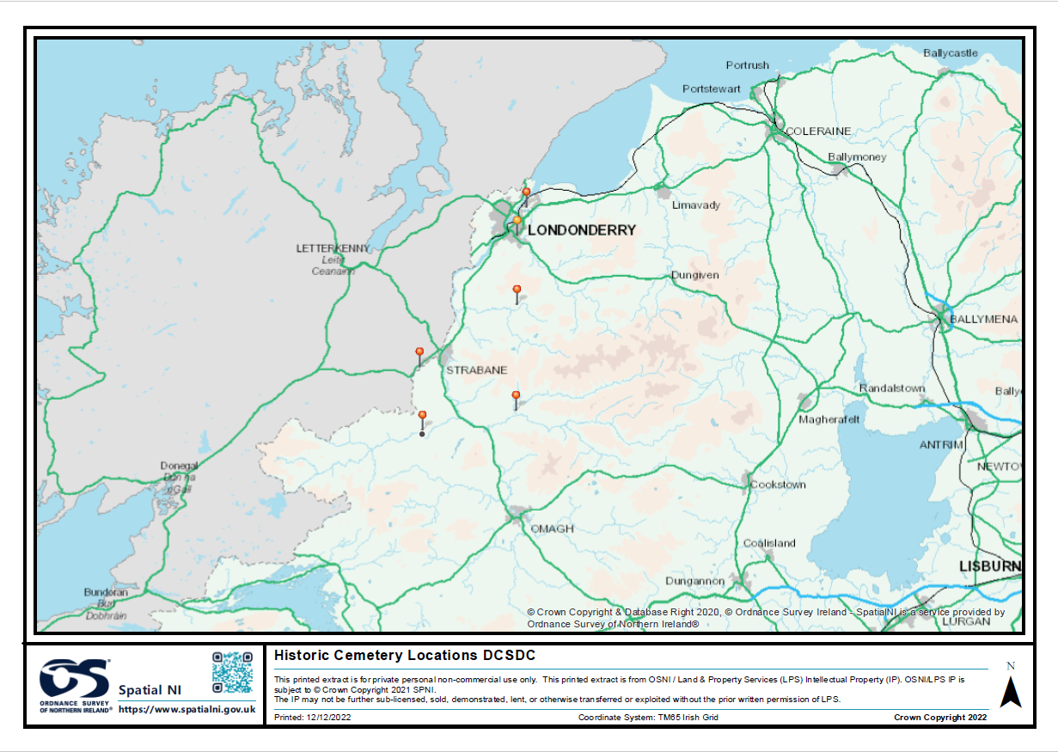

DCSDC Statutory responsibilities concerning cemeteries
The cemeteries which are part of this proposal are no longer active burial grounds (with the exception of occasional burials) Most of Council closed/historic cemeteries where once owned by churches and, once closed the responsibility for their upkeep transferred to Council. Given that Council has inherited these heritage sites, it has the responsibility to preserve and maintain these for future generations, in addition to ensuring that any statutory listed monuments within the cemeteries as preserved. Given that these cemeteries feature on Councils asset register it has an obligation to carry out regular maintenance which includes grass cutting once or twice a year, and addressing any immediate health and safety issues. No de-weeding takes place or repairs or maintenance of paths.
There is no responsibility or obligation upon Council to provide/improve access or historical interpretation to these local heritage assets.
This project therefore focuses on the historic elements of the cemeteries through interpretation and environmental improvements to enhance the visitor experience. Council currently has no responsibility for this. Without the interventions from this project the built heritage will be lost.
Need for the project
Across a number of operational areas, Officers have been requested by a number of groups to look at the deficiencies in these cemeteries across a number of themes such as:
- Sharing History through interpretation and engagement,
- Improving access to and within the cemeteries, and
- Creating a collaborative heritage and history network across the District with the cemeteries as an integral element.

Examples of the groups contacting Council include:
- Scarvagherin cemetery was brought up in Chairman’s business at Environment & Regeneration Committee on 10th November 2021 Councillor McHugh proposed, seconded by Councillor McGinley that Council Officers arrange to meet with the Historical Society in Castlederg to explore possibilities associated with the improvement to access and potential research and preservation projects at the Council maintained monastic ruins at Scarvagherin graveyard, Castlederg.
- Friends of Derry City cemetery are in regular correspondence with DCSDC Council regarding developing the tourism offering at the City Cemetery.
- Sion Mills Buildings Preservation Trust, George Irwin a member of the Sion Mills Buildings Preservation Trust has approached Council in 2020 about the SMBPT developing some sort of community based project around the graveyard, in particular a guided tour or research, archaeological survey, capital works, transcribing gravestones or interpretation type projects.
- Gleneely History Group approached Council Sept 2022 regarding a sign at the graveyard.

In addition, from an operational perspective, the relevant facilities managers with operational responsibilities for these cemeteries have also indicated there are key challenges with ensuring access to some key heritage sites namely Urney, Corrick and Donaghedy. The nature of the interventions fall outside the scope of the Peace Plus project in that they focus on essential health & safety and heritage at risk issues (Priority 0 and 1 repairs £589,934). The remaining three cemeteries at Enagh, Scarvagherin and Glendermott are not on the capital list, but have been identified as being important sites which merit inclusion within the Peace Plus proposal. The PEACE Team hold a copy of the committee paper approving spend for Priority 1 works to be carried out at Urney, Corrick and Donaheady cemeteries so that it is clear what is NOT included in the PEACE proposal.
Despite being on the Capital list it doesn’t guarantee funding due to the other Council funding priorities. Notwithstanding this, the works proposed under this EOI can still be safely implemented.
Mindful of the need from the community and the significant potential for cross community collaboration across the District, it is on this basis that the project has been designed and the EOI submitted.
The proposed project will deliver the following capital works across each of the 6 identified cemeteries and will include:
Item | Quantity | Rate | Total
Seats supply and delivery(benches) | 2 | £4,000 | £8,000
Paving under seating (25msq) | 2 | £30 | £60
Install seating | 2 | £750 | £1500
Interpretation Panel | 1 | £3,000 | £3,000
Installation of Interpretation Panel (supply and install) | 1 | £4,000 | £4000
Graphic design and historic interpretation of interpretation panel | 1 | £3000 | £3000
Finger Post design and delivery(varying locations | X4 | £1,300 | £5200
Finger post sign, installation | 1 | £500 | £2,000
Pathway repairs/reinstatement | 1 | £2000 | £2000
Soft landscaping | 1 | £750 | £750
Vegetation removal, (Arboriculture services ) | 1 | £750 | £750
Urgent H&S and HAR works |  |  | Notional sum £3,740
Civil engineering, manufacture and installation and contractor (15% for contractor) |  |  | £6000
TOTAL |  |  | £40,000

It is important to highlight that these are estimated costs based on recent similar environmental improvement projects delivered by Council. Given the current rapidly changing market conditions such construction and equipment costs may be subject to change with final costs being confirmed following the outcome of any public tendered exercise.
Programme costs (entirely tendered):

Activity | Cost
Staff costs (External non-DCSDC) for engagement and delivery of programmes outsourced tender to hire coordinator and facilitator(s) | £50,000
Costs associated with delivering engagement programmes, consultants and external facilitators. To include facilitating groups, transport, visits to cemeteries, day trip to other cemetery project (e.g. Cavan), full day event for project. | £100,000
Development of high-quality printed materials and digital tours including image licencing– includes photography and historic image licencing for interpretative panels. Six digital tours including narration, guidance and storytelling. Digitally designed maps. Digitisation of satellite cemetery records. | £30,000
Creation of a bespoke new legacy web platform to capture project outputs and digital licences. Will provide interpretation, access information on six cemeteries and also host cemetery record database. | £20,000
Event costs and photography and video capture across the project. | £10,000
Total | £210,000

In case of relevance: Costs for the original project proposal including all 12 historic cemeteries.
To deliver 12 cemeteries the project capital works costs would be:
Item | Quantity | Rate | Total
Seats supply and delivery(benches) | 1 | £4,000 | £4,000
Paving under seating (25msq) | 1 | £30 | £30
Install seating |  | £750 | £750
Interpretation Panel | 1 | £3,000 | £3,000
Installation of Interpretation Panel (supply and install) | 1 | £4,000 | £4000
Graphic design and historic interpretation of interpretation panel | 1 | £3000 | £3000
Soft landscaping | 1 | £750 | £750
Vegetation removal, (Arboriculture services ) | 1 | £750 | £750
Urgent H&S and HAR works |  |  | Notional sum £720
Civil engineering, manufacture and installation and contractor (15% for contractor) |  |  | £3000
TOTAL |  |  | £20,000
12 cemeteries: Camus, Castlederg Old, Corrick, Cumber Old, Donaheady, Enagh, Glendermott,
St Patricks, Pubble, Scarvaherin, Straidarran, Urney Old.
Appendix E: World War Memorial CRT Proposed Project.
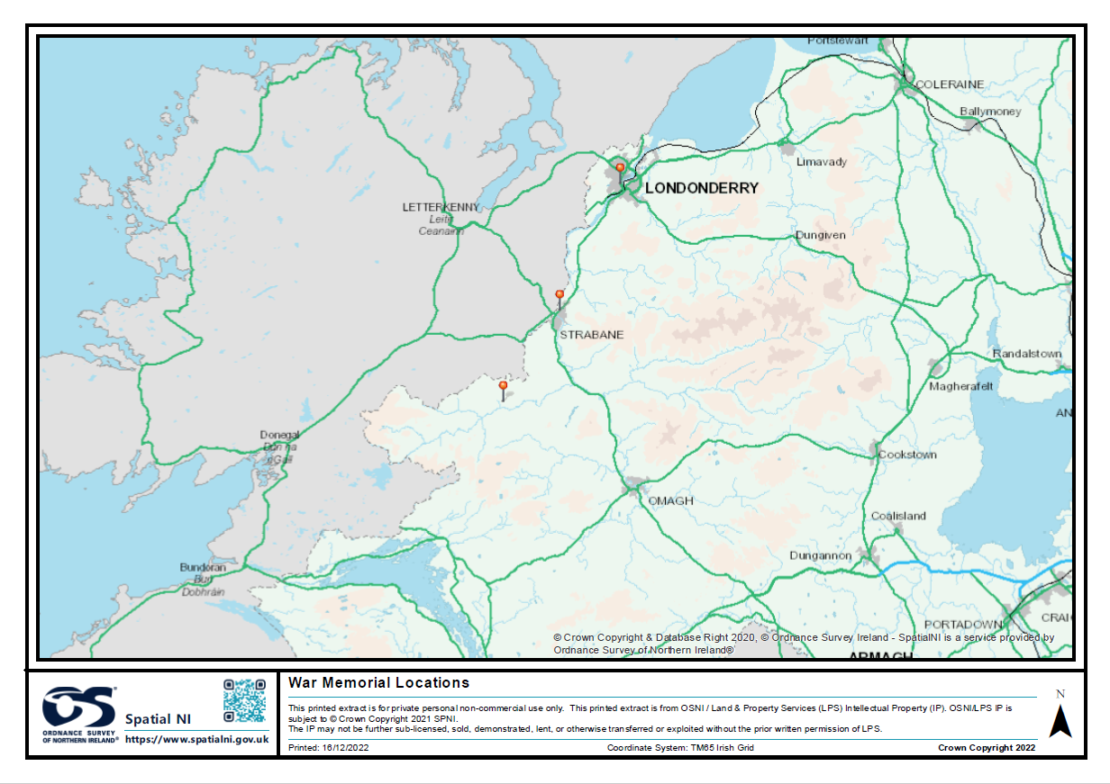

DCSDC Statutory responsibilities concerning the War Memorials
Council has a responsibility to maintain i.e keep clean and tidy the war memorials, there is no responsibility to maintain by way of refurbishment or repairs to the monuments themselves.
The proposed project for the World War memorials will deliver the following:
Costings:
Item (Capital works): | Total
Diamond War Memorial- construction cost estimate for the refurbishment works to the monument and the surrounding hard/soft landscaping within and including the monument railings and including professional fees | £240,000
Strabane War Memorial – environmental improvement works to surrounding hard and soft landscaping including professional fees | £20,000
Castlederg War Memorial – environmental improvement works to surrounding hard and soft landscaping including professional fees. | £20000
Total on capital works | £280,000
Participation Programme (reaching 450 participants on cross-community basis):
Tendered Programme (Element 1) Delivery of a Combined Project Cross-community History and Heritage Activity Programme (Launches, workshops, trips) | £105,000
Tendered Programme (Element 2) Historical Research & Interpretation (panels developed through engagement programmes and their installation). | £30,000
GRAND TOTAL | £415,000

Draft breakdown of programme content:

Tendered Programme (Element 1) Delivery of a Combined Project Cross-community History and Heritage Activity Programme (Launches, workshops, trips)  - Project launch, recruitment & initial publicity.  - Cross-community launch & workshop of restored Diamond War memorial (Minimum 50 participants)  - Cross-community launch & workshop of restored Strabane War memorial (Minimum 50 participants)  - Cross-community launch & workshop of restored Castlederg War memorial (Minimum 50 participants)  - Derry~Londonderry cross-community 1 day schools workshop and/or trip (minimum 50 participants)  - Strabane cross-community 1 day schools workshop and/or trip (minimum 50 participants)  - Castlederg cross-community 1 day schools workshop and/or trip (minimum 50 participants)  - Minimum 3 cross-community adult visits to relevant World War history sites eg. Somme Heritage Centre, HMS Caroline, Dublin, Fort Dunree, Cavan County Museum etc. (Total 150 participants) Including at least 1 cross-border.  - Relevant evaluation and monitoring requirements.  - Project close and final publicity.  - Note that workshops and trips can include relevant history of that era and discussion of a range of perspectives on that history and context. The principles of ethical and shared remembering will be applied to promote peace and reconciliation through dialogue and engagement. Creative approaches to learning, reflection and interaction are encouraged across the entire programme content. | £105,000
Tendered Programme (Element 2) Historical Research & Interpretation (panels developed through engagement programmes and their installation).  - Working cross-community with 50 participants (either by area or in total). | £30,000
NB. A total minimum of 500 participants have been counted as it is assumed that there will be some overlap of participants across the various programme activities. The programme will aim to reach 450 distinct individuals. The participant minimum counts are as a rough guide at this stage.

Appendix F: Collaborative Arts TPC Proposed Project.

In 2021 Derry City and Strabane District Council (DCSDC), with the support of the Arts Council of Northern Ireland (ACNI), commissioned the Collaborative Resilience Programme; an initiative that engaged 26 organisations that represented the core cultural infrastructure within the DCSDC area and which represent a range of identities and cultures.
The programme was designed to deliver a number of outputs including a Sectoral Investment Plan. Informed by impact assessment modelling and individual organisational diagnostics the sectoral wide investment plan identified where inter organisational synergies, challenges and opportunities existed.
The key emerging themes regarding potential synergies across cultural organisations included those relating to:
- Collaborative Arts Programming
- Training and Development
- Shared premises
- Shared utilities management
- Shared Services in marketing and box office provision
The PEACEPLUS potential project would be to use the existing (but not funded) Sectoral Investment Plan to tender for a supplier to engage with the cultural sector within DCSDC to develop two areas of collaboration that will leverage economies of scale for the participating organisations and enhance their collective sustainability.
Specification
- Design, secure participation on and coordinate thereafter, a programme of engagement between DCSD Council area cultural organisations to establish and operate shared service collaboration. There will be an initial engagement of the full group (26+ organisations) tasked with identifying the two most critical areas of collaborative working to be developed. Sub Groups would be formed to pursue these 2 work streams with the outcome being the compilation of a Partnership Agreement between the participating organisations establishing a mechanism for collaborative working thereafter. The 2 thematic sub-groups will meet, as a minimum, quarterly over a 2-year period (2 groups x 6 meetings x 2 hours = 24 hours’ engagement) and include a minimum of 40 participants in total (which must be cross-community including maximum 60% CNR and 40% PUL/BAME/Other identities). Diverse community and arts venues used should expand participants awareness of shared space and of the cultures represented within the group.
- To coordinate and deliver a launch event to promote the programme, its funders and participants and a close event (including short written report for the way forward).
- The identification, agreement upon, development and submission of at least one funding bid to facilitate the implementation of the Partnership Agreement for each work stream.
- The identification, coordination and delivery of two training courses (accredited or non-accredited) for the participants. The course must be relevant to the selected work streams. Venues used should expand participant’s awareness of shared space.
- The identification, coordination and delivery of two workshops per work stream (4 in total) for the participants. The workshops must be relevant to the selected work streams.
- The administrative, evaluation and monitoring requirements for this PEACEPLUS project (including attendance at 1 half day training session, recording participants, attendance, completion of evaluation forms and relevant evidence for each aspect of the project).
- Communications requirements for this PEACEPLUS project including 3 press releases (start, mid-way and end of project) with relevant high resolution photographs.

Estimated Budget
Programme development, preparation, administration
Communications and monitoring and evaluation - £4,000
Engagement Programme (Min 1 Full Meeting
& min 12 sub-group meetings, Launch and Close Events)- £10,000
2 Training Courses and 4 Workshops - £10,000
Venue Hire and Subsistence Costs - £2,000
TOTAL - £26,000
Core community, arts and cultural infrastructure organisations include:
- Acadamh Ceoil Chaoimhín Uí Dhochartaigh
- Abridged
- Alley Arts Centre
- An Gaelaras
- Bready and District Ulster-Scots Development Association
- Celtronic Derry Ltd
- Centre for Contemporary Art
- CoD International Choir Festival
- Echo Echo
- Eden Place Arts Centre
- Gasyard Development
- Greater Shantallow Community Arts
- In Your Space
- Millennium Forum
- North West Carnival Initiative
- North West Play Resource Centre (Playhouse)
- North West Cultural Partnership
- Obon on the Foyle
- Sole Purpose Productions
- Stage Beyond Theatre Company
- The Nerve Centre NI Ltd
- Void Art Centre
- Verbal Arts Centre
- Walled City Music Trust
- Waterside Theatre Company Ltd
- UV Arts CIC

