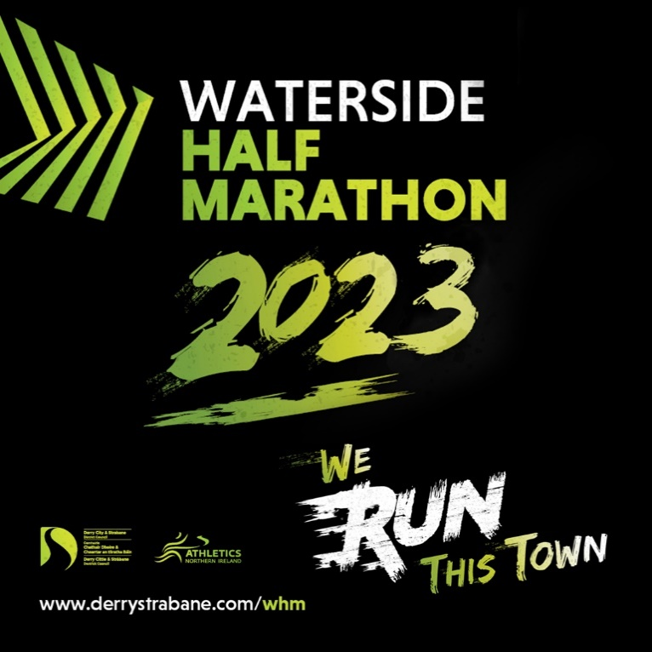

Waterside Half Marathon 2024 Course Description

Our Start point is adjacent to the Ebrington Hotel. Looking left across the Parade Square we run towards the Embankment restaurant, swinging right heading up an incline to Limavady Road passing Ebrington Car Park on your right.
At the junction with Limavady Road turn right along the slip road to Dales Corner in a coned runner’s lane. At Dales Corner turn right downhill continuing on the coned runner’s lane to Kings Link Roundabout.
From Kings Link roundabout you will continue to run downhill towards Duke Street Roundabout. Passing the Transport Hub on your right Mile 1. You will then switch to the left of the carriageway transversing two traffic lanes to run under the lower deck of Craigavon Bridge. At the end of the bridge city side swing right onto Foyle Road.
At the entrance to Foyle Road Car Park run through the car park to access the Greenway. Continue along the Greenway paths towards the iconic Peace Bridge. Cross the Peace Bridge for the first time towards Ebrington. At the end of the bridge Mile 2 swing right and run along the Star Fort wall descending with caution to a right sharp hairpin turn onto the St Columb’s Greenway. Run the greenway passing the St Columbs Park running track on your right. After you pass the play park Mile 3 all flat here, continue the greenway passing Mile 4 after Waterfoot Park. A relay change, water station and portaloo at this location. Continue, briefly entering the Gransha grounds and immediately turn left rising onto the new Strathfoyle Greenway.
Continue the Strathfoyle Greenway- all undulating terrain here passing Oakgrove College Mile 5 and Butlers Wharf on your right. As you approach the end of the Greenway at Strathfoyle Mile 6 swing right, running along the rear of the dwellings at Stradowen Drive with a short climb towards Temple Road. Turn right at the junction and run along the Temple Road towards Strathfoyle village. Run through the village descending on coned runners’ lane before passing Mile 7 onto the A2 Dual Carriageway junction passing Enagh Lough on your right. Turn right onto the A2 Dual Carriageway along the coned runners Lane-- and run towards Gransha Roundabout passing Judges Road and the rear access road to Gransha Grounds Mile 8. A relay change, water station and portaloo at this location
Continue running back towards the Caw Roundabout and right onto Madams Bank Road to begin crossing the Foyle Bridge--a coned runner’s lane all the way-- a downhill descend approaching the bridge Mile 9, then a pull up to the highest point of the Bridge, taking in the view of the river Foyle on the right before descending. A water station and portaloo at the layby. Continue running on towards the Culmore Road Roundabout passing the 10 Mile mark.

Turn right up the slip road towards Culmore you will be moved onto the pavement to swing right again at the pedestrian traffic lights just before the Foyle Hospice access road. Right again here and drop down along the Greenway to the ‘Donkey’ Sanctuary.
Drop further down onto Bay Road Park and swing left at the bottom of the descend to run along the banks of the Foyle heading back to the city Mile 11.Water Station and toilet located here. Run out of the park along the new greenway pathway towards the new Pennyburn pedestrian bridge. All flat running here passing Sainsburys, KFC on your right 12 Mile mark, pressing on towards the Peace Bridge passing Council offices on your right.
Swing left onto the Peace Bridge, rising all the way to enter the historic Ebrington site Mile 13 at the end of the Bridge. Small incline up the mall towards the Ebrington Hotel. At the top of the mall swing sharp right running a short 50m dash to the finish.
As you pass the finish you will be directed right onto the athletes/family zone to reflect on your achievement with friends and family on Ebrington Square.

