**DCSDC PEACEPLUS Local Co-Designed Action Plan – E Newsletter October 2024**

The PEACEPLUS Programme is a funding partnership between the European Union, the Governments of the United Kingdom and Ireland, and the Northern Ireland Executive and will be administered by the Special EU Programmes Body (SEUPB).

**Good news making the Headlines.**

As we move into the darker nights, it has been fantastic to see the light begin to shine across headlines, as some of our early PEACEPLUS projects get up and running. Our congratulations to all the projects that are officially launched across our city and district.

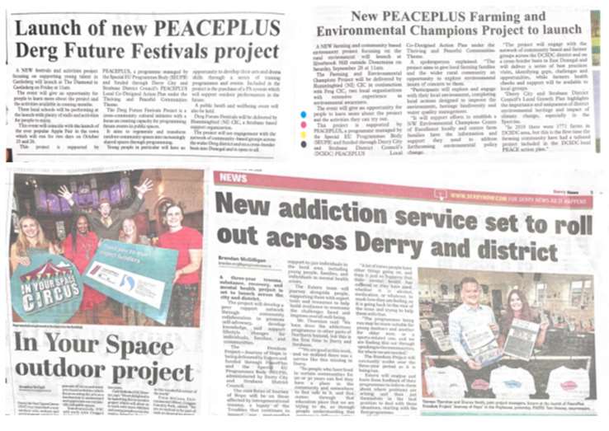

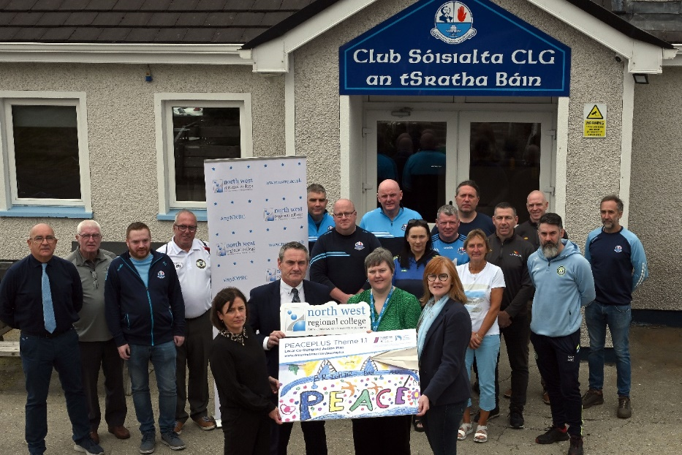

Green Clubs – Delivered by NW Regional College. This project is under the Community Regeneration and Transformation Theme and will involve the environmental transformation of 10 sports clubs.

Farming and Environmental Champions – Delivered by Hummingbird CIC. This is a cross-community, cross-border farming and environmental project exploring place, heritage, biodiversity, water, wellbeing, sustainability and best practice.

Our Place Our Planet – Delivered by In Your Space in partnership with Creggan Country Park. This is a children’s and youth outdoor culture and environment project. It will explore urban and rural shared space through street arts (music, dance, graffiti) and nature-based climate action and advocacy as part of the Thriving and Peaceful Communities theme.

Pre-Teen Transition Programme – delivered by RAPID. Under the Thriving and Peaceful Communities theme this cross-community after school’s programme will work with rural 10–11-year-olds. It will build confidence and awareness in the move to secondary schools.

**Current live tenders under DCSDC PEACEPLUS Local Co-Designed Action Plan:**

|  |
| --- |
| Tender |
| T24-127BUS PEACEPLUS A Centre of Hope |
| T24-133BUS PEACEPLUS Our Shared History (Political Ex-Prisoners) |
| T24-136BUS PEACEPLUS LGBTQIA+ Awareness |
| T24-137BUS PEACEPLUS Victims/Survivors Social Programme |
| T24-138BUS PEACEPLUS Culture Club |

For deadlines for returns, please see e-tenders NI website.

Council Website announcement: <https://www.derrystrabane.com/business/tenders>

All tenders are on E-Tenders NI: <https://etendersni.gov.uk/epps/home.do>

All our tenders are public procurement processes. Any organisations wishing to tender should do so via E-Tenders NI.

**Want information on the projects / tender opportunities (including order of advertisement)?**

**Download a user-friendly version of our Local Co-Designed Action Plan Here:**

[**https://www.derrystrabane.com/community/peace-plus/co-designed-action-plan**](https://www.derrystrabane.com/community/peace-plus/co-designed-action-plan)

**Download a more detailed project overview of the 58 included projects here:**

[**https://www.derrystrabane.com/community/peace-plus/co-designed-action-plan**](https://www.derrystrabane.com/community/peace-plus/co-designed-action-plan)

For email updates on tendering opportunities, see our website and make sure you’ve signed up to our email newsletter: <https://www.derrystrabane.com/community/peace-plus>

**Don’t miss out on wider PEACEPLUS funding opportunities!**

Remember, council doesn’t ‘run’ all of PEACEPLUS. Groups can apply directly to SEUPB.

Sign up to SEUPB’s emailing list here: <https://seupb.us7.list-manage.com/subscribe>

**SEUPB €100,000 Small Grants Opportunity.**

SEUPB have indicated they will issue a Small Grants Programme under Theme 1.2. Groups will be able to apply for up to €100,000. This is anticipated in the near future. <https://www.seupb.eu/PEACEPLUS>

**Grantfinder.**

Check out other funding options on Grantfinder: <https://search.mygrantfinder.co.uk/>

**Contact us:**

The Peace Team in council can be reached via [peace@derrystrabane.com](mailto:peace@derrystrabane.com)

Our website is: <https://www.derrystrabane.com/community/peace-plus>

The PEACEPLUS Programme is a funding partnership between the European Union, the Governments of the United Kingdom and Ireland, and the Northern Ireland Executive and will be administered by the Special EU Programmes Body (SEUPB). Match-funding for this element of the PEACEPLUS Programme has been provided by the Executive Office in Northern Ireland and the Department of Housing, Planning, Community and Local Government in Ireland.