DCSDC PEACEPLUS Local Co-Designed Action Plan – E Newsletter December 2024
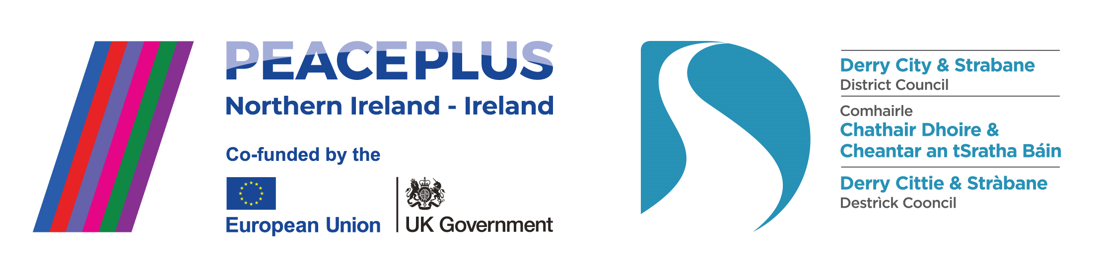
The PEACEPLUS Programme is a funding partnership between the European Union, the Governments of the United Kingdom and Ireland, and the Northern Ireland Executive and will be administered by the Special EU Programmes Body (SEUPB).
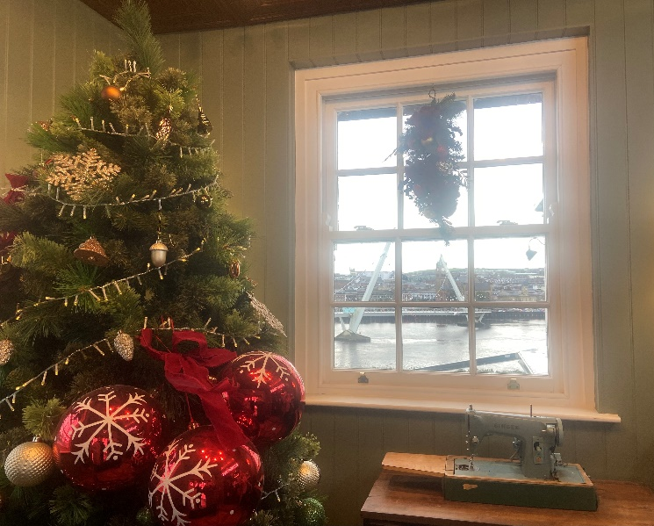

Wrapping up 2024!

Huge thanks to all our communities who have worked hard this year to create PEACE on Earth and goodwill between our diverse identities in our local area. As the winter weather closes in, the PEACE Team are glad to be closing in on the final phases of getting our 58 projects to contracting stage. By Christmas time over 80% of our contracts will have been awarded – that’s 47 out of a total of 58 projects. With a fair wind behind us we’d hope to have the full programme contracted before the end of this financial year so that 2024-25 sees our programme move completely into its delivery phase. Congratulations to all the community groups and organisations who have won contracts to date.

Current live tenders under DCSDC PEACEPLUS Local Co-Designed Action Plan:

Tender | Deadline
T24-201BUS PEACEPLUS Arts & Collaborative Resilience (Reissue) | 10th January 2024
T24-202BUS PEACEPLUS Ballyarnett Early Years Project (Reissue) | 10th January 2024
T24-203BUS PEACEPLUS Ballyarnett Women’s Programme (Reissue) | 10th January 2024
T24-213BUS PEACEPLUS Distance Travelled (Reissue) | 29th January 2024
For exact deadlines for returns, please see e-tenders NI website.
Council Website announcement: https://www.derrystrabane.com/business/tenders
All tenders are on E-Tenders NI: https://etendersni.gov.uk/epps/home.do
All our tenders are public procurement processes. Any organisations wishing to tender should do so via E-Tenders NI.

Celebrating recent project launches!
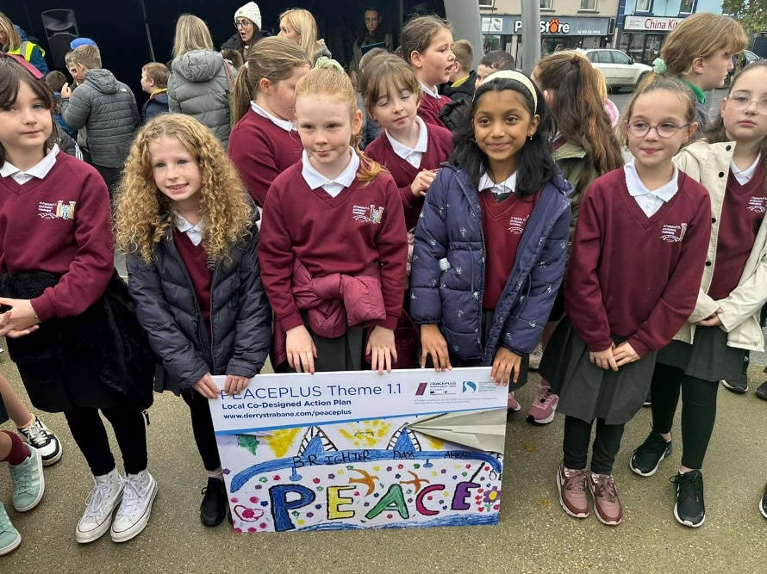
Derg Future Festivals – Delivered by Hummingbird CIC, this Castlederg area project is under the Community Regeneration and Transformation Theme. It will deliver a health and Wellbeing Festival, capacity development for future festivals and a young people’s cultural programme.
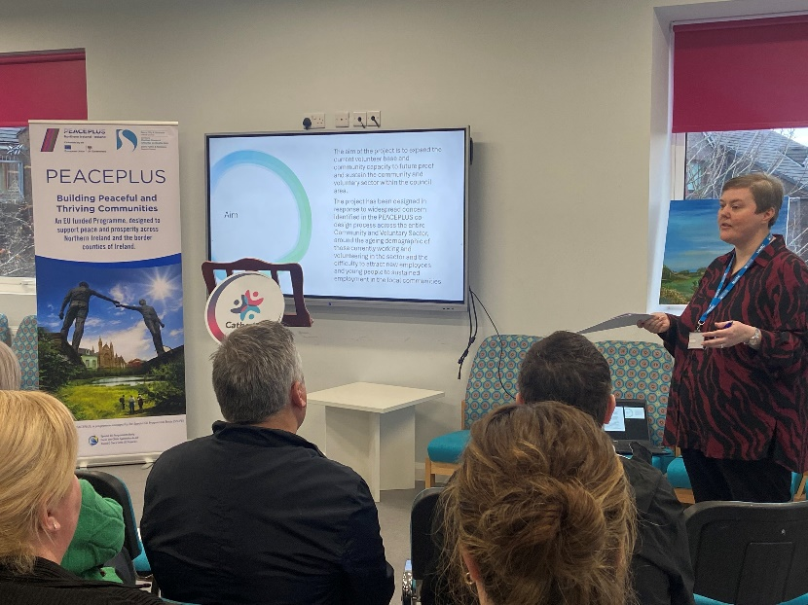
Inspire, Enthuse, Equip – Delivered by North West Regional College, this is a District level project under the Thriving and Peaceful Communities theme. It will provide OCN level 1,2 and 3 community development courses with visits and awareness to sustain future capacity and volunteering in the sector.
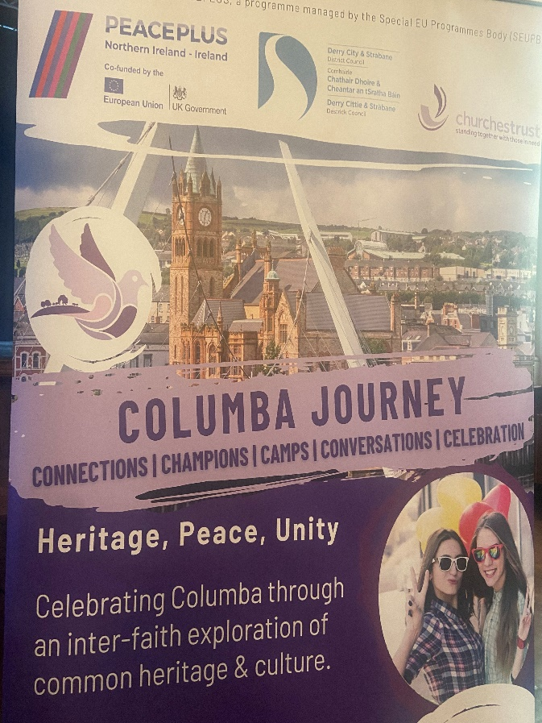

Columba Journey – Delivered by the Churches Trust, this is and inter-faith/inter-church community-based education and heritage programme around Columba, culture and identity. It’s a district wide project under our Celebrating Cultural Diversity theme.

Download a user-friendly version of our Local Co-Designed Action Plan Here:
https://www.derrystrabane.com/community/peace-plus/co-designed-action-plan

Don’t miss out on wider PEACEPLUS funding opportunities!
Remember, council doesn’t ‘run’ all of PEACEPLUS. Groups can apply directly to SEUPB.
Sign up to SEUPB’s emailing list here: https://seupb.us7.list-manage.com/subscribe

SEUPB €100,000 Small Grants Opportunity.
SEUPB have indicated they will issue a Small Grants Programme under Theme 1.2. Groups will be able to apply for up to €100,000. This is anticipated in January 2025. https://www.seupb.eu/PEACEPLUS

Grantfinder.
Check out other funding options on Grantfinder: https://search.mygrantfinder.co.uk/

Contact us:
The Peace Team in council can be reached via peace@derrystrabane.com
Our website is: https://www.derrystrabane.com/community/peace-plus

The PEACEPLUS Programme is a funding partnership between the European Union, the Governments of the United Kingdom and Ireland, and the Northern Ireland Executive and will be administered by the Special EU Programmes Body (SEUPB). Match-funding for this element of the PEACEPLUS Programme has been provided by the Executive Office in Northern Ireland and the Department of Housing, Planning, Community and Local Government in Ireland.

