DCSDC PEACEPLUS Local Co-Designed Action Plan – E Newsletter December 2025

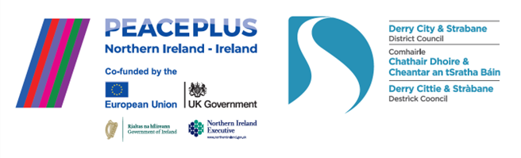

The PEACEPLUS Programme is a funding partnership between the European Union, the Governments of the United Kingdom and Ireland, and the Northern Ireland Executive and will be administered by the Special EU Programmes Body (SEUPB).

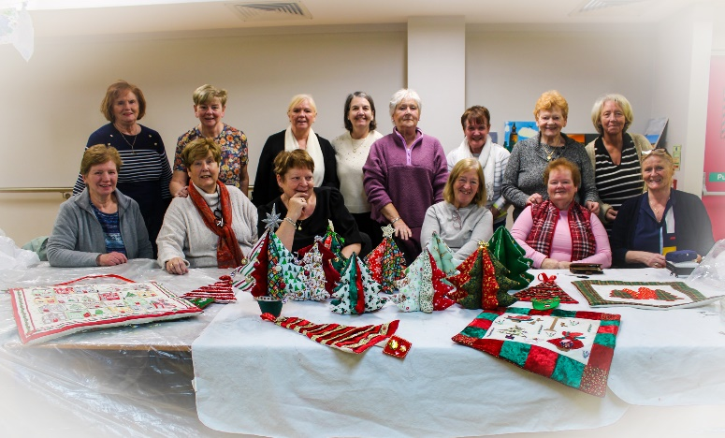
PEACEPLUS Project Art: Recovery to Discovery

A Happy Christmas and Seasons Greetings!

As we close out the year, we’d like to celebrate all that our PEACEPLUS projects are delivering on the ground for and with our local communities. A huge thank-you to all the community workers out there who work so hard year-round to bring light and joy to people’s lives.

In this e-newsletter, there’s a glimpse of some recent activity plus a short video about our programme delivery. Sit back with a marshmallow-loaded mug of hot-chocolate and smile.

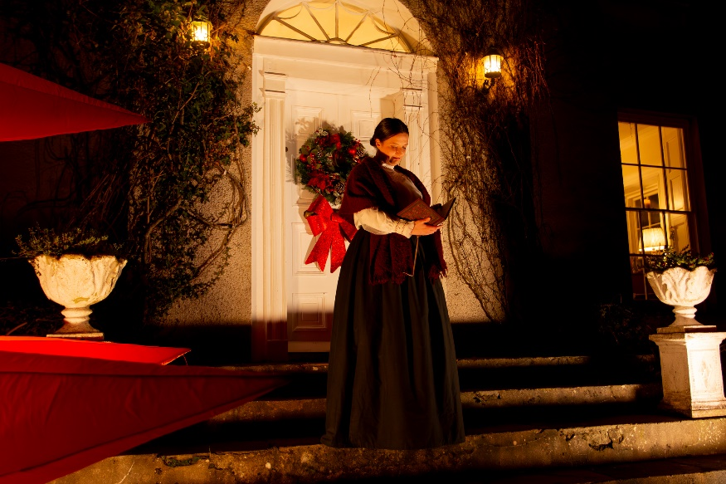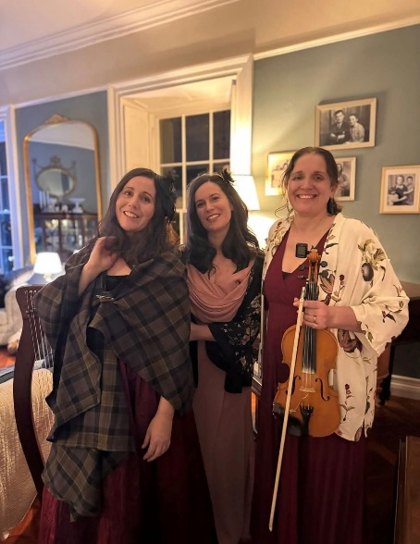
Cecil Frances Alexander Celebrated PEACEPLUS Project

Watch our video!

This short video captures in a nutshell how the PEACEPLUS Local Action Plan came about, what is being delivered through it, and some of the impact it is having at this early stage of delivery.

Insert Website or YouTube Link for video to directly open

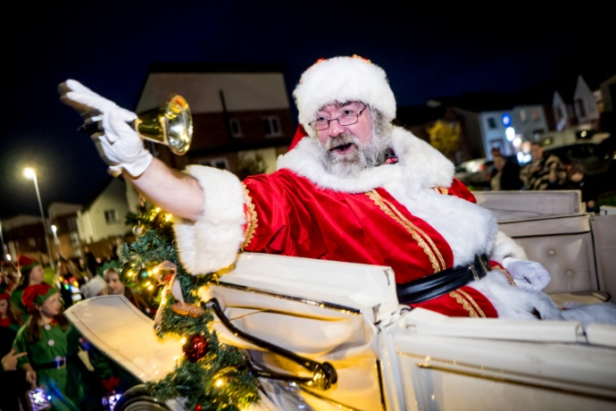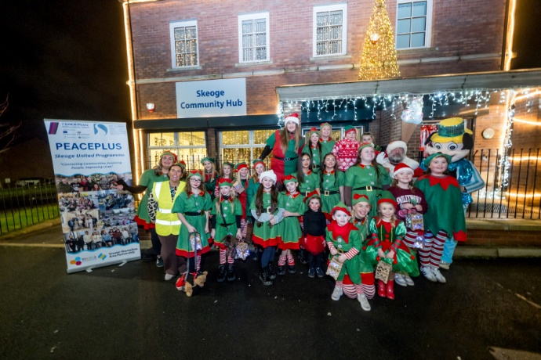
Christmas elf parade in PEACEPLUS Skeoge United Programme.

Want to take part?
Given the peace team a call on 028 71253253 or email us on peace@derrystrabane.com and we’ll try to link you with a project which suits your interests and needs. All our projects are free to take part in.
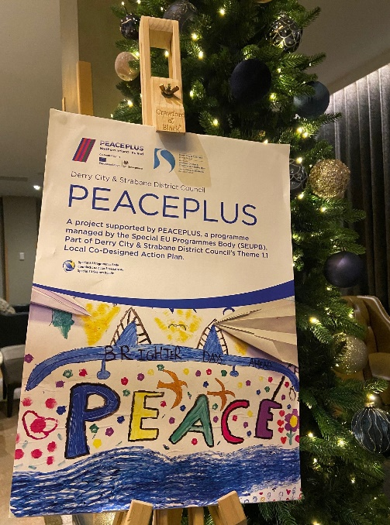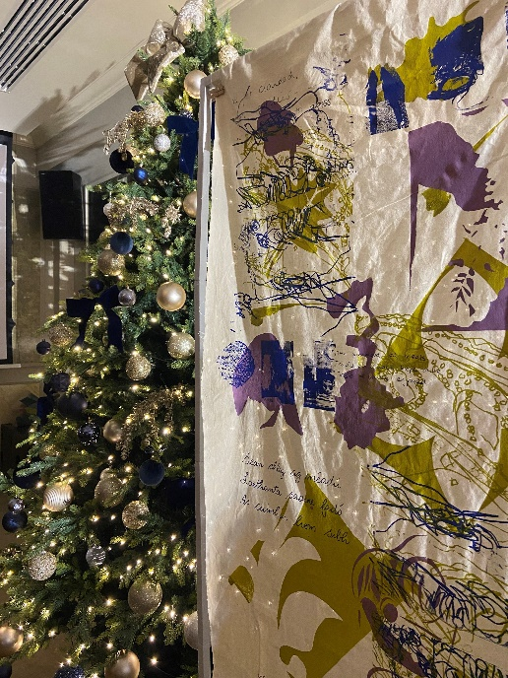
PEACEPLUS Creating Creatives Project

Contact us:
The PEACE Team in council can be reached via peace@derrystrabane.com
Our website is: https://www.derrystrabane.com/community/peace-plus

The PEACEPLUS Programme is a funding partnership between the European Union, the Governments of the United Kingdom and Ireland, and the Northern Ireland Executive and will be administered by the Special EU Programmes Body (SEUPB). Match-funding for this element of the PEACEPLUS Programme has been provided by the Executive Office in Northern Ireland and the Department of Housing, Planning, Community and Local Government in Ireland.

