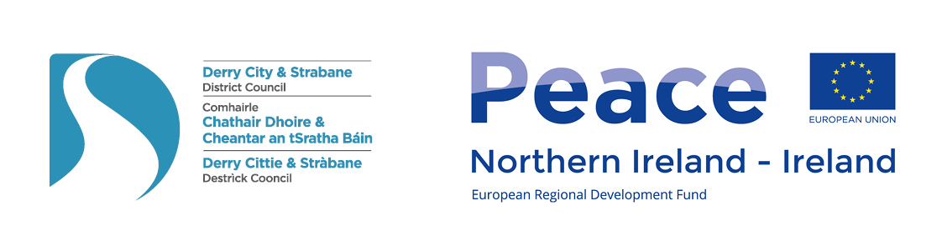
Derry City and Strabane District PEACEPLUS Partnership Board

Meeting Date: Tuesday 6th September 2022
Time: 10.00am – 12 noon
Venue: Sollus Centre, Bready.

AGENDA ITEM
1. Meeting Opening
1.1 Welcome and Apologies
Note welcome of new Board Members. June changeover of elected representation means we are now joined by Cllr Martin Reilly, Cllr Paul Gallagher, Cllr Brian Tierney and Ald. Drew Thompson.
Sperrin LGCP have confirmed Claire Russell as their new Board representative.

1.2 Minutes of previous meeting / Matters arising (p.3-6)

2. Management Update
2.1 Discussion on complementarity with other areas of PEACEPLUS Programme. Appx A. (Sue)
- Theme 4.1 Ben Fitzpatrick – University of Ulster - Collaborative Health and Social Care.
- Theme 4.2 (& possibly other) Susan Mullan – DCSDC Head of Community Services.
- Theme 1.4 Richard Osterhus – DCSDC Funding Manager
- Theme 2.3 Kevin O’Connor – DCSDC Head of Business
- Theme 4.1 Edel O’Doherty CAWT (information provided in Appendix A)

2.2 Update from SEUPB at Programme Level (Sue)
- See Appendix B. Key information on total budget, participant target and timeframe. Impacts.

2.3 Equality analysis of Board (Sue)
- See Appendix C.

2.4 Mileage Expenses Claim form (Sue)
- Note final update now scrutinized by SEUPB.

3. Communications Update (Sue)
3.1 Press & Social Media: Press release issued on Phase 1 / Concept forms opportunity. (Appx D)

3.2 Web & E-zine: July and August e-zines issued on Phase 1/Concept Forms & Phase 2 dates.

4. Key Business: Consultation and Co-design Process Update (Myriam and Sue)
4.1 Update on Youth, S75 & wider support – 2 Youth (Strabane/Rural). Est. 30 wider (70 people).

4.2 Concept Forms Summary. (Appendix E and Spreadsheet)

4.3 Gaps Identified (ie. From Phase 1 workshops but not in Concept Forms or missing entirely).

4.4 For Decision: Management of Expectations. Potential filter out of limited projects that clearly do not fit Theme 1.1.

4.5 For Decision In Principle: Modelling 50/50 split DEA/Thematic for use in Phase 2. Final decision to be made in a subsequent Board meeting. (Appendix G)

4.6 Agreeing approach to Phase 2 Co-Design Phase – Workshops, Questionnaire, Board role.

5. Meeting Closing
5.1 AOB

5.2 Date of Next Meeting: 10am Tuesday 4th October Derry~Londonderry

Phase 2 Workshops Information

All the phase 2 workshops (below) are open the public. Advance registration is not required – just turn up. Tea/Coffee will be provided. If you have any particular access / equality requirements please contact peace@derrystrabane.com in advance.

Date | Time (2 hr slot) | Venue* | DEA/LCGP Area
Wednesday 21st September | 10am – 12pm | Ballymagroarty Community Centre, Shaws Court | Outer West Area
Wednesday 21st September | 2-4pm | Ebrington Theatre | Waterside
Wednesday 21st September | 7pm – 9pm | Derg Valley Care | Derg
Thursday 22nd September | 10am – 12pm | Galliagh Community Centre | Ballyarnett
Thursday 22nd September | 2pm – 4pm | Drummond Centre, Donemana | Sperrin
Wednesday 28th September | 10am – 12pm | Civic room, Strabane Library | Strabane
Wednesday 28th September | 2pm – 4pm | Mullabuoy Community Centre, Lettershandoney | Faughan DEA
Thursday 29th September | 10am – 12pm | Verbal Arts Centre | The Moor
Thursday 29th September | 2pm – 4pm | St.Columb’s Park House | S75/Thematic

Derry City and Strabane District PEACEPLUS Partnership Board
Minutes of Meeting

Meeting Date: Tuesday 21st June 2022
Time: 10.00am – 11.30 pm
Venue: St Columb’s Park House, Derry~Londonderry

Sue Divin | DCSDC | Christopher Jackson | SF
Fiona Lafferty | DCSDC | Charles Lamberton | The Moor LGCP
Mary Claire Kerlin | DCSDC | Darren Guy | UUP
William Calderwood | PSNI | Craig Barr | Holywell Trust
Gus Hastings | Faughan LCGP | Catherine Cooke | Foyle Women’s Info Network
Mary O’Neill | NI Housing Executive | Sharon Doherty | St Columb’s Park Reconciliation Trust
Rory Farrell | SDLP | Noelle Donnell | Hummingbird (NI) CIC
Jacki Connolly | Ballyarnett LCGP | Declan Gallagher | EA
Maeve O’Neill | PBP | Derek Moore | NW Cultural Partnership
Keith Kerrigan | DUP | Nikki Yau | Foyle Racial Equality Forum
Maurice Devenny | DUP | Alison Wallace | Waterside LCGP
Lisa Moore Maguire | Foyle LCGP | Philip McKinney | Alliance

Apologies: Ruairi McHugh SF, Angela Dobbins SDLP, Steven Edwards SDLP, Anne McTaggart Youth Action NI, Martin Duffy Derg LGCP, Margaret McLaughlin Sperrin LGCP, Kevin O’Connor DCSDC, Seamus Ward WHSCNI, Kyra Reynolds BBI.

1.2 Change in Sperrin – resignation of Margaret McLaughlin. Patricia McNulty now full board member. Apologies were recorded.

1.3 Minutes of Previous meeting/Matters arising - Board meeting of 10 May 2022 were held to be an accurate record.
Approved Craig Barr

Management Update
2.1 Update from SEUPB at Programme Level (Sue)
Sue informed members that no update had been received regarding theme 1.1. Communication has been received regarding theme1.4. SEUPB are holding a hybrid information session on 8th July of which details are available on SEUPB website. Sue to pass on further details if required by board fellows.
2.2 Equality analysis of Board still pending return of Equality Monitoring Forms (PEACE Team) -
Sue to follow up
2.3 Update on Code of Conduct / Conflict of Interest & Partnership Agreement Signing (MCK/FL)
Fiona and Mary Claire to follow up with members on outstanding forms to be completed.
2.4 Revised Expenses policy and form – audit feedback. Appendix D. (Sue) – Sue advised members that a few changes have been made to the expenses form on advice from council audit. Revised form attached in appendix D.
2.5 New Councilors / Anyone who missed initial training – Workshop over summer (Sue) – Sue requested that members advise when new councilors for the board are elected and if any new members require training.

3. Communications Update
3.1 Press & Social Media: Coverage of Board launch and Co-Design Process - Members were updated on social media uptake from January-March 2022. The Peace Plus website had 300 hits but no new sign ups to our online newsletter during this period. Approximately 300 people have signed up to the newsletter to date with 41% of emails sent from Peace Plus opened by recipients.
3.2 Web & E-zine: Will issue 1 e-zine over summer – Sue advised that she plans to issue an e-zine over the summer months and left some copies of previous newsletters for members to take.

4. Key Business: Consultation and Co-design Process Update (Powerpoint Presentation by Myriam Fearon)
4.1 Summary of Engagement (Appendix A) – Members informed that 13 workshops had been delivered to date with the last one specifically targeted at youth taking place tonight in St Columb’s Park House.
4.2 Feedback from Phase 1 (May/June Workshops) - Myriam informed members that the feedback from the workshops have been extremely positive with 186 participants from 130 different organisations represented. Myriam referred to Appendix A, which provides a breakdown of Postcodes participants were from that demonstrated a good geographically spread. Myriam then provided an overview of the key findings from each workshop in terms of the strengths, challenges and opportunities identified in each area and potential programme ideas. The findings identified there was very much an individual personality in each area that came out in the workshop. With some cross cutting themes also identified throughout a number of workshops, particularly around deprivation and mental health.
4.3 Process Moving Forward – July/Aug/Sept Focus:
- Issue and collate back Concept Form for ideas
- Desk Research, context and evidence gathering
- Questionnaire Development for testing ideas
- Develop Concept of Project Selection Process

Sue explained the focus for the Peace Plus team over the summer months as above which will also include the scheduling of the 2nd round of workshops.
A discussion then took place regarding the work ahead in the next coming months and Sue advised there had been a lot of interest to date regarding capital projects and has advised a number of groups to investigate theme 1.4 as Theme 1.1 is mainly programme based. As a board, members were reminded that we need to prioritise what’s on council capital list first in terms of capital projects as these have already been through community planning processes.

A discussion then ensued by members regarding employability needs identified through the consultations. In particular, the long term unemployed and the need to develop the community sector. Charles Lamberton asked what other council departments are looking at in terms of theme 1.4 skills and theme 2 youth. Board members greed that it would be useful to know what other themes are being looked at by council so we do not duplicate other areas. Sue informed members that council officers are looking at these and other themes and that there are strands that the Community and Voluntary sector can also look it in its own right independent of council.

The discussion then continued with various queries from members regarding youth age group, which Sue clarified under PEACE IV was 0-24 but that there isn’t a specific CYP heading in PEACEPLUS Theme 1.1. Issue also made around the importance of the co-design process and working with all communities on project ideas. There was a concern stated around whether council led ideas would be prioritised over community wishes. Members also stated the importance of projects that could address the increased cost of living and how to deliver more sustainable projects. Sue informed them that council is working on a eco clubs programme that links in with reducing running costs in sports/community buildings whilst creating that long term sustainability. The final query issued by members was around single identity work and it’s need to be included in some capacity within the programme. Sue reported that this has been raised with SEUPB as part of the PEACE IV evaluation and is waiting for clarification on the issue.

Action - Community Services Manager and the funding manager to be invited to next board meeting in September to provide an update on their work to date regarding the other themes.

4.4 Official Youth Consultations – 1 in Strabane area, 1 in rural area. Board members were encouraged to spread the work and encourage engagement. Board Members were satisfied that 3 youth consultations (city, Strabane, rural) was a positive and sufficient level of engagement.
Sue informed members that the youth consultation will take place tonight in St Columb’s Park House where we are expecting around 40 young people to attend.

Action - Strabane and Rural meetings to be actioned over the summer.

4.5 Team follow ups to enhance inclusion: BAME, LGBTQ+, others. – Over the course of the summer months’ members were informed that the Peace team will continue to meet with various organisations to enhance engagement. Despite earlier meetings with the LGBTQ+ community. There has been no further engagement at any of the consultations. PEACE team to try to further engage as keen not to leave any sector out of the co-design process.

Action – Email out Peace Plus presentation and documents to these sectors.

5. Meeting Closing
5.1 Any Other Business - No meeting for the months of July and August. Sue suggested any other urgent business could be discussed with chair and co-chair. If full board approval required details will be emailed out to members and can be approved providing there is a quorum.

5.2 Review of Actions
Action - Community Services Manager and the funding manager to be invited to next board meeting in September to provide an update on their work to date regarding the other themes.
Action - Strabane and Rural meetings to be actioned over the summer.
Action – Email out Peace Plus presentation and documents to these sectors.

5.3 Date of Next Meeting: Tuesday 6th September 10am – 12 noon Rural or Strabane

Appendix A: PEACEPLUS Complementarity with wider Programme.

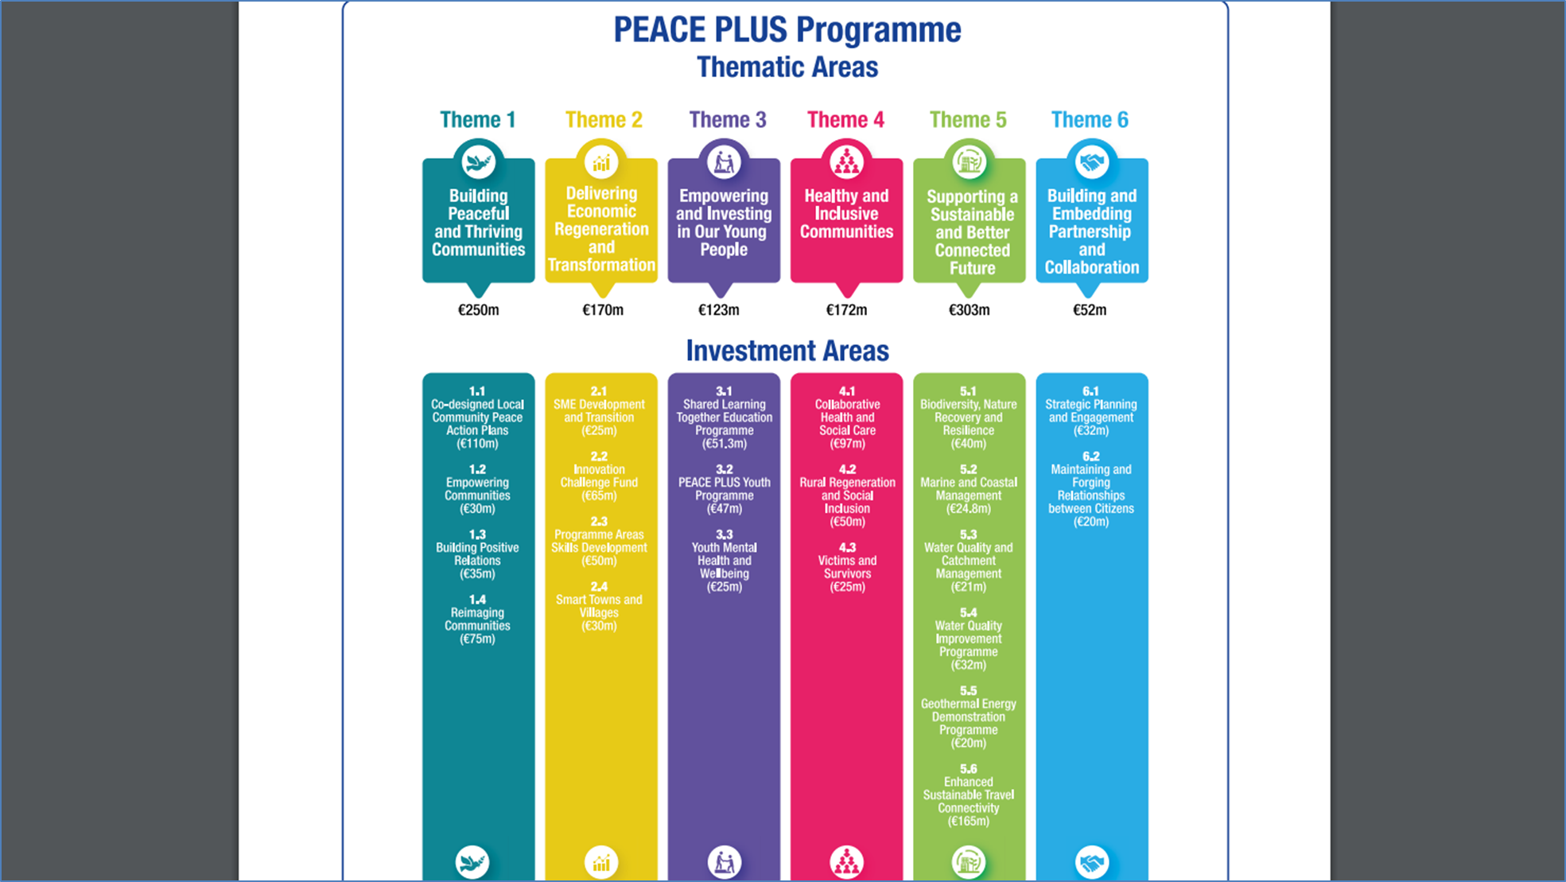

Theme 4.1 Healthy and Inclusive Communities.

CAWT Contact: Edel O’Doherty, Deputy Chief Officer, Cooperation and Working Together (CAWT)
Summary Info: CAWT are working on an application that has 4 key areas – Integrated Care (Multi-Morbidity Hubs), Disability (Social Inclusion of Disabled people, their carers and families), Mental Health (Resilient Services and Resilient Communities – including some social prescribing and community preventions like the BBI Right Time Right Place approach) and Children’s Services (Children at risk of harm, children in poverty, children with disabilities, family support). Much of it is more individually focused and more medically focused than our sustained cross-community reconciliation focus, however the Board should be aware of the need to avoid duplication.

Appendix B: key points in update from SEUPB.

PEACEPLUS programme was formally approved and adopted by the European Commission in July.

SEUPB have wrote to council on 26th July 2022 to confirm the maximum allocated budget which Derry City and Strabane District Council may bid for is €9,254,427. That indicative allocation is final and is not open to negotiation. (At €1 = £0.86 figure = £7,925,867).

SEUPB have determined the indicative allocations based on a methodology which ensures fairness and proportionality across the 17 local authorities in Northern Ireland and the border counties of Ireland. This includes a baseline allocation for each local authority, before applying a formula to the remaining balance, based on deprivation and population size in Northern Ireland, with additional criteria applied in Ireland including area size / border length.

The same correspondence indicates ‘Early 2023’ as the date by which councils should have submitted their respective bids.

- Participant targets are critically high and likely to impact project choice significantly (assuming that the same definition of ‘participant’ is applied as in PEACE IV. Ie. Participant = 1 non-duplicate person attending minimum 26 hours cross-community contact spread across minimum 6 months).

Council/ Local Authority | Local Authority Indicative Allocation (€) | Output target | Indicative Result target (pro-rata allocation)
Derry City and Strabane District Council | € 9,254,427 | 1 | 9,254

NB. Once flat rate management costs are applied to the total allocated budget and this participant target divided out on programme costs this equates to 1 participant per £736.

SEUPB have indicated this is set, however further information will be supplied on what constitutes the achievement of target numbers (ie how to define achievement of the output), following a meeting with the European Commission next week in which SEUPB are having further discussions. With regards to the breakdown of participants targets across the three strands, SEUPB preference is to provide as much flexibility as possible for each local authority to decide. They would like to extend as much flexibility as possible to the definition on achievement of the outputs.

If definition of participant does not change, the £/Participant ratio makes capital projects virtually impossible and emphasises need for limited hours (eg. 35hr contact) programmes which are highly cost effective.

Appendix C Board Equality Monitoring – Summary of responses.

There was a 71% return rate. Equality monitoring is based on those responses.
Age
Average age: 49 Age range: 29 – 79
Gender
Male: 46% Female: 54%
Community Background:
Protestant: 29% Catholic: 54% Neither: 13% Prefer Not to Say: 4%
Nationality:
British: 29% Irish: 59% Other: 8% (Including NI / Multiple) Pref not to say: 4%
Sexual Orientation/attraction to:
Same Sex: 13% Different Sex: 71% Other: 8% Prefer not to say: 8%
Ethnicity:
White: 96% Prefer not to say: 4%
Disability:
Yes – Physical Disability: 17% None: 54% Prefer not to say: 29%
Legal Marital Status:
Single 13% Married: 66% Divorced: 13% Prefer not to say: 4% Other: 4%
Political Opinion:
Unionist: 21% Nationalist: 33.5% Neither: 33.4% Other: 4% Prefer not to say: 8%

Deputy Board Members
There was a 91% return rate. Equality monitoring is based on those responses.
Age
Average age: 52 Age range: 35 - 71
Gender
Male: 60% Female: 40%
Community Background:
Protestant: 15% Catholic: 80% Neither: 5% Prefer Not to Say: 0%
Nationality:
British: 30% Irish: 56% Other: 14% (Including NI / Multiple) Pref not to say: 0%
Sexual Orientation/attraction to:
Same Sex: 10% Different Sex: 68% Other: 17% Prefer not to say: 5%
Ethnicity:
White: 95% Prefer not to say: 5%
Disability:
Yes – Physical Disability: 15% None: 75% Prefer not to say: 10%
Legal Marital Status:
Single 15% Married: 75% Divorced: 5% Prefer not to say: 5% Other: 0%
Political Opinion:
Unionist: 10% Nationalist: 60% Neither: 20% Other: 5% Prefer not to say: 5%

Appendix D: Communications

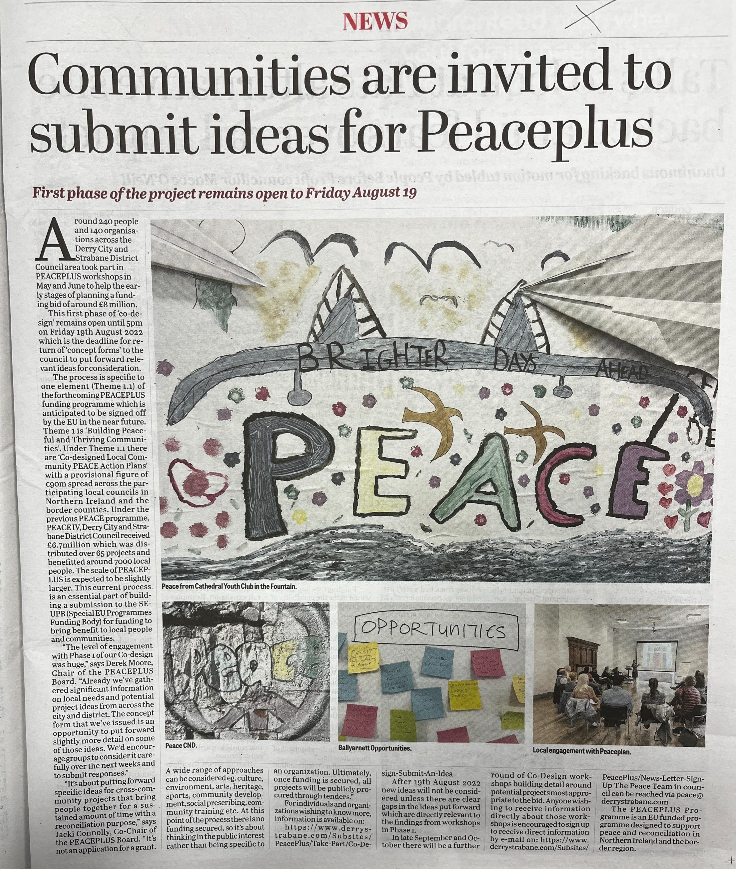

Appendix E. Summary Information Phase 1 Co-Design Forms.

CAVEAT: Bear in mind that this is very rough statistical analysis. Some individual project ideas will skew the results. Whilst many forms were completed accurately, some forms were not filled in with clear (or any) information on budgets or participants and some forms would have clear issues around costs or understanding of participant definition. There will also be relevant project ideas from some areas that were articulated in Phase 1 workshops that haven’t materialized into form submissions which should still be considered. Also so project ideas linked with other councils are not included. On the other hand, some project ideas submitted would be ineligible for this funding stream and/or are too large for this funding stream. Many project ideas submitted are scaleable (eg. Submitted as a 3 year but could be 2, or could operate with less participants etc).
Headline Summary.
95 Forms were received in Total.
62 Different Organisations submitted responses.
DCSDC SEUPB Allocation: €9,254,427 (estimate £7,763,631)
Total ask: £28,464,773 (ie. x3.6 more than available)
Total no. participants estimated: 20725
Average estimate cost per participant: £1373
Key Points:
Our average cost per participant is too high. We will need projects that get ‘scores on the doors’ ie. Lower ratio of cost per participant if we are to fund any more expensive or capital projects at all.
Area | No. Forms | Financial Ask | Participants+ | % of total £
Ballyarnett | 16** | £2,536,938 | 2339 | 8.9%
Derg | 3 | £107,695 | 121 | 0.4%
Faughan | 5 | £1,581,130 | 1060 | 5.5%
Foyleside | 3 | £2,308,005* | 1940 | 8.1%
Moor | 4 | £413,492 | 480 | 1.5%
Sperrin | 7 | £1,416,000 | 1290 | 5.0%
Strabane | 1 | £45,000 | 40 | 0.2%
Waterside | 5 | £1,244,513 | 697 | 4.4%
Grouped DEA’s (rural) | 5 | £1,497,836 | 962 | 5.2%
Grouped DEA’s (Other) | 3 | £3,650,000* | 375 | 12.8%
Thematic | 43 | £13,664,164 | 11421 | 48%
*One application severely skews this figure
** Ballyarnett includes a few applications that specified links with Waterside
+ Where an application was really unclear on participants numbers or understanding of counting this is counted in this table as a zero.
Appendix E continued.
PEACEPLUS Themes.
Celebrating Cultural Diversity: 22 Applications
Community Regeneration and Transformation: 21 Applications
Thriving & Peaceful Communities: 52 Applications
NB. Co-design process will need to bear in mind that, in very general terms, applications under TPC tended to be predominantly cross-community programmes with weaker emphasis on Peace and Reconciliation. Peace content would need enhanced. The ratio across the 3 categories will need explored. Also worth noting that many applications aren’t clear which category they fit in or ticked more than one.

 | General Topics
12 | Arts
11 | Capital & Associated Programme
8 | Heritage/History
6 | Wellbeing
5 | BAME
5 | Youth
4 | Elderly
4 | Women
3 | Environmental
3 | Cultural
3 | Dialogue
3 | Interfaith
4 | C&V Sector Capacity/Volunteering/Skills
3 | Sports
2 | Skills/Employability
2 | Disability
2 | Early Years
2 | Shared Space
14 | Individual applications covering:  Sustainability; Irish Language; Social Economy; Social Prescribing; Children; Laundry; Leadership; Men; Regeneration; NEET/Employability; Farming; Interface

Note:
There are some key gaps identified in Phase 1 workshops that did not materialize into Concept Forms. Where these have clear relevance and viability to Theme 1.1 these are still ‘on the table’ for phase 2. Includes eg. Anti-sectarianism/re-imaging ideas, LGBTQ+, linked projects with other councils such as East meets West concept, and others. Verbal update at meeting if required.

Appendix F: Board Member’s Attendance 2022

Statutory Pillar |  | 29/3 | 10/5 | 21/6
William Calderwood (d. Shannagh Farren) | PSNI | x | x | x
Deborah Cross (d. Declan Gallagher) | EA |  | x | x
Marie Gallaher (d. Sharon McCullagh) | DfC | x | x
Mary O'Neill (d.Noel McNulty) | NIHE | x | x | x
Seamus Ward (d.Bronach McMonagle) | WHSCNI | x | x
Gerard O’Neill (d.Ciaran McLaughlin) | DAERA |  | x
Social Partners – Local Growth Partnerships
Jacki Connolly (d.Darren Kirby) | Ballyarnett | x | x | x
Martin Duffy (d. Andy McKane) | Derg | x | x
Aodhán Harkin (d.Ursula Doherty) | Strabane | x | x
Gus Hastings (d.Martin McCartney) | Faughan |  |  | x
Charles Lamberton (d.Seamus Breslin) | Moor | x | x | x
Claire Russell (d.Patricia McNulty) | Sperrin |  | x
Alison Wallace (d.Geraldine Doherty) | Waterside |  | x | x
Lisa Moore-Maguire (d. Jim McColgan) | Foyleside |  | x | x
Elected Representatives Pillar
Conor Heaney | SF |  | x
Christopher Jackson | SF | x | x | x
Ruairi McHugh | SF
Angela Dobbins | SDLP | x
Maurice Devenney | DUP |  |  | x
Keith Kerrigan | DUP |  |  | x
Darren Guy | UUP | x | x | x
Philip McKinney | Alliance | x |  | x
Martin Reilly (from July 2022) | SDLP
Paul Gallagher (from July 2022) | Indep
Brian Tierney (from July 2022) | SDLP
Drew Thompson (from July 2022) | DUP
Social Partners Pillar
Craig Barr (d. Gerard Deane) | Holywell | x | x | x
Catherine Cooke (d. Amanda Leighton) | FWIN | x | x | x
Sharon Doherty (d. Michelle Simpson) | St.CPH | x | x | x
Noelle Donnell (d. Sinead Barr) | H’bird | x | x | x
Anne McTaggart (d. Dominic Bonner) | YANI | x
Derek Moore (d. Kyle Thompson) | NWCP | x | x | x
Kyra Reynolds (d. Rachel Mullan-Carlin) | BBI |  | x
Nikki Yau (d. Agnieszka Luczak) | FREF | x | x | x

Appendix G: Information on Thematic/District Wide/S75 and DEA/LCGP % split.

Recommendation is that based on demand in Phase 1, we move forward into a 50/50 model for Phase 2 in principle.
Final decision to be revisited by the Board at a later date when the co-design process is more advanced and fuller information available from SEUPB.

