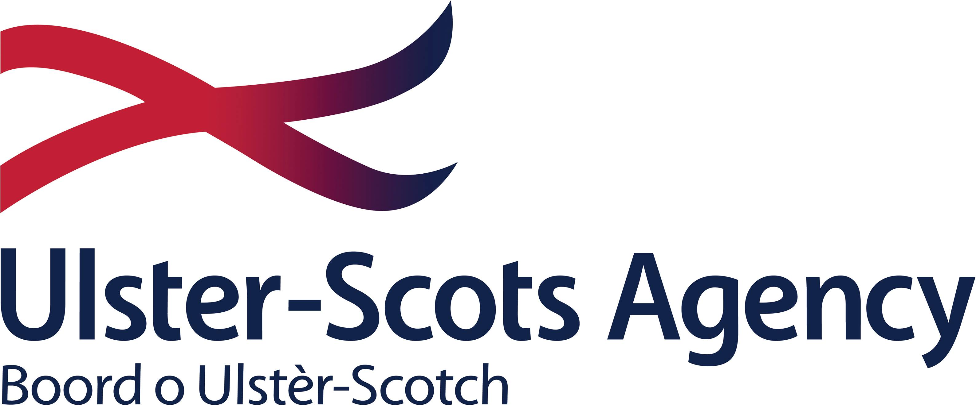

**Ulster-Scots Language Week 2025**

**Call for Applications**

**2025**

**Ulster-Scots Language Week 2025**

Derry City and Strabane District Council is offering grants of up to £250 to individuals, groups, and organisations who wish to develop projects, events or activities which aim to celebrate the Ulster-Scots language during Ulster-Scots Language Week 2025 (24-28 November).

**How to apply**

Applicants can apply for a grant up to a maximum value of £250 by completing the application form below. Applicants must provide details of any relevant qualifications and/or experience which they have, and provide an overview of their proposed project along with a breakdown of relevant costs.

Applicants must demonstrate how the project, event or activity will promote greater awareness, understanding and appreciation of the Ulster-Scots language. Please note that the Ulster-Scots language must be integral to the project; only projects which demonstrate that language is at the core of the proposal will be deemed eligible.

The definition of ‘project, event or activity’ will be interpreted as broadly as possible provided the proposal demonstrates that it can act to enhance awareness, understanding and appreciation of the Ulster-Scots language. Some examples of eligible projects, events and activities are included below, but please note that this list is illustrative rather than exhaustive. If you are unsure about whether your proposal meets the eligibility criteria, please get in touch, T: 028 71 376579 or email [ulsterscots@derrystrabane.com](mailto:ulsterscots@derrystrabane.com)

* Language learning events e.g. classes, workshops
* Language awareness projects e.g. presentations, webinars, resources
* Lectures, talks or workshops about the Ulster-Scots language
* Events which showcase original work in Ulster-Scots e.g. writing, poetry, music
* Drama, performance-based, and/or participatory activities
* Creative writing, storytelling, poetry, or spoken word events
* Creative media e.g. short film, video, digital, multimedia, social media content
* Visual arts-based projects

Applicants may submit more than one application, but please be aware that this is a competitive programme and we may receive more applications than we can fund. Those projects, events and initiatives which are selected for funding will be included as part of the Council’s annual Ulster-Scots Language Week programme.

**How we plan to score applications**

Applications will be scored using an 80% Quality, 20% Value for Money model. Appendix 1 provides more detail about how we plan to score applications.

Appendix 2 provides details of conditions associated with the award.

**Ulster-Scots Language Week 2025 – Application Form**

|  |  |
| --- | --- |
| **Applicant Name** |  |
| **Address** |  |
| **Telephone number** |  |
| **Email** |  |
| **Please provide details of any relevant qualifications and experience, or a CV where appropriate. You may also wish to include examples of, or links to previous work or activity in the Ulster-Scots language** |  |
| **Please provide a title, and details of your proposed project, event or activity (80%)**  Provide details of the proposed project/event/activity demonstrating how it will promote greater awareness and understanding of the Ulster-Scots language and/or promote opportunities for people to engage with the Ulster-Scots language.  Please include details of the proposed format and duration of your project/event/activity, i.e. in-person, digital, publication, resource, artwork etc. and who the intended audience might be.  For in-person events, the applicant must be available to deliver the event at a date between 24 and 28 November 2025. Please indicate any dates/times when you would be unavailable. Council may be able to provide venues for in-person events. Proposals for digital projects or artworks should detail the format(s)/medium in which the final work will be submitted. |  |
| **Value for Money (20%)**  Please provide a breakdown of the costs associated with your application. Total costs must not exceed £250 per application. |  |

**Deadline**

Please submit your application via email to [ulsterscots@derrystrabane.com](mailto:ulsterscots@derrystrabane.com) before 12 noon on **Friday 26 September 2025**.

Late or incomplete applications cannot be accepted.

**Appendix 1**

**How we plan to evaluate your application**

All applications will be assessed against the quality and value for money evaluation criteria below.

**Quality (80%)**

The following criteria and weightings will be applied to proposals.

|  |  |  |  |
| --- | --- | --- | --- |
| **Evaluation criteria** | **Criteria Weighting %** | **Details** | **Scoring** |
| Quality | Marks (0-5) weighted x 16 | The project, event or activity is language-focused and promotes awareness and understanding of the Ulster-Scots language.  Applications will be scored between 0-5 using the marking matrix in the table below. | 80% |

**Marking Matrix**

|  |  |  |
| --- | --- | --- |
| **Band** | **Comments** |  |
|  |
| **5** | Fully detailed evidence provided, very minor concerns on detail, relevance or complexity |  |
| **4** | Detailed evidence provided, some concerns on detail, relevance or complexity |  |
| **3** | Reasonable evidence provided, lacking in detail, relevance or complexity |  |
| **2** | Limited evidence provided, significant concerns on detail, relevance or complexity |  |
| **1** | Little or no evidence provided, very significant concerns on detail, relevance or complexity |  |
| **0** | Failed to submit details or to address question |  |

If a proposal scores in band 0-3 it will be deemed that the application has not met the required quality threshold and is therefore ineligible.

**Value for Money**

|  |  |
| --- | --- |
| **Value for Money** | **20%** |
| Applicants may submit costs up to a maximum of £250.  Applicants should note that the Council is not obliged to accept the lowest-costed proposal or any submission. | The following formula will be used to evaluate value for money:   1. Lowest cost submitted will be awarded the maximum score available (20%); and; 2. To calculate the value for money score, the following formula will be applied – the lowest submitted cost divided by the applicant’s requested amount, multiplied by the cost weighting (20%) |

**Final Score – combination of Quality (80%) and Value for Money (20%)**

Applicants which meet the quality threshold and who have submitted a price of £250 or lower will be deemed appointable. Council reserves the right to restrict or increase the number of successful proposals it selects as circumstances, requirements and/or funding dictate. Funding restrictions may mean that criteria may need to be enhanced. Appointments will be made on the basis of highest scoring applications.

**Appendix 2**

**Conditions of Participation**

1. Derry City and Strabane District Council accepts no responsibility, financial or otherwise, for expenditure or liabilities arising out of the work of the recipient. Any commitment incurred in excess of the approved award shall be the responsibility of the applicant.
2. No aspect of the project being funded should be perceived as promoting any particular political viewpoint or religion (in intention, use, or presentation), or be likely to be perceived as discriminatory, or failing to afford equality of opportunity to the categories identified in Section 75 of the Northern Ireland Act 1998, namely, between persons of different religious belief; political opinion; racial or ethnic origin; age; marital status; sexual orientation; men and women generally; persons with disability and those without, and between persons with dependants and those without, or which may amount to a breach of the European Convention on Human Rights.
3. Award recipients must acknowledge, when publicising any project, event or initiative, that they are in receipt of financial support from Derry City and Strabane District Council and the Ulster-Scots Agency.
4. All projects must comply with all relevant statutory policies and procedures. If a project involves children, young people and/or adults at risk, applicants must ensure that they adhere to best practice in relation to safeguarding and provide confirmation that they have all relevant safeguarding policies and procedures in place, with the ability to verify same upon request.
5. Events must be delivered in accordance with prevailing public health guidance and may be required to adapt to comply with such guidance.
6. The applicant must have sought all relevant permissions to use and/or present the content.
7. Derry City and Strabane District Council and the Ulster-Scots Agency reserve the right to make use of the content for the purposes of Ulster-Scots Language Week 2025 and for any related promotional purposes.

**If you have any questions or require clarification on any aspect of the application process please contact** [**ulsterscots@derrystrabane.com**](mailto:ulsterscots@derrystrabane.com)**.**