DCSDC PEACEPLUS Local Co-Designed Action Plan – E Newsletter October 2026
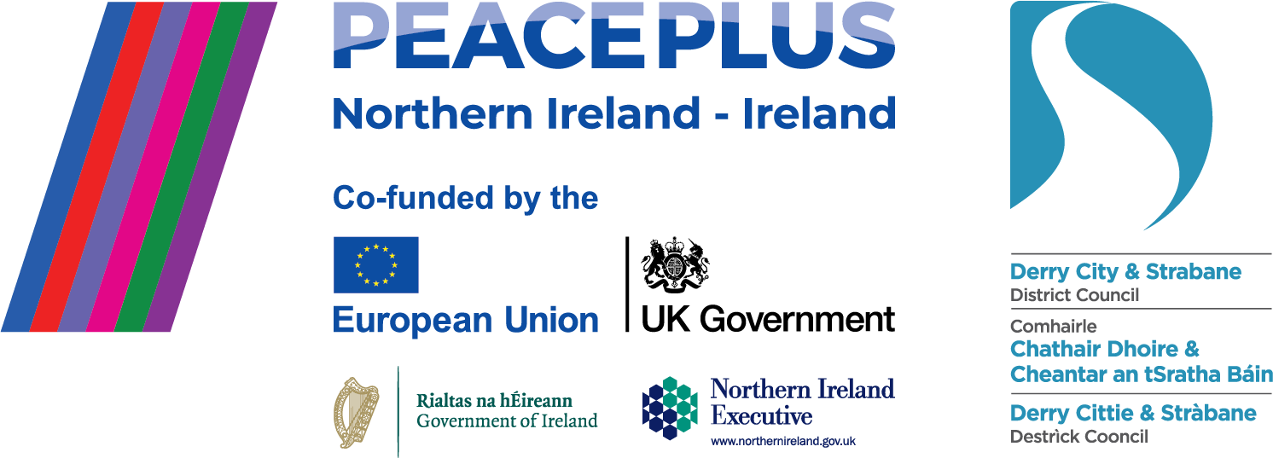

The PEACEPLUS Programme is a funding partnership between the European Union, the Governments of the United Kingdom and Ireland, and the Northern Ireland Executive and will be administered by the Special EU Programmes Body (SEUPB).

It’s Autumn!
The nights (and mornings) may be darkening, and recent events in ‘our wee part of the world’ haven’t been easy, but the local PEACEPLUS programme is proving people are invested in peace. As many of our PEACEPLUS funded projects in the council area are reaching the closing phases of their cross-community delivery, this newsletter brings you some wonderful local success stories. There are also opportunities to register for our public events at conferences and Mystery Tours for community workers and volunteers. Keep reading!

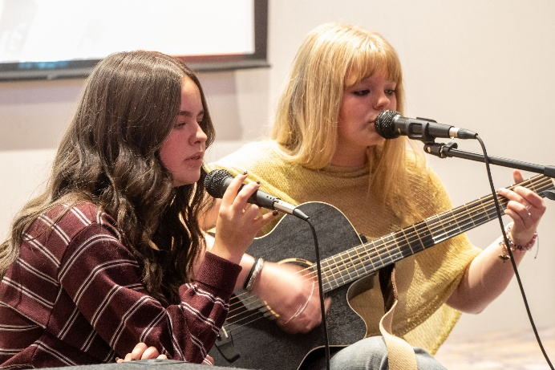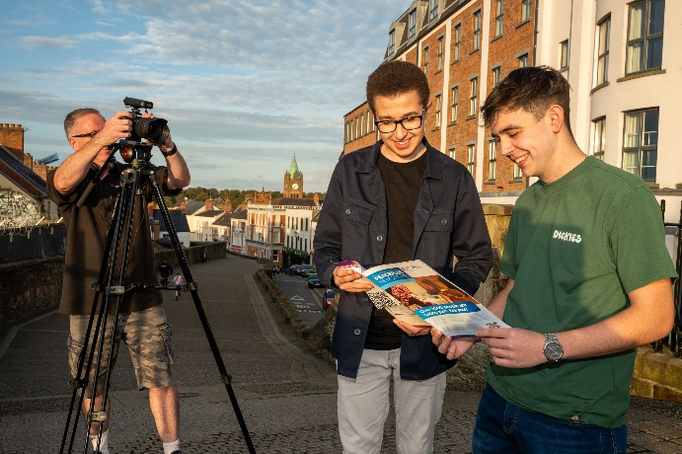
Let’s Talk Youth Dialogue project closes with impact.

Below is a speech from Eslam Abuelhana, a 16-year-old from the NW Islamic Association who completed a PEACEPLUS dialogue project through YouthActionNI. His speech, ‘Tomorrow is too Late,’ made a powerful impression on the audience at the project’s final celebration event in September. We’re publishing it here in full:

“You've probably been told that we are the future of the country—that today's youth are tomorrow's leaders. The truth is, tomorrow is too late. For too long, we have acted like mere bystanders in the face of social issues, sidelined by people who didn't want us to be heard. But what if I told you that true, lasting peace doesn't come from a politician's pen? It doesn't come from agreements, treaties, or bills. True, lasting peace comes from this. It comes from all of you. It comes from the conversations we have and the things we come together to achieve.

That is why peace projects are so pivotal for young people: they build a sense of community, shared purpose and belonging, while bridging societal divides and helping us find common ground. We are here to celebrate what we have achieved. We have shown the world that we can put our differences aside, make our voices heard and shape this country into what we want it to be.

Hatred isn't inherent in who we are. It is taught and fostered—and it is something we have stood up against by coming together and drawing on our shared values to create something truly great.
So yes, tomorrow is too late. We don't ask for permission to change the world; we are already doing it, one community and one conversation at a time.
We should be proud of what we have accomplished and look forward to the future. What we do today will shape our tomorrow—and how we shape that tomorrow starts now.”

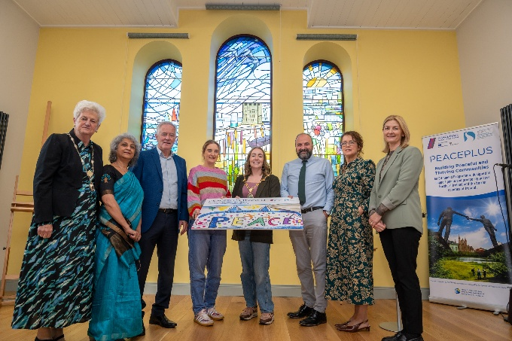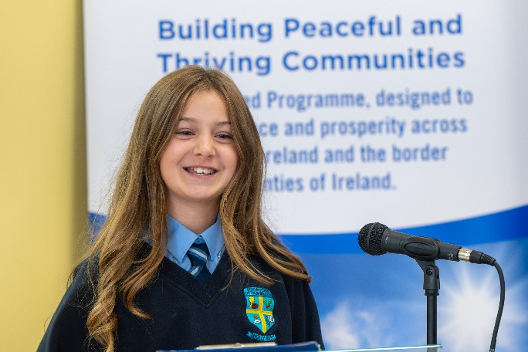
Culmore Connections celebrates project completion in style.
Coloured rays of sunlight filter through the newly designed and installed stained glass windows into Culmore Community Hub. ‘We’re not celebrating the end of a project,’ says Neil Doherty, Chairman of the Culmore Community Partnership. ‘We’re celebrating the start of a lasting legacy.’
The PEACEPLUS Culmore Connections project has done what it says on the tin – connected a community. More than that, it has done it with style, creativity and energy. Over 170 people have taken part, contributing time, enthusiasm and ideas. ‘It demonstrates what can be achieved when people take the time to listen and learn from each other,’ says the Mayor, Grace Uí Niallais. She speaks of the spirit of partnership which has defined this project. Partnerships between Culmore and Hollybush schools. Partnerships between churches and youth groups.
As well as funding cross-community history and heritage trips, the project has focused strongly on creative writing and the collection of community artistic ideas, all tying into the publication of a ‘Stories through the Years’ collection of memories of life in this cross-border area and the design of three stunning stained glass windows. Both the visual and written art proudly captures the essence and diversity of the Culmore area. ‘The real legacy of this project are the friendships and the conversations,’ says Una Cooper, Strategic Manager. ‘The contribution of all those who took part has transformed treasured memories into a permanent creative legacy.’
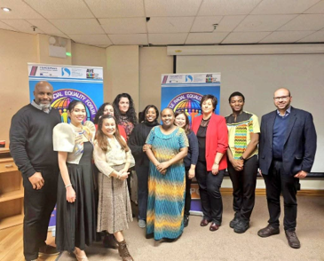
Distance Travelled Project – leaving a lasting legacy.
‘It’s fair to say that PEACEPLUS funding for inclusion and anti-racism work couldn’t have come at a more needed time,’ says Kat Healey, Project Worker with Strabane AYE who successfully delivered the Distance Travelled Project. The project, which engaged with Irish Travellers, Black and Minoritised Ethnic identities and the broader traditional communities in the northwest, connected people around ‘3 P’s’ – Practice, Partnership and Policy. ‘Often it was people who felt the most marginalised from mainstream services and positions of power who gravitated towards the project,’ explains Kat. ‘We think this is the only PEACEPLUS Traveller specific project north of the border.’ One strength has been how participants from PUL (Protestant/Unionist/Loyalist) and CNR (Catholic/Nationalist/Republican) identities have engaged alongside traveller and minoritised ethnic identities. ‘A PEACEPLUS networking event was key in the buy in and creating contacts,’ says Kat. ‘People need to stop believing stuff on social media. It’s not certain communities which are racist – it’s across society. And it’s through all of society that we can challenge racism and break down perceptions.’ Key highlights have included reflective training around dialogue and cultural awareness, creation of an online resource pack for people new to the area and the revival of FREF (Foyle Racial Equality Forum).
‘This wasn’t a big project,’ Kat explains. ‘But because of collaboration, it’s had a big impact. There’s also potential for a big legacy. We’ve achieved engagement with 80 sustained participants as contracted, but we’ve reached over 500 people and generated upwards of £1 million in linked future funding applications. That’s significant.’

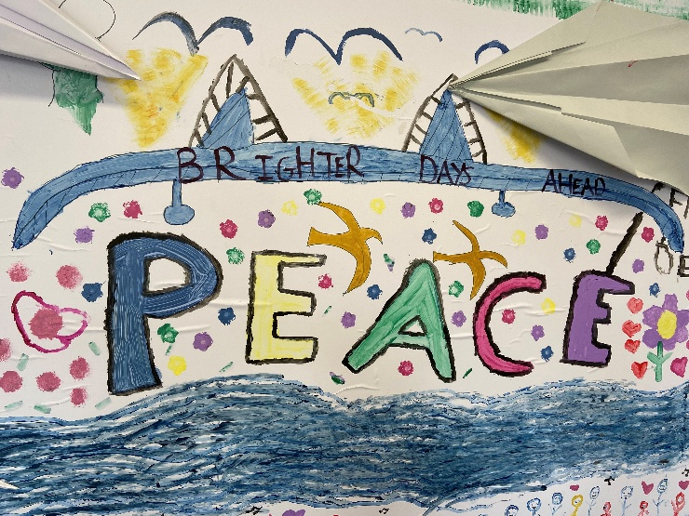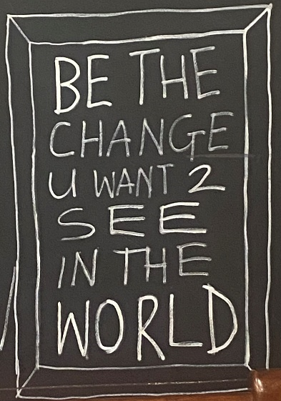
Want to get involved? Sign up for our events in October and November.
EXPAND (Exploring Places and New Dialogues)
Are you a community worker or community volunteer? Game for something different? EXPAND is an interactive, ‘hands on’ approach to exploring place and identity within the Derry City and Strabane District Council area. It aims to build the personal and professional experience of people who design and deliver peacebuilding and good-relations programmes to others. There are two ‘mystery’ days, expect to be taken out and about to 4 places to engage with different cultures and conversations and to experience ideas for locations and activities you could use in your own community work. Each day is unique and you can sign up to one or both. Catering included. Free.
Mystery Tour Day 1: Pick up and drop off to Shared Future Centre, Waterside.
EXPAND (Exploring Places and New Dialogues) Mystery Tour 1 Tickets, Thursday 22 October • 9:15 AM - 5 PM | Eventbrite
Mystery Tour Day 2: Pick up and drop off to Shared Future Centre, Waterside.
EXPAND (Exploring Places and New Dialogues) Mystery Tour 2 Tickets, Thursday 19 November • 9:15 AM - 5:30 PM | Eventbrite

Open invite to cross-border PEACEPLUS Capacity and Networking Event
Donegal County Council , PEACEPLUS Capacity Building and Networking Event Tickets, Friday, October 23 • 9:30 AM - 1:30 PM | Eventbrite
This is an event organised by our neighbouring PEACEPLUS team in Donegal County Council. The event welcomes people, especially representatives of community and voluntary sector groups, from both sides of the border to attend. Lunch and refreshments are included. The event will provide an opportunity to share experiences, build new connections, learn from others, and strengthen the capacity of individuals and organisations to deliver meaningful community engagement.
Contact us:
The PEACE Team in council can be reached via peace@derrystrabane.com
Our website is: https://www.derrystrabane.com/community/peace-plus

The PEACEPLUS Programme is a funding partnership between the European Union, the Governments of the United Kingdom and Ireland, and the Northern Ireland Executive and will be administered by the Special EU Programmes Body (SEUPB). Match-funding for this element of the PEACEPLUS Programme has been provided by the Executive Office in Northern Ireland and the Department of Housing, Planning, Community and Local Government in Ireland.

