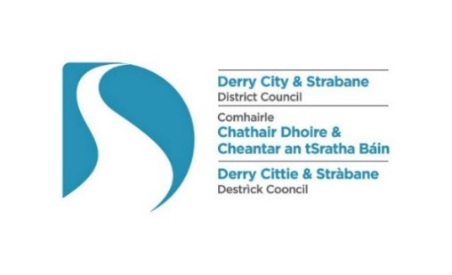

The Local Government (Miscellaneous Provisions) (Northern Ireland) Order 1985

Application for the Variation of an Indoor Entertainments Licence

1. Applicant details:
Applicant’s full name:
Business’ or organisation’s name:
Position in company or organisation:
Applicant’s address:

Post Code: | e-mail:
Telephone (Mobile): | Telephone (Landline):
2. Premise details:
Name of premises:
Address:

Post Code: | e-mail:
Key holder: | Key holder telephone:
3. Existing licence details:
Type of licence held:
Full (Annual) |  |  | Occasional (14 Specified days within 12 months)
Occasional (14 Unspecified days within 12 months) |  |  | Provisional (Premises currently being constructed, extended or altered)
Date of issue: |  |  | Expiry date:
4. Type of entertainments provided - please tick all that apply:
Indoor Entertainment: |  | Theatrical performance
 |  | Dancing, singing, music or any other entertainment of the like kind
 |  | Circus
Indoor public contest, match, exhibition or display of: |  | Boxing, wrestling, judo, karate or any similar sport
 |  | Billiards, pool, snooker or any similar game
 |  | Darts
 |  | Other sports
Indoor Machinery and Equipment: |  | Machines for entertainment or amusement
 |  | Equipment for playing billiards, pool, snooker, etc.

5. Days and Hours during which entertainment is provided under the existing licence:
Days |  | Hours
 |  | From: | Until:
Monday
Tuesday
Wednesday
Thursday
Friday
Saturday
Sunday

If the existing licence is an occasional licence, please specify dates and times, if known:
Day | Date | Entertainment times |  | Day | Date | Entertainment times
 |  | Start: | Finish: |  |  | Start: | Finish:
1 |  |  |  | 8
2 |  |  |  | 9
3 |  |  |  | 10
4 |  |  |  | 11
5 |  |  |  | 12
6 |  |  |  | 13
7 |  |  |  | 14
6. Rooms / locations licenced:
Room or location | Occupancy
7. Nature of the variation requested:

8. Reasons for the requested variation:
9. Supporting documentation:
There is no requirement to submit any supporting documentation with your application; however, depending on the nature of the variation requested, we may request additional information following receipt of the application.
10. Declaration
I hereby declare that:
- the particulars given by me on this form are correct, to the best of my knowledge and belief, and I hereby make application to Derry City and Strabane District Council for the variation of the entertainments licence as detailed above

- I confirm that I have made payment for the required fee of £80.00

- I have not, within the five years preceding the date of this application, been convicted under the Local Government (Miscellaneous Provision) (Northern Ireland) Order 1985 of an offence of providing unlicensed entertainment, or providing entertainments otherwise than in accordance with the terms and conditions of an entertainments licence

- I will give public notice of this application by publishing, within 7 days from the date of this application, an advertisement in a local newspaper having a wide circulation in the area and will submit proof of same to the Council immediately afterwards

- I undertake to comply fully with all the terms, conditions, or restrictions specified in the entertainments licence, including any variation of these.

I understand that a copy of this application will be shared with the relevant Council services, the Police Service for Northern Ireland and the Northern Ireland Fire and Rescue Service
Signature of Applicant: |  | Date:

This application form, plus relevant fee and other documents must be returned to one of the following addresses:
Derry office | Strabane office | e-mail:
Licensing & SAG, Derry City and Strabane District Council, 98 Strand Road, Derry, BT48 7NN | Licensing & SAG, Derry City and Strabane District Council, 47 Derry Road, Strabane, BT82 8DY | licensing@derrystrabane.com

Privacy Notice

Data Controller
Name: Health & Community Well Being Department/Licensing Derry City & Strabane District Council

Address: 98 Strand Road, Derry, BT48 7NN
Telephone: 02871 253253 Email: licensing@derrystrabane.com

Data Protection Officer
Name: Damian McCay
Telephone: 02871 253253 Email: Damian.McCay@derrystrabane.com

Why are you processing my personal information?
- For the logging, processing and determination of licensing/permit applications.
What categories of personal data are you processing?
- Personal contact details
Where do you get my personal data from?
- Application Forms and accompanying documents
Do you share my personal data with anyone else?
- Yes, where required by legislation we may share personal date with other agencies as outlined on Council website at the following link http://www.derrystrabane.com/Footer/Privacy-Policy
Do you transfer my personal data to other countries?
- No
How long do you keep my personal data?
- We will only retain your data for as long as necessary to process your application or investigate an Enforcement case, and in line with Council’s Retention and Disposal Schedule.

What rights do I have?
- You have the right to obtain confirmation that your data is being processed, and access to your personal data
- You are entitled to have personal data rectified if it is inaccurate or incomplete
- You have a right to have personal data erased and to prevent processing, in specific circumstances
- You have the right to ‘block’ or suppress processing of personal data, in specific circumstances
- You have the right to data portability, in specific circumstances
- You have the right to object to the processing of your data, in specific circumstances
- You have rights in relation to automated decision making and profiling

You should refer to the Council’s website for further information on your rights: http://www.derrystrabane.com/Footer/Privacy-Policy

How do I complain if I am not happy?
If you are unhappy with how any aspect of this privacy notice, or how your personal information is being processed, please contact our Data Protection Officer.

If you are still not happy, you have the right to lodge a complaint with the Information Commissioner’s Office (ICO):

Information Commissioner’s Office
Wycliffe House, Water Lane, Wilmslow, Cheshire, SK9 5AF

Tel: 0303 123 1113 Email: casework@ico.org.uk https://ico.org.uk/global/contact-us/

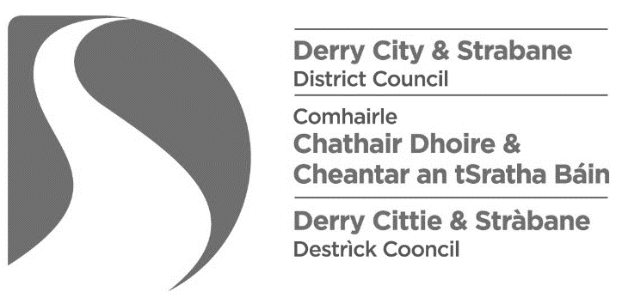
Items required at time of application for the variation of an indoor entertainments licence:
1. Application form
Applications must be made in writing, using Council’s approved application form, with all sections completed fully, to include details of the variation requested and the reason for the request, and the declaration completed and signed.

2. Appropriate fee
The law requires that applications are accompanied by the appropriate fee of £80.00.

Please note that this application fee has been determined by Government and is non-refundable.

Payment can be made by:

- Cash, by calling into the offices (do not send cash by post)
- Debit / Credit Card by calling into the offices or paying over the phone – Tel. 028 71253253
- Cheque, made payable to “Derry City and Strabane District Council”
- BACS, details for which are:

Bank Name & Branch: | DANSKE, 6 Shipquay Place, Derry, BT48 6DF.  Head Office: PO Box 183, Donegall Square North, Belfast.
Bank Account Number: | 40026018
Bank Sort Code: | 950797
IBAN: | GB54DABA95079740026018
SWIFT/BIC: | DABAGB2B
Account Name: | DERRY & STRABANE C
Send remittance to sales@derrystrabane.com stating that the payment is for the purposes of paying a fee for an entertainments licence (Code: 0024/90105), referencing the name of the premises.

3. Public notice advertisement
Not later than 7 days after the date of the application, public notice must be published, in the prescribed format, in ONE local newspaper, and a copy of the advertisement supplied to the council as soon as possible thereafter. You should supply the full page of the newspaper containing the notice, so that the publication’s name and date is clear, i.e. do not simply cut out notice.

The requirement to advertise in a local newspaper does not apply to an application for variation of an Occasional Entertainments Licence for an educational institution or a church hall, chapel hall or other similar building occupied in connection with a place of public religious worship.

4. Additional documentation / certification
Please note that in certain circumstances, depending on the nature of the variation requested, Council may request additional documentation and / or certification before making a determination of the application.

This page is blank

Form of Public Notice to advertise an application for the variation of an entertainments licence
The Local Government (Miscellaneous Provisions) (Northern Ireland) Order 1985
Article 3 and Schedule 1
Notice is hereby given that I / we*,
[insert name & address of applicant]

have today applied to the Derry City and Strabane District Council for the Variation of the terms, conditions and restrictions subject to which an Entertainments Licence is held by me in respect of:
[insert name & address of premises]

The nature of the variation sought by me is as follows:
[Specify nature of the variation sought, e.g. to include another type of named entertainment]

Any person wishing to make representation in relation to this application shall give notice in writing to the Council, addressed to Licensing & SAG, Derry City and Strabane District Council, 98 Strand Road, Derry, BT48 7NN or email licensing@derrystrabane.com, stating in general terms the nature of the representation, not later than 28 days after the date of the application.
Dated this |  | day of |  | 2021.
 | [insert number] |  | [insert month]

Signed:
[Signature of applicant]
Note to applicants: The requirement to advertise in a local newspaper does not apply to an application for variation of an Occasional Licence for an educational institution or a church hall, chapel hall or other similar building occupied in connection with a place of public religious worship.

This page is blank

Entertainments licensing - Table of fees

An application relating to an indoor place of entertainment to which paragraph 1(2)(a), (b) or (d) and (6) of [Schedule 1] applies, where that place or premises (as the case may be) may hold: | Occasional Licence Fee £ | Full Licence Fee £
Not more than 100 persons | 50 | 100
101 to 200 persons | 75 | 150
201 to 300 persons | 125 | 250
301 to 500 persons | 200 | 400
501 to 1,000 persons | 375 | 750
Over 1,000 persons | 500 | 1,000

An application relating to an indoor place of entertainment to which paragraph 1(2)(c) and (6) of [Schedule 1] applies (i.e. a circus). | 50
An application relating to an indoor place of entertainment to which paragraph 1(4) and (6) of [Schedule 1] applies (i.e. where machines for entertainment or amusement or equipment for the playing of billiards, pool, snooker or other similar games, are provided | 100
An application relating to an indoor place of entertainment of any capacity for a licence to be granted under paragraph 4(2) of [Schedule 1] (i.e. an occasional licence) in respect of:  (a) a place used wholly or mainly for public religious worship in relation to an entertainment to which paragraph 1(2)(a), (b) or (d) and (6) of [Schedule 1] applies, other than any music or singing;  (b) a place used for religious meetings or services in relation to an entertainment to which paragraph 1(2)(a), (b) or (d) and (6) of [Schedule 1] applies, other than any music or singing performed as an incident of a religious meeting or service; or  (c) an educational institution while not being used as such in relation to an entertainment to which paragraph 1(2)(a), (b) or (d) and (6) of [Schedule 1] applies. | 50
An application relating to an indoor place of entertainment of any capacity to which paragraph 1(2)(a), (b) or (d) and (6) of [Schedule 1] apply for a licence to be granted under paragraph 4 (2) of that schedule (i.e. an occasional licence) where the application is made by a voluntary organisation³ or a charity. | 50

An application by a voluntary organisation or a charity relating to outdoor musical entertainments to which paragraph 2 of [Schedule 1] applies, where that place may hold:
- Not more than 500 persons; or | 125
- Over 500 persons | 250
An application, other than by a voluntary organisation or a charity, relating to outdoor musical entertainments to which paragraph 2 of [Schedule 1] applies, where that place may hold:
- Not more than 500 persons; or | 1,000
- Over 500 persons | 2,000

An application under paragraph 7A of [Schedule 1] for the variation of the terms, conditions or restrictions on or subject to which an entertainments licence is held. | 80

Footnote:
- A ‘voluntary organisation’ means an organisation carrying on or proposing to carry on activities otherwise than for the purpose of gain by the organisation or individual members thereof.

“Schedule 1” is a reference to Schedule 1 to the Local Government (Miscellaneous Provisions) (NI) Order 1985
This page is blank

