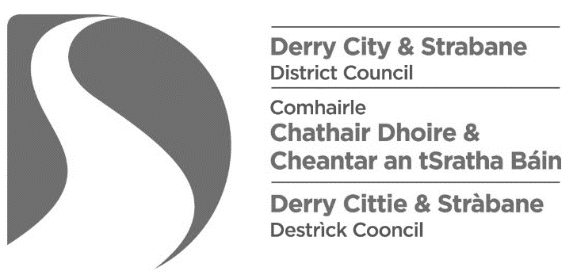
LOCAL GOVERNMENT (MISCELLANEOUS PROVISIONS) (NI) ORDER 1985
FIRE AND RESCUE SERVICES (NI) ORDER 2006
FIRE SAFETY REGULATIONS (NI) 2010

Entertainments licensing
Statement confirming review of fire risk assessment

Name of applicant:
Name of premises:
Address of premises:
Post Code:

Date on which Fire Risk Assessment was carried out:
Name of assessor:

I hereby confirm that the Fire Risk Assessment relating to the above premises has been reviewed on: [insert date of the review]
I confirm that there have not been any structural or material alterations to the premises or any significant changes to the organisation and management of the premises that would impact the fire safety arrangements.
I am satisfied, therefore that the fire risk assessment remains valid and satisfactory.
Any action points identified by the fire risk assessment have been completed.
Name (capital letters):
Signature:
Date:

