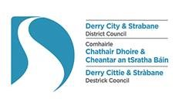
Derry City and Strabane District PEACEPLUS Partnership Board

Meeting Date: Tuesday 14th November 2023
Time: 10.00am – 11.30am
Venue: Sollus Centre, Bready.

AGENDA ITEM
1. Meeting Opening
1.1 Welcome and Apologies
Note formal retirement of Anne McTaggart (YouthActionNI). Dominic Bonner full board member.

1.2 Conflict of Interest
C of I forms still to be returned from Cllr. Brian Harte and Cllr. Alex Duffy.
Note appendix D now in place as standing conflicts of interest. Members update with Fiona.

1.3 Minutes of previous meeting / Matters arising (p.3-5)

2. Guest Speaker – Claire Lynch (Children and Young People’s Co-ordinator)
10 min presentation followed by Q&A on UNICEF Child Friendly Cities.
(NB. Support for this has been embedded into PEACEPLUS Tenders.)
3. Update from PEACE Team (Sue)
3.1 Progress of Bid / Update on SEUPB

Nothing formal from SEUPB bar acknowledgement. Possibly 5 councils have submitted. Declan McGarrigle has left SEUPB. He gave assurances that assessment of Theme 1.1 had been resourced and was on track. Conflicting information coming from other councils in 1-1 meetings with SEUPB.
Noting SEUPB indicative timetable for 1.2 and 6.2 Small Grants is March 2024.

3.2 Update on PEACE Team work

PEACEIV files now predominantly in storage. Final payments and closure of PEACEIV still pending. SSS outputs audit with Garret McGinty fine. Conflict of Interest Training for new board members ran 12th Sept. Tender’s systems for PEACEPLUS now in place. 7 tenders live and closing on 8th December 2023 (at risk). Panels established for 13th & 14th December (for Jan committee ratification). 3 x Tender Training Sessions run in October. PEACE Managers meeting 10th November Newtownabbey. Team will work on 2 x SLA’s, and prepping further tenders & related docs.

4. CRT (Comm Regen & Transformation)/ Management / Comms Update – Chair Gerard Deane

Steering Group Meeting - Good turnout in Holywell. Presentation from Cathy Burns, Climate Programme Manager DCSDC on Sustainability (Horizontal Principle).

CRT Workplan – 4 Tender Specifications reviewed. T23-092BUS Intercultural Café; T23-093BUS Green Clubs; T23-094BUS A Stitch In Time; T23-095BUS Urban Social Farm.

Management Workplan

Tender Training delivered: Tue 17th 3pm Strab. Lib., Wed 18th 10.30am An Chroí, Thurs 19th DCSDC 2pm. Fully Booked 70 places. 62 attended. Electronic systems on Eventbrite & Survey Monkey proved effective. Feedback in Appendix E. Feedback from the training was very positive. A quarter of those in attendance were entirely new to tendering. E-tendering was new to at least 50% of those in attendance. All respondents said the training was highly useful and monitoring also showed a geographical spread of participants attending from all 8 Local Growth Partnership areas and from diverse community backgrounds.
- Recruitment of Finance Officer: Process begun with HR. Post will not be filled until LOO received.
- Policy on Support to Groups: For Decision – Board to approve & adopt updated version.

Communications Workplan – Press release issued for Bid Awareness Event. Covered in Derry News and Strabane Weekly News as well as DCSDC social media. Sept, Oct & Nov e-bulletins issued. Branded folders, pens and banner stands received.

5. TPC (Thriving Peaceful Communities Theme) Update – Chair Alison Wallace

Steering Group Meeting – Just about quorate for meeting in Strabane. Board members please endeavour to attend and send deputies where applicable if unable to attend. Dates Appendix B.

TPC Workplan – 2 Tender specifications reviewed. T23-096BUS Dare 2 Dream; T23-097BUS Inspire, Enthuse, Equip.

6. CCD (Celebrating Cultural Diversity Theme) Update – Chair Sharon Doherty

Steering Group Meeting – Not quorate. Decisions done by e-mail circulation and approval. Board members please endeavour to attend and send deputies where applicable if unable to attend. Dates Appendix B. Are there issues with electronic diary invites?

CCD Workplan – 1 Tender specification reviewed. T23-098BUS.

7. New Tender Specifications for Consideration

Conflicts of Interest to be declared. Papers will not be circulated in advance.
- CRT Theme. T23-100BUS Waterside Together.
- CRT Theme. T23-102BUS Skeoge United.
- CRT Theme. T23-104BUS Food Poverty Project.
Recommendation: Board to consider each specification and comment and/or approve.

8. Meeting Closing

8.1 AOB – Board still content to keep board meetings hybrid or wish to review?

8.2 Date of Next Meetings:
Board: Tuesday 9th January 2024 (Venue TBC)
TPC: Wed 6th December (Shared Future Building, Waterside)
CRT: Tue 12th December (Iona Business Park, Cityside)
CCD: 14th December (Shared Future Building, Waterside)

Derry City and Strabane District PEACEPLUS Partnership Board
Minutes of Meeting

Meeting Date: Tuesday 7th September 2023
Time: 10.00am – 10.30am
Venue: Holywell Building, Bishop Street, Derry~Londonderry.

Sue Divin | DCSDC | Christopher Jackson | SF
Myriam Fearon | Fearon Consulting | Chelsea Cooke | DUP
Mary Claire Kelin | DCSDC | Mary O Neill | NIHE
Fiona Lafferty | DCSDC | Catherine Cooke | FWIN
Alison Wallace | Waterside LGP | Darren Guy | UUP
Lisa Moore-Maguire | Foyleside LGP | Nikki Yau | FREF
Martin Duffy | Derg LGP | Bronagh McMonagle | HSCNI
Alex Duffy | SF | Kyra Reynolds | BBI
Grace Uí Niallais | SF | Jackie Connolly | Ballyarnett LGP
Aodhan Harkin | Strabane LGP | Dominic Bonner | YouthAction NI
Claire Russell | Sperrin LGP | Gus Hastings | Faughan LGP
Derek Moore | NW Cultural P’Ship | Fiona Corvan | Holywell
Kevin O’Connor | DCSDC

- Meeting Opening
  - Welcome and Apologies

Apologies received from Lillian Seenoi Barr, William Calderwood, Yvonne McManus, Sharon Doherty, Ciaran McLaughlin, Ruairi McHugh.

1.2 Conflict of Interest - The chairperson reminded members of Conflict of Interest and their responsibility to declare throughout the meeting where relevant. A list of standing conflicts of interest now specifically based on the 58 bid projects submitted in the bid, is now being compiled. This is now a very clear system since the bid is in. All Board Members should make sure that the standing conflicts of interest list reflects their current position and notify Fiona if there are any updates needed. If a Board member has a connection to a group which may tender for a specific project, this should be noted in the list. Conflicts of Interest can also still be declared as appropriate during the meeting in addition to this list.

Action
It is the responsibility of each individual Board Member to ensure the standing conflict of interests list is accurate for them. Fiona will distribute a list of the 58 projects. Members should return forms to Fiona. The list will be an Appendix at Board meetings.

  - Minutes of Previous meeting/Matters arising - Board meeting of Thursday 10th August 2023 were held to be an accurate record.

Proposed: Gus Hastings Seconded: Martin Duffy

2. Update from PEACE Team and Myriam
2.1 Submission of Bid

The Bid was submitted on 24th August 23. If SEUPB honour their 22-week turnaround, then hopefully LOO would be issued by the end of January / early February 2024. DCSDC seems to be the first council to have submitted.

2.2 Final Local Co-Designed Action Plan

Sue informed members that the final co-designed local action plan was attached for Board Reference. Members were asked not to circulate beyond the Board as this is part of a bid document in an open process which other councils have not yet completed. They were also informed that the Magazine is a user-friendly version of the bid and is publicly available along with the summaries of the projects – which is the information groups are most likely to be interested in. It will be on our website https://www.derrystrabane.com/community/peace-plus
PEACE Team and Board extended their thanks to Myriam Fearon for all the work completed.

2.3 Riverine PEACE IV

For information, Karen Philips (Director of Environment and Regeneration) had asked that the Board be informed that SEUPB had rescinded the funding from the PEACE IV Riverine Programme. DCSDC were asked to scope if there was room in the Theme 1.1 Local Co-Design Bid to include the programming elements still outstanding. This request came through after the date that the Local Co-Designed Action Plan had already been ratified by the board and council. As September was the next scheduled Board Meeting at that point, the PEACE Team were asked to let the Board know that Donegal Council would instead lead on submission of a Theme 1.4 Capital Bid.

2.4 PEACE Team work for September/October

The PEACE Team will be clearing down and closing PEACE IV files and final audits/payments. Setting up storage and systems for PEACEPLUS. Aim will be to have the first few Tender specifications available (min 1 per steering group) in October. We will tender ‘at risk’ but cannot appoint any contracts until LOO is received and signed. Probable workload from SEUPB queries.

2.5 Training for new Board Members

Sue informed the board that training for the new elected reps on the board would take place on Tue 12th Sept 10am in the Council Offices, Strand Road.

3. Election of new Chair and Co-Chair (1 year post)

Sue gave formal thanks to Derek and Jackie who will complete their year at the bid launch event today. Members were reminded to consider diversity and equality in selecting the next Chair and Co-Chair and it would be helpful if possible, to have a gender balance, religious / community background balance and balance between the ‘pillars’ represented eg. Statutory, elected reps, DEA reps, social partners.

Catherine Cooke selected as the new Chairperson of the Peace Plus Board

Proposed: Jackie Connolly Seconded Derek Moore

Martin Duffy selected as the new Co-Chair of the Peace Plus Board

Proposed: Gus Hastings Seconded: Aodhan Harkin

4. Meeting Closing

4.1 Date of Next meeting: Tuesday 14th November, Sollus Centre, Bready.
Noting also Steering Groups meeting in October:
TPC Wed 4th October (Council Offices, Strabane)
CRT Tue 10th October (Holywell, Bishop St.)
CCD 12th October (Shared Future Building, Waterside)

4.2 AOB. Photoshoot of Board and Bid.

Appendix A: Board Member’s Attendance 2023/24 (Beginning post-May 23 elections)

Statutory Pillar |  | 20/7/23 | 10/8/23 | 7/9/23
William Calderwood (d. Shannagh Farren) | PSNI
Deborah Cross (d. Declan Gallagher) | EA
Marie Gallaher (d. Sharon McCullagh) | DfC | x
Mary O'Neill (d.Noel McNulty) | NIHE | x | x | x
Seamus Ward (d.Bronach McMonagle) | WHSCNI |  |  | x
Ciaran McLaughlin (d. Gerard O’Neill) | DAERA |  | x
Social Partners – Local Growth Partnerships
Jacki Connolly (d.Darren Kirby) | Ballyarnett | x | x | x
Martin Duffy (d. Andy McKane) | Derg | x | x | x
Aodhán Harkin (d.Ursula Doherty) | Strabane | x | x | x
Gus Hastings (d.Martin McCartney) | Faughan | x | x | x
Charles Lamberton (d.Seamus Breslin) | Moor | x
Claire Russell (d.Patricia McNulty) | Sperrin | x | x | x
Alison Wallace (d.Geraldine Doherty) | Waterside | x |  | x
Lisa Moore-Maguire (d. Jim McColgan) | Foyleside | x |  | x
Elected Representatives Pillar
Aisling Hutton | SF | x | x
Ruairi McHugh | SF | x
Brian Harte | SF | x
Christopher Jackson | SF | x | x | x
Alex Duffy | SF |  |  | x
Grace Uí Niallais | SF |  |  | x
Martin Reilly | SDLP |  | x
Lilian Seenoi Barr | SDLP | x | x
Declan Norris | SDLP | x | x
Brian Tierney | SDLP
Chelsea Cooke | DUP | x | x | x
Darren Guy | UUP | x | x | x
Social Partners Pillar
Gerard Deane (d. Fiona Corvan) | Holywell | x |  | x
Catherine Cooke (d. Bethany Moore) | FWIN | x | x | x
Sharon Doherty (d. Michelle Simpson) | St.CPH |  | x
Noelle Donnell (d. Sinead Barr) | H’bird
Anne McTaggart (d. Dominic Bonner) | YANI | x |  | x
Derek Moore (d. Kyle Thompson) | NWCP | x |  | x
Kyra Reynolds (d. Rachel Mullan-Carlin) | BBI | x | x | x
Nikki Yau (d. Agnieszka Luczak) | FREF | x | x | x

Appendix B: PEACEPLUS Timetable of meetings for Board & Steering Groups

 | Mar 23 | Apr  23 | May 23 | Jun 23 | Sept 23 | Oct  23 | Nov  23 | Dec  23 | Jan 24 | Feb 24 | Mar 24
PEACEPLUS Board  (Wk 2 Tuesdays) | 7th | - | - | - | 7th | - | 14th | - | 9th | - | 12th
CRT  (Cityside Wk 2 Tuesdays. DCSDC Strand Rd Offices, level 5) | - | - | 9th  Level 5 | 13th  Level 5 | - | 10th | - | 12th | - | 13th  (or 6th?) | -
TPC  (Strabane Wk 1 Wednesdays Glenelly or Function Rm, Strabane DCSDC Office) | - | - | 3rd  Glny | 7th  Glny | - | 4th Glny | - | 6th  TBC | - | 7th | -
CCD  (Waterside Wk 2 Thursdays. Shared Future Centre) | - | - | 11th  SFC | 15th  SFC | - | 12th  SFC | - | 14th  SFC | - | 8th  SFC | -

*No meeting April 2023 due to Easter & Purdah for Local Council Elections
** No Board or Steering Group Meetings July or August (except exceptional circumstances)
Appendix C – Membership of PEACEPLUS Steering Groups
CRT  Community Regeneration & Transformation, Management and Communications. | TPC  Thriving and Peaceful Communities. | BRCI  Celebrating Cultural Diversity.
Venue: Cityside | Venue: Strabane | Venue: Waterside
Day/Time/Week: Tue am Week 2 of month | Day/Time/Week: Wed am Week 1 of month | Day/Time/Week: Thurs am Week 2 of month
1 Ciaran McLaughlin (DAERA) | 1 Marie Gallaher (DfC) | 1 Deborah Cross (EA)
2 Mary O’Neill (NIHE) | 2 William Calderwood (PSNI) | 2 Seamus Ward (WHSCNI)
3 Gerard Deane (Holywell) | 3 Noelle Donnell (Hummingbird) | 3 Catherine Cooke (FWIN)
4 Kyra Reynolds (BBI) | 4 Anne McTaggart (YouthAction NI) | 4 Sharon Doherty (St.Columb’s Pk House)
5 Derek Moore (NWCP) | 5 Alison Wallace (Waterside DEA) | 5 Nikki Yau (Migrant Centre NI)
6 Charles Lamberton (Moor DEA) | 6 Lisa Moore-Maguire (Foyleside DEA) | 6 Martin Duffy (Castlederg DEA)
7 Aodhán Harkin (Strabane DEA) | 7 Gus Hastings (Faughan DEA) | 7 Jacki Connolly (Ballyarnett DEA)
8 Brian Tierney (SDLP) | 8 Claire Russell (Sperrin DEA) | 8 Christopher Jackson (SF)
9 Aisling Hutton (SF) | 9 Darren Guy (UUP) | 9 Martin Reilly (SDLP)
10 Chelsea Cooke (DUP) | 10 Ruairi McHugh (SF) | 10 Lilian Seenoi Barr (SDLP)
11 Alex Duffy (SF) | 11 Declan Norris (SDLP) | 11 Grace Uí Niallais (SF)
 | 12 Brian Harte (SF)

Free Choice | Statutory Partners | Social Partners (Open Call) | LCGP Partners | Elected Representatives
Appendix D: PEACE Plus Live Standing Conflict of Interest Declarations
Community Regeneration and Transformation Theme (CRT). |  | Thriving and Peaceful Communities Theme (TPC) |  | Celebrating Cultural Diversity Theme (CCD)
Project Title | C.O.I Declaration | Project Title | C.O.I Declaration | Project Title | C.O.I Declaration
Intercultural Café | Lillian Seenoi Barr | Dare 2 Dream | Alison Wallace, Sharon Doherty, Darren Guy | The Freedom Project | Seamus Ward, Cllr Aisling Hutton
Green Clubs | Aódhan Harkin | Inspire, Enthuse, Equip |  | Operation Desperation
Unlocking Silent Heritage |  | Gateways to Rural Participation | Derek Moore | HumanKind
War and Peace | Gerard Deane | Pre-teen transition Programme |  | Columba Journey
Skeoge United | Jacki Connolly | Empowered Communities Strabane | Aódhan Harkin | Culture Now Showcase | Derek Moore
A Stitch in Time | Lisa Moore-Maguire | Create: Youth Digital and Music Project. |  | Culmore Connections
Urban Social Farm | Charles Lamberton, | Creating Creatives |  | Out and About (BAME) | Nikki Yau
Waterside Together | Alison Wallace, Sharon Doherty, Catherine Cooke | Strabane Youth Programme | Anne McTaggart, Dominic Bonner, Aódhan Harkin | Connect (BAME)
Food Poverty Project | Sue Divin | Our Place, Our Planet |  | Let's Talk (Youth) | Anne McTaggart
Park Community Hall |  | Cricket Connects | Derek Moore | Muintearas
Our Space, Our Place | Martin Duffy | IDEA |  | Our Journey to Peace | Kyra Reynolds, Derek Moore
Derg Future Festivals | Martin Duffy | F.Y.I. Foyleside Youth Initiative | Lisa Moore-Maguire | Fit for Purpose
Street Art Reimaging | Kyra Reynolds, Charles Lamberton | Be Wild |  | Our Present Past | Gerard Deane  Kyra Reynolds
 |  | Farming & Environmental Champions | Noelle Donnell | Forward Thinking | Gerard Deane
 |  | Sperrin Youth Voices |  | Distance Travelled
 |  | Rural Teens |  | Our Shared History
 |  | Ballyarnett Women's Programme |  | The Exodus Project | Kyra Reynolds, Darren Guy
 |  | Be Driven | Claire Russell | Cecil Frances Alexander Celebrated | Aódhan Harkin
 |  | Arts & Collaborative Resilience |  | LGBTQIA+ Awareness
 |  | Ballyarnett Early Year’s Project | Jacki Connolly | Victims/Survivors Social Prog. | Aódhan Harkin
 |  | Ballyarnett Men's Programme |  | Culture Club | Martin Duffy
 |  | Reimage-Recycle
 |  | Centre of Hope | Martin Duffy
 |  | Art: Recovery to Discovery | Alex Duffy

Appendix E: Tender Training Evaluation (Covering all 3 sessions Oct 2023)

19 Responses. Estimated 60+ in attendance over the 3 sessions.
- Was the Tender Training today useful? 100% Yes.
Comments:
Very informative.
Well organised and presented
Excellent session - very useful
Very clear well delivered
Easy to understand information
While the information provided was useful, a lot of it was very self explanatory. I think the session could very easily have been delivered online (a benefit for the council in terms of reducing carbon emissions from travel) and the majority of the information could be explained in a reference document without the need for a training session.
very informative and well delivered by sue

- What were the most relevant things you learned? (Tick as many as you like)
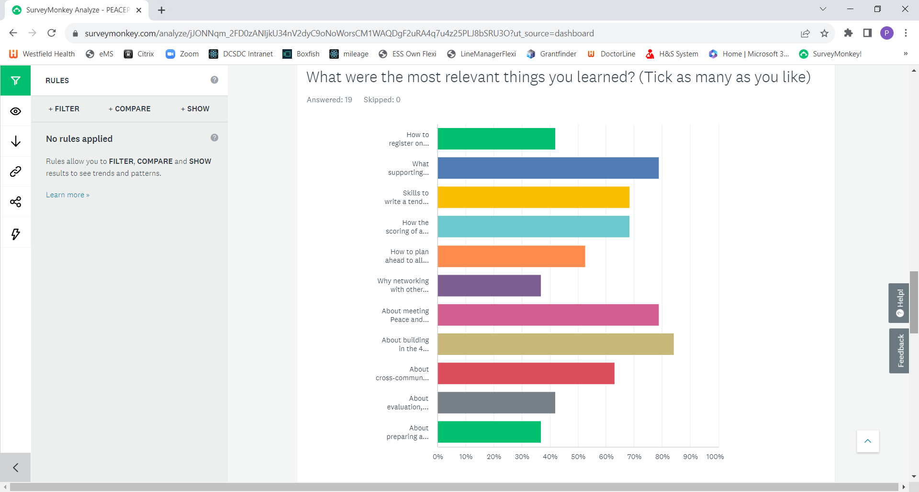
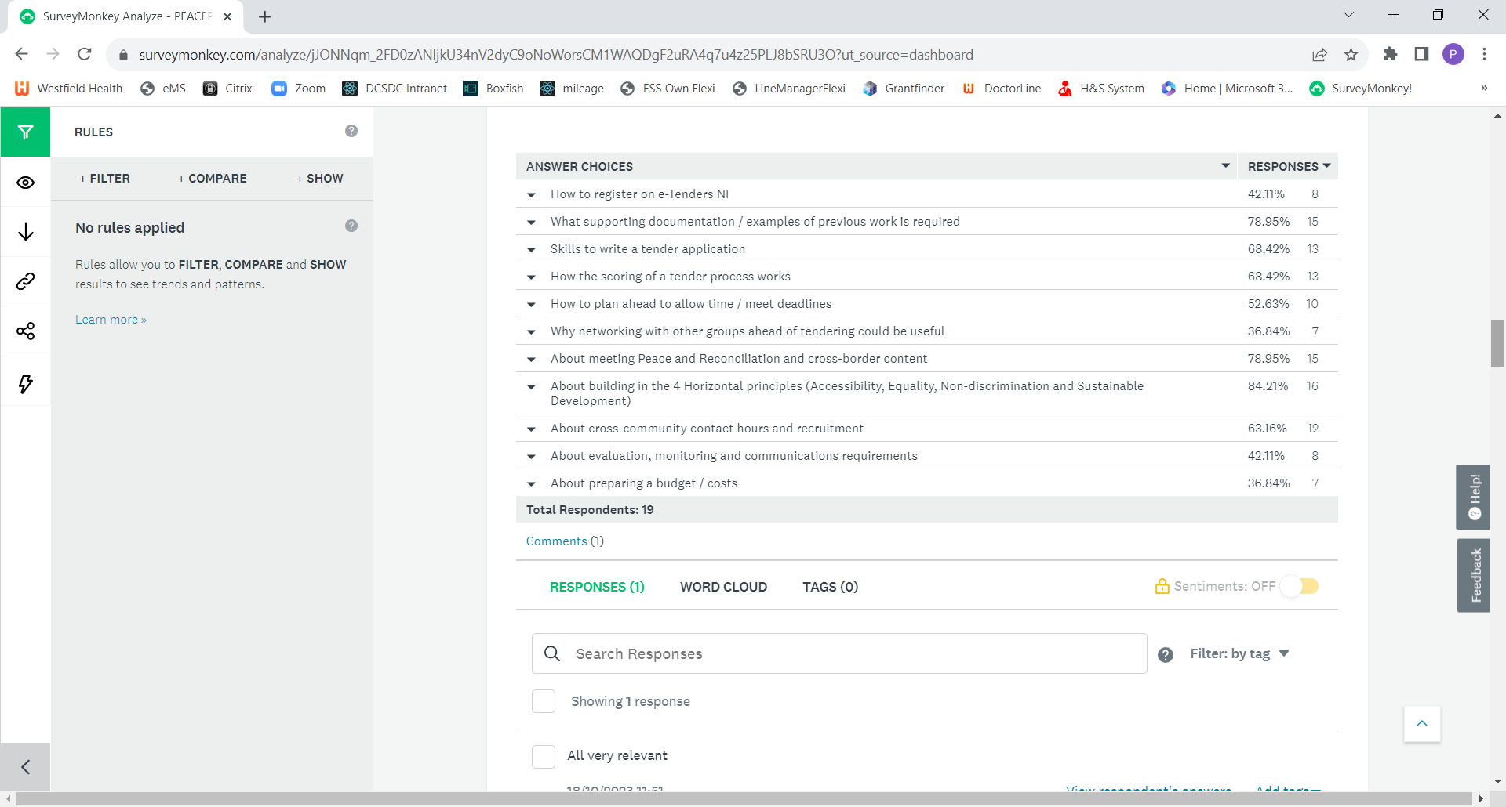
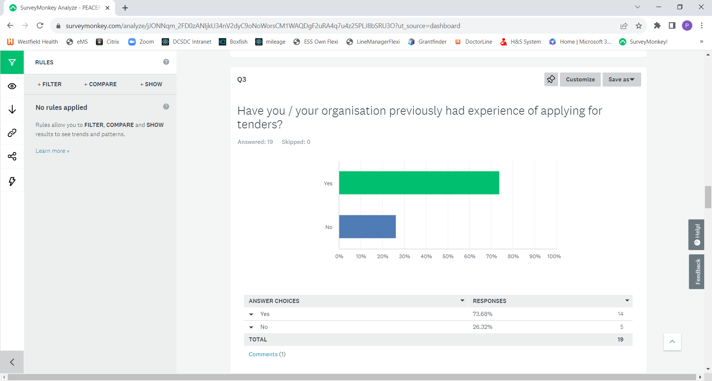
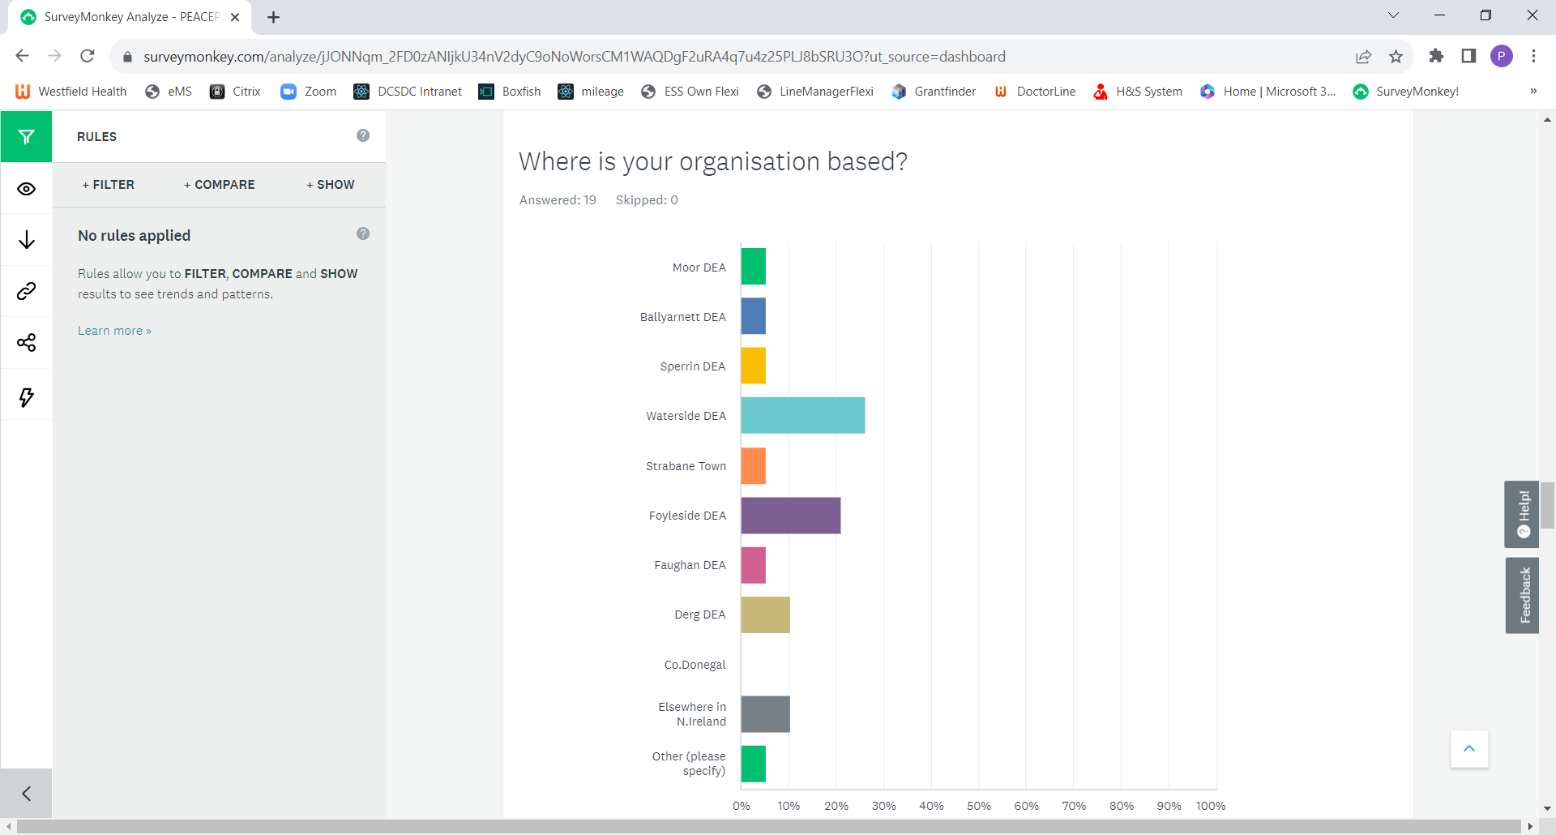
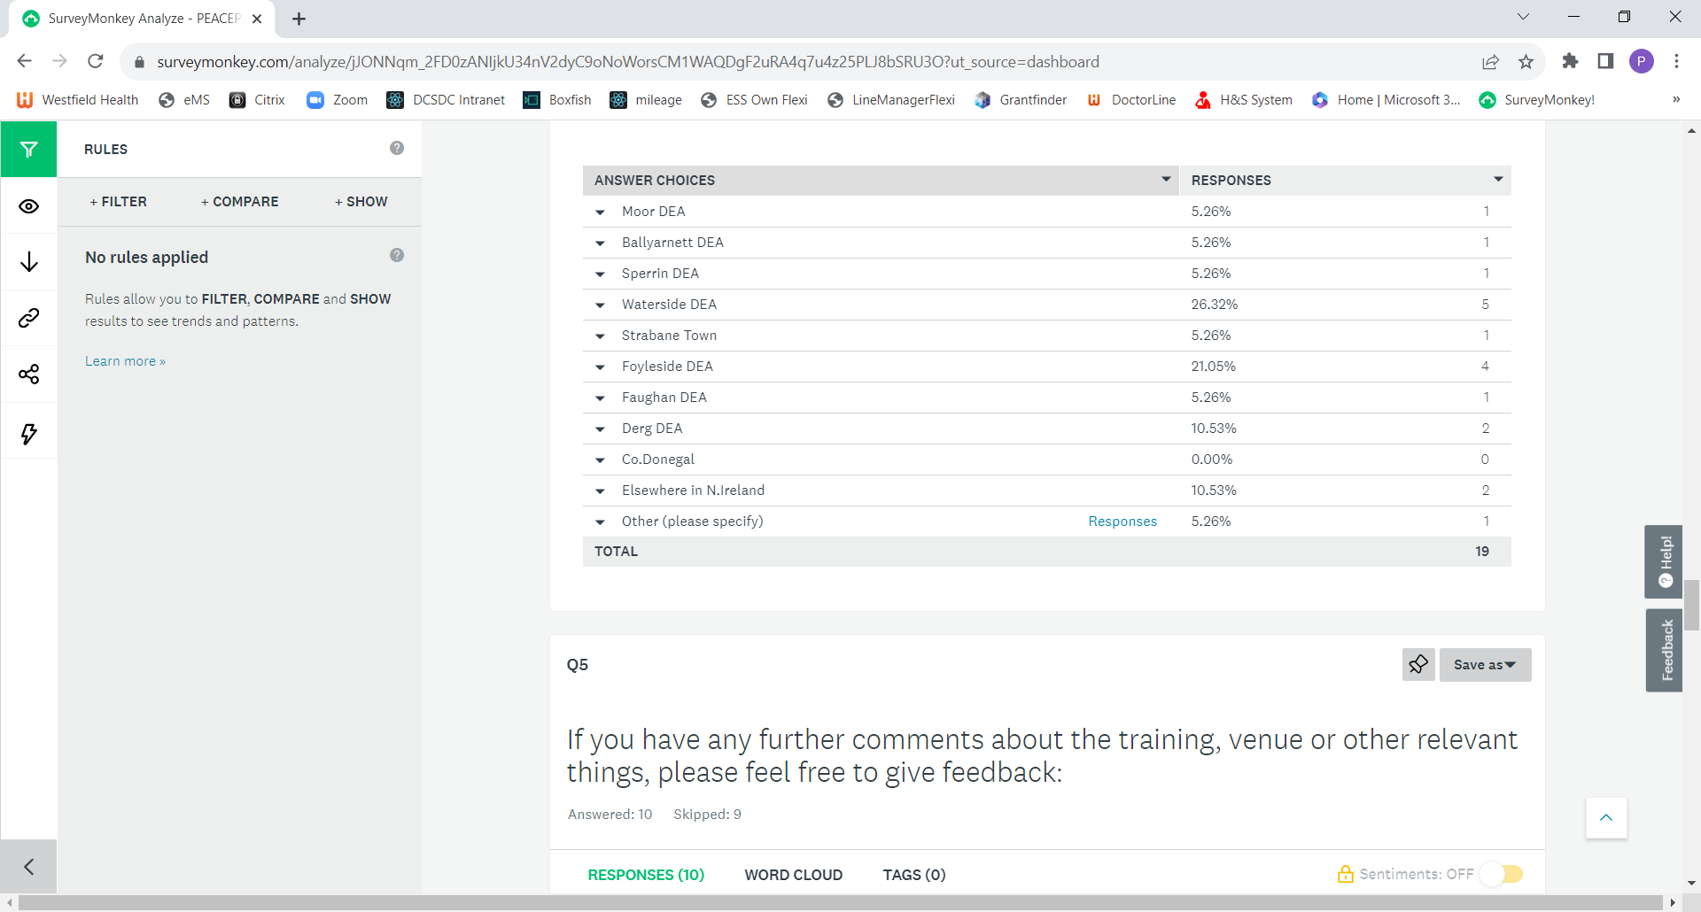

5. If you have any further comments about the training, venue or other relevant things, please feel free to give feedback:
Really practically helpful about how tenders will be issued
lovely space
Very informative
Not at this stage
Very well explained - easy to follow with great advice. Well done Sue, Fiona and Marie-Claire. We are fortunate that the DSCDC Peace plus staff are leading the way compared to other council areas. Innovative and proactive approach.
Very helpful and informative, thank you...
Really good session and very well presented.
Excellent clear presentation in lovely venue
In aiming to achieve equity and diversity it's essential that those who are CEV/immunocompromised are welcome and feel safe at training events. It was clear that a number of people present at the event had coughs/infections and I think it would be appropriate to remind people to wear masks at a minimum or consider not attending if they are ill, as this makes the space unsafe for CEV individuals.
Excellent - communicated clearly and concisely what is quite complex. Also feels relevant to other grant/funding applications
