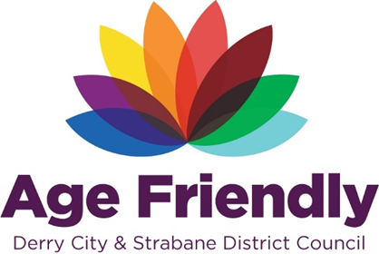
AGE FRIENDLY NEWS & UPDATES
Edition 23 – 29/06/2023

- What’s on in July 2023 – Libraries Derry and Strabane
Please see poster with details of services available from Libraries NI this July
- Want to find out more about the Multi-Disciplinary Teams in GP’s
Patients from the 28 GP Practices in Derry GP Federation area have the opportunity to find out more about the multi-disciplinary teams working alongside their GPs to improve the healthcare offering in the area. A public information event will give patients the opportunity to meet with some of the professionals including Social Work, Mental Health, Health Visiting and Physio’s who will be able to provide more information about the services they provide, and the opportunity for feedback of utilising the service. These events form part of the Involve Fest West week, and will be held on;
- Monday 3rd July from 10am-12noon in Quayside Shopping Centre
- Thursday 6th July from 11am-1pm in ASDA Superstore, Strabane
- Focus Group on Changes to Concessionary Fares
On Friday 23rd June, DFI hosted a focus group in Harbour House, Derry to hear the views in the area relating to the proposed changes. The presentation slides from the event are enclosed for reference. Individuals and organisations can respond to the online consultation using the following link https://www.infrastructure-ni.gov.uk/consultations/consultation-changes-concessionary-fares-scheme and also find enclosed their interactive easy read version. Please note the public consultation period will run for 12 weeks, this opened on 1st June and will close at 5pm on 24th August 2023.
- Deafblind Awareness Week – 26th June – 2nd July

Deafblind Awareness Week is 26th June to 2nd July and we’re asking everyone to tune in to their sight and hearing! This means being aware of changes and looking out for signs of deterioration in yourself and others. During the week, we’ll be sharing information about the early signs of sight and hearing loss and why it’s so important to seek support from day one. You can find more information on our website.

There are lots of ways that you can get involved in Deafblind Awareness Week and raise awareness of this increasingly common condition. Why not take the opportunity to make your workplace more inclusive and deafblind friendly too? Here are some ideas for you to get involved:
- Download free posters, email footers and social media content from our website
- Share our information on LinkedIn, Facebook, Instagram and Twitter. (Don't forget to use alt. text on your images, and of course the #DeafblindAwarenessWeek hashtag!)
- Learn how to make your business deafblind friendly
- Book a deafblind awareness talk to help your staff understand more about accessibility and supporting people with sight and hearing loss at work.
It is important that we make more people aware of deafblindness and make sure they know where to turn when they need support. Together, we can be there for everyone who is starting their deafblindness journey. Just £10 will allow us to take two more calls to our helpline and be there for two more people when they need us. Click here to donate.
For more information and downloads, visit deafblind.org.uk/dbaw

- New Shared Lives Carers Service

Age NI is the provider of a new regional Shared Lives service for older people, commissioned by the Department of Health. Shared Lives helps older people to stay as independent as they can, for as long as possible. It is very different from other traditional models of care. This type of care is about taking support back to family homes and ordinary, everyday activities. Imagine if, instead of relying on limited outside care services for help, an older person could be supported by a caring family, couple or individual living nearby. Interested in finding out more? If you like the sound of Age NI’s Shared Lives service and would like to find out more about becoming a Shared Lives Carer, or would like to access the service, Age NI would love to hear from you! Please get in touch with Alison Milford, Head of Shared Lives by e-mail to alison.milford@ageni.org or telephone 078 9098 6442

- NWCN E-bulletin 28th June 2023
Please see below link for the latest e-bulletin newsletter from NWCN
http://www.nwcn.org/content/nwcn-ebulletin-28-june-2023

- Charity Independence Tea Dance – 4th July

- Easilink Holiday Closure – 10th – 14th July 2023
Easilink Community Transport will be closed from Monday 10th July 2023 - Friday 14th July 2023 inclusive. All transport services will be back in operation on Monday 17th July 2023. All bookings for Monday 17th July and Tuesday 18th July must be made by Wednesday 5th July.
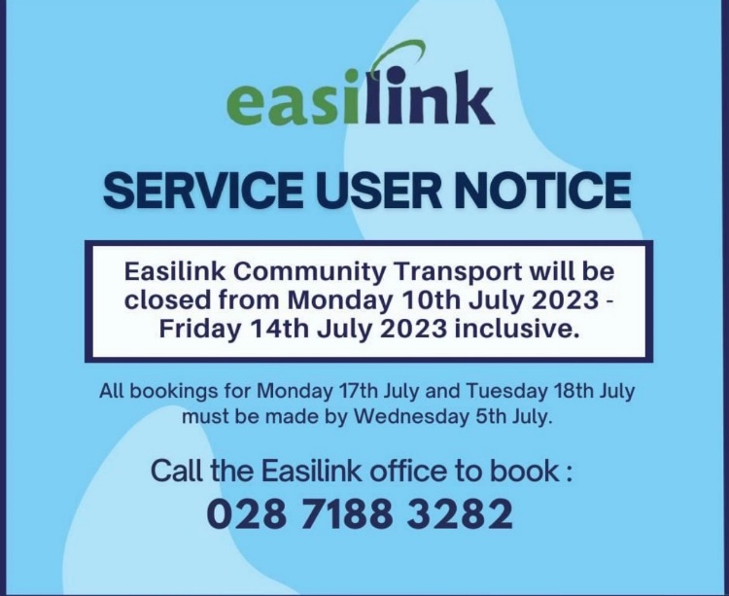

- Give Blood - Blood Transfusion Service to visit Claudy on 4th July

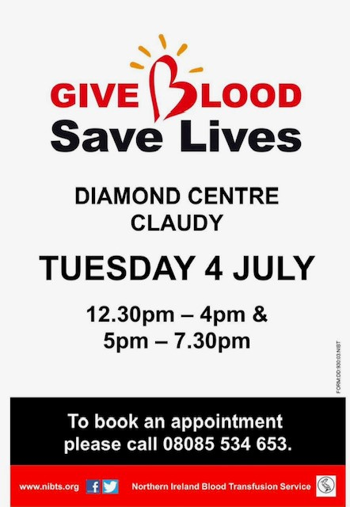

- Translating Age Workshops

Queen's University Belfast are inviting women aged 55+, who are now living here to come along to a series of free workshops. The events are a chance to meet others who have come here, from other cultures and share experiences of being an older women. All information and registration details in the flyer below.
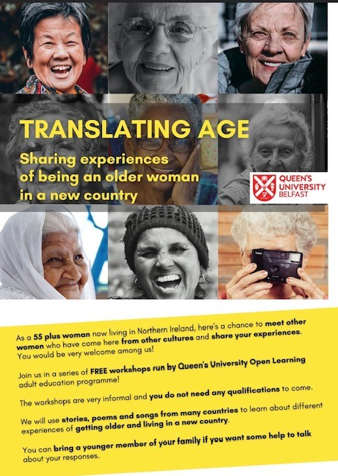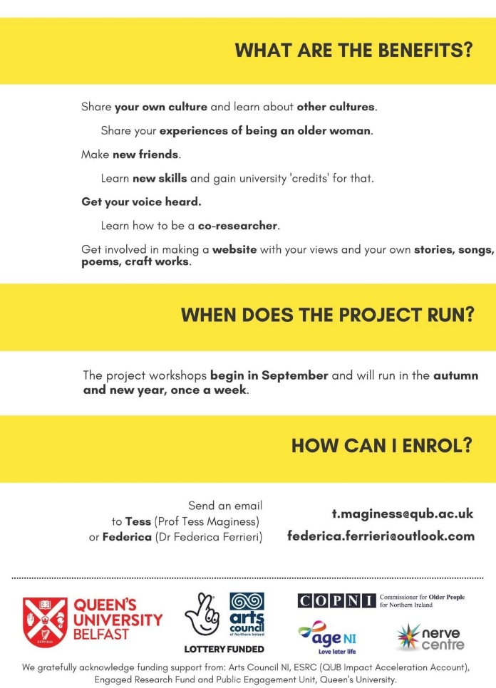
- Interested in the Waterside Half Marathon Couch 2 Relay programme
DCSDC’s Sports Development Team are offering beginner level runners the opportunity to run in the city’s biggest athletics event. The Couch 2 Relay programme is a free 8-week programme to train beginners to take part in the relay element of the Waterside Half Marathon on Sunday September 3rd. Anyone interested in taking part in the programme can attend a registration evening at the Foyle Arena on Wednesday July 5th. Coaching will be delivered from Wednesday July 5th at 6pm for eight weeks with runs leaving from the Foyle Arena and taking in parts of the Waterside Half Marathon course. Registrations for individual, wheelchair and relay elements of the Waterside Half Marathon are open now at www.derrystrabane.com/whm Every entrant in the Waterside Half Marathon relay receives a specially designed 40th anniversary t shirt and medal. For further Information email halfmarathon@derrystrabane.com or telephone 028 7125 3253
- Legal and Advocacy support from Commissioner for Older People
The Commissioner for Older People has a legal and advocacy team who can provide assistance to individual older people who need support, on a range of issues? For more information on how the legal team assist older people, visit our website: https://www.copni.org/about-us/legal-assistance or contact 028 9089 0892
- Free Workplace Health Support - Work Well Live Well Programme
Work Well Live Well is a regional workplace health support service funded by the Public Health Agency. Delivered to support to small, medium and large businesses; and target those with employees at risk of poor health and wellbeing, including low paid, sedentary, migrant and LGBTQ employees. What’s on offer
- An opportunity to complete an employee workplace health and wellbeing survey to determine employee health priorities
- A comprehensive report outlining the health of employees to inform the health and wellbeing action plan
- Assistance with the development and implementation of a workplace health and wellbeing action plan
- Workplace Health Champions Training for employees in your workplace to drive forward an action plan
- Access to further workplace health training including Mental Health First Aid
- Access to two health promotion talks/campaigns for employees
- Celebration Event and Networking opportunities for Workplace Health Champions
- Support from an experienced Health@Work NI workplace health and wellbeing team
- Register your workplace

Across the DCSDC area this programme is delivered by Developing Health Communities. To express an interest or to register your workplace please visit https://www.dhcni.com/forms/register-for-work-well-live-well-program

- Project Gigabit Broadband: Public Review 5 June 2023 – 6 July 2023

The Department of the Economy has assessed the industry’s responses to the Open Market Review (OMR) and is now conducting a Public Review (PR) to validate the results of the OMR, including seeking validation of the eligibility of the premises for subsidy. The Public Review seeks information about current broadband network coverage and any future plans to roll out broadband infrastructure, particularly within the next three years. The PR will be open for feedback from any interested stakeholders and will run for one calendar month. When completed, DfE will confirm the eligibility of the premises for procurement(s) and will publish an Outcome Report outlining postcode level maps of the final Unique Property Reference Numbers (UPRNs) which have been designated as ‘white’ and eligible for subsidy under the Gigabit Infrastructure Subsidy scheme.

DfE has published a Request for Information that can be read on DfE’s website at www.economy-ni.gov.uk and is also providing an online address checking facility at https://consultations.nidirect.gov.uk/dfe/project-gigabitni-open-market-review-public-review/ to allow the public, business and anyone interested in the Public Review to see how DfE has currently categorised addresses, as well as contact details to provide feedback to DfE.

