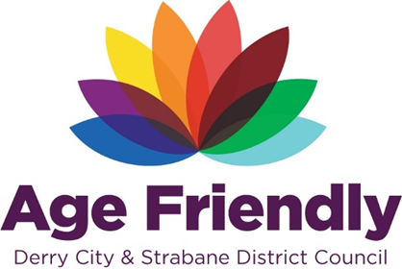
AGE FRIENDLY NEWS & UPDATES
Edition 24 – 07/07/2023

- International Day of Older People & Positive Ageing Month
The theme for International Day of Older People and Positive Ageing Month 2023 has been confirmed as “Know Our Place: Celebrating ageing in our community's past, present and future.” See attached briefing page on the theme received from the Centre of Ageing Better
- PHA Making Life Better Shot term funding Opportunities
Community and voluntary groups are being encouraged to apply for a short-term funding programme that focuses on improving mental health and emotional wellbeing. The Public Health Agency (PHA) scheme opens to applications aims to address health and wellbeing needs in local communities. The funding programme will also support a range of strategic themes and priorities under the ‘Making Life Better’ public health framework, in particular mental health, emotional wellbeing, suicide prevention and self-harm. The closing date for applications is Wednesday 26 July 2023 at 3pm, please visit PHA Making Life Better through Short-term funding programme (dhcni.com)
- Final Call for October 2023 Positive Ageing Month Events Brochure
A final call for any information to be included in this year’s Positive Ageing Month brochure for events and activities to help reach and support persons aged 50 and over across the Derry and Strabane Council area during the month of October. Please use the below template and return by 14th July to agefriendly@derrystrabane.com or visit www.derrystrabane.com/pamsubmit

- Commissioner for Older People’s Judicial Review Triumph as High Court Quashes Healthcare Policy

A High Court Judge has quashed the Department of Health’s Continuing Healthcare Policy in a landmark legal challenge brought by the Commissioner for Older People, Eddie Lynch. The ruling was made on Friday 30 June by Mr Justice Scoffield who examined the impact and delivery of both the 2010 Continuing Healthcare Policy and the new policy which came into effect in 2021.

Continuing Healthcare is a policy which is designed to ensure that everyone, no matter their age or where they reside, receives free healthcare. Healthcare is required by law to be provided free of charge. This means that the most acutely ill people in society should not contribute to their care home costs if their care needs are assessed as being primarily healthcare needs as opposed to social care needs. Further details of this case can be accessed by visiting https://www.copni.org/news/2023/july/commissioner-for-older-people-s-judicial-review-triumph-as-high-court-quashes-healthcare-policy

The Commissioner is always concerned to hear from older people who are experiencing issues with public services and often provides assistance to individuals who need advocacy or legal support. Contact Commissioner for Older Peoples office on 028 9089 0892 or email info@copni.org

- RNID Free online hearing checks
The online hearing test is for you if you’re aged 18 or over and have not been diagnosed with hearing loss. The test measures how well you can hear speech when there’s background noise. You’ll find out if you need to see someone about your hearing, and get our advice on what to do next. Please visit https://rnid.org.uk/information-and-support/take-online-hearing-check/

- Falls Prevention Information & Support
Please see below information leaflets regarding falls preventions and advice and support.

- What’s on Derry & Strabane
Looking for ideas of events and activities on across the Derry and Strabane areas, please visit https://www.derrystrabane.com/what-s-on. Also if you would like to include any events please use this link to update and submit an event.

- NWCN E-bulletin 7th July 2023
Please see below link for the latest e-bulletin newsletter from NWCN
http://www.nwcn.org/content/nwcn-ebulletin-05-july-2023

- Programmes available through AWARE NI

AWARE NI have some funding left for programmes across the Western Trust and any interested groups wishing to avail of these programmes/workshops (free of charge to them funding permitting) should contact Catherine McColgan, Education and Training Officer at AWARE NI on 028 90 357820 Ext 224 or email catherine@aware-ni.org. Programmes available include;

Mood Matters Adults (18+)
This light and interactive mental health awareness training session is an opportunity for you to think about how to look after your own mental health. The workshop will explore mental health stereotypes and look more closely at how to spot the early signs of mental health Illness, stress, depression, anxiety disorders and bipolar. This session will teach individuals coping skills for everyday life, how to avoid getting caught in a vicious circle and how to break unhelpful habits that we sometimes have when our mood is low, as well as where to get further help and support. This session will focus on you as an individual and will then allow you to apply these skills to supporting family, friends and others.
Duration: 2hrs
Group size: 12- 25 people per session
Delivery: Face to face or via zoom

Living Life to the Full (18+)
The is a programme that can make a big difference to your life. It can help you manage your feelings when you are stressed, worried or depressed and learn simple practical skills to help you cope with life’s challenges. Delivered over 6 weeks the programme looks more closely at the ways in which mental health can be impacted by life events and unhelpful thinking styles which may also then affect our physical health and overall enjoyment of life.
Duration: 2hrs per week
Group size: 12- 18 people
Delivery: Face to face or via zoom

- Current Public Consultations Open
A range of public consultations on various areas are currently opened individuals and organisations are welcome to review and submit their views on the different issues. Please visit the following link for further information
http://www.nwcn.org/content/nwcn-consultation-bulletin-june-2023

- What’s on in July 2023 – Libraries Derry and Strabane
Please see poster with details of services available from Libraries NI this July

- Millennium Forum Access Newsletter – July 2023
Please find enclosed the latest newsletter from the Millennium Form

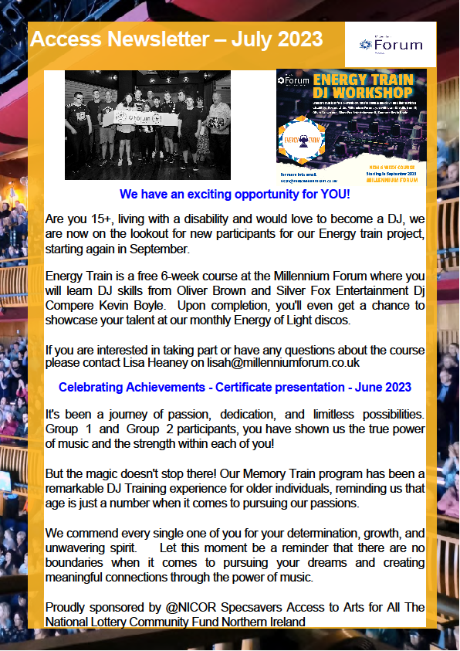

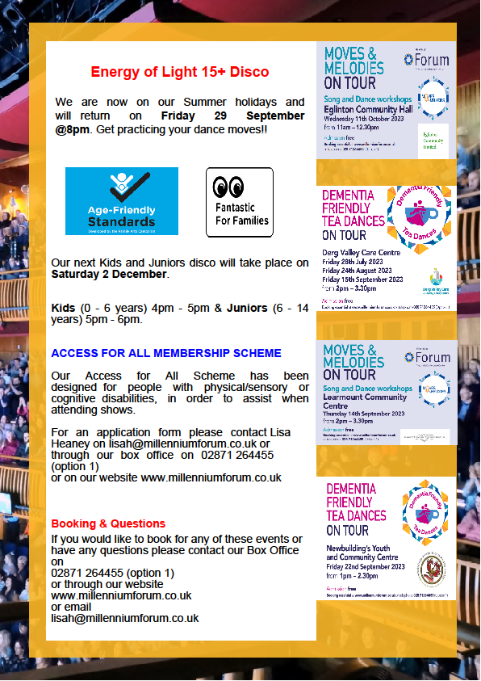

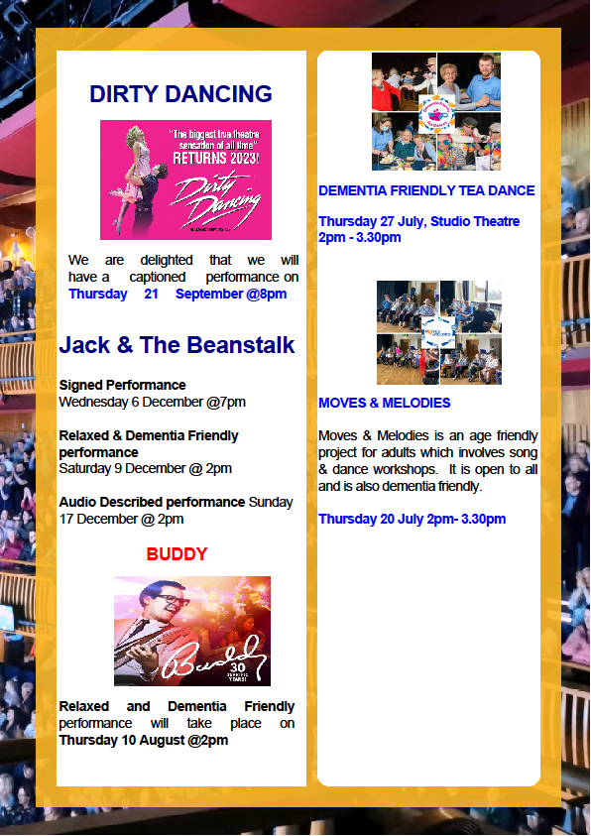

- Alzheimer’s Society Accelerator Programme is back!
New webinars are coming in July and August for applicants to learn more - first one to be held on Thursday 20 July. What could you do with an idea and up to £100k of funding? Do you have an idea or product that will transform the lives of people living with dementia? We want to help you make this a reality and Alzheimer’s Society Accelerator Programme is looking for someone like you. Applications open 30 August. This year you can join our Webinar Summer Series in July and August to learn more about the programme, for help and support on making an application, and to hear from our previous Accelerator Partners on how the programme has helped them. The programme can offer:
- Up to £100K of funding
- Expert innovation and dementia support for 12 months
- Peer-to-peer learning
- Opportunities to learn from people living with dementia through co-creation.
- Support during the application process
To find out more on applying and to register for a webinar visit: alzheimers.org.uk/accelerator if you have any questions please contact Innovation@alzheimers.org.uk

- Aquafit at Foyle Arena
Aquafit will be delivered in Foyle Arena on Tuesdays and Thursdays at 1:00pm starting on Tuesday 11th July until Thursday 31st August. If you are interested in attending, please contact Foyle Arena on 028 7137 6555
- Reminder of Easilink Holiday Closure – 10th – 14th July 2023
Easilink Community Transport will be closed from Monday 10th July 2023 - Friday 14th July 2023 inclusive. All transport services will be back in operation on Monday 17th July 2023. All bookings for Monday 17th July and Tuesday 18th July must be made by Wednesday 5th July.

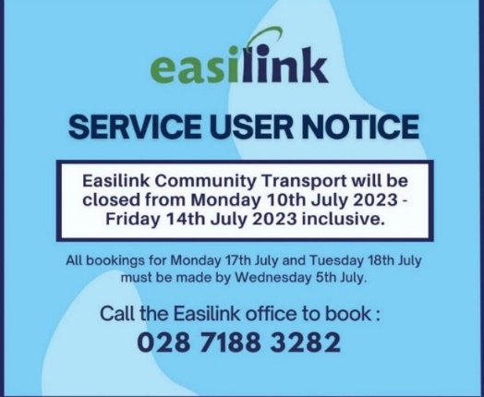

- Age Friendly News and Updates Bulletin
During the summer period the Age Friendly News and Updates Bulletin will be issued periodically, rather than weekly. Please forward details to be included by emailing agefriendly@derrystrabane.com and these can be issued in the next edition.

