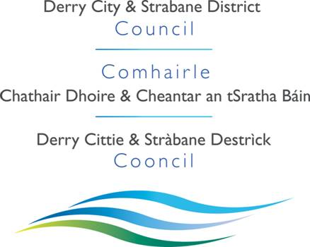

Draft Impact Assessment Report

for Leisure and Sports Pricing Policy

January 2015

Contents

- Introduction 3

- Executive Summary 4

- Background to the Policy 5

- Socio–Economic Profile of Derry City
and Strabane District Council Area 7

- Consideration of Available Data and Research 15

- Consideration of Measures to Mitigate any Adverse Impact 26

- Conclusions 26

Appendices

1.0 Introduction

1.1 Section 75 of the Northern Ireland Act 1998 (“the Act”) requires the Council in carrying out its functions, powers and duties to have due regard to the need to promote equality of opportunity:

- Between persons of different religious belief, political opinion, racial group, age, marital status or sexual orientation;
- Between men and women generally;
- Between persons with disability and persons without;
- Between persons with dependants and persons without.

  - In addition, without prejudice to its obligations above, the Council shall in carrying out its functions, powers and duties have regard to the desirability of promoting good relations between persons of different religious belief, political opinion or racial group. The Council supports the principles of good relations: equity, respecting diversity and interdependence, and the development of relationships built on trust and respect.

  - Derry City and Strabane District Council’s Equality Scheme commits the Council to assess how policy proposals impact on the promotion of equality of opportunity within the terms of Section 75 of the Act.

2.0 Executive Summary

The aim of any Pricing Policy is to support flexible pricing decisions that can help an organisation respond to customer requirements whilst recouping a reasonable proportion of the Council’s expenditure and/or making a satisfactory return on investment. At present Derry City and Strabane District Council aim to:-

- Provide value for money fairly and equally to all and to assist with increasing public access to Council leisure facilities.
- Increase the number of people utilising the leisure facilities and so contribute to the health of the population and the quality of life.
- Ensure that prices are comparable with competitors in the Derry City and Strabane District Council area and on a regional basis.

2.2
In reviewing the Council’s current approach to pricing, information was obtained from the leisure departments with the Northern Ireland Councils.

The information gathered provided guidance to the Charges Working Group in terms of the price and concessionary rates for leisure services.

2.3
It is noted that the Council provides services to a population base with some of the highest levels of deprivation across Northern Ireland therefore the pricing policy would need to reflect this characteristic in the local market.

Research has shown that cost remains one of the most significant barriers to physical activity, with cut-price deals the most effective way to incentivise exercise among UK consumers, according to the latest Health and Fitness Omnibus Survey (HAFOS).

2.4 Conclusions

Derry City and Strabane District Council wishes to implement a Leisure Pricing Policy, which ensures an equitable and consistent approach in terms of charges and concessionary rates across all facilities. The Council welcomes all contributions to this preliminary EQIA and welcomes views with regards to the issues, which were raised through the pre-development consultation.

3.0 Background to the Policy

3.1
Within Derry City and Strabane District Council’s Corporate Plan there is specific commitments to ensuring that citizens receive improved service delivery and more effective use of resources while improving the well-being of communities.

3.2
For the purposes of this draft EQIA, the policy has been restricted to leisure facilities and services

3.3
The development of a Leisure Pricing Policy will govern the range of pricing decisions for Council leisure services. Pricing is considered an integral part of the overall marketing programme, as it will encourage greater access and ultimately increase participation at Council facilities and use of services.

3.4
The current Pricing Policy is currently an unwritten policy, which has evolved over time on a location-by-location basis. Derry City and Strabane District Council delivers its universal services (i.e. supply of wheeled bins, Cemetery services etc.) to everyone who lives within the Council area on a standard price basis, i.e. the same charge is made to all purchasers subject to the nature of the service.

However in the choice based activities (i.e. leisure and arts services) there is a variation in pricing schedules for activities and services depending on the facility selected.

3.5
The `Chief Executive will have overall responsibility for ensuring the effective implementation of this policy. Staff, who are working in facility and service areas where a charge is levied, will have responsibility for its operational implementation.

As already stated the aim of a Pricing Policy is to support flexible pricing decisions that can help an organisation respond to customer requirements whilst recouping a reasonable proportion of the Council’s expenditure and/or making a satisfactory return on investment. At present Derry City and Strabane District Council aims to:

- Provide value for money fairly and equally to all and to assist with increasing public access to Council facilities.
- Increase the number of people utilising the leisure and other facilities and so contribute to the health of the population and the quality of life.
- Ensure that prices are comparable with competitors in the Derry City and Strabane District Council area and on a regional basis.

3.7
This policy is associated with the Council’s Marketing Strategy, Integrated Development Strategy and the Tourism Strategy.

3.8
The proposed policy will contribute towards the achievement of Council’s Corporate objectives where is a commitment to ensuring that citizens receive improved service delivery and more effective use of resources while improving the well-being of communities.

3.9
The main stakeholders who will be affected by this policy are local residents, businesses and visitors to the Derry City and Strabane District Council.

3.10
Derry City and Strabane District Council is not aware of any group which might be expected to benefit from the intended outcomes but which do not.

4.0Socio Economic Profile of Derry City and Strabane District

This section of the report is intended to provide an overview of the scoio-economic profile of the Derry City and Strabane District Council area using quantitative data collated from Northern Ireland Research Agency, Police Service for Northern Ireland, Department of Health and Social Services and the Northern Ireland Housing Executive.

4.1 Derry City and Strabane District Council Area Profile

Derry City and Strabane District Council has seven district electoral areas, comprising 40 electoral wards. See Table 1 below for details:-
Table : 1 Derry and Strabane Local Government District
Number of Wards 40 Total Electorate 104,749
Ward Electoral Average 2,619
DEA WARDS ELECTORATE DEA WARDS ELECTORATE
BALLYARNETT  6 Wards  Skeoge 2,597 Shantallow East 2,994  Culmore 2,893 Galliagh 2,857  Shantallow 2,764 Carn Hill 2,430  TOTAL 16,535  Councillor to electorate ratio: 1 to 2,756  Deviation from ward electoral average+5.2% | FOYLESIDE  5 Wards  Madam’s Bank 2,569 Northland 2,973  Springtown 2,608 Ballymagroarty 2,682  Foyle Springs 2,644  TOTAL 13,476  Councillor to electorate ratio: 1 to 2,695  Deviation from ward electoral average +2.9%
ROSEMOUNT  5 Wards  Sheriff’s Mountain 2,526 Creggan South 2,593  Brandywell 2,700 Creggan 2,835  CityWalls 2,522  TOTAL 13,176  Councillor to electorate ratio: 1 to 2,635  Deviation from ward electoral average+0.6% | WATERSIDE  7 Wards  Victoria 2,579 Clondermot 2,780  Ebrington 2,608 Caw 2,679  Lisnagelvin 2,568 Kilfennan 2,722  Drumahoe 2,744  TOTAL 18,680  Councillor to electorate ratio: 1 to 2,669  Deviation from ward electoral average +1.9%
FAUGHAN  5 Wards  Claudy 2,494 Enagh 2,610  Eglinton 2,761 Slievekirk 2 ,471  New Buildings 2,762  TOTAL 13,098  Councillor to electorate ratio: 1 to 2,620  Deviation from ward electoral average 0.0% | SPERRIN  7 Wards  Park 2,479 Dunnamanagh 2,461  Glenelly Valley 2,405 Artigarvan 2,438  Strabane North 2,430 Strabane West 2,426  Ballycolman 2,634  TOTAL 17,273  Councillor to electorate ratio: 1 to 2,468  Deviation from ward electoral average -5.8%
DERG
5 Wards
Glenderg 2,445 Castlederg 2,436
Newtownstewart 2,357 Sion Mills 2,550
Finn 2,723
TOTAL 12,51 1
Councillor to electorate ratio: 1 to 2,502
Deviation from ward electoral average -4.5%
An overview of the Section 75 profile of the new Derry/Strabane Council area is presented below. All data was sourced from the Census 2011 figures, unless otherwise stated.

Derry City and Strabane District Council is sixth largest of the eleven District Councils in Northern Ireland, serving a population of approximately 147,720. A large percentage of the council area is rural in nature with 1680 farms registered to addresses in the area in 2013 and a total agricultural labour force at that time of 3316 persons.

The Council area offers a wide range of attractions for visitors including the historic walls, the Tower Museum, the Sollus Centre and is an important centre for the arts accommodating the Millennium Forum, the Alley Theatre and Conference Centre, the Nerve Centre, the Playhouse and a diverse range of community arts groups.

Sport is well represented with a number of local football, rugby, cricket, GAA and other sporting clubs in the area.

4.2 Key Statistics

The mid year population estimates for 2013 indicate that the Derry City and Strabane District Council area is home to 148,632 people. Table 2 shows that Population projections indicate that by 2025 the population of the Derry City and Strabane District Council area will be 150,495 persons, with the greatest increase being in the over 65 years age group.

Table 2 – Population Projections
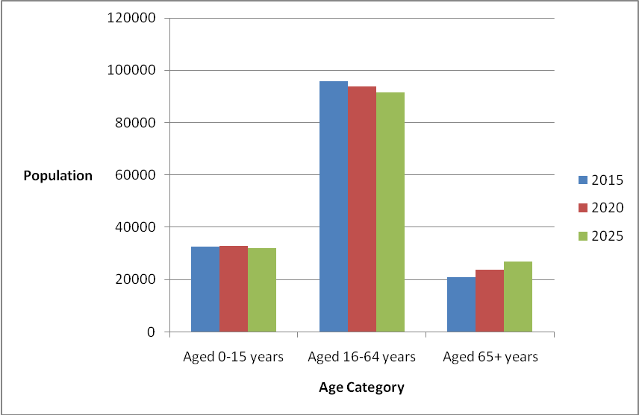

4.3 Health

Over the coming years, both the size and the age structure of the population of the Derry/Strabane Council area and indeed Northern Ireland as a whole will alter, potentially changing the demand for health and social care.

Statistics for the period 2009-2011 indicate that the council district has a higher than average mortality ratio. This trend is for both male and female residents – See Tables 3 and 4 below.

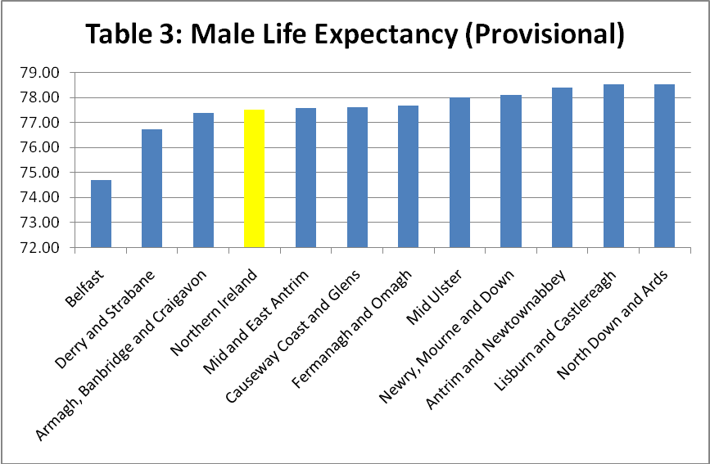

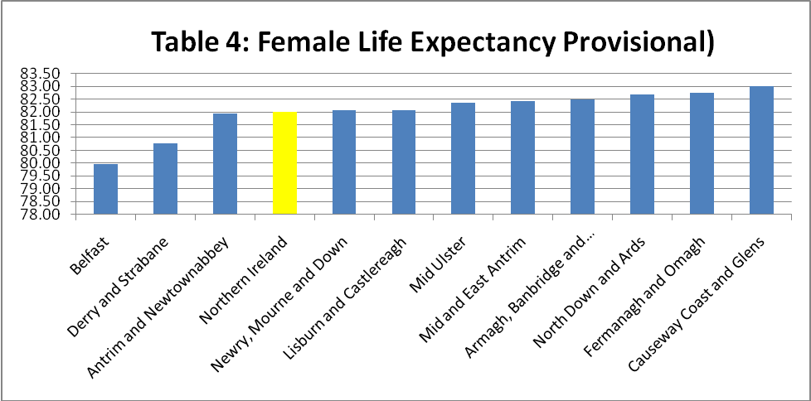

Causes of death within the district is detailed in Table 5 below:

LGD2014 | Deaths | Deaths due to Malignant Neoplasms (%) | Deaths due to Circulatory Diseases (%) | Deaths due to Respiratory Diseases (%) | Deaths due to External Causes (%) | Deaths from suicide and undetermined intent (%)
Northern Ireland | 14756 | 28.02 | 27.11 | 13.71 | 4.99 | 1.88
Derry and Strabane | 1089 | 28.37 | 26.91 | 15.34 | 5.05 | 2.11

In terms of external causes it would appear that alcohol and drugs are a major contributor – See Table 6 below:

2013
LGD2014 | Drug Related Deaths (Provisional) |  | Alcohol Related Deaths (Provisional)
Northern Ireland | 115 |  | 236
Derry and Strabane | 8 |  | 29

On Census Day 27th March 2011, in Derry/Strabane Local Government District:

- 22.9% of people had a long-term health problem or disability that limited their day-to-day activities;
- 77.1% of people stated their general health was either good or very good; and
- 11.3% of people stated that they provided unpaid care to family, friends, neighbours or others.

4.4 Economic Growth and Deprivation
The Derry/Strabane Council area has experienced low levels of economic activity and in 2011, it was well below the economic activity rates in Northern Ireland with 68.75%. (The NI figure for the same period was 72.5%.)

Table 7: Economic activity and employment
16-64 Economic activity – 2011
 | Northern Ireland |  | Derry City Council |  | Strabane District Council |  | Derry/Strabane District Council
 | No. (000s) | rate | No. (000s) | rate | No. (000s) | rate | No. (000s) | rate
Total economic activity | 837 | 72.50% | 49 | 70.90% | 17 | 62.7% | 66 | 68.75%
 | 452 | 79.10% | 27 | 76.20% |  |  | 38 | 80.50%
Men |  |  |  |  | 11 | 76.1% | 38 | 80.50%
 | 385 | 66.10% | 22 | 65.30% |  |  | 28 | 46.50%
Women |  |  |  |  | 6 | 47.9% | 28 | 46.50%
Economically inactive | 317 | 27.50% | 20 | 29.10% | 10 | 37.3% | 30 | 27.90%

Table 8 shows the unemployment rate for the Derry/Strabane area, which was 8.7% as compared to the Northern Ireland average of 5.4%.
District | Number of Claimants |  |  | % Of Working Age
Council Area | Males | Females | Total | Males | Females | Total
Derry | 4,252 | 2,021 | 6,273 | 12.3% | 5.6% | 8.9%
Strabane | 1,390 | 673 | 2,063 | 10.9% | 5.3% | 8.1%
Derry/Strabane | 5,642 | 2,694 | 8336 | 11.9% | 5.5% | 8.7%
NI TOTAL | 43,446 | 19,847 | 63,293 | 7.5% | 3.4% | 5.4%

From 2000 to 12th December 2014, there were 4801 redundancies the Derry City Council district with only Belfast City Council recording a higher figure. Strabane had 1173 confirmed redundancies in the same period thus making the total number of confirmed redundancies for the new Council area 5974.

The final results of the Northern Ireland Multiple Deprivation Measure 2010 (NIMDM 2010) were published in summer 2010. The report identifies small area concentrations of multiple deprivations across Northern Ireland. The results for the Derry and Strabane Council areas show that the districts have an Extent of 43% and 44% respectively: this means that 43% of the population of the Derry district and 44% of the population of the Strabane District live in the most deprived Super Output Areas in Northern Ireland. This shows a slight improvement from the Multiple Deprivation Measure 2005 when the Derry City Council area had an Extent of 46% and a significant change for the Strabane District Council area where in 2005 it had an Extent of 54%.
The Income Scale shows that there are 55,881 people in the Derry/Strabane district experiencing income deprivation, while the Employment Scale shows that a total of 16,487 people in the joint council district experience employment deprivation. Both the income and employment deprivation can be presented as rates of the relevant population. 37% of the population have been identified as income deprived while 18% of the population are identified as employment deprived. This can be compared to Northern Ireland as a whole where 25% were identified as being income deprived and 13% identified as being employment deprived.

Table 9: Multiple Deprivation Comparisons | Strabane (LGD)  Score | Derry (LGD) Score | Derry/Strabane (LGD)  Score
Income Scale | 14,394 | 41,487 | 55,881
Employment Scale | 4,603 | 11,884 | 16,487
Percentage of total population income deprived | 36% | 38% | 37%
Percentage of working age population employment deprived | 20% | 18% | 18%

4.5 Education

- On Census Day 27th March 2011, considering the population aged 16 years old and over in Derry/Strabane Council area:
- 20.3% had a degree or higher qualification (N.I. Average 23.65%); while
- 46.48% had no or low (Level 1*) qualifications (N.I. Average 40.63%).

School Leavers
- There were 2,201 school leavers in 2010/11
- Over half of school leavers (54.5%) achieved 2+ A levels (NI 53.3%)
- Over two thirds of school leavers (1552 or 70.5%) had achieved at least 5 GCSE’s at grades A-C (or equivalent) (NI 73.2%)
- Just over 60% of school leavers achieved at least 5 GCSE’s at grades A-C which included English and Maths (NI 62%)
- 2.27% of the 2,201 school leavers achieved no GCSE’s (NI 2.2%).

Table 10: School Leavers Report 2010/11
LGD | School Leavers | 2+ A-levels (or equiv) | 2+ A-levels (or equiv) % | At Least 5 GCSE's grades A*-C (or equiv) | At Least 5 GCSE's grades A*-C (or equiv) % | No GCSEs | No GCSEs %
Northern Ireland | 23160 | 12342 | 53.29 | 16949 | 73.18 | 521 | 2.25
Derry/ Strabane Area | 2201 | 1200 | 54.5 | 1552 | 70.5 | 50 | 2.27

In 2011 Only 4.2% of school leavers in the Derry/Strabane progressed into employment, this falls well below the Northern Ireland averaged of 6.2%.

Table 11: Destination of School Leavers 2010/11

LGD | School Leavers | Higher Education | Further Education | Employment | Training | Unemployed/ Unknown
Northern Ireland | 22568 | 9557 | 7808 | 1393 | 2510 | 1300
Derry/ Strabane | 2130 | 864 | 770 | 89 | 267 | 140

4.6 Housing and Transport

According to the findings from the Census 2011 there were
- 65.6% were owner occupied and 32.6% were rented properties in the Derry/Strabane City Council area; 1.8% live rent free.
- 24.6% homes were owned outright – (28.5% NI)

The average household size in 2011 was 2.6 for the new joint Council area, compared to 2.5 for NI as a whole.
LGD | All house-holds | 1 person | 2 people | 3 people | 4 people | 5 people | 6 people | 7 people | 8 or more people | Average household size
NI | 703275 | 196414 | 212286 | 117920 | 103137 | 49370 | 18209 | 3919 | 2020 | 2.54
Derry | 40779 | 11366 | 11364 | 7079 | 6130 | 3129 | 1239 | 304 | 168 | 2.61
Strabane | 14817 | 3981 | 4040 | 2504 | 2354 | 1255 | 530 | 100 | 53 | 2.67
Derry/ Strabane | 55596 | 15347 | 15404 | 9583 | 8484 | 4384 | 1769 | 404 | 221 | 2.6
Table 12: Average Household Size

Car Registration
In 2011, 7.3% (63604) of all cars registered in Northern Ireland were licensed to addresses in the Derry/Strabane Council area. 12.1% of which were cars registered to a disabled driver or for transporting disabled people as compared to the Northern Ireland average of 8.35%.

Table 13: Car Registration
 | Cars Registered | Cars Registered to a Disabled Driver or for Transporting Disabled People | Cars Registered to a Disabled Driver or for Transporting Disabled People (%)
Northern Ireland | 870439 | 72684 | 8.35
Derry | 44437 | 5367 | 12.08
Strabane | 19167 | 2332 | 12.17
Derry/Strabane | 63604 | 7699 | 12.1
The average rates bill in the Derry district in 2013/14 was £ 796 with average for Strabane District being £716 - This compares to NI average of £862.. The average new house price in the Derry in 2012 was £139,600, the average for Strabane was £124,600 – this compares to a NI average of £144,100.
5.0 Consideration of Available Data and Research

5.1 In conducting this preliminary EQIA the Council took fully into account data and research findings from the following sources.

Primary Research
- Comparative Pricing Research with Leisure Venues in Northern Ireland

Secondary Research
- NISRA,
- Museum Survey – Northern Ireland Museums Council, April 2004
- Wise Up to Child Poverty –Derry Children’s Commission, July 2005
- Fair Employment Return – July 2005
- Equality Database
- Labour Force Survey
- Northern Ireland Anti-Poverty Network, 2002
- Developing Audiences – Heritage Lottery Fund, 2000

  - Findings of research carried out among leisure facilities in the region

Research was conducted among leisure facilities in the region. The competitor information provides guidance in terms of prices for facilities. A summary of the information is detailed below.

Leisure & Sports Services – Schedule of Charges
Local Authority price comparisons:
 | Derry & Strabane  Proposed | Banbridge | Coleraine | Cookstown | Limavady | Omagh | Armagh | Lisburn
Adult Swim | £2.50 | £4.25 | £3.50 | £2.85 | £3.60 | £3.00 | £3.40 | £3.10
Junior Swim | £1.90 | £3.05 | £2.50 | £2.00 | £2.00 | £2.00 | £2.05 | £2.00
Pool Hire (25m x 6 lane) | £35.00 | £40.00 | £50.00 | £44.00 | £45.00 | £40.00 | £40.00 | n/a
Junior Swim Lessons (per class) | £4.50 | £5.60 | £5.75 | £3.50 | £4.75 | £6.00 | £5.53 | £6.00
Adult Swim Lessons (per class) | £4.50 | £6.66 | £5.75 | £3.95 | £6.50 | £6.00 | £6.00 | £6.00
Group Exercise (per session) | £4.00 | £5.00 | £4.00 | £4.50 | £4.80 | £4.50 | £3.90 | £4.20
Sauna, Steam & Swim | £4.00 | £5.20 | £5.70 | £4.95 | £4.80 | £5.00 | £4.80 | £4.50
Gym/Fitness Suite Session  Gym/Fitness Suite Monthly Membership | £5.00  £25.00 | £6.00  £35.00 | £6.00  £25.00 | £5.00  £30.00 | £5.50  £30.00 | £5.00  £24.00 | £4.50  £33.00 | £5.80  £34.00
Main Hall Hire (4 badminton court size) | £38.00 | £38.00 | £34.00 | £28.00 | £27.00 | £25.00 | £33.50 | £35.00
Squash | £5.50 | £6.55 | £7.00 | £5.80 | £4.50 | £5.00 | £7.00 | £5.30
Synthetic Pitch (full size)  With floodlights | £45.00  £55.00 | £52.00 | £32.00  £45.00 | £40.00  £55.00 | £38.00 | £38.00  £52.00 | £42.00 | £35.00
Grass Pitch Adult (full size)  Junior ½ price | £34.00 |  | £39.50 |  |  | £35.00 | £32.50 | £30.00

Table 14 | All usual residents | Catholic | Protestant and other Christian | Other religions | None
Northern Ireland | 1,810,863 | 817,385  (45.14%) | 875,717  (48.36%) | 16,592  (0.92%) | 101,169  (5.59%)
Derry & Strabane | 147,720 | 106,600  (72.16%) | 37,527  (25.40%) | 940  (0.64%) | 2,653  (1.80%)

5.4 Evidence of impact of policy on Religious Belief

Table 14 illustrates the 2011 Census figures breakdown of people by religious belief in the Derry City and Strabane District Council area as being:

The 2011 Census showed differences in general health according to religion. Those who were or had been brought up as Catholics were typically more likely than those who belonged to or had been brought up in Protestant denominations to assess their general health as either ‘bad’ or ‘very bad’. The relative differences were more noticeable in the older age groups.

In relation to persons with different religious beliefs using the leisure facilities there may be specific requirements such as Muslim women can only avail of the service where there is female only staff during the Ladies Only sessions.

The Continuous Household Survey (CHS) 2011‐12 showed that there was no difference between levels of participation in sport between people from a Catholic background and those from a Protestant background.

It is not anticipated that this issue would affect the pricing of leisure facilities and therefore this policy is not deemed to have an adverse impact on this Section 75 category.

Derry City and Strabane District Council would be particularly keen to hear views on how a Leisure pricing policy could promote greater equality of opportunity for people of different religious beliefs.

5.5 Evidence of impact of policy on Political Opinion

The political opinion of the Council’s elected members is as follows:

Sinn Féin 16 seats
SDLP 10 seats
Democratic Unionist 8 seats
Independents 4 seats
Ulster Unionist 2 seats

This breakdown is taken as an approximate representation of the political opinion of people within the Derry City and Strabane District Council area.

Leisure charges are fixed regardless of this s75 grouping and will thus have no differential impact on this category.

Derry City and Strabane District Council would be particularly keen to hear views on how a Leisure pricing policy could promote greater equality of opportunity for people with different political opinion.

5.6 Evidence of impact of policy on Racial Group

Table 15 illustrates the composition of racial groups in the Derry City and Strabane District Council area (NISRA 2011) as follows:

Table 15: Racial Profile of Derry City and Strabane District Council

Total Usual Residents | 147720
White | 145546
Chinese | 301
Irish Traveller | 116
Indian | 670
Pakistani | 48
Bangladeshi | 23
Other Asian | 222
Black Caribbean | 53
Black African | 86
Black Other | 41
Mixed | 462
Other | 163

Although racially and ethnically diverse groups have displayed advances in income levels, educational status, and employment since the 1960s, serious disparities remain that often lead to differentiated access to resources. With regard to leisure research, Limited access to resources is a commonly cited constraint among racially and ethnically diverse groups. Access manifests itself through financial resources, transportation, and physical access.

Research commissioned by the UK Sports Council in 2009 suggests that inequality and discrimination persist in the provision of and access to sport and physical recreation opportunities by black and ethnic minority communities. These communities are poorly represented at decision making levels and face a range of barriers to sports participation.

Derry City and Strabane District Council would be particularly keen to hear views on how a Leisure pricing policy could promote greater equality of opportunity for people from different racial backgrounds.

5.7 Evidence of impact of policy on Age (Consider each age group – Under 16, 16-25years, 26-65 years and 65+)

Table 16 shows the age composition of the population in the Derry City and Strabane District Council area as follows:
Age Profile | NI | Derry and Strabane
0-4 | 124382 | 10259
5-7 | 67662 | 5653
8-9 | 43625 | 3858
10-14 | 119034 | 10904
15 | 24620 | 2363
16-17 | 51440 | 4729
18-19 | 50181 | 4443
20-24 | 126013 | 10399
25-29 | 124099 | 10481
30-44 | 373947 | 30635
45-59 | 347850 | 28082
60-64 | 94290 | 7475
65-74 | 145600 | 10775
75-84 | 86724 | 5876
85-89 | 21165 | 1217
90+ | 10231 | 571

According to the “End Child Poverty” Report (October 2014) Derry and Strabane district council areas have the highest levels of child poverty (after housing costs) out of the existing 26 councils at 31.17% and 29.35% respectively

Table 17 below shows that the incidence of people having a long-term health problem or disability which limited their day-to-day activities rises continuously with increasing age. For example, whereas 1.4 per cent of those aged 0-4 had a long-term health problem or disability which limited their day-to-day activities ‘a lot’, this rises to approximately one person in fifteen (6.8 per cent) among those aged 35-39, approximately one person in eight (12 per cent) among those aged 45-49 and approximately one person in three (36 per cent) among those aged 75-79. Over three-fifths (62 per cent) of those aged 85 and over had a long-term health problem or disability which limited their day-to-day activities ‘a lot’

Table 17: Incidence of persons with long-term health problems which limits day to day activities in Northern Ireland-2011
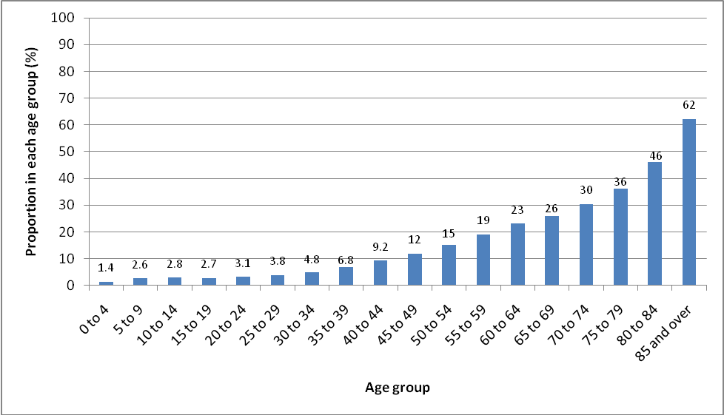

The Council offers separate prices for
- Persons between five and eighteen years of age (Child)
- Persons over eighteen years of age (Adult)
- Concessionary rates for senior citizens (persons over 65 years of age)

Given that the concessionary rates, which Council have in place, take cognisance of the earning capacity at various ages and it is therefore considered that the pricing policy would have a differential impact in terms of age.

Derry City and Strabane District Council would be particularly keen to hear views on how a Leisure pricing policy could promote greater equality of opportunity for people of different age groups.

5.8 Evidence of impact of policy on Men and Women (including boys, girls, transgendered and transsexual people)

Table 18 below shows the gender breakdown of residents in the Derry City and Strabane District Council area according to the Census 2011 data.

Table 18: Gender Profile of Derry City & Strabane District Council

LGD | Male | Female
Northern Ireland | 887323 | 923540
Derry and Strabane LGD | 72475 | 75245

According to the DCALNI report on “Experience of sport and physical activity by adults in Northern Ireland” for 2013/14 men were more likely to state that there was nothing that acted as a barrier to sports club membership (22%) than women (16%). On the other hand, women were more likely than men to cite the following as one of the barriers to sports club membership than men:

- It is too expensive to join a sports club (women: 18%; men: 13%)

Leisure prices do not have a differential impact on people of different genders but that other factors such as programming or activities offered are having an impact on the user profile of facilities

Derry City and Strabane District Council would be particularly keen to hear views on how a Leisure pricing policy could promote greater equality of opportunity for people of different genders.

5.9 Evidence of impact of policy on People with/without a disability
- People with/without a Learning disability
- People with/without a sensory disability
- People with/without a physical disability

According to the 2011 Census 22.95% of people in the Derry and Strabane LGD have a long-term health problem or disability that limits their day-to-day activities See Table 19 below;

Table 19: Incidence of persons with long-term health problems which limits day to day activities in new Council area-2011

 | All usual residents | Long-term health problem or disability: Day-to-day activities  limited a lot | Long-term health problem or disability: Day-to-day activities limited a little | Long-term health problem or disability: Day-to-day activities not limited
Northern Ireland | 1810863 | 215232  (11.89%) | 159414  (8.8%) | 1436217  (79.31%)
Derry and Strabane | 147720 | 20710  (14.02%) | 13193  (8.93%) | 113817  (77.05%)

The Council has received feedback from consultations held in the past where one respondent stated that it would be patronising to award a special rate to this grouping just because they have a disability – some people with a disability are in employment and are as able and in some case more able to pay for services as people without a disability.

People with mental health problems tend to have significantly higher rates of long‐term physical health problems. There is also some evidence to suggest that obesity may be more prevalent among disabled people.
People with learning disabilities may experience a risk of dementia because of premature ageing. People with Down’s syndrome have an increased genetic risk of developing dementia.

In terms of employment the latest figures show that just over a third (37.6%) of disabled persons are in employment compared to 74.7% of non‐disabled persons. Only about one fifth of people with mental ill‐health or learning disability are in employment, despite the fact that research in the USA suggests that up to 58% of adults in this category are able to work.

The Poverty Site - Poverty is based on a household’s income level. A much higher proportion of families receive DLA or AA in NI (20 per cent) than in the rest of GB (13 per cent). The DWP (2013) report states that disabled people are more than twice as likely as non-disabled people to experience material deprivation, as measured by indicating which goods they cannot afford on a deprivation scale.

Twice the proportion (12%) of disabled adults live in persistent poverty compared to non-disabled adults (6%). Persistent poverty is defined as spending three or more years, out of any four-year period, in a household with an income below 60% of median income (DWP 2013).

As a result of these data, it is clear that people with disabilities would be proportionately more likely to be entitled to access concessionary rates
It is noted that some Councils within the region give concessionary rates/free access to carers accompanying people with a disability when using Council facilities so as to enable them to participate and enjoy the activity.

In overall terms the Leisure Pricing Policy may have a potential differential impact on this s75 grouping depending on the implementation of concessionary rates.

This data would indicate that people with a disability are less likely to be in employment that people without a disability and this may affect the level of disposable income available to a person with a disability.

Derry City and Strabane District Council would be particularly keen to hear views on how the leisure pricing policy could promote greater equality of opportunity for people with/without disabilities.

5.10 Evidence of impact of policy on People with/without dependants

According to the 2011 Census 37.65% of households in the Derry and Strabane LGD have a dependants as compared to the Northern Ireland average of 33.85% households – See Table 20 below;

Table 20: People with Dependants in Derry City and Strabane District Council area
 | All households | Married or in a registered same-sex civil partnership couple:  Dependent children | Cohabiting couple:  Dependent children | Lone parent: Dependent children | With dependent children
Northern Ireland | 703275 | 138677  (19.72%) | 16186  (2.3%) | 64228  (9.13% | 18980  (2.7%)
Derry and Strabane | 55596 | 10370  (18.65%) | 1097  (1.97%) | 7284  (13.1%) | 2187  (3.93%)

There is a significant proportion of one parent families (13.1%) who reside in the Derry City and Strabane District Council area – affordability may be a factor in their ability to participate in the Council leisure services - the findings from the DCAL research “Barriers to Participation in Culture Arts and Leisure – Final Report” supports this as it highlighted that service providers should consider reducing the cost of services in order to encourage participation by groups such as families, the elderly, those on low incomes and the unemployed.

At present the Council has identified ‘family membership’ in certain instances as 2 adults and 2 children but the application of this concession is not uniform as for example in the heritage and museum service where a family pass is for 2 adults and 3 children.
Sport NI raised an issue stating that it was recognised that there is a drop in participation in sports after children are born. Whenever a busy lifestyle becomes hectic, people have less time for themselves. They also face the additional problems of getting childcare and crèche facilities and finding the personal space to get out and be active.[This point is linked to the issue of women not prioritising themselves and being reluctant to devote time and money to their own well-being.
Difficulties with the actual cost of accessing provision seemed to be
particularly applicable to people on relatively low incomes, but just
above the eligibility threshold for exemptions or concessions. For
example, parents on low incomes said that they found it difficult to take
the whole family to leisure centres since the entrance costs mount up
when there are 4 or 5 people.

The census data above highlights that there is a significant number of lone parents in Northern Ireland and the concessionary ‘family pass’ may have a potential differential impact on this grouping.

There is therefore a large target audience for increasing the participation of under‐represented groups by providing high quality, accessible and affordable facilities and activities.

Derry City and Strabane District Council would be particularly keen to hear views on how a Leisure pricing policy could promote greater equality of opportunity for people with/without dependants.

  - Evidence of impact of policy on Marital Status

Table 21 below illustrates the marital status profile of the Derry and Strabane LGD:

Table 21: Marital Status Profile of Derry City and Strabane District Council area.
Marital Status | Derry and Strabane LGD | NI
All usual residents: Aged 16+ years | 83663 | 1431540
Single (never married or never registered a same-sex civil partnership): Aged 16+ years | 46326  (40.39%) | 517393  (36.14%)
Married: Aged 16+ years | 49218  (42.92%) | 680831  (47.56%)
In a registered same-sex civil p’ship: Aged 16+ years | 93  (0.08%) | 1243  (0.09%)
Separated (but still legally married or still legally in a same-sex civil p’ship): Aged 16+ years | 5886  (5.13%) | 56911  (3.98%)
Divorced or formerly in a same-sex civil partnership which is now legally dissolved: | 6179  (5.39%) | 78074  (5.45%)
Widowed or surviving partner from a same-sex civil partnership: Aged 16+ years | 6981  (6.09%) | 97088  (6.78%)

Leisure charges are fixed regardless of this s75 grouping and will thus have no differential impact on this category.

Derry City and Strabane District Council would be particularly keen to hear views on how a Leisure pricing policy could promote greater equality of opportunity for people of different marital status.

  - Sexual Orientation

Analysis of the Census 2011 indicates that between 2% and 10% of the population may be lesbian, gay or bisexual.

There are no official statistics in relation to the number of gay, lesbian or bisexual people in Northern Ireland. However, research conducted by the HM Treasury shows that between 5% - 7% of the UK population identify themselves as gay, lesbian, bisexual or ´trans´ (transsexual, transgendered and transvestites) (LGBT). This is a sizeable proportion of the population here in Northern Ireland.

Research commissioned by the UK Sports Councils in 2009 concluded
that there is no reliable evidence to allow analysis of the extent to which
Lesbian Gay and Bisexual (LGB) people undertake different levels of
sports participation but that there was anecdotal evidence that non‐
inclusive attitudes, homophobia and self‐censorship exist.

It is noted that when considering the definition of ‘family pass’ Council must be mindful to be inclusive so as not to have an adverse impact on this category. Council must also ensure that when the concessionary ‘couple’ rate which is in place within the fitness suites across the leisure centres that the definition of ‘couple’ extends to same-sex partners.

Derry City and Strabane District Council would be particularly keen to hear views on how a Leisure pricing policy could promote greater equality of opportunity for people of different sexual orientation.

5.13 Evidence of impact on Good Relations

The Leisure Pricing Policy aims to arrive at a scale of charges for its services, which is consistent, fair and equal to all its residents and visitors, with no adverse impact on any section of its community.

Derry City and Strabane District Council would particularly welcome views on how good relations could be promoted via the Leisure Pricing Policy.

5.14 Evidence of impact on sustainable development

The long-term financial sustainability of Derry City and Strabane District Council is dependant on the optimisation of available opportunities for the generation of income. Wherever possible this optimisation is achieved by the setting of discretionary fees and charges for services provided in a fair and equal manner so as to provide value for money for the service user whilst recouping a reasonable proportion of the Council’s expenditure.

5.15 Summary of Impacts

The EQIA process has identified that this policy may impact on a number of Section 75 groupings, albeit to varying degrees. The groups potentially affected are;
- Racial Grouping
- Age
- Marital Status
- Gender
- Sexual Orientation
- People with/without a disability
- People with/without dependants

6.0 Consideration of Measures to Mitigate any Adverse Impact

  - The Council is committed to developing a Leisure Pricing Policy, which will mitigate any adverse impacts. Consequently the results of this preliminary EQIA and views obtained on how better to promote equality of opportunity will be used to inform the development of the new policy thus improving the resultant policy and policy outcomes.

  - At this stage the following preliminary options have been identified, which it is felt may mitigate against some of the adverse impacts in relation to its Leisure Pricing Policy:

- Application of concessionary rates for the following groups

- Under 5’s
- Over 65’s
- Economically disadvantaged
- Students
- Child/Junior
- Council Staff

Derry City and Strabane District Council would particularly welcome views on the above mitigation measures.

7.0 Conclusions

  - Derry City and Strabane District Council has carefully considered the findings of the research and consultation. As a result the Council has concluded that the data collated indicates that this preliminary draft equality impact assessment has identified potential differential impacts in relation to the aforementioned Section 75 groups in terms of the provision or non-provision of concessionary rates.

7.2 The Council wishes to consult as widely as possible on the findings included in this preliminary draft equality impact assessment report together with the preliminary draft recommendations offered above:

http://www.harboroughsport.org.uk/news/2014/12/study-finds-cost-is-still-the-biggest-barrier-to-physical-activity
Farm Census 2013 (ww.ninis2.nisra.gov.uk/public/pivotgrid.aspx?dataSetVars=ds-5431-lh-73-yn-1999-2013-sk-38-sn-Agriculture%20and%20Environment-yearfilter—)
3http://www.ninis2.nisra.gov.uk/public/Theme.aspx?themeNumber=74&themeName=Population
http://www.detini.gov.uk/deti-stats-index/stats-regional-analysis.htm (September 2013) - dc briefing 57
http://www.detini.gov.uk/deti-stats-index/stats-surveys/stats-claimant-count.htm (Table 3.8)
http://www.detini.gov.uk/dca_breakdown_november_2014.xls?rev=0
www.ninis.nisra.gov.uk/mapxtreme/pf_report.asp?Level=Dc&sID=MM&sName=Derry
http://www.deni.gov.uk/qualifications_and_destinations_1011_revised_aug_12.pdf
8. http://www.ninis2.nisra.gov.uk/public/pivotgrid.aspx?dataSetVars=ds-3153-lh-37-yn-2003-2006,2008-2011-sk-118-sn-Travel%20and%20Transport-yearfilter--
http://www.ninis2.nisra.gov.uk/public/pivotgrid.aspx?dataSetVars=ds-5782-lh-37-yn-2004-2013-sk-10-sn-People%20and%20Places-yearfilter--
http://www.nisra.gov.uk/census/detailedcharacteristics_stats_bulletin_2011.pdf
Table K506 Ethnic Group, NINIS, NISRA, 2001.
http://www.humankinetics.com/excerpts/excerpts/leisure-constraints-relevant-to-racially-and-ethnically-diverse-groups
file://dcc-fp-01/HomeDirs/Kay.McIvor/Downloads/Final_Draft_LTP_EQIA_Report%20(4).pdf
http://www.nisra.gov.uk/census/detailedcharacteristics_stats_bulletin_2011.pdf
http://www.dcalni.gov.uk/sport_bulletin_201314.pdf
Department for Work and Pensions (2013) Fulfilling Potential: Building a deeper understanding of disability in the UK today. London: Department for Work and Pensions.
http://archive.niassembly.gov.uk/culture/2007mandate/reports/report73_09_10r.htm#footnote-323133-44-backlink
http://www.ofmdfmni.gov.uk/barriers.pdf
2 A systematic review of the literature on Black and Ethnic Minority Communities in Sport and Physical Education, 2009

