Form of Public Notice to advertise an application for an outdoor entertainments licence | 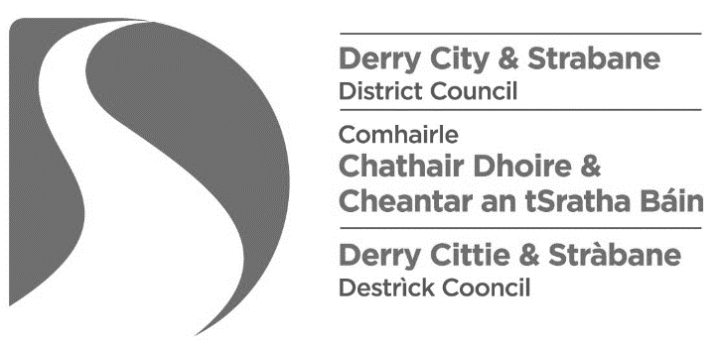
The Local Government (Miscellaneous Provisions) (Northern Ireland) Order 1985
Article 3 and Schedule 1
Notice is hereby given that I / we*,
[insert name & address of applicant]

have today applied to the Derry City and Strabane District Council for the Grant of an Entertainments Licence in respect of an outdoor musical event to be held at:
[insert name & address of location in which the event will be held]

Entertainment is to be provided on the following days and between the following hours:
[insert days / hours of entertainment]

The nature of the entertainments to be provided is as follows:
[Specify the nature of the entertainments to be provided]

Any person wishing to make representation in relation to this application shall give notice in writing to the Council, addressed to Licensing & SAG, Derry City and Strabane District Council, 98 Strand Road, Derry, BT48 7NN or email licensing@derrystrabane.com, stating in general terms the nature of the representation, not later than 28 days after the date of the application.
Dated this |  | day of |  | 2021.
 | [insert number] |  | [insert month]

Signed:
[Signature of applicant]

