

Come to FestivALL

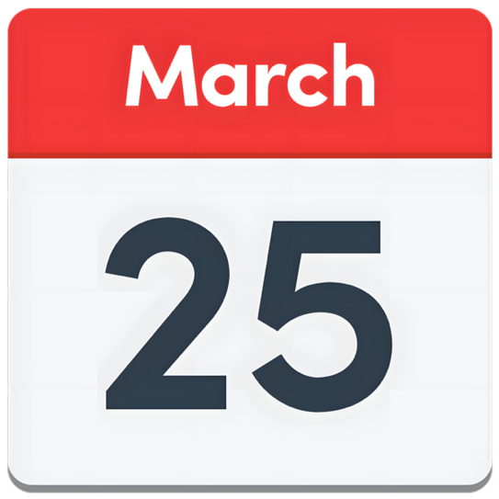
FestivALL is an exciting event for people with disabilities, carers and older people.

It is on Wednesday 25 March and Thursday 26 March 2026.

It is at the Foyle Arena in Derry.
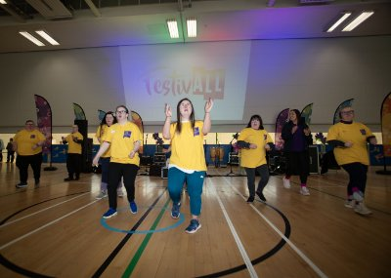
You can do fun things like:

- See music bands playing.

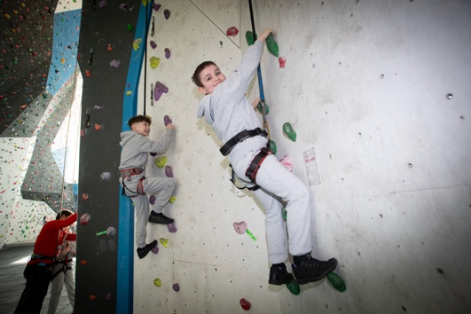
- Try some art, dance, sport or music.

- Do some games and competitions.

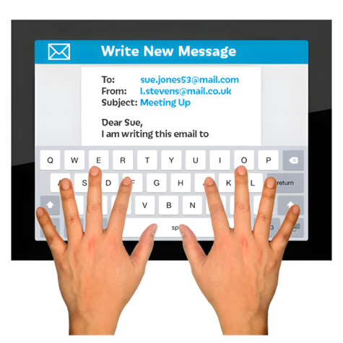
- Learn how to climb a wall.
You need to book a ticket for the event and some things at the event first.
Email Catriona Porter to find out more at:
Caitriona.Porter@derrystrabane.com

What you can do at the event

Wednesday 25 March

10.30am to 1pm

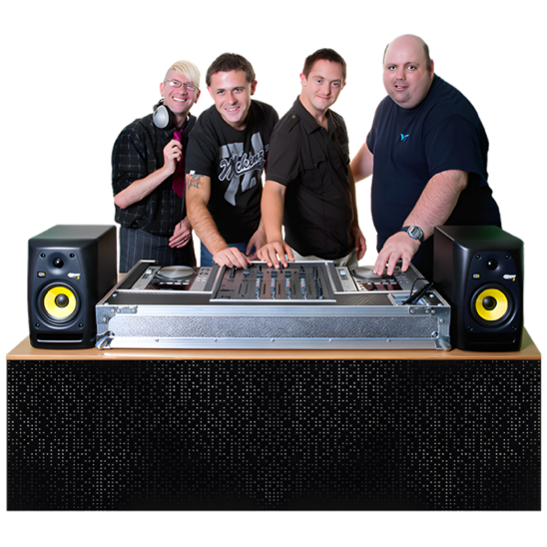
There are lots of things to see and learn from groups like:

- NW Spectrum Group and Destined

- Schools and colleges like Ardnashee Knockavoe and St. Brigid's


- ASpace2

- Jammz Crew who play music. They are part of the Tuned-In group.

- Music bands called The High-End Dead and Renegade Zoo.

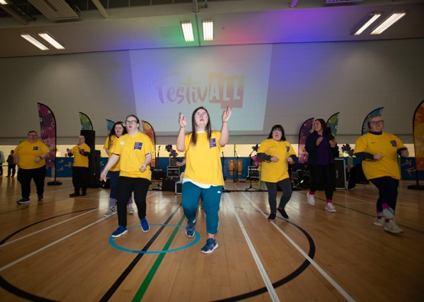
1.30pm to 3.30pm
You can try doing some dance, music, art and making things.
You need to book these things first.
They are called taster sessions.
Thursday 26 March

10.30am to 12pm
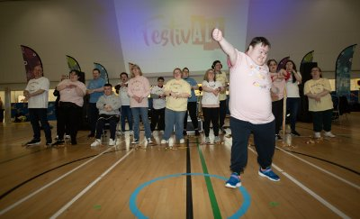
Take part in some games and competitions with your friends.

You need to be over 16 years old.

Games and competitions can be changed so that more people can take part.
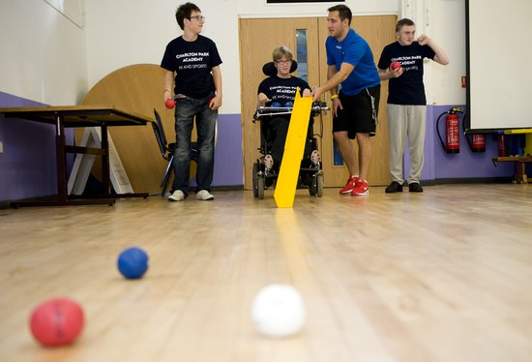

Or try playing Boccia. This is a sport you play in a team with a ball.

You have to be 10 to 12 years old.
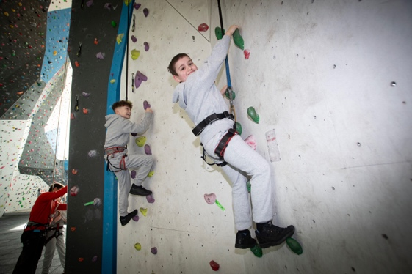

10am to 1pm

Try climbing a wall for fun. There will be people to help you.

There can be up to 12 people each time.

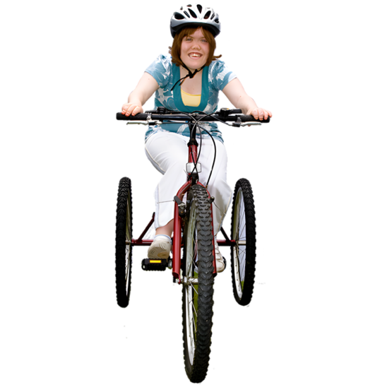
12.30pm to 1pm

Go for a fun and safe walk in St Columb’s Park.

12.30pm to 2.30pm


Try our bikes that are easier for people with disabilities to use. This will be indoors.

