Form of Public Notice to advertise an application for the variation of an entertainments licence | 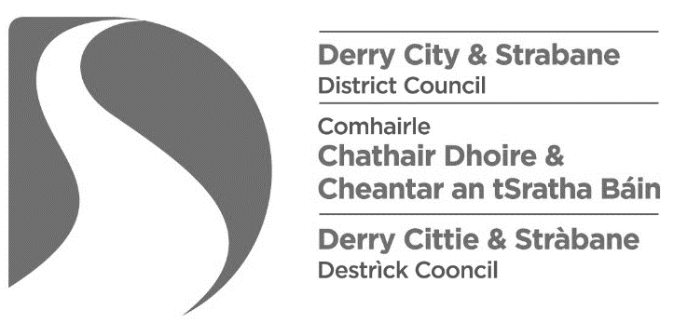
The Local Government (Miscellaneous Provisions) (Northern Ireland) Order 1985
Article 3 and Schedule 1
Notice is hereby given that I / we*,
[insert name & address of applicant]

have today applied to the Derry City and Strabane District Council for the Variation of the terms, conditions and restrictions subject to which an Entertainments Licence is held by me in respect of:
[insert name & address of premises]

The nature of the variation sought by me is as follows:
[Specify nature of the variation sought, e.g. to include another type of named entertainment]

Any person wishing to make representation in relation to this application shall give notice in writing to the Council, addressed to Licensing & SAG, Derry City and Strabane District Council, 98 Strand Road, Derry, BT48 7NN or email licensing@derrystrabane.com, stating in general terms the nature of the representation, not later than 28 days after the date of the application.
Dated this |  | day of |  | 2021.
 | [insert number] |  | [insert month]

Signed:
[Signature of applicant]
Note to applicants: The requirement to advertise in a local newspaper does not apply to an application for variation of an Occasional Licence for an educational institution or a church hall, chapel hall or other similar building occupied in connection with a place of public religious worship.

