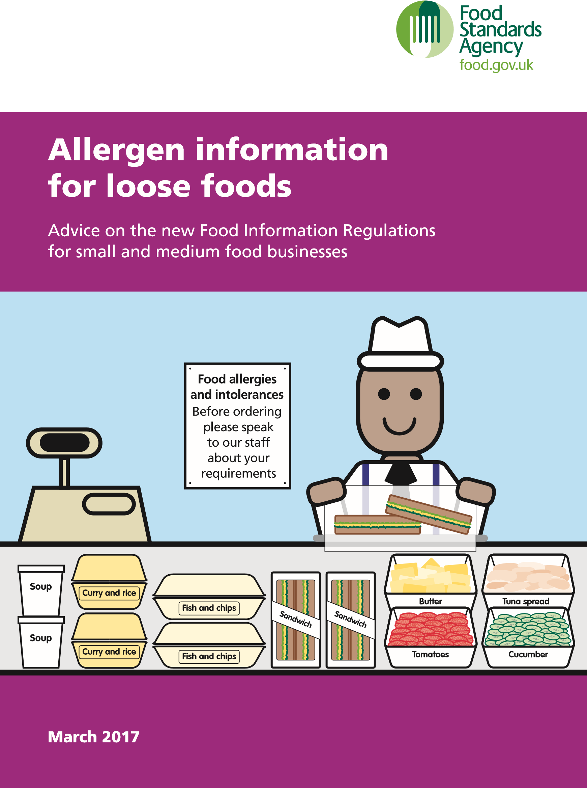
Contents
Introduction
. . . . . . . . . . . . . . . . . . . . . . . . . . . . . . . . . . . . . . . . . . . . . . . . . . . . . . . . . . . . . . .
1
New rules for loose foods
. . . . . . . . . . . . . . . . . . . . . . . . . . . . . . . . . . . . . . . . . . . . . . .
3
The 14 allergens
. . . . . . . . . . . . . . . . . . . . . . . . . . . . . . . . . . . . . . . . . . . . . . . . . . . . . . . . . .
5
How to provide allergen information
. . . . . . . . . . . . . . . . . . . . . . . . . . . . . . . . . .
9

Dealing with severe allergic reaction
. . . . . . . . . . . . . . . . . . . . . . . . . . . . . . . . . .
13
Dealing with allergen information: Your quick checklist
. . . . . . . . . . .
14
More information
. . . . . . . . . . . . . . . . . . . . . . . . . . . . . . . . . . . . . . . . . . . . . . . . . . . . . . . .
16

Introduction
There are big changes to the information that food businesses must give to their customers .
On 13 December 2014, the EU
Food Information for Consumers Regulation (EU FIC) came into force . These European rules are enforced in the UK by the Food Information Regulations 2014 (FIR) .
FIR changes the way you and your staff provide information to your customers . You can find out more about FIR here: http://food .gov .uk/science/allergyintolerance/label/
Who is this booklet for?
This booklet is for you if, for example, you:
●● provide meals in a café or restaurant
●● sell food that you wrap yourself, such as loose bread rolls, sandwiches, cakes, deli products or other unpackaged foods
●● provide institutional catering such as in schools, hospitals and care homes
During the preparation of loose food, you may be using prepacked foods as ingredients in your recipe . Allergenic ingredients will be emphasised within the ingredients list of prepacked foods .
Also, bear in mind that some products (such as tinned or dried food) have a long shelf life . It’s possible that you could see both types of labelling being used on these types of products for a few years after December 2014 .
If you want to know more about prepacked foods and how to identify allergenic ingredients contained within them, you should refer to the leaflet on prepacked food ‘Allergy: what to consider when labelling food’ which you can find here:
http://www .food .gov .uk/ multimedia/pdfs/publication/ allergy-labelling-prepacked .pdf

Why food allergy matters
Allergic reactions can make people very ill and can sometimes lead to death . However, there is no cure for food allergy . The only way someone can avoid getting ill is to make sure they don’t eat the foods they are allergic to .
If you work with food, it is important to take food allergy seriously . With the new FIR rules, you have a legal responsibility to provide the correct allergen information about the ingredients that is in the food you make or serve, to your customer .
IMPORTANT

The definition of loose foods
Prepacked foods refer to any food put into packaging before being placed on sale, when all of the following apply:
●● The food is either fully or partly enclosed by packaging
●● Cannot be altered without opening or changing the packaging
●● The product is ready for sale to the public or to a catering establishment . Loose or foods that are not prepacked describe everything else . This includes foods which are wrapped on the same site as they are sold, such as in a sandwich bar, bakery or from a delicatessen counter .
1

–

Remove
blue

safety
r
e
le
a
s
e
by

pulling
straight

up
w
it
h
ou
t
bending

or
twisting it.
2

–

Swing
and

firmly
push

orange
tip

against
outer

thigh
so

it

“clicks”
AND

HOLD
on

thigh
aoo
r
ox.

10

seconds

to
deliver drug.
3

–

Seek
eme
r
g
e
n
c
y
m
e
dic
a
l
attention!
Please note: For the purposes of this leaflet, we will be using the term ‘loose food’ to mean all foods that are sold not prepacked . This includes unpackaged food or food that is packaged on site (prepacked for direct sale) .
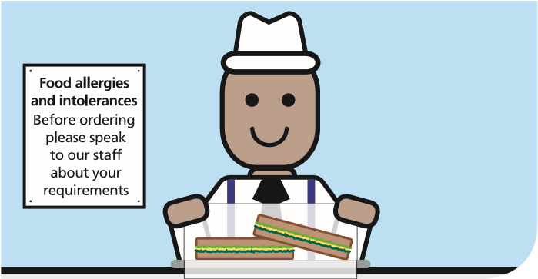
New rules for loose foods
The EU law has listed 14 allergens that need to be identified if they are used as ingredients in a dish . This means all food businesses need to provide information about the allergenic ingredients used in foods sold or provided by them .
There are also new requirements for businesses which are providing loose food, such as supermarket food counters, delicatessens, restaurants and takeaways .
As a food business serving loose foods, you will have to supply information for every item on your menu that contains any of the 14 allergens as ingredients .

How to provide this information
Details of these allergens will have to be listed clearly in an obvious place such as:
●● a menu
●● chalkboard
●● information pack
If it is not provided upfront, you will need to signpost to where it could be obtained, either in written or oral formats .
MENU
Egg sandwich
contains:
egg, wheat, soy and milk
Tuna salad
contains:
fish, celery and mustard
Chicken couscous
contains: wheat and celery
If the allergen information is provided orally there must be a way for:
●● this information to be checked by others (verifiable)
●● it to be confirmed as accurate
●● the same information to be given every time (consistent)
You can find more information about this in How to provide allergen information on page 9 .
IMPORTANT
Ignorance is no excuse
The change in the law means
that you will no longer be able
to say that you don’t know
what allergens are in the food
you serve . You are also not
allowed to say that all the
foods you serve could contain
an allergen .
You will need to know what is
in the food you provide .
MENU

Other ways of selling
If food is sold at a distance, such as through a telephone order for a takeaway, the allergen information must be provided:
●● before the purchase of the food is complete (this could be in writing or orally)
●● when the food is delivered (this could be in writing or orally)

The 14 allergens
There are 14 major allergens which need to be declared when used as ingredients . The following list tells you what these allergens are and provides some examples of foods where they may be found:
Celery This includes celery stalks, leaves and seeds and celeriac . It is often found in celery salt, salads, some meat products, soups and stock cubes .
Cereals containing gluten | This includes wheat (such as spelt and Khorasan wheat/ Kamut), rye, barley and oats . It is often found in foods containing flour, such as some baking powders, batter,
breadcrumbs, bread, cakes, couscous, meat products, pasta, pastry, sauces, soups and foods dusted with flour . The cereal will need to be declared . However, it is up to you if you want to declare the presence of gluten with this .
Crustaceans This includes crabs, lobster, prawns and scampi . It is often found in shrimp paste used in Thai curries or salads .
Eggs This is often found in cakes, some meat products, mayonnaise, mousses, pasta, quiche, sauces and foods brushed or glazed with egg .
Fish This is often found in some fish sauces, pizzas, relishes, salad dressings, stock cubes and in Worcestershire sauce .
Lupin This includes lupin seeds and flour, and can be found in some types of bread, pastries and pasta .
Milk This is found in butter, cheese, cream, milk powders and yoghurt . It is often used in foods glazed with milk, powdered soups and sauces .
Molluscs This includes mussels, land snails, squid and whelks . It is often found in oyster sauce or as an ingredient in fish stews .
Mustard This includes liquid mustard, mustard powder and
mustard seeds . It is often found in breads, curries, marinades, meat products, salad dressing, sauces and soups .
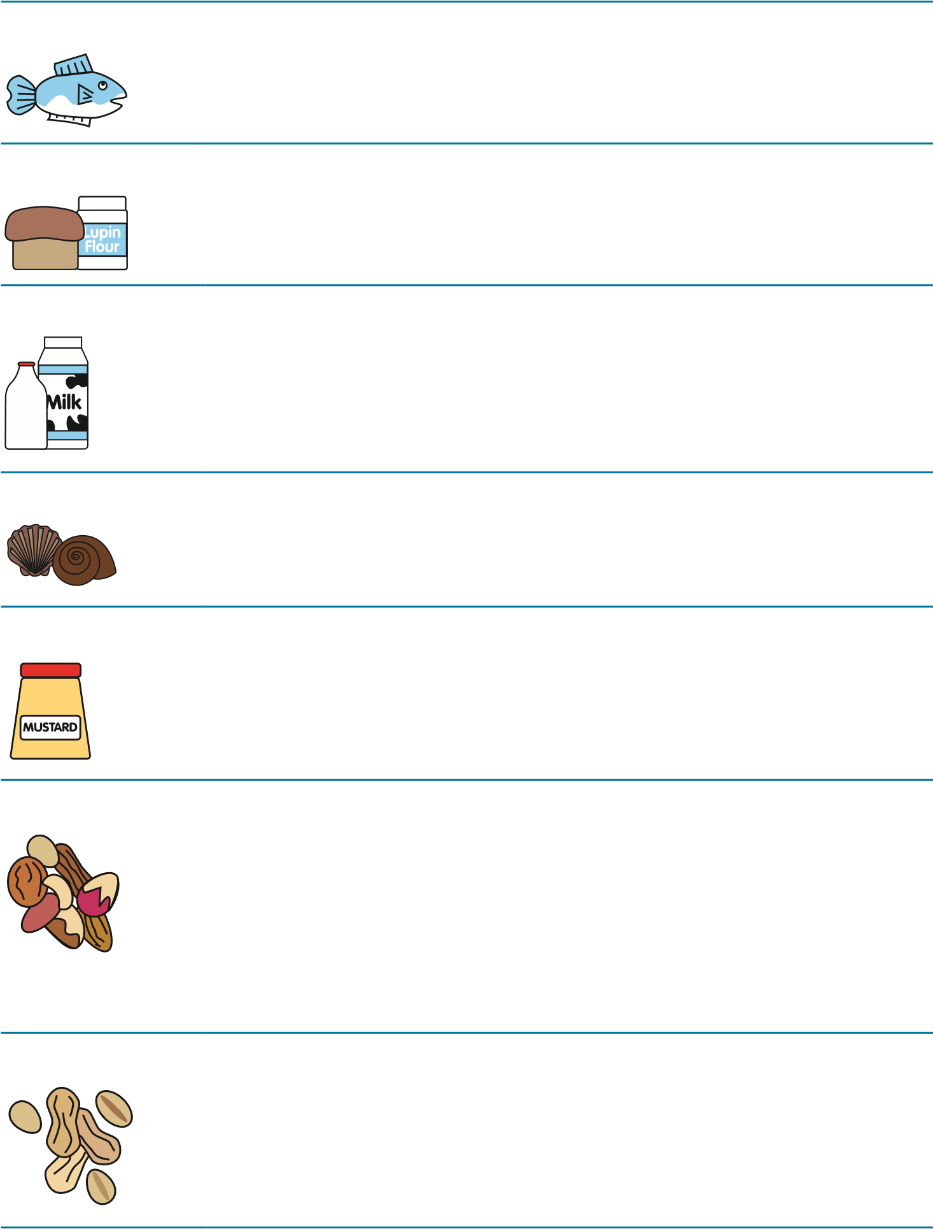
Nuts This includes almonds, hazelnuts, walnuts, cashews, pecan nuts, Brazil nuts, pistachio nuts, macadamia or Queensland nuts . These can be found in breads, biscuits, crackers, desserts, ice cream, marzipan (almond paste), nut oils and sauces . Ground, crushed or flaked almonds are often used in Asian dishes such as curries or stir fries .
Peanuts This can be found in biscuits, cakes, curries, desserts and sauces such as for satay . It is also found in groundnut oil and peanut flour .

Sesame seeds This can be found in bread, breadsticks, houmous, sesame oil and tahini (sesame paste) .
Soya This can be found in beancurd, edamame beans, miso
paste, textured soya protein, soya flour or tofu . It is often used in some desserts, ice cream, meat products, sauces and vegetarian products .
Sulphur dioxide | This is often used as a preservative in dried fruit, meat products, soft drinks and vegetables as well as in wine
and beer .

Recording information about ingredients
When preparing a dish, think about the ingredients you use in your recipe, and then carefully record the ones which are used in each dish.
If you are using prepacked foods as an ingredient in your recipe or as a meal, please remember that some products have a long shelf life. You may see both types of labelling (old and new) being used on these products for a few years after
December 2014. Always remember to read the label!
To help to identify which dishes contain allergens:
●● make sure that your kitchen staff use the same recipes every time
●● keep a copy of the ingredient information on labels of prepacked foods for example, sauces, desserts etc
●● ensure that containers are clearly labelled, for ingredients which are delivered in bulk, and then transferred or stored in smaller containers
●● make sure that staff are aware of where this allergen information is stored and how it is kept
●● ensure that the allergen information is kept up to date (for example, if recipes are changed or products substituted)
●● always check deliveries to make sure what is delivered is what was ordered. Ensure that the relevant labelling information is provided or is available with the order
●● make sure that any records are updated, to help trace back to the source of your information
●● keep ingredients in the original containers where possible, or keep a copy of the labelling information in a central place (either on paper or stored electronically)
●● check that the food delivered is the same brand that is normally used, as different brands might have different ingredients.
There are a number of ways in which allergen information can be provided to your customers . You will need to choose the method which is best for your business and the type of food you serve .

Keep staff trained and informed
Businesses should ensure, as a minimum, that all their staff are aware of the procedures and policies of the business when it comes to handling all requests for allergen information . All staff should receive some form of training on handling allergy information requests from their first day in the job .
How to provide allergen information
As a food business, it is your responsibility to know which allergenic ingredients are present in the foods you sell . Where you have a group of foods such as cereals containing gluten and nuts, you will need to say what they are; for example wheat and almonds .
Make sure the allergen information is accessible to all staff and that it is kept up-to-date . If you use part-prepared ingredients, make sure you know what’s in them and make sure they are clearly labelled . When handling and preparing foods, consider the risk of allergen cross-contamination .

Signposting allergen information
Where allergen information is not provided upfront in writing, signposting a customer to where they can get this information will be required .
Your sign should be where customers expect to find this information; for example where they would be making their food orders such as at the till point, on menu board, or on the menu .
Food allergies
and intolerances
Before ordering
please speak
to our staff
about your
requirements
?

Written allergen information
This can be provided on menus, menu boards or on websites, when selling online . For example:
●● Chicken Korma – Contains: Milk,
Almonds (nuts)
●● Carrot cake – Contains: Milk,
Egg, Wheat, Walnuts (nuts)

Allergen menu folders
Allergen menu folders that contain:
●● product specification sheets
●● ingredients labels
●● recipes or charts of the dishes provided and the allergen content could be used to communicate or aid communication of allergen information to the consumer .

Telling a customer about allergens
Allergy information can also be provided as part of a conversation with the customer as well as using any of the ways described above . You can also use methods you have devised yourself to ensure that the information provided is correct and consistent .
An example of a chart of the dishes provided and their allergen content
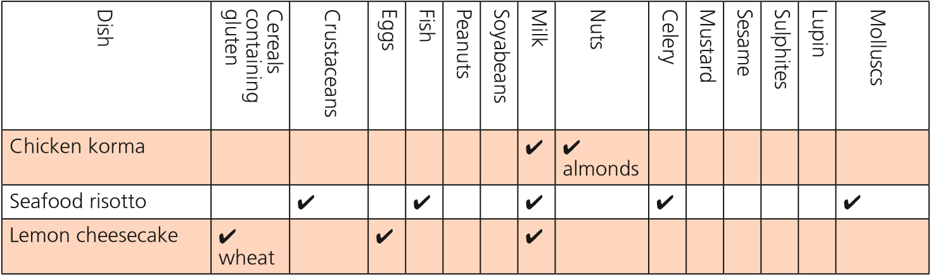

Effective communication
Effective communication among your staff, with the customer and with your suppliers will help to ensure that customers with food allergy are given accurate information .
Remember that customers use the information you provide about the allergenic ingredients in the dishes you offer, to make the final decision on whether or not to buy and eat the food you provide .
You will need to think carefully

IMPORTANT

Customers must play their part
Where a business says, on a signpost, that allergy information can be obtained by talking to staff, the customer also has a responsibility to ask for information and relay their dietary needs to the person providing the food .
about how:
●● you handle these requests for allergen information
●● you provide the information to your customer
●● your staff can access the information .

Gluten-free and no gluten containing ingredients
If you say that any of the foods you serve are gluten-free, please note that there are strict rules surrounding this . The foods that you serve to your customer that are declared as gluten-free must not contain more than 20mg/kg of gluten .
If you are making a gluten-free claim on a loose food that you sell, consider whether you have the required processes in place to prevent cross-contamination .
If you want more gluten-free guidance, please go to: https://www.food.gov.uk/ business-industry/allergy-guide/ labelling-of-gluten-free-foods
When someone has an allergic reaction to a food it is important that all staff should know what to do .
IMPORTANT

Warning signs
It is not always clear if someone is having an allergic reaction because other serious conditions can have similar symptoms . However, warning signs to look out for is if they are finding it hard to breathe, if their lips or mouth are swollen, or if they collapse .
If the above happens, this is what you should do:
●● Do not move the customer, because this could make them worse .
●● Call 999 immediately and describe what is happening; explain that you think the customer may be having a serious allergic reaction or anaphylaxis (pronounced anna-
Dealing with severe allergic reaction
fill-axis) . It is important to
mention the word anaphylaxis to ensure that the urgency of the situation is communicated and that appropriate medication will be available .
●● Ask the customer if they carry an adrenaline pen and, if necessary help them retrieve it . If a staff member or first aider is trained in administrating adrenaline and the customer is struggling to self-administer, then offer to assist them .
●● Send someone outside to wait for the ambulance while you stay with your customer until help arrives .
Dealing with allergen information:

Your quick checklist
- . When someone asks you if a food contains a particular ingredient, always check every time – never guess .
- . If you are selling a food that contains one or more allergenic ingredients, list them on the card, label, chart or menu – and make sure the information is kept up to date and is accurate .
- . Keep up-to-date ingredients information for any ready-made foods that you use (for example, ready-made sandwich filling) . The ingredients are usually on the label or invoice .
- . When you are making food, keep a record of all the ingredients (and what they contain), including cooking oils, dressings, toppings, sauces and garnishes .
- . If you change the ingredients of a food, make sure you update your ingredients information and tell your staff about the change .
- . If someone asks you to make food that does not contain a particular ingredient, don’t say yes unless you can be absolutely sure that none of that ingredient will be in the food .
- . If you’re making food for someone with an allergy, make sure work surfaces and equipment have been thoroughly cleaned . And wash your hands thoroughly before preparing that food . Control the risks .

Serving a customer who has a food allergy
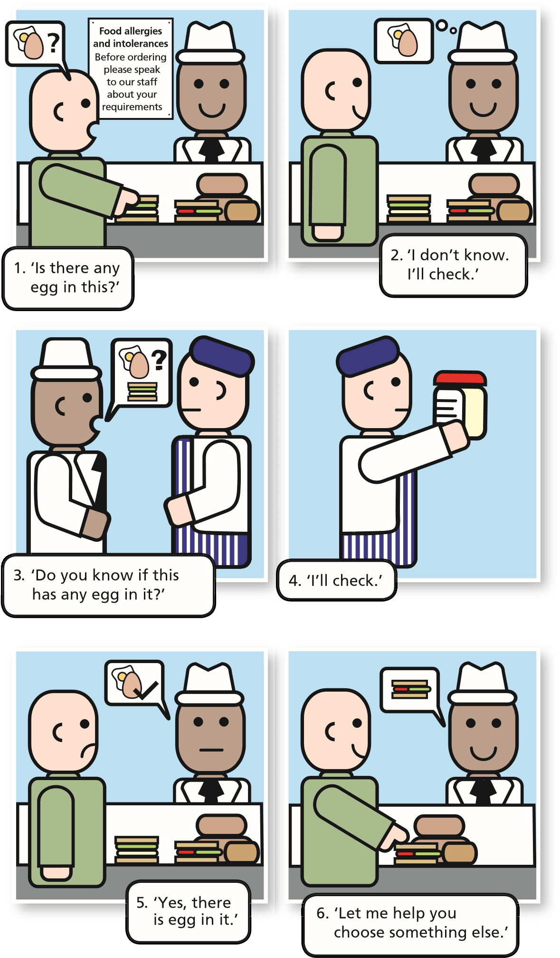
More information
●
●
You can find more allergen information and resources at
www .food .gov .uk/allergen-resource
s
●
●
Free online allergen training can be obtained on:
http://allergytraining .food .gov .uk
/
●
●
For information and advice about food allergies and
intolerances, visit the Food Standards Agency website:
www .food .gov .uk/allerg
y
●
●
For information on the EU Food Information for Consumers
Regulation 1169/2011 visit:
http://ec .europa .eu/food/food/labellingnutrition/foodlabelling
/
index_en .ht
m
●
●
For information on gluten, visit the Coeliac UK website:
www .coeliac .org .u
k

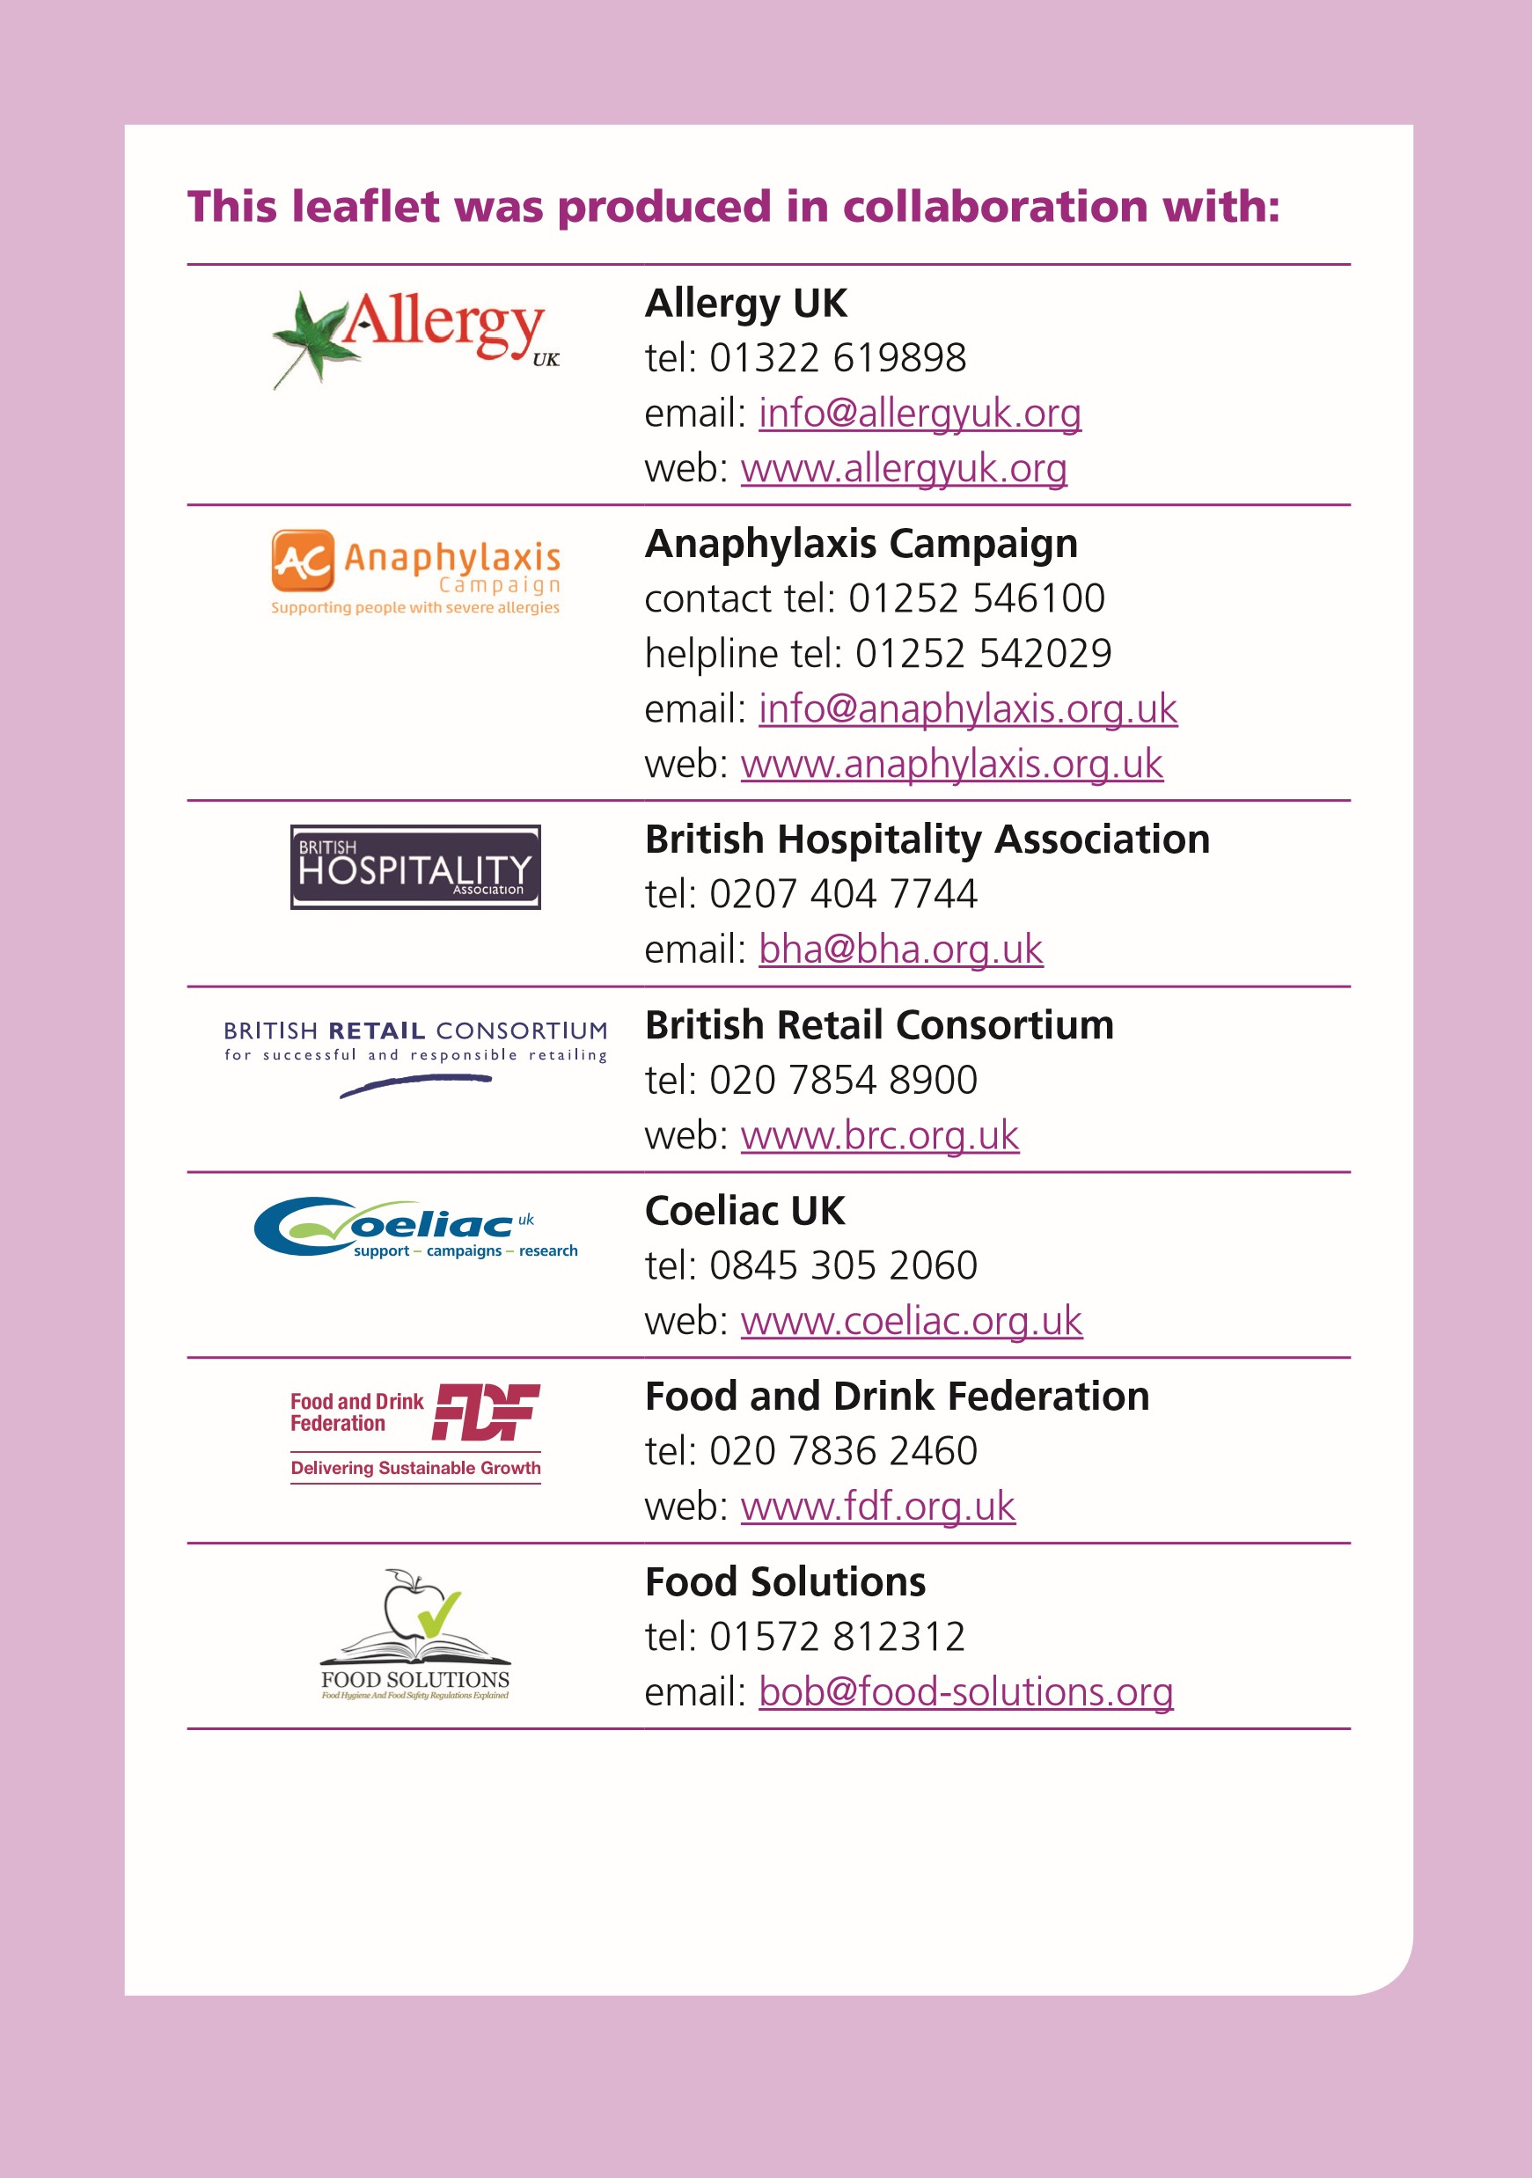
For further information and advice about food, or to download this publication, visit the Food Standards Agency’s website: food.gov.uk
Connect with us
Like us on Facebook food.gov.uk/facebook
Join our conversation food.gov.uk/twitter
© Crown Copyright 2015
Any enquiries regarding the use and re-use of this information
resource should be emailed to:
psi@nationalarchives.gsi.gov.uk
Published by the Food Standards Agency March 2015
Printed in England FSA/1735/0614
Watch us on YouTube food.gov.uk/youtube
Get our news by RSS food.gov.uk/rss
Get our news by email food.gov.uk/email
Scan our QR vCard to easily store our contact details in your smart phone

