PEACE IV Case Studies | A compilation of some the impactful projects supported by the PEACE IV Programme, the lessons and the consequence of them working on the Programme.
Table of
Contents

Introduction 1
Understanding the Decade of Commemorations 3
Growing Shared Spaces in Castlederg 6
Culture Fuse 10
Let's Talk Programme 14
Restoration of a Walled Garden 20
North West Ministry of Youth 23
Liberation from Patriarchy for Gender Justice 27
Don't Shoot My Wane…Shoot Me 31
Natural Connections - Peace Tourism 34
Take Back the Streets 38
Arts, Reconciation and Cultural Heritage Project (ARCH) 41
Connecting Communities Project 44
Waterside Shared Village 47
Beacon Project with YouthAction NI 50
Youth Leaders and Citizenship - Strabane Brass Band 53

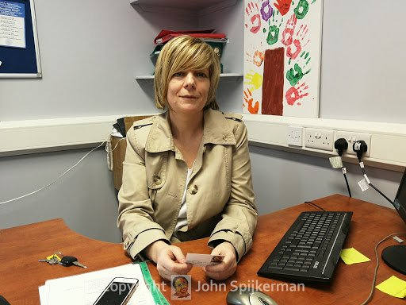
Introduction by the Chair of the Derry City and Strabane District PEACE IV Partnership

Alison Wallace

We are role models for our children and grandchildren, said one participant on a PEACE IV project.

The legacy we are leaving for our children and their children, of course, depends on what we teach them and what we encourage them to experience.

How the EU PEACE IV programme has affected this city and district over the last four years can only really be measured over time, as children and young people grow and mature – but if what we have witnessed is anything to go by, its impact will be transformational.

There are too many projects and activities to mention all of them. However, the 15 case studies included in this publication gives a snapshot of impressive, empathetic, ambitious, energetic and determined delivery – by the staff of the PEACE IV Partnership, by the projects and, most importantly, by the young people and participants.

These case studies give their own words and their own impression of their projects and the PEACE IV Programme.

In the last four years we have seen one of the first ever summer schemes to cross an interface. The young people who at the start were bussed across the interface ended up walking to and through each other’s areas.

St Patrick’s Day was celebrated in many mainly unionist areas while Ulster Scots activities, piping, drumming and dancing, were also enjoyed in many mainly nationalist ones. Thousands of people from all sides of the community came together for hundreds of events, and they enjoyed them.

In one project, 35 young people from Strabane Derry/Londonderry and Donegal took part in a special initiative – to start with they were terrified, said one youth worker…but the journey they have been on has been incredible to now see their confidence, skills and ability to speak out.

Another project, with over 200 young people from Derry City and Strabane District and Donegal, decided to take over the streets with performance and art. Self-confidence and being able to go anywhere were the themes of the project. We constantly wove this narrative through all the art forms…reclaiming our streets, our town…Make this town yours… stamp your identity on it…have courage and walk with your head held high said one of the activists.

In yet another project over 800 children were taught about their own and other cultures. By encouraging children to experience different cultures in a positive, creative and fun way, they became more open to engaging in a range of activities without any preconceptions or misconceptions, said one project leader.

We perhaps need to be better at involving the older generation – those who are caught and trapped in old stories, said one young participant.

These are just a few examples of what has been delivered through the PEACE IV programme across the district. Nearly 7,000 people of all ages and backgrounds have been directly involved and many more indirectly by attending events. Around 90% say they respect their own culture and identity more and have more respect also for the culture and identity of others. People, including our young people, are now better equipped to stand up to racism and sectarianism regardless of background or belief.

This is across the community. The programme engaged many more people from the Protestant and Unionist minority than some would credit – while the 2011 Census indicated 25% of people in the district were brought up from a Protestant background, 40% of the PEACE IV Programme’s 7,000 participants were brought up as Protestant.

A few words in a foreword cannot do justice to the thousands of hours delivered; or the thousands of people who benefited and whose lives will never be the same as a result. So please read the case studies for yourself.

Because of funding from the EU PEACE Programme this city and district has more role models, more young people skilled and experienced to be leaders in the future.

Our young people can reach higher than they think because they are not yet fully grown. Our job, as parents, educators and supporters, is to help them believe in themselves and understand that they can reach higher still as they grow and do more with their skills and experience, so that unlike previous generations this generation of young leaders can do better by all, for all.

  - Understanding the Decade of Commemorations

  - INTRODUCTION
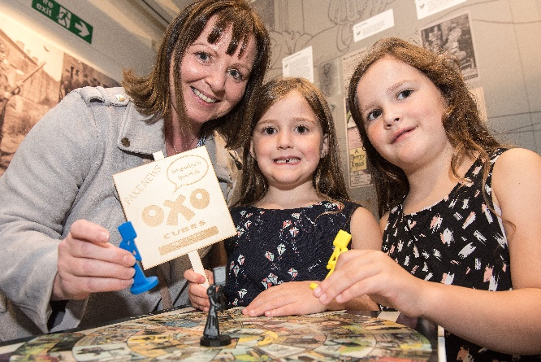
Understanding the Decade of Commemorations began in 2017 delivered by the Nerve Centre in partnership with the Tower Museum. The total cost of the project was £250 000. The range of activities included: delivering two exhibitions focusing on 1912-1922 period (WWI, General Election, Gender Equality and Suffrage) and 1920-25 period (Partition, formation of Northern Ireland, Industry and Labour movements); community education using creative digital skills; a cross-community outreach programme; and a series of events that included talks, music, tours, literature and drama. A final conference was delivered in February 2021 marking the end of the project.

  - WHAT WAS ACHIEVED?

Creating civic public spaces and opportunities where memories of the past such as artefacts are preserved, whilst at the same time providing opportunities for new responses to this past is an important indicator of a healthy society; a society where political equality is about bringing visibility to all stories. This project has clearly served to occupy and positively fill the public space, in the absence of any clear and coherent political leadership, as to how we should engage with the decade of centenaries and what it can teach us about shaping the next 100 years. The weave of historical archives and quirky facts, such as the 'fake news' of the OXO cube being a cure for Spanish Flu, with inviting people to explore their own creativity and art in using this material has been a very powerful approach.

The Nerve Centre has 20 plus years of experience in good relations practice, creativity and a strong legacy of audio-visual work. “Our key objective was to focus on the Decade of Centenaries and extend an invitation to delve deeper, giving people the tools to explore different perspectives. If the politicians can’t agree a common approach, then the political vacuum needs filled with something positive. We and other organisations such as the Tower Museum have been providing positive civic leadership." (Nerve Centre)

The project helped to make the people and the issues that had been made invisible by history, visible, bringing a renewed sense of public agency and purpose for the museum. The community engagement programmes developed citizens’ capacity to respond rather than react to that appearance. And whilst the concept of borders will always be a rich seam to mine on the island of Ireland, the combination of Brexit and COVID-19 also brought another depth to the discussions: the shifting borders of Ireland and Britain with the new border of our doorstep which accompanied the pandemic.

WHAT WAS LEARNED?

There has been a great deal of learning for the Nerve Centre, the Tower Museum and all the partners involved in moving programmes and exhibitions online. The experience over the last year will change how programmes in the future are delivered with a more blended approach to face-to-face and online work.

"The Slack Channel was a great communication medium with the posting of recipes, poetry, songs, personal stories etc.. We were lucky to move relatively quickly with COVID; 3-4 weeks and we were ready to go online. Overall, it has made us reassess our methodologies and we will sustain the idea of blended approach and engagement. Online can reach a much wider audience; it lets people engage in their own time with recordings posted. The Slack Channel allows people to comment and engage in their own time as well. For example, we had 188 participants at the Archive event last week – if we had held it at the Tower Museum at best, we would have got 20 or 30 people. Who wouldn’t shift to online?" (Nerve Centre)

There has also been a significant increase in workload as digital skills and capacity were grown.

"Our digital capacity was very low, so we’ve been on a steep learning curve moving our exhibitions online. In some ways when you are online you learn a lot more, develop more networks, meet more people." (Tower Museum)

There have also been clear downsides. Whilst a blended approach using digital technology allows the tracking of online access, less people got to see the Dividing Ireland exhibition. Online cannot replace the loss of the curated physical safe space where people can visually interact with artefacts.

"I enjoy watching where people stop at things, where they go, what interests them, how they interact with others. A digital exhibition is not a replacement for an onsite installation, but it can certainly complement what we are trying to achieve which essentially is to link with the community and help tell their stories. (Tower Museum)

The multi-disciplinary approach using digital technology, accessing and researching history and the creation and expression of art has been shown to be a powerful tool in giving people access to our layered and contested past. Working on such projects demands very precise and committed approaches to design, to history, to the materials and artefacts and above all towards surfacing the multiple narratives and layers.

There has been a very interesting mutual learning process between the museum and the many artists and makers that formed part of the engagement programmes.

"This last year has been wonderful with so many artists now connected to us and creative makers. We have built relationships with different audiences and allowed the artists and creative makers to start looking at our collections and museums for inspiration." (Tower Museum)

  - PEACE IV PROGAMME CONCLUSIONS

The 'outsourcing' of the administration to the Nerve Centre allowed the small team at the Tower Museum to get on with what they do best. There was also appreciation of the conversations and planning that took place in shaping the programme with the Peace IV team. From an administrative perspective, there was a degree of frustration with regards the 'rules' across different Council areas creating inconsistency and confusion. Whilst there was support for the tendering approach, more clarity could be developed as to the distinction of monitoring requirements between a grant and a tender. The challenges of 'unique' participants was also raised, particularly when there were so many projects all looking for young people more or less at the same time. It was also hard to keep young people participating over the 6-months period. Intensive programmes over shorter periods can have equally good, and sometimes better, outcomes.

Becoming cleverer and more effective with regards evaluation approaches that actually help inform programme delivery and answer 'where to now' questions was raised as an area for development. Finally, there was praise for the networking events that had taken place between the Peace IV projects with a suggestion that for Peace Plus, an interactive map be created with pins indicating the location of different projects, short summary of activities and contact details. This would remind groups and organisations of the bigger picture and purpose as well as enabling collaboration and mutual learning.

  - Growing Shared Spaces in Castlederg
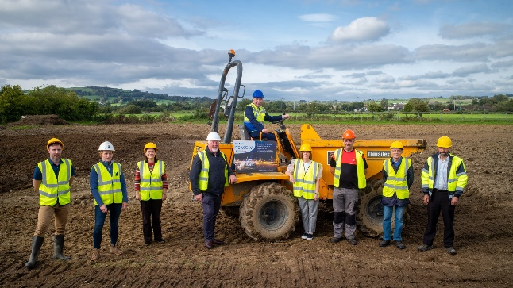
  - INTRODUCTION

The Shared Spaces Castlederg Project received £293,000 from PEACE IV. This consisted of a number of different strands of work including:

-The development, through community and stakeholder engagement, of a Green Infrastructure Master Plan for Castlederg to develop new shared-use green infrastructure and to improve upon the current offering. The first phase of master plan implementation will see 1.1km of new greenway delivered, supported by the Department of Agriculture, Environment and Rural Affairs (DAERA).

-The improvement of the pitches at Dergview FC and St Eugene's GAC by Derry City and Strabane District Council (DCSDC).

-The shared development and delivery of a programme of events and activities designed to animate the new Castlederg shared space area and support cross-community and cross-border participation. DCSDC commissioned RAPID Ltd to deliver this project element.

Castlederg is a rural town of many stories. A dominant story has been the legacy of the Troubles and how this has shaped and still shapes relationships, groups and community behaviour. Another story is a town of music and creativity, connecting through green spaces and the environment, and sporting traditions generating energy and new civic leadership. This Peace IV Programme was about investing and nurturing this story.

  - WHAT HAS BEEN ACHIEVED

An aspiration of the Peace IV Programme was to embed and sustain previous peace and reconciliation place-based initiatives as well as continuing to maintain the continuum of approaches from directly addressing the core contested issues such as flags, emblems and language to focusing on creating activities, spaces and structures that work towards bringing people together on shared issues and interests. This project has been more focused on the latter end with the overall ambition as set out by the Greenspace Infrastructure Master Plan of creating and enhancing green shared spaces in the town where people can connect informally and grow more positive relations.

At the time of writing, the capital works in both the clubs and the new greenway were still in process. A Steering Group was established for the pitches’ improvement as well as a Steering Group of 25 individuals/groups for the wider Greenspace Master Plan.
An audience development plan was conducted over 2018 to inform the development of the programme of events and activities which took place over 2019-2020. This has now been completed with significant changes required for some of the activities due to COVID-19. The range of activities included:

-Community history project
-Community dance project
-Horticultural programme
-Water based activity programme-
-Inclusive sports coaching programme
-Make your own kind of music event held in the Alley Theatre, Strabane
-Cross-community walking event.

Overall, 141 participants engaged with this programme.

The audience development plan (ADF) was led by Hummingbird Consultancy, sub-contracted by RAPID (Rural Area Partnership in Derry). It intentionally went at the pace that was appropriate for the many groups and individuals involved. There was substantial engagement, conversations and research conducted allowing collective decision-making process at the Steering Group level around where the resources should be allocated to determine a shared programme of activity and events.

  - WHAT WAS LEARNED

One of the challenges identified throughout the animation process was the absence of sufficient resources to support and sustain long term community animation and development work. The lack of adequate resources was an issue in coordinating and supporting the delivery of the programme, but it has also been an ongoing issue that has faced rural community development for many years. This can then place unrealistic expectations on volunteers.

"One of the core problems identified throughout the animation process was a lack of resource funding in the area. There are only small numbers of paid staff, with capacity still low and infrastructure weak. These factors combine in a manner which ensures the community sector lags behind other areas. All groups feeding into this ADP process highlighted the need for increased financial support. This was necessary for the following reasons: to provide a focused approach to community development locally; to ensure properly resourced activities could be delivered locally; to build local capacity and provide long-term sustainability to local actions; to ensure Castlederg and wider district is represented across statutory, community and business levels. The Mourne-Derg Strategy highlighted the fractured nature of community development through the animation process. However, there is an expressed will for greater integration and sharing, with the key community groups stating a desire to work on a partnership basis in the future." (ADP)

The focus on assets through this project, whether the assets of land or the assets held by people is important to recognize. Asset Based Community Development builds on the assets that are found in the community and mobilizes individuals, associations, and institutions to come together to realise and develop their strengths. This makes it different to a deficit-based approach that focuses on identifying and servicing needs. The energies grown by focusing on music, the environment and sports was a vital aspect of the project.

"We have a troubled history and have found ourselves economically on the edge. The river has been our fault-line, our dividing line. The two clubs never associated. It took this funding to finally see the potential of what surrounds us." (Participant)

An important counterbalance to fragmentation at a community level is place based civic leadership. This was evidenced through people's commitment to joining the different Steering Groups that were formed, their participation in the programme of activities as well as positions taken and the courage shown in public. Civic leadership consists of being curious about others, it's about persistence and clarity of vision, it's about developing the skills of consensus building and negotiation, it's about seeking to grow your knowledge beyond what you already know. All these elements were evidenced, and need supported and nurtured beyond project timeframes. It is also important to notice and value the new leadership that emerged during lockdown.

"Other issues considered as a challenge and acting as a barrier to peace building focused on current leadership models within the community, business and political sectors. There has been some change in leadership in the area in recent years that is still bedding down. Feedback received from stakeholders during the animation phase indicated a local aspiration that a more positive future lies ahead for the town and wider community. Local community voices highlight the need for less community division with a focus on commonality and activities/actions designed to bring people together and increase community pride rather than highlighting old issues which many are unable to change or have any power to control." (ADP)

Peace and reconciliation work is often referred to as the 'cha cha' dance: two steps forward and one step back. Wider politics can create chaos with fragile relationships and spaces. And yet, the history of places like Castlederg is that there is a resilience and commitment by so many citizens to keep moving forward.

"If we can get small steps along the way. Incidentally even. New infrastructure brings people together, year on year. My dream is that everyone in Castlederg can belong at any time, in any place – and that the small steps we’ve taken moves us towards this vision." (Participant)

"The physical links are there now. That’s the easy bit. The difficult bit is to keep people involved and behind this; creating spaces for people to meet and respect each other. But the two clubs can lead the way." (Participant)

  - Peace IV Programme Conclusions

The tendering process was a positive experience allowing much more flexibility and easier to administer. The support of the Peace IV staff as well as Jonathan Henderson from DCSDC who managed the project was also greatly appreciated. Issues to consider include the possibility of a pre-application development phase along the lines used by the Heritage Lottery Fund allowing the time to develop the plans and partnerships. The monitoring and evaluation tasks associated with the programme work were also onerous, off putting for participants and challenging for volunteers to deliver on. They required appropriate resourcing of personnel.

  - CULTURE FUSE

  - INTRODUCTION

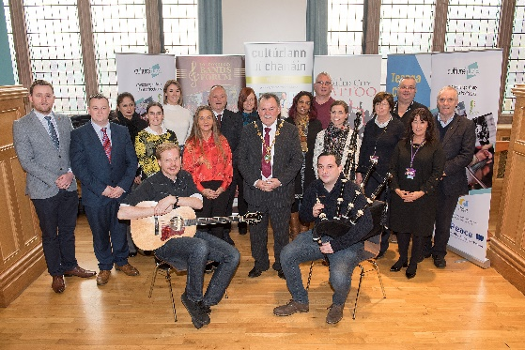
Culture Fuse brought together and celebrated the distinct and diverse cultural expressions found in the Derry City and Strabane District Council area and the wider cross-border region including the Irish language community, Ulster Scots and Marching Bands traditions. The development of Culture Fuse formalised and grew previous relationships and efforts between a number of key stakeholders involved in community development.

Droichead is a community-based project that developed in 2012 when Cultúrlann Uí Chanáin was the lead partner in delivering Fleadh Cheoil na hÉireann 2013. The strategic objective adopted by the Fleadh Cheoil na hÉireann Executive Committee in May 2012 was to make the 2013 Fleadh “inclusive of the entire community in the city”. This was achieved successfully and sparked a relationship with the Londonderry Bands Forum (LBF) that grew into a formal working relationship with the North West Cultural Partnership that includes the LBF as well as Bready and District Ulster Scots Development Association, Sollus school of Highland Dance, Sollus Cultural Promotions, Bob Harte Memorial Trust and Blue Eagle Productions.

This partnership then developed and delivered Culture Fuse.

  - WHAT WAS ACHIEVED?

The aim of the project was to promote cultural diversity, inclusion and peace through an extensive programme of activities. This included:

Women in Culture - Exploration of women’s contribution to cultural expression and the understanding of how they define their identity.

Language Initiatives - The delivery of Irish Language classes in perceived shared and neutral spaces, engaging learners from broadly PUL communities and other non-traditional learners.

Traditions Meet - The exploration of traditions, heritage and culture. This included but was not limited to music, language, history, dance and aspects of culture inclusive of PUL, CNR, Rural, Urban, Irish, Ulster Scots and ethnic communities.

Dialogue and Discussions - A forum for frank, honest conversations and debate and discussions on all the subjects related to the things that divide us. The project offered the opportunity for dialogue between those from broadly Unionist and Loyalist traditions and communities, those from Republican and Nationalist traditions and communities as well as Irish speakers.

New Gate Fringe Festival and Walled City Tattoo - This project supported the Tattoo to expand these cross-cultural performances to include more musicians, particularly from the local Irish traditional sector.

Mentoring & Advocacy with St Johnson's groups as a cross-border relationship building.

The total budget for the project was £175 000.

The commissioned independent evaluation by Dr Laura Bradley McCauley of the University of Ulster Business School of participant experience indicated that the largest number of participants out of those who responded to their survey took part in the Walled City Tattoo activity (61%) followed by Traditions Meet (22%), Irish Language Initiatives (10%) and Women in Culture (5,7%). Most participants completed the activities (94%). On average the programme exceeded expectations (62%,) whilst 30% of participants felt the programme met what their expectations were prior to commencing. A critical measure of success for this programme was the impact that the activities would have on participants everyday support for more inclusive and integrated communities.

Across three key areas of education, home and work the activities increased the level of support among participants specifically:

• 74% increased support for mixed religion neighbourhoods.
• 68% increased support for mixed religion/integrated schools.
• 74% increased support for mixed religion workplaces.

There was also an increased confidence in 74% of participants to challenge racism and sectarianism going forward. As the report concludes, "this is a profound outcome and another critical impact to be celebrated by the Culture Fuse team."

  - WHAT WAS LEARNED?

This project's biggest strength was its foundations. It was created from a successful engagement and relationship that was established from 2013. Trust is key for any engagement to work and this had been well established prior to the project starting.

"No one dominated. All parts were leading and equal. Often the PUL is seen as the weaker player – not in this project. We were able to challenge misconceptions around the PUL community and culture." (Culture Fuse)
This web of relationships helped create mediative opportunities and spaces with other individuals and places beyond this project.

The approach of using music and dance was very important at an individual level as people engage on the basis of enjoyment and fun. The establishment of friendships in an environment where people are perceived as culturally different but have formed friendships based on a shared love of music or dance exemplifies the potential that we all have of finding common links. Engaging with language can however be more problematic.

"There is still gatekeeping with regards the Irish language. Music and bands etc.. can be much easier. With the language, politics and the media keep the barriers up." (Culture Fuse)

We all inhabit different spaces: secret, private and public. There are always challenges in any social change projects about what people can say and do in their different spaces and with their different social networks. This can sometimes be very hard for workers when they see participants seemingly ‘back-tracking’.

"All we can do is invite people into experiences that give them more choices and different memories hopefully triggering the comment “I never thought about that before.” My expectations used to be world peace and now it’s “I never thought about that before.” (Culture Fuse).

An example of this is how gender relations function across these spaces. What might be seen as ‘acceptable' in a private space with regards women's cultural identities might not be 'acceptable' in a public cultural space, often still shaped by men.

Building and challenging relationships through cultural activities cannot just sit with the singing and dancing.

"It's what happens before and after the performance and the human connections and relationships that are built up. Projects have to be given the space, resources and time to grow from the performance." (Culture Fuse)

It's also important that cultural activities don't focus on 'observing the other' but shift the gaze inwards, to ourselves.

When reconciliation is based on equality rather than equity it can often compound differences. If you have an Irish dancer you need to have an Ulster Scots dancer; the 50/50 rule cements the two tribes.
"The monitoring and the funding and the whole system contradicts the objectives and what people are trying to do. We play the game and in the playing the rules are upheld and the system is maintained." (Culture Fuse)

As a sector, the reconciliation/good relations sector can be competitive as groups compete for limited resources. We need to be a sector that acknowledges that working with middle class communities is as valuable as working in economically deprived areas.

"We run on a shoestring and we need to support each other, encourage critical thinking and be generous to each other." (Culture Fuse)

An area that requires more critical thinking is the relationship between poverty and cultural identities, choices around engaging with a variety of cultural activities and how power can be exercised as a consequence of those choices.
"Those areas with very little resources have few options with regards cultural expression and life. They are offered a limited menu and they take it. In more affluent areas they can choose which cultural activities to go with." (Culture Fuse)

Sustaining the web of relationships and civic leadership grown over the last number of years between key organisations has been challenging during COVID-19 and the many lockdowns. This is in a context where political activity around identity, culture and the Decade of Centenaries has not stopped and where a strong mediative space remains vital.

  - PEACE IV PROGRAMME CONCLUSIONS

The importance of an existing strong partnership and preparatory public information sessions to better understand processes and requirements prior to applying was invaluable to this project. The tender process was also experienced as much more flexible and easier to manage than a grant. There was a recurring theme around needing more resources to manage the level of administrative accountability required through this programme. Droichead has also been doing a lot of work and thinking about monitoring and evaluation with a recent report 'Measuring Up' by Rubicon Consulting outlining their recommendations. It would be important that these are considered as part of any new Peace Plus programme.

  - LET’S TALK PROGRAMME

  - INTRODUCTION

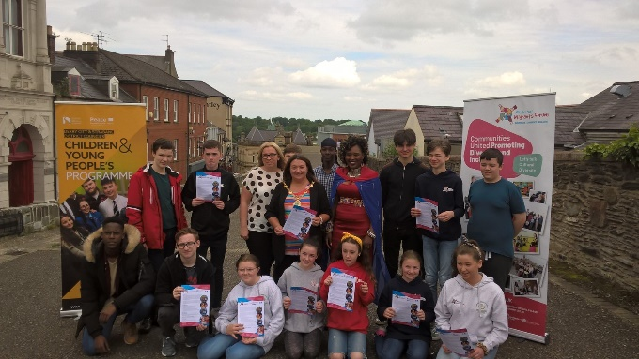
The Let's Talk Programme was a tendered programme focusing on engaging young people at secondary school level in four thematic areas: Gender Identity, Cultural Diversity, Disability and Health & Wellbeing. In total around 500 young people were involved across the four programmes with a total budget of approximately £188,000. Four different organisations successfully tendered with the project building on their existing work, focus and networks.

Gender Identity - Delivered by Rainbow
The main aims were to help young people, brought together from different communities, understand how gender roles and stereotyping may influence their sense of selves and life choices. This included discussing LGBTQ issues and the ways to combat some of the adverse effects of sticking to rigid ideas of gender.

Cultural Diversity - Delivered by North West Migrants Forum (NWMF)
This project built on NWMF's work in addressing ethnic, religious, linguistic and cultural divisions and invited participation from young people from all backgrounds.
"It allowed us to discuss politics in a respectful and inclusive setting. Talking politics in Northern Ireland can be contentious and intimidating for some. This project provided a platform for young people from different cultural and religious backgrounds to explore different identities, discuss controversial political and social issues in a constructive manner and to learn democratic forms of communication based on shared values." (NWMF)

Disability - Delivered by Destined
This programme provided support for marginalised young people with learning disabilities and those without to meet up and grow their knowledge of the culture of minority ethnic groups and learn to challenge prejudice, discrimination and intolerance. ·

Health & Wellbeing - Delivered by Kinship Care
Kinship Care's purpose is "to support children who cannot be cared for by their own parents to live safely and securely within their own families and communities." This project invited young people from all kinds of family and identity backgrounds to explore key issues such as Identity Alcohol and Drug Related Harm, Confidence and Self Esteem, Housing and Homelessness and Mental Health.

  - WHAT WAS ACHIEVED?

Each organisation used this project to connect and broaden the network of young people they work with supporting young people challenge being reduced to one identity or one label or box.

The project was also an important piece in helping to deliver wider strategies such as the We All Belong campaign running since 2018 and Hate Crime campaigns. In the context of homophobic and racist incidents and crimes rising in the Council area over this last year, such a project becomes even more significant supporting young people understand, notice and where appropriate challenge prejudice and discrimination.

A key achievement for the four organisations, to a greater or lesser extent, was rethinking their programme to take it online during the pandemic. This was particularly challenging for Rainbow as they hadn't started their project when the pandemic begun, as more time was needed with regards recruitment of young people. Maintaining relationships with young people during the past year has also been critical and the organisations’ collective learning around moving towards blended programming and the advantages and disadvantages of this with young people has been important.

"COVID has created massive issues for families and looked after kids. Grieving, poverty, social services pressure. People have demonstrated incredible kindness. But there is a tsunami of care issues about to land on us." (Kinship Care).

"We struggled to find new participants at the beginning – when we moved online and opened it up things started moving. Online was challenging in that some young people didn’t join in because it’s in the house; the worry about what their parents might say. Others weren’t allowed to join when the information went out to the schools. On the other hand, online you got the young people that wanted to participate." (Rainbow)

"The Covid-19 Lockdown impacted greatly on many of the vulnerable participants involved in this project, resulting in alternate means being used to present activities." (Destined)

All four organisations have grown and developed their learning and training resources which has been tested and developed with different young people. Collectively this provides a great resource for the Council, Youth Service and other youth related bodies to use.

"How do we share their expertise and skills with other youth workers. We need the four Let's Talk organisations to share their skills and learning with each other." (Rainbow)

Sustaining relationships following end of project either through an expanded Youth Club (North West Migrants Forum), a city side centre (Destined), online and through further programmes (Kinship Care and Rainbow) is a key achievement that characterises all four programmes of work. The relationships established during this year with key adults are and will be critical as we emerge from lockdown.

"We especially would like to thank our young people who made us laugh more than 1,000 times and our PEACE IV Coordinator for advising, guiding and supporting us along the way." (Kinship Care)

  - What Was Learned

Whilst it might seem self-evident it is worth repeating that youth led programmes where adults relinquish some power are those which are of most benefit.

"A steering group of 7 young people supported by project staff organised the residential including sourcing potential vendors, organising the venue and selecting activities to be delivered during residential days." (NWMF)

"We observed that we received more positive feedback from workshops as we encouraged young people to take the lead on these. We asked young people to share their opinions, we encouraged them to speak in front of the group or lead a ‘mini workshop’ to the group on a topic or message they felt was important for other young people to know." (Kinship Care)

"Knowledge is only a rumour until it sits on the muscle." The different approaches used by the four organisations shared a common characteristic of focusing on experiential learning as opposed to 'learning about' others.

"The Intercultural Dialogue approach we used throughout the delivery of our project activities cultivate trust, understanding and sustainable development through connecting people across cultures and sectors while building their knowledge, attitudes and skills to create fairer and more resilient societies. This we believe is an excellent example of good practice, methodologies or learning that may help future work for others." (NWMF)

"I never let anyone be an observer- everyone is a participant in any situation. Don’t just talk the talk, walk the walk." (Destined)

"The biggest strength of the Project was how open and honest young people were with each other. Young people had the ability to educate each other without belittling anyone which was refreshing to witness. Young people were also able to explain their backgrounds and beliefs to each other without fear of being judged." (Kinship Care)

"The programme made me realise it’s not just me, that my body is not broken, that who I am is perfectly normal. I no longer felt so terribly isolated. The programme was delivered in a way that made me feel comfortable." (Rainbow)

Inclusion by design is key. Whether it is the attention paid to the physical or online space ensuring that it allows young people to feel that they are safe and that they matter or thinking about the design of structures and institutions which often have power over young people. For example, Destined connected to Health & Social Care students from North West Regional College as potential care workers further down the line working with people with learning disabilities.

"Many of the Health & Social Care Faculty students from the North West Regional College have drifted into this area of study without really considering career options open to them. During the project they explored the roles of key health-professionals in the area of Learning Disability. Prior to their involvement the majority had never interacted with or had any direct life-experience of people with learning disabilities. Getting involved with us gave them a language to think and talk about career options. These students met kids in a different setting - they began to develop relationships." (Destined)

"With each group we had the conference room set up differently. The importance of preparation of resources, session and space. Then let the magic happen. We want people to say, ‘my house is just down there from the centre’. So many young people don’t know where they live in relation to others. We’re allowing young people to place themselves in their community." (Destined)

Many of the young people who were part of this project have experienced the dangers of a single story which reduces us to simple stereotypes and just one story about who we are. Whether it was a young person defined by their arrival in Northern Ireland as a refugee or migrant, or perhaps a young person defined by their learning ability, or the structure and shape of their family or their gender or their religion. As Chimamanda Adichie says, to connect authentically with a person is to connect with all the stories of that person. Each organisation in their programme had to balance both deepening the understanding of that 'single story' but allowing each young person to reclaim all their other stories. This approach led to some challenges with the monitoring and evaluation requirements.

"Young people commented that they ‘do not care’ about someone's religious background, and that by us asking them to identify in registration forms and in group scenarios that we were creating a problem of a difference that otherwise they would not see." (Kinship Care)

"There were challenges in recruiting young people from the PUL communities. There were also different challenges in recruiting young people from economically deprived and better off backgrounds. There are different pressures facing young people in deprived areas in their engagement with identity, with the police, with gatekeeping structures. Until the structures of education change, it is very hard to make lasting changes." (NWMF)

"We were educating people about kinship care –to move beyond embarrassment, to be able to talk about their family situation openly. And for others not to assume the perfect nuclear family. I think for the kids there are more important issues than being protestant and catholic– they just don’t care about such stuff." (Kinship Care)

Families figured in all four programmes with different approaches taken to include carers. The involvement of families was also a challenge, particularly for Rainbow.

"Northern Ireland is very good at sitting down and saying nothing. The older generation is deeply scarred by the Troubles and they have no room to consider other things such as gender. We need to work with older generations – to release them."(Rainbow)

There was deep appreciation from the organisations as to how the pandemic has tested the mettle of families and relationships and how this has placed so many young people in a vulnerable place.

Finding the right size for community relations and sectarianism was a struggle for all the organisations.

"A lot of young people didn’t identify as protestant or catholic. They were questioning their faith. On the other hand, it is still an issue in many areas and for many people. Young people need to have that conversation and we need to find ways of engaging with the gatekeepers who are stopping that engagement taking place." (Rainbow)

It is a very difficult learning path to shape with young people. On the one hand, many young people do not see issues of sectarianism as of any relevance to their day to day lives; there are other issues that are more pressing, and they are frustrated by the institutions and structures that seem to be operating from the past. For many others, their lives are constrained by this single story. The craft of finding the right place and size for these issues whilst also opening up to other stories characterised the Let's Talk Programme.

  - PEACE IV PROGRAMME CONCLUSIONS

The tendering process was experienced as positive, allowing the groups to take their time and work out what is possible. All commented on the support of the Peace IV staff and their flexibility, particularly when programmes were rethought in light of the pandemic. Some challenges faced included the unique participant rule. None of these organisations turned away young people if they had participated in another Peace IV programme but they ended up having to pay for the costs due to SEUPB regulations. The monitoring forms and accessing the tablets was seen as problematic. The forms at times excluded participants due to learning or physical abilities; being supported by an adult to fill them in was sometimes experienced as disempowering. The logistics of organising large numbers of young people when the tablets became available was also challenging. Finally, all four organisations expressed real interest in working with the Council to continue exploring effective and appropriate monitoring and evaluation methods.

  - RESTORATION OF A WALLED GARDEN

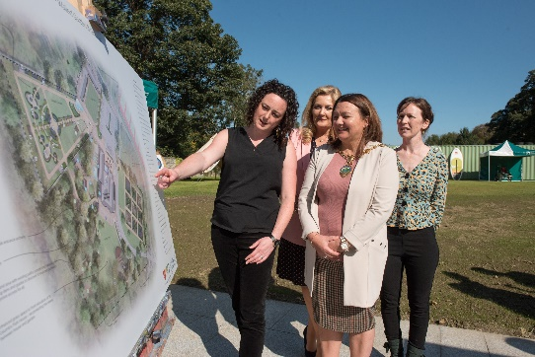
  - INTRODUCTION

St Columb's Park House recently celebrated 25 years of reconciliation and peace building work in the heart of St Columb's Park. The restoration of the Victorian Walled Garden, which lies at the back of the house, was identified as a priority in Derry City and Strabane District Council’s Parks Development Programme and the Strategic Growth Plan. This commits to protect and promote the natural and built heritage assets and develop local parks and green spaces. The project was delivered in close collaboration between the Council, St Columb’s Park House and the Acorn Fund. The project received over £370,000 through the EU’s Peace IV Programme for the completion of Phase 1 of the garden and a supporting programme of animation and peace building activity led by SCPH.

"The vision was the physical transformation of space – a derelict community space bringing back the history and ethos of a walled garden in a historic domain. The garden needed to be true to the history of the place and the people around it." (DCSDC)

"The experience of people walking into the Walled Garden and being blown away; it is such an attractive space to people of all ages and backgrounds and through listening to and involving people they surprise us with their ideas about how to shape the space that works for them and others." (SCPH)

  - WHAT WAS ACHIEVED?

The plans for the restoration project were developed by the partners prior to the funding being available. Once the funding was in place the construction and restoration work was relatively straightforward which included clearing the site, laying out the historic path network and the rebuilding and restoring of the Walled Garden enclosure. This took place over 2018-2019 with the official opening taking place in September 2019. The completion of the capital works then allowed the animation programme to begin, inviting people into the space to explore how they might wish to connect to it and grow a space where they could feel valued and safe. This one year 'taster programme' with a budget of £40 000 focused on a number of different areas including Health & Wellbeing, Young People, Permaculture, History. It employed one development worker for 20 hours a week with a target of 150 people participating for 26 hours each.

  - WHAT WAS LEARNED

It has been well documented that over this last year, shaped by intermittent lockdowns, there has been renewed interest and focus on our relationships with the rest of the natural world and the benefits of these relationships to our wellbeing.

"The pandemic has driven home to us how essential nature is to our wellbeing. We have been learning to appreciate what lies on our doorstep. Prior to the pandemic what SCPH did might have been cast as ‘touchy feely’. Now it’s become centre stage." (SCPH)

Dementia Engaged and Empowered in Derry and Strabane (DEEDS) was one of the groups involved in the animation programme whose members deeply benefited from the Walled Garden space.

" I have learned that being outdoors is vital for our health and wellbeing. I have taken green therapy across the organisation allowing people to understand that it goes beyond just a walk. So many care homes have no outdoor spaces and are so hot and claustrophobic. When I’m in one, I’m often gasping for breath. People closed in behind walls need the wind in their face and to feel the elements. When we are in the park, it always starts with a walk and then progresses. We forage, we observe. One woman, a very keen crafter and knitter stopped once to talk about how she was noticing nature’s patterns." (DEEDS)

Outdoor spaces can be places of conflict or reconciliation. St Columb's Park has been an area of anti-social behaviour and sectarian attacks and a great deal of work has taken place to ensure that it is a safe space for all to access. Using the reality and the metaphor of nature we can surface our need as human beings to have our own space to grow, and our interdependencies and connections. And as we recover our own place, we begin to understand how our economic system has led us to the limits of the Earth's carrying capacity.

The importance of understanding not only the history of people, a constant of peace and reconciliation work, but also how this history is connected to the history of the land itself. Land and the natural world is never neutral. St Columb's Park House and the Park have been shaped by the power of many institutions including the church, the military and the financial power of the families who lived in the house. The perspective of someone who carries the history of being excluded by these powers must be listened to and taken seriously otherwise nature-based work and environmentalism will remain exclusive. This project was about opening up the grounds to all communities and backgrounds as an important part of tackling the mindset of exclusion.

The relationship between the capital and animation phases of this project generates important learning. Traditionally the results from capital projects are much more visible and often seem more attractive in terms of investment. The investment in people is where the buildings, the parks begin to come alive, but it takes time if we are to shift from service delivery and facilities development to community development.

“No society has the money to buy, at market prices, what it takes to raise children, make a neighbourhood safe, care for the elderly, make democracy work or address systemic injustices. The only way the world is going to address social problems is by enlisting the very people who are now classified as ‘clients’ and ‘consumers’ and converting them into co-workers, partners and rebuilders.” (Edgar Cahn)

More than ever local authorities are struggling with the challenges of "ever-increasing complexity, growing demand for services, and continuing reductions in resources." Many Councils, such as DCSDC, have been reviewing their relationships with citizens and developing ways of working and operating models that begin with the strengths, skills and expertise that people have in their own lives. The evolving relationship between the Council and SCPH through this project offers important learning as to the possibilities and challenges ahead around the shared management and care of natural spaces and assets.

  - PEACE IV PROGRAMME CONCLUSIONS

The experience of managing a tender was referred to as positive by SCPH and both the Council and SCPH reflected on the value of ensuring that the development plans and partnerships are in place as a pre-application process. A challenge was ensuring sufficient resources to deliver on the development work required to meet the set targets as well as the administrative tasks. There was an overall reflection about the need to design a monitoring and evaluation system that responds compassionately to change and to the realities that participants’ lives change: some might find it hard to complete end of project surveys; some might have moved on; others might be unwell either mentally or physically following this long pandemic year. Without compassion built into a system, those trying to implement it and respond to it can face incredibly pressure and stress.

  - North West Ministry of Youth

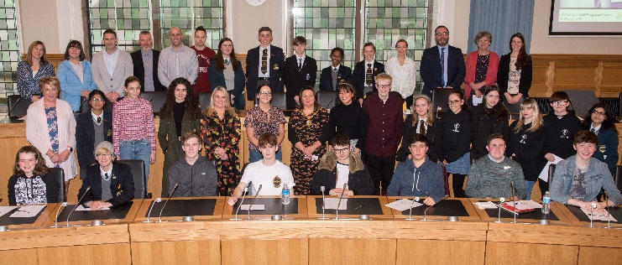
  - Introduction

The voices as well as the growth and personal development of young people across our society was the focus of Co-operation Ireland, the Education Authority and Pennyburn Youth Centre who worked together on this Peace IV Project from September 2019. The North West Ministry of Youth – Youth Voices Project was a local youth engagement project for young people aged between 14 to 18 recruited from Strabane, Derry and Donegal. Those involved became the voice for other young people providing a range of opportunities for youth to create change for the better.

The project received just under £80 000.

  - What was achieved

A participative structure was established made up of a diverse group of 35 young people aged 14-18 years, representative of each of the post-primary, special education schools and further education colleges.

“We’d had loads of career talks over 3 days, and this felt so different. I felt that this was the first time ever that something was being set up by young people for young people.” (Ministry of Youth Member)

All eight District Electoral Areas were represented on the first cohort with 2 cross-border representatives from Donegal. The project was launched in October 2019.

“A key memory for me was the first time the young people came together in Pilot’s Row, they were terrified out of their minds. The journey that they have been on has been incredible. To see now their confidence, skills, ability to speak out and presentation skills.” (Project Partner)

The young people had five months together, pre-COVID, growing their relationships, participating in training and engaging with elected representatives and Council officers. In early March 2020 they went on two-day study visit to Wales which turned out to be a significant turning point for young people and adults alike.

“We were asked at short notice to quickly prepare a presentation on our process and journey. The adults were trying to sort out a few things at that moment, so we had to let the young people get on with it themselves. And they just blew everyone away. The diversity of voices and their clarity and confidence was incredible. People were amazed that they had only been meeting since 5th October.” (Project Partner)

The trip to Wales opened up the space for what was possible and allowed the shift of the power from adults to the young people. From April 2020 onwards, there has been an impressive amount of online work done by the young people: the development of a Manifesto, participation in media interviews, City Deal, and campaigns such as the ‘Trousers for All’ leading to a motion passed unanimously within the Council Chamber setting out to change the school rules and allow young female students the opportunity to wear trousers if they so wish.

“The Trouser Campaign was phenomenal. And it has rippled out across the schools. Through a small Zoom conversation there started off a conversation about how unfair it was that girls had to wear skirts all year round. And it rippled out from houses, into the street and then into the classroom.” (Project Partner)

It is important to note that the bulk of this work has been conducted online as the project shifted to mainly Zoom. It is even more of a credit to the young people that they were doing this whilst their own lives were being transformed by the pandemic, with many of them taking on new roles in the home. The role of the supporting youth workers in making the online experience work for the young people was important, particularly as everyone was learning and thinking on their feet.

“During the beginning of COVID, nothing else was happening. This kept me going – the only thing that kept me going.” (Ministry of Youth Member)

In addition to what was achieved in the project, there have many ripples as the young people in their own areas take on projects as well as learning within the EA with other statutory agencies as they grow the Youth Voice structures regionally and at a local government level.

  - What was learned

The willingness to keep things going despite Covid and the working relationships that developed between the key practitioners (those that delivered and facilitated sessions) involved was noted as a key strength of the project.

A distinctive feature of the North West Ministry of Youth was that there was a greater shift of power from adults to the young people. There was clarity with regards the levels of participation and the young people’s ambition. The project opened up understanding around the different levels of engagement, what is possible and what the dream is. But to sustain this shift of power to young people requires structural changes in hierarchies, ways of working, assumptions, power structures within institutions, and resource allocation.

The ‘what if’ and ‘why not?’ attitude of the supporting adults was critical.

“Our recipe was teamwork and being able to bounce off each other. We also had great leaders who just kept saying, go for it. Give it a go.” (Ministry of Youth Member)

This kind of entrepreneurial outlook does not necessarily sit easily with the culture of many statutory organisations and in particular financial processes and it is credit to the partnership that it became so much part of the culture of this project.

A strong partnership grew between the youth workers of the supporting organisations. Investing in these relationships at the start, building trust, ensuring shared understandings and clarity on roles created the space for the young people to grow and flourish. Without this investment in relationships between adults, the space for the young people can quickly be one of control as opposed to ‘letting go’.

The North West Ministry of Youth has been treated with a greater level of seriousness and respect that many previous youth engagement structures have been. There seems to be a number of different reasons for this including the nature and strength of the partnership, as well as the creation of a formal structure with departments that reflected the areas of responsibility within the Council. This allowed a mirroring of the adult structure and a formal engagement with key areas of responsibility. However, the NW Ministry of Youth did not just reflect the Council structures, it also offered a different way of making decisions.

“Whilst there were departments, the young people jumped in and out of departments if others needed help, were missing or sick. Each young person could talk about all departments. They understood the full picture.” (Project Partner).

  - Peace IV Programme Conclusions

This project was Council led sub-contracted through a tendering process to Cooperation Ireland working in partnership with the Education Authority and Pennyburn Youth Centre. The nature of this partnership was vital to the success of this project with a clear accountability path back to the Council in terms of taking the young people seriously. Post Peace IV funding, a new cohort of young people are being recruited now with the project supported by the EA, Pennyburn Youth Centre and the Council. This will require ongoing resourcing and investment to ensure that the North West Ministry of Youth does not slip back down the participation ladder and that the young people continue to dance to their own tunes. Finally, a plea was made with regards the development of monitoring and evaluation surveys that are relevant and appropriate to young people.

  - Liberation from Patriarchy for Gender Justice

  - Introduction
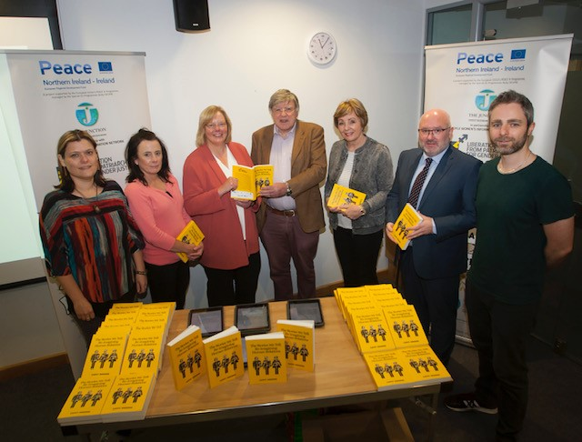
This Junction Project on Liberation from Patriarchy for Gender Justice developed out of a previous Junction programme, on Ethical and Shared Remembering 1912-1922. This explored how we remember and commemorate significant centenary events in an ethical and inclusive way. As this programme was being delivered out, one of the key themes that emerged was that of patriarchy as a foundational issue that required much more exploration and understanding if the ambition of peace and reconciliation was to be achieved.

“Peace IV funding enabled the development and delivery of a project which provided participants with a language and framework to identify and understand how patriarchy and patriarchal systems work. The hope is to empower participants, through knowledge and understanding, to identify strategies and actions that will help transform patriarchy into gender parity, equality and justice.” (Education and Training Programme Manual)

The project was informed by an intersectional approach recognizing patriarchy as a system intersected with other oppressive systems, including sectarian and racist systems. If we use the metaphor of an onion to understand intersectionality, then the premise of the project was that patriarchy is the first skin of the onion, our most intimate layer of division, injustice and inequality. One of the definitions used by the project to describe patriarchy is from Carol Gilligan and Naomi Snider, American academics.

They explain patriarchy as
“…a culture based on gender binary and hierarchy, which results in the division of human qualities and capacities as either ‘masculine’ or ‘feminine’, with the masculine privileged as superior; and the elevation of some men over all men, and all men over women.”

This was one of a number of definitions used by the project with the premise that a multitude of definitions and ways of knowing is part of dismantling a patriarchal system.

  - What was achieved

There have been a number of components to this project including:

-The Stories We Tell, a publication emerging from interviews with 28 contributors offering insights into gender justice and patriarchy.
-An education and training resource for educationalists, facilitators and trainers.
-The delivery of two Training of Trainers (cross-community) gender based programmes.
-The newly trained trainers delivered six community education programmes with the Junction delivering another four.
-Two conferences held.
-The dissemination of the resources and key messages to wider audiences including the Equality Commission, the wider women’s sector and key influencers such as Monica McWilliams, Mary McAleese, Avila Kilmurray, among others, with a demand for workshops on patriarchy from groups and organisations visiting the city including international study groups and delegations.

“This project was not about giving simple or easy answers. It was about giving people access to information so that they can become change agents in their own contexts. If participants on the education and training programme learn something that they did not know before about patriarchy, if they hold onto the vision of building peace between people and for the sake of the planet, then the programme was doing its job and transformation will happen.” (Education and Training Programme Manual)

  - What was learned

The importance of an intersectional approach in supporting people make sense of the layers of their identity and how those layers can work together to deepen the experience of exclusion. For example, being a woman, being from a minority, being black, being a lesbian, being a wheelchair user, all individually can bring experiences of exclusion and injustice. When these form the layers in one person then the way these multiples forms of oppression work with each other need understood for any meaningful change to happen.

“In both the education and training programmes and roll out courses one session in particular elucidated the importance of an intersectional approach. One of the participants on the programme, who met with many of the roll out groups to share her experience, was a woman with a transgender history. She helped others to appreciate how she had suffered abuse and mental anguish because of the binary model of sex and gender endorsed by patriarchy. Participants were introduced to new scientific and biological understandings of the human genome in the field of genetics, which have positively complicated a binary understanding of the human as either man or woman, and male or female. Hearing someone share her story of gender dysphoria created the space for participants on the programmes and courses to discover more liberating and inclusive understandings of humanness.” (The Junction)

Sexism, sectarianism and racism are all socially constructed systems, they are not natural or innate conditions of humanness. In fact, they dehumanise everyone: the ‘victim and survivor’, the ‘perpetrator’ and the ‘colluder’.

“Our biggest challenge is how men can be invited into this conversation and allowing them to realise that dismantling patriarchy is not an attack on them, that it dehumanises them as well, and that we need each other if we are ever to change this system.” (Participant)

The community education model used by the project remains a powerful approach to effect individual and community change. Through offering statistics, stories, the latest research, powerful speakers and creativity participants begin to see what has been normalised and stitched into the fabric of our lives and begin to put words on what has been felt and experienced.

“We are never done learning about this issue – it informs every part of our lives. It affects us all and is stitched into the most intimate fabric of our lives. To unpick the seams is incredibly difficult – to make sense of it. You think you’ve grasped it and then it escapes you again. The key thing is to have a glimpse of what it means – once you’ve seen it you can’t unsee it. Then to name what you have seen – the power of language. If you can’t name it, it can’t exist. It’s about knowing, seeing, naming.” (Participant & Trainer).

This roundtable leadership approach is an alternative to the top down and authoritarian style of patriarchal control, which the programme critiqued. The educational content and methodology worked in tandem to liberate participants from patriarchal conditioning.

Creativity and the arts allows the learning about what are sometimes deeply dark moments of our own history and the history of human being across nations and cultures to be generative.

“A key moment was when a participant, horrified by the role of science and medicine in propping up and legitimising the oppression of women, went away and created an incredibly funny sketch. She didn’t think she could be so funny. To turn something so dark and awful into a hilariously funny sketch was magic. It invited more people into the space as well as allowing the healing power of laugher to work.” (Participant & Trainer)

As we make comedy, we take our power back. As we learn that everything is about stories, we can create agencies and possibilities. Stories can be retold.

The nature of violence is that it shifts and moves across different spaces of our lives. What is learned and experienced in the home can shift to the streets, to the pulpit, to politics, to schools or to the place of work. How violence works in each of these spaces is distinct but also deeply inter-related. Post Covid, we need to think bigger and deeper. Peacebuilding requires bigger thinking, more inclusive understandings and language that particularly appeals to younger people

The absence of a devolved government over the duration of the project impacted on the ability to advocate on the learning generated at an Assembly level.

“If we had a Stormont we could have targeted and lobbied. The continuous instability of government is a key factor in Northern Ireland. If we had stability politicians would be able to seriously deal with serious issues.” (Project Leader)

  - Peace IV Programme Conclusions

There was deep appreciation of the Peace IV staff team for their support and encouragement with this project. The use of a tendering process rather than grant was also seen as positive. The ask was around the monitoring forms which seemed to have nothing to do with the project with many participants expressing discomfort in filling them in.

“You develop layered understandings of your identity and then the system and bureaucracy reduce them to one-dimensional again.” (Project Leader)

The project had to develop their own forms to gather useful data. In addition, the time needed to chase people up to fill in the Peace IV forms was extensive. The challenge of Peace IV’s requirement of ‘unique participants’ was also raised with the project having to cover the costs of participants who had already participated in another Peace IV project. There was a final important reflection on the Peace IV administrative system.

“So many of us engaged in peacebuilding work are trying to work with compassion and generosity with each other, knowing that systemic change can only come about through open collaboration based on trust rather than empire building.” (Project Leader)

It would be interesting to explore whether Peace Plus might introduce a new horizontal principle: working with compassion and generosity across the system. The implementation of this principled approach would encourage more women into leadership and contribute to the dismantling of the patriarchal model and mind-sets.

  - Don’t Shoot My Wane…..Shoot Me

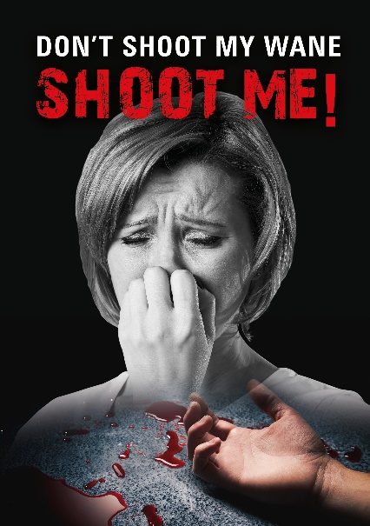
  - Introduction

The "Don't Shoot My Wane! Shoot Me!" Project was delivered by Greater Shantallow Community Arts. It was about informing, challenging and creating the space for deliberative conversations to take place on the issue of punishment attacks and their impact on communities across Northern Ireland over the last 40 years. It did this through the medium of participatory theatre with a vote cast at the end with regards whether a punishment shooting should proceed. The play was also recorded into a film that has been widely distributed. The project applied as a grant under Peace IV and received just under £50 000.

  - What was achieved

Using real stories and experiences from research on punishment attacks, through drama and devising workshops with 56 participants the narrative was consolidated into an immersive drama production. The final script was developed in such a way that the story line and the names of the characters could be set in any community.

Based on the form of a debate, the performance centres on a meeting which is being held in the local community centre to discuss concerns about an elderly woman who has been assaulted in her home and whether the alleged perpetrator should be shot.

“Centred around a mixture of raw emotion, outrage, fear, honesty, despair, and good-natured banter, a thought-provoking story unfolds.” (Post-Project Evaluation)

The production ends with the audience having to take a vote as to whether they agree with the shooting going ahead or not. The collated vote at the end of the four performances by audience members of all ages, religions, and cultures from throughout and outside of the city, was 89% - No, 11% Yes.

The filmed documentation of production has also been distributed as DVD and online to schools and community groups.

  - What was learned

This production carved out the space for deliberations and discussions around a very difficult topic. The story personalises the issues and allows the audience to step back, hear different perspectives, understand the consequences of different actions and thereby reach a more informed response.

“It was about moving beyond the ‘condemming’ and ‘deserving’ responses. To hear the back story. It wasn’t about endorsing criminality or endorsing paramilitaries – there is a rationale for all perspectives in the history of Northern Ireland’s conflict.” (Project Staff)

The ‘private’ stories and experiences collected through the research were woven into a ‘public’ story that was performed in four different community venues across the city. It took a great deal of courage to shift from the ‘private’ to the ‘public’ space and shift people from the cultural scripts that we are expected to follow.

“The story is that a certain young fella is going to get shot. We were very nervous whether we would get away with it. Real emotion involved – one of the participants was a mother whose son had died. Then we had the social worker who had a back story. We discover that there is more than one victim in the room.” (Project Staff)

All sides of the community were involved in this project and relationships were formed among the participants that were unexpected and potentially long lasting.

“One of the final output performances was held in Caw Youth Centre which is perceived as being located in a Protestant community; within this setting we had numerous friendships transpire between both sides and have had members from the Catholic community attend the performance and then to return to the Caw Youth Centre to partake in further cross community events and vice versa, to have members from the Protestant community travel to Pilots Row based in the predominately nationalist city side of Derry City and to sit and form friendships with participants from the Catholic community. This unexpected forming of friendships, the interest in finding out about each others culture, habits, routines etc was an eye opener for our creative team and a pleasure to watch grow and flourish.” (Post-Project Evaluation Report)

The invitation at the end of the performance was to vote in a manner that would show the best that we can be as human beings and as a community.

  - Peace IV Programme Conclusions

The hard work and dedication of the Peace IV team based at DCSDC was very much valued by this project.

“They were a pleasure to work with and always very approachable and eager to address any issues that may have occurred during the life of the project.” (Post-Project Evaluation Report)

  - Natural Connections: Peace Tourism

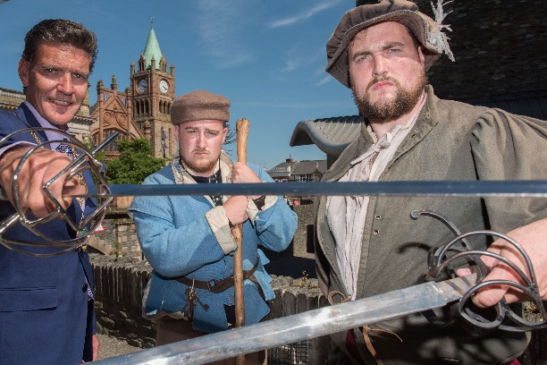
  - Introduction

This was a Council led project connecting citizens and groups across the city from different cultural heritages, backgrounds and experiences to develop a community led tourism offer for the local and international tourism market. The offer were the stories and histories of conflict and reconciliation that have shaped the city. The intention was also to contribute to the financial sustainability of the groups involved.

“Among the objectives of the overall project is allowing Derry City and Strabane District Council (DCSDC) area to position itself as a place for community, local, regional and international field trips and residential and training/awareness experiences for the benefit of dialogue and peacebuilding.” (https://acityforpeace.com)

The project received £318,805.

  - What was achieved

There were a number of strands to the project which were amended in response to the pandemic context. These included:

-The establishment of a Steering Group of around 20 community-based groups and organisations from across the city wishing to grow their community led tourism provision.

“The relationship with Council and with each other as stakeholders has been invaluable. To be part of and connect to wider networks. This will last well beyond the Peace IV funding.” (Project Staff)

“The ingredients of this project’s success was the collaboration and the diversity of groups. This project brought people together through sustained engagement of 26 hours over 26 weeks and it worked.” (Project Participant)

-A Development Programme to grow the skills and confidence of those wishing to become community led tourism providers. This included: the funding of minor infrastructure such as Museum Archival software and an audio system to help with presentations in the Free Derry Museum; an audio tour guide system to help facilitate tour groups at the museum, and also incorporating visits to the Derry Walls and Walkers Plinth; audio tour guide systems to facilitate tours focused on St. Columba across the city by the Churches Trust; re-plastering and restoring Free Derry Corner with the Gasyard Development Trust. There were also a number of conferences, a trip to Dublin and training programmes on themes such as marketing, tour guiding, signage, cataloguing and caring for artefacts.

-An Animation Programme linked to eight key areas including the City’s Walls and significant shared spaces.

“The animation programme enabled local, regional and international visitors to explore the often contested stories on or around the Walls. The animation allowed our communities and visitors to step back in time and discover our contested history through the implementation of innovative animation and interpretation. The main venues and shared spaces used to facilitate the animation included Derry’s Walls, St. Columb’s Cathedral, Siege Museum, First Derry Presbyterian/Blue Coat School, St. Augustine’s, Guildhall, Tower Museum, Guildhall Square and Museum of Free Derry.” (Post-Project Evaluation Report)

-The development of a brand with three experiences and pilot packages created: Crucible City; Walled Town; Island of Derry. Website https://acityforpeace.com.

“It is hoped that the brand will be incorporated into future marketing, which can showcase the experiences developed as well as the improved offerings from members of the steering group, as well as working toward including experiences in larger scale campaigns such as “Embrace a Giant Spirit” which is the new Northern Ireland tourism experience-based brand launched in 2019.” (Post-Project Evaluation Report)

-Research initiation/engagement around Migration and Maritime Museum including historical Irish/Ulster Scots and contemporary migration/refugees, tackling racism, promotion of diversity.

Feedback from the project was very positive with 95% of the participants feeling that being involved resulted in a positive impact on peace and reconciliation. This, combined with a 95% better understanding of other people’s culture and heritage helped to underpin the work on peace and reconciliation. Participants also indicated that 98% of them were more respectful of other cultures being celebrated, as well as 72% of them being more confident in speaking up to stop racism or sectarianism that they might encounter. 88% of people also said they were now more confident in going into new venues, visiting communities and places which they hadn’t been to before, which helped develop their sense of shared places and narratives.

  - What was learned

Right from the outset, the project was clear that this was not about creating one agreed shared narrative.

“It’s ok being a city with different narratives – we haven’t tried to create one story. Each group and organisation could shape and tell their own narrative within a set of guidelines we created. Within the collaborative network, people heard each other’s stories and learned about different perspectives.” (Project Staff)

The groups involved had a range of different experiences and capacities with regards developing a tourism offer and for some, getting to the stage of being able to generate an income contributing to their sustainability is still some way off.

“Unlike established tourist groups these skills are not core to many of these groups, not their purpose or necessarily passion. During COVID, our focus has just been on how they might even open their doors again. COVID gave us the change to continue developing that confidence rather than rushing into delivery.” (Project Staff)

Inspiring confidence in many of the groups to recognize the value of their stories, buildings and/or artefacts was vital. This will require a commitment to ongoing investment in the community led tourism infrastructure.

“It’s a challenge to persuade people not to underprice their offer. It’s also about increasing the bed nights in the city. Giving tourists a reason to visit places on the Walls, to stay in a B & B. There can be a tendence to see the city as ‘a £1 Town’ – that everything should be free. We have a valuable tourism product and people should value themselves and charge. We have to continue investing in these organisations to keep them open and to support them share those stories and develop their programmes.” (Project Staff)

“We learned that the city has so much to offer. And that we need to watch our backs less and build real collaborative relationships. On the surface in this city, we are all friendly and ‘how’s your mother’ but underneath we can be deeply suspicious. We need to get to the point where we realise that 1 + 1 = 5 not 0.“ (Project Participant)

There has been important learning for the Council with regards how civil society can enhance the tourism offer. For example, there is as yet an untapped religious tourism market with church leaders and churches working together.

“With Brexit, a huge emphasis needs to be on the relationship between these islands. We also need to look at the significant economic potential of religious tourism and religious tourist products; for example, there is an Irish Camino started following the life of Columba. There are incredible opportunities this year marking the 1500 years since the birth of St Colmcille through community, churches and local authorities working together – he is such a unifying figure across the islands at this moment in time.” (Project Participant)

  - Peace IV Programme Conclusions

There were reflections on the level of paperwork required and the slowness of the system with regards getting approval for spend, particularly when changes to the programme had been agreed in principle. The categories of PUL/CNR didn’t work for a number of projects. A broader reflection is how entrepreneurship and social enterprise can be supported with ease through Peace funding.

“Peace Plus needs to imbue an entrepreneurial spirit.”

  - Take Back the Streets
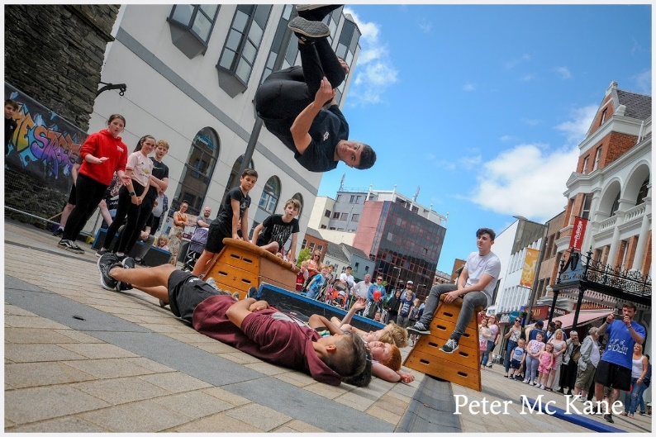
  - Introduction

This was a powerful project exploring concepts of identity, shared space and physical, social and mental borders using four different street art forms: circus; dance; graffiti; parkour. In Your Space Circus, Create Dance, UV Arts and Jump NI worked as a partnership with over 200 young people recruited from across the Council area and Donegal with activities delivered across the region. The project received £45 000.

  - What was achieved

Take Back the Streets was delivered in four phases with initial open recruitment to attract unattached young people. The first phase offered introductory classes in each of the street art forms; the second phase was an intensive Summer Academy.

“We took over Derry City for one week in July with our Big Top tent erected in Guildhall Square and using facilities around the City including Playhouse (Graffiti), Pilot’s Row (Parkour) and Nerve Centre (Dance). The Academy week involved intense training in each of the disciplines, coupled with the Peace and Reconciliation content and exploration of incorporating the themes into the development of the final showcase work for each discipline.” (End of Project Report)

The Academy week was a major component of the Derry City and Strabane District Council’s REWIRE festival which finished with a Street Arts Festival and was attended by more than 12 000 people. The young people were at the very heart of the Festival in terms of planning, delivery and performance. The week culminated in a performance in the Big Top.

“This was an incredible journey of growth and development culminating in an intensive week with our performance at the end. The adrenaline, the pep talks, the excitement…we were living and working together for a whole week in the lead up to that event! “(Project Facilitator)

The fourth phase focused on recruiting existing groups of young people. These included: Killygordon Community Group – based in Donegal; Jigsaw Project – Autism group based in the Waterside area; Londonderry YMCA – Based in Drumahoe on the Waterside; IYSC Aerial Flyers Group – based in the centre of Derry City. COVID-19 hit in the middle of this programme. However, an online programme of Circus and street arts was later developed which included a digital Christmas showcase and daily sessions in various circus disciplines.

“Online delivery was a great success, much to our surprise, and ensured we could engage new participants alongside existing Circus School members. These young people were engaged in online classes alongside Good Relations ‘homework’ activity sheets (developed through another Good Relations project we have been delivering.’ (End of Project Report)

  - What was learned

The narrative ‘taking back our streets’ was very powerful, lending itself to art forms which expanded young people’s sense of self and confidence as well as expanding their ease in moving their bodies through their physical spaces.

“We constantly wove this narrative through all the art forms. Reclaiming our streets, our town. Make this town yours. Stamp your identity on to it. Have courage and walk with your head held high.” (Project Facilitator)

“This project really helped my daughter's anxiety, had a positive impact on her mental wellbeing and helped her confidence. The people who ran the circus were amazing and Luke's wise words "just be yourself, but if that's too hard be whoever you want to be" was exactly what she needed to hear and meant she was able to perform in front of crowds! I cannot thank you enough!” (Parent)

There was great learning across the four street art disciplines with regards stitching in Good Relations into the practice. For example, circus equipment and practice was used to metaphorically explore issues.

“We used the tightwire to discuss moving from one place to another, crossing a border, and how it feels to be on that journey. The tightwire is also useful for exploring balance, both literal and attitudinal.” (Project Facilitator)

The concept of borders was viewed differently, often depending on where the young people were coming from with the facilitators learning and adapting with the young people.

“It was interesting to see how rural based groups (including a group from Killygordon in Donegal) raised different issues in term of attitudes towards borders, as did people from different backgrounds, and the metaphorical border between those living in towns/cities and rural communities.” (Project Facilitator)

Differences in understanding between the lived experience of young people and the lived experience of bureaucracies around political and religious identities was a tension. This became most apparent in the completion of the Peace IV monitoring forms.

“Often the people who work in these structures and bureaucracies are living in a completely different world to young people. A different constellation. They need to work with young people to develop the questions in the future. The forms seemed to introduce a very different narrative than that of the project They felt extractive, putting us into boxes rather than inclusive, empowering and layered.” (Project Facilitator)

A lot of the young people didn’t know that these differences existed. What mattered to them were issues around sexuality, education, mental health, having craic with mates. We need to develop that larger definition of how we achieve a peaceful society.

Taking Back the Streets closed as a project just as we are coming to grips with the emergency facing young people who have survived the pandemic in a very difficult political environment.

“We need to grow that sense of collective emergency. But there is limited money at the moment, so our focus is on surviving internally before we can look outwards. There are just no resources.” (Project Facilitator)

  - Peace IV Programme Conclusions

The tender amount for this project was not enough for its size and and the targets expected in terms of numbers. This caused significant challenges for existing Project Staff. The retention of young people was also difficult over a long period of time, particularly with a limited budget. It was far easier to engage with participants in a more deep and meaningful way over an intense, shorter time period. Finally, there was very positive feedback about the support of the Peace IV staff, their encouragement kindness and flexibility.

“We are extremely proud of the project; it has laid a template for future projects and partnership development. There is also a legacy of a number of participants who are now engaging across our other projects and programmes.” (Project Facilitator)

  - Arts, Reconciliation and Cultural Heritage Project (ARCH)

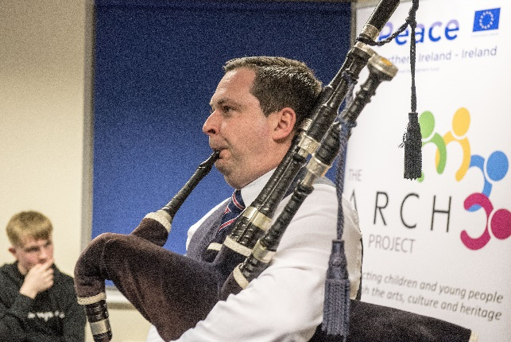
  - Introduction

The North West Cultural Partnership (NWCP) successfully tendered for six individual Peace IV Programmes: three Cross Community Children’s Programmes (and three Cross Community Youth Programmes focusing on Derry-Londonderry, Faughan & Derg). These programmes formed the Arts, Reconciliation and Cultural Heritage (ARCH) Project. Overall NWCP received £307 680 and worked with more than 830 young people across the Council area.

The project’s overall purpose was to introduce young people to a range of different cultural activities in a way that is engaging, entertaining and meaningful. Through the activities young people’s natural curiosity would grow, they would engage with people from different cultural backgrounds and build a better understanding of the cultural identities and their associated activities.

  - What was achieved

The ARCH project built on a previous Peace IV project called Culture Fuse that was delivered by NWCP and Cultúrlann Uí Chanáin.

“We built on Culture Fuses’ achievement and the confidence that grew through that project. We knew through Culture Fuse that the use of arts and culture works so well – if people are enjoying themselves then they will learn.” (Project Facilitator)

This was a large project engaging with a significant number of young people across three areas. The project planned to use different approaches including: interactive day trips to places of historical interest across the wider district council area such as Noose or Necklace (a walking tour of the historic walls of Londonderry), and The Honest Sod (comedy theatre-in-education project dealing with the plantation and the different languages used); a series of themed workshops which explored drama, music, art, dance and film making; a special matinee performance at the Walled City Tattoo; a residential visit; and a final celebration event. As with all projects, Covid-19 interrupted the plans halfway through the project with residentials and the final celebration unable to happen. However, significant work and effort went into moving as much as possible online.

“To ensure that all participants had access to the workshops we created online tutorial videos, forum theatre workshops, which were shared with participants via our social media platforms, on YouTube, our website and via email to parents/guardians, as well as group leaders. We are proud of how we responded to the pandemic, how we changed our approach and the delivery of the programme in order to achieve the aims and objectives of the programme and keep our participants engaged.” (End of Project Report)

Interestingly, the change in approach allowed the project to invest much more heavily in online and physical resources which are open to be used by all and is one of the important legacies of the project.

  - What was learned

A confirmation that real learning comes when people feel relaxed, are enjoying themselves and feel that they matter and are valued.

“All too often peace and reconciliation programmes focus on the differences that cause division and encourage people to discuss these, which can in our opinion reinforce division. By encouraging children to experience different cultures in a positive, creative and fun way, they become more open to engaging in a range of activities without any preconceptions or misconceptions.” (End of Project Report)

There were significant challenges in meeting the targets set for participants, particularly as the project wasn’t able to work in schools. This meant that time and resources were spent reconnecting and building up relationships with individual youth groups which was of significant value. This was particularly important for rural youth groups, who often find themselves isolated and solely run by volunteers. The project normalised engagement and created important networks providing a great springboard for further work.

The use of Forum Theatre and the online videos produced around key themes such as racism, bullying and mental health was a very powerful and empowering way of engaging with young people.

Inter-generational programmes and engagement is a priority. Working with the whole family will create the space for young people to grow well. This becomes particularly important when working with teenagers who are naturally testing boundaries. This can lead to conversations about the tensions between different understandings around the concept of culture: is it static or fluid; what are young people being given that they wish to preserve and honour; what has been imposed upon them that traps them; what can they choose to embrace.

“We perhaps need to be better at involving the older generation in delivering projects – those who are caught and trapped in old stories.” (Project Facilitator).

How people perceive and and engage with different physical spaces and their stories in their landscape has always been a core part of Peace and Reconciliaiton.

“All too often people define shared space as neutral space, where no cultural heritage is present. This in our view is a mistake and discourages people from engaging meaningfully. Certain locations will have more importance to different cultures and it is important that people from different backgrounds are encouraged to visit and gain a better understanding of the cultural heritage present at that location. Participants visited places such as the Alley Threatre, Derry’s Walls, the Millenium Forum, as well as a number of schools and community centres across the area to engage in cross-community activities. Participants have told us that it was the first time they had visted some of the places and this as well as the activities taking place at the locations, will have broaden their preceptions on what shared space is.” (End of Project Report)

  - Peace IV Programme Conclusions

This was NWCP’s largest project to date, part delivered during a pandemic, and the relationships, networks and learning developed creates a powerful springboard for future work. The support of the Peace IV Team was also core to the project’s success. The project also noted that tenders provide more flexibility and less administrative burden of the Peace IV staff. A challenge was the number of Peace IV Projects all taking place at the same time competing for participants, often with similar invitations. The baseline and end surveys were problematic and often affected people’s willingness to participate as well as potentially the accuracy of any results.

“Case studies, testimonies and other such qualitative methods provide a better understanding of the success of the project than quantitative surveys.” (End of Project Report).

  - Connecting Communities Project

  - Interface Investment Programme - Fountain & Bishop Street area & Bogside Brandywell Initiative
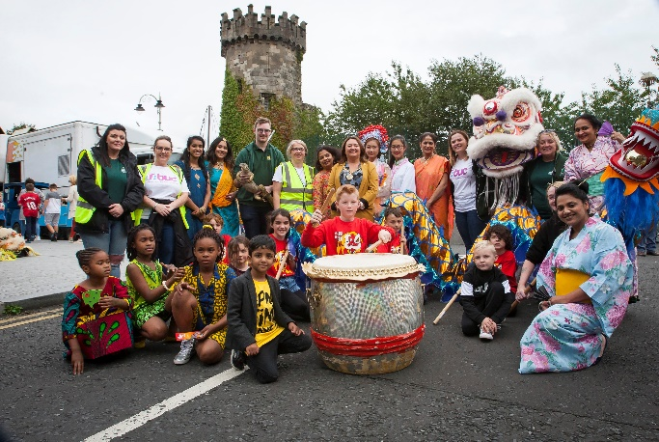
  - Introduction

This project continued the long journey within the Triax area of Derry/Londonderry of connecting neighbours and growing resilience as communities get buffeted by wider events and uncertain politics. The Triax area is the Neighbourhood Renewal area covering the Bogside, Brandywell, Creggan, Fountain and Bishop Street. Delivered by the Bogside and Brandywell Initiative, the Connecting Communities Project received £80 000 to run a diverse programme of activities for different demographics, continuing to build relationships across all sections of the community with a specific focus on citizens from a black, Asian and/or minority ethnic background (BAME). It built on previous IFI Peace Walls and Urban Villages funding.

  - What was achieved

The project’s activities included seasonal festival, cross-cultural workshops, history and heritage, crafts, volunteering, trips, health & wellbeing programmes, learning new languages, and ‘get togethers’ over food. Anything and everything was tried which might trigger a shared interest between people and create the space to feel safe in each other’s company and to be proud of welcoming each other into their spaces and communities.

“In terms of shared space, we’d progressed, but we needed more events. Initially some people refused to go to the Fountain out of fear. After reassurances they did and found a great welcome. We’ve found a changing attitude. When we plan events or bus pickups we don’t have to say in advance where they’ll be. There’s a willingness to go wherever we can get a space… open doors now for residents from across the area to access services. People are moving more freely.” (End of Project Report)

A highlight for the project was developing relationships with citizens from BAME backgrounds.

“This is best demonstrated by the Cross-Culture Initiative project where we brought together the members of the Pink Ladies Cancer Support Group and the Islamic Society. This created the opportunity for the Pink Ladies to visit the Islamic Society, where eight different nationalities come together to share and learn about their different cultures and traditions. This permitted learning on both sides with the Pink Ladies providing Cancer awareness information to the BME groups, while promoting understanding tolerance and respect, and incorporate cross cultural engagements.” (End of Project Report)

The project is rightly proud that since the project there has been a reduction in tension, sectarianism and violence within the area which has an immediate impact on people’s sense of safety and opportunities to focus on key issues such as poverty, mental health and education. Relationships make things possible. The lack of them reduces opportunities.

“The Mela event we held at the interface was the most successful event we have ever held with 3500 people. Peace IV gave us the confidence to hold it.” (Project Coordinator)

  - What was learned

Starting with people’s skills, gifts, and what they are proud is a powerful way of connecting neighbours in new ways, often generating new answers to shared wellbeing concerns. It is a kind of organizing that offers a contrast to one based on anger and fear.

The monitoring surveys indicate that greater number of women were involved than men. This is a common pattern within wider community development and highlights the importance of understanding how gender dynamics play out in wider community relations and change.

It was at times challenging to find facilitators who are skilled in supporting inter-sectional learning, helping people critically engage with all their layers of identities as opposed to just one. Investing in building this capacity for the city might be a useful consideration for any pre-programme work and investment. Without these skills, it can be difficult to deliver programmes that take people into much deeper conversations.

Peace and reconciliation work is multi-track: different levels and working with people who are all at different stages, often shaped by age and generation.

“Peace work is so hard – it’s about nudging it forward with tiny steps. And we need to engage differently with different generations and peoples. We still need the bread-and-butter work – those coming behind us. And we need to push others deeper. Those born 1995 onwards are still being educated on their history. You then have pre-ceasefire generation, post ceasefire and then older folk – all with different stories and experiences.” (Project Coordinator)

The pandemic pressed the pause button for BBI which was very welcome. It allowed staff and volunteers to step back and have the space to think as well as allowing new relationships to be built through the delivery of food and hampers.

  - Peace IV Programme Conclusions

The Connecting Communities project was a tender process, which worked very well with the Peace IV team always really and available to help with any issues or problems. There was an interesting reflection about whether different Council departments had different tendering and procurement rules and processes and whether these could be aligned. The absence of a designated officer in Donegal County Council to liaise with, with regards connecting to groups for cross-border Peace IV work was also noted as challenging. Finally, the pre and post questionnaires were felt to be too long, with many repeated questions. Feedback indicated that a number of people were put off participating in other elements of the project if they had experienced the questionnaires. There was also a strong recommendation that any future Peace funding there should continue to focus on the integration of current or emerging BAME groups in the region.

  - Waterside Shared Village

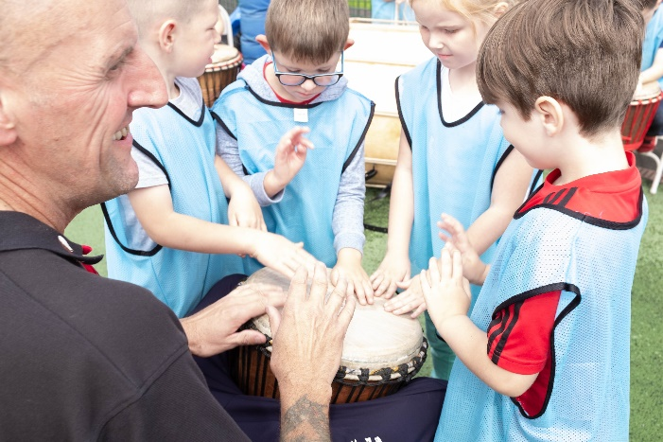
  - Introduction

This project grew out of existing relationships between Top of the Hill and Irish Street with a focus on increasing the movement of citizens between the areas thickening the relational web that hold both places together. Historically the area has been scarred by sectarian tensions and violence.

The project received a total of £499,271.56 to run a range of high-quality programmes catering for all ages including: the Terrific Twos programme; Brilliant Babies; primary school after schools; primary school summer scheme; post-primary homework support; post primary summer scheme; detached youth programme; a number of festivals per year (including Christmas and Hallowe’en); festival arts programme; cross border programme; basketball programme; football programme.

  - What was achieved

The core achievement of this project was normalising spaces, opportunities and reasons for people of all ages to meet and connect as mums, dads, grannies and grandads, and children.

“Only see folk from the other community at events. I wouldn’t see them normally. You stick to what you know.” (Project Participant)

With regards specific achievements, the summer scheme brought together 265 children from both Top of the Hill and Irish Street for a four-week programme. During the first year the children were bused, the second year they walked. This was a very symbolic act for many adults.

“When reviewing the project’s best case example with regards to Peace and Reconciliation it is hard not to focus on the Summer Scheme. Organisationally this was a huge undertaking, but it was very much a team effort from both communities. We were unaware of such a large scale cross community summer scheme on an interface in Northern Ireland at the time. Children were either bused or walked to the different centres in each area and it was heartening that they were so unware of how significant it was for the adults. One mother remarked that she used to be involved in violence on the interface growing up during the summer and now her child was going to Irish Street for summer scheme, she commented ‘this is the way it should be’. “ (End of Project Report)
Another important symbolic event was the first Christmas Winter Wonderland. It was the first time both communities celebrated it together.

“We were worried; weren’t sure people would go to Irish Street. But they did. In their hundreds.” (Project Staff)

The Cross Border programme brought older people from Irish Street, Top of the Hill and Inishowen. The programme called the ‘Great Get Together’ was run for 2 years with 94 participants. Activities included tea dances, shared history workshops, arts/crafts, day trips, lunches, exercise classes, baking and many more.

“This is a really good starting place – we are role models for our children and grandchildren.” (Project Participant)

As the centre manager from Irish Street Community Centre reflected:

“One of the key highlights of the programme has been that residents from each interface community have taken part in cultural activities and events which would not normally be celebrated by their respective communities. Two stand out examples of this has been the festivals which have taken place to mark St. Patrick's Day and the Ulster Scots summer scheme. Even ten years ago it would probably have been unthinkable that Irish Street residents would be enjoying a St. Patrick's festival and that Top of the Hill children would be taking part in Ulster Scots based activities, including piping, drumming, and dancing.”

  - What was learned

A strong ‘shared village’ partnership model created the space for this programme to grow and allowed the communities, staff and volunteers to take some risks. But partnership working doesn’t happen automatically; it takes intensive and continuous effort.

“You have to work at it all the time, even with ones you know really well. You constantly have to think about people’s own communities and context and how much to push. Everything has to be checked and double checked. You have to work at partnership for it to work. Not a given at all. “(Project Staff).

High quality events and programmes allow new patterns of meeting and relationship building to take place. An ongoing challenge is ensuring that there are structures and organisations within the community that have the resources to sustain and support these relationships grow from ‘cradle to grave’. These structures and organisations need to hold the line even when the political atmosphere changes and doors and windows can slam shut.

Acknowledging, understanding and transforming the attitudes and reasons for fear and hatred requires a level of conversation that takes time and patience. In some senses, funding often allows the ground to be prepared but when it’s ready, the funding is over.

“We need more work done on the hard conversations around peace & reconciliation.” (Project Staff)

Whilst there are examples of good practice, Good Relations still remains and is seen as an add on by many statutory bodies.

“Good relations needs woven into decisions on health, poverty and capital infrastructure.”

“If we are really serious about co-design with communities then good relations needs to be at the heart of it.” (Project Partner)

  - Peace IV Programme Conclusions

The delivery of funding through a tender process instead of a grant was a much more flexible approach which allowed changes to be made to the project delivery as it evolved over its 3-year delivery period. The monitoring forms were a challenge. The rationale behind some of the questions wasn’t clear nor seemed appropriate for different demographic groups. Ideally, SEUPB needs to be co-designing its questions with groups. The practicalities of booking the iPads were also challenging when dealing with large numbers of people.

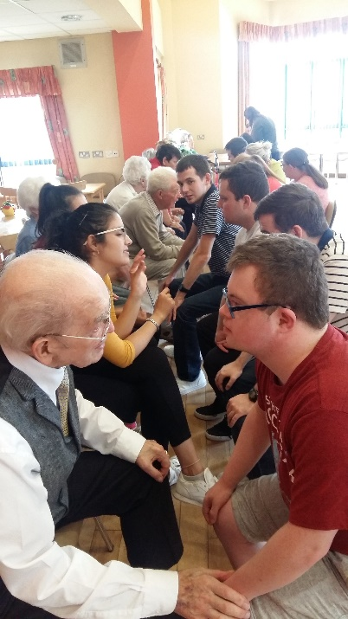
  - Beacon Project with YouthAction NI

  - Introduction

The Beacon Project was a Youth Leadership, Social Action and Entrepreneurship Programme working with young people from 27 community partnerships across rural and urban areas in the Council as well as both sides of the border including Buncrana, Burnfoot, Fahan, Letterkenny, Lifford, Muff and Raphoe.

The project built on YouthAction NI’s long presence and work in the North West offering proper resources and time. A total of 113 young people participated in the programme and the project received £340,965.

  - What was achieved

All young people participated in the creative Leadership Development Programme which delivered a range of different accredited courses including personal development, good relations, life maps, citizenship training, positive mental health, money for life, equality, and youth work weaving in visits and residentials to a variety of different places.

“I had never been to the Fountain before; people would have told me it was not a safe place to go. It was good to go there with our group and to see murals in the area. I got the chance to learn about the culture in the Fountain and it was really interesting. I would have no problem going back there now.” (Project Participant)

“We visited the North West Islamic Association in Derry/Londonderry to learn about the Muslim and Islam culture and faith and dispel myths and fears. Participants had developed a series of questions prior to the visit and had an engaging question and answer session with NWIA representatives. It challenged what many of them had heard from family and media” (End of Project Report)

Following completion of the Leadership Programme, young people were offered a number of different routes to practice and grow their interests and skills.

These included:

-A Cross Community Volunteering Programme where for example, 28 young people living with disabilities took part in a cross-community intergenerational volunteering with Older People North West “Looking back, looking forward” themed events and designed a mural to be painted on the wall opposite Older people North West called ‘Creative Ages’ project.

-Peer Leadership Delivery Programme where young people were invited through YouthBank to assess the applications for support for a number of youth led projects. Forty six young people were involved supporting six local community youth initiatives focusing on sports and play activities that impacted on mental wellbeing. This resulted in a positive impact on 247 children and young people.

“Young people developing projects with then young people making the decisions has opened up our thinking in the clubs about how much they are capable of.” (Project Partner)

-Social Enterprise Projects where for example, 30 young people who live with disabilities decided to complete a Social Enterprise training. This included completing Money for Life training that helped the young people learn money management skills and financial health before embarking on their social enterprise project. They then decided to run a peer money mentoring programme for their social enterprise project. The group submitted an application to take part in the UK Youth Money for Life Community Challenge Awards. They were successful at the Northern Ireland regional heat and represented Northern Ireland in the National Finals in the BAFTA building in London in March 2019 where they pitched their idea to a panel of judges. The group were thrilled to win the UK Champion Award.

“Often young people with a disability are overlooked in helping shape the future of our city.” (End of Project Report)

  - What was learned

Good youth workers provide the scaffolding for young people to stay rooted and grow, particularly young people who need to focus so much energy on just getting through the day and the week. Holding a broader definition of Peace & Reconciliation allows young people to explore and learn to be at ease with many more identities and cultures than just ‘green and orange’.

“We delivered visual and creative workshops looking at different cultures and backgrounds and opened this to discussion including what we all have in common. We then looked at positive roles these people played in the community. After discussion, their views had changed. This was the same with all the cultures we looked at. The reason for this is that we found that young people knew very little about different cultures and only learnt the negative messages from their parents and peers. These workshops gave the young people more understanding of different cultures in their community and helped to break down barriers.” (End of Project Report)

The lack of political leadership can be frustrating as well as the language used. A lot of the time can be spent in groups picking up on and making sense of the politics.

Inviting young people to experience new spaces, whether physical or developmental, was a critical part of building their confidence.

“ For example, in Strabane we meet a few times at “Tinnies” which is just on the Donegal border. We have had young people progress on to join other youth groups and some have become volunteers and also paid workers. For example, one young man from Strabane area has now become a unit commander within the local rescue services. One of our Youth Champions got a youth work post with the Education Authority, another took up a new post as a classroom assistant and a third got a post in a childcare setting.” (End of Project Report)

Maintaining relationships with young people during this last year has highlighted the importance of young people, particularly from poorer backgrounds, being supported to be the creators of technology, not just the consumers. “I think young people are learning that the binary world of social media is not how real life actually works.” (Project Partner)

It has also demonstrated the benefits of outdoor learning and development which needs further resourced and invested in as a key aspect of youth work.

The pandemic became the opportunity for youth based clubs and groups to look outwards and engage in community support work. This has extended networks and relationships creating more possibilities around volunteering and community support.

“Our young people were giving out food parcels and we built new relationships on the doorstep. People want to give back now. I think this year has profoundly changed how we think and go forward in the future. This project was part of this new direction of travel”. (Project Partner)

  - Peace IV Programme Conclusions

The monitoring forms were challenging for those young people to complete if the ‘boxes’ did not seem to fit. Being sensitive to different learning abilities was also noted as important for any future monitoring requirements. Perhaps ensuring that any documentation meets the ‘easy read’ kitemark would be a good standard to meet. There was great praise for the Peace IV team in terms of their support throughout the project and the value of networking and training events held, particularly during the pandemic.
  - Youth Leaders & Citizenship – Strabane Brass Band

  - Introduction
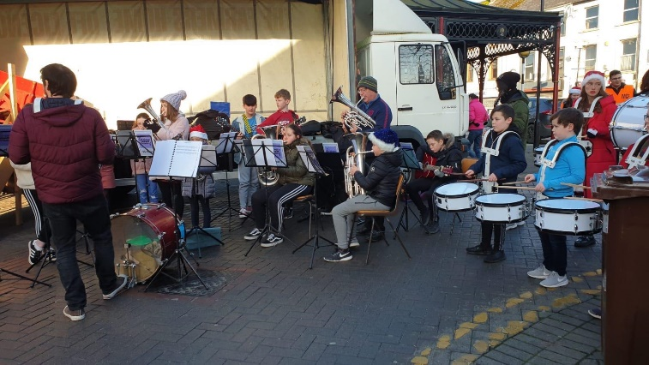
Strabane Brass Brand received a grant of £10,250 to set up the Strabane Groove Orchestra for 50 young people. From Brass Bands to Rock and Classical Guitar, Pianists and Percussionists, Drummers to those from Ulster Scots traditions and pupils with a learning disability the Groove Orchestra created a space for everyone to make music together.

This project came under the Youth Leaders and Citizenship – Street Art Programme whose purpose was to encourage groups of young people to come together and through public art engage with each other as citizens At a neighbourhood level, young people would use their art to publicly express their commitments and relationships.

  - What was achieved

This project was not designed to take young people away from their existing musical projects and traditions but rather to provide an additional , new and fresh shared platform for performance, cultural and social exchange. The project wanted young people to come together to learn from and respect each other.

As a six-months project, the Strabane Groove Orchestra achieved miracles. It brought together 50 young people from different traditions and different musical abilities and managed to create an orchestra which performed in a number of different venues over 2019-2020. These included playing at the Halloween Celebrations at Melvin Sports Track, providing festive entertainment at the Strabane Christmas Fayre and several performances as part of the Omagh Jazz Festival.

“Our performance at the Strabane Halloween Celebrations was described by some spectators as “the highlight of the evening”. This was our first public performance and the young musicians were completely professional and fully embraced the ‘dress up’ theme. One of the parents approached us after the performance to thank us for giving her child with additional needs the opportunity to perform within a group – she commented on their excitement and confidence boost over the previous weeks and how this performance was the first time that they had dressed up for Halloween and allowed their face to be painted. This performance had surpassed all our expectations from the first rehearsal.” (Post-Project Evaluation Report)

“Hearing young musicians make comments such as “I’ve never done this before, but I’ll give it a go…” (to improvising a solo over above the orchestra) has shown that this project has increased musicianship, understanding and confidence without the young person/people even realising.” (Post-Project Evaluation Report)

The project opened a new door to what might be possible using the magic of music and builds on a long tradition of music in Strabane with the Brass Bands at the heart of it.

“Running this project has given us a great solid foundation for what is going to be an exciting future for young musicians in Strabane. It has been the first step in creating the legacy we are striving for.” (Post-Project Evaluation Report)

  - What was learned

The project has been a working idea for many years but had struggled to take off until the opportunity of Peace IV allowed Strabane Brass Band to bring this idea to a reality. It sought to do two things – create a truly inclusive space and develop musical abilities and performance.

“There is a balance to be had between inclusion and performance. We have learned a great deal about this during this project.” (Project Lead)

The project was also very clear that engaging on peace and reconciliation issues with young people needed to be done in a completely different manner than the conversations with adults. If we deal with these issues in the same way with young people, we will never change the stories. A key learning moment was the workshop on Good Relations facilitated by Janie Crone.

“She talked with us about different cultures of the world- the dances associated with the cultures and the different varieties of foods within them e.g Scotland for its bagpipes and highland dancing, Ireland for its Irish dancing and stew! We then assessed our own local area- Strabane- and pointed out that it is widely known for its talent in the arts, from brass bands to drama schools, dance classes and amazing voices. We realised there are a myriad of cultures within our communities from Indian to Polish etc. We then assessed our own nationalities and who we identify as, either as British, Irish a part of Northern Ireland, the UK or other countries across the world. Although those in attendance identified as Irish or British, the lady made the interesting point that she did not identify as just one nationality but many. We had fun designing posters that related to different cultures in Scotland, Ireland and our own local area- Strabane in the Strabane Groove Orchestra.” (Participant)

The wider context for the Strabane Groove Orchestra is the decimation of music teaching in schools due to rising costs of tuition, curricular changes and wider cultural attitudes. Finding ways to engage young people in learning about and performing music will require adults to be imaginative and creative and learn to listen and teach in ways that make sense to today’s generation. If we fail in this, we will lose an important part of what it means to be a community and the medium to build new relationships.

“Music allows young people to grow and the town to grow.” (Project Lead)

  - Peace IV Programme Conclusions

The support and willingness to go the extra mile of the Peace IV staff in relation to this project was strongly stated. The downside was the paperwork, and in particular the monitoring forms which were deemed as totally inappropriate for young people.

