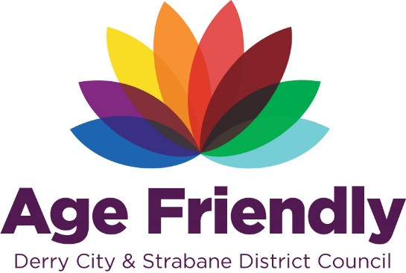

**AGE FRIENDLY BASELINE SURVEY 2021**

**Summary Report**

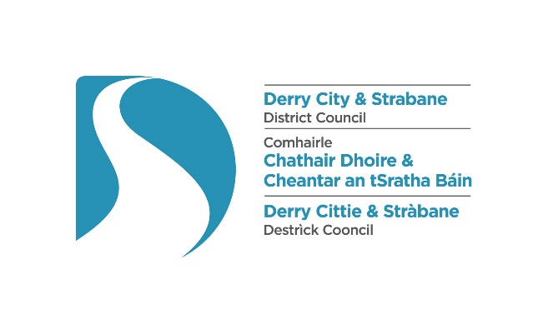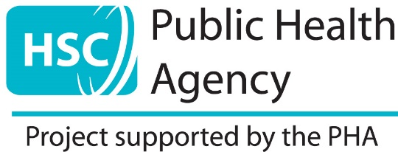

Contents

**1.0 Introduction to Age Friendly** 4

**2.0 Timeframes** 5

**3.0 What Derry City and Strabane District do best for older people** 5

3.1 Further feedback on what the area does best for Older People 6

**4.0 Who responded to the survey** 9

4.1 Where respondents live 9

4.2 Gender and Age Profile of Respondents 10

4.3 Current Employment Status of Respondents 10

4.4 General Health of Respondents 11

4.5 Quality of Life of Respondents 12

4.6 Who lives in same household as respondent’s 12

4.7 Caring Responsibilities 13

**5.0 Outdoor Spaces and Buildings** 13

5.1 Summary of Responses to Outdoor Spaces and Buildings 14

5.2 Feedback on comments or strongly expressed feelings relating to Outdoor Spaces and Buildings 15

**6.0 Transportation** 19

6.1 Summary of Responses to Transportation 20

6.2 Feedback on comments or strongly expressed feelings relating to Transportation 20

**7.0 Housing** 22

7.1 Summary of Responses to Housing 23

7.2 Feedback on comments or strongly expressed feelings relating to Housing 24

**8.0 Social Participation** 25

8.1 Summary of Responses to Social Participation 26

8.2 Feedback on comments or strongly expressed feelings relating to Social Participation 26

8.3 Interaction with Friend, Family, Neighbours and Others 29

8.4 Feedback on additional comments relating to interaction with Friends, Family, Neighbours and Others 29

**9.0 Civic Participation and Employment** 30

9.1 Summary of Responses to Civic Participation and Employment 31

9.2 Feedback on comments or strongly expressed feelings relating to Civic Participation and Employment 31

9.3 Availability for flexible opportunities for working, volunteering after retirement and adult education and courses. 33

9.4 Feedback on comments or strongly expressed feelings relating to availability for flexible opportunities for working, volunteering after retirement and adult education and courses. 33

**10.0 Respect and Inclusion** 34

10.1 Summary of Responses to Respect and Inclusion 34

10.2 Feedback on additional comments or strongly expressed feelings relating to Respect and Inclusion 35

**11.0 Communication and Information** 37

11.1 Summary of Responses to Communication and Information 38

11.2 Feedback on comments or strongly expressed feelings relating to Communication and Information 39

**12.0 Community and Health Services** 40

12.1 Summary of Responses to Community and Health Services 40

12.2 Feedback on comments or strongly expressed feelings relating to Community and Health Services 41

**13.0 Areas for Improvement across Derry City and Strabane District area** 43

**14.0 Acknowledgements and Next Steps** 48

**15.0 Stay Involved** 48

**16.0 Appendix – Copy of the Baseline Survey** 49

# **1.0 Introduction to Age Friendly**

Derry City and Strabane District Council became members of the World Health Organisation’s (WHO) Network of Age Friendly Cities & Communities in January 2017, reaffirming its commitment to make Derry City and Strabane a great place to grow old in, enabling the inclusion of older persons to help make our region a more age-friendly place.

Derry City and Strabane District Council and its partners are committed to the Age Friendly agenda through its community planning processes, the Inclusive Strategic Growth Plan: Our Community Plan (2017-2032) and the eight Local Growth Plans. The specific outcome within our Community Plan is ‘We Live Long, Healthy and fulfilling lives’. The key action within this outcome is to ‘Develop an Age Friendly City and Region through an integrated programme of action, based on a rights-based approach, and on the eight World Health Organisation’s key themes’.

The Age Friendly programme wants to help improve the quality of life for older people living within the Derry City and Strabane District Council area. As an Age Friendly Community it is important for us to all work together to identify and make the changes in both the physical environment (e.g. transport, housing, outdoors spaces) and social environment (e.g. volunteering, leisure, employment, and services) that are relevant to enable people to lead healthy and active later lives. Because older people know best what they need, it is really important that their voice is at the centre of any efforts to create a more age-friendly community for Derry City and Strabane.

Derry City & Strabane District Council, alongside its partners involved with Age Friendly use this survey to engage with older residents to assess our City and Districts age friendliness in relation to the World Health Organisation’s (WHO) Age Friendly Cities Framework. The framework proposes eight interconnected domains that can help to identify and address barriers to the well-being and participation of older people. The eight domains of the Age Friendly Framework are:

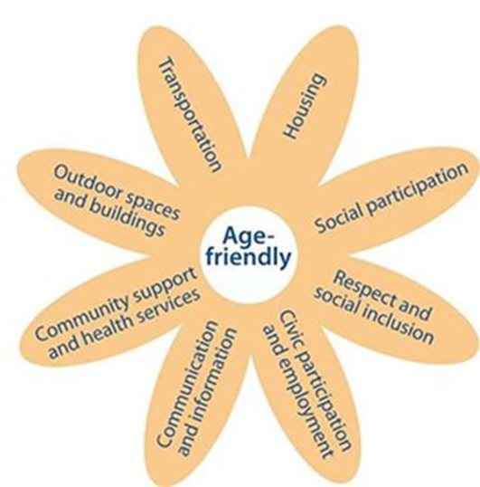

*Source - World Health Organisation*

All information gathered helps to develop a baseline assessment of the age friendliness of our city and district which will support the co design and development of an Age Friendly Strategy and action plan in the future.

# **2.0 Timeframes**

The Age Friendly Baseline survey was completed between the period of February and March 2021, during the Covid-19 pandemic when restrictions and guidelines were in place and citizens were required to adhere to these.

In the interests of health, safety and guidance the survey was distributed electronically using Survey Monkey and alongside this alternative formats were also available. Derry City and Strabane District Council offered additional support to help people who were unable to access or complete the survey online using Survey Monkey.

# **3.0 What Derry City and Strabane District do best for older people**

Respondents were provided with an opportunity to highlight and identify the key aspects which the area of Derry and Strabane District does best for older people. This open ended question provided participants with a platform to respond and below is a sample diagram of some of the responses and the comments received are detailed in the additional table.

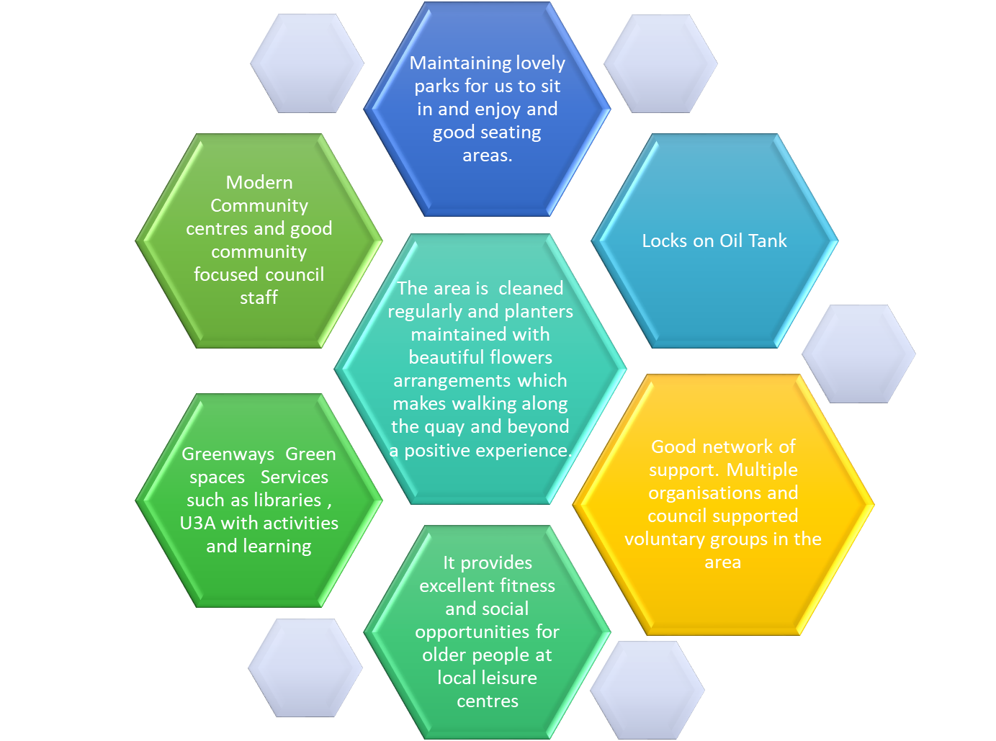

## 3.1 Further feedback on what the area does best for Older People

|  |  |
| --- | --- |
| * They hold social events in Guildhall for people in urban areas – not so in rural areas- nor do we hear about them * Everyone admires hanging baskets * Run Mayors Tea Dances * Yes, older people on the whole are well catered for in this area and would like to thank everyone who tries to help. * Maintaining lovely parks for us to sit in and enjoy and good seating areas. * Don't know * I think the council work hard to provide a lovely walkway along the river with seating and flowers. Lots of walking space (if cyclists would stay in the space provided for them). Seating area in front of the Guildhall is goo especially when weather is good. overall I think the council does work hard to provide a pleasant city environment * No knowledge on this subject? Except -£70 to £80 for a 1-bedroom flat, while here @ Culmore Park over £100 and all the community areas locked to community areas * They hold events in Guildhall for people in urban areas. Not for people in rural areas nor do we hear about them * Information for older people is very good * Delighted that there is an age friendly coordinator * Don’t know what it does for them * No idea * Yes, but you’re still a ‘young’ learning area Council and I wish you well. Thank you for this document we are an ageing and aged community. * Provision of food parcels locally for those in need. * DCSDC are not strategic in their thought process or vision nor delivery and the older agenda isn’t something they’ve even started to address * Plenty of assistance to those living in the towns but those in the countryside and villages miss out * Greenways, Green spaces, services such as libraries, U3A with activities and learning * I haven’t seen any age specific examples of service. I was told off at Pennyburn dump for not being able to lift a wooden cupboard over the metal barrier. I was snapped at that I should have broken the shelf up. I've watched as council workmen watched me struggle to lift things out of my car to try and put / throw over a barrier into the skips. * Courses. Well Women Centre, Over Sixties (Young at Heart) provides information as well. * A good bus service and good times to travel on the bus * Do not have much contact with DC&SD * Not enough * I am not aware if they even have an older people's officer like the youth have. I am not sure what they do * Befriending * The best they can at present * Good network of support. Multiple organisations and council supported voluntary groups in the area. * Stop playing the Green and Orange Game! * I feel we never see our local councillor. In fact, I don’t know who he or she is. * Not sure as I am still very independent but when I no longer drive I envisage difficulty getting to my usual pursuits * accessible and well lit walk ways * If I knew where to ring or who to ask for help, then I could answer that I have my family helping as it’s mainly trying to get hospital appointments which is very hard but understandable. It’s a crisis, and there’s to many chiefs and not enough Indians. * Offer different services * Provides free transport passes. Provides plenty of groups to join * Community Support * In normal times the like of swimming pools being free is good * This survey and that they will take action * Bin collection are good * EBA has been a positive programme. Appointment of an age friendly officer is positive. * Access * Community spirit * Neglect the statutory responsibilities to properly manage and maintain Public Parks and open spaces. No proper enforcement, supervision, management. Lack of proper facilities toilets, disabled access, risk assessments, information signage at all public spaces * There are quite a few organisations helping older people. A more cohesive approach would be helpful * Everything that I have disagreed with on this survey * Print a leaflet to let us know what is going on within the city. Also had a few more seconds on pedestrian crossings to give us a chance to get clear of traffic as i have been nearly hit with a car crossing the road as drivers are very fast on the take off * Awareness * Information * I think Derry City and Strabane District could publish more what they do best for older people. Personally I do not know either way what they do and do not do. If people, my age do not use social technology then they are minus updates on what is happening. * Older people have access to better sheltered accommodation now. | * Subjugation * Older people have access to better sheltered accommodation now. * Security * Locks on Oil Tank * Don’t know. Very much think it is not Age Friendly and ongoing efforts to make progress in this regard have been an appalling failure despite significant tax payers money been spent for this purpose. * Not very much they are too busy with their own agendas * Not a lot in Strabane anyway * I feel they are good at gathering people together for suitable activities pre covid and they have supported communities with funding during the pandemic. * Can’t think of anything * Not enough information for older people, like myself who cannot use the internet. * Events * Tea Dances for those who are interested. I can't think of anything else * Treats them equally * Provides community services for the people in the town of Strabane and the city of Derry * Support some community based programmes but could do more. * I can't think of anything it does for older people, other than fund community groups to run tea dances and bingo. There needs to be a paradigm shift in how it thinks about all this of this. * Education community and exercise programmes opportunities. The city centre area is cleaned regularly and planters maintained with beautiful flowers arrangements which makes walking along the quay and beyond a positive experience. * Communication * It provides excellent fitness and social opportunities for older people through the Everybody Active scheme which runs at local leisure centres * I'm unsure of what they do for older people. I noticed a few more seats erected in the pedestrian street in town. * I’m not sure of what DCSDC does for older people. I access activities in my local centre but l m not sure how many of these are provided by DCSDC * Modern Community centres and good community focused council staff * Maintenance for services as the Council does for everyone * The tea dances for dementia are really good. * Doing this survey * Community centres are an asset when you get older * I think they are pretty good but as someone who lives in greater Shantallow area I have to travel to Eglinton and Creggan for group activities * I think services for older people in rural communities are very limited, especially transport and access * Arranges interesting classes and has transferred to Zoom meetings during the pandemic - the centre in Eglinton has been very helpful and proactive. * Since I do not need any help or support I can’t answer this * Provide /Fund /Support The community groups * The activities were superb until funding was lost. It caused depression because of sudden loss of contacts. Took a while to recover. * Running Classes for older people * Great sports facilities and Everybody Active Programmes at Foyle Arena - brilliant coaches * The local applications are keeping in touch by Facebook. Only problem is lots of elderly don't have computers. * DC&SDC have provided funding to local community groups to help older people. * Includes people in their events and allows for special access * Have more sheltered housing areas * It should do a lot more in communities and advertise it more to the older age group, we don’t know what available, not everyone is on Facebook * Provides regular sessions in community facilities for older people in non-rates contributing areas * I feel as regards accommodation for older people is lacking. * Other than the tea dances not sure of anything they do. * Assisted wheelie bin facility, collection of bulky items * Advertised their activities. Have ramps in footpaths. bus accessible for people with disability, collection of refuge excellent and street cleaning, excellent street lighting * There are events organised to accommodate the needs of older people Listen to the views of older people * It’s probably quite well intentioned towards older people but it will be interesting to see if any concrete action is taken on foot of this survey! * Care * Provides funding for some community projects. Otherwise I am not aware of what Council does for older people * I don't know * Should prioritize older people’s complaints as they are more likely to be vulnerable * Information for older people is very good * More activities for those living in sheltered accommodation |

# **4.0 Who responded to the survey**

A total of 239 responses were returned and a total of 213 responses were received to the online in addition to 26 received in hard copy format.

Responses were received from all the District Electoral Areas (DEA) within Derry and Strabane council. Of the responses were received, the majority of respondents were females (69%) and 20% were males, with the majority of respondents aged within the 65-74-year category (40%).

The majority of respondents were from persons who consider themselves to be retired (64%) and are living with their spouse or partner (47%), closely followed by almost 32% living alone.

The majority of respondents outlined that they did not have any caring responsibilities with almost one fifth (18%) indicating they cared for someone in their household or living elsewhere.

## 4.1 Where respondents live

From the post codes provided by the participants these were able to be mapped against District Electoral Areas (DEA) to reflect the geographic area of residence of the participants. The majority of respondents live within the Foyleside DEA area (23%) and over 27% of respondents lived within the rural DEA areas (Sperrin, Derg and Faughan). Almost 3% of respondents lived outside of Derry and Strabane council area. See below bar chart to outline place of residence

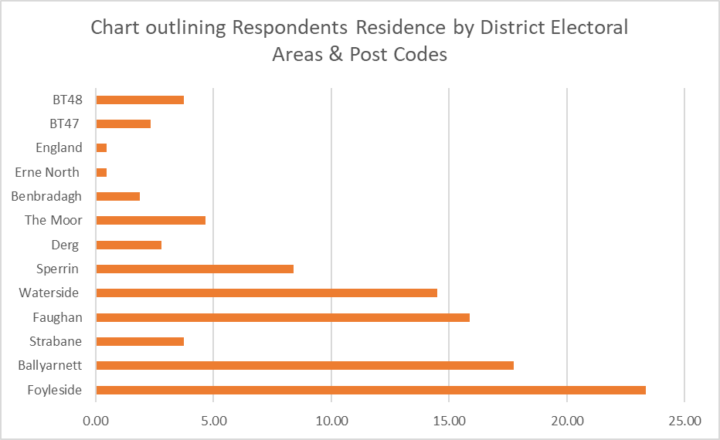

## 4.2 Gender and Age Profile of Respondents

Of the responses were received, the majority of respondents were females (69%) and 20% were males. The majority of respondents aged within the 65-74-year category (40%)

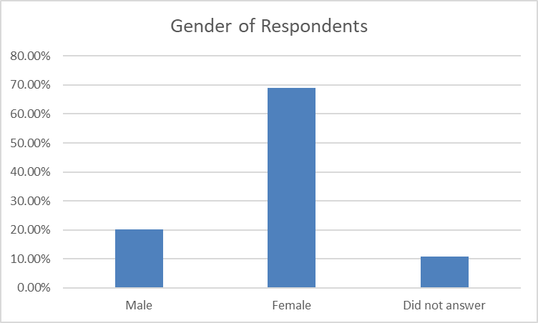

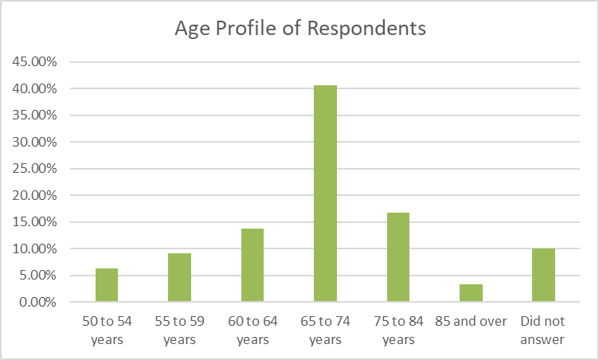

## 4.3 Current Employment Status of Respondents

The majority of respondents to the baseline survey were from persons who consider themselves to be retired (64%)

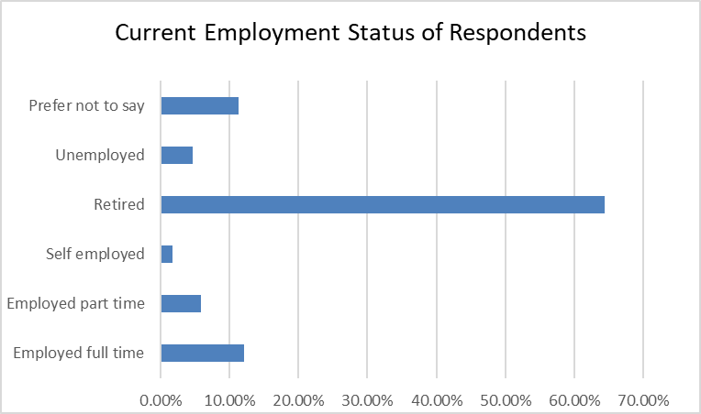

## 4.4 General Health of Respondents

Respondents self-reported their health in general with over half of the participants indicating that their health was with very good or good (52%)

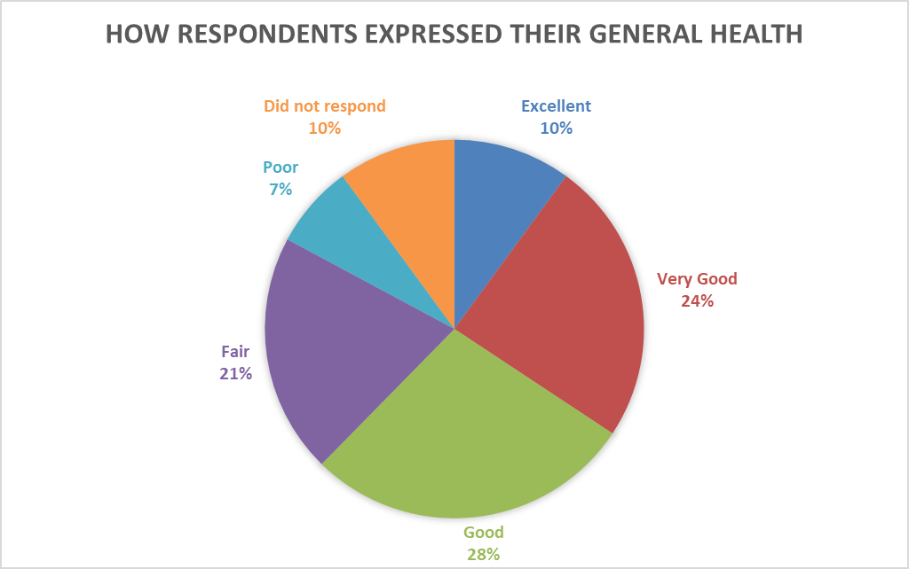

## 4.5 Quality of Life of Respondents

Respondents self-reported their quality of life with over three quarters (77%) of participants indicating that their quality of life was either very good or good.

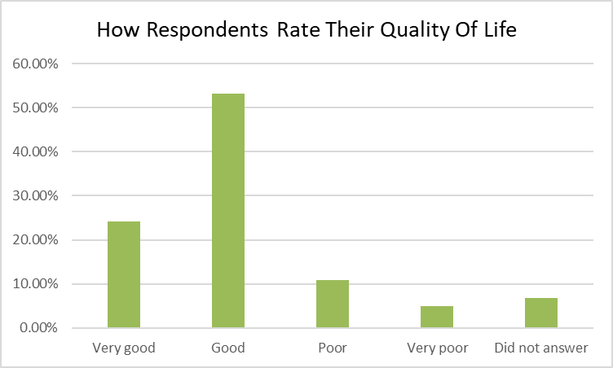

Participants who outlined that their quality of life was poor or very poor described the following;

|  |  |
| --- | --- |
| * Self-isolating because of Covid * Essential shopping only and not all people wearing masks * No social life or close friends * Mostly health problems restricting my lifestyle | * Not able to get out because of Covid restrictions * Must rely on other people to take me out because of health difficulties * Limited use of legs |

## 4.6 Who lives in same household as respondent’s

The majority of participants (47%) outlined that they live with either their spouse or partner.

*Please note that as this was a multiple option answer and therefore the percentages do not add up to 100%*

## 4.7 Caring Responsibilities

The majority of participants (71%) outlined that they did not have any caring responsibilities for someone living in their household or elsewhere.

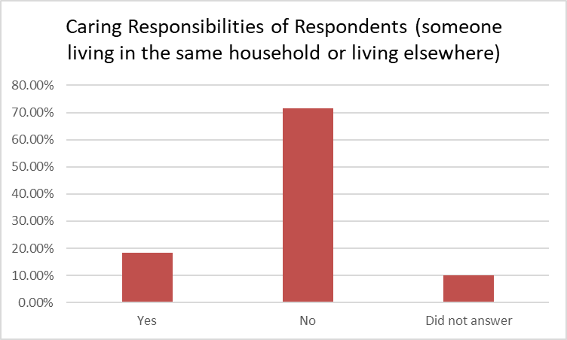

# **5.0 Outdoor Spaces and Buildings**

*Getting out and about safely and independently*

Participants outlined their feelings on an array of statements and overall 87% of respondents felt that businesses and shops are accessible to enter and access easily. Respondents agreed that businesses and shops are accessible to walk to (69%), to drive to (72%) and park near (59%).

A total of 82% outlined that businesses and shops make them feel welcome and safe to visit. However, 72% of respondents disagreed that the businesses and shops are accessible to walk around with just over a quarter of respondents agreed that businesses and shops are accessible to rest inside and outside.

The majority of respondents felt that there are not enough public seating areas to rest (70%). Almost 40% of respondents disagreed that they were able to access public toilets outdoors and indoors, with almost half (48%) disagreed that businesses and shops are accessible to avail of toilet facilities.

Almost half of respondents (47%) disagreed that there are enough pedestrian crossings with adequate time given for crossing the road and 48% disagreed that pavements are well maintained, free from obstruction and there are enough dropped kerbs to cross the road.

Approximately three quarters of respondents feel safe when out in their local area (75%), with 74% regularly walking or exercising outdoors. Nearly one third of respondents (27%) outlined that there are no parks and or green spaces in my area to visit.

## 5.1 Summary of Responses to Outdoor Spaces and Buildings

|  |  |  |  |  |
| --- | --- | --- | --- | --- |
| **Outdoor Spaces and Buildings**  Getting out and about safely & independently | **Agree** | **Disagree** | **Don't know** | **N/A** |
| Pavements are well maintained, free from obstruction and there are enough dropped kerbs to cross the road. | 40.65% | 48.13% | 7.11% | 3.27% |
| There is enough pedestrian crossings with adequate time given for crossing the road | 41.09% | 47.48% | 6.39% | 5.02% |
| Businesses and shops make me feel welcome and safe to visit | 82.19% | 13.24% | 4.56% | 0.45% |
| Outdoor spaces and buildings are clean and well maintained | 54.37% | 35.94% | 9.21% | 0.92% |
| I am able to access public buildings | 83.48% | 8.71% | 4.12% | 3.66% |
| I am able to access public toilets outdoors and indoors | 49.54% | 39.90% | 4.58% | 6.42% |
| There are parks and or green spaces in my area to visit | 70.83% | 27.77% | 1.38% | 0.46% |
| There are enough public seating areas to rest | 25.11% | 70.69% | 2.79% | 1.39% |
| I feel safe when out in my local area | 75.70% | 18.22% | 5.60% | 1.86% |
| I regularly walk/exercise outdoors | 74.31% | 20.64% | 1.37% | 3.66% |
| Businesses and shops are accessible for me to walk to | 69.86% | 26.02% | 0.00% | 4.10% |
| Businesses and shops are accessible for me to drive to | 72.64% | 6.13% | 0.94% | 20.28% |
| Businesses and shops are accessible for me to park near | 59.44% | 19.35% | 1.84% | 19.35% |
| Businesses and shops are accessible for me to enter and access easily | 87.09% | 10.13% | 2.30% | 0.92% |
| Businesses and shops are accessible for me to walk around | 18.26% | 72.60% | 5.93% | 3.65% |
| Businesses and shops are accessible for me to rest inside and outside | 25.57% | 63.92% | 9.13% | 2.73% |
| Businesses and shops are accessible for me to avail of toilet facilities | 40.65% | 48.13% | 7.11% | 3.27% |

## 5.2 Feedback on comments or strongly expressed feelings relating to Outdoor Spaces and Buildings

|  |  |
| --- | --- |
| * Not enough toilets or seating areas * Few pavements in really bad conditions. Very few public toilets. More help in supermarkets while bagging groceries * My local area has become unsafe for me for a number of reasons.1) Cyclists who continually refuse requests from me & friends to use a bell to let us know they are behind us. This has to be sorted! 2) Dog fouling on footpaths. I pick up my dogs poo its awful to step on. Some people are too lazy. 3) Not enough post offices around Bishop Street/ Foyle Road areas in recent times we have seen closures of 3 post offices * Taxi fare from here to hospital £7.50 Likewise return is £7.50. £15 to make an appointment * Pavements - not always, Businesses making me welcome - Could do better in some shops, Public seating - Could do with some more, Feeling safe - Except when vehicles (vans & Lorries) park on the pavement in busy Eglinton village. People are forced to step down to the road to get past * Most shops don't have toilets available * Currently nothing is simple- shops do their best - staff very helpful & friendly. For walkers like myself young lads cycling on the pavements on the quayside can be a hazard. Pedestrian crossings are not enough time to cross * Bring back seating in parks and walkways. * Not enough toilets or seating areas. * The seats in Foyleside were taken away during the pandemic which caused great difficulty when walking through, there was nowhere to rest. No seating in shops. Public seating very low * I live in Creggmount sheltered/shared accommodation, Claudy, situated at top of Claudy Brae. Claudy is nearby but is all downhill when going and uphill coming back again with heavy bags of shopping. It is impossible to get parked anywhere!!! Therefore, walking to the shops I the only way!!! There are taxis but this would work out expensive for older people. * I often take my grandkids to the park, which is accessible for me as I still drive. They’re many parks that aren’t fit or safe for any child and I wonder why the Council will not refurbish these old parks or replace them with something else. * I think more shops should have a seat at various parts of shop to help someone who had trouble walking. * Public walkways e.g. Bay Road not enough seats during cold spell no evidence of council salting and not enough recreational focus on our river * Not many places where you can rest outside * Very Little Public Toilets in Shops, Only Larger Complexes---Same with Public seating both inside and Out----Local Sainsbury Store Good. I'm chair of the [REDACTED] and being part which I love we have mindfulness programs and planting all kind of plants which is very therapeutic myself as chairman [REDACTED] along with are well experienced people or [REDACTED] and [REDACTED] I was promised 75 small Oak trees as part of the UK wide planting project no luck yet may be something to do with Brexit? We also have a young lady who train's dogs and we had a walk in the park 3 Sundays ago but we're funding this ourselves for our health and fitness and anyone's anyone is free to join but as I said we are restricted by antisocial activities especially at the weekend the council our great but I feel they are being held back in the sense of not utilising this beautiful park stepped in history Amelia Earhart etc. I have forwarded on pictures * As a physically disabled person I could not use a wheelchair to access local shops in urban or country small villages also I could not manage to navigate the footpaths as in places they are impossible to use and dropped kerbs are usually blocked with parked cars there are no public toilets suitable for me and local public toilets are locked and not maintained * More people are not cleaning up dog mess on Dellwood. Dellwood is full of potholes for driving * Need more seats in my area and crossing * Too much dog mess on the pavements, leaves are not cleared adequately and frequently from the pavements - especially in rural villages. Shops in rural villages usually don't have toilets available for the public. This seems like a very urban-centric questionnaire with very closed questions, no options given for an answer like "sometimes" * Public toilets closed. Cafes closed. No open toilets near town centre. * I use a walking aid, but most shops are large business’s so not local They don’t care at all about us and the staff are worrying trying to keep jobs so there’s no help whatsoever. the range is the worse. I try to shop local as much as I can. * No public toilet in Claudy or Park. * Generally, toilets are closed to public use since the shop doesn’t want to clean after each use * There isn’t enough toilet facilities-need more outside facilities * I have put disagree to a number of these questions as l feel public transport businesses seating for older people attitude at times to older people can be condescending * Because of his health problems my husband needs easy access to toilets at all times. This considerably restricts us. * Public seats are very low * Foyleside/Carlisle Road, Bridges no disabled spaces * Can be variable - Toilet conditions are not up to standards * The seats in Foyleside were taken away during the pandemic which caused great difficulty when walking through, there was nowhere to rest, no seating in shops. * Knowledge of drivers dealing with portable oxygen and consistency in the driver’s/support workers. * My only outing would be to visit my daughter’s homes * Not enough time to cross the road at pedestrian crossings * Getting better with time (businesses and shops make me feel welcome and safe to visit) * Currently nothing is simple, shops do their best, staff very helpful and friendly. For walkers, like myself, young lads cycling on the pavements can be a hazard. * My current/sheltered flat is very adequate * Most shops don’t have toilets available * A few pavements in really bad condition * Very few public toilets * More help in supermarkets while bagging groceries * I feel safe when out in my local area except when vehicles are parked on the footpath * Vans and lorries park on the footpath in busy Eglington Village. People are forced to step down to the road to get past. * Not enough seating on walking tracks * Local shops almost never advertise a public toilet and it is embarrassing to ask. * No toilet facilities at local crescent link retail park | * The built and business environment is not geared to cater for older people with frailty and/or disability problems in particular, even for those simply not able to walk far due to their chronological age * There’s no park or green area where people can go for a walk or to sit with meet friend. I love to walk outdoors but not on a footpath where in breathing in toxic fumes from then nonstop traffic whizzing past. This town definitely needs a maintained green park with paths and benches * Toilets are not always accessible! * I think free parking for the first half hour would be great especially in Strabane town * Issues with people parking on pavements and restricting passage for prams, wheelchairs etc. * No Parks for people to visit * Public toilets need to be available. Need bus or access to walking areas and they need seating for rests along walks. * Footpath in my area are either non existing or not well maintained. Dogs fowling regularly. * Have to drive ten miles to access safe place to exercise * This is usually true but has been less true during covid with more shops closed and more seating blocked off. This has been a problem in town * Not all shops and businesses are accessible there can be great disparity in provision of e.g. toilets, resting areas etc. * I have poor mobility and need to be able to sit down for short periods in shops but there never are any * Not enough public facilities * The amount of dog dirt on streets in the city is a hindrance to properly enjoy walking. * No seating in shops during covid and limited seating inside shops and in outside areas to rest * Litter and dog fouling are constant problems and increasing, as well as barking dogs ('noise nuisance'). Many public toilet facilities are closed (even pre-Covid). In local areas i.e. villages, one is dependent on the goodwill of shop owners. * As a recent wheelchair user I find that there are poor spaces for me to get about and at times I am forced onto the road which affects my safety. * Need more dropped kerbs to connect one place to another. More public seating in the centre of town. * Could do with more seating areas in villages and towns * Public toilets should be kept open during the pandemic. * There are no public toilets available in the city centre for both residents and tourists. This is very poor, I have a bowel disease and I normally have to go home to use toilet facilities. Tourists always ask about public toilets but there is none available. The toilet initiative scheme with businesses is not widely known about and has extremely limited opening hours. * It’s difficult to generalise. There should be much more blue badge parking at the Crescent Link M&S. Covid has meant I have not been able to access the bigger shops and before that I was limited by needing a knee replacement. Getting from the Foyleside car park to the lifts is difficult as walking space is limited and the surface can be slippery * People not maintaining their distance. People walking 4 abreast. Runners, particularly in St Columbs Park, running in packs, breathing heavily. Cyclists not using their bell. Reduced hearing so not hearing until cyclists beside me. Can we not have signs ‘Please walk on the left’. Dog poo not policed. * Why are there no seating areas for disabled people in shopping centres? Essential! * I live near Park village and we are so lucky to have Learmount forest so near It has always been very popular with walkers but we don’t have access to a toilet. The public toilets in the village were closed years ago. There is a toilet in our community centre but that facility is not always open and closed every weekend, when there’re more walkers availing of the forest walks. Hopefully that is something that could be looked into. * Really miss well maintained public toilet facilities. Be useful at places like Culmore Country Park or along the Greenways to give older people with weak bladders confidence to walk more without worrying about toilet facilities * Lack of toilet facilities. Staff welcoming but other customers not following covid guidelines. No seating. Potholes in roads. * More toilet facilities would be helpful It would be good to have more outdoor seating somewhere in town - just small benches * Not enough disabled parking in town centre * Have many issues with dog waste - think dog owners and all communities need a confined space for dogs to run e.g. greenwalk in Creggan could lend itself to an enclosed area so the rest of area is poo free and therefore would be safer for families. Lowry's lane also has a poo problem. Need a campaign. Since dog owners need a licence maybe a letter to dog owners is needed. There are no public toilets. The businesses that are supported are not well publicised and the pandemic has been particularly stressful along the quay and in the parks. Seating has been taken away within the shopping centres. * Too few public toilets in Derry. * There are very few businesses/shops with even one seat to sit and rest on. * Shop nearby have not got enough parking spaces as large delivery trucks also have to use these spaces or park on the main road blocking vision of other driver going in and out totally dangerous * Disabled facilities often not available or stuffed with child equipment that makes access impossible or used as a storage facility by shops especially at busy times. So much abuse and left in disgusting state by able-bodied persons. * Many shops do not have public toilets available. never seen a city with so many pedestrian crossings on or just past a corner, too many to name!! * Car park spaces very narrow. As we age we are not as agile and need more room to get out of car. Have been unable to open driver’s door on many occasions. Sainsbury’s car park very good. * Not all shops have toilets * Definitely not enough seating to rest * Not enough toilet facilities in or outdoors * Public toilets are few and far between * I am surprised that no question about public transport or community facilities is included * I think all shops should have available toilet facilities * I find that toilet facilities in some shopping centres are inadequate, not fit for purpose with maybe just one disabled toilet. * When walking there is great lack of public toilets. * Could do with some chairs in shops * Could do with some more public seating areas to rest |

# **6.0 Transportation**

*To get to where you want to go, when you want to go*

The majority of respondents never use community transport (91%), although 57% indicated that they would travel more if community transport was available and accessible where public transportation is too limited. Almost three quarters of respondents (72%) agreed that If public transport could bring them to where needed, was convenient and reliable it would help them to travel more. A further 65% of respondents agreed that they would travel more if shelters, timetables, waiting areas, drivers, seats, location, accessibility and route choices are adequate.

Over half of respondents (58%) felt confident and safe using transport services with nearly a quarter of respondents (23%) outlining that this was not applicable to them. Affordability was an issue identified from respondents with nearly half (48%) outlining they would travel more if public or community transport was affordable. Nearly 60% of respondents indicated that if it was easier to find parking in towns and city centres it would encourage them to travel more. Below is a chart outlining how respondents usually travel and the frequency of their use.

## 6.1 Summary of Responses to Transportation

|  |  |  |  |  |
| --- | --- | --- | --- | --- |
| **TRANSPORTATION**  **To get to where you want to go, when you want to go** | | | | |
| **What would help you to travel more?** | **Agree** | **Disagree** | **Don’t Know** | **N/A** |
| If it was easier to find parking in the town and city centre | 59.34% | 13.18% | 6.59% | 21.42% |
| If public transport could get me where I need to go and was convenient and reliable | 72.22% | 6.66% | 6.66% | 14.44% |
| If community transport was available and accessible where public transportation is too limited | 57.95% | 5.68% | 13.06% | 23.29% |
| If public or community transport was affordable | 48.29% | 9.09% | 11.36% | 31.81% |
| If I felt confident and safe using transport services | 58.19% | 9.03% | 9.60% | 23.16% |
| If Shelters/Timetable/Waiting Area/Drivers/Seats/Location/Accessibility and route choices are adequate | 65.90% | 11.93% | 5.68% | 16.47% |

## 6.2 Feedback on comments or strongly expressed feelings relating to Transportation

|  |  |
| --- | --- |
| * Permission from the government, can’t travel anywhere now * Bus timetable just every hour. No transport on a Sunday * I am living with ME which means the energy is limited and I have to pace myself. Have to rest for 30 minutes every hour and going out is not possible. * Difficult to give a fair assessment in these difficult times. I think most people both drivers and passengers do the best they can. Not fair to judge when anything unexpected can happen. Bus shelters at all stops would be welcome * Why oh why are a lot of Waterside Derry/Londonderry bus timetables not on the stands? I do not carry my phone with me this cannot download a timetable. This has been the case for over a year. Disgraceful. Plenty on cityside bus stops though * Permission from Government * Would travel more if no pandemic * Claudy is quite a hilly area for walking * Knowledge of drivers dealing with portable oxygen and consistency in the driver’s/support workers * There should be on street parking meters with a wait time of more than an hour * Getting on and off trains and buses can be difficult. Often there is quite a long walk to get out of the station and not enough seats on the platform. * I wouldn’t go out more on public transport because I wouldn’t be fit to walk when I got off it. * What about a wee circular bus route that would go from Foyle St, up Shipquay St, through Diamond, down Carlisle Road and back again - A hop on and hop off route that would enable shoppers, with prams, walkers, sticks to access shopping areas without having to negotiate hills or worry about parking. * Public transport is excellent * I need to be picked up and returned to my own door as I can't walk to bus stops * Had our community transport and social activities withdrawn from us before lockdown. Groups of us used to be taken to social events. Lost funding and caused distress because of lack of company. * Public transport finish too early in the evening * Community transport is too restrictive because it does not cross council boundaries even if your doctor is in a different council area. Community Transport needs to be much more flexible and take people to the places they need to go i.e. doctor, chemist, shops even if they are just over the next council boundary. Public transport is really poor in the rural wards of Derry and Strabane and at the moment older people are not using any of this transport because of Covid. * Footpaths are often very uneven, ramped kerbs are often blocked by cars. At the moment it is very difficult as there is nowhere to go to meet other people and I need assistance to get out of my home and lack this support. * Claudy is quite a hilly area for walking. * Seaside towns allow 2 hours on street parking, I think this would be helpful in Derry. An hour can be a rush * Turn the Austin's building in the Diamond into a multi storage car park. | * Personally I would use Easilink Community Transport. Their service is excellent. During the Covid 19 their services are amended. Tel 02871883282 * There is a great need for Door to door Community Transport, including wheelchair access to it. This would be a game changer across urban and rural areas * As I live 1 mile from town, in a rural area, there are no transport links at all for me to use. * Public transport is in serious need of overhaul, more affordable buses needed and an expanded rail network * Feel quite strongly that inside the city walls should be pedestrianised for most of the day. We need more and better public transport * Impossible to get parked anywhere near shops in city centre. Impossible to get a blue badge anymore. Public transport doesn't go close enough. So it's a taxi or nothing. Geography of the city makes it difficult if you have mobility problems. Pedestrianisation will just make things worse. * Public transport in rural areas is infrequent. Proper shelters are needed at all bus stops. Easilink is an excellent community service but is not available to individuals. * Bus timetables should be updated at bus stops. * Too often seating is limited and public transport is crowded. Could not travel on public transport during last year. * Lots of elderly people do not know they can avail of community transport. * I live out of the city, Culmore, because of the address, we’re the forgotten village. it’s always...you don’t need it, it’s not a poor area. * Not travelling at all at present except for food shopping. * Again Covid-19 plays a major part. Used to go maybe once a week/fortnight to Belfast on train. * More small local mini buses would help * Don’t be I’m restricted * Buses tend to go from area to Foyle street as opposed to going say from my areas to Shantallow. Also a second bus is needed to go to hospital * Disabled taxis or community services are so restrictive that they are basically never available if you can't drive yourself plus disabled taxis’ are far too expensive & non-existent or very limited & restrictive. All community stuff is always too busy. * We Need a Council controlled and managed Bus Service. Everything is run by people who do not live in Derry and they manage the current system from a distant Belfast. * Happy enough with public transport * Every bus stop should have sheltered seating * Parking in the city centre is a joke with very few disabled bays. I spend a lot of time driving round if I need to go to Ferryquay Street. Even Foyleside greatly reduced the disabled bays at ground level. * Travelling free is a great privilege but, for example, we cannot use the train because we cannot get parked near the station. * Running a car is very expensive for those who worked and have all the other bills to pay. More accessible voluntary transport |

# **7.0 Housing**

*To stay living in our own homes and communities*

The majority of respondents feel safe to live where they reside (90%) with three quarters (73%) agreeing that their community is a good place for people to live in as they age. Two thirds of respondents (66%) agreed that services are accessible to their home (e.g. Shops, Post Office, Banks, Libraries etc.)

Currently 84% agree that their home is suited to their current needs, with 81% outlining that their home is the right size for all who live in their household. Almost two thirds (64%) outlining that their home could be adapted to meet their future needs if required. Just over half (52%) know where to access home repair contractors who are trustworthy, do quality work and are affordable and a further 34% disagreed with this statement.

Almost one third (30%) of respondents are spending 10-15% of their income on heating to keep their home warm, with over a quarter of respondents (26%) unsure of how much of their income they spend on heating their home. Nearly three quarters (70%) agreed that their home could be more energy efficient with only 15% disagreeing on this statement. Half of respondents (50%) were aware of the average temperature is to keep their home adequately warm.

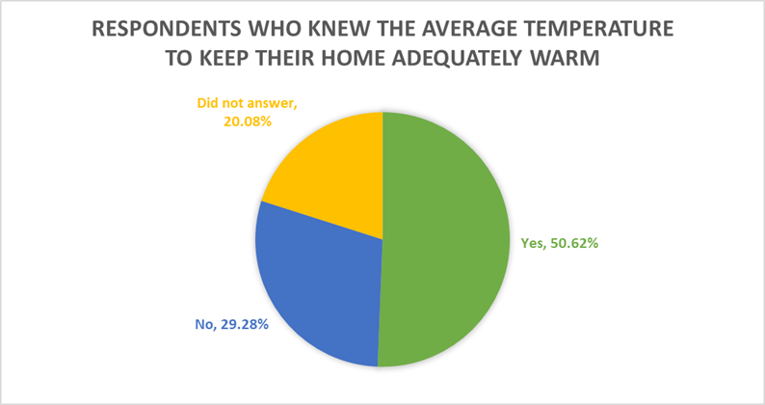

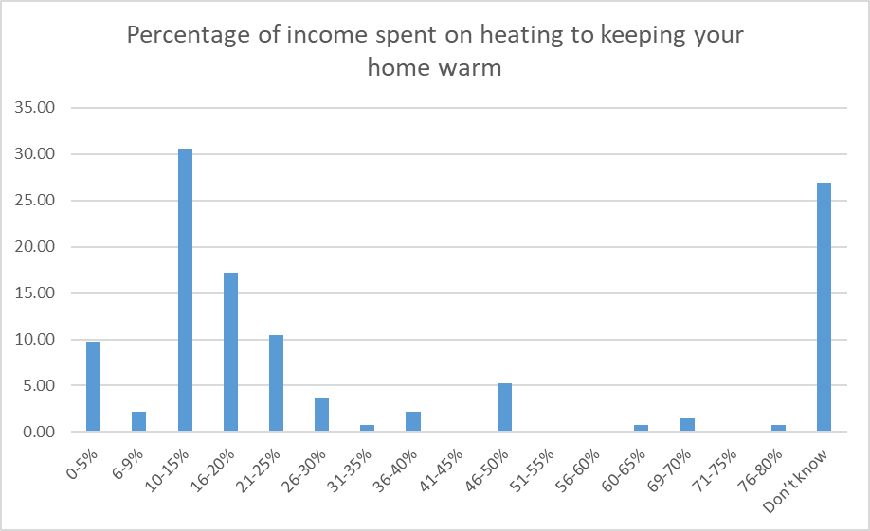

## 7.1 Summary of Responses to Housing

|  |  |  |  |  |
| --- | --- | --- | --- | --- |
| **HOUSING**  To stay living in our own homes and communities | | | | |
|  | **Agree** | **Disagree** | **Don’t Know** | **N/A** |
| I feel safe to live where I live | 90.76% | 7.06% | 2.71% | 0.00% |
| My home is suited to my current needs | 84.78% | 14.13% | 1.63% | 0.00% |
| My home could be adapted to meet my future needs if required. | 64.80% | 17.31% | 11.17% | 7.26% |
| Services are accessible to my home e.g. Shops, Post Office, Banks, Libraries etc. | 66.84% | 30.97% | 1.63% | 1.08% |
| My home could be more energy efficient | 70.62% | 15.81% | 14.68% | 0.56% |
| I know where to access home repair contractors who are trustworthy, do quality work and are affordable | 52.73% | 34.32% | 7.46% | 5.47% |
| My community is a good place for people to live in as they age | 73.36% | 18.09% | 7.53% | 1.05% |
| My home is the right size for all who live in my household | 81.40% | 14.57% | 2.51% | 1.50% |

## 7.2 Feedback on comments or strongly expressed feelings relating to Housing

|  |  |
| --- | --- |
| * I live in sheltered accommodation * Difficulty in getting home repairers who are trustworthy i.e. gardening, power washing etc. * I am not sure how Great James St. will be in ten years’ time. When we moved in 40 years ago there was a lot of families. Now very few and most are elderly who are likely to move. More flats and apartments and offices causes me worry as to what the future might hold if we stay. * We own house it is hard to get help with damp and mould. And help with not having money to get oil in the tank. Two years I had no oil. I have a social worker who signposted me nowhere. * Footpaths are often very uneven, ramped kerbs are often blocked by cars. At the moment it is very difficult as there is nowhere to go to meet other people and I need assistance to get out of my home and lack this support (skilled support for Older people) * I live in sheltered accommodation and because I worked all my life I pay full rent out of my pension. If I was on certain benefits I would be entitled to freebies! Why punish people who worked. * Homes for life and specifically old age ready, irrespective of ability is one of the most crucial needs for now and into the future but they must not be just crammed spaces in barren environments. They have to be fit for physical purpose but also emotional and natural wellbeing. * There needs to be more awareness of “homes for life” so people think about what their needs may be as they get older. Also needs to be more help for those who want to adapt their house e.g. a streamlined way to get planning permission for simple things like a downstairs toilet * Would certainly benefit from having a list of reliable affordable contractors * Organisations which have helped elderly people have disappeared e.g. Gable. We took great advantage of this agency and felt confident that they were trustworthy and efficient. * Renewable energy sources are not available easily and need to be introduced by Council. * I live at the top of a steep drive which I can manage while I can drive but I will probably have to move eventually. Similarly shops etc. are accessible while I can drive * What can you do about hills and the fact that homes built in the late 20th Century have steps; bathrooms upstairs. On the plus side close to all amenities unlike new builds which necessitate transport to access shops * My community has no health or community facilities * Difficult to find a reputable contractor. * There is a need for more community based services. | * Stairs can be a problem as get older * It is slightly too big but we can manage at the moment * My home is to big now family has all left * Some local shops have risen to the challenge of Covid and will do deliveries - that is something which many older people are saying - how good some shops have been. Other shops have been more resistant. Online grocery shopping is grand if you want to do that, I would prefer to shop local and get a delivery from a small local business * Trying to get workman at times is a nightmare, the job is too small, the address gives them some mad notions to add zeros. * Home could be more energy efficient. Will be too big for me soon. Rural area with no amenities in walking distance but lovely area. * More advice or help in using electricity to reduce the need to burn fossil fuels for heating. * It is very difficult to home repairs done as it doesn't pay worker to do small jobs. Need this vacuum filled with an approved list of qualified workmen * Part of my estate have no pavements for the elderly to walk. Urgently needing flow of traffic regulation so cars can get out of Templegrove but nobody is listening to the people living there * Proper & adequate wheelchair housing is non-existent in this city it is shameful. * Noisy neighbours who have no consideration for anyone other than themselves. * I feel there should be more retirement houses in this area * Home too big for two people * Older people are afraid to challenge anti-social behaviour, drugs are playing a major part in all of these issues * Hard to get an electrician to do small jobs. * Living here in Culmore we enjoy a village atmosphere and few outsiders (including potential burglars/criminals) come in. However, you pay for it - more than twice what people pay in Carnhill for example. * Lack of any local amenities means we could not live here if we did not drive. * I live in sheltered accommodation * Most shops require a car journey to access. * I don't like having to use communal laundry and risks with others not following rules. I am desperately seeking my own not shared accommodation. * Banks are closing too many branches, do not want customer to bank in branch. * More age appropriate social events at my local community centre would be great for my age group |

# **8.0 Social Participation**

*To participate in social, economic and public life*

The majority of participants agreed (67%) that during the pandemic, they felt lonelier than before. Just over half of respondents (52%) agreed that there are good public places to meet and spend time (e.g. parks, halls, centres for exercise, learn or socialise), with a large proportion of people (40%) disagreeing to this statement.

Almost three quarters (69%) of respondent’s fee confident to join groups, events and activities when they start to get back up and running again with over 25% responding to outline that they do not know or disagree with the statement.

The majority of respondents (44%) disagreed that there is a wide variety of activities that are available to appeal to a diverse population of older people to come out safely.

Over a quarter of respondents (28%) outlined that they face difficulties getting to various programmes, events or activities.

Approximately 14% of respondents felt their caring responsibilities limit how much they would like to get out and about to (e.g. events, activities etc.) as part of their wider social participation.

## 8.1 Summary of Responses to Social Participation

|  |  |  |  |  |
| --- | --- | --- | --- | --- |
| **SOCIAL PARTICIPATION**  **To participate in social, economic and public life** | | | | |
|  | **Agree** | **Disagree** | **Don’t Know** | **N/A** |
| There is a wide variety of activities that are available to appeal to a diverse population of older people to come out safely. | 36.26% | 44.55% | 17.61% | 2.07% |
| There are good public places to meet and spend time (eg parks, halls, centres for exercise, learn or socialise) | 52.33% | 38.86% | 6.73% | 2.07% |
| I feel confident to join groups, events and activities when they start to get back up and running again | 69.89% | 17.85% | 8.16% | 4.08% |
| I face difficulties getting to various programmes, events or activities | 28.19% | 53.72% | 7.44% | 11.17% |
| My caring responsibilities limit how much I would like to get out and about (e.g. events, activities etc.) | 14.13% | 46.07% | 3.66% | 36.12% |
| During the pandemic, I feel more lonely than before | 67.51% | 23.35% | 2.03% | 7.10% |

## 8.2 Feedback on comments or strongly expressed feelings relating to Social Participation

|  |  |
| --- | --- |
| * I missed clubs during the Pandemic * Sometimes there are events and programmes only available at night. I can't attend unless I am offered a lift or pay for a taxi service * I do believe the management has no idea how to treat he elderly and still charge full rent for the premises even if half of it is locked? * Because I am long time sufferer of ME/CFS (8 years) apart from being able to go out for a walk for about an hour, I am confined to the house. Having more events linked to zoom or YouTube would make events and programmes a great deal more accessible * Despite being a strong extrovert I found ways to keep sufficiently occupied - happily and creatively. I just enjoy the gift of life and good health thankfully * These questions can't be answered properly because of pandemic. * Moved to sheltered housing but very little mixing due to the pandemic. All social activities off. Older people are suffering too. * Sometimes you just want out of the house for a cuppa and chat with no other agenda or outcome measures. I need support to attend any social gathering but am very keen to access. Also just going around the town meeting people is what I enjoy doing. * I feel there are a good variety of activities. Before the pandemic I attended a few of these. They could be much better attended if more information was available to the public about them. * There is a need to reimagine and develop places, projects and support systems for older people to reengage, regain lost confidence, fitness and real connections. Covid restrictions have caused incalculable problems with regard to participation. It has to be a priority as to how to address it. * Everywhere is closed during the pandemic. Social groups are badly missed for both women and men. * This area has no community hall, there’s a new “hub” but because of the pandemic it’s closed.it is almost impossible to get any help here at all. I’ve tried, I personally paid for crafts, fundays, kids things to help my neighbours. it’s all political and it’s all very hard to get any contact. * There were activities for my age group but will people come out again? * It will be good to meet up with people again and have chats and coffees etc. * I have agreed with most of the questions the pandemic has raised a lot of issues l have zoomed but nothing makes up for personal face to face and human interaction * Not everyone knows about activities or the cost or location. Need a directory which would give details. The current community groups need to facilitate local responses to overcome isolation especially those who live alone and who don't drive and or have mobility issues. * I just feel it’s necessary to stay safe but it lonely * Have plenty of home entertainment * I feel that available classes etc. for older members of our community are not well advertised or well thought out. Perhaps a survey to gauge what pursuits older people would like to participate in might be an idea. Then advertise them well. I have been at a few classes where numbers were very poor, * There’s a definite lack of green space in the immediate area (Sevenoaks). Council planning approvals for developers seems to be biased with little account for local residents. There are few play areas for young people and I frequently see football being played on the streets! * I work from home, but home never felt claustrophobic until lockdown and I was told I couldn't go out when I needed a break! * Very lonely through pandemic. Anxiety and depression issues * I feel there are a good variety of activities! Before the pandemic I attended a few of these. They could be much better attended if more information was available to the public about them. * Sometimes you just want out of the house for a cuppa and chat with no other agenda or outcome measures. I need support to attend any social gathering but am very keen to access also just going down the town meeting people is what I enjoy doing. * I missed clubs during pandemic * Sometimes lonely and maybe bored * Nothing available locally for social participation | * I feel there is a need for services etc. for people who are younger/older * Older people aren't all the same. Not all of us want to go to bingo or on a bus trip. No cognisance that people who are now classed as older were young during the punk era. As if we'd want to play bowls. * I can’t see my children, grandchildren or give them a hug. No one can come into the house, very isolating. * The excellent facilities in the Claudy/Eglinton area depend upon a huge amount of voluntary effort to raise funds on the part of a small group of people. More input from Council is necessary to ensure a long-term strategy. * Will be glad to get out and meet friends at my clubs in Eglinton again * Need more group activities that are outside the city limits in the parks. E.g. the bay road park is a cracking facility, surrounded by a large retired community. But it's full of 'packs' of runners / cyclists. * Sometimes groups don’t easily welcome new members. There are limited opportunities to socialise. I have started a walking group a few years ago, but couldn't continue during lockdown. * Derry has a wide range of activities available and a great community spirit * I have activities in my supported living home. I don’t want to go anywhere else. * The pandemic rules are a farce! * Most of the groups I belong to have predominantly female participants. More encouragement/inclusion needed for men * Difficult to motivate self to ring friends as one day is pretty much the same as the day before * Normally apart from lunches my local community centre does not offer activities for more mature people * We live in the country * I miss the social interaction of meeting every week. * The first 4 points would normally earn Yes, but not in current circumstances. To me loneliness is a state of mind that I cover by keeping busy. It is essential that we get funding again to go to the Foyle Arena, Millennium Theatre, Guildhall, Galleries, meet people from other cultures, craft classes, speakers. * Was lucky had the internet in my home was able to do classes through zoom and do face time with family * Sadly, none of this will come to anything because when budgets are revised because of Covid19 and its ramifications the first pot that will be targeted is the most vulnerable as it always has been. Even before Covid19 the most vulnerable had their budgets hacked to pieces before 'joe public" so all this survey will do is sit on a shelf gathering dust. * Do not see any physical exercise infrastructure or keep fit equipment in our public spaces for seniors unlike in the continent. * Have been doing well. Eating alone all the time gets to me as I met friends each week for coffee/ lunch. Zoom is Ok but not the same as face to face. * These questions can’t be answered properly because of Scamdemic * I expect Derry City Council to make available relevant and specific information to seniors in terms of health, safety, availability of safe and properly serviced, disability friendly recreation spaces. Some City Parks are in a disgraceful state and certainly not maintained nor managed at all. There is great criticism in the city about the poor and potentially dangerous condition of parks and open spaces. Better on site management and accountability does not exist. Emails of complaint went sent to the parks management are not acknowledged or replied to. * There are no facilities in my local area that I feel would accommodate my needs * Moved to sheltered housing but very little mixing due to the pandemic. All social activities are off. Older people are suffering too. * Despite being a strong extrovert, I have found ways to keep sufficiently occupied happily and creatively. I just enjoy the gift of good life and good health thankfully. * Sometimes there are events and programmes only available at night. I can’t attend unless I am offered a lift and pay for a taxi. * During pandemic we have not gone out at all. Life has been very difficult and I think we need to move away from Derry to be closer to family. * Sometimes lonely and maybe bored |

## 8.3 Interaction with Friend, Family, Neighbours and Others

Family remains the most popular grouping of people that respondents interact with on a daily basis (64%) closely followed by friends at 30%. The following chart outlines frequency of interactions between various groupings.

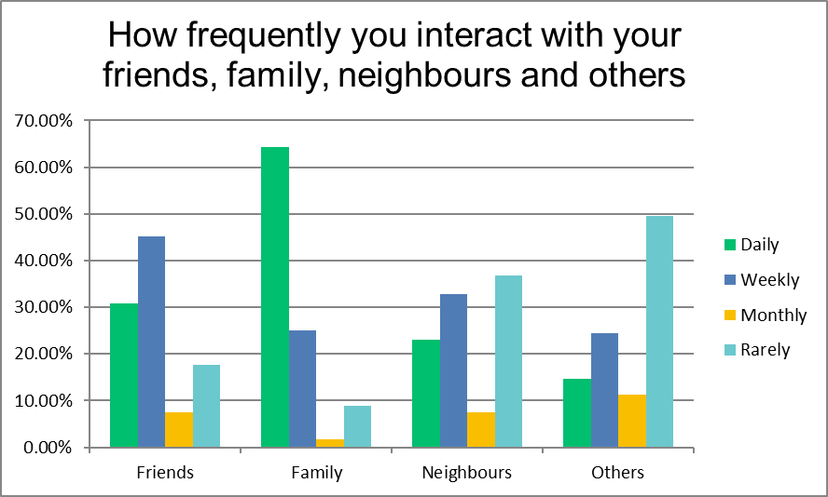

## 8.4 Feedback on additional comments relating to interaction with Friends, Family, Neighbours and Others

|  |  |
| --- | --- |
| * My only contact with friends and others would be by phone * GP, Podiatry Appointments, Physio Appointments * Don't see neighbours as much due to the Pandemic * Very little interaction between persons so my mental health is in jeopardy * Fellow residents in my community * Not mixing during pandemic. In a support bubble with daughter. * Other family and friends * I phone the above on a daily basis. Sometimes I would like to hear from other volunteer groups. I do receive a good morning park call on a daily basis. More volunteer phone calls please. * Just through volunteering and all via Zoom and Social media. * Do not have contact outside my building * Work colleague as I work two mornings each week * This is by phone. * Family visit with shopping weekly as they can’t come indoor other times by phone * Any one I come in contact with be that through daily interactions * Lack of safe spaces to meet people in a social setting. No visible public campaigns to encourage same. * Interacting and meeting up is very different. * Friends in different areas of Derry City and abroad. * Without the support of Foyle Woman’s Information Network and the staff of the Junction Bishop Street I would feel totally isolated * Shop staff etc. * Covid obviously has put paid to a lot but normally as chairperson of a local autism group we meet up on a very regular basis. At the moment all our contact is via group chat on What’s App and sharing info via our private and public group page and I also post a video every Friday. * Not mixing during pandemic. In a support bubble with daughter. * People at my part time job | * I do a lot of things by Zoom these days. It's brilliant for those of us who are unable to get out and more local events should be accessible this way now and in the future. * All interact is on the phone * 50+ group / choir * Other Shoppers Whom I Meet * People from groups I might know. U3A is very expensive and no similar groups encourage group learning, apart from trivial topics. * Staff in the Home * Clubs and U3A * Not during the pandemic * Eglinton exercise group * Sister brings shopping, hands over at door. Contacts by FaceTime. Pharmacy * Delivery man and Postman say hello. * Out for a walk every day was able to see people * I am working still and have lots of interaction * Being a voluntary driver, I get talking to my passengers on a weekly basis. * Only on an I pad now, and phoning, there’s nowhere here to meet up. * Since the virus I don’t meet anyone * just passer-by’s when walking * Friends and family who live in other countries * Shop assistants. Phone enquires * Was thinking that some of the faith communities provided daily contact and the pandemic has changed that. This needs to be rebuilt and support provided. * Through phone calls, Zoom, Messenger, * Internet * Not sure if 'interact' includes social media but at the moment in Culmore, Facebook is the new Magnet! (It's byo) * I phone the above (Friends, family, neighbours and others) on a daily basis! Sometimes I would like to hear from other volunteer groups. I do receive a Good Morning Park call on a daily basis. More volunteer calls please. * Other family and friends * On the internet only. |

# **9.0 Civic Participation and Employment**

*To continue to learn, develop, work and contribute to Society.*

The majority of respondents (93%) utilise their right to vote during elections. With over 62% agreeing that they know where to access information to help them continue to learn, develop, work and contribute to society, over half (53%) disagree that there are employment opportunities for older persons.

Just over half of the respondents (52%) know where to access and receive advice on income and accessing benefits. Less than half of respondents (47%) would volunteer if they felt supported to do so through practical support e.g. encouragement and reimbursement for transport.

## 9.1 Summary of Responses to Civic Participation and Employment

|  |  |  |  |  |
| --- | --- | --- | --- | --- |
| **CIVIC PARTICIPATION AND EMPLOYMENT**  To continue to learn, develop, work and contribute to Society. | | | | |
|  | **Agree** | **Disagree** | **Don’t Know** | **N/A** |
| I take part in civic activities that benefit the community | 43.85% | 38.01% | 3.50% | 14.61% |
| I know where to access information | 62.20% | 27.32% | 7.55% | 2.90% |
| I know where to access and receive advice on income and accessing benefits | 52.03% | 29.47% | 10.40% | 8.67% |
| I would volunteer if I felt supported to do so (e.g. encouraged and reimbursed for transport costs) | 47.33% | 23.66% | 13.60% | 15.38% |
| There are employment opportunities for older persons | 8.67% | 53.17% | 26.01% | 12.71% |
| During elections I cast my vote | 93.25% | 5.61% | 0.00% | 1.12% |

## 9.2 Feedback on comments or strongly expressed feelings relating to Civic Participation and Employment

|  |  |
| --- | --- |
| * Due to my age and disability i am unable to volunteer * Good opportunities for older people to avail of volunteering in health service or community or supermarkets * I am unable to take part in civic activities or volunteer because I am living with severe ME/CFS * I always cast my vote - It took long enough for women to be "allowed" to vote! As a person in mid-eighties I am retired just a year ago from work in the community. I help still whenever I can where I can use my expertise * I feel my stories and life experiences could benefit civic society but there is no connection between young and old. Everyone is in their silos. We are segregated in more than creed. * I worked all my life in the public sector and was glad to get retired. I am not selfish about volunteering but I find that I am enjoying getting away from the public sector! I do not think I could ever change my mind if something else was available I would change my mind. If I was reimbursed for any costs! * There is hardly any where more ageist than work environments for people as they get older. Legislation needs to be enacted and advocacy systems in place to protect older people in the workplace and in relation to their increasing exclusion from work opportunities. * I volunteer two mornings each week with a befriending group * We should be able to vote electronically as polling stations are often inaccessible or difficult to navigate for older people or those with disabilities * There no one worth voting for, no one to unit people. No one to move on from the past. * Need to establish why some older people don't engage. Our leaders need to be proactive in engaging and publicly demonstrate this by supporting a community council for older people. good to see this initiative but more is needed * Feel older people living in public housing are looked after better than others that live in private housing as they have community groups and volunteers in their area. * Vote but get nothing for it but more cuts & ignoring of all disabled needs including housing transport social activities etc. * I already do volunteering. * It is difficult to get Council information on what support/Council responses is available to seniors when problems in council recreation places. | * I began a part time cleaning job during lock down in order to get out of the house as I was feeling increasingly isolated and depressed. I don't feel there are many work opportunities for older people. I only got the job because my daughter worked for the company and put me forward and no one else applied. * I do volunteer already locally * There are few opportunities for employment for older people in our community. We could help in many ways but we never get the chance. I volunteer but I have never had any support or encouragement. * Before the pandemic I did volunteering for our community centre * If there is anything that I could volunteer for I would not require financial support. * This is a forgotten village, it’s Culmore so people say we don’t need anything! there’s now a ‘hub’ I can’t get to it yet we have to drive to the city for everything. hairdressers, medical, clothes which I don’t mind I have to pay the parking and go from there. * I would volunteer without payment. * There is frequently a lack of skill capacity in small voluntary groups to manage the admin tasks like accounts and reporting to CCNI, funding applications. SC NI used to provide help but they have reduced their efforts. BIGGER groups can engage paid mangers but smaller groups are left on their own * As regards casting my vote l have always done so but on reflection l feel democracy is not being applied * I feel my stories and life experiences could benefit our society but there is no connection between young and old. Everyone is in their roles we are segregated in more than creed. * Due to my age and disability I am unable to volunteer * I have been a volunteer for the past 30 years and do everything in my power to support the people of this city and make it a better place to live in * I know that there is a silent ageism everywhere - if you are job-hunting in your 50s, nobody believes in paying for your years of experience; the fresh graduate is cheaper and always wins out. * I worked all my life in the public sector and was glad to get retired. I am not selfish about volunteering but I find I enjoy getting away from the public sector. I do not think I could ever change my mind, if something else was available I would change my mind, if I was reimbursed for any costs. |

## 9.3 Availability for flexible opportunities for working, volunteering after retirement and adult education and courses.

Respondents were given the opportunity to reflect on the availability for flexible opportunities for working, volunteering after retirement and adult education and courses.

The below chart indicates that over 64% disagree or don’t know about flexible opportunities for working, with the majority agreeing that there are opportunities for volunteering after retirement and adult education and courses.

## 9.4 Feedback on comments or strongly expressed feelings relating to availability for flexible opportunities for working, volunteering after retirement and adult education and courses.

|  |  |
| --- | --- |
| * Not at 75 years of age * It all depends on what the offer is * I wouldn’t be interested in any of this * Education and courses need to be online for me to access them because of ME and limited energy * Personally education around technology - computers especially would be very helpful in today’s fast world. * I am really not sure about the above answers! It all depends on what is on offer! * Much more could be done to harness the knowledge and experience of older people but it's all lip service. No practical proposals or ideas. * For persons not in receipt of Pension Credit, courses etc. can be expensive. Frequently, it is difficult to reach the quota required in villages for a course to run. * Few if any opportunities exist for such participation. * Not in my area for older people * Have attended U3A courses | * As I’ve said, this is a forgotten village, maybe when the ‘hub’ opens and people can get together I can get some company. * Not necessarily such flexible options or costs with regards education courses etc. * A serious lack of provision of the above. Seniors and the disabled appear to be invisible to the statutory authorities. * I do not buy local newspapers. * Not just lack of courses activities but also cost, location, scheduling at appropriate time and access * I feel now it’s older people who tend to volunteer * I again would say that there is not enough information given about courses and classes available for older people * Too many courses are too expensive. * Was a Church attender * Volunteering is excellent for your mental health. Gives you a reason to get up in the morning. |

# **10.0 Respect and Inclusion**

*It is essential that older people are valued, respected and especially included in matters that directly affect the*

Over 60% of respondents feel respected and included within their community with almost one fifth (17%) of respondents have experienced ageism where they believe they have been discriminated against due to their age.

Over half of respondents (54%) disagree that older people are consulted by public, voluntary and private organisations on ways to serve them better.

Furthermore, over half of respondents (52%) also disagreed that facilities have helpful and courteous staff to respond to older people (e.g. offering priority hours, allowing use of cash, space for people to stop and rest).

Less than a quarter of survey participants (23%) outlined that activities that bring generations together for mutual enjoyment and enrichment are regularly held.

## 10.1 Summary of Responses to Respect and Inclusion

|  |  |  |  |  |
| --- | --- | --- | --- | --- |
| **RESPECT AND INCLUSION**  It is essential that older people are valued, respected and especially included in matters that directly affect them | | | | |
|  | **Agree** | **Disagree** | **Don’t Know** | **N/A** |
| Older people are consulted by public, voluntary and private organisations on ways to serve them better | 26.77% | 54.64% | 18.03% | 0.54% |
| Facilities have helpful and courteous staff to respond to older people (eg offering priority hours, allowing use of cash, space for people to stop and rest) | 27.02% | 52.43% | 20.00% | 1.62% |
| I have experienced ageism where I believe I have been discriminated against due to my age. | 17.64% | 59.35% | 14.97% | 8.02% |
| Activities that bring generations together for mutual enjoyment and enrichment are regularly held | 23.24% | 53.51% | 22.16% | 1.08% |
| I feel respected and included within my community | 61.82% | 19.35% | 15.59% | 3.22% |

## 10.2 Feedback on additional comments or strongly expressed feelings relating to Respect and Inclusion

|  |  |
| --- | --- |
| * Due to the pandemic any activities are prohibited which I think is a pity e.g. a few of us did weekly exercises together weekly but now not allowed * Few seating areas in supermarkets * There are no activities held at Culmore Park and we are not respected and not included in any decisions. We are just dictated to * I find younger generation disrespectful when approached about playing football outside my house. I have notified the council but to no effect * Respect is a lot more than toleration and if I don’t respect myself or know how to then I cannot respect anyone else. This is something I feel very strongly about * Consultation with older people needs focused effort and needs to be creative. * I think that there are lots of things that could be sorted out in the community. If you're on social media you’re on the ball about everything while other people not on social media have not got a clue!! * There are no community activities * I find younger people especially in shops/supermarkets talking to me as if I’m old and decrepit * Some limited activities are available and are mainly targeted at the very elderly. * I have experienced ageism against my elderly mum in my local supermarket. It was the security guard in the store who was impatient and unkind. He didn't realise I was with her and he didn't realise I was watching him. * In my community it’s a very new hub they call it, I have to phone every time to try and get anything for our area. I know a lot of people don’t need as much as other areas, but I really do know a lot of families and elderly could do with some help. * Once we get established in groups we are consulted. Many people don’t join groups especially men. * Again Covid-19 * Condescending attitude to older people and l feel this pandemic has increased this from media talk of vulnerable as if we should be put down we exited we worked and played our part in the world * I don’t feel included as there is nothing for older people to do * In the past I have applied for jobs where I doubt anyone else would have had the experience that I have, but I got no reply. Similarly, my wife, who is an experienced HR professional. This is particularly true in DCSDC * Community centre locally are just clicks for family and friends and very politically biased. * I don't know of any activities for my age group in my local community * Ageism is everywhere. From being ignored in shops to being referred to loudly as ‘this wee woman’. We are very much not part of this community because we are ‘blow ins’ * I think that there are lots of things that could be sorted out in the community. If you are on social media you’re on the ball about everything while other people not on social media have not got a clue. * Consultation with older people needs focussed effort and needs to be creative. * Due to pandemic my activities are prohibited which I think is a pity, e.g. a few of us did weekly exercises together weekly but now not allowed. * Respect is a lot more than toleration, and if I don’t respect myself, know how to, then I cannot respect anyone else. This is something that I feel very strongly about. | * Older people now regarded as burdens on society. Regular abuse on social media e.g. "Boomers” Try getting a job with any responsibility once you're over 50. No promotion of job shares or part-time working for older people who might want to semi retire. Poor use of online provision to address mobility barriers. No cognisance that older people aren't a monolithic group. * Learmount Community group tries hard to address issues for older people. Needs more Government support * Generally, there is a feeling that older people are being overtaken by technology e.g. use of cards, internet purchase. There is an expectation that everyone is computer competent (and I write as someone who uses a computer regularly. * Living out in the country feel disconnected from the community. * No community where I leave * Feel that there are very few opportunities for multi-generational working/socialising. Shops cater for younger people - insufficient services include seating * Most people are kind and considerate * I think older people are mostly ignored and our views treated as though we are suffering dementia. * Older women in particular seem to develop a cloak of invisibility and there are still quite sexist expectations about women carrying out caring responsibilities as a due. Male peers carrying out caring tasks often are thanked more often * Fractured my wrist was told surgery not considered after the age of 65 * Previous work I know I was pushed ever so slightly in a very nice way * Local store always pack food and carry to car. Very courteous. Until lockdown we had activities for all ages, e.g. Christmas Carols, Scarecrow competition, garden party. Party at Cricket Club * We need more ways of consulting older people. Wonder has anyone asked how would you like to be consulted. We also need to see results of consultation. Many suspect that decisions are already made and the views of the public ignored. Have experienced this in relation to planning and housing. Experts thinking, they know best - more respect is needed to hear a challenging points of view and to examine perspectives before decision are made. Think the pandemic has been challenging for older people and the narrative around how older people are described. * I have been disrespected humiliated and attacked by my own community and nothing was done except me being made homeless and destroying my life. No support was forthcoming at all * There is little respect for seniors using Derry Council's Parks and open spaces, for example parks I use are a disgrace each morning after young people enjoy nights of uncontrolled drinking, vandalism and public property vandalism and damage. Each day the council do not clean up the mess. No full park inspections take place in fact there is no visible physical management or supervision of most parks. * Very few places to take a short rest. Most shops have none. * Rude and aggressive neighbours who have no consideration nor respect. * There are no facilities * I find younger generation disrespectful when approached about playing football outside my house. I have notified DCSDC but to no effect. * Few seating areas in some supermarkets |

# **11.0 Communication and Information**

*To have the information we need to lead full lives*

The majority of participants (85%) outlined that a service that signposts them to services would be very beneficial to help access the information they need to lead full lives. Less than a quarter of respondents (23%) use their local community centre for information on what is on (e.g. services / programmes / events). Over half (52%) identified that the media (local papers, radio, etc.) has useful bulletins on local events and activities.

Regarding information about services being widely available received a more mixed feedback with only 40% agreeing to this being available. This was furthered with another trend in relation to participant’s feedback regarding having all the information needed regarding citizens and consumer rights with 39% agreeing.

Over three quarters of survey participants (77%) agreed that during the pandemic, they were able to use the internet to keep in touch and get the information they needed. With just over a third (37%) outlining that they would benefit from assistance with information technology (e.g. computers, smart phones, internet). The below chart outlines how respondents use different types of tools for information and to communicate.

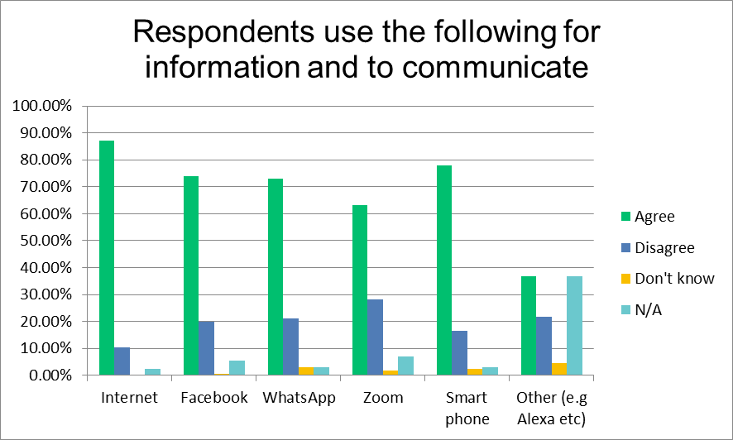

The below are additional comments received from participants relating to information and communication

|  |  |
| --- | --- |
| * Alexa * Drone, editing software, all technical equipment and apps. Retired IT professional. Condescending question as most older people know everything about new technology. * Instagram, Snapchat & Tik Tok * I would like to see more facilities for older people to learn how to use social media more independently. I attended a few such classes but they seemed to always have too many advanced people. (Beginners please) * Friend helps with Internet & online as I don’t know how to set it up * My son uses the Internet and WhatsApp, and I connect with family though it | * Laptop * I pad * I don’t need to * Computer * Tablet * landline, snail mail * Skype, Twitter * Webex, Microsoft Teams * Instagram, snapchat and tik tok * All social media. * Work email * Other social media such as twitter and Instagram; online services such as ebooks * Computer programmes e.g. Microsoft and graphics packages and other social media |

## 11.1 Summary of Responses to Communication and Information

|  |  |  |  |  |
| --- | --- | --- | --- | --- |
| **COMMUNICATION AND INFORMATION**  To have the information we need to lead full lives | | | | |
|  | **Agree** | **Disagree** | **Don’t Know** | **N/A** |
| There is information about services widely available | 40.96% | 40.36% | 17.46% | 0.00% |
| The media (local papers, radio, etc.) has useful bulletins on local events/activities | 52.94% | 24.70% | 21.76% | 1.17% |
| I have all the information I need regarding citizens and consumer rights | 39.05% | 42.01% | 17.15% | 1.77% |
| I use my local community Centre for information on what is on (e.g. services / programmes / events) | 23.95% | 56.28% | 5.98% | 14.37% |
| A service that signposts me to services would be very beneficial | 85.88% | 3.06% | 6.13% | 4.90% |
| During the pandemic, I am able to use the internet to keep in touch and get the information I needed | 77.58% | 16.66% | 2.87% | 2.87% |
| I would benefit from assistance with information technology (e.g. computers, smart phones, internet) | 37.64% | 38.23% | 7.05% | 16.47% |

## 11.2 Feedback on comments or strongly expressed feelings relating to Communication and Information

|  |  |
| --- | --- |
| * No transport available to community centre or information centres (well we were not informed) * Very ageist questions, assumption that older people are somehow unable to find out any information unless they are led by the nose. Mind you not all people read local papers or listen to local radio. Social media is the best option for information or online news. * Information - Not in all rural areas * I no longer read any newspapers. Where I live we do have a list of certain available services * I have just bought one of those other phones. I can access Church services but it takes a bit of getting used to! That is when a helping hand would come in useful! * Digital exclusion of older people has to be quantified and resolved. * How would anyone access this survey if they couldn't access the internet? Very poor use of online methods by local council etc. They're in the dark ages. * I and my spouse became computer literate at an earlier stage e.g. ECDL. However, as the years have gone on, there are fewer classes to 'upgrade' our use of technology to a point where we feel more skilled. * Religious services information is usually available but from my experience little else. * There is a lot of information floating about. Written guidance is useful but it is the interaction with a human being that reassures and informs. Online gives sketchy details about common situations but fails miserably with specific issues. | * I do not buy newspapers I would like to be informed of events etc. by email. The last time I checked the Council website I gave up because a lot of the information in the site was years old and not updated. Not worth viewing. * I’ve limited knowledge of the internet * The U3A Foyle covers all activities via zoom great keep fit yoga languages painting bridge etc. * There is no Community Centre in the immediate area. These tend to be located in areas where so called “community groups” are active and can utilise political funding!! * We often find out about things by accident. * I have just bought one of those other phones I can access Church services but it takes a bit of getting used to. That is when a helping hand would come in useful! * Local papers * Memory isn't what it used to be * The statement “I have all the information I need regarding citizens and consumer rights" cannot be answered unless I am told of all the detailed rights available beforehand, seems a strange statement to make * If you are on social media you may hear about events, courses etc. but if not you could hear about nothing. * Being left homeless left me with no Internet radio or information so pretty much left in the dark as well as being left homeless shame on this city for treating people like they do. * It’s been so difficult to get information. I’m not at all technical and using the phone is a nightmare as it’s all machines. * My daughter sorts anything out for me on internet. |

# **12.0 Community and Health Services**

*To help older people to live healthier, active and independent lives for longer*

Community and Health Services are a vital link to help older people to live healthier, active and independent lives for longer. The pandemic has had an impact on community and health services and how to help older people to live healthier, active and independent lives for longer.

The majority of people (86%) who responded agreed that they have been able to access their medication with 66% agreed that they are able to access support from health professionals and services when needed. The majority of people (60%) indicated that their mental health and wellbeing has been affected by the pandemic.

Over half of respondents (55%) agreed that they are able to rely on others outside their family network for support and nearly one fifth (17%) indicated that they were not sure who they can turn to for help and 19% expressed difficulty in getting food to their home during the pandemic.

Half of respondents (50%) outlined that Health and social services are conveniently located and accessible by all means of transport.

Just over two thirds of respondents (66%) are able to access GP Appointments when needed and the majority (80%) of respondents indicated that they were able to access good quality GP services (e.g. practice nurse/repeat prescriptions) when required.

A further 71% agreed they had access to good quality health care facilities and services when needed, however less than one third (31%) agreed that facilities and support exist for older people living with chronic health conditions.

Over three quarters (77%) agreed that they are prepared if faced with a health crisis and know who to contact if help is needed. The majority of participants (91%) responded outlining that they felt they eat well and have nutritional meals.

## 12.1 Summary of Responses to Community and Health Services

|  |  |  |  |  |
| --- | --- | --- | --- | --- |
| **COMMUNITY AND HEALTH SERVICES**  To help older people to live healthier, active and independent lives for longer | | | | |
|  | **Agree** | **Disagree** | **Don’t Know** | **N/A** |
| I have access to good quality health care facilities and services when I need them. | 71.42% | 26.08% | 1.86% | 0.62% |
| I eat well and have nutritional meals | 91.35% | 6.79% | 1.23% | 1.23% |
| I am able to access good quality GP services (eg practice nurse/repeat prescriptions) when needed | 80.12% | 18.01% | 1.86% | 0.62% |
| I am able to access GP Appointments when I need them | 66.87% | 31.25% | 1.87% | 0.62% |
| Facilities and support exist for older people living with chronic health conditions | 31.84% | 25.47% | 35.03% | 8.28% |
| Health and social services are conveniently located and accessible by all means of transport | 50.64% | 32.46% | 16.23% | 1.29% |
| I am prepared if I have a health crisis and know who to contact if I need help | 77.01% | 14.28% | 9.31% | 0.00% |
| During the pandemic my mental health and wellbeing has been affected | 60.36% | 29.26% | 7.31% | 3.04% |
| During the pandemic I have been able to access my medication | 86.06% | 4.84% | 0.60% | 9.09% |
| During the pandemic, I am able to access support from Health professionals and services when needed | 57.66% | 28.83% | 4.90% | 8.58% |
| During the pandemic, getting food to my home is difficult | 19.55% | 74.86% | 0.55% | 5.02% |
| During the pandemic, I am able to rely on others outside my family network for support | 55.19% | 27.86% | 4.91% | 12.02% |
| During the pandemic I’m not sure who I can turn to for help | 17.97% | 62.92% | 5.05% | 14.04% |

## 12.2 Feedback on comments or strongly expressed feelings relating to Community and Health Services

|  |  |
| --- | --- |
| * More help in supermarkets when bagging groceries * There is nobody here to complain about residents. The management here only dictates what they would like us to do without any consultation. * It can be hard to get to the GP * Sometimes the GP will phone the ambulance rather than come out to see me * My GP has now relocated to Rathmore centre and it's a bit difficult to get to by public transport * My experience is that people are kind, willing and helpful * No podiatrist was available apart from in the private sector - it cost £40 a visit! * It has been harder to get seen by my GP during this pandemic. * I am single and find difficulty accessing help! I would like to have more hands on support whenever I do not have any family of my own. * During this pandemic where I live its everyone for themselves * It’s not always easy to get an appointment with a doctor worse since the pandemic began * Services are limited and have been affected by Covid 19, GP surgeries have been particularly sketchy in their provision and could have organised better I feel. I also have experienced administration staff triaging on the telephone outrageous * GP practice was bad before pandemic re appointments (at one point you had to queue outside from 8am to make one) Appointments like gold dust and most of the decent GPs have been forcibly retired. I'd change my practice except it's impossible to get on anyone else's list. They're a law unto themselves these days. * I have found access to health professionals more difficult during the pandemic. I do however still get my bloods taken by nurses in health centre every month. I avoid going into shops or town where possible and depend on family to get shopping and prescriptions for me and leave it at back door. This is not always easy as I live quite rural and not easily got to especially during the snow where house is not accessible by car and it’s a particularly steep hill to climb to access on foot * During the pandemic l have felt cut off from the good health services we normally have in this area especially GP and hospital appointments. * Didn’t feel the questionnaire gave enough options * I find that sometimes GP surgeries are hard to contact. Waiting times for follow up medical consultations /treatment are very long. * Car parking at some health centres could be improved * The staff help me with everything * My GP has now relocated to Rathmore Centre and it is a bit difficult to get to by public transport. | * Doctors’ appointments are non-existent. Phone calls are not being answered. * There’s so much to access now by phone and if it’s a machine there’s no chance of help, then it’s always different people if I ring looking for help. It’s all big shops open, big chains, so no one knows anything. I wish I could have more local shops again. * Family and neighbours have been very supportive during the pandemic. I am also aware of that local community support is also available * Waiting years for a joint replacement * Community respiratory team excellent. Women's health physiotherapy is great but has been reduced during pandemic. GPs need to review the 8.30 appointment system that they operate. * Totally isolated and homeless wonderful combination with poor health in a pandemic with no support it is a joke each person passing the buck and ignoring the complete lack of services that existed way before the pandemic arrived - just has made life not worth living at all. * Have had great difficulties accessing both medication delivery and food deliveries. Therefore, very dependent on others which does not always work. Have to ensure dried and tinned foods were available for my use when needed. There are no facilities/ services available for people with chronic health conditions that I know of. * I have a good family network * Getting a doctor’s appointment when needed is literally impossible * GP phone consultations OK but feel reluctant to ring GP. Have been referred to A&E when I thought GP could solve! * The only place we have gone is to the pharmacy and on occasions that has been so hazardous my husband is currently without medication because he won’t go. Again if we couldn’t drive we couldn’t access anything. Our GP surgery is very dependent on who you get. * I am single and find difficulty accessing help! I would like to have more hands on support whenever I do not have any family of my own. * No podiatrist was available apart from in the private sector- it costs £40 a visit! * My experience is that people are very glad, willing and helpful * More help in supermarkets while bagging groceries. * It has been harder to get seen by my GP during this pandemic. * I am paying for weekly supermarket home delivery. I have to collect my prescription from chemist and other customers don't all wear masks * Medicine delivered weekly. Have phone numbers of three neighbours for an emergency. |

# **13.0 Areas for Improvement across Derry City and Strabane District area**

Respondents were provided with an opportunity to highlight and identify the key aspects which they feel could be improved to make the Derry City and Strabane area better for older people. This open ended question provided participants with a platform to respond. The following is an outline of the responses contributed.

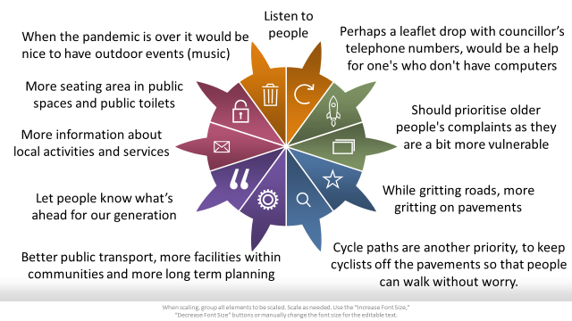

Further comments and responses include

|  |  |
| --- | --- |
| * More activities for those living in sheltered accommodation * Don't know * Tired looking buildings and shop fronts could be spruced up * No idea * While gritting roads, more gritting on footpaths. Salt boxes left in each street * Make it compulsory for cyclists to have a bell. Lots of signage for some bike owners to remember that older people walk slower as do families with children. none of us have eyes at the back of our heads to know someone is racing behind them. I've been close several times to being knocked over. Most of them are rude. Provide a skateboard park for young people also space for those that want to play netball/basketball. * It would be great if inspectors could be employed to visit sheltered housing on unannounced visits to see what the conditions are like and why some residents want to be relocated * Not to send our rates money up in smoke on Halloween night. (A pagan festival). Put the crib in the Guildhall out on display early in December to re-Christianise some people and fro children to see. Too much money spent on the secular side of Christmas. The crib could be installed outside of the Guildhall (like it was many years ago) and a protective barrier erected around it. * I feel they do a very good job that's relevant to enable people to lead healthy lives * Should prioritise older people's complaints as they are a bit more vulnerable * because of constant digging on roads and pavements for yet more phonelines or other additions I do think more attention needs to be given to this area of our lives. Cycle paths are another priority to keep cyclists off the pavements so that people can walk without worry * Make Waterside community groups participate in Social Prescribing and have them leaflet drop local housing estates. * Could provide more information on what is available. * Tired looking buildings and shop fronts - could be spruced up. * Approach some older people’s services as integrated with other generations. Provide accessible transport to access services with someone who can provide assistance to help me out. Create spaces for older people to connect that is not facilitated formally, nor has outcomes but is safe and accessible, relaxed and enjoyable without stigma. * I do not use social technology therefore I am unaware what is happening in all of these public areas? Please inform older people like me about what is happening and not happening in Derry and Strabane District! * How much time do you have? * Consider there are many people living in the countryside and villages who should get equal facilities and opportunities to part take in projects * Less emphasis on community centres which cater for single communities such as Irish St and Top of the Hill; more programmes for mixed generations * More information about local activities and services * Be more customer focused, what can you do for your customers, more flexibility to do more things that aren't a million miles from what you already do. * Provide More Information about Benefits and Workmen! * Maybe more info on services available to older people * Be easier to get in touch with and reach when we need them * A whole lot * Offer employment opportunities for older people, listen and hear our voices and respect us as a resource. Start work on encouraging use of renewable energy in our homes and on our streets and in local business. Take environmental issues more seriously. * Provide public toilets and more street parking * Improve access to swimming pools * Communication * Get information about their services to a wider network * Places for taxis to pull in closer to shop doors * Seats in parks with signs to ask that priority be given to senior citizens. Designated seats where strangers are encouraged to meet and talk. * Support local groups & encourage older people to participate more in the various activities already provided * Pavements could be improved. Cleaner lanes and big bulky lifts for people to get rid of stuff * Ensure that the community centre provides classes, hobbies, activities for local older people and that they are well advertised to include people who do not attend the luncheon club. Provide seating and toilet facilities in the village. * Provide more variety of activities - day trips for a fee local history outings * Provide more rural accessibility * More living Advice * Please try to start all activities once it is safe to do so. * Lobby DAERA, DFI to make rural and urban community transport more flexible * Perhaps a leaflet drop with councillor’s telephone numbers, would be a help for one's who don't have computers. * Cut down on the amount of red tape/documentation needed. * Communicate * At least have some consideration for the water ways.no mad planning for shops on the waterfront. Help with more shops that are local as the rates are too much so no one can rent all the beautiful buildings are going to rot there not in use, or there’s an excuse as to who owns it!! so it can’t be opened, there’s far too many health and safety as in claims and worrying about the criminal instead of the victim. I am one of the people who’ chose’ to live here, my connections are through my husband, so it was a big move for us. But I love it, love the people, love the area, just the political moves are hard to take. * Concentrate on reducing expenditure especially in areas that are outside normal council activities * I was in a music group a few years ago unfortunately funding was withdrawn. I really miss this interaction and would love if council could look at getting this program and others back up and running again. * Listen to older people don’t be condescending we have a brain * more skip sites to stop rubbish being dumped in the country side. * Not totally sure as it lagged behind in appointing an age friendly officer. Older people are not represented at strategic planning and there has been no system established to make this happen. Older people have life experiences that could be helpful to planning processes. Think there's a we know best by professionals and of course they do have knowledge and information that is valuable but think the views of citizens is seen as less than the professional. I've seen citizen reduced to tears at public meeting where they were making an input but the input was not acknowledged as relevant and the outcome often demonstrated this. * I do not use social technology therefore I am unaware what is happening in all of these public? Please inform older people like ma about what is happening and not happening in Derry and Strabane District? * Cycle paths are another priority, to keep cyclists off the pavements so that people can walk without worry. * Make it compulsory for cyclists to have a bell, lots of signage for some bike owners to remember older people walk slower as do families with children. None of us have eyes in the back of our heads to know someone is coming racing behind them. I’ve been close several times to be knocked over, most of them are rude. Provide a skateboard park for young people, also space for those that want to play netball/basketball. * I feel they do a very good job that’s relevant to enable people to lead healthy lives. | * Don't think I am in a position to answer this question * When the pandemic is over it would be nice to have outdoor events (music) * Too much to say here in a rush. This in different circumstances should be the sole theme of fact finding and listening to the voice of older people and of working in partnership with older people to plan and develop. * Representing all the people in Londonderry * Provide more open spaces for walking, meeting friends or simply to sit to read or watch the world go by. Create a walkway along the river from Strabane to Sion Milks and develop the Swinging Bridge area by making it more accessible and safe for walking and provide picnic areas. * Just continue what you are doing * Give more support to local community services in Strabane * Post more information to over 85s * Prioritise older people's issues by directly involving them when consultations are required. * More separated cycle paths. shared paths are currently so busy as there are so many people using them during the pandemic. Designated outside space where you can access free Wi-Fi As high street shops leave the city centre we need to rethink what are city centres should look like and how we encourage people to return to our city centres for both leisure and work * Listen to people * Anything would be better than at the moment * Better public transport, more facilities within communities and more long term planning. Most importantly recognising that we are not a homogenous group and our needs are more nuanced than is generally accepted. * Have more relevant events for older people - tea dances may have been grand for our parents or grandparents but Bruce Springsteen is 70 and Mick Jagger is 77 - some older people are a lot livelier today * Recognise that older people are not a monolithic group, that we range in age from late 50s to late 90s and therefore require different services. Ask us what you can do and then do it. Stop issuing 100 page "strategies" which then get ignored. * Encourage mixing of generations to encourage mutual respect amongst younger and older people. Give all generations a sense of ownership of their environment which would instil pride in their city and reduce unsociable behaviour. Increase number of people being fined for causing litter and dog excrement on our footpaths. * More seating area in public spaces and public toilets * I think the council is doing a good job in providing for the needs of older people. * I believe they need to make information more readily available to older people of services, activities and events available to them. In town it’s difficult to find parking close to the shops and the car parks are too far to walk with shopping. * Have more seating in public spaces for older people, public toilets and take away lots of outdoor signs on pavements * Better maintenance of parks some we are reluctant to visit any more due to broken glass litter anti-social behaviour and general neglect * There needs to be a robust and effective policy for noise and fouling pollution (dogs) * More support services for carers and groups that exist for both. * Reach out to lower functioning older people. Is this available on other platforms- posted to older people with SAE? I think that only high functioning older people will answer this survey? * I’m happy as it is * Let older people in remote areas know what is available in their area. * More seats in the park in Kilfennan. * More information in local papers about availability of services provided by council * Better attention for Older People and their needs and requirements * Social activities * Expand community services to include people living in need outside areas of social deprivation as well. * Don’t really know other than mend the pot holes in my area and main roads and better access from Templegrove * Everything * Deliver better safer and properly qualified staff to manage recreation spaces in accordance with their legal statutory responsibility. * Practically everything! * Get more information out there about different services and events. * Anything, provide community based activities, including physical activities, craft, cooking educational, historical etc. at no cost * A bit more * Focus finances in areas that actually matter and not e.g. bilingual street signs * Let people know what’s ahead for our generation * More information on clubs for pensioners * Implement findings from surveys * I feel they could do more to make sure older people are properly housed * Open local leisure centres * communicate what they do offer to the public in a manner that older people do not have to go looking for all the services. * Park wardens, prohibiting motor cycles etc. in pedestrian areas. Gritting of footpaths as well as roads * Listen more often to the views of older people before introducing changes to services. * More toilet in walks and town when the shops close. Make sure everyone wears a mask and adheres to Covid restrictions please * More toilet facilities accessible in the city centre. More events * I think they are lacking in what facilities they provide. They even recently upped the age for free swims to over 65 and their provision for timed swims for the older generation suffer greatly with schools etc. being given priority and older people being either asked to leave the pool or swim in a crowded area. More swimming classes for older generation would be great and access and availability to council bikes and trikes would be great. Fast track queues for older drivers or disabled cars at recycle centres. Better advertisement of available resources would greatly benefit us. * Facilitate the setting of resident’s associations in new developments. * More cycle tracks especially to Culmore * Adopt an age-friendly employment policy that does not advertise jobs that have already been allocated on the basis of cronyism or nepotism * Have more organised activities for older people. Build a community centre in Drumahoe * Lots of things for the forgotten for us oldies after all we are still important * Keep the walkways clear of dog dirt and cycles to be slowed down a bit * Doing Ok * Remember the older generation are getting younger! i.e. not all interested in tea dances, maybe a tea disco. * Many of the problems are not of the making of the council but maybe your planning department could have a rethink? * Create spaces for older people to reconnect that is not facilitate formally, nor has outcomes but is safe and accessible, relaxed and enjoyable without stigma. * Could provide more information on what is available. * When the pandemic is over it would be nice to have outdoor events (music) * Because of constant digging in roads and pavements for yet more phone or other additions, I think more attention needs to be given to this section of our lives. * Salt boxes left on each street * While gritting roads, more gritting on pavements * Approach some older people’s services as integrated with other generations. * Provide accessible transport to access services with someone who can provide assistance to help me out. |

# **14.0 Acknowledgements and Next Steps**

Thank you to every citizen in the area who participated and completed the survey as it is your lived experience which will help shape the future strategy based on the needs identified. Your time, insights and feedback provided is very much appreciated and will be used to help inform the next Age Friendly Strategy and Action Plan for 2022-2025 and how this aligns to the Strategic Growth Plan and community planning for the area.

Furthermore, acknowledgement and recognition to the community partners involved who helped reach and engage with persons in their community to gain their views. Recognition and a word of thanks is also extended to the participants and also Age NI who were involved in the preparation, development and testing of the survey to ensure the needs of the target participants were carefully considered.

A continued word of thanks to the Public Health Agency for their ongoing support and funding resources to help enable Age Friendly to develop, the Centre for Ageing Better UK and the wider Age Friendly Network NI for their insights.

# **15.0 Stay Involved**

Be part of our Age-Friendly journey across the council area of Derry City and Strabane District Council. For further details on how you can be involved with Age Friendly across Derry City and Strabane District Council area please consider consenting to the Age Friendly database to recent regular news and updates.

Feel free to contact the Age Friendly Co-ordinator by telephone on 028 7125 3253, alternatively email [agefriendly@derrystrabane.com](mailto:agefriendly@derrystrabane.com) or visit the website [www.derrystrabane.com/agefriendly](http://www.derrystrabane.com/agefriendly)

# **16.0 Appendix – Copy of the Baseline Survey**



**AGE FRIENDLY BASELINE SURVEY**

**Closing Date for Survey: 9th March 2021**

If you require any assistance or guidance to complete the survey you can ask a family member, friend or neighbour to help. If you require additional support to complete this survey or require the survey in an alternative format, please contact:

Age Friendly Co-ordinator

**Telephone:** 028 7125 3253

**E-mail :** [agefriendly@derrystrabane.com](mailto:agefriendly@derrystrabane.com)

**Website**: [bit.ly/37mUrWu](http://bit.ly/37mUrWu)

**Introduction to Age Friendly**

The Age Friendly programme wants to help improve the quality of life for older people living within the Derry City and Strabane District Council area. As an Age Friendly Community it is important for us to all work together to identify and make the changes in both the physical environment (e.g. transport, housing, outdoors spaces) and social environment (e.g. volunteering, leisure, employment, and services) that are relevant to enable people to lead healthy and active later lives. Because older people know best what they need, it is really important that you are at the centre of any efforts to create a more age-friendly community for Derry City and Strabane.

We will use this survey to assess our City and Districts age friendliness in relation to the World Health Organisation’s (WHO) Age Friendly Cities Framework. The framework proposes eight interconnected domains that can help to identify and address barriers to the well-being and participation of older people. All information gathered will help to develop a baseline assessment of the age friendliness of our city and district which will support the co design and development of an Age Friendly Strategy and action plan. The eight domains of the Age Friendly Framework are:

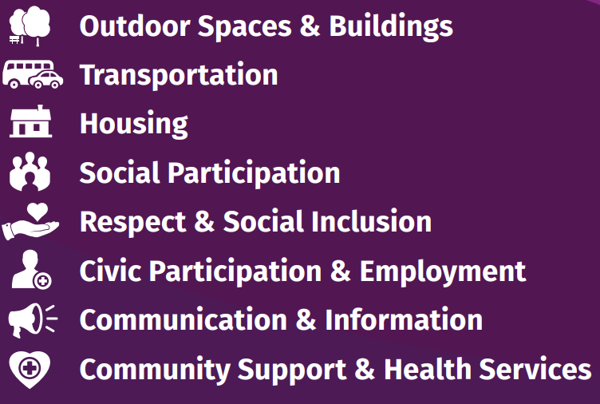

The information gathered will be held in the strictest confidence and will not be used for any other purposes.

**Are you male or female?**

|  |  |
| --- | --- |
| Male 🞎 | Female 🞎 |

**It is important for us to understand the issues for people of different ages, which of the following groups includes your age?**

|  |  |  |  |  |  |
| --- | --- | --- | --- | --- | --- |
| 50 to 54 years  🞎 | 55 to 59 years  🞎 | 60 to 64 years  🞎 | 65 to 74 years  🞎 | 75 to 84 years  🞎 | 85 and over |

**What is your current employment status?**

|  |  |  |  |  |  |
| --- | --- | --- | --- | --- | --- |
| **Employed full time**  **🞎** | **Employed part time**  **🞎** | **Self Employed**  **🞎** | **Retired**  **🞎** | **Unemployed**  **🞎** | **Prefer not to say**  **🞎** |

**How is your health in general?**

|  |  |  |  |  |
| --- | --- | --- | --- | --- |
| Excellent  🞎 | Very good  🞎 | Good  🞎 | Fair  🞎 | Poor  🞎 |

**How would you rate your quality of life?**

|  |  |  |  |
| --- | --- | --- | --- |
| Very good    🞎 | Good    🞎 | Poor  🞎 | Very poor  🞎 |

**If you answered Poor or Very Poor would you like to describe further?**

|  |
| --- |
|  |

**Please enter your post code**

**Who lives in your household? (Please tick all that apply)**

|  |  |  |  |  |  |
| --- | --- | --- | --- | --- | --- |
| Live Alone    🞎 | Spouse/  partner    🞎 | Children  🞎 | Other relatives  🞎 | Non-family members  🞎 | I live in Sheltered /Shared Accommodation  🞎 |

**Do you have caring responsibilities for someone in your household or living elsewhere?**

|  |  |
| --- | --- |
| Yes 🞎 | No 🞎 |

**Do you agree or disagree with the following statements? You also have the option to answer do not know or not applicable. Please include any further comments, observations or solutions in the comments box.**

|  |  |  |  |  |
| --- | --- | --- | --- | --- |
| **Outdoor Spaces and Buildings**  Getting out and about safely & independently | | | | |
|  | **Agree** | **Disagree** | **Don’t Know** | **N/A** |
| Pavements are well maintained, free from obstruction and there are enough dropped kerbs to cross the road |  |  |  |  |
| There is enough pedestrian crossings with adequate time given for crossing the road |  |  |  |  |
| Businesses and shops make me feel welcome and safe to visit |  |  |  |  |
| Outdoor spaces and buildings are clean and well maintained |  |  |  |  |
| I am able to access public buildings |  |  |  |  |
| I am able to access public toilets outdoors and indoors |  |  |  |  |
| There are parks and or green spaces in my area to visit |  |  |  |  |
| There are enough public seating areas to rest |  |  |  |  |
| I feel safe when out in my local area |  |  |  |  |
| I regularly walk/exercise outdoors |  |  |  |  |
| Businesses and shops are accessible for me to walk to |  |  |  |  |
| Businesses and shops are accessible for me to drive to |  |  |  |  |
| Businesses and shops are accessible for me to park near |  |  |  |  |
| Businesses and shops are accessible for me to enter and access easily |  |  |  |  |
| Businesses and shops are accessible for me to rest inside and outside |  |  |  |  |
| Businesses and shops are accessible for me to avail of toilet facilities |  |  |  |  |
| ***Please note any comments or strongly expressed feelings on this topic:*** | | | | |

|  |
| --- |
| **TRANSPORTATION**  To get to where you want to go, when you want to go |

**How often do you usually travel? (Please tick all that apply)**

|  |  |  |  |  |  |  |
| --- | --- | --- | --- | --- | --- | --- |
|  | **Every day** | **Three days a week or more** | **Once a week or more** | **Once a month or more** | **Less than once a month** | **Never** |
| By car as a driver |  |  |  |  |  |  |
| By car as a passenger |  |  |  |  |  |  |
| By public transport |  |  |  |  |  |  |
| By voluntary transport |  |  |  |  |  |  |

**What would help you to travel more?**

|  |  |  |  |  |
| --- | --- | --- | --- | --- |
|  | **Agree** | **Disagree** | **Don’t Know** | **N/A** |
| If it was easier to find parking in the town and city centre |  |  |  |  |
| If public transport could get me where I need to go and was convenient and reliable |  |  |  |  |
| If community transport was available and accessible where public transportation is too limited |  |  |  |  |
| If public or community transport was affordable |  |  |  |  |
| If I felt confident and safe using transport services |  |  |  |  |
| If Shelters/Timetable/Waiting Area/Drivers/Seats/Location/Accessibility and route choices are adequate |  |  |  |  |
| ***Please note any comments or strongly expressed feelings on this topic:*** | | | | |

|  |  |  |  |  |
| --- | --- | --- | --- | --- |
| **HOUSING**  To stay living in our own homes and communities | | | | |
|  | **Agree** | **Disagree** | **Don’t Know** | **N/A** |
| I feel safe to live where I live |  |  |  |  |
| My home is suited to my current needs |  |  |  |  |
| My home could be adapted to meet my future needs if required. |  |  |  |  |
| Services are accessible to my home eg Shops, Post Office, Banks, Libraries etc. |  |  |  |  |
| My home could be more energy efficient |  |  |  |  |
| I know where to access home repair contractors who are trustworthy, do quality work and are affordable |  |  |  |  |
| My community is a good place for people to live in as they age |  |  |  |  |
| My home is the right size for all who live in my household |  |  |  |  |
| ***Please note any comments or strongly expressed feelings on this topic:*** | | | | |

**What % of your income is spent on heating to keep your home warm?**

________

**Do you know what is the average temperature to keep your home adequately warm?**

Yes / No* (please delete as appropriate)

|  |  |  |  |  |
| --- | --- | --- | --- | --- |
| **SOCIAL PARTICIPATION**  To participate in social, economic and public life | | | | |
|  | **Agree** | **Disagree** | **Don’t Know** | **N/A** |
| There is a wide variety of activities that are available to appeal to a diverse population of older people to come out safely. |  |  |  |  |
| There are good public places to meet and spend time (eg parks, halls, centres for exercise, learn or socialise) |  |  |  |  |
| I feel confident to join groups, events and activities when they start to get back up and running again |  |  |  |  |
| I face difficulties getting to various programmes, events or activities |  |  |  |  |
| My caring responsibilities limit how much I would like to get out and about (e.g. events, activities etc.) |  |  |  |  |
| During the pandemic, I feel more lonely than before |  |  |  |  |
| ***Please note any comments or strongly expressed feelings on this topic:*** | | | | |

|  |  |  |  |  |
| --- | --- | --- | --- | --- |
|  | **Daily** | **Weekly** | **Monthly** | **Rarely** |
| I interact (ie by phone, in person, email or social media with the following: |  |  |  |  |
| * Friends |  |  |  |  |
| * Family |  |  |  |  |
| * Neighbours |  |  |  |  |
| * Others |  |  |  |  |
| If Others, please describe | | | | |

|  |  |  |  |  |
| --- | --- | --- | --- | --- |
| **CIVIC PARTICIPATION AND EMPLOYMENT**  To continue to learn, develop, work and contribute to Society. | | | | |
|  | **Agree** | **Disagree** | **Don’t Know** | **N/A** |
| I take part in civic activities that benefit the community |  |  |  |  |
| I know where to access information |  |  |  |  |
| I know where to access and receive advice on income and accessing benefits |  |  |  |  |
| I would volunteer if I felt supported to do so (e.g. encouraged and reimbursed for transport costs) |  |  |  |  |
| There are employment opportunities for older persons |  |  |  |  |
| During elections I cast my vote |  |  |  |  |
| ***Please note any comments or strongly expressed feelings on this topic:*** | | | | |

|  |  |  |  |  |  |  |
| --- | --- | --- | --- | --- | --- | --- |
|  | | **Agree** | **Disagree** | | **Don’t Know** | **N/A** |
| Flexible opportunities exist for: | |  |  | |  |  |
| * Working | |  |  | |  |  |
| * Volunteering After Retirement | |  |  | |  |  |
| * Adult Education and Courses | |  |  | |  |  |
| Please add any comments or strong feelings on this topic: | | | | | | |
| **RESPECT AND INCLUSION**  It is essential that older people are valued, respected and especially included in matters that directly affect them | | | | | | | |
|  | **Agree** | | **Disagree** | **Don’t Know** | | **N/A** | |
| Older people are consulted by public, voluntary and private organisations on ways to serve them better |  | |  |  | |  | |
| Facilities have helpful and courteous staff to respond to older people (eg offering priority hours, allowing use of cash, space for people to stop and rest) |  | |  |  | |  | |
| I have experienced ageism where I believe I have been discriminated against due to my age.  *If you agree, it would be helpful if you could give examples in the comment box below*. |  | |  |  | |  | |
| Activities that bring generations together for mutual enjoyment and enrichment are regularly held |  | |  |  | |  | |
| I feel respected and included within my community  *If you disagree, can you please give us examples of why you feel this way?* |  | |  |  | |  | |
| ***Please note any comments or strongly expressed feelings on this topic:*** | | | | | | | |

|  |  |  |  |  |
| --- | --- | --- | --- | --- |
| **COMMUNICATION AND INFORMATION**  To have the information we need to lead full lives | | | | |
|  | **Agree** | **Disagree** | **Don’t Know** | **N/A** |
| I can access the internet and know how to use it |  |  |  |  |
| I use the following: |  |  |  |  |
| * Internet / search engines |  |  |  |  |
| * Facebook |  |  |  |  |
| * Whatsapp |  |  |  |  |
| * Alexa |  |  |  |  |
| * Zoom |  |  |  |  |
| * Smartphone |  |  |  |  |
| Other – *If other please give details* | | | | |
| There is information about services widely available |  |  |  |  |
| The media (local papers, radio, etc.) has useful bulletins on local events/activities |  |  |  |  |
| I have all the information I need regarding citizens and consumer rights |  |  |  |  |
| I use my local community Centre for information on what is on (e.g. services / programmes / events) |  |  |  |  |
| A service that signposts me to services would be very beneficial |  |  |  |  |
| During the pandemic, I am able to use the internet to keep in touch and get the information I needed |  |  |  |  |
| I would benefit from assistance with information technology (e.g. computers, smart phones, internet) |  |  |  |  |
| ***Please note any comments or strongly expressed feelings on this topic:*** | | | | |

|  |  |  |  |  |
| --- | --- | --- | --- | --- |
| **COMMUNITY AND HEALTH SERVICES**  To help older people to live healthier, active and independent lives for longer | | | | |
|  | **Agree** | **Disagree** | **Don’t Know** | **N/A** |
| I have access to good quality health care facilities and services when I need them. |  |  |  |  |
| I eat well and have nutritional meals |  |  |  |  |
| I am able to access good quality GP services (eg practice nurse/repeat prescriptions) when needed |  |  |  |  |
| I am able to access GP Appointments when I need them |  |  |  |  |
| Facilities and support exist for older people living with chronic health conditions |  |  |  |  |
| Health and social services are conveniently located and accessible by all means of transport |  |  |  |  |
| I am prepared if I have a health crisis and know who to contact if I need help |  |  |  |  |
| During the pandemic my mental health and wellbeing has been affected |  |  |  |  |
| During the pandemic I have been able to access my medication |  |  |  |  |
| During the pandemic, I am able to access support from Health professionals and services when needed |  |  |  |  |
| During the pandemic, getting food to my home is difficult |  |  |  |  |
| During the pandemic, I am able to rely on others outside my family network for support |  |  |  |  |
| During the pandemic I’m not sure who I can turn to for help |  |  |  |  |
| ***Please note any comments or strongly expressed feelings on this topic:*** | | | | |

**What you think the Derry City and Strabane District area does best for older people?**

|  |
| --- |
|  |

**What could Derry City and Strabane District area do better?**

|  |
| --- |
|  |