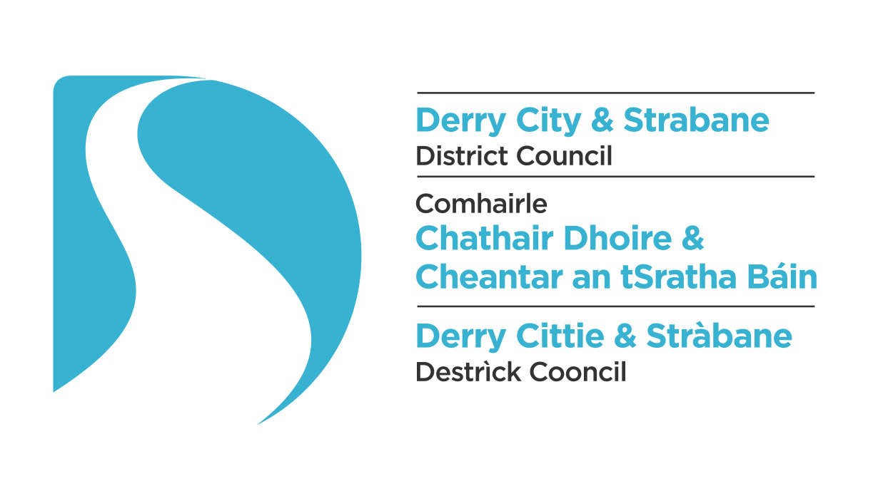
 |  | Car Pool Scheme
DCSDC Policy
Document Number |  | TBC
Responsible Officer |  | Strategic Director - Environment
Contact Officer |  | Head of Environment
Approval |  | Environment & Regeneration Committee (minute reference).  Full Council meeting (minute reference).
Effective Date |  | TBC
Modifications |  | Record of all amendments and modifications to this policy, including dates that amendments were approved and/or came into effect.
Superseded Documents |  | None
Review Date |  | TBC
File Number |  | All documents relating to the development, communication, implementation and review of a policy must be held on a registered file.
Associated Documents |  | List any supporting documents (guidelines, procedures etc.) and other Council documents which may be a useful reference for policy users.

Policy on Managing Council’s Car Pool Scheme

- Preamble
Derry City and Strabane District Council are keen to promote both sustainable travel and to reduce the impacts of business travel on the environment. Council has brought forward and is working in partnership with a number of organisations to achieve these combined objectives. The introduction of a car pool scheme is considered an integral component within this process.

  - Purpose
The purpose of this policy is to regulate and manage Council’s Car pool scheme.
- Scope
This policy applies to all pool vehicles provided by Derry City and Strabane District Council ‘the Council’ intended for use by employees.
The policy applies to all vehicle related activity and should be interpreted taking account of the differing licensing and legal requirements according to where the vehicle is being used.
- Definitions
Car Pool Scheme: The provision of a motor vehicle for use by authorised Council staff for lawful business use.
- Policy Statement

  - Roles and Responsibilities
Strategic Director Environment - will oversee the scheme who in turn will report directly to the Chief Executive.
Head of Environment – will administer the scheme and will co-ordinate the delivery and operation of the scheme with the appointed scheme provider.
Lead Finance Officer / Lead Assurance Officer - will manage the financial aspects of the scheme.
Lead Human Resources Manager – will manage the employee elements.
Responsible Directorates –
Environment and Regeneration

  - General Principles
Council has committed to the following:
- Council aims to reduce the impact of car emissions on the environment by encouraging shared use of transport and to encourage employees to switch to alternative sustainable mode of transport to, from and during work.

- To reduce the annual spend on ‘grey fleet’ transport through a reduction in mileage claimed across the organisation.

- Legal & Policy Framework

  - Linkage to Corporate Plan

    - Complements Corporate Objectives to:

- Promote Healthy Communities
- Protect our Environment and deliver physical regeneration

The policy will link with the Councils Strategic Community Plan 2016-2030

- Impact Assessment

  - Screening and Equality Impact Assessment
Screening questionnaire attached to document.
  - Impact on staff and financial resources
It is intended that the introduction of this policy will bring positive benefits to staff and Elected Members. Having the pool cars available will enable employees and Elected members to consider alternative sustainable and healthier means of travel to and from work on the basis that the pool cars are available for business use during the working day.
The scheme will be resourced from within existing Departmental budgets as the scheme will be funded through savings achieved from the offset of grey fleet mileage.
  - Sustainable development
This policy supports Councils commitment to sustainable development.
  - Other impacts
Positive Impacts associated with implementation of the Policy:
- Support sustainable travel to and from work.
- Contribute to achieving financial savings.
- Reduce the environmental impacts associated with multiple vehicle journeys and associated traffic congestion.

- Implementation

A proposed bonfire on Council land would only be considered when the event organiser demonstrates that the event will be managed safely and conditions relating to collection/type of materials to be burned, site/public safety, emblems/flags etc. will be achieved.
Responsibility for implementation of this policy will sit with Health and Communities and Environment and Regeneration Directorates.
Support and Advice
Head of Environment
  - Procedures

Responsibility

It is the driver’s responsibility to understand and comply with the policy and for line management to oversee compliance

User Status

All employees and are reminded that when using vehicles on Council business, they remain subject to all the terms and conditions of their contract with Council.

Non-compliance

Please note that non-compliance with this policy may lead to disciplinary action and in serious cases, the breach may be treated as gross misconduct leading to summary dismissal.

Pool Cars

Derry City and Strabane District Council provides pool cars for staff travelling for business purposes only. The Council retains a fleet of 5 cars for staff use; the pool vehicles are either electric or hybrid/petrol/battery.
Authorised Driver

You have to be an authorised driver with the Council before using a pool car.
To register as an authorised driver, please complete a ‘driver declaration form’ and return this to the Councils Insurance Manager based in the Finance Department at 98 Strand Road. These forms must be completed on an annual basis.

In addition the following criteria also apply

- Approval of your line manager to drive on Council business

- Hold a full, current and valid driving licence appropriate for the type of vehicle being driven and;

- Not be suffering from any health condition or infirmity or on any medication which may affect your ability to drive safely.

You must notify the Insurance Manager of any changes to your driving license as soon as possible, failure to do so could invalidate any insurance cover.

The Council reserves the right to inspect the driving licence of any anyone driving on Council business, at any time.

Bookings

Booking a vehicle can be done through the designated Pool Car Booking System using the following link:-

Fuel

The vehicles are either fully electric or use unleaded fuel.

- Fuel for the pool cars is paid for by the Council with fuel cards.
- Fuel cards are provided in each pool car.
- Please ensure that, on returning the pool car to the designated parking bays there is a full tank of fuel in the car and that the fuel cards are left in the vehicle on return.
- Copies of fuel receipts should be retained and stored next to the fuel card in the vehicle.
- Electric charging points have been installed at each of the designated parking bays at both 98 Strand Rd, Derry and 47 Derry Rd, Strabane. Please ensure that cars are plugged in on return and charged for use.

Please note that fuel cards can only be used to purchase fuel or oil. Use will be monitored and inappropriate use followed up.

Vehicle Safety Checklist

Before driving a pool car, you should ensure that a vehicle safety checklist is completed. It is the driver’s responsibility to ensure that the vehicle is roadworthy before every journey.

PLEASE ENSURE THAT THE VEHICLE IS LEFT CLEAN, ALL RUBBISH IS TO BE TAKEN WITH YOU AND THERE IS TO BE NO SMOKING IN ANY OF THE VEHICLES.

Mobile Phones

The use of a hand held mobile phone whilst driving is illegal within the UK. It is Council policy to prohibit the use of mobile phones whilst driving.

Passengers Carried

Passengers carried must not exceed the seat belt capacity of the vehicle. If you are carrying equipment you must not exceed the gross vehicle weight which includes vehicle, driver, passengers, goods and fuel.

Equipment Carried

Any items carried in the vehicle must be adequately secured and fastened.

Smoking

Smoking is not permitted in any vehicle provided by Council.

Motoring Offences and Fines

A new driver declaration form must be completed as soon as is possible (within 7 days maximum) if a driver receives a motoring conviction, endorsement on their licence or is made aware by the relevant authority that a conviction is pending. This requirement applies irrespective of whether the offence or alleged offence occurred whilst driving on Council business.

Parking fines and fines relating to traffic offences should be dealt with promptly and – if not appealed paid immediately by the driver. Some offences will be reported to Council of the hire Company directly e.g. speeding and other offences caught by camera and Council has a legal obligation to provide, when requested, the full name and address of the driver at the time of the alleged offence.

Vehicle Keys

Keys will be only be issued to drivers authorised under the scheme. Keys must be collected from and returned to

Strand Rd, Derry - XXXXXX

Derry Rd, Strabane – XXXXX

Drivers must sigh on both receiving and returning keys.

Pool Car Terms and Conditions

- The pool cars are for use on official Council business only, NOT personal use. Use is therefore restricted to the following:

  - Travel to and from meetings between Council premises
  - Travel to meetings, conferences, seminars etc. outside of Council

- Pool cars MUST NOT under any circumstances, be taken home prior to a journey unless your journey starts very early, and it’s not practical to travel to the Council first to pick up the vehicle (unless express permission has been given by the driver’s Head of Department).

- Pool cars MUST be returned to the Council at the end of your journey and not taken home unless your journey ends very late and it is not practical to travel to the Council to return the vehicle (unless express permission has been given by the driver’s Head of Department).

- The cars are for the use of business travel only. They are NOT to be used under any circumstances for the carriage of heavy equipment, tools or for field trips. Pool cars must only be driven by staff that have completed a Driver Declaration Form which has been approved by the Council’s Insurance Manager.

- When booking a pool car, you must submit the name of the actual driver for insurance purposes and details of the purpose of the journey. Bookings MUST be confirmed through the automated booking system as detailed above.

- Before you use any vehicle, a Pool Vehicle Check Form must be completed. You will not be permitted to use the pool cars unless this form is fully completed and returned to XXXXX prior to use. This form also requires completion on the return of the vehicle.

- If the vehicle is low on fuel, please fill up the vehicle with fuel using the fuel card supplied. You are not expected to pay for the fuel yourself. A receipt MUST be obtained and submitted to XXXX on your return.

- Any mechanical problems should be reported immediately to XXXX.

- Any damage to the cars must be reported when you return the vehicle to XXXX, the cost of any repairs will fall to the driver’s department. If there is insured damage the driver's department is responsible for paying the insurance excess.

  - Communication Strategy

The contents of this policy and the positive messaging around it will be conveyed internally to all staff through internal promotions, staff newsletters, staff briefings etc.

7.3 Risk Management
If the Policy is not implemented the Council may experience one or more of the following risks:
Reputational Damage manifested through lack of leadership with regard to the development / promotion of sustainable travel initiatives.
Limited reduction / potential increase in health impacts associated with emissions to air form car journeys to and from work, vehicle congestion etc.
Implementation of the policy will help mitigate these risks.
- Monitoring, review and evaluation
Continual monitoring and reporting has been included as a central requirement within the scheme. Annual, monthly and quarterly financial reports will be produced measuring the success of the scheme in terms of , numbers participating, percentage of time vehicles are in use, total mileage travelled, fuel used, mileage claimed / offset within the grey fleet, co2 emitted and saved, equality data.
The policy will be reviewed annually unless more frequent review deemed necessary.

- Acknowledgements
9.1 N/A

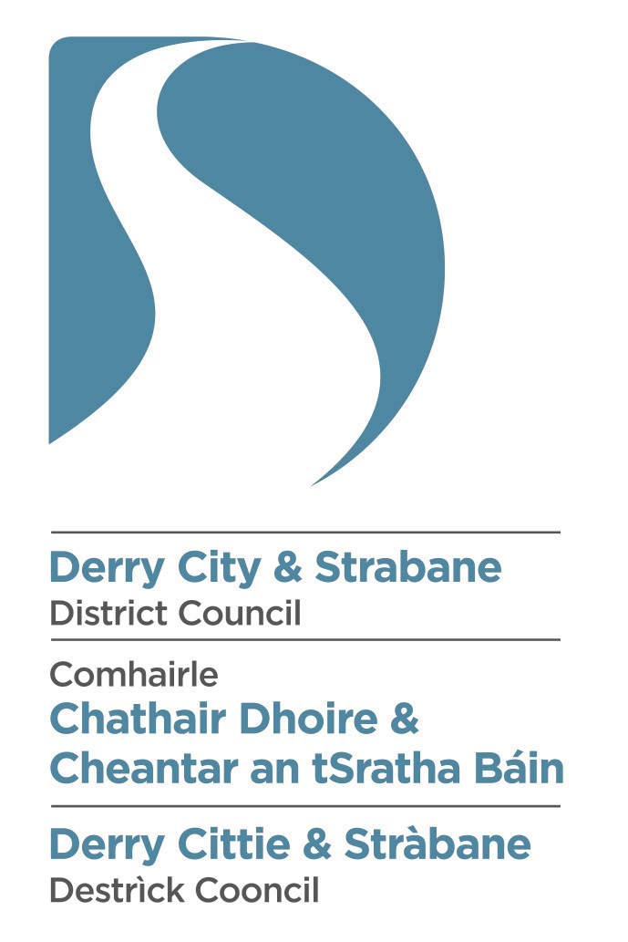
Statutory Equality Duties

Screening Of Policy for Council Car Pool Scheme

Screening of New/Revised Policies
Introduction and Guidance Notes

  - Section 75 of the Northern Ireland 1998 (“The Act”) requires the Council in carrying out its functions, powers and duties to have due regard to the need to promote equality of opportunity:

- between persons of different religious belief, political opinion, racial group, age, marital status or sexual orientation;
- between men and women generally;
- between persons with disability and persons without;
- between persons with dependants and persons without.

  - In addition, without prejudice to its obligations above, the Council shall in carrying out its functions, powers and duties have regard to the desirability of promoting good relations between persons of different religious belief, political opinion or racial group. The Council supports the principles of good relations: equity, respecting diversity and interdependence, and the development of relationships built on trust and respect.

  - As stated in its Equality Scheme, the Council intends to screen all of its policies (formal and informal), functions and roles in order to determine which would require a fuller equality analysis in the form of an impact assessment.

  - This questionnaire is aimed at providing a standardised, systematic approach to the
screening exercise. A summary of this document will be made available to the Council’s consultees and the general public, via the Council’s web-site and in other formats, (upon request). This document may also be produced, in full, as part of consultations regarding Equality Impact Assessments.

  - When the Council is considering a new/revised policy, it will determine whether the policy has the potential to have significant implications for equality of opportunity and/or good relations and if so will conduct a full impact assessment.

It will also help to determine if there are opportunities to:-
• Better promote good relations through tackling prejudice and/ or promoting understanding between the three Section 75 (2) categories, namely persons of different religious belief, political opinion and racial group.
• Promote positive attitudes towards people with a disability
• Encourage participation by disabled people in public life.

Where such opportunities are identified the new/revised policy will be referred to a designated working group for consideration.

  - Where due limited quantitative and/or qualitative research data, it is not possible to establish the ‘significance’ of the equality impact, policies which score positively against any of the screening criteria should be designated for detailed impact assessment.

Part 1: Policy Scoping
- Name of Policy: Car Pool Scheme
- Please tick as appropriate

New Policy Revised Policy
√

Corporate Policy Departmental Policy

If Departmental, please specify which department; Health and Community Directorate

3a. Please describe the aims of the policy:

This policy is to assist the Council to comply with the implementation of sustainable transport initiatives and to reduce environmental impacts of the business and to contribute to corporate financial savings.

3b. Are there any associated objectives of the policy? If so, what are they?
- Reduced grey fleet mileage claims.
- Promote sustainable travel to, from and within work.
- Reduce the negative environmental impacts associated with multiple car journeys.

- Are there any Section75 groups which might be expected to benefit from the intended policy? If so, explain how

This policy will be applied universally

- Who initiated or wrote the policy?
Head of Environment

- Who is responsible for the implementation of the policy?

7. Are there any factors which could contribute to/detract from the intended aim/outcome of the policy/decision?
If yes, are they
Financial
√

Legislative
$$√$$

Other, please specify

8. Who are the internal/external stakeholders (actual or potential) that the policy will impact upon?
√√
Staff

Service Users

Other public sector organisations

Voluntary/Community/Trade Unions

Other, Please specify – Elected Members
√

9. Is this policy associated with any other Council Policy(s)?
Yes No

√

If yes, please state the related policy(s) below.
Enforcement Policy (Environment)
Good Relations

10(a). How does the policy contribute towards the achievement of the Council’s strategic objectives?
This order helps to enable Council to meet its corporate objectives, in particular to:
1. Protect the environment and deliver physical regeneration.
2. Promote healthy communities

11. How does the Council interface with other bodies in relation to the implementation of this policy?
Council will interface with partner organisations through the implementation of the Action Plan.

Available evidence
Evidence to help inform the screening process may take many forms. Public authorities should ensure that their screening decision is informed by relevant data.
What evidence/information (both qualitative and quantitative) have you gathered to inform this policy? Specify details for each of the Section 75 categories.

Section 75 category | Details of evidence/information
Religious belief | LGD All usual residents Catholic Protestant and other Christian Other religions None  Northern Ireland 1,810,863 817,385 (45.14%) 875,717 (48.36%) 16,592 (0.92%) 101,169 (5.59%)  Derry & Strabane 147,720 106,600 (72.16%) 37,527 (25.40%) 940 (0.64%) 2,653 (1.80%)  The breakdown detailing the religious belief profile of residents in the Derry City and Strabane District Council is as follows:  There is no evidence to suggest that issues regarding this policy is affected by a person’s religious belief.
Political opinion | The political opinion of the Council’s elected members is as follows:  Sinn Féin 16 seats  SDLP 8 seats  Democratic Unionist 7 seats  Independents 7 seats  Ulster Unionist 2 seats  This breakdown is taken as an approximate representation of the political opinion of people within the Derry City and Strabane District Council area.  There is no evidence to suggest that issues regarding this policy is affected by a person’s political opinion.
Racial group | The breakdown detailing the ethnic profile of the residents of the new Council area is as follows:  Total Usual Residents 147720  White 145546  Chinese 301  Irish Traveller 116  Indian 670  Pakistani 48  Bangladeshi 23  Other Asian 222  Black Caribbean 53  Black African 86  Black Other 41  Mixed 462  Other 163  There is no evidence to suggest that issues regarding this policy is affected by a person’s racial group.
Age | The age profile of the Derry and Strabane LGD area at Census Day 2011 is as follows:  Age Profile NI Derry and Strabane  0-4 124382 10259  5-7 67662 5653  8-9 43625 3858  10-14 119034 10904  15 24620 2363  16-17 51440 4729  18-19 50181 4443  20-24 126013 10399  25-29 124099 10481  30-44 373947 30635  45-59 347850 28082  60-64 94290 7475  65-74 145600 10775  75-84 86724 5876  85-89 21165 1217  90+ 10231 571  This policy will only be applicable to those members of staff who are over 18 years of age with a full driving licence.
Marital status | The table below illustrates the marital status profile of the Derry and Strabane LGD:  Marital Status Derry and Strabane LGD NI  All usual residents: Aged 16+ years 83663 1431540  Single (never married or never registered a same-sex civil partnership): Aged 16+ years 46326 (40.39%) 517393 (36.14%)  Married: Aged 16+ years 49218 (42.92%) 680831 (47.56%)  In a registered same-sex civil p’ship: Aged 16+ years 93 (0.08%) 1243 (0.09%)  Separated (but still legally married or still legally in a same-sex civil p’ship): Aged 16+ years 5886 (5.13%) 56911 (3.98%)  Divorced or formerly in a same-sex civil partnership which is now legally dissolved: 6179 (5.39%) 78074 (5.45%)  Widowed or surviving partner from a same-sex civil partnership: Aged 16+ years 6981 (6.09%) 97088 (6.78%)  There is no evidence to suggest that issues regarding this policy is affected by a person’s marital status
Sexual orientation | Analysis of the Census 2011 indicates that between 2% and 10% of the population may be lesbian, gay or bisexual.  There are no official statistics in relation to the number of gay, lesbian or bisexual people in Northern Ireland. However, research conducted by the HM Treasury shows that between 5% - 7% of the UK population identify themselves as gay, lesbian, bisexual or ´trans´ (transsexual, transgendered and transvestites) (LGBT). This is a sizeable proportion of the population here in Northern Ireland.  There is no evidence to suggest that issues regarding this policy is affected by a person’s sexual orientation
Men and women generally | The gender profile for the Derry and Strabane LGD is as follows:  LGD Male Female  Northern Ireland 887323 923540  Derry and Strabane LGD 72475 75245  The gender profile of Council workforce is similar to that of the Council area and it could be suggested that this policy would have a differential impact on this grouping. Women are more likely to need their own transport to deal with caring responsibilities than men and therefore less likely to avail of the car pool option.
Disability | According to the 2011 Census 22.95% of people in the Derry and Strabane LGD have a long-term health problem or disability that limits their day-to-day activities;  LGD All usual residents Day-to-day activities limited a lot Day-to-day activities limited a little Day-to-day activities not limited  Northern Ireland 1810863 215232 (11.89%) 159414 (8.8%) 1436217 (79.31%)  Derry and Strabane 147720 20710 (14.02%) 13193 (8.93%) 113817 (77.05%)  Employees with a disability, particularly those with a mobility issue may have difficulty in carrying out vehicle safety checks.  Cars will not be suitable for use by people with disabilities whose vehicles have been adjusted to meet their specific requirements.  Both is these issues may mean that this grouping would be less likely to avail of this facility
Dependant | According to the 2011 Census 37.65% of households in the Derry and Strabane LGD have a dependants as compared to the Northern Ireland average of 33.85% households;  All households Married or in a registered same-sex civil partnership couple: Dependent children Cohabiting couple: Dependent children Lone parent: Dependent children Other household types: With dependent children  Northern Ireland 703275 138677 (19.72%) 16186 (2.3%) 64228 (9.13% 18980 (2.7%)  Derry and Strabane 55596 10370 (18.65%) 1097 (1.97%) 7284 (13.1%) 2187 (3.93%)  Possible adverse impact on mothers/fathers who use private vehicles to get to work, dropping children at school/child care on the way. Staff who may be eligible to use a pool car to attend early meetings or if meetings were running late would require staff to factor this in to take into account drop off/pick up responsibilities.  Pool cars also would not be suitable for this grouping on these occasions as they would not be fitted with appropriate child seats to accommodate a range of children.
Needs, experiences and priorities
Taking into account the information referred to above, what are the different needs, experiences and priorities of each of the following categories, in relation to the particular policy/decision? Specify details for each of the Section 75 categories
Section 75 category | Details of needs/experiences/priorities
Religious belief

Political opinion

Racial group

Age

Marital status

Sexual orientation

Men and women generally

Disability | Employees with a disability may require support in carrying out vehicle safety checks
Dependants

Part 2: Screening questions

Introduction
In making a decision as to whether or not there is a need to carry out an equality impact assessment, the public authority should consider its answers to the questions 1-4.
If the public authority’s conclusion is none in respect of all of the Section 75 equality of opportunity and/or good relations categories, then the public authority may decide to screen the policy out. If a policy is ‘screened out’ as having no relevance to equality of opportunity or good relations, a public authority should give details of the reasons for the decision taken.
If the public authority’s conclusion is major in respect of one or more of the Section 75 equality of opportunity and/or good relations categories, then consideration should be given to subjecting the policy to the equality impact assessment procedure.
If the public authority’s conclusion is minor in respect of one or more of the Section 75 equality categories and/or good relations categories, then consideration should still be given to proceeding with an equality impact assessment, or to:
- measures to mitigate the adverse impact; or
- the introduction of an alternative policy to better promote equality of opportunity and/or good relations.

In favour of a ‘major’ impact
- The policy is significant in terms of its strategic importance;
- Potential equality impacts are unknown, because, for example, there is insufficient data upon which to make an assessment or because they are complex, and it would be appropriate to conduct an equality impact assessment in order to better assess them;
- Potential equality and/or good relations impacts are likely to be adverse or are likely to be experienced disproportionately by groups of people including those who are marginalised or disadvantaged;
- Further assessment offers a valuable way to examine the evidence and develop recommendations in respect of a policy about which there are concerns amongst affected individuals and representative groups, for example in respect of multiple identities;
- The policy is likely to be challenged by way of judicial review;
- The policy is significant in terms of expenditure.

In favour of ‘minor’ impact
- The policy is not unlawfully discriminatory and any residual potential impacts on people are judged to be negligible;
- The policy, or certain proposals within it, are potentially unlawfully discriminatory, but this possibility can readily and easily be eliminated by making appropriate changes to the policy or by adopting appropriate mitigating measures;
- Any asymmetrical equality impacts caused by the policy are intentional because they are specifically designed to promote equality of opportunity for particular groups of disadvantaged people;
- By amending the policy there are better opportunities to better promote equality of opportunity and/or good relations.

In favour of none
The policy has no relevance to equality of opportunity or good relations.
- The policy is purely technical in nature and will have no bearing in terms of its likely impact on equality of opportunity or good relations for people within the equality and good relations categories.

Taking into account the evidence presented above, consider and comment on the likely impact on equality of opportunity and good relations for those affected by this policy, in any way, for each of the equality and good relations categories, by applying the screening questions given overleaf and indicate the level of impact on the group i.e. minor, major or none.

Screening questions
- What is the likely impact on equality of opportunity for those affected by this policy, for each of the Section 75 equality categories? minor/major/none
Section 75 category |  | Details of policy impact |  | Level of impact? minor/major/none
Religious belief
Political opinion
Racial group
Age
Marital status
Sexual orientation
Men and women generally |  | The gender profile of Council workforce is similar to that of the Council area and it could be suggested that this policy would have a differential impact on this grouping. Women are more likely to need their own transport to deal with caring responsibilities than men and therefore less likely to avail of the car pool option. |  | Minor (Negative)
Disability |  | Cars will not be suitable for use by people with disabilities whose vehicles have been adjusted to meet their specific requirements and therefore may mean that this grouping would be less likely to avail of this facility  Drivers with a disability particularly those with mobility issues may not be able to carry out all vehicle checks to ensure car is roadworthy |  | Minor (Negative)
Dependants |  | Possible differential impact on mothers/fathers who use private vehicles to get to work, dropping children at school/child care on the way. Staff who may be eligible to use a pool car to attend early meetings or if meetings were running late would require staff to factor this in to take into account drop off/pick up responsibilities.  Pool cars also would not be suitable for this grouping on these occasions as they would not be fitted with appropriate child seats to accommodate a range of children. |  | Minor (Negative)
- Are there opportunities to better promote equality of opportunity for people within the Section 75 equalities categories?

Section 75 category | If Yes, provide details |  | If No, provide reasons
Religious belief
Political opinion
Racial group | Council must ensure all information regarding this policy is available in appropriate formats as the need is identified.
Age | Council must ensure all information regarding this policy is available in appropriate formats as the need is identified
Marital status
Sexual orientation
Men and women generally
Disability | Council must ensure all information regarding this policy is available in appropriate formats as the need is identified
Dependants

- Are there opportunities to better promote good relations between Section 75 equality categories through tackling prejudice and/or promoting understanding?

Section 75 category | If Yes, provide details | If No, provide reasons
Religious belief |  | None
Political opinion |  | None
Racial group |  | None
Age |  | None
Marital status |  | None
Sexual orientation |  | None
Men & women generally |  | None
Disability |  | None
Dependants |  | None

4. Is there evidence to suggest that this policy would promote positive attitudes towards people with a disability?

If Yes, provide details | If No, provide reasons
 | No – this policy is available to all suitably qualified drivers within the Council’s employment who need to attend external meetings on behalf of Council
5. Is there evidence to suggest that this policy would encourage the participation of people with a disability in public life?

If Yes, provide details | If No, provide reasons
 | No – this policy is available to all suitably qualified drivers within the Council’s employment who need to attend external meetings on behalf of Council
Additional considerations

Multiple identity

Generally speaking, people can fall into more than one Section 75 category. Taking this into consideration, are there any potential impacts of the policy/decision on people with multiple identities?
(For example; disabled minority ethnic people; disabled women; young Protestant men; and young lesbians, gay and bisexual people).

Provide details of data on the impact of the policy on people with multiple identities. Specify relevant Section 75 categories concerned.

Part 3. Screening decision

If the decision is not to conduct an equality impact assessment, please provide details of the reasons.
Whilst it has been identified that this Car Pool Scheme may not be suitable for all employees it is in place as an option to assist the Council to comply with the implementation of sustainable transport initiatives and to reduce environmental impacts of the business and to contribute to corporate financial savings.
The uptake and usage of the scheme will be continually monitored and identification of any potential improvements will be considered and acted upon to increase its accessibility to staff

If the decision is not to conduct an equality impact assessment the public authority should consider if the policy should be mitigated or an alternative policy be introduced. Please provide details

If the decision is to subject the policy to an equality impact assessment, please provide details of the reasons.

Part 4: Mitigation

When the public authority concludes that the likely impact is ‘minor’ and an equality impact assessment is not to be conducted, the public authority may consider mitigation to lessen the severity of any equality impact, or the introduction of an alternative policy to better promote equality of opportunity or good relations.

Can the policy/decision be amended or changed or an alternative policy introduced to better promote equality of opportunity and/or good relations?

If so, give the reasons to support your decision, together with the proposed changes/amendments or alternative policy.
It was highlighted within the screening process that employees with a disability, particularly those with mobility issues, may not be able to carry out the full range of vehicle checks required to ensure the vehicle is roadworthy – the policy has been amended to allow the employee with a disability to get help and support to carry out necessary checks – it is the employees responsibility however to ensure that these have been done.

Part 5 - Approval and authorisation
Screened by: | Position/Job Title | Date
Kay McIvor | Policy Officer (Equality) | 6th April 2017
Approved by:
Conor Canning | Head of Environment | 6th April 2017

Note: A copy of the Screening Template, for each policy screened should be ‘signed off’ and approved by a senior manager responsible for the policy, made easily accessible on the public authority’s website as soon as possible following completion and made available on request.

