Funded and supported by the Ulster-Scots Agency

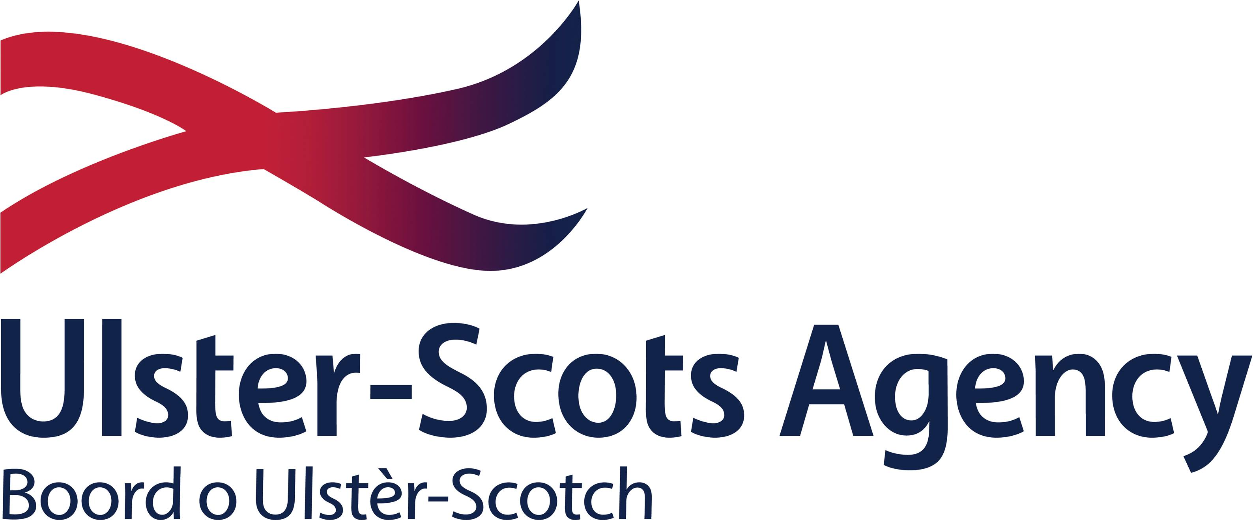

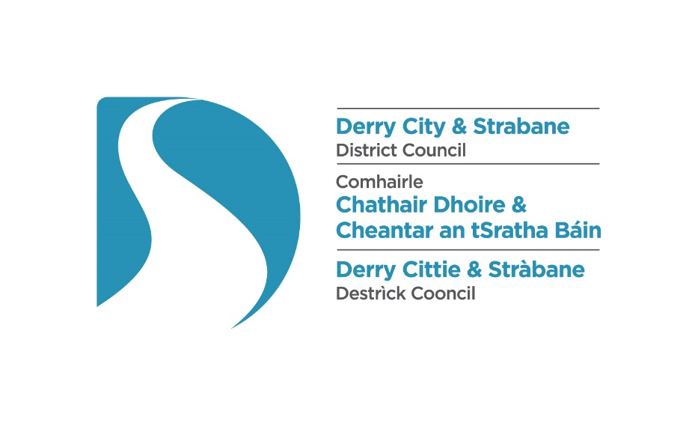

**Ulster-Scots Language Week 2021**

**Invitation for Proposals**

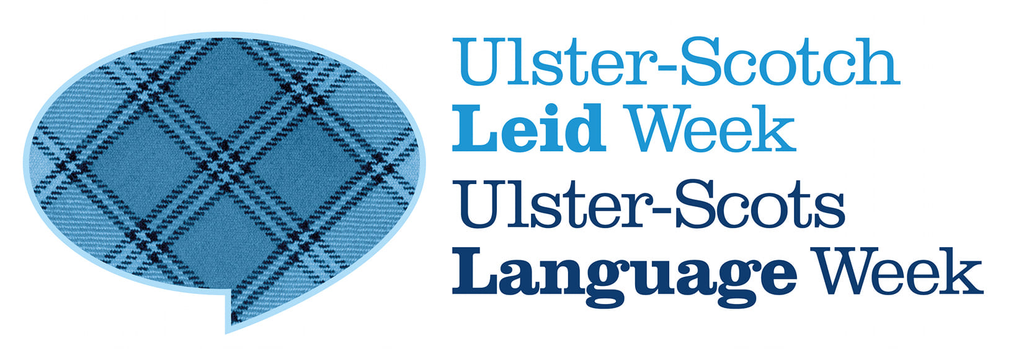

**Ulster-Scots Language Week 2021**

**Invitation for Proposals**

Derry City and Strabane District Council invites proposals for digital content in video format for an online programme of events to promote and celebrate Ulster-Scots Language Week 2021.

The aim of Ulster-Scots Language Week is to promote awareness of the Ulster-Scots language and to provide opportunities for people to learn about and engage with the language in a range of ways. Derry City and Strabane District Council plans to commission a week-long programme of digital content aimed at promoting awareness of the Ulster-Scots language by engaging with Ulster-Scots speakers, creatives, artists, facilitators, performers and other relevant individuals to procure original digital content in Ulster-Scots for our programme.

We are particularly keen to showcase a range of creative and innovative digital content which showcases the rich tradition of the Ulster-Scots language in all its forms and which can engage audiences, both young and old. Proposals might include some of the following: poetry, the spoken word, storytelling, song, language-based drama or performance, narrated talks or lectures, short films, educational videos, interviews with Ulster-Scots speakers, e-books, or online language awareness videos, but this list is not exhaustive. The content must be language-focussed, original, and must be submitted in a pre-recorded video format suitable for upload to our web and social media platforms; i.e. .MOV, .MPEG, .MP4, .WMV etc.

Applicants are invited to submit a proposal by completing the proposal form outlining how they would, if successful, create an original piece of digital content featuring the Ulster-Scots language. Proposals must not exceed a budget of £250. It is anticipated that up to a maximum of 10 proposals will be funded, but the Council reserves the right to restrict the number of successful submissions.

All applicants who are successful under the scheme will be required to have completed and submitted the finished, web-ready content in an appropriate video format to the Council by Wednesday 17 November 2021.

Proposals will be scored using an 80% Quality and 20% Cost model. Please see more detail about how we plan to score applications at Appendix 1. Please see Appendix 2 for conditions associated with the award.

**Ulster-Scots Language Week 2021 – Proposal Form**

|  |  |
| --- | --- |
| **Applicant or Group Contact Name** |  |
| **Address** |  |
| **Telephone number** |  |
| **Email** |  |
| **Please provide details of any relevant qualifications, experience, background** |  |
| **Please describe your proposal (80%)**  Provide details of the proposed project and its relevance to the stated aims of Ulster-Scots Language Week i.e. to promote awareness of the Ulster-Scots language and engage audiences.  Please note that the proposed content must be original, and must not have been presented and/or be currently available to audiences in a digital format. Detail how you will deliver the content in an appropriate web-ready format and within the timeframe. |  |
| **Costs (20%)**  What are the costs associated with your proposal? Total costs must not exceed £250 per application |  |

**Deadline for Proposals**

Please submit your proposal via email before Friday 22 October 2021 to [ulsterscots@derrystrabane.com](mailto:ulsterscots@derrystrabane.com). Please note that successful applicants will be required to submit their completed digital content projects in the appropriate video format by Wednesday 17 November 2021.

**Appendix 1**

**How we plan to evaluate your proposal**

All proposals will be assessed against the quality and cost evaluation criteria below.

**Quality (80%)**

The following criteria and weightings will be applied to proposals.

|  |  |  |  |
| --- | --- | --- | --- |
| **Evaluation criteria** | **Criteria Weighting %** | **Sub-criteria** | **Sub-criteria Weighting %** |
| Methodology | 80% | Q1. Details of the proposed project and its relevance to the stated aims of Ulster-Scots Language Week i.e. to promote awareness of the Ulster-Scots language and engage audiences.  Q2. Details on how the applicant will deliver the content in an appropriate, web-ready format and within the timeframe. | 70%  10% |

**A minimum threshold of 60% must be achieved in order to be appointable.**

Submissions will be evaluated on the following basis:

**Methodology (80%)**

The response must include, but is not limited to;

* A clear concept for an engaging project featuring the Ulster-Scots language which can be presented in a pre-recorded, web-ready video format, and which can be delivered within the timeframe.

Methodology will be scored based on the below table.

|  |  |  |
| --- | --- | --- |
| **Band** | **Comments** |  |
|  |
| **5** | Fully detailed evidence provided, very minor concerns on detail, relevance or complexity |  |
| **4** | Detailed evidence provided, some concerns on detail, relevance or complexity |  |
| **3** | Reasonable evidence provided, lacking in detail, relevance or complexity |  |
| **2** | Limited evidence provided, significant concerns on detail, relevance or complexity |  |
| **1** | Little or no evidence provided, very significant concerns on detail, relevance or complexity |  |
| **0** | Failed to submit details or to address question |  |

If a proposal scores in band 0, 1 or 2 then it shall be deemed that they have failed to meet the requirements and will be eliminated.

**Cost**

|  |  |
| --- | --- |
| **Cost** | **20%** |
| Applicants may submit costs up to a maximum of £250. Submissions in excess of the maximum available award of £250 will not be accepted. |  |

The following formula will be used to evaluate Cost:

1. Lowest cost submitted will be awarded the maximum score available (20%) and;
2. To calculate the score for the costs submitted by the remaining proposals, the following formula will be applied – the lowest submitted cost divided by the proposer’s price, multiplied by the cost weighting (20%)

Applicants should note that the Council is not obliged to accept the lowest cost or any submission.

**Final Score – combination of Quality and Cost**

Applicants who meet the quality threshold of 60% and who have submitted a price of £250 or below will be deemed appointable. Appointments will be made on the basis of highest scoring proposals.

**Appendix 2**

**Conditions**

1. Derry City and Strabane District Council accepts no responsibility, financial or otherwise, for expenditure or liabilities arising out of the work of the recipient. Any commitment incurred in excess of the approved award shall be the responsibility of the applicant;
2. No aspect of the project being funded should be perceived as political or promote a particular religion in intention, use or presentation or be likely to be perceived as discriminatory, or failing to afford equality of opportunity to the categories of persons identified in Section 75 of the Northern Ireland Act 1998, namely, between persons of different religious belief; political opinion; racial or ethnic origin; age; marital status; sexual orientation; men and women generally; persons with disability and those without and between persons with dependants and those without or which may amount to a breach of the European Convention on Human Rights;
3. Award recipients must acknowledge, when publicising the content, that they are in receipt of financial support from Derry City and Strabane District Council and the Ulster-Scots Agency;
4. All projects, where relevant, must comply with all relevant policies and procedures. If a project involves children, young people and/or adults at risk applicants must ensure that they adhere to best practice in relation to Safeguarding. If a project involves any of the above, applicants must provide confirmation that they have all relevant Safeguarding policies and procedures in place and can verify same upon request.
5. Content must be recorded in accordance with current public health guidelines;
6. Derry City and Strabane District Council and the Ulster-Scots Agency reserve the right to make use of the content for the purposes of Ulster-Scots Language Week and for any related promotional purposes.

**Further information:**

Pól Ó Frighil

Policy Officer (Irish & Ulster-Scots)

Derry City and Strabane District Council

ulsterscots@derrystrabane.com

www.derrystrabane.com/ulsterscots