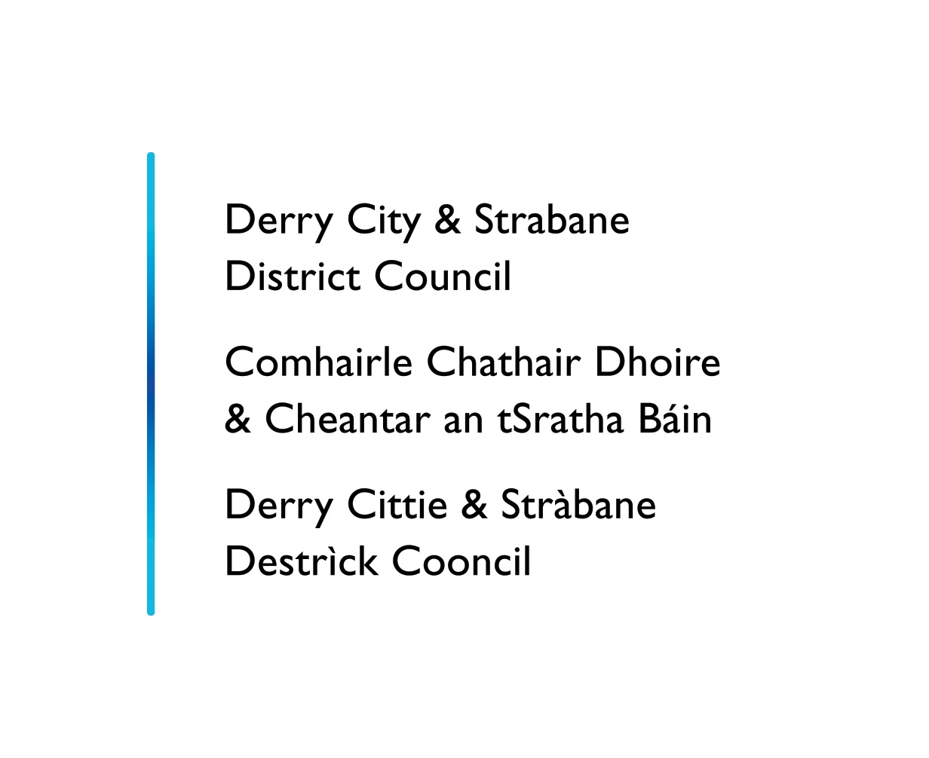
Statutory Equality Duties

Screening Of New Council Policies

(Questionnaire)

Screening of New Policies
Introduction and Guidance Notes

  - Section 75 of the Northern Ireland 1998 (“The Act”) requires the Council in carrying out its functions, powers and duties to have due regard to the need to promote equality of opportunity:

- between persons of different religious belief, political opinion, racial group, age, marital
status or sexual orientation;
- between men and women generally;
- between persons with disability and persons without;
- between persons with dependants and persons without.

1.2 In addition, without prejudice to its obligations above, the Council shall in carrying out its functions, powers and duties have regard to the desirability of promoting good relations between persons of different religious belief, political opinion or racial group. The Council supports the principles of good relations: equity, respecting diversity and interdependence, and the development of relationships built on trust and respect.

1.3 As stated in its Equality Scheme, the Council intends to screen all of its policies (formal
and informal), functions and roles in order to determine which would require a fuller
equality analysis in the form of an impact assessment.

  - This questionnaire is aimed at providing a standardised, systematic approach to the
screening exercise. A summary of this document will be made available to the Council’s
consultees and the general public, via the Council’s web-site and in other formats, (upon
request). This document may also be produced, in full, as part of consultations
regarding Equality Impact Assessments.

1.5 When the Council is considering a new policy, it will determine whether the policy has the
potential to have significant implications for equality of opportunity and/or good relations and if so will conduct a full impact assessment.

  - Where due limited quantitative and/or qualitative research data, it is not possible to establish the ‘significance’ of the equality impact, policies which score positively against any of the screening criteria should be designated for detailed impact assessment.

Part 1: Policy Scoping - Protecting Dignity At Work

Please tick as appropriate

√

New Policy Revised Policy
√

Corporate Policy Departmental Policy

If Departmental, please specify which department; __________________ _

3a. Please describe the aims of the policy:
The aim of this policy and the accompanying procedure is to prevent harassment and bullying in the workplace, provide guidance to resolve any problems should it occur and prevent recurrence.
3b. Are there any associated objectives of the policy? If so, what are they?
Derry City and Strabane District Council is fully committed to promoting a good and harmonious working environment where every employee is treated with dignity and respect and in which no worker feels threatened or intimidated because of his or her sex, marital status, family status, religious belief, political opinion, disability, age, race or ethnic origin, sexual orientation, trade union membership/non membership or criminal record.

Are there any Section75 groups which might be expected to benefit from the intended policy? If so, explain how
All Section 75 groups are expected to benefit from this policy

Who initiated or wrote the policy?
This policy has been developed by the HR Working Group

Who is responsible for the implementation of the policy?
Employees Responsibilities
All employees have a responsibility to help ensure a working environment in which the dignity of employees is respected. Everyone must comply with this policy and employees should ensure that their behaviour towards colleagues and the public does not cause offence and could not in any way be considered to be harassment or bullying.

Employees should discourage harassment by making it clear that they find such behaviour unacceptable and by supporting colleagues who suffer such treatment and are considering making a complaint. They should alert a manager or supervisor to any incident of harassment or bullying to enable the Council to deal with the matter.

Managers’ and Supervisors’ Responsibilities
Managers and supervisors have a duty to implement this policy and to make every effort to ensure that harassment and bullying does not occur, particularly in areas for which they are responsible. Managers and supervisors have responsibility for any incidents of harassment or bullying of which they are aware or ought to be aware. If harassment or bullying does occur, they must effectively deal with the situation.

Managers and supervisors should:

- Explain the Council's policy to their staff and take steps to positively promote awareness of the procedure for dealing with complaints and ensure that each member of staff has been given a copy.
- Be responsive and supportive to any employee who makes an allegation of harassment or bullying, provide full and clear advice on the procedure to be adopted, maintain confidentiality and seek to ensure there is no further problem of harassment or victimisation after a complaint has been resolved.
- Set a good example by treating all staff and the public with dignity and respect
- Be alert to unacceptable behaviour and take appropriate action.
- Ensure that staff know how to raise harassment or bullying problems.

The Council’s Responsibilities
The Council will ensure that adequate resources are made available to promote respect and dignity in the workplace and to deal effectively with all complaints of harassment or bullying.

This policy and procedure will be communicated effectively to all employees and the Council will ensure that all employees and that all managers and supervisors are aware of their responsibilities. Appropriate training will be provided including training on induction and management courses.

The Council will make others aware that employees are entitled to be treated with respect and dignity, by incorporating a statement to this effect in its rules and regulations, which it displays in its public buildings.

Individuals will be appointed to provide advice and assistance to employees who are subject to harassment or bullying. The name of these designated advisors will be made known to all employees. The Council will ensure, where possible, that employees can raise complaints, should they wish, with someone of their own gender, religion or race, or who is aware of and sensitive to disability or sexual orientation issues. All complaints of harassment will be dealt with promptly, seriously and confidentially.

Managers, supervisors and designated advisors will receive appropriate training so that they can perform their roles sensitively and effectively. In addition, those playing an official role in any formal complaints procedures will receive appropriate training.

Designated Advisors
The Council recognises that in certain cases victims may feel isolated, vulnerable, or too embarrassed to raise their concerns directly with management. The Council will appointed Designated Advisors who are able to assist and advise employees who may wish to pursue a complaint.

The role of a Designated Advisor is to:
- act as a point of contact for employees who feel they have a complaint
- listen to the complaint and advise on the options available for resolving the matter
- assist individuals with the informal resolution of complaints
- support the employee in lodging and progressing the complaint, if they so wish.

If the alleged harasser asks for assistance it may be appropriate to assign an advisor to act as a source of information and advice. This role may include providing information about the disciplinary procedure and forwarding documentation as necessary but should not extend to acting as an advocate, nor assisting the alleged harasser in the preparation of a defence.

The names of the Designated Advisors will be communicate to all staff.

7. Are there any factors which could contribute to/detract from the intended aim/outcome of the policy/decision?
If yes, are they
Financial

√
Legislative

Other, please specify _____________

8. Who are the internal/external stakeholders (actual or potential) that the policy will impact upon?
√
Staff
√

Service Users

Other public sector organisations

Voluntary/Community/Trade Unions

Other, Please specify – _________________________________________

9. Is this policy associated with any other Council Policy(s)?
Yes No

√

If yes, please state the related policy(s) below.
- Equality Scheme
- Corporate Plan
- Code of Conduct for Local Government employees.
- Disciplinary Policy and Procedure
- Grievance Policy and Procedure
- Equal Opportunities Policy
10(a). How does the policy contribute towards the achievement of the Council’s strategic objectives?
This policy is consistent with the Council’s mission to “Deliver improved social, economic and environmental outcomes for everyone.” It contributes to the cross cutting service of “People” where the key strategic outcomes are
- Supporting and developing the capacity and capability of staff to deliver on the Council’s objective to recognise its staff as its key asset in developing and promoting the quality of the area and serving its citizens and businesses
- Developing new skills and behaviours to build the culture of the new Council, ensuring that the new organisation grows and prospers for the benefit of the community and that its objectives and priorities are delivered effectively.
- Supporting directorates by providing HR advice and guidance services including policy development and implementation, recruitment, job profile development and
attendance management

11. How does the Council interface with other bodies in relation to the implementation of this policy?
Council will take advice and guidance from the Equality Commission and Labour Relations Agency in the implementation of this policy, should the need arise.

Available evidence
Evidence to help inform the screening process may take many forms. Public authorities should ensure that their screening decision is informed by relevant data.

What evidence/information (both qualitative and quantitative) have you gathered to inform this policy? Specify details for each of the Section 75 categories.

Section 75 category | Details of evidence/information
Religious belief | LGD All usual residents Catholic Protestant and other Christian Other religions None  Northern Ireland 1,810,863 817,385 (45.14%) 875,717 (48.36%) 16,592 (0.92%) 101,169 (5.59%)  Derry & Strabane 147,720 106,600 (72.16%) 37,527 (25.40%) 940 (0.64%) 2,653 (1.80%)  The breakdown detailing the religious belief profile of residents in the Derry City and Strabane District Council is as follows:  The religious profile of the Council workforce is a similar reflection of that for the new Council area. As this policy will be applied universally to all council staff regardless of Section 75 category there is no qualitative or quantitative information to suggest that this policy would have an adverse impact on this grouping.
Political opinion | The political opinion of the Council’s elected members is as follows:  Sinn Féin 16 seats  SDLP 10 seats  Democratic Unionist 8 seats  Independents 4 seats  Ulster Unionist 2 seats  This breakdown is taken as an approximate representation of the political opinion of people within the Derry City and Strabane District Council area.  Political opinion of staff is not collated however using the religious profile as a proxy indicator. As this policy will be applied universally to all council staff regardless of Section 75 category there is no qualitative or quantitative information to suggest that this policy would have an adverse impact on this grouping.
Racial group | The breakdown detailing the ethnic profile of the residents of the new Council area is as follows:  Total Usual Residents 147720  White 145546  Chinese 301  Irish Traveller 116  Indian 670  Pakistani 48  Bangladeshi 23  Other Asian 222  Black Caribbean 53  Black African 86  Black Other 41  Mixed 462  Other 163  Council do not monitor the racial group of staff as per the Article 55 Review however given the profile of residents within the Council area there is potential that Council may have applicants/employees from minority ethnic groups.  As this policy will be applied universally to all council staff regardless of Section 75 category there is no qualitative or quantitative information to suggest that this policy would have an adverse impact on this grouping.
Age | The age profile of the Derry and Strabane LGD area at Census Day 2011 is as follows:  Age Profile NI Derry and Strabane  0-4 124382 10259  5-7 67662 5653  8-9 43625 3858  10-14 119034 10904  15 24620 2363  16-17 51440 4729  18-19 50181 4443  20-24 126013 10399  25-29 124099 10481  30-44 373947 30635  45-59 347850 28082  60-64 94290 7475  65-74 145600 10775  75-84 86724 5876  85-89 21165 1217  90+ 10231 571  Council employ staff from 16 to 65+ years. As this policy will be applied universally to all council staff regardless of Section 75 category there is no qualitative or quantitative information to suggest that this policy would have an adverse impact on this grouping
Marital status | The table below illustrates the marital status profile of Derry and Strabane  LGD:  Marital Status Derry and Strabane LGD NI  All usual residents: Aged 16+ years 83663 1431540  Single (never married or never registered a same-sex civil partnership): Aged 16+ years 46326 (40.39%) 517393 (36.14%)  Married: Aged 16+ years 49218 (42.92%) 680831 (47.56%)  In a registered same-sex civil p’ship: Aged 16+ years 93 (0.08%) 1243 (0.09%)  Separated (but still legally married or still legally in a same-sex civil p’ship): Aged 16+ years 5886 (5.13%) 56911 (3.98%)  Divorced or formerly in a same-sex civil partnership which is now legally dissolved: 6179 (5.39%) 78074 (5.45%)  Widowed or surviving partner from a same-sex civil partnership: Aged 16+ years 6981 (6.09%) 97088 (6.78%)  As this policy will be applied universally to all council staff regardless of Section 75 category there is no qualitative or quantitative information to suggest that this policy would have an adverse impact on this grouping.
Sexual orientation | Analysis of the Census 2011 indicates that between 2% and 10% of the population may be lesbian, gay or bisexual.  There are no official statistics in relation to the number of gay, lesbian or bisexual people in Northern Ireland. However, research conducted by the HM Treasury shows that between 5% - 7% of the UK population identify themselves as gay, lesbian, bisexual or ´trans´ (transsexual, transgendered and transvestites) (LGBT). This is a sizeable proportion of the population here in Northern Ireland.  In terms of this policy, it will be applied universally to all council staff regardless of Section 75 category there is no qualitative or quantitative information to suggest that this policy would have an adverse impact on this grouping.
Men and women generally | The gender profile for the Derry and Strabane LGD is as follows:  LGD Male Female  Northern Ireland 887323 923540  Derry and Strabane LGD 72475 75245  The gender profile of Council workforce is similar to that of the Council area and There is no qualitative or quantitative information to suggest that this policy would have an adverse impact on this grouping.
Disability | According to the 2011 Census 22.95% of people in the Derry and Strabane LGD have a long-term health problem or disability that limits their day-to-day activities;  LGD All usual residents Day-to-day activities limited a lot Day-to-day activities limited a little Day-to-day activities not limited  Northern Ireland 1810863 215232 (11.89%) 159414 (8.8%) 1436217 (79.31%)  Derry & Strabane 147720 20710 (14.02%) 13193 (8.93%) 113817 (77.05%)  In terms of this policy, it will be applied universally to all council staff regardless of Section 75 category there is no qualitative or quantitative information to suggest that this policy would have an adverse impact on this grouping.
Dependant | According to the 2011 Census 37.65% of households in the Derry and Strabane LGD have a dependants as compared to the Northern Ireland average of 33.85% households;  All households Married or in a registered same-sex civil partnership couple: Cohabiting couple: Lone parent: Other household types:  Northern Ireland 703275 138677 (19.72%) 16186 (2.3%) 64228 (9.13% 18980 (2.7%)  Derry and Strabane 55596 10370 (18.65%) 1097 (1.97%) 7284 (13.1%) 2187 (3.93%)  In terms of this policy, it will be applied universally to all council staff regardless of Section 75 category there is no qualitative or quantitative information to suggest that this policy would have an adverse impact on this grouping.

Needs, experiences and priorities

Taking into account the information referred to above, what are the different needs, experiences and priorities of each of the following categories, in relation to the particular policy/decision? Specify details for each of the Section 75 categories

Section 75 category | Details of needs/experiences/priorities
Religious belief | None
Political opinion | None
Racial group | None – Although Council must be mindful to present all policy information in an appropriate format where there are staff members whose first language is not English.
Age | None
Marital status | None
Sexual orientation | None
Men and women generally | None
Disability | None – Although Council must be mindful to present all policy information in an appropriate format where there are staff members who may have a sensory impairment or learning difficulties.
Dependants | None

Part 2: Screening questions

Introduction

In making a decision as to whether or not there is a need to carry out an equality impact assessment, the public authority should consider its answers to the questions 1-4.

If the public authority’s conclusion is none in respect of all of the Section 75 equality of opportunity and/or good relations categories, then the public authority may decide to screen the policy out. If a policy is ‘screened out’ as having no relevance to equality of opportunity or good relations, a public authority should give details of the reasons for the decision taken.

If the public authority’s conclusion is major in respect of one or more of the Section 75 equality of opportunity and/or good relations categories, then consideration should be given to subjecting the policy to the equality impact assessment procedure.

If the public authority’s conclusion is minor in respect of one or more of the Section 75 equality categories and/or good relations categories, then consideration should still be given to proceeding with an equality impact assessment, or to:

- measures to mitigate the adverse impact; or
- the introduction of an alternative policy to better promote equality of opportunity and/or good relations.

In favour of a ‘major’ impact
- The policy is significant in terms of its strategic importance;
- Potential equality impacts are unknown, because, for example, there is insufficient data upon which to make an assessment or because they are complex, and it would be appropriate to conduct an equality impact assessment in order to better assess them;
- Potential equality and/or good relations impacts are likely to be adverse or are likely to be experienced disproportionately by groups of people including those who are marginalised or disadvantaged;
- Further assessment offers a valuable way to examine the evidence and develop recommendations in respect of a policy about which there are concerns amongst affected individuals and representative groups, for example in respect of multiple identities;
- The policy is likely to be challenged by way of judicial review;
- The policy is significant in terms of expenditure.

In favour of ‘minor’ impact
- The policy is not unlawfully discriminatory and any residual potential impacts on people are judged to be negligible;
- The policy, or certain proposals within it, are potentially unlawfully discriminatory, but this possibility can readily and easily be eliminated by making appropriate changes to the policy or by adopting appropriate mitigating measures;
- Any asymmetrical equality impacts caused by the policy are intentional because they are specifically designed to promote equality of opportunity for particular groups of disadvantaged people;
- By amending the policy there are better opportunities to better promote equality of opportunity and/or good relations.

In favour of none
The policy has no relevance to equality of opportunity or good relations.
- The policy is purely technical in nature and will have no bearing in terms of its likely impact on equality of opportunity or good relations for people within the equality and good relations categories.

Taking into account the evidence presented above, consider and comment on the likely impact on equality of opportunity and good relations for those affected by this policy, in any way, for each of the equality and good relations categories, by applying the screening questions given overleaf and indicate the level of impact on the group i.e. minor, major or none.

Screening questions
- What is the likely impact on equality of opportunity for those affected by this policy, for each of the Section 75 equality categories? minor/major/none

Section 75 category |  | Details of policy impact |  | Level of impact? minor/major/none
Religious belief |  | Policy will be applied equally to all employees |  | None
Political opinion |  | Policy will be applied equally to all employees |  | None
Racial group |  | Policy will be applied equally to all employees |  | None
Age |  | Policy will be applied equally to all employees |  | None
Marital status |  | Policy will be applied equally to all employees |  | None
Sexual orientation |  | Policy will be applied equally to all employees |  | None
Men and women generally |  | Policy will be applied equally to all employees |  | None
Disability |  | Policy will be applied equally to all employees |  | None
Dependants |  | Policy will be applied equally to all employees |  | None
- Are there opportunities to better promote equality of opportunity for people within the Section 75 equalities categories?

Section 75 category | If Yes, provide details |  | If No, provide reasons
Religious belief |  |  | No – this policy will be applied equally to all staff members without exception
Political opinion |  |  | No – this policy will be applied equally to all staff members without exception
Racial group |  |  | No – this policy will be applied equally to all staff members without exception
Age |  |  | No – this policy will be applied equally to all staff members without exception
Marital status |  |  | No – this policy will be applied equally to all staff members without exception
Sexual orientation |  |  | No – this policy will be applied equally to all staff members without exception
Men and women generally |  |  | No – this policy will be applied equally to all staff members without exception
Disability |  |  | No – this policy will be applied equally to all staff members without exception
Dependants |  |  | No – this policy will be applied equally to all staff members without exception

- Are there opportunities to better promote good relations between Section 75 equality categories through tackling prejudice and/or promoting understanding?

Section 75 category | Details of policy impact | Level of impact minor/major/none
Religious belief |  | No – this policy will be applied equally to all staff members without exception
Political opinion |  | No – this policy will be applied equally to all staff members without exception
Racial group |  | No – this policy will be applied equally to all staff members without exception
Age |  | No – this policy will be applied equally to all staff members without exception
Marital status |  | No – this policy will be applied equally to all staff members without exception
Sexual orientation |  | No – this policy will be applied equally to all staff members without exception
Men and women generally |  | No – this policy will be applied equally to all staff members without exception
Disability |  | No – this policy will be applied equally to all staff members without exception
Dependants |  | No – this policy will be applied equally to all staff members without exception

- Is there evidence to suggest that this policy would promote positive attitudes towards people with a disability?

If Yes, provide details | If No, provide reasons
 | No – this policy will be applied equally to all staff members without exception – however Council will ensure that information is presented in an appropriate
- Is there evidence to suggest that this policy would encourage the participation of people with a disability in public life?

If Yes, provide details | If No, provide reasons
 | No

Additional considerations

Multiple identity

Generally speaking, people can fall into more than one Section 75 category. Taking this into consideration, are there any potential impacts of the policy/decision on people with multiple identities?
(For example; disabled minority ethnic people; disabled women; young Protestant men; and young lesbians, gay and bisexual people).

Provide details of data on the impact of the policy on people with multiple identities. Specify relevant Section 75 categories concerned.

Part 3. Screening decision

If the decision is not to conduct an equality impact assessment, please provide details of the reasons.
The policy applies to all Council employees and has no negative or adverse impact on any Section 75 target groups. The policy has been written specifically with these target groups in mind to ensure that any person affected by unwanted behaviour or conduct has a confidential process to follow to ensure that the value of dignity and respect for all employees is adhered to.

If the decision is not to conduct an equality impact assessment the public authority should consider if the policy should be mitigated or an alternative policy be introduced. Please provide details

If the decision is to subject the policy to an equality impact assessment, please provide details of the reasons.

Part 4: Mitigation

When the public authority concludes that the likely impact is ‘minor’ and an equality impact assessment is not to be conducted, the public authority may consider mitigation to lessen the severity of any equality impact, or the introduction of an alternative policy to better promote equality of opportunity or good relations.

Can the policy/decision be amended or changed or an alternative policy introduced to better promote equality of opportunity and/or good relations?

If so, give the reasons to support your decision, together with the proposed changes/amendments or alternative policy.

Part 5 - Approval and authorisation
Screened by: | Position/Job Title | Date
Kay McIvor | Equality Officer | 8th April 2016
Approved by:

Note: A copy of the Screening Template, for each policy screened should be ‘signed off’ and approved by a senior manager responsible for the policy, made easily accessible on the public authority’s website as soon as possible following completion and made available on request.

