**AGE FRIENDLY NEWS & UPDATES**

**Edition 34 – 13/10/2023**

* **Halfway through this year’s Positive Ageing Month Campaign**

Given we are now in mind October, it’s an opportunity to recognize and celebrate the activities that have been on offer already this month. If you haven’t got along, it’s not too late. Revisit the brochure and get along to some of the remaining activities planned. Information on the campaign and also Positive Ageing Month brochures can be accessed online by visiting [www.derrystrabane.com/agefriendly](http://www.derrystrabane.com/agefriendly) Copies of the brochures will be distributed across the area and are available from the Western Trust Health Improvement, Equality and Involvement Department by emailing [Health.Improvement@westerntrust.hscni.net](mailto:Health.Improvement@westerntrust.hscni.net)  or phone 028 7186 5127, or from Derry City & Strabane District Council by telephoning  028 7125 3253



* **Intergenerational Practice to Combat Ageism**

Ageism exists when “age” is used to categorise individuals and create social divisions, with ensuing injustice and harm and lack of solidarity across generations. Ageism is highly detrimental to our health and well-being and imposes a heavy cost on societies. The World Health Organization (WHO) was requested to develop, in cooperation with partners, a global campaign to combat ageism. This guide, developed for the campaign, builds on the evidence in the Global report on ageism that interventions for intergenerational contact is one of three strategies that have been proven to work in addressing ageism, together with policy and law and educational interventions. The guide provides step-by-step guidance for anyone who is using or wishes to use intergenerational practice to combat ageism and to promote understanding and mutual respect among generations. Please visit

<https://www.decadeofhealthyageing.org/find-knowledge/resources/publications/detail/connecting-generations-planning-and-implementing-interventions-for-intergenerational-contact>

* **Walking for Health During Positive Ageing Month**

Walking for Health across Derry and Strabane for a Walk Leader led free gentle and inclusive walk lasting approximately 1 hour. On Monday 16th October between 10.30am-11.30am from Ebrington Square. Join in the Meet at Ebrington Square at the Bakery (Peace Tree) or on Wednesday 18th October between 10.30am – 11.30am from Strabane Towpath. Contact [Ellie.Leonard@westerntrust.hscni.net](mailto:Ellie.Leonard@westerntrust.hscni.net) or phone 028 7186 5127 for further details.

* **What do you need to know about pensions? (Online via Teams)**

ON Tuesday 17th October from 11am-12.30pm join MoneyHelper. Planning for a more certain future. Join experts from the government-backed MoneyHelper to cut through the complexity and talk about your pension rights including planning and budgeting for retirement. Webinar delivered by the Money & Pensions Service covering general pensions, state pensions, options on retirement, scams etc with an opportunity for Q&A. Join the online session on Microsoft Teams using meeting ID 392 141 323 32 and Passcode kebr25.

* **City of Derry International Choir Festival Community Event for Dementia**

Mellow DEEDS Choir will perform as part of the City of Derry Choir Festival, alongside a visiting international choir and a community choir from the Derry/Strabane area. These wonderful choirs will perform to an audience of dementia social and activity groups at Shantallow Community Centre on Thursday 19th October from 12.30pm-2.30pm. This is open to DEEDS dementia groups, registration via DEEDS Support Workers. Includes light lunch. Contact Sinead Devine on 028 71 373870 or email [sinead@olt.ie](mailto:sinead@olt.ie)

* **Moves and Melodies in the Millennium Forum**

Moves and Melodies takes place on Thursday 19th October from 2-3.30pm and is a free monthly song and dance workshop to learn new dance skills and sing a range of song styles every month. Early booking is advisable. Contact Lisa Heaney on 028 7127 2779 (option 1) or email [lisah@millenniumforum.co.uk](mailto:lisah@millenniumforum.co.uk)

* **City of Derry International Choir Festival in Eglington**

Eglington Community Hall will host performances by visiting Community Choirs on Saturday 21st October from 3pm-4.30pm as part of the City of Derry International Choir Festival. No booking required. Further information available from Mairead Nic Bhloscaidh, Derry Choir Festival by emailing [mairead@derrychoirfest.com](mailto:mairead@derrychoirfest.com) or telephone 028 7136 3672

* **Autumn/winter Vaccination programme**

Please see below the link to the Autumn/winter vaccination resources [Resources to support the PHA autumn vaccine programme (mailchi.mp)](https://protect-eu.mimecast.com/s/sXLLCAPNpfNv0xri8JZ3s?domain=mailchi.mp) You can download and use the resources in the link or share directly from our social media channels.

* **Winter Information Session**

Please see below further information on the Winter Information session available next week, hosted by Marie Curie, Supporting terminally ill people in the community, which will take place on 16 October 10.30-12.30pm online.

|  |  |
| --- | --- |
| 10.30-10.40 | Welcome and Introductions |
| 10.40-11.00 | Marie Curie – I&S (Energy Support Officers) |
| 11.00-11.20 | Macmillan Welfare Benefits Advice |
| 11.20-11.40 | Consumer Council |
| 11.40- 12.00 | National Energy Action |
| 12.00-12.20 | Food Bank Network |
| 12.20-12.30 | Final Comments and Close |

Please feel free to share this event with other colleagues who might be interested in attending. If you would like to attend please contact Christine Irvine at Marie Curie [Christine.Irvine@mariecurie.org.uk](mailto:Christine.Irvine@mariecurie.org.uk) who will share the required link.

* **Human Library**

This will be an interactive but intimate event based on the 'Human Library' concept were real people, in this case volunteers, are like a book that is on loan to members of the public to read and find out more about, asking questions and having meaningful conversations. Volunteers will be representing a range of local voluntary organisations who will also be attending and actively recruiting volunteers on the day.

<https://www.eventbrite.co.uk/e/volunteer-voices-tickets-726778222227?aff=oddtdtcreator>

* **Deafblind NI**

Deafblind NI is in the process of gathering feedback from service providers on the issues and challenges faced by people with a dual sensory impairment, i.e. a level of sight loss and a level hearing loss, e.g. someone who wear glasses for reading and is hard of hearing, through to someone who is profound deaf and completely blind. The survey should take around 10 minutes to complete, and we would ask that you complete it by Monday 13th November. We would be extremely grateful if you could click on the following link and complete the short survey

<https://forms.office.com/Pages/ResponsePage.aspx?id=syTHb2hMfUW70Noj2LVCc4vnWImcMpZKufoOciQOMrNUNVJLOTFPWE1JWlczRjdXMUE1U0M4RFFPMSQlQCN0PWcu>

* **Remedial work at Altnagelvin Hospital’s Emergency Department**

Remedial work is due to start at Altnagelvin Hospital’s Emergency Department (ED).  The work is to repair and improve the flooring in the ‘Majors 1’ area of the Department. To facilitate the works ‘Majors 1’ will close from Wednesday 11 October for approximately ten days. This will mean a small reduction in seating and treatment space during this time. To support the continuation of safe care for our ED patients we have re-allocated seven spaces at our Ambulatory Care Unit (Level 2, Tower Block, Altnagelvin Hospital). This will be staffed by the ED team for patients being admitted into the hospital for further diagnostics, treatment and care.

Due to the temporary reduction in available space,  we would ask if you are attending the Emergency Department at Altnagelvin Hospital over the next few weeks, to please do so alone. Exemptions will apply to children and adults with communication difficulties/additional needs.  We would also encourage you to consider other appropriate avenues of care, such as, their local Pharmacy, their GP, GP Out Of Hours or the Urgent Care and Treatment Centre in Omagh during this time. Thank you for your cooperation and patience.

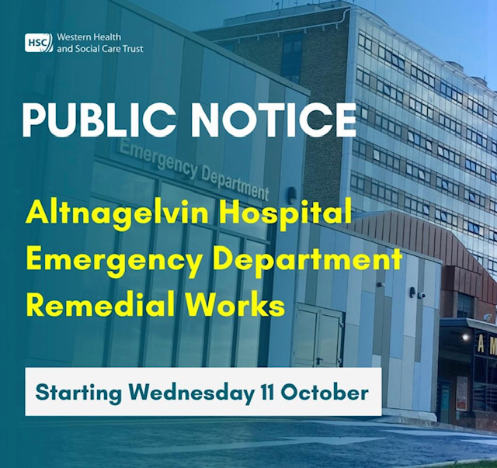

* **Volunteer Opportunity with Repair Café Foyle**



Are you looking for a volunteer opportunity that leaves smiles on faces? Look no further! Repair Café Foyle are looking for a bit a' help each month at our pop up events. If you like to bake and are happy to donate or drop off a wee tray bake now and then we'd be absolutely delighted!  We're happy to cover costs for ingredients and have a strict no nuts policy! Drop us a wee message here or via email for a catch up on joining our register of bakers!

* **Library of Things Foyle Survey**

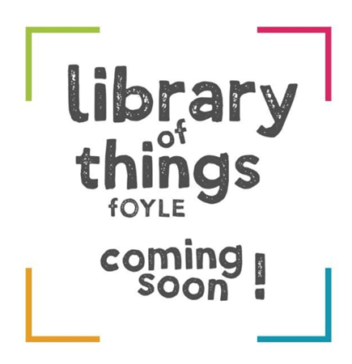

We are working towards opening a 'Library of Things' and want to know your thoughts on borrowing. Respondents who leave their email will be in with the chance of winning a year’s free membership!  Please complete our Library of Things Foyle survey so we can ensure our projects remain community led! [https://docs.google.com/forms/d/1IpPaZcl2SxvjQfzlOflez_Wp25yRGDNswlCEa8zwyy0/edit](https://protect-eu.mimecast.com/s/GVqdCQ0nMfk5KAXHx_agl?domain=docs.google.com)

* **Repair Café Foyle**

The next Repair Café will be held in Clooney Community Centre on the 21st which also happens to be International Repair Day. So don't be repair shy, get yer' broken bits and bobs and bring them along for our volunteer fixers to get a look. If we can't fix it we'll aim to signpost you to a local business. Things we like to try and fix are (but not limited to):

* Small household electricals ( All PAT tested by our team)
* Toys
* Textiles
* Leather
* Bikes
* Electronics (Software diagnostics)
* Small pieces of furniture or woodwork
* Magic Wands
* Basically we'll give most things a go!

*Arrive early to avoid disappointment esp. if it's an electrical item :)

* **Men’s Physical Fitness Sessions at Fountain Street**

Men's Physical Fitness session continues on Friday mornings from 10-11am at Fountain Street Community Centre, Strabane. Come along and enjoy a bit of light physical activity, a wee bit of music and plenty of craic followed by tea/coffee and biscuits. New faces are extremely welcome, you don't have to reside in the area in order to attend.

* **Weaving Your Way to Better Health**

Please see below poster for further information

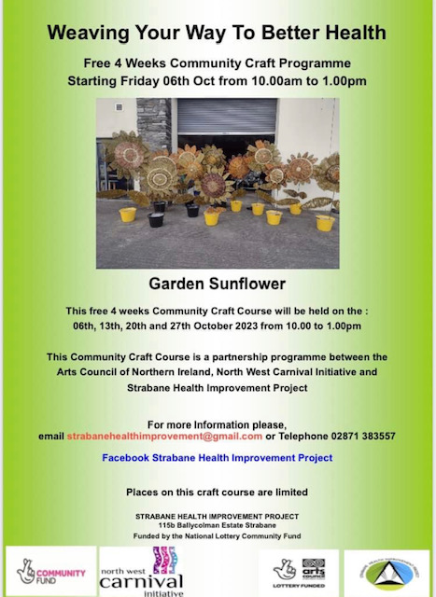

* **Council launched Paint Reuse Scheme**

Council has launched a Paint Reuse Scheme & are calling for people to donate leftover paint to their 3 main recycling centres. Once a stock of paint is established, people will be able to come and collect paint for home DIY, their school or community projects. Paint can be donated at the Paint Reuse Points at Pennyburn, Strahans Rd & Strathfoyle recycling centres. So have a wee look in the shed this weekend & do your bit for the planet and our community by donating. For infomation see [www.derrystrabane.com/paintscheme](https://protect-eu.mimecast.com/s/X5ATCnrx1i7J1OYh9WO-a?domain=derrystrabane.com)

* **Will you become a platelet donor?**



Will you become a platelet donor?  Platelets are needed to help patients receiving chemotherapy, bone marrow transplants, undergoing surgery, especially cardiac surgery and for patients with serious bleeding after an accident.  Become a lifesaver today - visit [nibts.org](https://protect-eu.mimecast.com/s/bKcqCoQV1Cr71q0Hz0Kk5?domain=nibts.org) for more info.  Northern Ireland Blood Transfusion Service

* **NIAPN presents Poverty is a Political Choice**

NIAPN presents Poverty is a Political Choice to mark International Day for the Eradication of Poverty. This event will be held on Tuesday, 17 October from 9.30am-1pm in The Guildhall, Whittaker Suite, Derry. Featuring

Amie Gallagher, The Focus Project; Rayna Downey, The Women's Centre, Derry; and Karen Mullen, The Foyle Foodbank alongside keynote speakers: Dr. Ciara Fitzpatrick and Bernadette McAliskey. Refreshments will be provided. Space is limited, reserve a ticket: <https://NIAPNeradicationpoverty.eventbrite.co.uk> For more information contact Becca by emailing [becca.niapn@gmail.com](mailto:becca.niapn@gmail.com) or telephone 07519470305

* **NWCN E-bulletin**

For the latest NWCN e-bulletin please visit <http://www.nwcn.org/content/nwcn-ebulletin-11-october-2023>

* **Volunteers Required**

