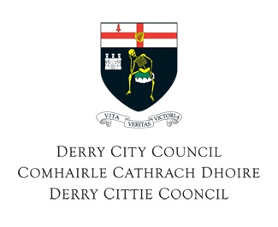

Our Ref: CS

26th September 2013

Dear Consultee

As part of its Statutory Equality Duties under Section 75 and Schedule 9 of the Northern Ireland Act 1998, Derry City Council is carrying out an equality impact assessment on the following draft policy and would invite you to take part in our consultation process.

Derry City Council Good Relations Strategy 2014-2017

Under Section 75 legislation, Derry City Council has a statutory responsibility to promote Good Relations between people of different race, religion and political opinion.
This Strategy sets out Council’s priorities for the promotion of Good Relations
- Aim 1: Our Council support
- Aim 2: Our children and young people
- Aim 3: Our shared community
- Aim 4: Our safe community
- Aim 5: Our cultural expression
The implementation of this strategy will also be guided the cross-cutting themes / underpinning principles of Equality and Fairness; Sustainability, Sharing and Interdependence; Innovation and Creativity; Rights, Respect and Responsibilities; Inclusion and Participation; Cohesion and Integration; and Diversity and Acceptance.

The Council is keen to consult as widely as possible, and hopes that you will find time to comment this draft policy. If you wish to receive further

In order to request further nformation on this policy and a copy of the Council’s equality impact assessment questionnaire, please complete and return the attached reply slip.

Please note that the draft policy and consultation response questionnaire are also available on the Council’s web site: www.derrycity.gov.uk and are available in other formats on request.

Your contribution to the consultative process is important and will be taken into consideration in finalising our policy proposals.

/contd…..
-2-

26th September 2013

Re: Derry City Council Good Relations Strategy 2014-2017

All comments/completed questionnaires should be forwarded to, Carol Stewart, Community Relations Officer, Shared Future Centre, Irish Street, Derry~Londonderry, no later than 20th December 2013.

Alternatively, you can contact Ms Carol Stewart and seek a face to face meeting to relay any comments you wish to make.

Your co-operation in this matter is greatly appreciated.

Yours faithfully,

Sharon O’Connor
Town Clerk and Chief Executive

Enc

Reply Slip

Please note that the Council has prepared an equality impact assessment questionnaire to help collate consultation responses. The Council is willing to accept comments in other formats such as e-mail or by telephone. We are also willing to facilitate meetings on request. The draft policy documents and questionnaires are also available in a range of formats, upon request.

Please forward a copy of the following draft policy and equality impact assessment questionnaire: (Please tick all required)

Derry City Council Good Relations Strategy 2014-2017

Please indicate in which format you would like to receive the policy information:

- Braille

- Large Print

- Tape

- Disc

- Language other than English – Please Specify ___________

Name of Organisation: ____________________________________

Address for Correspondence: ______________________________
______________________________
______________________________

Contact Person: __________________________________________

