**AGE FRIENDLY NEWS & UPDATES**

**Edition 36 – 27/10/2023**

* **Derry Halloween 2023 returns 28th – 31st October**

Be part of Europe’s Largest Halloween Festival as the Walled City of Derry welcomes the spirit of Samhain through its historic gates for a festival like no other! For four nights the worlds of past and present collide to bring you a dazzling street celebration of all things spooky in the official home of Halloween. Follow the Awakening the Walled City Trail and find out more about the folklore, history and heritage that makes this place so special. The story of Halloween is brought to life through illumination, aerial performance, pyrotechnics, and music, as the spirits cross over to join the festivities, bringing magic and mischief to the streets. For full details of the programme please visit <https://derryhalloween.com/> and for accessibility information regarding attending the events, please visit <https://derryhalloween.com/accessibility/>

* **Mayors Boccia Initiative**

Mayor of Derry City and Strabane District Council, Councillor Patricia Logue, has agreed to gift Boccia kits to each District Electoral Area in the Council area to allow older people to avail of the game’s benefits. The kits will be used in Western Health and Social Care Trust Day Centres with the intention of encouraging physical activity and participation among those who attend.

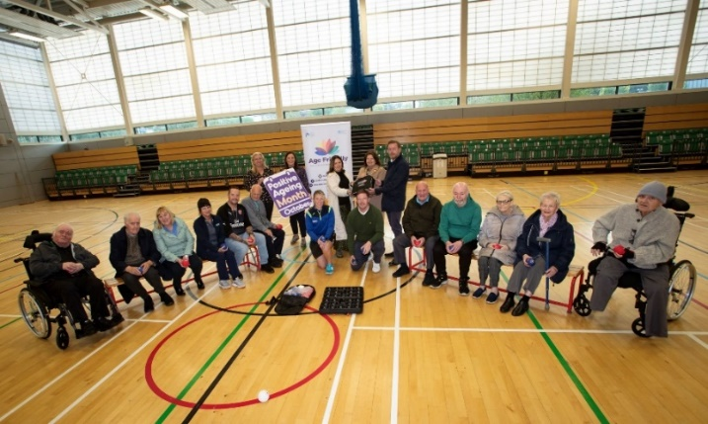

* **NI Frailty Network Newsletter**

Please see attached the latest NI Frailty Network Newsletter

* **Join the NI Ambulance Service (NIAS) Partner Voice Forum**

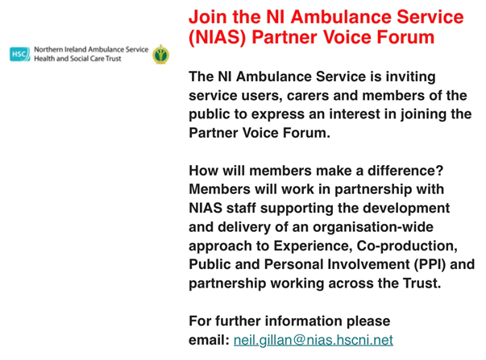

* **Cooperation & Working Together Engagement Events**

Cooperation and Working Together (CAWT) are hosting some online Community Engagement Events with reference to PeacePlus Mental Health and Wellbeing. Please see attached flyer, programme, and registration form. For further information please contact Fiona Lafferty, CAWT Business Support Officer & Event Coordinator, CAWT (Co-operation and Working Together) Cross Border Health and Social Care by telephoning 028 7127 2100 or email [fiona.lafferty@westerntrust.hscni.net](mailto:fiona.lafferty@westerntrust.hscni.net)

  

* **Commissioner supports PSNI campaign to stay safe**

The Commissioner for Older People, Eddie Lynch supports PSNI campaign which aims to ‘empower older people’ to stay safe from scammers. Please see weblink for further information [Commissioner supports PSNI campaign which aims to ‘e... (copni.org)](https://www.copni.org/news/2023/october/commissioner-supports-psni-campaign-which-aims-to-empower-older-people-to-stay-safe-from-scammers)

* **Understanding Rare Disease Workshop**

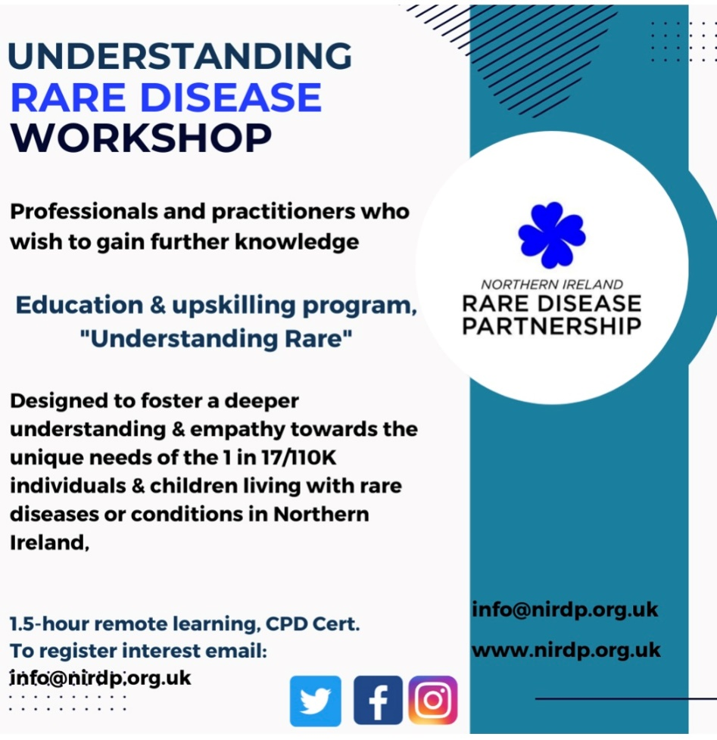

* **Rural Community Transport Partnerships receive a boost**

Funding of £3.4 Million from the Motability Foundation into Rural Community Transport Partnerships across the North, West and Mid-Ulster areas of NI Will Enhance Transport Options for People with Disabilities and Mobility Issues. For further information please visit <https://www.communityni.org/news/funding-ps34-million-motability-foundation-rural-community-transport-partnerships-across-north>

* **Volunteer Voices**

**North West Community Network in partnership with North West Volunteer Centre presents: Volunteer Voices, which will be held on Wednesday 8th November from 12-2pm in North West Community Network, 8 Bishop Street.** So many reasons and benefits to volunteering in your local community, come along and hear firsthand local volunteer stories. This will be an interactive but intimate event based on the 'Human Library' concept were real people, in this case volunteers, are like a book that is on loan to members of the public to read and find out more about, asking questions and having meaningful conversations. Volunteers will be representing a range of local voluntary organisations who will also be attending and actively recruiting volunteers on the day. To register please visit   
[Volunteer Voices Tickets, Wed, Nov 8, 2023 at 12:00 PM | Eventbrite](https://www.eventbrite.co.uk/e/volunteer-voices-tickets-726778222227?aff=oddtdtcreator)

* **Good Relations Awards 2024 Launched**

The Good Relations Awards 2024 are now open for nominations. The Awards will spotlight the vital role that members of the community throughout Northern Ireland play in delivering peacebuilding and community cohesion. The Good Relations Awards are run annually by the Community Relations Council in partnership with The Executive Office (TEO). They recognise exceptional commitment to Good Relations work by those selfless individuals who go above and beyond, every single day, to make Northern Ireland a better place. The Awards celebrate those who unite and champion our local communities, and they also showcase the wide range of projects connecting communities though peace, understanding and cultural respect. There are five award categories: The Community Relations Council Exceptional Achievement Award; Good Relations Volunteer of the Year Award; Good Relations Community Champion Award; Good Relations Youth Award (Under 25); and the Good Relations Connecting Communities Project of the Year Award. Each of the Award categories is supported by a partner organisation: Volunteer Now; NICVA; NI Youth Forum, and Community Foundation for Northern Ireland. If you know a local group, individual or organisation in Northern Ireland deserving of recognition for their work, then nominate now for the 2024 Good Relations Awards. The closing date for nominations is Tuesday 19 December 2024 at 12 noon. Please visit [www.goodrelationsawards.com](http://www.goodrelationsawards.com)

* **ALLY Foyle Free** **Cookery Packs & Keep Warm at Home Packs**

**ALLY Foyle have received funding for a limited number of individual packs for older people, these include Cookery Packs & Keep Warm at Home Packs. To request a pack for an older person, ring 02871265098 / 07419987095 or email info@allyfoyle.com with name & address so the pack can be delivered.**

**Cookery packs**

For older people to use at home to encourage people to cook healthy meals instead of depending on processed foods.  They will contain a recipe book, apron, chopping board and some cookery / cleaning utensil’s.

**Keep Warm at home packs**

These individual packs for older people include a fleece blanket, hat, scarf, gloves, and socks to enable people to keep warm during the winter, especially with the increase of electricity, oil. Etc.

* **Skills Inequalities in Older people (50+ years)**

Please find enclosed a presentation outlining research around skills inequalities in older people (50+) in Northern Ireland, from the Department for the Economy [Older people Inequalities in the Northern Ireland Skills System | Department for the Economy (economy-ni.gov.uk)](https://www.economy-ni.gov.uk/publications/older-people-inequalities-northern-ireland-skills-system)

* **Later Years Physical Activity Survey**

The HSC Physical Activity forum have extended the closing date of the Later Years Physical Activity Survey to 3rd November 2023 and would appreciate if you could please take the opportunity to complete the below survey. We know, professionals and practitioners working in this field are key to promoting physical activity within this population and we are keen to hear your views on how best to support our later years population in being active. Please click on the flyer below or scan the QR code to access the Survey. Please encourage your colleagues working with Later Years to also complete the Survey. Survey Link: <https://forms.office.com/e/cADzidS2En>

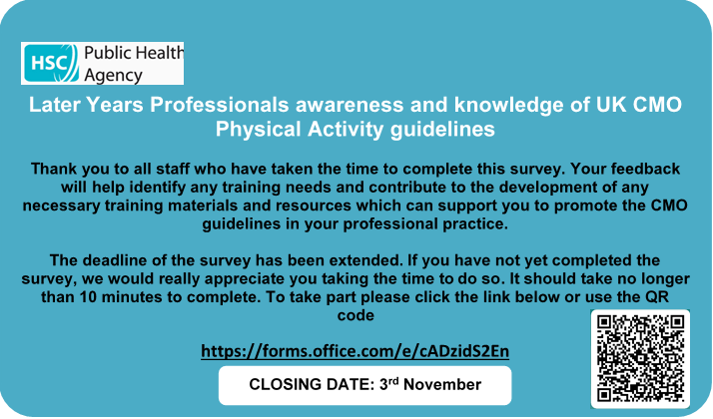

* **Ageism Campaign Champions Information Session**

The Centre for Ageing Better are organising an Ageism Campaign Champions information session on 31st October 10 – 11.30am.  For more information and Zoom invitation, please email [experience@ageing-better.org.uk](mailto:experience@ageing-better.org.uk)

* **National Energy Action Webinars**

As part the Winter Pressures measures to help ease financial burden please see links to the following webinars:

• Introduction to Domestic Energy Efficiency in Northern Ireland

• Fuel Poverty and Health in Northern Ireland

• Changing Energy Related Behaviour

Further details via the link below:

<http://r.newsletter.nea.org.uk/mk/mr/sh/1t6AVsg9Ynm8rajEtTiU5B0NMTck7d/IhySO_5kIVxb>

* **Letters to Heaven**

Derry City and Strabane District Council are set to launch a new scheme across selected cemeteries that will allow mourners to remember their loved ones in a special way.  Letters to Heaven is a new initiative that will see special letterboxes placed in four of the largest cemeteries across the city and district, allowing visitors to send letters to those they have lost.  The special Letters to Heaven Letterboxes will be situated in the City Cemetery and Ballyoan in Derry, Castlederg and Strabane cemeteries.

* **ALLY Foyle Newsletter – 18th October 2023**

Please find enclosed the latest newsletter from ALLY Foyle



* **Talk Money Week 2023 – 6th-10th November**

Money and Pensions Service as part of their #TalkMoney Week (6 – 10 November) are offering a free demonstration of their ‘Mid Life MOT’ finance tool on Thursday 9 November at 1pm via Microsoft Teams meeting within [www.MoneyHelper.org.uk](http://www.MoneyHelper.org.uk) registration link included the attachment. MaPS Financial Wellbeing Survey 2021 reveals that 50% of people in Northern Ireland do not feel confident in making decisions about financial products and services and 60% of working age people do not have a plan for their finances in retirement. This Talk Money Week – MaPS are asking people to “Do One Thing” and are asking people to join them to see a live demonstration of the Mid Life MOT finance tool within [www.MoneyHelper.org.uk](http://www.MoneyHelper.org.uk) The Money Midlife MOT is a tool to help you assess your current financial situation and plan for the future. Your personalised report will tell you what to prioritise and link to guidance on how to improve your financial wellbeing from midlife through to retirement. Join an online session. See below poster



* **Stress Awareness Day – 1st November 2023**

Although we all need some stress to be able to function effectively, too much stress creates an imbalance and has the potential to make us physically and mentally unwell.  The Public Health Agency (PHA)  is offering a series of stress control classesonline which will help you identify how and why you feel stressed and what to do about it. Wednesday 1st November is[Stress Awareness Day](https://protect-eu.mimecast.com/s/S_w9CYvW8iLwKVYH0fMPq?domain=wellnet.dorset.nhs.uk)and to coincide with this, a course is available on the following dates.  Each session is available to view for 48 hours after going live on YouTube:

* Session One: Starts Monday 6th November at 9am and is available to view online until 8am on 9th November
* Session Two: Starts Thursday 9th November at 9am and is available to view online until 8am on 13th November
* Session Three: Starts Monday 13th November at 9am and is available to view online until 8am on 16th November
* Session Four: Starts Thursday 16th November at 9am and is available to view online until 8am on 20th November
* Session Five: Starts Monday 20th November at 9am and is available to view online until 8am on 23rd November
* Session Six: Starts Thursday 23rd November at 9am and is available to view online until 8am on 27th November at 8am

You don't  need to register or log in!  With free online resources to support the learning available on the website, you can watch the six sessions at the scheduled time on the [Stress Control YouTube channel](https://protect-eu.mimecast.com/s/9_cuCZVY1S501KvijDJGy?domain=youtube.com)

If November doesn’t suit you, more courses are available and dates are on the website. To find out more about Stress Control and to register for classes visit [https://ni.stresscontrol.org/](https://protect-eu.mimecast.com/s/AxATC1rWLiMlrJgSpUKPD?domain=ni.stresscontrol.org/)

* **National Energy Action’s Fuel Poverty Awareness Day**

National Energy Action’s Fuel Poverty Awareness Day (FPAD) is on Thursday 30 November 2023.FPAD is a fantastic time to showcase the brilliant work you have been doing on the ground to tackle fuel poverty. We appreciate that this has been extremely difficult since the energy crisis began, but our members and partner organisations continue to do amazing work against all odds. Ways that you can support the campaign are:

* Hold an energy advice session and invite clients along. You could invite your MP to the event so they can meet households that will struggle this winter.
* Write a press release about the work that you have been doing in your area to help those in fuel poverty.
* Write to your MP to support legislation to help low-income and vulnerable householders this winter. We have recently updated our [template lette](https://protect-eu.mimecast.com/s/hxt1C59QPhZVBZVCPg7BE?domain=r.newsletter.nea.org.uk)r.
* [Support our call for a social tariff](https://protect-eu.mimecast.com/s/LRFtC6RXQfrn5rniw2kab?domain=r.newsletter.nea.org.uk) by signing the letter that we recently sent to the Prime Minister and Secretary of State for Energy Security and Net Zero. You can read the letter [here](https://protect-eu.mimecast.com/s/deAoC7L1RSAODAOHGiZfD?domain=r.newsletter.nea.org.uk).

For other ways in which you can help fight fuel poverty, find out more [here](https://protect-eu.mimecast.com/s/Ca2bC861VC67o67CYbmWy?domain=r.newsletter.nea.org.uk).

* **NWCN Consultation Bulletin - October 2023**

Please visit the below link to view upcoming Consultations

[**http://www.nwcn.org/content/nwcn-consultation-bulletin-october-2023**](http://www.nwcn.org/content/nwcn-consultation-bulletin-october-2023)

* **Women's Regional Consortium Survey 2023**

Northern Ireland Rural Women’s Network (NIRWN) is a member of the Women’s Regional Consortium. We provide the rural element of delivery. We would encourage you to complete the survey as this will inform and help shape the regional delivery of infrastructure support for women. It is important that rural women have their views included. The survey should only take a few minutes of your time. Please visit the survey link <https://forms.gle/x9ZaNZ7NkiyCrNaN9>