**AGE FRIENDLY NEWS & UPDATES**

**Edition 28 – 11/08/2023**

* **Mayors Tea Dances**

The Mayors Tea Dances are free events, with registration for the events essential. Mayor Logue is committed to raising much-needed funds for the Foyle Hospice and The Ryan McBride Foundation while she is in office. with donations to the Mayor’s Charities welcomed at the Tea Dances.

These will take place on the following dates;

* 6th September at the Guildhall
* 11th October at the Guildhall
* 1st November at the Guildhall
* 6th December at the Guildhall
* Tuesday 12th December, Mayor’s Christmas Tea Dance will take place in St Pat’s Hall, Strabane on from 2pm until 4pm

2024 dates for the diary

* 10th January, a special Tea Dance will be held in The Alley Theatre
* 7th February at the Guildhall
* 20th March at the Guildhall
* 10th April at the Guildhall
* 8th May 2024 at the Guildhall

Registration for the Tea Dance events is essential, contact the Mayor’s Office either by calling 028 7137 6508 or email [mayor@derrystrabane.com](mailto:mayor@derrystrabane.com)

* **August Craft Month**

August Craft Month, Ireland’s unique celebration of the craft sector, providing opportunities for all to learn about, make, see and buy craft! August Craft Month in collaboration with Design & Crafts Council Ireland, CRAFT NI and Cork Craft and Design has launched their calendar of activities to mark the month. Visit [www.augustcraftmonth.org](http://www.augustcraftmonth.org) for all events!

* **WHSCT Latest Training Brochure**

The WHSCT Health Improvement Equality & Involvement (HIEI) Department has published their latest Training Brochure which offers free training courses taking place across the Trust from September 2023 to March 2024.

This edition of the HIEI Training Brochure offers four NEW courses: Building our Children’s Developing Brain, On your Feet, Food and Health Essentials and a Sexual Health Services Session. We are delighted to offer all of our nutrition courses again. The courses will be delivered either via Zoom or face to face in a range of locations across the WHSCT.

To view the Training Brochure click this link - [Health Improvement, Equality and Involvement Training Brochure | Western Health & Social Care Trust (hscni.net)](https://protect-eu.mimecast.com/s/YqSxCQ0nMfkA2YDfPLD1u?domain=westerntrust.hscni.net/) or view below. For course details including times and course content and to book a place, please click the ‘Click Here to Register’ icon below each course which takes you to the Eventbrite registration page. For further information and any queries in relation to the Training Brochure, please email [health.improvement@westerntrust.hscni.net](mailto:health.improvement@westerntrust.hscni.net) or telephone 028 7186 5127.



* **Positive Ageing Month Events - Call for Exhibitors to attend**

The month of October is Positive Ageing Month, an initiative supported by the Public Health Agency and Western Health & Social Care Trust to recognise, value and support the contributions older people make in the area. To help mark Positive Ageing Month across the Derry City and Strabane District Council area a number of information and networking events are being held as part of the Age Friendly programme of activities for people aged 50+ years in the community. These events are free to attend and are targeted at people aged 50+ years. These will be held on

* Tuesday 3rd October (2-4pm) in Derg Valley Leisure Centre, Castlederg
* Wednesday 11th October (11am-2pm) in Foyle Arena, Derry

These events are an opportunity to engage with people aged 50+ years across the area and to promote and provide information on your role and the services you provide with a pop-up stand. Please note that exhibitor places will be limited. If you would like to attend as an exhibitor, please complete the following form <https://forms.office.com/e/XmRrtG5xUX> or scan the following QR code.

For further information or have any queries, please get in contact with the Age Friendly Co-ordinator on 028 7125 3253 or email [agefriendly@derrystrabane.com](mailto:agefriendly@derrystrabane.com)

* **Healthy Ageing Conference 13-14th November 2023**

Kicking off Longevity Week again, this year’s Healthy Ageing conference, delivered by UKRI’s Healthy Ageing Challenge, will be held both in-person and online on 13 and 14 Nov, with registration free to all. Join us and our innovative project investments, together with thought leaders, investors, commissioners and policy makers working across geographies, sectors and academic disciplines, for a conference which will share the impact innovation is having around the UK, major research programme insights, alongside providing numerous collaboration and networking opportunities. This year’s headline theme is ‘Adding Life to Years’ within this context the conference will focus on the 4 areas where innovation is achieving the greatest impact: Care, Work, Staying Active and Housing. It will also bring to life other hot topics that regularly inspire discussion and shared learning including co-production, addressing inequalities, demonstrating impact, and how to support mental health and wellbeing.  
  
The UKRI Healthy Ageing Conference is part of Longevity Week, which runs 13 - 17 November and this year focuses on 100 Minutes of Longevity and the Changing Life Course. Secure this in your diary and [**register now**](https://www.healthyageinguk.org/2023/login.aspx?logout=True) or visit for further information [Healthy Ageing 2023 - Welcome to Healthy Ageing 2023 (healthyageinguk.org)](https://www.healthyageinguk.org/2023/?mc_cid=f4e1f477c2&mc_eid=c81f32623e)

* **City of Longevity**

The City of Longevity is a dynamic, evidence-based, open-source framework and a playful toolkit for cities to design and deliver practical actions to help residents and tourists live longer, healthier lives. For further information please visit <https://cityoflongevity.uknica.co.uk/>

* **Programmes available from Action Mental Health**

Action Mental Health continue to offer a number of funded programmes to groups within the community and voluntary sector, see below and enclosed for more information.

Mindset is a three-hour programme available to both young people 14 to 17 years and adult groups which aims to raise awareness and increase knowledge and understanding of:

• Mental and Emotional Health and Wellbeing

• the signs and symptoms of mental ill health

• self-help/resilience techniques and how to maintain a safe level of positive mental and emotional health and wellbeing

• the importance of self-care with respect to our well-being

• Information and/or resources on mental health support organisations available (locally and regionally)

The YEW Programme is a six-week programme (2hr session per week)

• Session 1: Mental Health & Coping with Change: Improving knowledge of mental and emotional well-being and learning tools to cope with change.

• Session 2: Mental & Emotional Resilience: Discussing what resilience is and learning about ways to improve your resilience.

• Session 3: Managing Stress: Learning more about how stress affects your mental health and the things you can do which will help you to manage it.

• Session 4: Understanding Feelings & Emotions: Learning more about managing your feelings and emotions and learning tools to help you cope well with emotions.

• Session 5: Communication & Relationships: Learning more about good communication skills and how they can support healthy relationships.

• Session 6: Self Esteem & Confidence: Learning about the links between mental health and self-esteem and ways to boost one’s self esteem.

If anyone has any queries or is interested in making a booking, please feel free to contact Michael McLean, Project Worker (MensSana Team) on 079 7663 9909 or email[mmclean@amh.org.uk](mailto:mmclean@amh.org.uk)



* **Good Relations Week 2023**

Good Relations Week 2023 is scheduled to run from Monday 18th September to Sunday 24th September 2023. It will deliver a positive message of togetherness as it celebrates peace-building and cultural diversity in an effort to eradicate sectarianism, racism and inequality across Northern Ireland. The annual celebration will highlight the importance of local organisations working collaboratively and collectively to drive meaningful progress towards building a shared future for everyone. The theme for this year’s celebration is ‘Together’ which will shine a light on individuals and organisations working together and sharing ideas and experiences in tackling everything from sectarianism and racism to gender inequality, shared spaces, peace-building, and cultural diversity. #GRWEEK23. Please see enclosed application form for Good Relations week. Maximum fund up to £500 per organization/individual. Please return to Pauline O’Neill via email [Pauline.oneill@derrystrabane.com](mailto:Pauline.oneill@derrystrabane.com) by Tuesday 15th August 2023. For further information or enquiries please contact 028 7125 3253



* **Health Innovation and Sustainable Futures Conference**

Register for the 2023 Derry & Strabane Healthy City and District conference, in partnership with Ulster University, and join the movement for a healthier and more sustainable home. This will be held on Friday 8 September from 9am-1pm at Ulster University Magee Campus. Celebrate local leadership and global inspiration in health at the 2023 Derry City & Strabane Healthy City and District conference in Partnership with Ulster University and play your part in making our home healthier and more sustainable. This year we have a fantastic line-up of expert speakers on health improvement, sustainability and innovation who will consider the critical roles that innovation and sustainability have in health.

Presentations will be followed by a lunch and expo which highlight key developments in sustainable food and transport within the Derry City & Strabane council area. Contributors include Kira Fortune, World Health Organisation Regional Advisor for Healthy Cities, Health Promotion and Well-being, who has extensive experience in implementation and practical application of Healthy Ageing, Social Determinants of Health, Violence & Injury Prevention, Community Engagement and Health in all Policies; and Professor Mark Taylor, Consultant HPB Surgeon and Visiting Professor at Ulster University’s School of Medicine. To register please visit <https://www.dhcni.com/Event/health-innovation-and-sustainable-futures-the-2023-derry-and-strabane-healthy-city-and-district-conference>

* **International Federation on Ageing (IFA) Global Café**

The International Federation on Ageing held a Global Cafe event recently called, In conversation with Mr. Seth Ginsberg on “Education and advocacy to improve access to care.” A recording of this event will be available on the Federation’s website <https://ifa.ngo/ifa-global-cafe/> and <https://drbarometer.com/community/resource-library>

* **Falls Health Event - Wednesday 20th September in Foyle Arena**

You are invited to a Falls Health Event to coincide with Falls Awareness Week where you can access a range of services and supports to reduce your risk of falls. Drop in on the day as the event runs from 10.30am – 2pm on Wednesday 20th September in Foyle Arena. Please see below poster. Also if you wish to attend the event and promote information please contact Shona McEleney,GP Social Work Assistant on (028) 7131 4950 or email) [ShonaP.McEleney@westerntrust.hscni.net](mailto:ShonaP.McEleney@westerntrust.hscni.net)



* **Dementia Research Conference at QUB for World Alzheimer’s Month**

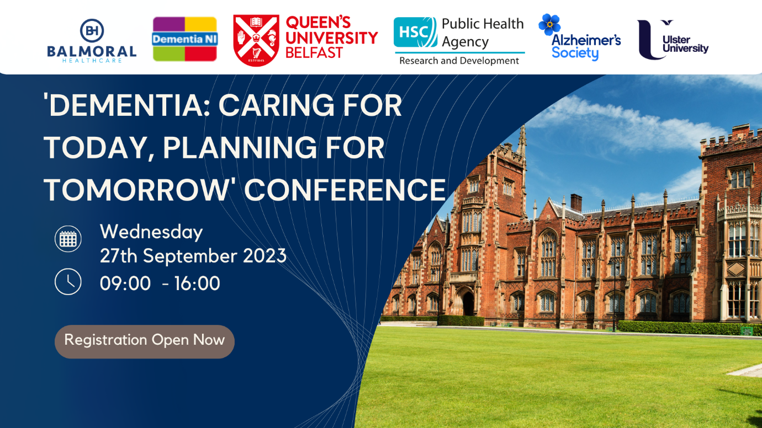

Dementia: Caring for Today, Planning for Tomorrow Conference **at Queen's University Belfast (The Great Hall).** This co-designed conference will mark the end of World Alzheimer's Month on **Wednesday 27th September 2023,** it will provide delegates with an overview of the latest local research to optimise both the quality of care and the quality of life for people living with dementia.

Presentations will include Dr Julie Christie, Professor Christine Brown Wilson, Dr Frances Duffy, The InspireD Reminiscence App Team, Dementia NI, Alzheimer's Society and many more! Places are available at no cost on a first come first served basis. Early booking is essential. Register using this link [Dementia: Caring for Today, Planning for Tomorrow Conference. Tickets, Wed 27 Sep 2023 at 09:30 | Eventbrite](https://protect-eu.mimecast.com/s/r1kbCL87EHRvpJgHBkMHU?domain=eventbrite.co.uk) and any further queries contact [scraig22@qub.ac.uk](mailto:scraig22@qub.ac.uk)

* **Interested in joining the Older Persons Reference Panel?**

Are you interested in joining a new older persons reference group for the Derry City and Strabane District Council area? As part of developing the Age Friendly structures locally, DCSDC are inviting persons aged 50+ years from across the council area to get involved with the Older Persons Reference Group. Demographically and geographically representative of older people across all council areas, the group members will also be reflective of the World Health Organisations eight domains for creating age friendly cities and communities. This group will be co-designed by older people, including its function, name, frequency of how often it meets. The group should also design regular events to share and review progress and make sure that older voices continue to be heard throughout the Age Friendly programme journey. Please see enclosed below Expression of Interest Form, also available on website[Derry City & Strabane - Over 50s Reference Group (derrystrabane.com)](https://www.derrystrabane.com/community/community/over-50s-reference-group) and these should be returned by 1st September 2023. Further hard copies are available by contacting Alexandra Wallace at DCSDC on 028 7125 3253 or by emailing [Alexandra.wallace@derrystrabane.com](mailto:Alexandra.wallace@derrystrabane.com)



* **Heritage Week 2023 – 12th – 20th August 2023**

Heritage Week takes place from 12th - 20th of August, with the theme for the Ireland wide initiative is Living Heritage and the varied programme invites the public to explore the traditions, practices, knowledge and skills that have been passed down through generations. The City Walls, the River Foyle, Strabane, the iconic Guildhall and The Tower Museum will all feature during the week which aims to bring together communities, families, organisations, cultural institutions, academics and enthusiasts to build awareness about the value of heritage and support its conservation. For more information, visit [www.heritageweek.ie](http://www.heritageweek.ie)

* **Storytelling Event - ‘Together' tenx9 event**

Integrated Education Fund are again linking up with tenx9 to organise a story telling event in Derry, this time on the theme ‘Together’ and as part of the 2023 Good Relations Week. Tenx9 is a storytelling event where nine people have up to ten minutes each to tell a true story from their own life. We are now inviting submissions of true stories for this event on anything related to the theme ‘Together’. If this is something you are interested in and you happen to be available on Thursday 21st September, 7.30-9.30pm, we’d be delighted if you could submit your story on <http://www.tenx9.com/submissions> We hope to see you on 21th September at the Nerve Centre, as a story contributor or of course just attending our free event!. If you have questions or want more information, please don’t hesitate to get in touch with me [Jessica@ief.org.uk](mailto:Jessica@ief.org.uk) or email [tenx9belfast@gmail.com](mailto:tenx9belfast@gmail.com) directly.

* **Practical advice about making and updating your will**

Making a will is vital if you want to be certain that your wishes will be met after you die – and it can also make sure you don’t pay more Inheritance Tax than you need to. It can be easy to put off making a will, but the process may not be as difficult as you think. Age NI have prepared a guide to highlight the benefits of making a will, the issues you should think about and the areas in which you need to seek professional advice. Remember, it’s important to review and update your will regularly to make sure it always reflects what you want to happen to your estate. Please visit this link to access Age NI’s Guide. <https://www.ageuk.org.uk/globalassets/age-ni/documents/advice/age-ni-wills-guide.pdf>

* **NWCN E-bulletin – 9th August 2023**

For the latest NWCN e-bulletin please visit [www.nwcn.org/content/nwcn-ebulletin-09-august-2023](http://www.nwcn.org/content/nwcn-ebulletin-09-august-2023)

* **Increased listeria risk in older people from cold-smoked and cured fish**

Please see the below information on increased listeria risk in older people from cold-smoked and cured fish. Learn more from Food Standards Agency in and read the full report here: [https://www.food.gov.uk/news-alerts/news/food-standards-agency-and-food-standards-scotland-issue-updated-advice-to-higher-risk-consumers-on-ready-to-eat-cold-smoked-and?fbclid=IwAR0wsWueHFsOw45pt9Fdt9tNRPnpL5aEjLbQmhBrmGHWvzTTvbis6c32VM8](https://protect-eu.mimecast.com/s/S86-Cvol1C7X7lyUQ7F7W?domain=food.gov.uk)

* **New to online shopping?**

Join Supporting Communities to learn how to stay safe and find a bargain online! Sign up for this course on 24 August at 10am. Get more info:

[https://supportingcommunities.org/latest-events/2021/1/7/online-shopping-24aug](https://protect-eu.mimecast.com/s/JWgNCwmV1uGpGNRfquy0c?domain=supportingcommunities.org)

* **Want to be on the cover of Age NI's Lived Experience 2023 report?**

 Check out the examples from Age NI’s 2021 report below, they have received nearly 1000 response to this year's survey, and hope to feature as many faces as possible to represent all the older people who have told us what is most important to them. If you'd like to be one of the cover stars, please email [michele.young@ageni.org](mailto:michele.young@ageni.org) your portrait photo by 31 August 2023. Please make sure your photo is...

• In focus and in colour

• Recent

• Head and shoulders only

• Doesn’t feature anyone else

• Doesn’t have a distracting background

• Is taken in portrait mode (upright) vs landscape (wide)

Please reach out to [michele.young@ageni.org](mailto:michele.young@ageni.org) or call 028 9024 5729 with any questions. Thank you!

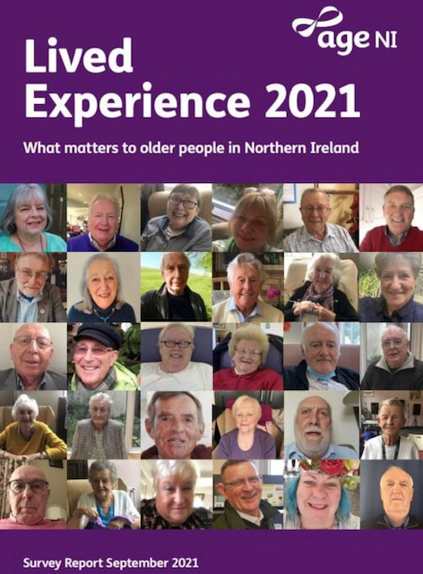

* **Best Kept Community Hero Award**

Applications are currently open for the 'Best Kept Community Hero' Award, this award is presented to someone who is very active in their community and who always goes that extra mile in making a positive difference in improving the environment in which they live or work. The winner of this award will be announced at the Best Kept Award Ceremony which will take place at the Linen Suite, Mossley Mill, Newtownabbey on the 18th October 2023. Please see below the nomination form.



* **Changes to Concessionary Fare Consultation – Closing Soon**

The Department for Infrastructure (DfI) is considering making changes to the Concessionary Fares Scheme. This Scheme provides free and discounted public transport for some groups of people, including older people and people with disabilities. The consultation on changes to the Concessionary Fares Scheme will close on 24th August at 5pm. Please see the easy read version of this consultation which is interactive and people can complete and return to DFI. Please visit for further information please visit <https://www.infrastructure-ni.gov.uk/consultations/consultation-changes-concessionary-fares-scheme>



* **Safeguarding Clients from Carbon Monoxide**

Aimed at front-line staff and volunteers who deliver services in the homes of vulnerable people, this free workshop will train you in how to spot the dangers and safety risks of carbon monoxide poisoning so you can make your clients more CO aware, as well as gain information and find out more about the resources available to help vulnerable people. This will be held on Thursday, 7 September from 10am to 12.30pm at The Junction,12 Beechvalley Way, Dungannon. To book visit <https://www.eventbrite.co.uk/e/safeguarding-your-clients-from-carbon-monoxide-risks-tickets-652647595527>

* **National Energy Action Impact Report (April 2022-March 2023)**

The latest National Energy Action (NEA) Impact Report (April 2022-March 2023) has just been published. Visit weblink to access the report and findings

<https://www.nea.org.uk/wp-content/uploads/2023/07/NEA-Impact-Report-2023-FINAL.pdf?utm_source=brevo&utm_campaign=Impact%20Report%2022-23&utm_medium=email>

* **Summer Break for the Bulletin**

The Age Friendly Bulletin will take a break during the month of August and will resume again in September.